WORLD METEOROLOGICAL ORGANIZATION  COMMISSION FOR BASIC SYSTEMS  -----------------------------  FOURTH MEETING OF  INTER-PROGRAMME EXPERT TEAM ON  DATA REPRESENTATION MAINTENANCE AND MONITORING  GENEVA, SWITZERLAND, 30 MAY - 3 JUNE 2016 |  | IPET-DRMM-IV / Doc. 7.3  (23. 5. 2016)  -------------------------  ITEM 7.3  ENGLISH ONLY

MIGRATION TO TABLE DRIVEN CODE FORMS (TDCF)
TAC2BUFR Check at DWD
Submitted by Andreas Gerth, Daniel Lee and Sibylle Krebber (DWD)

_______________________________________________________________________

Summary and Purpose of Document

This document proposes to make a web-based tool available without access restriction to assist in the TAC2TDCF migration.

_______________________________________________________________________

ACTION PROPOSED

We propose that the meeting endorse the tool’s use without access restriction in order to assist in quality assurance and promote dialog about the migration from TAC to TDCF.

DISCUSSIONS

Motivation

Difficulties have been found in the course migrating from the use of Traditional, Alphanumeric Codes (TAC) to Table Driven Code Forms (TDCF). The transition from the TAC SYNOP report FM12 to FM94 BUFR has proven particularly challenging. In some cases, messages with encoding errors have been put into circulation which can have negative effects on operational numerical weather prediction and lower the quality of climate-scale time series data. Often this is the result of falsely encoded BUFR messages.

The tool: TAC2BUFR Check

During the transition period messages are disseminated as FM12 and FM94 in parallel. This affords us the opportunity to compare individual observations encoded in different formats, which can greatly assist in finding and removing encoding errors. DWD uses a web-based tool built in-house which automates the complex task of comparing messages encoded in different code forms and shows discrepancies between each. This has been used in successfully evaluating messages which have recently begun to be encoded in BUFR for internal use, as well as for engaging other originating centers in dialog about their BUFR when issues have arisen. The tool’s daily results are available online and are currently password protected in order to respect the privacy of other centers. It can be found at the following URI:
http://www.deutscher-wetterdienst.de/TAC2BUFR/SV/webt2b_main.html

The tool makes use of a relational database which converts input data into a normalized form for climate research. The database is able to ingest both FM12 and FM94, making a direct comparison possible using the database’s observation metamodel.

Each day, the synoptical observations from the previous day which were provided both in FM12 and FM94 are compared with each other. The results are presented in the web view. The web view shows only observations in which a deviance between both code forms was found. These deviances are highlighted. A deviance does not necessarily signify an error, as the implementation details between data encoding in FM12 and FM94 are not always directly compatible with one another. This is compensated in the tool as well as possible, but deviances still need to be investigated on a case-by-case basis.

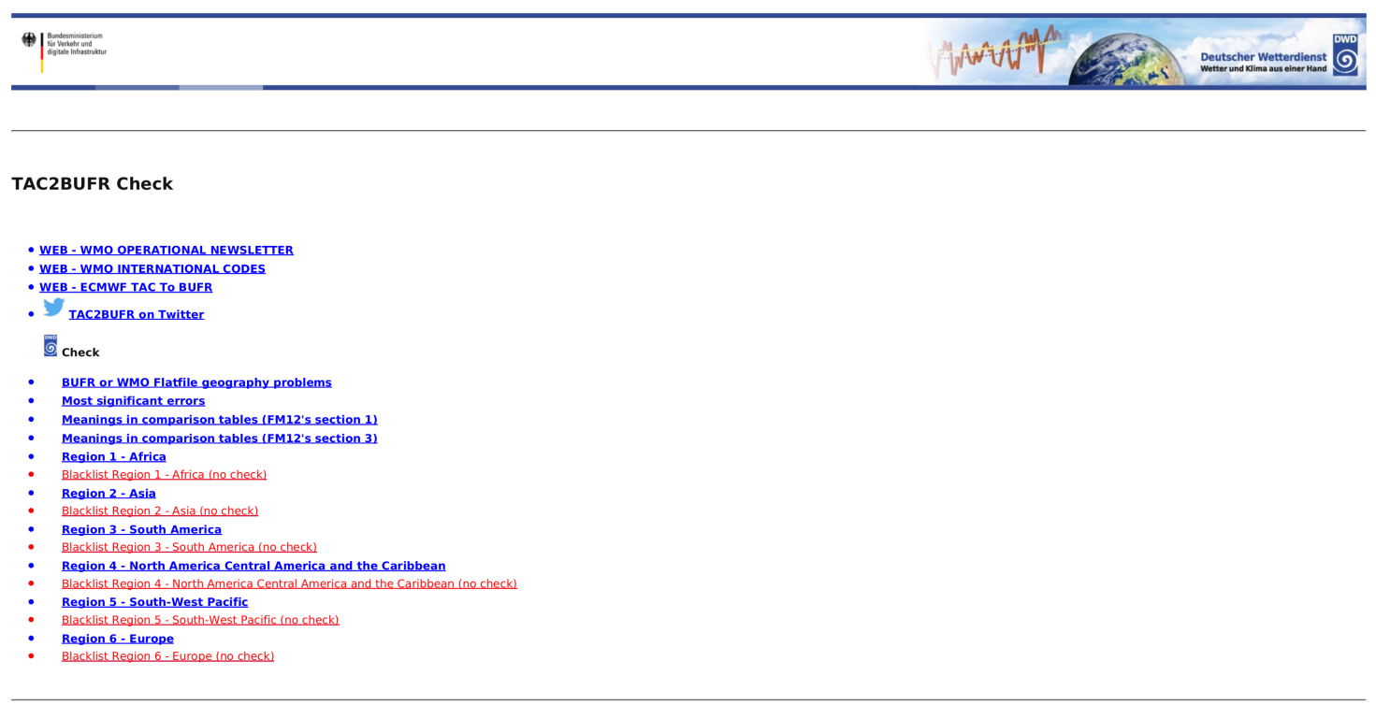
Figure 1: The TAC2BUFR Check start page.
Station IDs are assigned to originating centers based on the entries in Volume A. Observations from individual stations are stored only once. That means that if an observation is disseminated by several stations (a common case e.g. in Antarctica), the first message received is accepted into the database and the rest are rejected as duplicates.

Two comparison tables are shown, comparing sections 1 and 3 from the FM12 messages, respectively. The section 1 tables are created for all regions and centers, whereas the section 3 tables are only created by need or request. Further information can be found under the link “Meanings in comparison tables ...“ on the start page.

FM94 messages that could not be compared because they were malformed are found under the menu item “Most significant errors". The lists stored here are created manually, on demand.

BUFR with ambiguous metadata can be found under menu item "BUFR or WMO Flatfile geography problems“. This link leads to a private website due to unclear policies at DWD concerning the use of Google imagery. On this page, stations whose geographic positions differ by more than 0.2° are shown as pairs. The page is rebuilt sporadically.

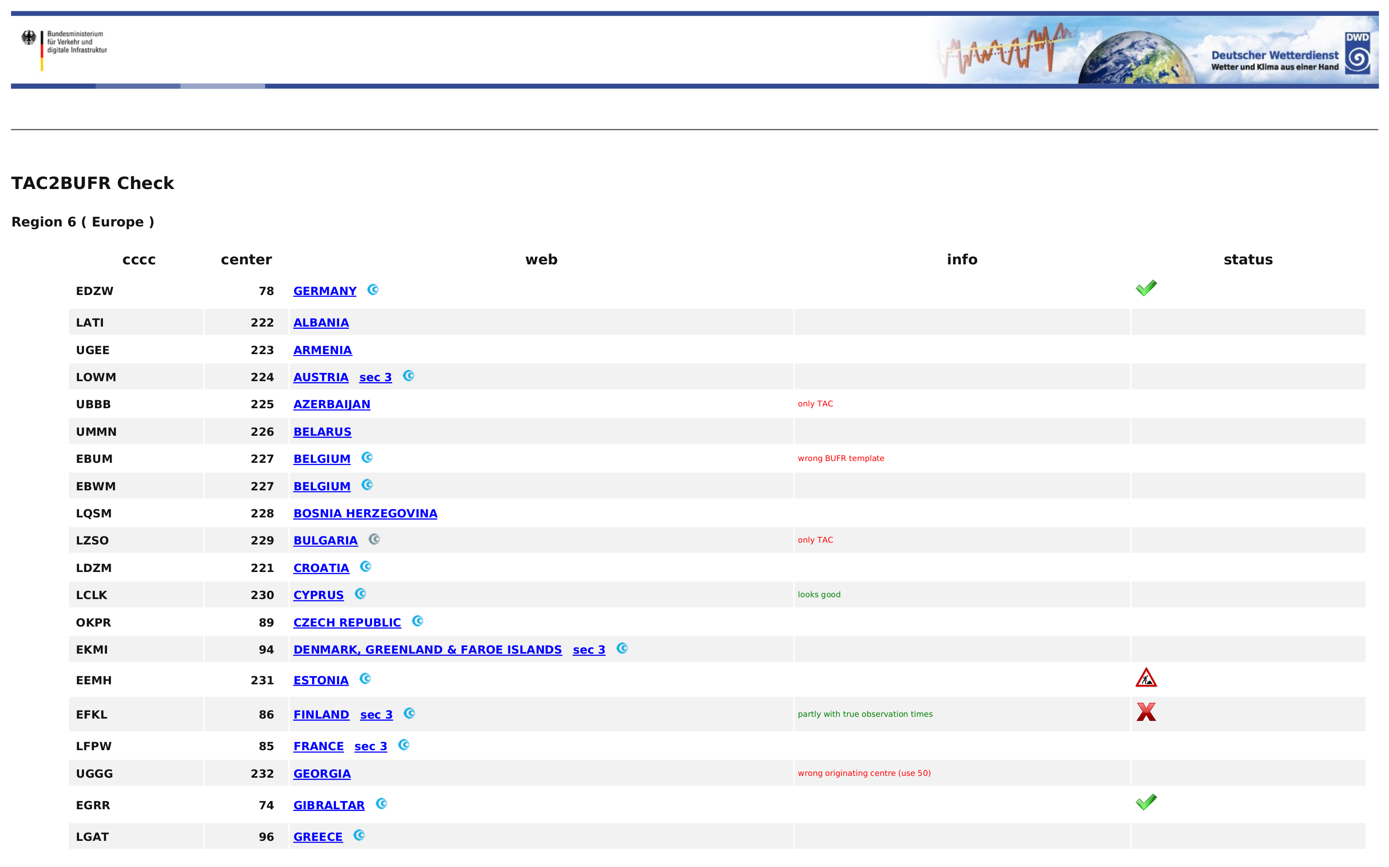
Figure 2: Center overview for region 6.
An overview is provided showing all centers in a given region (see fig. 2).

Migration completed
Comparison passes with minor ambiguities
Comparison seems to show errors, ambiguities present
Comparison contains errors and many ambiguities, use of FM94 not recommended
Encoding scheme is known to be under revision
Table 1: Status summary symbols in use to describe original centers.
A summary of the tool’s evaluation of each center is provided in the status column. The symbols currently in use are found in table 1. This may expand to include other symbols if needed.

Future updates may also provide support for comparing TEMP messages.

PROPOSAL

Beyond the current use of showing issues with FM94 messages on a bilateral basis, this tool could be used to support higher transparency and participation during the TAC2BUFR migration. Please endorse the removal of password protection for this page and allow the TAC2BUFR wiki and DWD pages to publicize it.

