WORLD METEOROLOGICAL ORGANIZATION  COMMISSION FOR BASIC SYSTEMS  -----------------------------  FOURTH MEETING OF  INTER-PROGRAMME EXPERT TEAM ON  DATA REPRESENTATION MAINTENANCE AND MONITORING  GENEVA, SWITZERLAND, 30 MAY - 3 JUNE 2016 |  | IPET-DRMM-IV / Doc. 7.2 (2)  (26. 5. 2016)  -------------------------  ITEM 7.2  ENGLISH ONLY

MIGRATION TO TABLE DRIVEN CODE FORMS (TDCF)
Status of the migration to TDCF in RA II
Submitted by Jitsuko Hasegawa (Japan)

_______________________________________________________________________

Summary and Purpose of Document

The document describes the status of migration to Table-Driven Code Forms in RA II (Asia), highlighting monitoring results in April 2016 and related activities of Members since the last meeting.

_______________________________________________________________________

ACTION PROPOSED

The meeting is requested to note the information.

ANNEXES:
1.

1 Background of this report

Following the decisions of the fifteenth session of Regional Association II (Doha, December 13-19, 2012), the Management Group defined working structures and the terms of reference of Working Groups and Theme Leaders. The Theme Leader in Data Representation and Metadata, appointed under the Working Group on WMO Integrated Global Observing System (WIGOS) and WMO Information System (WIS) (WG-WIGOS/WIS), is responsible for:
(a) Keeping under review inter-programme data representation matters, including migration to Table Driven Code Forms and regional codes, and make recommendations.
(b) Keeping under review the status of implementation of the WIS DAR metadata catalogue and migration from WMO Catalogue of Meteorological Bulletins (Volume C1) to DAR metadata.
In accordance with this mandate, the theme leader monitors and gives technical assistance as well as conducts survey on migration status on a regular basis. This document summarizes the monitoring results of migration status of RA-II Members as of April 2016 and related activities by RA-II Members during the period between July 2015 and May 2016.

2 RA-II Member activities related to TDCF
Several activities related to TDCF were reported by RA-II Members since the last meeting in July 2015:
2.1 Kazakhstan
Kazakhstan started dissemination of surface data in BUFR format in September 2015 with GTS bulletin headings of ISMD[01|20|21] UAAA (00, 06, 12, 18UTC), ISID[20|30|31] UAAA (03, 09, 15, 21UTC).
2.2 Laos
Laos started dissemination of surface data in BUFR format in April 2016 with GTS bulletin headings of ISMD01 VLIV (00, 06, 12, 18UTC) and ISIC20 VLIV (03, 09, 15, 21UTC).
2.3 Sri Lanka
Sri Lanka started dissemination of surface data in BUFR format in September 2016 with GTS bulletin headings of ISME01 TLPC (00, 06, 12, 18UTC), ISIE01 TLPC (03, 09, 15, 21UTC), ISME01 TLPL (00, 06, 12, 18UTC) and ISIE[01|20] TLPL (03, 09, 15, 21UTC).
2.4 Bhutan
GTS connection between Bhutan and RTH (GISC) New Delhi, India was established in June 2015 and started disseminating AWS data of one station in BUFR format in April 2016. (AWS data in CREX format is collected through satellite data collection system, brought back to the met office and reformatted to BUFR and put into GTS.)

3 Monitoring and Analysis of Migration Status
3.1 Monitoring method
Statistics were collected for the period of 1 through 15 of January, April, July and October, 2013-2016 (till April 2016). Resources were derived from the results of Special MTN Monitoring (SMM) pre-analysis and Integrated WWW Monitoring (IWM) created by WMC Melbourne/RTH Tokyo and from the latest version of the surface and upper-air (RBSN) station list of Regional Basic Synoptic Networks at the time of analysis.
In addition to WWW monitoring, the status of TDCF data communication is also monitored based on a catalogue created by GISC Tokyo (available at http://www.wis-jma.go.jp/csv/catalog.csv).
3.2 Migration progress and status
(1) SYNOP, TEMP and PILOT reports
The figures below show numerical representations of the progress of stations issuing BUFR-format bulletins equivalent to SYNOP and TEMP reports over the past three years. In the latest monitoring period from April 1 to 15, 2016, RTH Tokyo received (i) at least one surface synoptic observation report (excluding NIL reports) in BUFR format from 77% of RA II observation stations registered as part of RBSN (TAC format from 94%), and (ii) at least one upper-air sounding report in BUFR format from 55% of registered stations (TAC format from 91%). Eighteen BUFR reports equivalent to PILOT reports were received by RTH Tokyo in the monitoring period, while TAC bulletins were received from 16r stations.
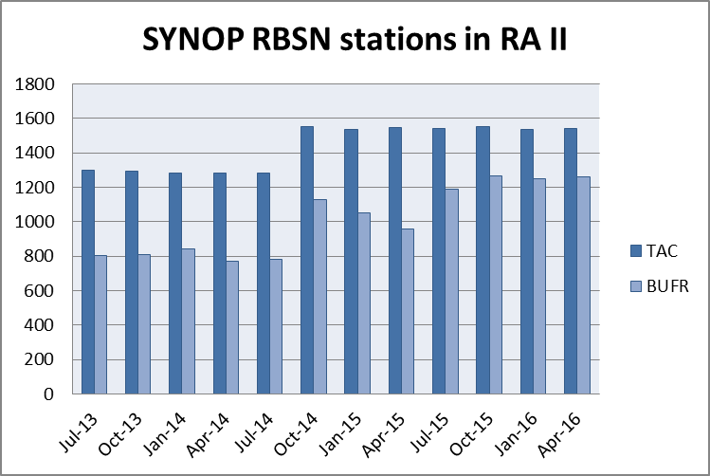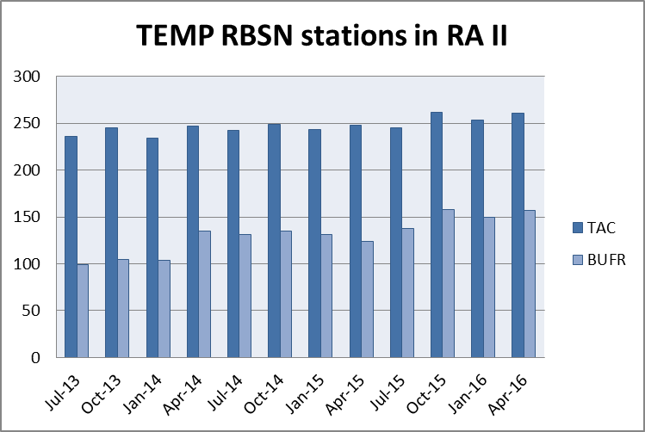
Number of RA-II RBSN stations issuing surface synoptic observation (SYNOP) and upper-air sounding (TEMP) reports in TAC and BUFR format from July 2013 to April 2016

(2) CLIMAT reports
As of May 2016, ten Members were reporting CLIMAT data in BUFR format: China; India; Mongolia; Saudi Arabia; Pakistan; Japan; Bangladesh; Hong Kong, China; Macao, China and Thailand.
(3) Marine reports
As of May 2016, India (TESAC), Hong Kong, China (SHIP), Japan (TESAC, TRACKOB, SHIP) and Republic of Korea (TESAC) were routinely disseminating marine observation data in BUFR format. Adoption of new templates for TESAC and BATHY is limited.

4. Questionnaire conducted in November 2015
4.1. Summary of response
The theme leader sent a questionnaire to all listed focal points (34 Members) in November 2015 and received responses from 18 Members (53%) with in the same month.
4.2. Questions and responses: see Annex.
4.3. Findings obtained from the survey results
(1) Creation and dissemination of TDCF
- Out of 18 respondents, 13 members (72%) are already disseminating TDCF reports and 2 centers (12%) is planning to start in near future, while 3 centers have no plan.
- Three members are planning to discontinue TAC dissemination by 2016, 2017 and 2018.
- Main challenges or obstacles in migrating TDCF are encoding software (56%), GTS communication (11%) and lack of awareness about the benefits of TDCF (22%). Management is also raised as a challenge.
(2) Use of TDCF
- Out of 18 respondents, 9 members (50%) are already using TDCF reports for daily forecasts, numerical weather prediction system and/or statistics, 5 centers (28%) are planning to start in near future, while 4 centers (22%) have no plan.
- Five members (28%) out of 18 respondents answered that they were not ready for continuing daily operation without TAC reports.
- Most members recognize the greater variety of data, station metadata included in reports and the higher quality of data are the benefits of TDCF.
- Decoding, lack of data and data quality, continued availability of TAC reports and lack of awareness about the benefits of TDCF were identified as challenges or obstacles in using TDCF by about a quarter of respondents.
- Two respondents identified variety of BUFR templates as a challenge.
- A respondent pointed out that BUFR reports are not convenient for the use for manual plotting of observations on weather maps.
(3) Issue of upper-air reports in BUFR format
- The format/quality issue of upper-air reports in BUFR format was recognized by two-thirds of respondents.
- Regarding the production of native BUFR reports, 3 respondents are already producing and 9 have plans for it.
(4) Processing of TDCF
- About half of respondents answered they were using in-house software of GTS message switching system, observation/NWP visualization, weather map analysis and report production, while another half were using vendor software.

4.4 Analysis of RA-II TDCF migration status
(1) Creation and dissemination of TDCF
- As of October 2015, about 80% of stations that send SYNOP reports also send reports in BUFR format, which is a notable achievement of RA-II.
- The number of upper-air sounding reports in BUFR format also increased by about 30 % in 2014-2015, compared to the year 2013-2014, reaching about 55 % of registered RBSN stations.
- Percentage of Members who report CLIMAT in BUFR format has been remaining around 25% for several years.
- A new sequence descriptor (a Table D entry of FM94) for CLIMAT BUFR is being approved to enable representation of time period for accumulation of monthly precipitation data that starts in the previous month (before 00UTC of the 1st day of month), which happens in eastern hemisphere countries.
- Progress with the migration of marine observation reports (Category 3) has been limited; one reason for this is the delay in developing regulatory materials for migration and BUFR templates for marine data.
- As CBS and JCOMM have now published regulations for reporting SHIP data in TDCF (B/C10) and BUFR templates suitable for SHIP, TESAC, TRACKOB and BATHY data, accelerated migration is expected in the next few years.
- There are a few Members who have plans for discontinue TAC dissemination, but majority has not.
(2) Use of TDCF
- BUFR reports are used for daily forecasts, numerical weather prediction system and/or statistics.
- There are a certain number of Members who are not ready for continuing daily operation without TAC reports.
- Most members recognize the greater variety of data, station metadata included in reports and the higher quality of data are the benefits of TDCF.
- There are concerns over lack of data quality and quality control over TDCF.
- Decoding, lack of data and data quality, continued availability of TAC reports and lack of awareness about the benefits of TDCF were identified as challenges or obstacles in using TDCF.
- Variety of BUFR templates are identified as a challenge for users, although the flexibility of templates is one of the features of TDCF.
- There are situations where TAC reports are more convenient than BUFR reports, for example in the situation where forecasters manually plot observations on weather maps.
(3) Issue of upper-air reports in BUFR format
- The quality issue of upper-air reports in BUFR formats raged a huge discussion in NWP community and was broadly recognized by RA II Members.
- It was the first time for the community to be discouraged production of BUFR messages through conversion of TAC equivalent.
- Many centres are forced to review and change their migration policy and it naturally takes time to change the direction to production of native BUFR reports; the 2015 survey revealed that three Member is already producing BUFR reports directly from raw data (not by conversion of TEMP/PILOT, native BUFR) and about half of the respondents have plans for the change, which confirmed the expectation that it would take long time for all the upper reports to be produced without conversion and to solve quality issues caused by TAC conversion.
(4) Processing of TDCF
- Most of Members are producing BUFR messages by converting TAC reports.
- As shown in questionnaire surveys, RA II Members tend to prefer BUFR production by themselves and many in-house software applications are used.

Annex

Questions and responses of November 2015 RA-II Questionnaire

Questions for the survey on TDCF migration
1.
Please indicate your name, contact email address and organization.
Response from 18 Members: Bahrain; Bangladesh; Cambodia; China; Hong Kong, China; Iran; Japan; Kuwait; Macao, China; Mongolia; Oman; Qatar; Republic of Korea; Russia; Thailand; UAE; Uzbekistan; Viet Nam
2.
Does your organization disseminate TDCF reports via GTS?
13 Yes
3 No (proceed to 4.)
0 No, but arrangements for converting TAC data into TDCF have already made with a supporting center (please specify the supporting center: )
2 Not yet, but plans are being made to start in the near future
3.
Which categories of data does your organization (or the supporting center) disseminate (or plan to disseminate) in TDCF? If dissemination is scheduled to start in the near future, please indicate the planned time frame.
15 Category 1 (SYNOP, SYNOP MOBIL, PILOT, PILOT MOBIL, TEMP, TEMP MOBIL, TEMP DROP, CLIMAT)
3 Category 2 (SARAD, SAREP, SATEM, SATOB)
3 Category 3 (AMDAR)
4 Category 4 (BUOY, TRACKOB, BATHY, TESAC, WAVEOB, SHIP, CLIMAT SHIP, PILOT SHIP, TEMP SHIP, Argos data)
3 Category 5 (RADOB, IAC, IAC FLEET, GRID, RADOF)
Others (please specify below)
Wind profiler (Hong Kong)
CSR and AMV from COMS satellite (Republic of Korea)
Wind profiler, tide level, tropical cyclone track, various satellite data (Japan)
4.
Does your organization have a specific plan to discontinue TAC dissemination?
15 No
3 Yes (please specify data types and time below)
Example: Category 1 in January 2016
Category 1 in December 2018 (Bangladesh)
So far no specific plan exists due to Roshydromet's obligations on regional exchange (Russia)
Category 1 in Junary 2016 (Iran)
Category 1 in 31 July 2017 (Uzbekistan)
5.
What are the main challenges or obstacles in migrating to TDCF at your organization?
10 Encoding software
2 GTS communication
4 Lack of awareness about the benefits of TDCF
Others (please specify below)
We have completed migration to TDCF but till we are using TAC data as we are analyzing data manually. (Bangladesh)
Large proportion of manual work for message compilation (CLIMAT), big variety of sounding systems (TEMP) (Russia)
Just IRIMO's TDCF format should check by another center (Iran)
We are still coordinating with Jeddah. (Qatar)
6.
Does your organization currently use TDCF reports for daily forecasts, numerical weather prediction systems and/or statistics?
9 Yes
4 No (proceed to 8.)
5 Not yet, but testing is being conducted for use in the near future.
7.
Which categories of data does your organization use (or plan to use) in TDCF?
15 Category 1 (SYNOP, SYNOP MOBIL, PILOT, PILOT MOBIL, TEMP, TEMP MOBIL, TEMP DROP, CLIMAT)
5 Category 2 (SARAD, SAREP, SATEM, SATOB)
5 Category 3 (AMDAR)
5 Category 4 (BUOY, TRACKOB, BATHY, TESAC, WAVEOB, SHIP, CLIMAT SHIP, PILOT SHIP, TEMP SHIP, Argos data)
6 Category 5 (RADOB, IAC, IAC FLEET, GRID, RADOF)
Others (please specify below)
For example, Atmospheric Motion Vector (AMV) and scatterometer wind. (Hong Kong)
Various satellite data available in BUFR (Japan)
8. Some centers have discontinued dissemination of TAC since November 2014. Is your organization ready for continuing daily forecasts, numerical weather prediction and other operational activities without TAC reports?
10 Yes
1 No, but arrangements for converting TDCF data into TAC have already made with a supporting center (please specify the supporting center: )
5 No (please specify data types you still need and time below)
Example: We need SYNOP until December 2015.
We need catagory1 (SYNOP, PILOT, TEMP) until December 2018. (Bangladesh)
Remark: Advanced notification from meteorological centres of discontinuing TAC reporting is required. (Hong Kong)
For category1 we are ready and we checked the TDCF converter, but for other we should check. (Iran)
We are still coordinating with Jeddah. (Qatar)
December 2016 (Mongolia)
We need SYNOP until July 2017 (Uzbekistan)
9.
What are the main benefits of using TDCF compared to traditional alphanumeric code (TAC) forms for your organization?
16 The greater variety of data available in TDCF
11 The inclusion of station metadata in reports
12 The higher quality of data
Others (please specify below)
We are not sure. (Bangladesh)
Security in data transfer (Iran)
10.
What are the main challenges or obstacles in using TDCF at your organization?
6 Decoding
5 Lack of data
2 Lack of data types
4 Lack of data quality
3 Continued availability of TAC reports (processing of both forms is undesirable)
5 Lack of awareness about the benefits of using TDCF
Others (please specify below)
We are receiving both TAC and BUFR format data. As we are plotting and analyzing data manually in operation. It is inconvenient for our staff to plot this data manually. (Bangladesh)
The database management of BUFR data with different templates. (China)
Quality of encoding, variety of templates (Russia)
Please note that RKSL is disseminating Category 1, 3 data in TDCF, partially. (Republic of Korea)
Lack of data (reports) caused by routing. (Japan)
11.
Is your organization producing BUFR reports by converting SYNOP, TEMP/PILOT, SHIP and CLIMAT, instead of producing them directly from raw data?
SYNOP: 14 Yes 2 No
TEMP/PILOT: 8 Yes 6 No
SHIP: 3 Yes 4 No
CLIMAT: 8 Yes 4 No
12.
Since the beginning of 2014 there have been discussions over the quality of upper-air observation BUFR reports converted from TEMP/PILOT. Are you aware of the issue?
12 Yes
6 No
13.
The CBS Management Group sent out a letter about the issue and the Inter-programme Expert Team on Data Representation Maintenance and Monitoring (IPET-DRMM) published a report on the issue and recommendations (both are attached). Does your organization have any plans for producing upper-air BUFR reports directly from raw data?
3 Already producing upper-air BUFR reports directly from raw data
9 Yes, there are plans for producing upper-air BUFR reports directly from raw data in future.
6 No
Others (please specify below)
The Meteorological Observation Bureau acknowledged this but has no plan to report in BUFR directly from raw data yet. (Thailand)
Our NMH has no upper-air observation (Cambodia)
14.
If you don’t mind, please indicate the vendor(s) of software your organization is using.
GTS message switching system: 8 in-house 3 COROBOR 3 IBL
2 MFI 3 Oriental Electronics
1 Other (please specify: Telvent)
Observation/NWP visualization, weather map analysis:
8 in-house 3 COROBOR 4 IBL
2 MFI 2 Oriental Electronics
2 Other (please specify: Telvent, MapMakers Group Ltd. )
Report production: 10 in-house 2 COROBOR 2 IBL
2 MFI 2 Oriental Electronics
1 Other (please specify: Microstep, Intelcom-Delta)
15.
Indicate any questions or comments about migration to Table Driven Code Forms below. If your organization operates as an RTH, include any plans on TAC-BUFR conversion for other centres.
RTH Beijing will provide TDCF technical support and/or encoding/decoding software for the countries in its responsible area. (China)
Yes, SYNOP->BUFR conversion is offered to Members of CIS Interstate Council for Hydrometeorology (Russia)
We may provide the TAC-BUFR conversion services, if neccessary, for Lao PDR in case of no supported system at Lao PDR after TAC termination.(Thailand)
We would like to request JMA/Tokyo for providing technical assistance, guidance and experts for complete migration to TDCF and TAC-BUFR (Cambodia)
It is a good plan, but it's better to provide some standard library to use by RTH centers, like jar file for Java or dll for other programming language. (Iran)
Is it possible to use the TAC locally and BUFR internationally? Or Do we need to use BUFR on both locally and internationally? (Mongolia)

