|  |  |  |
| --- | --- | --- |
| WORLD METEOROLOGICAL ORGANIZATION  COMMISSION FOR BASIC SYSTEMS  -----------------------------  FOURTH MEETING OF  INTER-PROGRAMME EXPERT TEAM ON DATA REPRESENTATION MAINTENANCE AND MONITORING  GENEVA, SWITZERLAND, 30 MAY - 3 JUNE 2016 |  | IPET-DRMM-IV / Doc. 3.2 (9)  (24. 5. 2016)  -------------------------  ITEM 3.2  ENGLISH ONLY |

BUFR AND CREX

**Revised and additional new descriptors for radar data products**

*Submitted by* *Michael Mott, Sibylle Krebber (DWD)*

_______________________________________________________________________

**Summary and Purpose of Document**

This document contains proposals of revised and additional new BUFR descriptors for radar composite products.

_______________________________________________________________________

**ACTION PROPOSED**

The meeting in invited to review the document and the validation report and recommend the contents for fast-track approval in November 2016 (FT2016-2).

**ANNEXES:**

1. Validation report

**DISCUSSIONS**

DWD changed the radar composite routines to a new system. In this context the BUFR-format was updated. Especially more meta information is given. Currently the used descriptors are in the local table version 8 from originating centre 247 sub-centre 0. Such products are already exchanged within OPERA[1].

To create the composite within centre 78 sub-centre 10 the DWD had already proposed new descriptors for the BUFR master table which were accepted with some changes for validation at IPET-DRMM III. During the validation process it turned out that additional descriptors were desired for a better understanding of the BUFR Radar products.

An example of such a product could be:

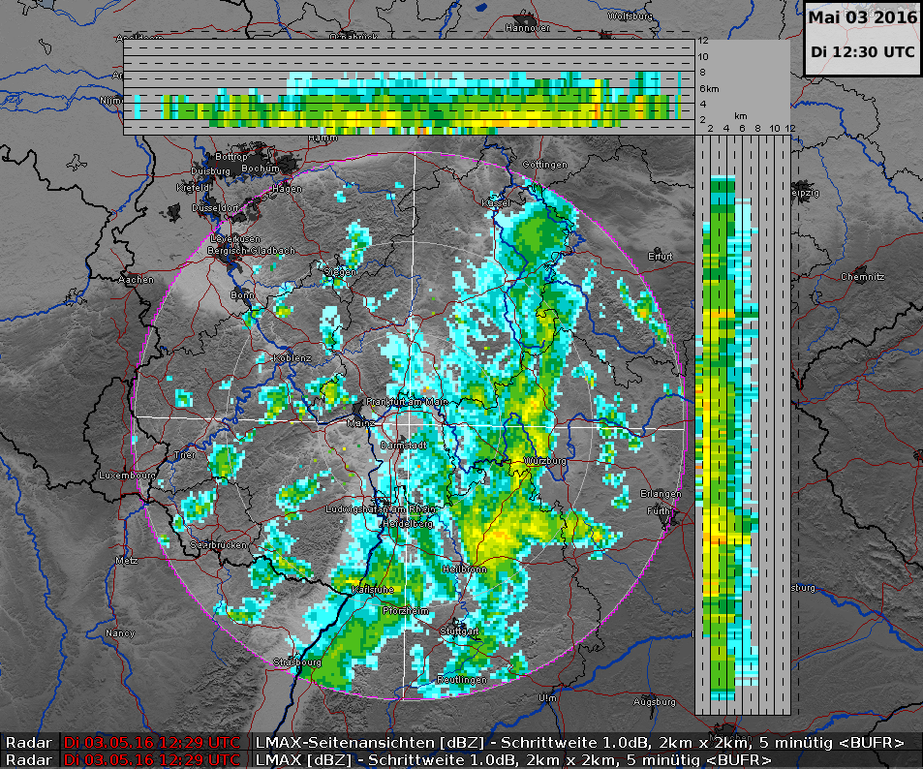

**PROPOSAL**

Proposed new BUFR Table B descriptors in Validation with incorporated changes.

During the validation also the categories of new entries were changed as the new entries are more or less coordinates and should be in classes 01-07.

|  |  |  |  |  |  |  |  |  |  |  |
| --- | --- | --- | --- | --- | --- | --- | --- | --- | --- | --- |
| **TABLE**  **REFERENCE** | | |  | **BUFR** | | | | **CREX** | | |
| **F** | **X** | **Y** | **ELEMENT NAME** | **UNIT** | **SCALE** | **REFERENCE VALUE** | **DATA**  **WIDTH**  **(Bits)** | **UNIT** | **SCALE** | **DATA**  **WIDTH**  **(Char)** |
| 0 | 01 | 152 | Semi-major axis of rotation ellipsoid | m | 2 | 0 | 31 | m | 2 | 11 |
| 0 | 01 | 153 | Semi-minor axis of rotation ellipsoid | m | 2 | 0 | 31 | m | 2 | 11 |
| ~~0~~ | ~~29~~ | ~~12~~ | ~~Longitude origin~~ | ~~Degree~~ | ~~5~~ | ~~-18000000~~ | ~~26~~ | ~~Degree~~ | ~~5~~ | ~~10~~ |
| ~~0~~ | ~~29~~ | ~~13~~ | ~~Latitude origin~~ | ~~Degree~~ | ~~5~~ | ~~-9000000~~ | ~~25~~ | ~~Degree~~ | ~~5~~ | ~~9~~ |
| ~~0~~ | ~~29~~ | ~~14~~ | ~~Latitude of true scale~~ | ~~Degree~~ | ~~5~~ | ~~-9000000~~ | ~~25~~ | ~~Degree~~ | ~~5~~ | ~~9~~ |
| 0 | 06 | 32 | X coordinate (see Note 6) | m | 2 | -1073741824 | 31 | m | 2 | 11 |
| 0 | 05 | 32 | Y coordinate (see Note 6) | m | 2 | -1073741824 | 31 | m | 2 | 11 |
| 0 | 29 | 14 | Optional list of parameters for an external map projection library | CCITT_IA5 | 0 | 0 | 800 | Character | 0 | 100 |

Add Note under Class 5 – BUFR/CREX Location (horizontal–1):

(6) Y coordinate is the distance between the projection origin and the upper left corner of the upper left pixel in a map as explained in the following drawing:



Projection origin

Upper left pixel

X-coordinate

Y-coordinate

Add Note under Class 6 – BUFR/CREX Location (horizontal–2):

(6) X coordinate is the distance between the projection origin and the upper left corner of the upper left pixel in a map as explained in the following drawing:



Projection origin

Upper left pixel

X-coordinate

Y-coordinate

**Code table 0 08 091 – Coordinates significance**

|  |  |
| --- | --- |
| **Code figure** |  |
| 0 | Satellite coordinates |
| 1 | Observations coordinates |
| 2 | Start of observation |
| 3 | End of observation |
| 4 | Horizontal centre of gravity of the observation |
| 5 | Top of the observation |
| 6 | Bottom of the observation |
| 7 | Vertical centre of gravity of the observation |
| 8 | Projection origin |
| 9 | Coordinates of true scale |
| 10 - 254 | Reserved |
| 255 | Missing value |

New BUFR Table B descriptors are proposed:

**Class 8 – BUFR/CREX Significance qualifiers**

|  |  |  |  |  |  |  |  |  |  |  |
| --- | --- | --- | --- | --- | --- | --- | --- | --- | --- | --- |
| **TABLE**  **REFERENCE** | | |  | **BUFR** | | | | **CREX** | | |
| **F** | **X** | **Y** | **ELEMENT NAME** | **UNIT** | **SCALE** | **REFERENCE VALUE** | **DATA**  **WIDTH**  **(Bits)** | **UNIT** | **SCALE** | **DATA**  **WIDTH**  **(Char)** |
| 0 | 08 | 088 | Map significance | Code table | 0 | 0 | 6 | Code table | 0 | 2 |
| 0 | 20 | 129 | Lightning density | m-2 | 6 | 0 | 10 | m-2 | 6 | 4 |

**Code table 0 08 088 – Map significance**

|  |  |
| --- | --- |
| **Code figure** |  |
| 0 | Top view (geographical longitude on X axis and latitude on Y axis) |
| 1 | North-South view (transect with geographical longitude on X axis and vertical height on Y axis) |
| 2 | East-West view (transect with geographical latitude on X axis and vertical height on Y axis) |
| 3-63 | Reserved |
| 64 | Missing |

1. <http://www.eumetnet.eu/sites/default/files/bufr_sw_desc.pdf>