WORLD METEOROLOGICAL ORGANIZATION  COMMISSION FOR BASIC SYSTEMS  -----------------------------  FOURTH MEETING OF  INTER-PROGRAMME EXPERT TEAM ON  DATA REPRESENTATION MAINTENANCE AND MONITORING  GENEVA, SWITZERLAND, 30 MAY - 3 JUNE 2016 |  | IPET-DRMM-IV / Doc. 3.2 (4)  (18. 5. 2016)  -------------------------  ITEM 3.2  ENGLISH ONLY

BUFR
New BUFR elements for C-band synthetic aperture radar instrument (C-SAR)
Submitted by Marijana Crepulja(ECMWF), Enrico Fucile(ECMWF), Saleh Abdalla(ECMWF) and Nuno Miranda (ESA)

_______________________________________________________________________

Summary and Purpose of Document

New BUFR elements are proposed to support encoding the C-SAR Ocean Swell Wave (OSW) data from Sentinel-1A

_______________________________________________________________________

ACTION PROPOSED

The team is requested to review the proposal validate the proposed elements and accept them for FT2016-2, at this purpose example data and a dump are provided.

ANNEXES:
1. An example of BUFR sequence to encode Sentinel 1 OSW.
DISCUSSIONS

ECMWF is preparing for the operational processing of Sentinel 1 Ocean Swell Wave (OSW) data. Sentinel-1 is the first in the new fleet of ESA Sentinels satellites and carries an advanced C-band Synthetic Aperture Radar (SAR) instrument to provide an all-weather, day-and-night supply of imagery of Earth’s surface.
In the context of this activity ECMWF has developed in collaboration with ESA a new BUFR sequence for the level L2 data to support ESA in the definition of the Sentinel 1 OSW data in BUFR which are of interest for the data assimilation in NWP models and exchanging Sentinel 1 OSW data activities.

Sentinel-1 CSAR modes of operation

The radar operates in two main modes: Interferometric Wide swath and Wave.

Interferometric Wide swath mode is the default mode over land, has a swath width of 250 km and a ground resolution of 5 x 20 m.
Wave mode acquisitions which can help to determine the direction, wavelength and heights of waves on the open oceans are 20 x 20 km, acquired alternately on two different incidence angles every 100 km.

There is also the potential of operating it in two additional modes: Stripmap and Extra Wide Swath.

Stripmap mode provides a continuity of ERS and Envisat data, offering a 5 x 5 m resolution over a narrow swath width of 80 km.
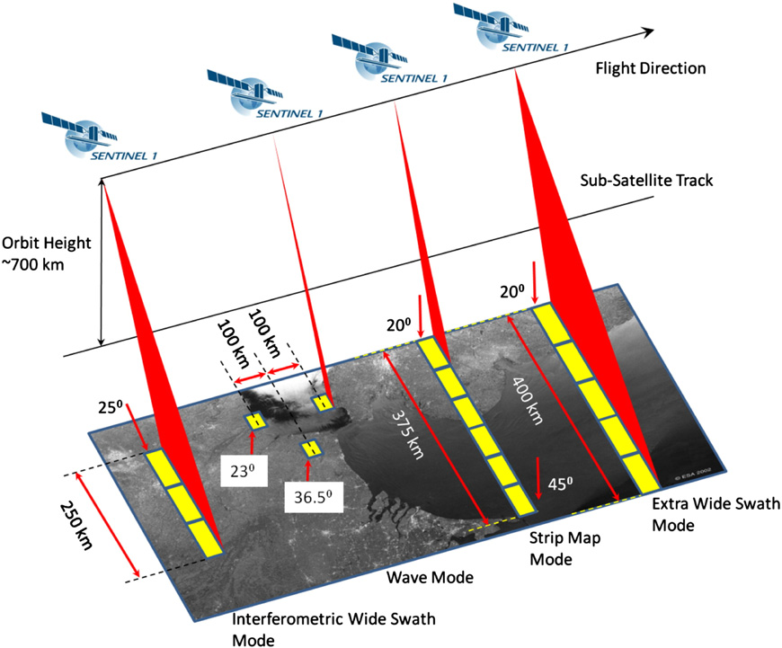
Extra Wide Swath mode is intended for maritime, ice and polar zone operational services where wide coverage and short revisit times are demanded.

The new elements: number of spectra in range direction, number of spectra in azimuthal direction, index in range direction and index in azimuthal direction in the BUFR table B are proposed to allow more flexibility and reusability for encoding data from Wave mode and Strip map mode in the future.

One single observation in the L2 data set is characterised by number of spectra in range direction, number of spectra in azimuthal direction, number of angular and wavenumber bins. Those four elements are enough to fully describe the observation volume.

The new element Stripmap identifier is proposed to distinguish the data coming from Wave and Stripmap mode.

This document proposes new entries in the BUFR/CREX Table B, class 03, 05, 25, 40.

Noting that class 22 (Oceanographic elements) is full and does not allow the definition of a new element we propose Class 42 as an extension.

PROPOSAL

The following new BUFR table B entries and corresponding code table are proposed:

Class 03 – BUFR/CREX Instrumentation
TABLE  REFERENCE | ELEMENT  NAME | BUFR |  |  |  | CREX
F X Y |  | UNIT | SCALE | REFERENCE  VALUE | DATA  WIDTH  (Bits) | UNIT | SCALE | DATA  WIDTH  (Characters) | Description
0 03 025 | Cross-track estimation area size | m | 0 | 5000 | 16 | m | 0 | 16 | Ground range size of the estimation area [m].
0 03 026 | Along-track estimation area size | m | 0 | 5000 | 16 | m | 0 | 16 | Azimuth size of the estimation area [m].

Class 05 – BUFR/CREX Location (horizontal – 1)
TABLE  REFERENCE | ELEMENT  NAME | BUFR |  |  |  | CREX
F X Y |  | UNIT | SCALE | REFERENCE  VALUE | DATA  WIDTH  (Bits) | UNIT | SCALE | DATA  WIDTH  (Characters) | Description
0 05 071 | Stripmap identifier | Numeric | 0 | 0 | 16 | Numeric | 0 | 16 | In the case of SM mode the product contained in a single netCDF file will be split in several BUFR messages. We need to have an identifier to rebuild the original product and to mark the single parts to belong to the same product. This is the function of Stripmat identifier
0 05 072 | Number of spectra in range direction | Numeric | 0 | 0 | 8 | Numeric | 0 | 8 | Number of range swell wave spectra cells. For WV mode this dimension is set to 1 as there is 1 swell wave spectra per WV vignette. For SM this dimension is set to the number of cells in the range direction, nominally 4. This parameter does not apply to IW nor EW mode.
0 05 073 | Number of spectra in azimuthal direction | Numeric | 0 | 0 | 8 | Numeric | 0 | 8 | Number of azimuth swell wave spectra cells. For WV mode this dimension is set to 1 as there is 1 swell wave spectra per WV vignette. For SM this dimension is set to the number of cells in the azimuth direction, nominally 4; although, this will vary with the length of the input image strip. This parameter does not apply to IW nor EW mode.
0 05 074 | Index in range direction | Numeric | 0 | 0 | 8 | Numeric | 0 | 8 | Index of range swell wave spectra cell.
0 05 075 | Index in azimuthal direction | Numeric | 0 | 0 | 8 | Numeric | 0 | 8 | Index of azimuth swell wave spectra cell.

Class 25 – BUFR/CREX Processing information
TABLE  REFERENCE | ELEMENT  NAME | BUFR |  |  |  | CREX
F X Y |  | UNIT | SCALE | REFERENCE  VALUE | DATA  WIDTH  (Bits) | UNIT | SCALE | DATA  WIDTH  (Characters) | Description
0 25 189 | Range cut-off wavelength | m | 0 | 1 | 9 | m | 0 | 9 | The range cut-off wavelength [m] is the shortest wavelength in range direction that can be resolved in the swell wave spectra. The cut-off wavelength is computed from the slant range resolution (or range bandwidth, fsf ) and the local incidence angle as: λrange(θ)=c/fsfsinθ

Class 40 – BUFR/CREX Satellite data
TABLE  REFERENCE | ELEMENT  NAME | BUFR |  |  |  | CREX
F X Y |  | UNIT | SCALE | REFERENCE  VALUE | DATA  WIDTH  (Bits) | UNIT | SCALE | DATA  WIDTH  (Characters) | Description
0 40 038 | Partition number |  | 0 | 1 | 4 |  | 0 | 4 | Number of wave partitions
0 40 039 | Single Look Complex image intensity | Numeric | 0 | -25 | 5 | Numeric | 0 | 16 | The input Single Look Complex (SLC) image intensity estimated within each wave cell
0 40 040 | Single Look Complex image skewness | Numeric | 2 | 1 | 13 | Numeric | 0 | 13 | The skewness of the input SLC image [dimensionless] estimated within each wave cell
0 40 041 | Single Look Complex image kurtosis | Numeric | 2 | 1 | 13 | Numeric | 0 | 13 | The kurtosis of the input SLC image [dimensionless] estimated within each wave cell
0 40 042 | Single Look Complex image variance | Numeric | 2 | 1 | 13 | Numeric | 0 | 13 | The variance of the input SLC image normalized by the square of the mean intensity [dimensionless] estimated within each wave cell.

Class 42 – BUFR/CREX Oceanographic elements

TABLE  REFERENCE | ELEMENT  NAME | BUFR |  |  |  | CREX
F X Y |  | UNIT | SCALE | REFERENCE  VALUE | DATA  WIDTH  (Bits) | UNIT | SCALE | DATA  WIDTH  (Characters) | Description
0 42 001 | Dominant swell wave direction of spectral partition | degree | 0 | 0 | 9 | degree | 0 | 9 | Dominant wave direction [degree] for each partition of the swell wave spectra.
0 42 002 | Significant swell wave height of spectral partition | m | 1 | 0 | 9 | m | 1 | 9 | Significant wave height [m] for each partition of the swell wave spectra
0 42 003 | Dominant swell wavelength of spectral partition | m | 2 | 100 | 17 | m | 2 | 17 | Dominant wave length [m] for each partition of the swell wave spectra
0 42 004 | Confidence of inversion for each partition of swell wave spectra |  | 0 | 0 | 4 |  | 0 | 4 | Confidence of inversion for each partition of swell wave spectra
0 42 005 | Ambiguity removal factor for swell wave partition |  | 5 | -100000 | 18 |  | 5 | 18 | The ambiguity removal factor [dimensionless] for each wave partition
0 42 006 | Wave age |  | 2 | 1 | 8 |  | 2 | 8 | Wave age
0 42 007 | Shortest ocean wavelength on spectral resolution | m | 2 | 0 | 16 |  | 2 | 16 | The spectral resolution gives the shortest ocean wavelength [m] that can be detected.
0 42 008 | Nonlinear inverse spectral width | m | 2 | 0 | 16 |  | 2 | 14 | Nonlinear inverse spectral width [m] describing non-linear spectral cut-off computed from the cross-spectra.
0 42 009 | Bin partition reference |  | 0 | 0 | 8 |  | 0 | 8 | Two-dimensional representation of the ocean swell wave partitions number given on a polar grid of wavenumber [rad/m] and angle [degN].  Giving the partitioning mask allowing to associate to each spectra bin the partitions it belongs to.

Code table 0 42 004 – Confidence of inversion for each partition of swell wave spectra
Code figure
0 | WAVE DIRECTION RESOLVED
1 | 180-DEGREE AMBIGUITY NOT RESOLVE
2 | Reserved
3 | Missing

The following sequence has been used for validation of the proposed new entries.

TABLE  REFERENCES | Element name
0 01 007 | Satellite identifier
0 02 019 | Satellite instruments
0 01 096 | Station acquisition
0 25 061 | Software identification and version number
0 05 071 | Strip map identifier
0 05 072 | Number of spectra in range direction
0 05 073 | Number of spectra in azimuthal direction
0 05 074 | Index in range direction
0 05 075 | Index in azimuthal direction
0 05 040 | Orbit number
0 08 075 | Ascending/descending orbit qualifier
3 01 011 | Year, month, day
3 01 013 | Hour, minute, second
3 01 021 | Latitude/longitude (high accuracy)
0 01 012 | Direction of motion of moving observing platform
0 07 002 | Height or altitude
0 22 063 | Total water depth
0 08 012 | Land/sea qualifier
0 02 104 | Antenna polarization
0 21 105 | Normalised radar cross section
0 42 008 | Nonlinear inverse spectral width
0 25 103 | Number of directional bins
0 25 104 | Number of wavelength bins
0 25 105 | First directional bin
0 25 106 | Directional bin step
0 25 107 | First wavelength bin
0 25 108 | Last wavelength bin
0 11 001 | Wind direction
0 11 002 | Wind speed
0 42 006 | Wave age
0 21 030 | Signal to noise ratio
2 01 130 | Change data width
2 02 129 | Change scale
0 22 022 | Height of wind waves
2 02 000 | Change scale
2 01 000 | Change data width
0 02 026 | Cross-track resolution
0 02 027 | Along-track resolution
0 03 025 | Cross-track estimation area size
0 03 026 | Along-track estimation area size
0 40 039 | Single Look Complex image intensity
0 40 040 | Single Look Complex image skewness
0 40 041 | Single Look Complex image kurtosis
0 40 042 | Single Look Complex image variance
0 02 111 | Radar Incidence angle
0 25 014 | Azimuth clutter cut-off
0 25 189 | Range cut-off wavelength
1 06 000 | Delayed replication of 6 descriptors
0 31 001 | Delayed descriptors replication factor
0 40 038 | Partition number
0 42 001 | Dominant swell wave direction of spectral partition
0 42 002 | Significant swell wave height of spectral partition
0 42 003 | Dominant swell wavelength of spectral partition
0 42 004 | Confidence of inversion for each partition of swell wave spectra
0 42 005 | Ambiguity removal factor for swell wave partition
1 09 000 | Delayed replication of 9 descriptors
0 31 001 | Delayed descriptors replication factor
0 05 030 | Direction (spectral)
2 01 130 | Change data width
0 06 030 | Wave number (spectral)
2 01 000 | Change data width
0 21 135 | Real part of cross spectra polar grid number of bins
0 21 136 | Imaginary part of cross spectra polar grid number of bins
0 22 161 | Wave spectra
0 42 009 | Bin partitions reference
0 42 007 | Shortest ocean wavelength (spectral)

