WORLD METEOROLOGICAL ORGANIZATION  COMMISSION FOR BASIC SYSTEMS  -----------------------------  SECOND MEETING OF  INTER-PROGRAMME EXPERT TEAM ON  DATA REPRESENTATION MAINTENANCE AND MONITORING  COLLEGE PARK, USA, 28 APRIL - 2 MAY 2014 |  | IPET-DRMM-II / Doc. 7.2(6) Rev  (23. 4 . 2014)  -------------------------  ITEM 7.2  ENGLISH ONLY

MIGRATION TO TABLE-DRIVEN CODE FORMS (TDCF)

Status of Migration to TDCF in RA VI

Submitted by Eva Červená (Czech Republic)

________________________________________________________________

Summary and Purpose of Document

The document contains information related to the progress
of Migration to TDCF in RA VI countries
________________________________________________________________

ACTION PROPOSED

The meeting is invited to take the content of this document into consideration.

Annex: RA VI-16/Doc. 4.4(3), APPENDIX C

1. Status of Migration to TDCF in RA VI
At least one type of Category 1 data from the following countries of RA VI are produced in TDCF (Albania, Armenia, Austria, Belarus, Bosnia and Herzegovina, Belgium, Croatia, Cyprus, Czech Republic, Denmark and Faroe Islands, Estonia, Finland, France, Germany, Georgia, Greece, Hungary, Ireland, Israel, Italy, Jordan, Latvia, Lithuania, Lebanon, Luxembourg, Montenegro, Netherlands, Norway, Poland, Portugal, Romania, Russian Federation, Serbia, Slovakia, Slovenia, Spain, Sweden, Switzerland, Syria, The Former Yugoslav Republic of Macedonia, Turkey, United Kingdom of Great Britain and Northern Ireland); the underlined countries (28) produce all types of their Category 1 data in BUFR. Synoptic data in BUFR are produced by 39 countries, upper-air data in BUFR by 29 countries, CLIMAT data in BUFR by 25 countries. Ukraine used to produce synoptic data in BUFR, as shown in the ANNEX, but they are not currently available. High resolution radiosonde data are produced by Cyprus, Czech Republic, Denmark and Faroe Islands, Germany, Greece, Ireland, Netherlands, Norway, Russian Federation, Slovakia, Spain, Sweden and Switzerland, the underlined countries at all their stations. SHIP data from France, Israel, Netherlands, Norway and Sweden are produced in BUFR.
The status of Migration to TDCF in RA VI is based on the list of BUFR bulletins published in WMO-No. 9, Volume C1, on the “BUFR surface coverage” and “BUFR upper air coverage” in the ECMWF wiki page and on the actual bulletins received at the RTH Prague. It is to be noted that the Special MTN Monitoring may not provide the complete information as explained in the ANNEX.
Majority of RA VI countries are able to transmit/receive, store and process BUFR data. It is to be noted, however, that some countries would need the assistance of GISCs/DCPCs to provide conversion TAC ⬄ BUFR if distribution of TAC data is terminated in November 2014.

2. Activities of some RA VI members
The migration process in RA VI has been supported by members of the Task Team on Migration to TDCF under the leadership of Dr Eva Červená, officially only till the Sixteen Session of the RA VI (Helsinki, Finland, 11-17 September 2013). The new composition of the RA VI WG TDI and the Task Teams will be confirmed at the meeting of the RA VI Management Group on 14-15 May 2014, where also the new Leader of TT-MTDCF is to be nominated.
The ECMWF has created a wiki page “TAC To BUFR Migration” which is accessible in view mode under https://software.ecmwf.int/wiki/display/TCBUF/TAC+To+BUFR+Migration and where the information on BUFR and TAC data availability (completeness, timeliness, duplicates, structure) is provided. There are also two latest versions of the program synop2bufr available, prepared mainly by Mr. Perisa Sunderic (Serbia). Detailed description of the updates is included.
The Norwegian Meteorological Institute has made freely available several programs for BUFR decoding and encoding under https://wiki.met.no/bufr.pm/start, most notably the CPAN module Geo::BUFR.
The Irish Meteorological Service is preparing a program for conversion of SHIP data to BUFR. After additional testing it may be available to NMSs within a few months.
3. Proposal for recommendations
The RA VI seems to be an advanced Region regarding Migration to TDCF and some countries, already processing the data in BUFR, are troubled by the necessity to deal with both formats. There are some countries, however, that would need TAC data not only in November 2014, but probably for considerable time after it. These countries have been invited to ask for assistance from a GISC or a DCPC to perform conversion TDCF <=> TAC for them, e.g. GISC Offenbach or DCPC Prague. Postponing the termination of all Category 1 data distribution in TAC would lead merely to repetition of the current situation in the future. The gradual termination of parallel dissemination of TAC and BUFR data should be recommended. It would speed up the finalization of BUFR data processing or encourage the NMSs to make the relevant arrangements for conversion TDCF <=> TAC by another Centre.
RA VI-16/Doc. 4.4(3), APPENDIX C ANNEX

Migration to Table Driven Code Forms
1. Significant progress has been made towards exchanging information in Table Driven Code Forms. The Special Main Telecommunications Network Monitoring (SMM) identifies reports for stations in the Regional Basic Synoptic Network that are exchanged in BUFR. Figure 1 and Figure 2 show areas for which the SMM for April 2013 identified BUFR information for Regional Basic Synoptic Network (RBSN) stations being exchanged. There may be more countries actually exchanging information in BUFR that these figures show. Two reasons for this that have already been identified are that BUFR reports may be exchanged for stations that are not in the RBSN (for example, Belgium provides upper-air information for a station that is not in the RBSN), or that BUFR reports that are provided are not being routed to the monitoring centres (for example, Portugal produces reports in BUFR that were not received in Offenbach).
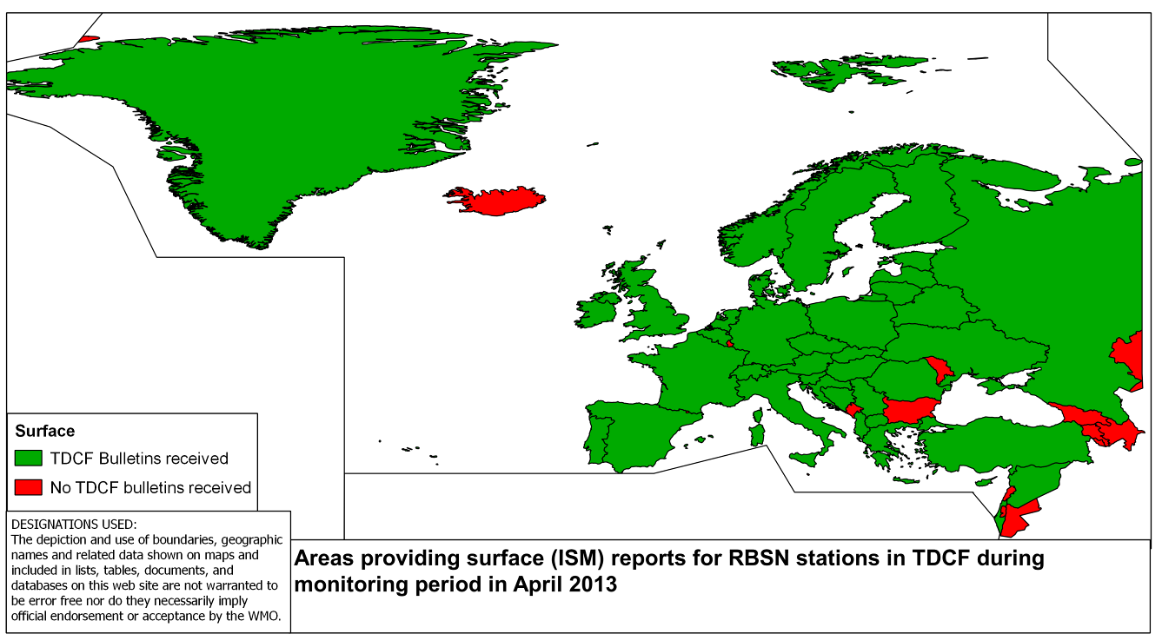
Figure 1. Surface synoptic reports exchanged in BUFR during the SMM in April 2013

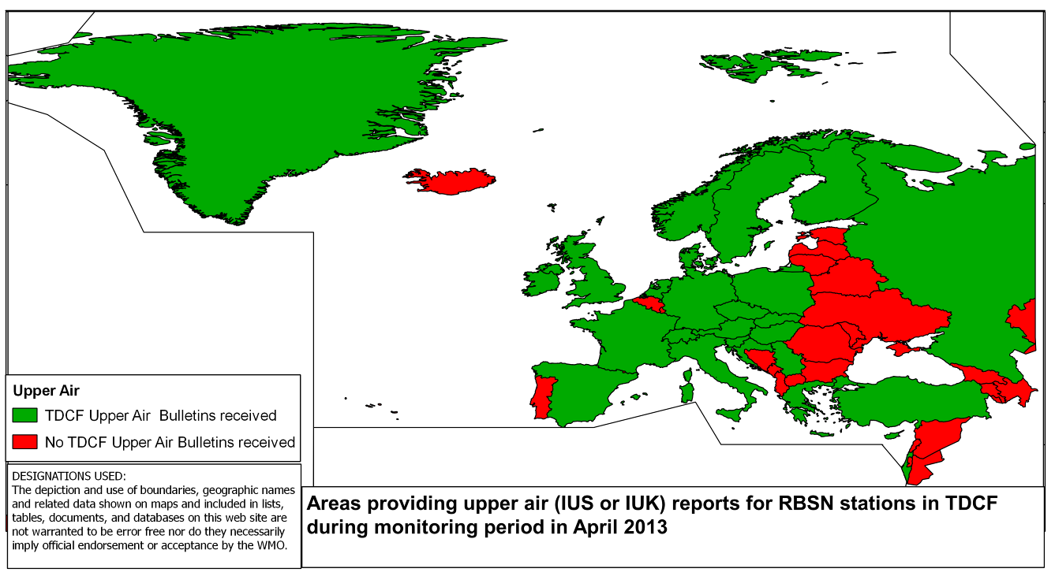
Figure 2. Upper-air synoptic reports exchanged in BUFR during the SMM in April 2013

