WORLD METEOROLOGICAL ORGANIZATION  COMMISSION FOR BASIC SYSTEMS  -----------------------------  SECOND MEETING OF  INTER-PROGRAMME EXPERT TEAM ON  DATA REPRESENTATION MAINTENANCE AND MONITORING  COLLEGE PARK, USA, 28 APRIL - 2 MAY 2014 |  | IPET-DRMM-II / Doc. 7.1 (1)  (10.4. 2014)  -------------------------  ITEM 7.1  ENGLISH ONLY

MIGRATION TO TABLE DRIVEN CODE FORMS (TDCF)

Status of Migration by WWW Monitoring Exercise

Submitted by Secretariat

_______________________________________________________________________

Summary and Purpose of Document

The WWW monitoring includes the Special MTN Monitoring (SMM). This records the stations contained in bulletins received by Regional Telecommunications Hubs on the Main Telecommunications Network. The records produced during the SMM period of 1-15 October were analyzed to identify how many station reports in BUFR were recorded.

IPET-DRMM should recommend to CBS Ext. (2014) any actions that are needed to complete migration.
_______________________________________________________________________

ACTION PROPOSED

Recommend to CBS Ext. (2014) that:
a) Migration should be considered complete when:
- WMO no longer maintains the World Weather Watch Traditional Alphanumeric Codes (but OPMET codes will be maintained as long as ICAO requires them)
- all centres using information that is exchanged on the GTS Main Telecommunications Network can operate based on the TDCF information flow
- no National Centre is required to produce information in TAC for the purpose of GTS exchange.
b) Encourage projects working in those areas that are least prepared for the exchange of information in TDCF to install only equipment that is configured to prepare reports in TDCF (in addition to formats required for local use).
c) Continue capacity development activities to assist Members to modify their production processes to be able to use information provided in TDCF.

DISCUSSIONS

The results of the Special MTN Monitoring for reports that were exchanged in BUFR format during 1-15 October 2013 are shown in Figures 1-3 and summarized in Tables 1-3.

There were special circumstances in October 2013 that resulted in CLIMAT messages originating in the United States were not created until after the monitoring period ended.

In Region I there are very few observations being reported in TDCF, but it is a region where few reports (especially upper air reports) reach the MTN in TAC. There is an opportunity when addressing the paucity of TAC observations to ensure that equipment is installed configured to disseminate information in BUFR. Nevertheless, there appears to remain a need to provide technical and training support in Region I, the southern part of Region II, much of Region III, Caribbean areas of Region IV and the more remote islands in Region V.

Figure 1: Surface BUFR reports for RBSN stations captured by the SMM exercise during 1-15 October 2015 shown as a percentage of the expected number of reports. Both TDCF (Large chart) and TAC (small chart) are shown.

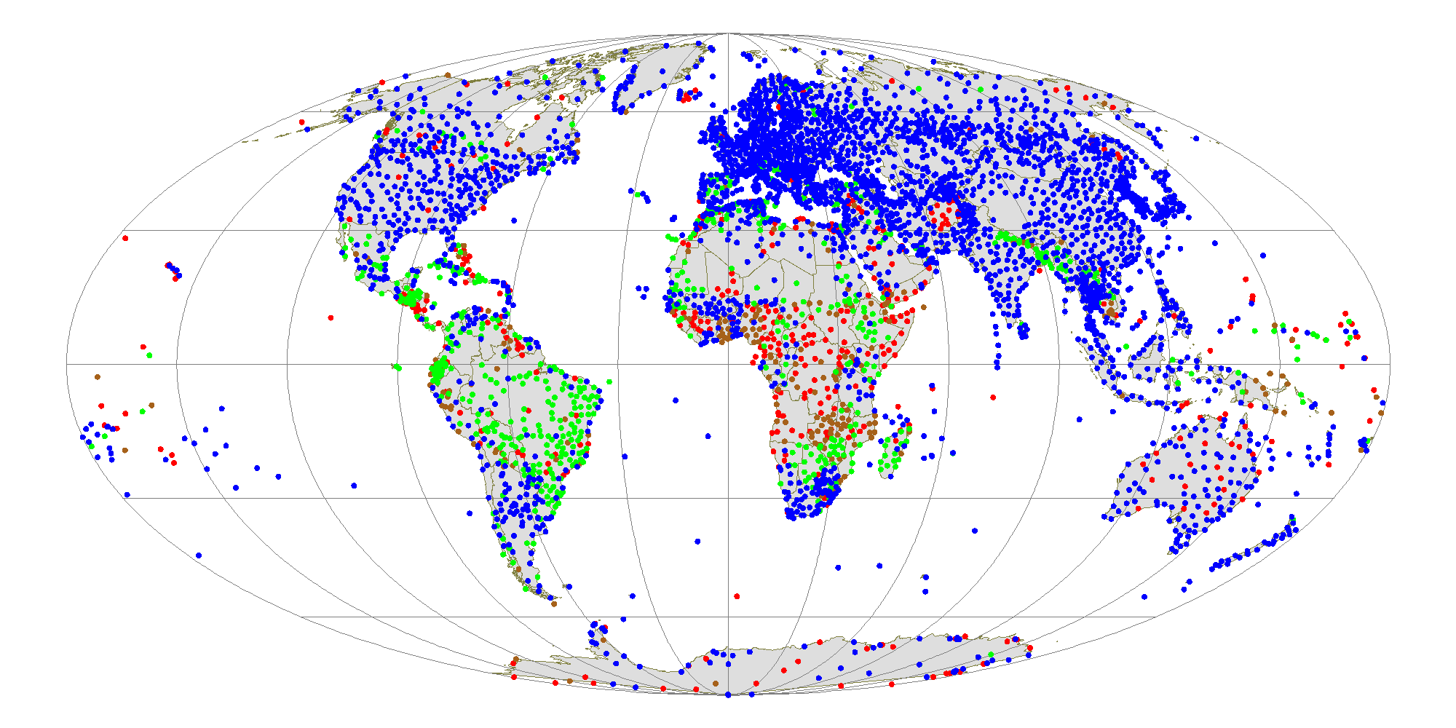
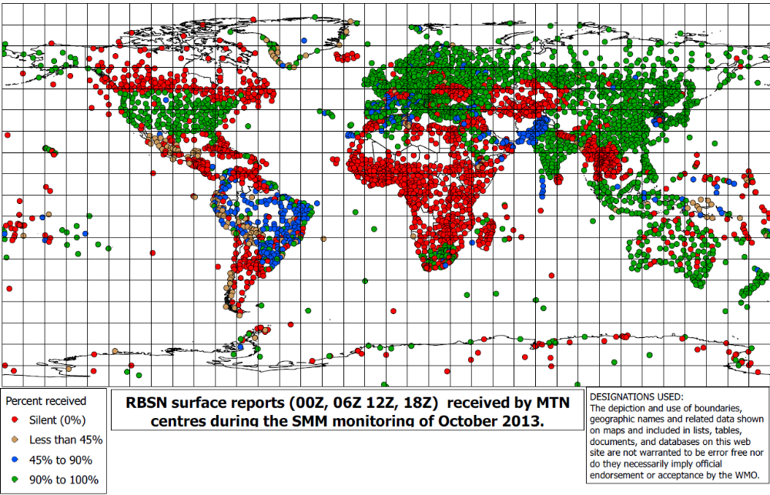
TDCF Reports
TAC reports

Figure 2: Upper air BUFR reports for RBSN stations captured by the SMM exercise during 1-15 October 2015 shown as a percentage of the expected number of reports. Both TDCF (Large chart) and TAC (small chart) are shown.

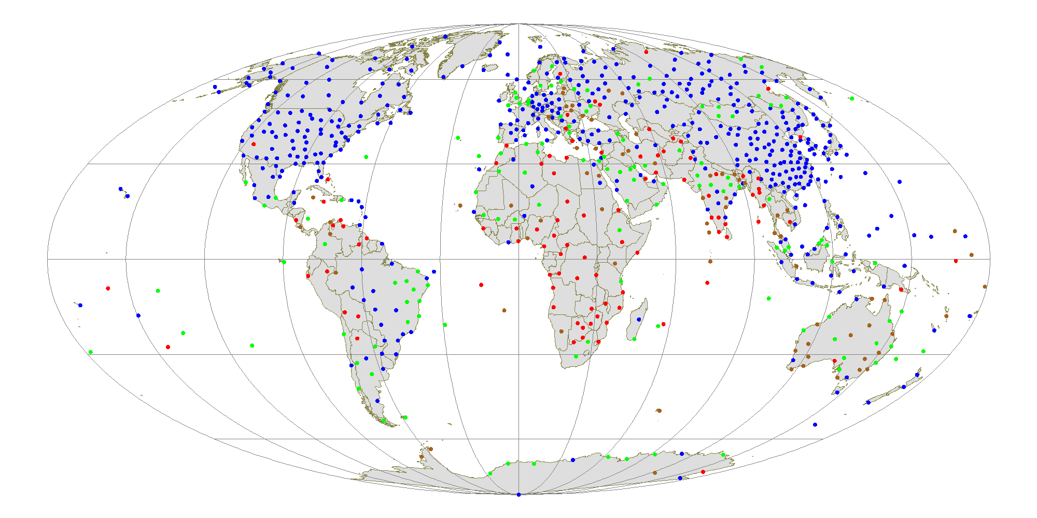
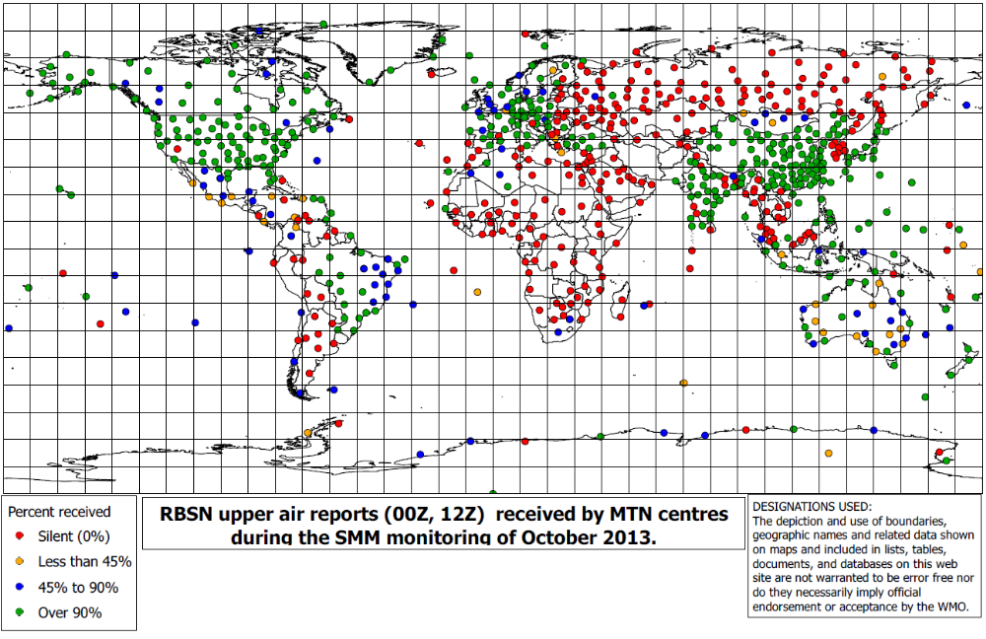
TDCF Reports

TAC reports

Figure 3: Climate BUFR reports for RBSN stations captured by the SMM exercise during 1-15 October 2015 shown as a percentage of the expected number of reports. Both TDCF (Large chart) and TAC (small chart) are shown.

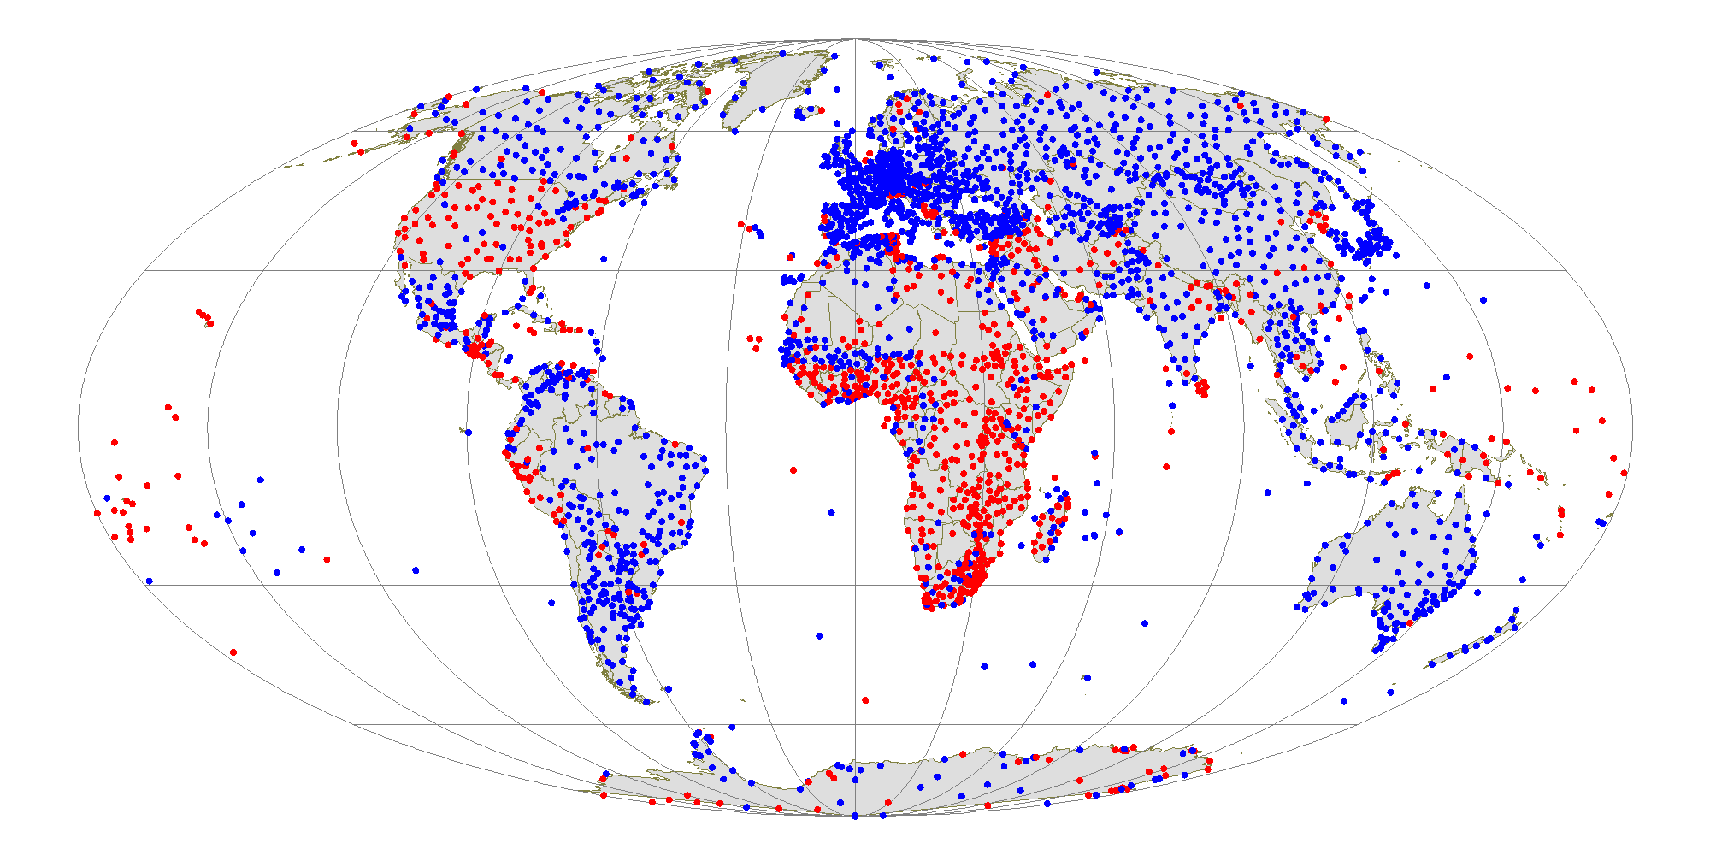
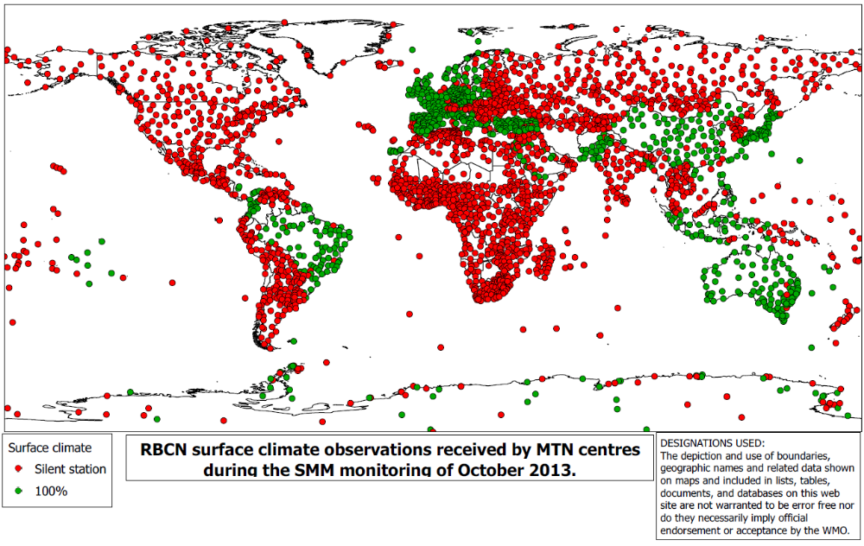
TDCF Reports
TAC reports

Table 1: Average by country of the number of surface reports from RBSN stations recorded in BUFR messages during the SMM of 1-15 October 2014. The number of reports expected from each station is 60.
RA | Country/Territory | Count of STN | Average Number
1 | ALGERIA | 49 | 52
 | ANGOLA | 14 | 0
 | BENIN | 6 | 0
 | BOTSWANA | 12 | 0
 | BOUVET ISLAND | 1 | 0
 | BURKINA FASO | 9 | 0
 | BURUNDI | 1 | 0
 | CAMEROON | 14 | 0
 | CAPE VERDE | 3 | 0
 | CENTRAL AFRICAN REPUBLIC | 13 | 0
 | CHAD | 11 | 0
 | COMOROS | 2 | 30
 | CONGO | 8 | 0
 | COTE D'IVOIRE | 14 | 0
 | DEMOCRATIC REPUBLIC OF THE CONGO | 29 | 0
 | DJIBOUTI | 1 | 0
 | EGYPT | 28 | 0
 | EQUATORIAL GUINEA | 2 | 0
 | ERITREA | 2 | 0
 | ETHIOPIA | 16 | 0
 | GABON | 9 | 0
 | GAMBIA | 2 | 0
 | GHANA | 13 | 0
 | GUINEA | 12 | 0
 | GUINEA-BISSAU | 1 | 0
 | KENYA | 18 | 0
 | LESOTHO | 3 | 0
 | LIBERIA | 1 | 0
 | LIBYAN ARAB JAMAHIRIYA | 26 | 0
 | MADAGASCAR | 26 | 0
 | MADEIRA | 3 | 60
 | MALAWI | 2 | 1
 | MALI | 17 | 0
 | MAURITANIA | 13 | 0
 | MAURITIUS | 6 | 0
 | MOROCCO | 24 | 0
 | MOZAMBIQUE | 15 | 0
 | NAMIBIA | 15 | 0
 | NIGER | 14 | 0
 | NIGERIA | 25 | 0
 | OCEAN ISLANDS | 5 | 24
 | OCEAN ISLANDS BETWEEN 0o and 30oS | 5 | 56
 | OCEAN ISLANDS BETWEEN 30o and 60oS | 3 | 40
 | RWANDA | 1 | 0
 | SENEGAL | 12 | 0
 | SEYCHELLES | 3 | 19
 | SIERRA LEONE | 1 | 0
 | SOMALIA | 14 | 0
 | SOUTH AFRICA | 87 | 37
 | SPAIN (CANARY ISLANDS) | 8 | 40
 | SPAIN (CEUTA AND MELILLA) | 1 | 45
 | SUDAN | 28 | 0
 | SWAZILAND | 1 | 0
 | TOGO | 5 | 0
 | TUNISIA | 19 | 24
 | UGANDA | 10 | 0
 | UNITED REPUBLIC OF TANZANIA | 16 | 0
 | WESTERN SAHARA | 2 | 0
 | ZAMBIA | 26 | 0
 | ZIMBABWE | 17 | 0
1 Total |  | 744 | 10
2 | AFGHANISTAN, ISLAMIC STATE OF | 13 | 0
 | BAHRAIN | 7 | 4
 | BANGLADESH | 11 | 21
 | CAMBODIA | 8 | 0
 | CHINA | 219 | 54
 | DEMOCRATIC PEOPLE'S REPUBLIC OF KOREA | 27 | 59
 | HONG KONG, CHINA | 1 | 60
 | INDIA | 82 | 59
 | IRAN, ISLAMIC REPUBLIC OF | 77 | 0
 | IRAQ | 11 | 0
 | JAPAN | 52 | 60
 | KAZAKHSTAN (IN ASIA) | 62 | 0
 | KUWAIT | 2 | 15
 | KYRGYZSTAN | 7 | 0
 | LAO PEOPLE'S DEMOCRATIC REPUBLIC | 14 | 0
 | MACAO, CHINA | 1 | 57
 | MALDIVES | 5 | 53
 | MONGOLIA | 35 | 58
 | MYANMAR | 27 | 0
 | NEPAL | 15 | 0
 | OMAN | 23 | 12
 | PAKISTAN | 54 | 53
 | QATAR | 1 | 33
 | REPUBLIC OF KOREA | 41 | 55
 | RUSSIAN FEDERATION (IN ASIA) | 324 | 58
 | SAUDI ARABIA | 35 | 43
 | SRI LANKA | 9 | 0
 | TAJIKISTAN | 14 | 0
 | THAILAND | 87 | 0
 | TURKMENISTAN | 20 | 0
 | UNITED ARAB EMIRATES | 5 | 40
 | UZBEKISTAN | 19 | 0
 | VIET NAM | 25 | 0
 | YEMEN | 22 | 7
2 Total |  | 1355 | 37
3 | ARGENTINA | 59 | 0
 | BOLIVIA | 35 | 25
 | BRAZIL | 159 | 40
 | CHILE | 22 | 3
 | COLOMBIA | 24 | 39
 | ECUADOR | 13 | 10
 | FRENCH GUIANA | 4 | 60
 | GUYANA | 6 | 0
 | ISLANDS (88: 800 - 998) | 2 | 60
 | PARAGUAY | 19 | 41
 | PERU | 29 | 30
 | SURINAME | 7 | 19
 | URUGUAY | 6 | 36
 | VENEZUELA | 22 | 0
3 Total |  | 407 | 26
4 | ANTIGUA AND BARBUDA | 1 | 0
 | BAHAMAS | 12 | 0
 | BARBADOS | 1 | 0
 | BELIZE | 2 | 0
 | BERMUDA | 1 | 60
 | CANADA | 172 | 0
 | CAYMAN ISLANDS | 1 | 0
 | CLIPPERTON | 1 | 0
 | COLOMBIA (SAN ANDRES AND PROVIDENCIA ISLANDS) | 2 | 47
 | COSTA RICA | 4 | 0
 | CUBA | 20 | 0
 | DOMINICA | 2 | 0
 | DOMINICAN REPUBLIC | 6 | 0
 | EL SALVADOR | 8 | 0
 | GRENADA | 1 | 0
 | GUADELOUPE, ST MARTIN, ST BARTHELEMY (AND OTHER FRENCH ISLANDS IN THE VICINITY) | 3 | 0
 | GUATEMALA | 9 | 0
 | HAITI | 2 | 0
 | HONDURAS | 14 | 0
 | JAMAICA | 2 | 0
 | MARTINIQUE | 2 | 30
 | MEXICO | 50 | 3
 | NETHERLANDS ANTILLES AND ARUBA | 5 | 0
 | NICARAGUA | 7 | 0
 | PANAMA | 3 | 0
 | PUERTO RICO AND US POSSESSIONS IN THE CARIBBEAN AREA | 2 | 57
 | RA-IV AUTOMATIC MARINE STATIONS | 27 | 0
 | SAINT LUCIA | 2 | 0
 | ST. PIERRE AND MIQUELON | 1 | 0
 | TRINIDAD AND TOBAGO | 2 | 0
 | UNITED STATES OF AMERICA | 180 | 56
 | UNITED STATES OF AMERICA (ALASKA) | 19 | 49
 | VENEZUELA (ISLA DE AVES) | 1 | 0
4 Total |  | 565 | 20
5 | AUSTRALIA | 129 | 48
 | BRUNEI DARUSSALAM | 1 | 0
 | COOK ISLANDS | 7 | 15
 | DETACHED ISLANDS | 3 | 20
 | EAST TIMOR | 2 | 0
 | FIJI | 12 | 47
 | FRENCH POLYNESIA (AUSTRAL ISLANDS) | 2 | 60
 | FRENCH POLYNESIA (MARQUESAS ISLANDS) | 1 | 60
 | FRENCH POLYNESIA (SOCIETY ISLANDS) | 2 | 60
 | FRENCH POLYNESIA (TUAMOTU AND GAMBIER ISLANDS) | 4 | 55
 | INDONESIA | 60 | 56
 | ISLANDS IN THE PACIFIC OCEAN NORTH OF THE EQUATOR | 51 | 16
 | KIRIBATI | 2 | 0
 | MALAYSIA | 14 | 60
 | NAURU | 1 | 0
 | NEW CALEDONIA | 6 | 30
 | NEW ZEALAND | 29 | 57
 | NIUE | 1 | 15
 | PAPUA NEW GUINEA | 11 | 15
 | PHILIPPINES | 27 | 57
 | PHOENIX ISLANDS | 1 | 0
 | SAMOA AND AMERICAN SAMOA | 12 | 5
 | SINGAPORE | 1 | 60
 | SOLOMON ISLANDS | 5 | 49
 | TOKELAU (AND SWAINS IS.) | 1 | 0
 | TONGA | 5 | 0
 | TUVALU | 4 | 0
 | VANUATU | 6 | 0
5 Total |  | 400 | 41
6 | ARMENIA | 3 | 0
 | AUSTRIA | 7 | 59
 | AZERBAIJAN | 7 | 0
 | BELARUS | 10 | 54
 | BELGIUM | 3 | 0
 | BOSNIA AND HERZEGOVINA | 4 | 56
 | BULGARIA | 9 | 0
 | CROATIA | 7 | 54
 | CYPRUS | 2 | 57
 | CZECH REPUBLIC | 7 | 60
 | DENMARK AND FAROE ISLANDS | 7 | 57
 | ESTONIA | 7 | 59
 | FINLAND | 22 | 54
 | FRANCE | 44 | 35
 | FYR OF MACEDONIA | 3 | 0
 | GEORGIA | 11 | 0
 | GERMANY | 28 | 58
 | GIBRALTAR | 1 | 60
 | GREECE | 22 | 53
 | GREENLAND | 30 | 33
 | HUNGARY | 7 | 59
 | ICELAND | 10 | 0
 | IRELAND | 9 | 53
 | ISRAEL | 4 | 60
 | ITALY | 48 | 58
 | JORDAN | 4 | 0
 | KAZAKHSTAN | 3 | 0
 | LATVIA | 6 | 0
 | LEBANON | 2 | 0
 | LITHUANIA | 7 | 60
 | LUXEMBOURG | 1 | 57
 | MALTA | 1 | 0
 | MONTENEGRO | 6 | 35
 | NETHERLANDS | 9 | 60
 | NORWAY | 40 | 56
 | POLAND | 22 | 60
 | PORTUGAL | 16 | 53
 | REPUBLIC OF MOLDOVA | 1 | 0
 | ROMANIA | 23 | 60
 | RUSSIAN FEDERATION (IN EUROPE) | 131 | 58
 | SERBIA | 28 | 55
 | SLOVAKIA | 4 | 60
 | SLOVENIA | 2 | 60
 | SPAIN | 33 | 55
 | SWEDEN | 44 | 60
 | SWITZERLAND AND LIECHTENSTEIN | 7 | 17
 | SYRIA | 9 | 12
 | TURKEY | 58 | 55
 | UKRAINE | 36 | 0
 | UNITED KINGDOM OF GREAT BRITAIN AND NORTHERN IRELAND | 30 | 57
6 Total |  | 835 | 47
7 | STATIONS OPERATED BY ARGENTINA | 6 | 0
 | STATIONS OPERATED BY AUSTRALIA | 18 | 10
 | STATIONS OPERATED BY BRAZIL | 1 | 0
 | STATIONS OPERATED BY CHILE | 2 | 6
 | STATIONS OPERATED BY CHINA | 2 | 30
 | STATIONS OPERATED BY FINLAND | 1 | 0
 | STATIONS OPERATED BY FRANCE | 1 | 60
 | STATIONS OPERATED BY GERMANY | 1 | 60
 | STATIONS OPERATED BY INDIA | 1 | 0
 | STATIONS OPERATED BY ITALY | 7 | 8
 | STATIONS OPERATED BY JAPAN | 1 | 60
 | STATIONS OPERATED BY NETHERLANDS | 3 | 0
 | STATIONS OPERATED BY NORWAY | 1 | 60
 | STATIONS OPERATED BY SOUTH AFRICA | 1 | 60
 | STATIONS OPERATED BY SPAIN | 1 | 0
 | STATIONS OPERATED BY THE REPUBLIC OF KOREA | 1 | 0
 | STATIONS OPERATED BY THE RUSSIAN FEDERATION | 8 | 38
 | STATIONS OPERATED BY THE UNITED KINGDOM | 4 | 42
 | STATIONS OPERATED BY THE UNITED STATES OF AMERICA | 4 | 30
 | STATIONS OPERATED BY THE USA (UNIVERSITY OF WISCONSIN) | 28 | 26
 | STATIONS OPERATED BY UKRAINE | 1 | 60
 | STATIONS OPERATED BY URUGUAY | 1 | 0
7 Total |  | 94 | 21
Grand Total |  | 4400 | 31

Table 2: Average by country of the number of upper air reports from RBSN stations recorded in BUFR messages during the SMM of 1-15 October 2014. The number of reports expected from each station is 60.
RA | Country/Territory | Count of STN | Average Number
1 | ALGERIA | 5 | 23
 | ANGOLA | 2 | 0
 | BOTSWANA | 4 | 0
 | BURKINA FASO | 1 | 0
 | CAMEROON | 2 | 0
 | CAPE VERDE | 1 | 0
 | CENTRAL AFRICAN REPUBLIC | 1 | 0
 | CHAD | 2 | 0
 | CONGO | 2 | 0
 | COTE D'IVOIRE | 1 | 0
 | DEMOCRATIC REPUBLIC OF THE CONGO | 3 | 0
 | EGYPT | 6 | 0
 | ERITREA | 1 | 0
 | ETHIOPIA | 2 | 0
 | GHANA | 2 | 0
 | GUINEA | 1 | 0
 | KENYA | 1 | 0
 | LIBYA | 4 | 0
 | MADAGASCAR | 2 | 0
 | MADEIRA | 1 | 0
 | MALAWI | 1 | 0
 | MALI | 2 | 0
 | MAURITANIA | 1 | 0
 | MAURITIUS | 1 | 0
 | MOROCCO | 2 | 0
 | MOZAMBIQUE | 3 | 0
 | NAMIBIA | 1 | 0
 | NIGER | 2 | 0
 | NIGERIA | 3 | 0
 | OCEAN ISLANDS | 5 | 7
 | SENEGAL | 2 | 15
 | SOMALIA | 1 | 0
 | SOUTH AFRICA | 2 | 15
 | SPAIN (CANARY ISLANDS) | 1 | 30
 | SUDAN | 2 | 0
 | TUNISIA | 2 | 0
 | UNITED REPUBLIC OF TANZANIA | 3 | 0
 | ZAMBIA | 1 | 0
 | ZIMBABWE | 2 | 0
1 Total |  | 81 | 3
2 | AFGHANISTAN, ISLAMIC STATE OF | 2 | 0
 | BANGLADESH | 2 | 0
 | CAMBODIA | 1 | 0
 | CHINA | 82 | 30
 | DEMOCRATIC PEOPLE'S REPUBLIC OF KOREA | 1 | 0
 | HONG KONG, CHINA | 1 | 30
 | INDIA | 34 | 24
 | IRAN, ISLAMIC REPUBLIC OF | 9 | 0
 | IRAQ | 1 | 0
 | JAPAN | 16 | 30
 | KAZAKHSTAN | 8 | 0
 | KUWAIT | 1 | 0
 | MALDIVES | 1 | 0
 | MONGOLIA | 6 | 18
 | MYANMAR | 5 | 0
 | OMAN | 2 | 0
 | PAKISTAN | 3 | 29
 | QATAR | 1 | 0
 | REPUBLIC OF KOREA | 7 | 0
 | RUSSIAN FEDERATION (IN ASIA) | 69 | 0
 | SAUDI ARABIA | 8 | 0
 | SRI LANKA | 1 | 0
 | TAJIKISTAN | 2 | 0
 | THAILAND | 5 | 0
 | TURKMENISTAN | 2 | 0
 | UNITED ARAB EMIRATES | 1 | 0
 | VIET NAM | 3 | 0
2 Total |  | 274 | 15
3 | ARGENTINA | 7 | 0
 | BOLIVIA | 2 | 0
 | BRAZIL | 26 | 24
 | CHILE | 5 | 12
 | COLOMBIA | 3 | 5
 | ECUADOR | 1 | 16
 | FRENCH GUIANA | 1 | 28
 | GUYANA | 1 | 0
 | ISLANDS (88: 800 - 998) | 1 | 15
 | PERU | 2 | 0
 | VENEZUELA | 4 | 2
3 Total |  | 53 | 15
4 | BAHAMAS | 1 | 0
 | BARBADOS | 1 | 30
 | BELIZE | 1 | 27
 | BERMUDA | 1 | 20
 | CANADA | 30 | 27
 | CAYMAN ISLANDS | 1 | 6
 | COLOMBIA (SAN ANDRES AND PROVIDENCIA ISLANDS) | 1 | 15
 | COSTA RICA | 1 | 11
 | CURACAO AND BONAIRE | 1 | 0
 | DOMINICAN REPUBLIC | 1 | 11
 | GUADELOUPE, ST MARTIN, ST BARTHELEMY (AND OTHER FRENCH ISLANDS IN THE VICINITY) | 1 | 30
 | JAMAICA | 1 | 0
 | MEXICO | 9 | 15
 | NETHERLANDS ANTILLES AND ARUBA | 1 | 30
 | NICARAGUA | 1 | 0
 | PUERTO RICO AND US POSSESSIONS IN THE CARIBBEAN AREA | 1 | 30
 | TRINIDAD AND TOBAGO | 1 | 30
 | UNITED STATES OF AMERICA | 64 | 30
 | UNITED STATES OF AMERICA (ALASKA) | 14 | 29
4 Total |  | 132 | 26
5 | AUSTRALIA | 34 | 19
 | BRUNEI DARUSSALAM | 1 | 0
 | COOK ISLANDS | 1 | 0
 | FIJI | 1 | 28
 | FRENCH POLYNESIA (AUSTRAL ISLANDS) | 1 | 0
 | FRENCH POLYNESIA (MARQUESAS ISLANDS) | 1 | 15
 | FRENCH POLYNESIA (SOCIETY ISLANDS) | 1 | 30
 | FRENCH POLYNESIA (TUAMOTU ISLANDS AND GAMBIER ISLANDS) | 1 | 15
 | INDONESIA | 13 | 26
 | ISLANDS (96: 995, 996) | 1 | 15
 | ISLANDS IN THE PACIFIC OCEAN NORTH OF THE EQUATOR | 9 | 27
 | KIRIBATI | 1 | 1
 | MALAYSIA | 8 | 0
 | NAURU | 1 | 0
 | NEW CALEDONIA | 1 | 30
 | NEW ZEALAND | 4 | 26
 | PAPUA NEW GUINEA | 2 | 14
 | PHILIPPINES | 4 | 30
 | SAMOA AND AMERICAN SAMOA | 1 | 30
 | SINGAPORE | 1 | 30
 | TUVALU | 1 | 3
 | VANUATU | 1 | 0
5 Total |  | 89 | 19
6 | ARMENIA | 1 | 0
 | AUSTRIA | 1 | 29
 | BELGIUM | 1 | 12
 | BULGARIA | 1 | 0
 | CROATIA | 1 | 30
 | CYPRUS | 1 | 0
 | CZECH REPUBLIC | 1 | 30
 | DENMARK AND FAROE ISLANDS | 1 | 29
 | ESTONIA | 1 | 0
 | FINLAND | 3 | 20
 | FRANCE | 5 | 29
 | GERMANY | 10 | 30
 | GIBRALTAR | 1 | 0
 | GREECE | 3 | 4
 | GREENLAND | 4 | 30
 | HUNGARY | 2 | 23
 | ICELAND | 1 | 0
 | IRELAND | 1 | 30
 | ISRAEL | 1 | 0
 | ITALY | 4 | 30
 | JORDAN | 1 | 0
 | LATVIA | 1 | 0
 | LEBANON | 1 | 0
 | LITHUANIA | 1 | 0
 | NETHERLANDS | 1 | 18
 | NORWAY | 7 | 25
 | POLAND | 3 | 30
 | PORTUGAL | 2 | 0
 | ROMANIA | 2 | 15
 | RUSSIAN FEDERATION (IN EUROPE) | 26 | 3
 | SERBIA | 1 | 29
 | SLOVAKIA | 1 | 30
 | SLOVENIA | 1 | 0
 | SPAIN | 7 | 25
 | SWEDEN | 4 | 20
 | SWITZERLAND AND LIECHTENSTEIN | 1 | 30
 | THE FORMER YUGOSLAV REPUBLIC OF MACEDONIA | 1 | 0
 | TURKEY | 7 | 30
 | UKRAINE | 8 | 0
 | UNITED KINGDOM OF GREAT BRITAIN AND NORTHERN IRELAND | 5 | 23
6 Total |  | 125 | 16
7 | STATIONS IN THE ANTARCTIC | 15 | 13
7 Total |  | 15 | 13
Grand Total |  | 769 | 16

Table 3: Average by country of the number of climate reports from RBSN stations recorded in BUFR messages during the SMM of 1-15 October 2014. The number of reports expected from each station is 60.
RA | Country/Territory | Count of STN | Average Number
1 | ALGERIA / ALGERIE | 51 | 0
 | ANGOLA | 17 | 0
 | BENIN | 6 | 0
 | BOTSWANA | 1 | 0
 | BOUVET ISLAND / ILE BOUVET | 1 | 0
 | BURKINA FASO | 8 | 0
 | BURUNDI | 2 | 0
 | CAMEROON / CAMEROUN | 14 | 0
 | CAPE VERDE / CAP-VERT | 3 | 0
 | CENTRAL AFRICAN REPUBLIC / REPUBLIQUE CENTRAFRICAINE | 13 | 0
 | CHAD / TCHAD | 12 | 0
 | COMOROS / COMORES | 1 | 0
 | CONGO | 8 | 0
 | COTE D'IVOIRE | 13 | 0
 | DEMOCRATIC REPUBLIC OF THE CONGO / REPUBLIQUE DEMOCRATIQUE DU CONGO | 29 | 0
 | DJIBOUTI | 1 | 0
 | EGYPT / EGYPTE | 15 | 0
 | EQUATORIAL GUINEA / GUINEE EQUATORIALE | 2 | 0
 | ERITREA / ERYTHREE | 2 | 0
 | ETHIOPIA / ETHIOPIE | 16 | 0
 | GABON | 6 | 0
 | GAMBIA / GAMBIE | 2 | 0
 | GHANA | 17 | 0
 | GUINEA / GUINEE | 12 | 0
 | GUINEA-BISSAU / GUINEE-BISSAU | 1 | 0
 | KENYA | 18 | 0
 | LESOTHO | 3 | 0
 | LIBERIA | 1 | 0
 | LIBYA / LIBYE | 25 | 0
 | MADAGASCAR | 26 | 0
 | MADEIRA / MADERE | 3 | 0
 | MALAWI | 3 | 0
 | MALI | 18 | 0
 | MAURITANIA / MAURITANIE | 13 | 0
 | MAURITIUS / MAURICE | 6 | 0
 | MOROCCO / MAROC | 11 | 0
 | MOZAMBIQUE | 15 | 0
 | NAMIBIA / NAMIBIE | 14 | 0
 | NIGER | 14 | 0
 | NIGERIA | 26 | 0
 | OCEAN ISLANDS / ILES DANS L'OCEAN | 13 | 0
 | OTHER STATIONS IN REGION I / AUTRES STATIONS DANS LA REGION I | 4 | 0
 | RWANDA | 3 | 0
 | SENEGAL | 12 | 0
 | SEYCHELLES | 3 | 0
 | SIERRA LEONE | 1 | 0
 | SOMALIA / SOMALIE | 14 | 0
 | SOUTH AFRICA / AFRIQUE DU SUD | 89 | 0
 | SPAIN (CANARY ISLANDS) / ESPAGNE (ILES CANARIES) | 8 | 1
 | SPAIN (CEUTA AND MELILLA) / ESPAGNE (CEUTA ET MELILLA) | 1 | 1
 | SUDAN / SOUDAN | 24 | 0
 | SWAZILAND | 1 | 0
 | TOGO | 5 | 0
 | TUNISIA / TUNISIE | 22 | 0
 | UGANDA / OUGANDA | 8 | 0
 | UNITED REPUBLIC OF TANZANIA / REPUBLIQUE UNIE DE TANZANIE | 15 | 0
 | WESTERN SAHARA / SAHARA OCCIDENTAL | 1 | 0
 | ZAMBIA / ZAMBIE | 28 | 0
 | ZIMBABWE | 18 | 0
1 Total |  | 719 | 0
2 | AFGHANISTAN, ISLAMIC STATE OF / AFGHANISTAN, ETAT ISLAMIQUE D' | 4 | 0
 | BAHRAIN / BAHREIN | 1 | 0
 | BANGLADESH | 6 | 1
 | CAMBODIA / CAMBODGE | 2 | 0
 | CHINA / CHINE | 82 | 1
 | DEMOCRATIC PEOPLE'S REPUBLIC OF KOREA / REPUBLIQUE POPULAIRE DEMOCRATIQUE DE COREE | 7 | 0
 | HONG KONG, CHINA / HONG-KONG, CHINE | 1 | 1
 | INDIA (STATIONS NORTH OF LATITUDE 20~N) / INDE (STATIONS AU NORD DE LA LATITUDE 20~N) | 30 | 0
 | INDIA (STATIONS SOUTH OF LATITUDE 20~N) / INDE (STATIONS AU SUD DE LA LATITUDE 20~N) | 18 | 0
 | IRAN, ISLAMIC REPUBLIC OF / IRAN, REPUBLIQUE ISLAMIQUE D' | 13 | 0
 | IRAQ | 7 | 0
 | JAPAN / JAPON | 52 | 1
 | KAZAKHSTAN / KAZAKHSTAN | 42 | 0
 | KUWAIT / KOWEIT | 1 | 0
 | KYRGYZSTAN / KIRGHIZISTAN | 5 | 0
 | LAO PEOPLE'S DEMOCRATIC REPUBLIC / REPUBLIQUE DEMOCRATIQUE POPULAIRE LAO | 4 | 0
 | MACAO, CHINA / MACAO, CHINE | 1 | 0
 | MALDIVES | 2 | 0
 | MONGOLIA / MONGOLIE | 36 | 0
 | MYANMAR | 5 | 0
 | NEPAL | 2 | 0
 | OMAN | 12 | 0
 | PAKISTAN | 25 | 1
 | QATAR | 1 | 0
 | REPUBLIC OF KOREA / REPUBLIQUE DE COREE | 11 | 0
 | RUSSIAN FEDERATION (IN ASIA) / FEDERATION DE RUSSIE (EN ASIE) | 184 | 0
 | SAUDI ARABIA / ARABIE SAOUDITE | 31 | 0
 | SRI LANKA | 6 | 0
 | TAJIKISTAN / TADJIKISTAN | 13 | 0
 | THAILAND / THAILANDE | 13 | 0
 | TURKMENISTAN | 13 | 0
 | UNITED ARAB EMIRATES / EMIRATS ARABES UNIS | 2 | 0
 | UZBEKISTAN / OUZBEKISTAN | 12 | 0
 | VIET NAM | 17 | 0
 | YEMEN | 4 | 0
2 Total |  | 665 | 0
3 | ARGENTINA / ARGENTINE | 65 | 0
 | BOLIVIA / BOLIVIE | 20 | 0
 | BRAZIL / BRESIL | 78 | 1
 | CHILE / CHILI | 17 | 0
 | COLOMBIA / COLOMBIE | 20 | 1
 | ECUADOR / EQUATEUR | 7 | 0
 | FRENCH GUIANA / GUYANE FRANCAISE | 4 | 1
 | GUYANA | 1 | 0
 | ISLANDS / ILES (88: 800 - 998) | 1 | 1
 | PARAGUAY | 15 | 0
 | PERU / PEROU | 23 | 0
 | SURINAME / SURINAM | 1 | 0
 | URUGUAY | 9 | 0
 | VENEZUELA | 29 | 0
3 Total |  | 290 | 0
4 | BAHAMAS | 1 | 0
 | BARBADOS / BARBADE | 1 | 0
 | BELIZE | 1 | 0
 | BERMUDA / BERMUDES | 1 | 0
 | CANADA | 115 | 0
 | CAYMAN ISLANDS / ILES CAIMANES | 1 | 0
 | COLOMBIA / COLOMBIE (SAN ANDRES AND PROVIDENCIA ISLANDS / ILES SAN ANDRES ET PROVIDENCIA) | 2 | 1
 | COSTA RICA | 2 | 0
 | CUBA | 4 | 0
 | CURACAO AND BONAIRE / CURACAO ET BONAIRE | 1 | 0
 | DOMINICAN REPUBLIC / REPUBLIQUE DOMINICAINE | 3 | 0
 | EL SALVADOR | 4 | 0
 | GUADELOUPE, ST MARTIN, ST BARTHELEMY (AND OTHER FRENCH ISLANDS IN THE VICINITY / ET AUTRES ILES FRANCAISES DANS LE VOISINAGE) | 1 | 0
 | GUATEMALA | 9 | 0
 | HONDURAS | 4 | 0
 | JAMAICA / JAMAIQUE | 2 | 0
 | MARTINIQUE | 1 | 0
 | MEXICO / MEXIQUE | 53 | 0
 | NETHERLANDS ANTILLES AND ARUBA / ANTILLES NEERLANDAISES ET ARUBA | 1 | 0
 | NICARAGUA | 1 | 0
 | PANAMA | 1 | 0
 | PUERTO RICO AND US POSSESSIONS IN THE CARIBBEAN AREA / PORTO-RICO ET POSSESSIONS DES ETATS-UNIS DANS LA REGION DES CARAIBES | 1 | 0
 | TRINIDAD AND TOBAGO / TRINITE ET TOBAGO | 1 | 0
 | UNITED STATES OF AMERICA (ALASKA) / ETATS-UNIS D'AMERIQUE (ALASKA) | 14 | 0
 | UNITED STATES OF AMERICA / ETATS-UNIS D'AMERIQUE | 91 | 0
4 Total |  | 316 | 0
5 | AUSTRALIA (ADDITIONAL ISLANDS) / AUSTRALIE (ILES SUPPLEMENTAIRES) | 3 | 1
 | AUSTRALIA / AUSTRALIE (LAT 10~S - 15~S) | 5 | 1
 | AUSTRALIA / AUSTRALIE (LAT 15~S - 20~S) | 8 | 1
 | AUSTRALIA / AUSTRALIE (LAT 20~S - 25~S) | 13 | 1
 | AUSTRALIA / AUSTRALIE (LAT 25~S - 30~S) | 17 | 1
 | AUSTRALIA / AUSTRALIE (LAT 30~S - 35~S) | 32 | 1
 | AUSTRALIA / AUSTRALIE (LAT 35~S - 40~S) | 19 | 1
 | AUSTRALIA / AUSTRALIE (LAT 40~S - 45~S) | 6 | 1
 | BRUNEI DARUSSALAM | 1 | 0
 | COOK ISLANDS / ARCHIPEL DE COOK | 5 | 0
 | DETACHED ISLANDS / ILES ISOLEES (91 : 753, 754) | 1 | 1
 | DETACHED ISLANDS / ILES ISOLEES (91: 960 - 998) | 1 | 0
 | FIJI / FIDJI | 5 | 0
 | FRENCH POLYNESIA (AUSTRAL ISLANDS) / POLYNESIE FRANCAISE (ILES AUSTRALES) | 2 | 1
 | FRENCH POLYNESIA (MARQUESAS ISLANDS) / POLYNESIE FRANCAISE (ILES MARQUISES) | 1 | 1
 | FRENCH POLYNESIA (SOCIETY ISLANDS) / POLYNESIE FRANCAISE (ILES DE LA SOCIETE) | 2 | 1
 | FRENCH POLYNESIA (TUAMOTU ISLANDS AND GAMBIER ISLANDS) / POLYNESIE FRANCAISE (ILES TUAMOTU ET ILES GAMBIER) | 3 | 1
 | INDONESIA / INDONESIE (JAWA) | 5 | 1
 | INDONESIA / INDONESIE (KALIMANTAN) | 2 | 1
 | INDONESIA / INDONESIE (MALUKU AND / ET IRIAN JAYA) | 11 | 1
 | INDONESIA / INDONESIE (NUSATENGGARA) | 4 | 1
 | INDONESIA / INDONESIE (SULAWESI) | 6 | 1
 | INDONESIA / INDONESIE (SUMATRA) | 7 | 1
 | ISLANDS / ILES (96: 995, 996) | 2 | 1
 | ISLANDS IN THE PACIFIC OCEAN NORTH OF THE EQUATOR / ILES DANS L'OCEAN PACIFIQUE AU NORD DE L'EQUATEUR | 13 | 0
 | KIRIBATI | 1 | 0
 | MALAYSIA (PENINSULAR MALAYSIA) / MALAISIE (MALAISIE PENINSULAIRE) | 7 | 0
 | MALAYSIA (SABAH AND SARAWAK) / MALAISIE (SABAH ET SARAWAK) | 8 | 0
 | NAURU | 1 | 0
 | NEW CALEDONIA / NOUVELLE-CALEDONIE | 2 | 1
 | NEW ZEALAND / NOUVELLE-ZELANDE | 14 | 0
 | NIUE / NIOUE | 1 | 0
 | PAPUA NEW GUINEA / PAPOUASIE - NOUVELLE-GUINEE | 10 | 0
 | PHILIPPINES | 8 | 1
 | PHOENIX ISLANDS / ILES PHOENIX | 1 | 0
 | SAMOA AND AMERICAN SAMOA / SAMOA ET SAMOA AMERICAIN | 2 | 0
 | SINGAPORE / SINGAPOUR | 1 | 1
 | SOLOMON ISLANDS / ILES SALOMON | 2 | 0
 | TIMOR-LESTE | 3 | 0
 | TOKELAU (AND SWAINS IS.) / TOKELAOU (ET ILE SWAINS) | 1 | 0
 | TONGA | 5 | 0
 | TUVALU | 2 | 0
 | VANUATU | 3 | 0
5 Total |  | 246 | 1
6 | ALBANIA / ALBANIE | 1 | 0
 | ARMENIA / ARMENIE | 4 | 0
 | AUSTRIA / AUTRICHE | 9 | 0
 | AZERBAIJAN / AZERBAIDJAN | 6 | 0
 | BELARUS | 12 | 0
 | BELGIUM / BELGIQUE | 1 | 0
 | BOSNIA AND HERZEGOVINA / BOSNIE-HERZEGOVINE | 5 | 0
 | BULGARIA / BULGARIE | 4 | 0
 | CROATIA / CROATIE | 2 | 1
 | CYPRUS / CHYPRE | 2 | 0
 | CZECH REPUBLIC / REPUBLIQUE TCHEQUE | 9 | 1
 | DENMARK AND FAROE ISLANDS / DANEMARK ET ILES FEROE | 4 | 0
 | ESTONIA / ESTONIE | 3 | 0
 | FINLAND / FINLANDE | 11 | 0
 | FRANCE | 42 | 1
 | GEORGIA / GEORGIE | 6 | 0
 | GERMANY / ALLEMAGNE | 56 | 1
 | GIBRALTAR | 1 | 1
 | GREECE / GRECE | 9 | 1
 | GREENLAND / GROENLAND | 8 | 0
 | HUNGARY / HONGRIE | 7 | 0
 | ICELAND / ISLANDE | 6 | 0
 | IRELAND / IRLANDE | 8 | 1
 | ISRAEL | 3 | 1
 | ITALY / ITALIE | 34 | 1
 | JORDAN / JORDANIE | 4 | 0
 | KAZAKHSTAN / KAZAKHSTAN (EUROPE) | 2 | 0
 | LATVIA / LETTONIE | 4 | 0
 | LEBANON / LIBAN | 2 | 0
 | LITHUANIA / LITUANIE | 5 | 0
 | LUXEMBOURG | 1 | 0
 | MALTA / MALTE | 1 | 0
 | MONTENEGRO | 2 | 0
 | NETHERLANDS / PAYS-BAS | 6 | 1
 | NORWAY / NORVEGE | 14 | 1
 | POLAND / POLOGNE | 10 | 1
 | PORTUGAL | 12 | 0
 | REPUBLIC OF MOLDOVA / REPUBLIQUE DE MOLDOVA | 2 | 0
 | ROMANIA / ROUMANIE | 14 | 0
 | RUSSIAN FEDERATION (IN EUROPE) / FEDERATION DE RUSSIE (EN EUROPE) | 53 | 0
 | SERBIA / SERBIE | 3 | 0
 | SLOVAKIA / SLOVAQUIE | 5 | 0
 | SLOVENIA / SLOVENIE | 4 | 0
 | SPAIN / ESPAGNE | 46 | 1
 | SWEDEN / SUEDE | 13 | 1
 | SWITZERLAND AND LIECHTENSTEIN / SUISSE ET LIECHTENSTEIN | 8 | 0
 | SYRIAN ARAB REPUBLIC / REPUBLIQUE ARABE SYRIENNE | 7 | 0
 | THE FORMER YUGOSLAV REPUBLIC OF MACEDONIA / EX-REPUBLIQUE YOUGOSLAVE DE MACEDOINE | 4 | 0
 | TURKEY / TURQUIE | 56 | 1
 | UKRAINE | 30 | 0
 | UNITED KINGDOM OF GREAT BRITAIN AND NORTHERN IRELAND / ROYAUME-UNI DE GRANDE-BRETAGNE ET D'IRLANDE DU NORD | 20 | 1
6 Total |  | 581 | 1
7 | STATIONS IN THE ANTARCTIC | 101 | 0
7 Total |  | 101 | 0
(blank) | (blank)
(blank) Total
Grand Total |  | 2918 | 0

