WORLD METEOROLOGICAL ORGANIZATION  COMMISSION FOR BASIC SYSTEMS  -----------------------------  THIRD MEETING OF  INTER-PROGRAMME EXPERT TEAM ON  DATA REPRESENTATION MAINTENANCE AND MONITORING  BEIJING, CHINA, 20 - 24 JULY 2015 |  | IPET-DRMM-III / Doc. 7.1 rev.  (8. 7. 2015)  -------------------------  ITEM 7.1  ENGLISH ONLY

MIGRATION TO TABLE DRIVEN CODE FORMS (TDCF)
Status of migration by WWW Monitoring Exercise
Submitted by the Secretariat
_______________________________________________________________________

Summary and Purpose of Document

The WWW Monitoring includes the Special MTN Monitoring (SMM). These records the stations contained in bulletins received by Regional Telecommunication Hubs (RTHs) on the Main Telecommunication Network (MTN). The records produced during the SMM period of 1-15 April 2015 were analyzed to identify how many station reports in BUFR were recorded.
_______________________________________________________________________

ACTION PROPOSED

The meeting is invited to note the information in this document.

DISCUSSIONS

The results of the Special MTN Monitoring (SMM) for reports that were exchanged in BUFR format during 1-15 April 2015 are shown in the Figures 1-3 and summarized in the Table 1.

It should be noted that in the statistics,
a) only reports from stations in the RBSN or RBCN are counted;
b) for SYNOP, only reports at 00, 06, 12 or 18 UTC are counted;
c) for TEMP, only reports at 00 or 12 UTC are counted.
d) it therefore means that stations that report at other times are not included in the statistics.

GENERAL OVERVIEW (Figures 1-3)

Surface BUFR reports: Green (90-100%) is dominant in both half-squares [Region VI]. While green is dominant in left half-square, a large number of yellow (equal or less than 45%) are seen in right half-square [Region II]. Green is dominant in left half-square and red is dominant in right half-square [Region IV]. This would show progress of the migration (high to low).

Red is dominant but green (north and south east) and yellow (central) are seen in both half-squares [Region I]. Red or blue (45-90%) is seen in both half-squares [Region III]. Green or red is seen in both half-squares [Region V]. This would show the migration has progressed where TAC data are available.

Upper-air BUFR reports: Green is dominant in both half-squares [Regions IV, VI]. Green is seen in both half-squares [Regions II (east), III (central), V (north and east)]. Yellow or blue is seen in both half-squares [Regions II (south), V (south)]. However, a large number of green in left and red in right half-square are seen [Region II (north)]. This would show the migration has progressed where TAC data are available but there would be possibility of further improvement.

Red is dominant in both half-squares [Region I]

Climate BUFR reports: The migration has completed where TAC data are available [Regions II, III, VI]. There would be possibility of further improvement [Regions I, IV].

Figure 1: Surface BUFR reports for RBSN stations captured by the SMM exercise during 1-15 April 2015 shown as a percentage of the expected number of reports.

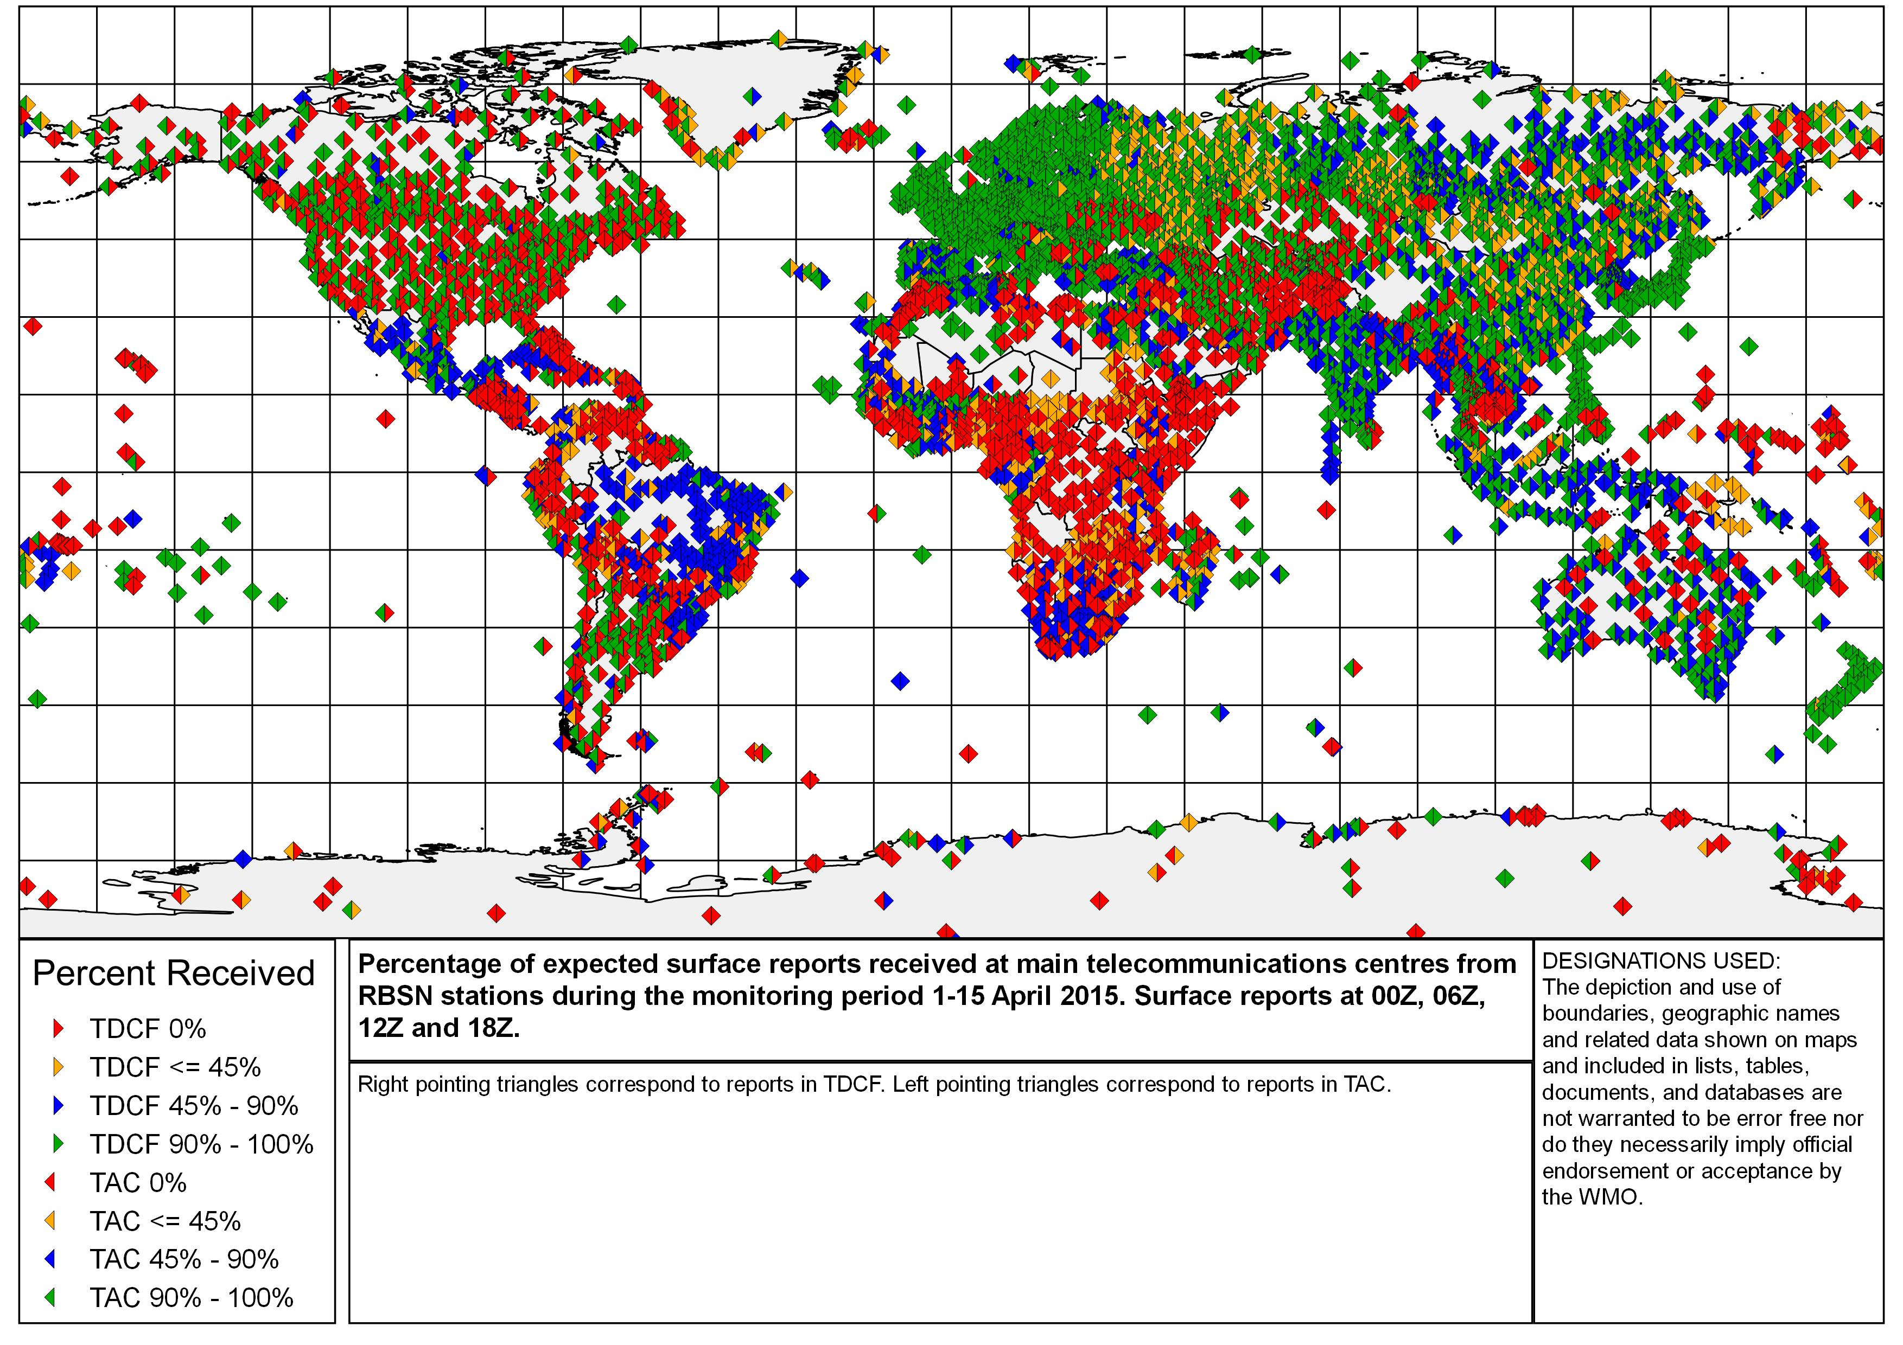
Figure 2: Upper-air BUFR reports for RBSN stations captured by the SMM exercise during 1-15 April 2015 shown as a percentage of the expected number of reports.

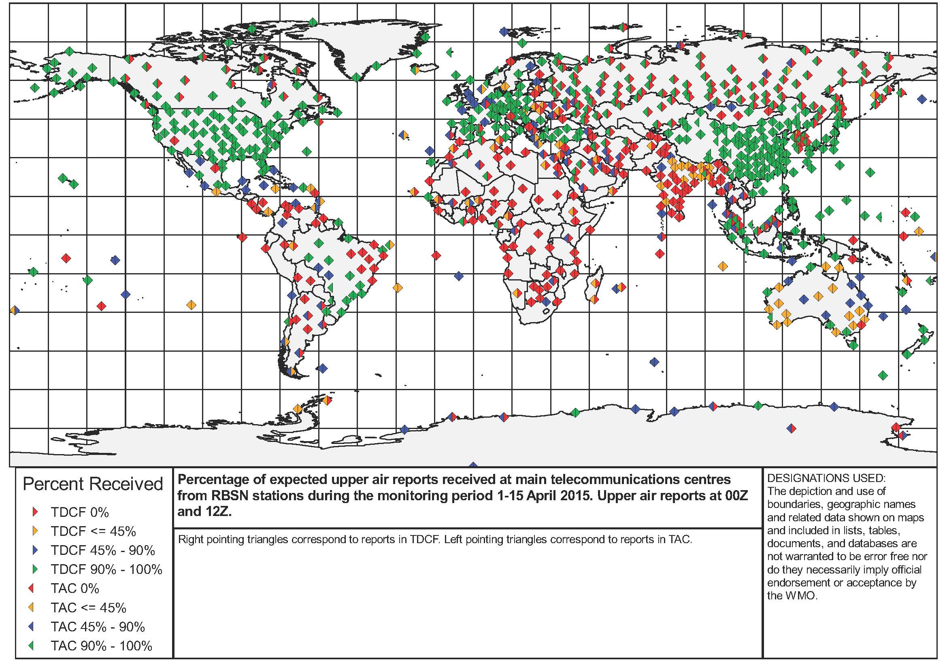
Figure 3: Climate BUFR reports for RBSN stations captured by the SMM exercise during 1-15 April 2015 shown as a percentage of the expected number of reports.

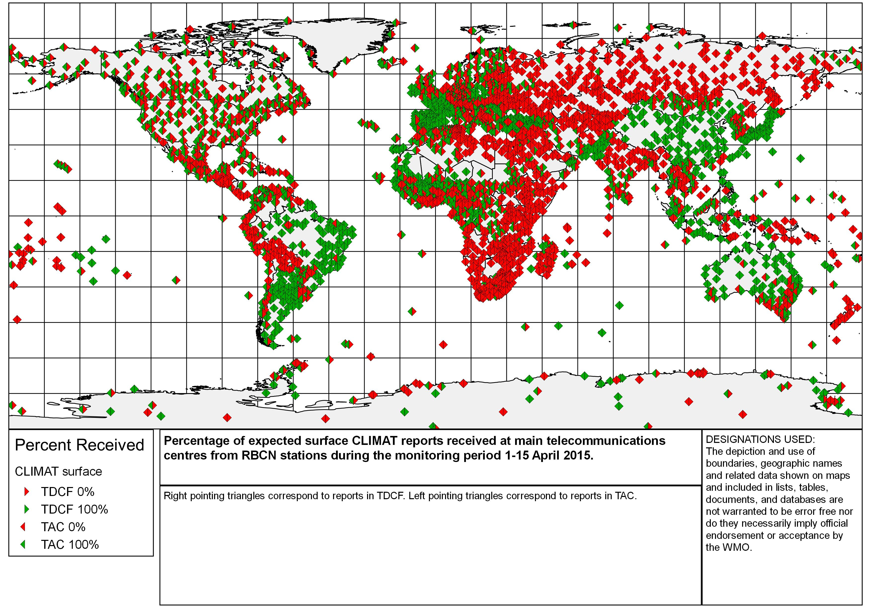
Table 1: Average by country of the number of surface and upper-air reports from RBSN stations and climate reports from RBCN stations recorded in BUFR messages during the SMM of 1-15 April 2015. The number of reports expected from each station is 60 (surface), 30 (upper-air) and 1 (climate), respectively.

Surface RBSN

Country/Territory | Average of TAC | Average of TDCF
REGION 1
Algeria | 92 | 90
Angola | 8 | 0
Benin | 100 | 0
Botswana | 54 | 0
Bouvet Island (Norway) | 0 | 0
Burkina Faso | 93 | 66
Burundi | 62 | 0
Cabo Verde | 99 | 98
Cameroon | 24 | 0
Canary Islands (Spain) | 81 | 85
Central African Republic | 21 | 21
Ceuta And Melilla (Spain) | 70 | 73
Chad | 34 | 15
Comoros | 93 | 49
Congo | 88 | 51
Cote D'ivoire | 80 | 36
Democratic Republic Of The Congo | 5 | 0
Djibouti | 25 | 0
Egypt | 85 | 39
Equatorial Guinea | 0 | 79
Eritrea | 0 | 0
Ethiopia | 43 | 0
Gabon | 55 | 43
Gambia | 91 | 0
Ghana | 54 | 0
Guinea | 16 | 0
Guinea-Bissau | 10 | 8
Kenya | 58 | 2
Lesotho | 13 | 0
Liberia | 28 | 0
Libya | 33 | 0
Madagascar | 60 | 37
Madeira | 99 | 38
Malawi | 43 | 0
Mali | 65 | 40
Mauritania | 53 | 38
Mauritius | 94 | 100
Morocco | 50 | 0
Mozambique | 23 | 0
Namibia | 51 | 0
Niger | 91 | 3
Nigeria | 8 | 0
Ocean Islands | 69 | 36
Rwanda | 48 | 0
Senegal | 90 | 25
Seychelles | 32 | 31
Sierra Leone | 0 | 0
Somalia | 0 | 0
South Africa | 74 | 45
South Sudan | 0 | 0
Sudan | 5 | 0
Swaziland | 45 | 0
Togo | 92 | 0
Tunisia | 77 | 1
Uganda | 23 | 0
United Republic Of Tanzania | 59 | 32
Western Sahara | 38 | 0
Zambia | 11 | 0
Zimbabwe | 57 | 23
REGION 2
Afghanistan, Islamic State Of | 0 | 0
Bahrain | 19 | 5
Bangladesh | 84 | 15
Cambodia | 5 | 5
China | 100 | 51
Democratic People's Republic Of Korea | 100 | 61
Hong Kong, China | 100 | 57
India | 95 | 87
Iran, Islamic Republic Of | 97 | 0
Iraq | 50 | 0
Japan | 100 | 100
Kazakhstan | 98 | 0
Kuwait | 100 | 13
Kyrgyzstan | 100 | 0
Lao People's Democratic Republic | 73 | 0
Macao, China | 98 | 0
Maldives | 67 | 85
Mongolia | 100 | 39
Myanmar | 76 | 0
Nepal | 71 | 0
Oman | 91 | 11
Pakistan | 72 | 42
Qatar | 63 | 18
Republic Of Korea | 100 | 57
Russian Federation | 96 | 54
Saudi Arabia | 72 | 44
Sri Lanka | 86 | 0
Tajikistan | 94 | 0
Thailand | 100 | 0
Turkmenistan | 100 | 0
United Arab Emirates | 84 | 19
Uzbekistan | 100 | 0
Viet Nam | 96 | 51
Yemen | 0 | 0
REGION 3
Argentina | 98 | 0
Bolivia | 45 | 0
Brazil | 67 | 50
Chile | 77 | 0
Colombia | 61 | 33
Ecuador | 53 | 6
French Guiana | 98 | 99
Guyana | 27 | 0
Islands (88: 800 - 998) | 0 | 68
Paraguay | 66 | 0
Peru | 55 | 0
South America | 0 | 79
Suriname | 24 | 0
Uruguay | 82 | 0
Venezuela | 7 | 0
REGION 4
Antigua And Barbuda | 65 | 67
Bahamas | 14 | 0
Barbados | 98 | 0
Belize | 48 | 0
Bermuda | 98 | 98
Canada | 96 | 16
Cayman Islands | 73 | 0
Clipperton | 0 | 0
Colombia (San Andres And Providencia Islands) | 71 | 38
Costa Rica | 59 | 0
Cuba | 76 | 0
Curacao, St Maarten And Aruba (Nl) | 98 | 0
Dominica | 73 | 0
Dominican Republic | 83 | 0
El Salvador | 0 | 0
Grenada | 98 | 0
Guadeloupe, St Martin, St Barthelemy And Other French Islands In The Vicinity | 0 | 0
Guatemala | 34 | 0
Haiti | 0 | 0
Honduras | 82 | 0
Jamaica | 100 | 0
Martinique | 99 | 50
Mexico | 85 | 59
Nicaragua | 0 | 0
Panama | 0 | 0
Puerto Rico And Us Possessions In The Caribbean Area | 66 | 0
Saint Lucia | 82 | 0
St Eustatius And Bonaire (Nl) | 48 | 0
St. Pierre And Miquelon (France) | 100 | 0
Trinidad And Tobago | 93 | 0
United States Of America | 96 | 0
United States Of America (Alaska) | 84 | 0
Venezuela (Isla De Aves) | 0 | 0
REGION 5
American Samoa | 20 | 0
Australia | 80 | 65
Brunei Darussalam | 92 | 0
Cook Islands | 39 | 37
Detached Islands (91 : 753, 754) | 93 | 0
Detached Islands (91: 960 - 998) | 100 | 100
Fiji | 76 | 22
French Polynesia (Austral Islands) | 100 | 100
French Polynesia (Marquesas Islands) | 100 | 100
French Polynesia (Society Islands) | 100 | 100
French Polynesia (Tuamotu Islands And Gambier Islands) | 98 | 75
Indonesia | 94 | 76
Islands (96: 995, 996) | 100 | 82
Islands In The Pacific Ocean North Of The Equator | 32 | 0
Kiribati | 46 | 0
Malaysia | 2 | 98
Nauru | 0 | 0
New Caledonia | 83 | 50
New Zealand | 100 | 95
Niue | 28 | 27
Papua New Guinea | 24 | 14
Philippines | 89 | 84
Phoenix Islands | 0 | 0
Samoa | 28 | 0
Singapore | 100 | 100
Solomon Islands | 87 | 72
Timor-Leste | 0 | 0
Tokelau (And Swains Is.) | 0 | 0
Tonga | 70 | 69
Tuvalu | 50 | 0
Vanuatu | 78 | 0
REGION 6
Armenia | 100 | 0
Austria | 100 | 96
Azerbaijan | 100 | 0
Belarus | 100 | 87
Belgium | 100 | 95
Bosnia And Herzegovina | 78 | 78
Bulgaria | 100 | 0
Croatia | 93 | 70
Cyprus | 100 | 7
Czech Republic | 100 | 95
Denmark And Faroe Islands | 99 | 73
Estonia | 100 | 99
Finland | 100 | 100
France | 100 | 100
Georgia | 89 | 0
Germany | 100 | 100
Gibraltar | 98 | 98
Greece | 91 | 87
Greenland | 74 | 28
Hungary | 100 | 100
Iceland | 57 | 55
Ireland | 100 | 100
Israel | 100 | 38
Italy | 92 | 100
Jordan | 96 | 0
Kazakhstan | 100 | 0
Latvia | 100 | 85
Lebanon | 95 | 0
Lithuania | 100 | 100
Luxembourg | 98 | 98
Malta | 95 | 0
Montenegro | 96 | 59
Netherlands | 100 | 100
Norway | 96 | 89
Poland | 97 | 95
Portugal | 96 | 46
Republic Of Moldova | 100 | 0
Romania | 100 | 100
Russian Federation | 99 | 37
Serbia | 93 | 89
Slovakia | 100 | 100
Slovenia | 100 | 78
Spain | 82 | 88
Sweden | 97 | 100
Switzerland And Liechtenstein | 100 | 88
Syrian Arab Republic | 48 | 3
The Former Yugoslav Republic Of Macedonia | 66 | 43
Turkey | 90 | 89
Ukraine | 94 | 2
United Kingdom Of Great Britain And Northern Ireland | 98 | 100
ANTARCTICA
Stations In The Antarctic | 48 | 19

Upper air

Country/territory | Average of TAC | Average of TDCF
REGION 1
Algeria | 79 | 0
Angola | 0 | 0
Botswana | 0 | 0
Burkina Faso | 43 | 47
Cabo Verde | 23 | 0
Cameroon | 53 | 0
Canary Islands (Spain) | 100 | 100
Central African Republic | 0 | 0
Chad | 0 | 0
Congo | 45 | 0
Cote D'ivoire | 100 | 0
Democratic Republic Of The Congo | 0 | 0
Egypt | 36 | 0
Eritrea | 0 | 0
Ethiopia | 8 | 0
Ghana | 0 | 0
Guinea | 0 | 0
Kenya | 47 | 0
Libya | 0 | 0
Madagascar | 3 | 0
Madeira | 50 | 50
Malawi | 0 | 0
Mali | 43 | 0
Mauritania | 0 | 0
Mauritius | 23 | 0
Morocco | 2 | 0
Mozambique | 0 | 0
Namibia | 37 | 0
Niger | 7 | 0
Nigeria | 0 | 0
Ocean Islands | 29 | 29
Senegal | 63 | 48
Somalia | 0 | 0
South Africa | 83 | 83
Sudan | 0 | 0
Tunisia | 32 | 0
United Republic Of Tanzania | 0 | 0
Zambia | 0 | 0
Zimbabwe | 23 | 0
REGION 2
Afghanistan, Islamic State Of | 20 | 0
Bangladesh | 38 | 0
China | 100 | 93
Democratic People's Republic Of Korea | 20 | 0
Hong Kong, China | 100 | 100
India | 15 | 14
Iran, Islamic Republic Of | 49 | 0
Iraq | 0 | 0
Japan | 100 | 100
Kazakhstan | 100 | 0
Kuwait | 43 | 0
Maldives | 50 | 0
Mongolia | 33 | 32
Myanmar | 0 | 0
Oman | 18 | 0
Pakistan | 0 | 0
Qatar | 0 | 0
Republic Of Korea | 100 | 0
Russian Federation | 98 | 0
Saudi Arabia | 84 | 0
Sri Lanka | 0 | 0
Tajikistan | 0 | 0
Thailand | 49 | 0
Turkmenistan | 97 | 0
United Arab Emirates | 90 | 0
Viet Nam | 100 | 100
REGION 3
Argentina | 28 | 0
Bolivia | 0 | 0
Brazil | 66 | 59
Chile | 59 | 28
Colombia | 26 | 16
Ecuador | 0 | 0
French Guiana | 100 | 100
Guyana | 0 | 0
Islands (88: 800 - 998) | 47 | 47
Peru | 0 | 0
Venezuela | 0 | 0
REGION 4
Bahamas | 47 | 50
Barbados | 50 | 43
Belize | 50 | 50
Bermuda | 100 | 100
Canada | 98 | 44
Cayman Islands | 47 | 47
Colombia (San Andres And Providencia Islands) | 0 | 0
Costa Rica | 0 | 0
Curacao, St Maarten And Aruba (Nl) | 45 | 42
Dominican Republic | 50 | 50
Guadeloupe, St Martin, St Barthelemy And Other French Islands In The Vicinity | 0 | 0
Jamaica | 33 | 33
Mexico | 64 | 60
Nicaragua | 0 | 0
Panama | 20 | 20
Puerto Rico And Us Possessions In The Caribbean Area | 100 | 100
Trinidad And Tobago | 40 | 50
United States Of America | 98 | 98
United States Of America (Alaska) | 98 | 97
REGION 5
American Samoa | 97 | 97
Australia | 49 | 47
Brunei Darussalam | 50 | 0
Cook Islands | 0 | 0
Fiji | 100 | 83
French Polynesia (Austral Islands) | 0 | 0
French Polynesia (Marquesas Islands) | 50 | 50
French Polynesia (Society Islands) | 100 | 100
French Polynesia (Tuamotu Islands And Gambier Islands) | 50 | 50
Indonesia | 96 | 92
Islands (96: 995, 996) | 40 | 40
Islands In The Pacific Ocean North Of The Equator | 89 | 84
Kiribati | 23 | 3
Malaysia | 95 | 0
Nauru | 0 | 0
New Caledonia | 100 | 100
New Zealand | 85 | 88
Papua New Guinea | 0 | 0
Philippines | 98 | 98
Singapore | 100 | 100
Tuvalu | 50 | 10
Vanuatu | 7 | 0
REGION 6
Armenia | 47 | 0
Austria | 100 | 100
Belgium | 57 | 0
Bulgaria | 50 | 50
Croatia | 100 | 97
Cyprus | 23 | 3
Czech Republic | 100 | 100
Denmark And Faroe Islands | 100 | 100
Estonia | 50 | 50
Finland | 50 | 50
France | 92 | 91
Germany | 97 | 97
Gibraltar | 0 | 0
Greece | 47 | 14
Greenland | 99 | 98
Hungary | 100 | 28
Iceland | 97 | 3
Ireland | 100 | 100
Israel | 100 | 100
Italy | 100 | 100
Jordan | 50 | 50
Latvia | 23 | 0
Lebanon | 0 | 0
Lithuania | 0 | 0
Netherlands | 57 | 57
Norway | 73 | 67
Poland | 97 | 97
Portugal | 47 | 22
Romania | 97 | 93
Russian Federation | 97 | 12
Serbia | 100 | 97
Slovakia | 100 | 97
Slovenia | 0 | 0
Spain | 99 | 83
Sweden | 73 | 73
Switzerland And Liechtenstein | 100 | 100
The Former Yugoslav Republic Of Macedonia | 0 | 0
Turkey | 99 | 95
Ukraine | 30 | 0
United Kingdom Of Great Britain And Northern Ireland | 81 | 79
ANTARCTICA
Stations In The Antarctic | 46 | 36

CLIMAT surface

Country/territory | Average of TAC | Average of TDCF
REGION 1
Algeria | 98 | 0
Angola | 6 | 0
Benin | 50 | 50
Botswana | 0 | 0
Bouvet Island | 0 | 0
Burkina Faso | 100 | 100
Burundi | 0 | 0
Cabo Verde | 100 | 0
Cameroon | 57 | 7
Central African Republic | 92 | 0
Chad | 75 | 8
Comoros | 100 | 100
Congo | 100 | 100
Cote D'ivoire | 77 | 15
Democratic Republic Of The Congo | 86 | 0
Djibouti | 0 | 0
Egypt | 0 | 0
Equatorial Guinea | 100 | 0
Eritrea | 0 | 0
Ethiopia | 13 | 0
Gabon | 83 | 0
Gambia | 50 | 50
Ghana | 53 | 0
Guinea | 100 | 0
Guinea-Bissau | 100 | 0
Kenya | 0 | 0
Lesotho | 0 | 0
Liberia | 100 | 0
Libya | 0 | 0
Madagascar | 31 | 4
Madeira | 100 | 67
Malawi | 0 | 0
Mali | 94 | 56
Mauritania | 100 | 85
Mauritius | 0 | 0
Morocco | 82 | 0
Mozambique | 0 | 0
Namibia | 0 | 0
Niger | 100 | 93
Nigeria | 92 | 8
Ocean Islands | 69 | 54
Rwanda | 0 | 0
Senegal | 100 | 100
Seychelles | 0 | 0
Sierra Leone | 100 | 0
Somalia | 0 | 0
South Africa | 18 | 0
South Sudan | 0 | 0
Spain (Canary Islands) | 100 | 100
Spain (Ceuta And Melilla) | 100 | 100
Sudan | 100 | 0
Swaziland | 0 | 0
Togo | 80 | 0
Tunisia | 18 | 0
Uganda | 0 | 0
United Republic Of Tanzania | 33 | 0
Western Sahara | 100 | 0
Zambia | 0 | 0
Zimbabwe | 11 | 0
REGION 2
Afghanistan, Islamic State Of | 0 | 0
Bahrain | 0 | 0
Bangladesh | 100 | 0
Cambodia | 0 | 0
China | 97 | 96
Democratic People's Republic Of Korea | 86 | 0
Hong Kong, China | 100 | 100
India | 35 | 0
Iran, Islamic Republic Of | 100 | 0
Iraq | 0 | 0
Japan | 100 | 100
Kazakhstan | 0 | 0
Kuwait | 0 | 0
Kyrgyzstan | 0 | 0
Lao People's Democratic Republic | 0 | 0
Macao, China | 100 | 0
Maldives | 50 | 0
Mongolia | 100 | 0
Myanmar | 0 | 0
Nepal | 0 | 0
Oman | 100 | 0
Pakistan | 100 | 96
Qatar | 0 | 0
Republic Of Korea | 100 | 0
Russian Federation | 12 | 0
Saudi Arabia | 0 | 32
Sri Lanka | 83 | 0
Tajikistan | 0 | 0
Thailand | 100 | 0
Turkmenistan | 0 | 0
United Arab Emirates | 0 | 0
Uzbekistan | 0 | 0
Viet Nam | 88 | 0
Yemen | 0 | 0
REGION 3
Argentina | 100 | 100
Bolivia | 0 | 0
Brazil | 95 | 92
Chile | 94 | 0
Colombia | 100 | 0
Ecuador | 71 | 14
French Guiana | 100 | 100
Guyana | 0 | 0
Islands (88: 800 - 998) | 80 | 20
Paraguay | 80 | 0
Peru | 41 | 0
Suriname | 0 | 0
Uruguay | 89 | 0
Venezuela | 97 | 0
REGION 4
Bahamas | 100 | 0
Barbados | 0 | 0
Belize | 100 | 0
Bermuda | 100 | 0
Canada | 95 | 0
Cayman Islands | 0 | 0
Colombia (San Andres And Providencia Islands | 100 | 0
Costa Rica | 0 | 0
Cuba | 100 | 0
Curacao, St Maarten And Aruba (Nl) | 0 | 0
Dominican Republic | 0 | 0
El Salvador | 0 | 0
Guadeloupe, St Martin, St Barthelemy And Other French Islands In The Vicinity | 100 | 100
Guatemala | 0 | 0
Honduras | 25 | 0
Jamaica | 100 | 0
Martinique | 100 | 100
Mexico | 81 | 0
Nicaragua | 100 | 0
Panama | 0 | 0
Puerto Rico And Us Possessions In The Caribbean Area | 100 | 0
Trinidad And Tobago | 100 | 0
United States Of America | 98 | 0
United States Of America (Alaska) | 93 | 0
REGION 5
American Samoa | 100 | 0
Australia | 54 | 97
Brunei Darussalam | 100 | 0
Cook Islands | 0 | 0
Detached Islands (91 : 753, 754) | 100 | 100
Detached Islands (91: 960 - 998) | 0 | 0
Fiji | 100 | 0
French Polynesia (Austral Islands) | 100 | 50
French Polynesia (Marquesas Islands) | 100 | 100
French Polynesia (Society Islands) | 100 | 100
French Polynesia (Tuamotu Islands And Gambier Islands) | 100 | 100
Indonesia | 77 | 74
Islands (96: 995, 996) | 0 | 100
Islands In The Pacific Ocean North Of The Equator | 85 | 0
Kiribati | 0 | 0
Malaysia | 100 | 0
Nauru | 0 | 0
New Caledonia | 100 | 100
New Zealand | 0 | 0
Niue | 100 | 0
Papua New Guinea | 0 | 0
Philippines | 88 | 88
Phoenix Islands | 0 | 0
Samoa | 0 | 0
Singapore | 100 | 100
Solomon Islands | 0 | 0
Timor-Leste | 0 | 0
Tokelau (And Swains Is.) | 0 | 0
Tonga | 0 | 0
Tuvalu | 0 | 0
Vanuatu | 0 | 0
REGION 6
Albania | 0 | 0
Armenia | 100 | 0
Austria | 0 | 100
Azerbaijan | 100 | 0
Belarus | 0 | 92
Belgium | 100 | 0
Bosnia And Herzegovina | 100 | 0
Bulgaria | 100 | 0
Croatia | 0 | 100
Cyprus | 50 | 50
Czech Republic | 100 | 100
Denmark And Faroe Islands | 100 | 0
Estonia | 0 | 0
Finland | 100 | 0
France | 100 | 100
Georgia | 100 | 0
Germany | 7 | 100
Gibraltar | 100 | 0
Greece | 100 | 0
Greenland | 100 | 0
Hungary | 71 | 71
Iceland | 83 | 0
Ireland | 100 | 100
Israel | 0 | 100
Italy | 94 | 0
Jordan | 100 | 0
Kazakhstan (In Europe) | 0 | 0
Latvia | 100 | 100
Lebanon | 0 | 0
Lithuania | 0 | 100
Luxembourg | 0 | 0
Malta | 100 | 0
Montenegro | 0 | 0
Netherlands | 67 | 67
Norway | 0 | 100
Poland | 100 | 100
Portugal | 100 | 50
Republic Of Moldova | 0 | 0
Romania | 100 | 100
Russian Federation | 13 | 0
Serbia | 100 | 33
Slovakia | 100 | 60
Slovenia | 100 | 0
Spain | 100 | 100
Sweden | 0 | 100
Switzerland And Liechtenstein | 88 | 13
Syrian Arab Republic | 38 | 0
The Former Yugoslav Republic Of Macedonia | 0 | 0
Turkey | 97 | 97
Ukraine | 7 | 0
United Kingdom Of Great Britain And Northern Ireland | 0 | 95
ANTARCTICA
Stations In The Antarctic | 69 | 44

Percentage of expected number of reports is indicated by colours (green, blue, yellow and red) in a square. The left or right half square is the percentage of TAC or TDCF, respectively.

