WORLD METEOROLOGICAL ORGANIZATION  COMMISSION FOR BASIC SYSTEMS  ----------------------------  SECOND MEETING OF  INTER-PROGRAMME EXPERT TEAM  ON DATA REPRESENTATION AND CODES  BRASILIA, BRAZIL, 31 AUGUST - 3 SEPTEMBER 2010 |  | IPET-DRC-II / Doc.5.1 (11)  -------------------------  ITEM 5.1  ENGLISH ONLY

Migration status and activities of CMA

Submitted by Fang ZHAO (CMA)

________________________________________________________________

Summary and Purpose of Document

The document introduces the migration status and the recent activities within CMA.
________________________________________________________________

ACTION PROPOSED

The meeting is invited to take note of the information.
1. Review of the migration status
(1) Draft national migration plan of CMA was made in 2005.
(2) The BUFR message of Category 1 (except PILOT, and CLIMAT TEMP is canceled) has been sent on GTS since Aug 2008 as follows, PILOT would be sent on GTS in November 2010.
Data type | Frequency | Bulletin header | Number of bulletins | Number of stations | Volume of data
SYNOP | 00,06,12,18/Day | ISMN[01-09] | ~150/DAY | 219/Hour | 156KB/Day
TEMP | 00,12/Day | IUKN[11-12]  IUFN[01-09] | ~48/DAY | 82/Hour | 99KB/Day
CLIMAT | 06/Month | ISCN[01-06] | 6/month | 82/Month | 19KB/Month

2. Some progress of the migration project
(1) Infrastructure and the data flow
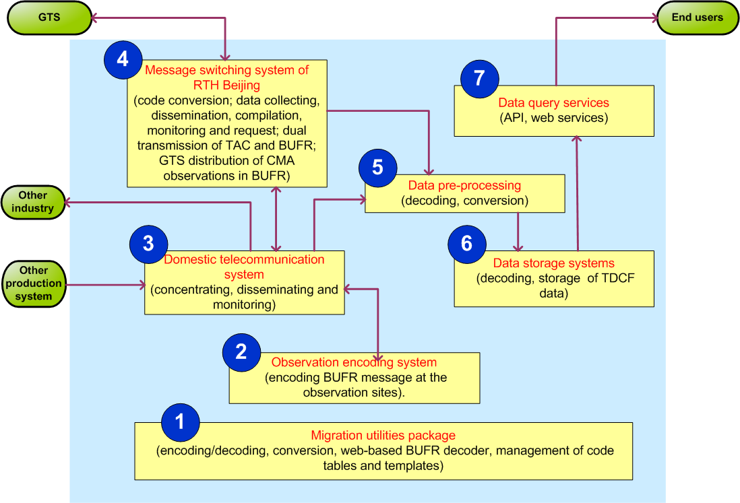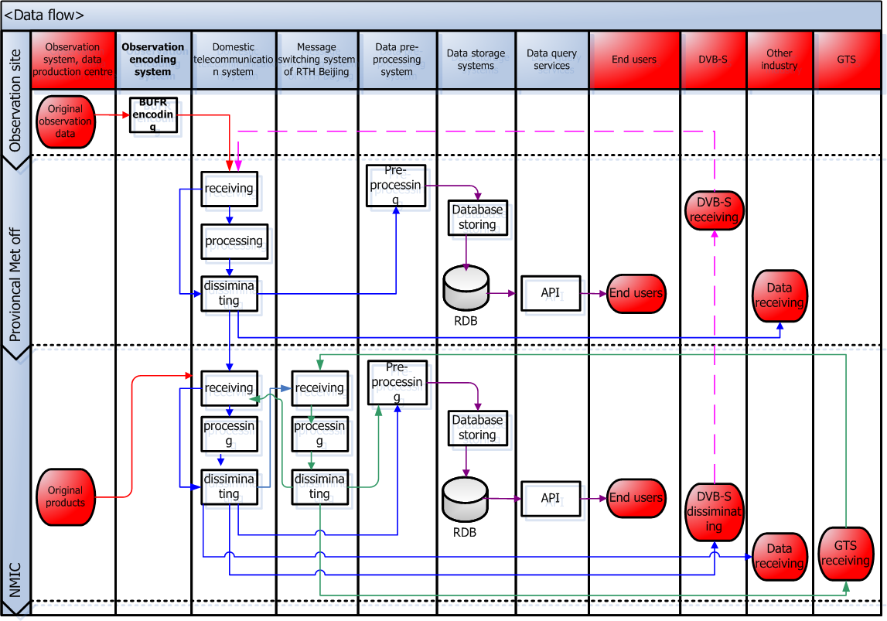

(2) Encode data in BUFR experimentally at observation site
Data type | Template | 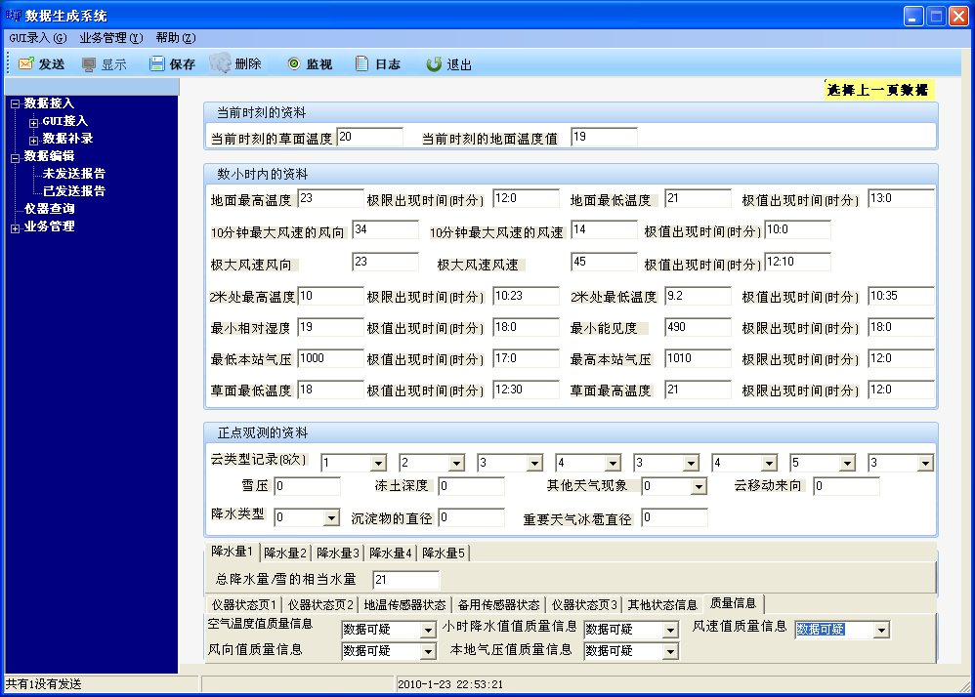
AWS | Mixed template of SYNOP, one-hour and n-minute period (national practice), include the “Instantaneous” data and “Period” data, attached with the quality control information and the equipment status information
TEMP | TM 309052
PILOT | TM 309050, TM309051
PM10 | National template
- Local descriptors
TABLE REFERENCE |  |  | TABLE  ELEMENT NAME | BUFR
 |  |  | TABLE  ELEMENT NAME | UNIT | SCALE | REFERENCE VALUE | DATA WIDTH (Bits)
F | X | Y
0 | 20 | 250 | Cloud type | Code table | 0 | 0 | 6
0 | 13 | 230 | Snow pressure | g/cm² | 0 | 0 | 11
0 | 20 | 136 | Depth of frozen soil | m | 2 | 0 | 12
0 | 02 | 201 | Identifies of the AWS instrument indicators | Code table | 0 | 0 | 6
0 | 02 | 202 | Status of the AWS instrument indicators | Code table | 0 | 0 | 2
0 | 02 | 203 | The motherboard voltage of the AWS sensors | V | 1 | 0 | 10
0 | 02 | 204 | The motherboard temperature of the AWS sensors | K | 1 | 0 | 12
0 | 15 | 221 | Total mass | mg | 5 | 0 | 17
0 | 15 | 222 | Mass flow | L/min | 5 | 0 | 17
0 | 33 | 201 | Quality control indication | Code table | 0 | 0 | 4
- The new types of radiosonde are not registered in C-2.
- Some uncertain usage of the extended vertical sounding significance, like the ‘Beginning of missing wind data’ and the ‘End of missing wind data’.

(3) Capability of handling TDCF data
- Encoding/decoding
- Collection, dissemination, compilation, monitoring and request
- Data archive, Database storage and service
- Conversion (TAC<--->BUFR of category 1, BUFR ---> MICAPS)
- Web-based BUFR decoder, include the query of BUFR tables
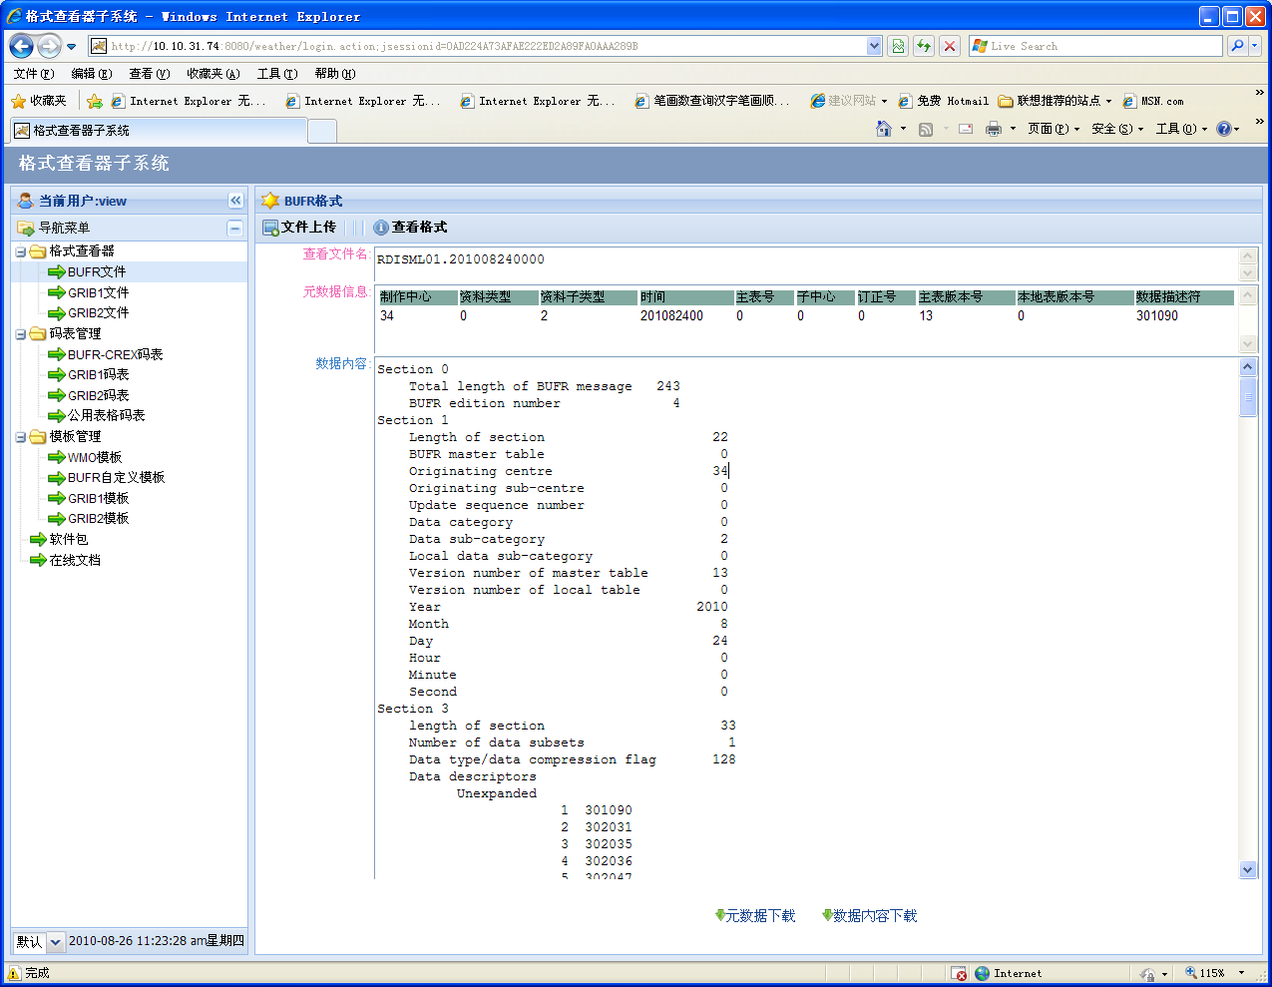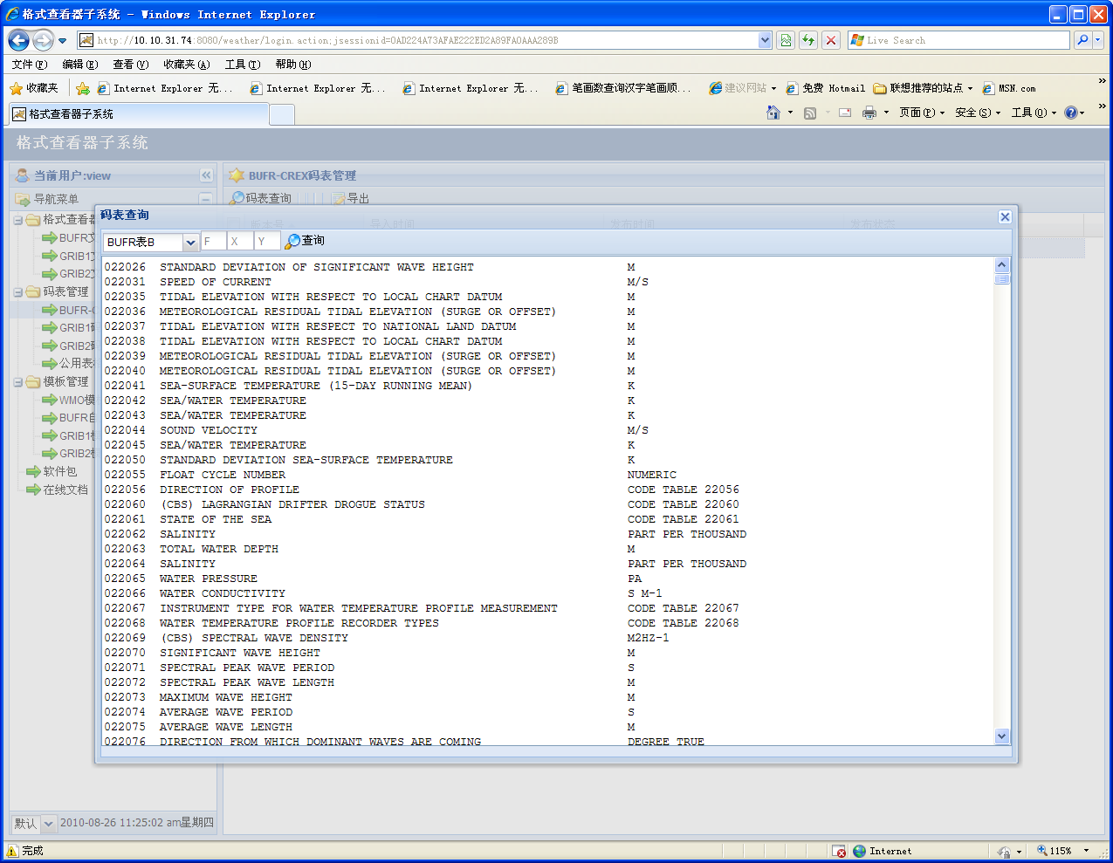
3. Current and future activities
(1) The BUFR tables would be migrated to the txt files published by WMO Secretariat.
(2) The capability of handling TDCF data is integrated in CIMISS (new generation China Integrated Meteorological Information Service System) both at the national level and the provincial level. The migration to TDCF would be transparent to the end users by decoding and putting the BUFR data into database, and the merge of BUFR and TAC data is also considered to provide more data and high quality to the users.
(3) The national training of TDCF and the migration would be held at the end of this year to the staff of national and local met. Offices, including level 1 and level 2.

