Information Note for Participants

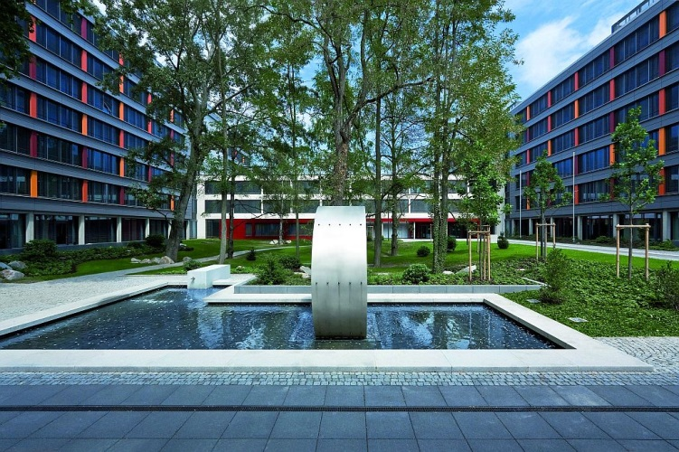

Second Meeting of the WMO Interprogramme Expert Team
on Codes Maintenance (IPET-CM-II)
Offenbach am Main, Germany, 28 May – 1 June 2018

The second meeting of the WMO Interprogramme Expert Team on Codes Maintenance (IPET-CM) will be held from 28th of May to 1st June 2018 at Deutscher Wetterdienst headquarters, Offenbach am Main, Germany.

Venue
Room „Gartensaal“ (on the ground floor)
Deutsche Wetterdienst
Frankfurter Straße 135
63067 Offenbach am Main
Germany
Phone: +49 (0)69 / 8062 – 0

The meeting will begin at 9:00 am on Monday 28th of May 2018.
The meeting will be conducted in English, and all documents and information papers will be prepared in English only.

Accommodations
Several rooms have been blocked at the hotel Offenbacher Hof (https://www.novum-hotels.de/hotel-offenbacher-hof-offenbach), about 10 minutes walk from DWD.
The special single-room rate is 64 Euro per night including breakfast and VAT.
Participants whishing to stay at this hotel should make their reservation directly with the hotel (via telephone, fax, e-mail or post) using the keyword “IPET-CM”.

Novum Hotel Offenbacher Hof
Ludwigstraße 33–37
63067 Offenbach am Main

Phone: +49 69 829 82 0
Fax: +49 69 829 82 333
E-mail: offenbacherhof@novum-hotels.de

This special room contingent is bookable until the 22nd of April 2018.

Travel
Offenbach can easily be reached by plane via Frankfurt International Airport (FRA) and train (suburban railway services – “S-Bahn”) from the regional train station of the airport (accessible via Terminal 1).
At the airport follow the signs to the Regional trains
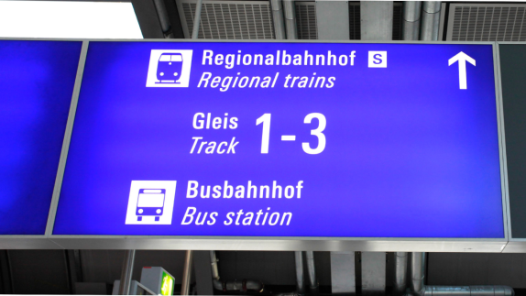
and try to find track 1.
Take the train S 8 or S 9 in direction “Hanau Hauptbahnhof”. (Departure of the trains is usually on track 1.)

The fare is 4,90 Euro for adults for a single ticket.
More details on how to use the ticket machines will be provided later.
Get off the train at station “(Offenbach-)Ledermuseum“.
To get to the hotel Offenbacher Hof, please take the exit (in German: “AUSGANG”) “Ledermuseum, Ludwigstraße” in the direction of travel.
Turn right into Ludwigstraße and you will find the hotel after 750 m on the left (Ludwigstraße 33-37).

Visa Requirement
Participants who require a visa to enter Germany should make arrangements through the embassies or consulates‑general of the Federal Republic of Germany responsible for their area. If a letter of invitation is needed please send an e-mail to Sibylle.Krebber@dwd.de with following data:

- First name
- Surname
- Gender (Female / Male)
- Date of birth
- Place of birth
- Institute
- Full address of the institute
- Passport number
- Date of arrival
- Date of departure
- Email address

A letter will be provided to you.

Currency
The currency of Germany is Euro €.

Time Zone
From 25 March to 27 October 2018 the time in Offenbach is UTC+2 hours (i.e. CEST – Central European Summer Time).

Electricity
Electricity in Germany is at 230 V, 50 Hz.
Plugs and plug sockets looks like:
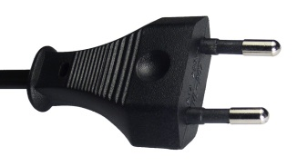

Climate
The climate in Offenbach in May is as follows:

Average mean temperature: ~ 15 °C
Average maximum temperature: ~ 21 °C
Average minimum temperature: ~ 7 °C

Contact
Ms Sibylle Krebber
Deutscher Wetterdienst, DWD
Frankfurter Straße 135
63067 Offenbach am Main
E-Mail: sibylle.krebber@dwd.de
Phone: +49 69 8062 2647
Fax: +49 69 8062 3829

Links and maps
DWD headquarters: https://www.dwd.de/EN/aboutus/locations/headquarters/headquarters_node.html
With the map “How to find us”:
https://www.dwd.de/SharedDocs/downloads/EN/anfahrtsskizzen/zentrale_offenbach_en.pdf?__blob=publicationFile&v=5

To plan your trip from (e.g. “Frankfurt (Main) Flughafen Regionalbahnhof” to “Offenbach (Main) S-Bahn-Station Ledermuseum”): http://www.rmv.de/auskunft/bin/jp/query.exe/en

Map of Offenbach am Main around DWD
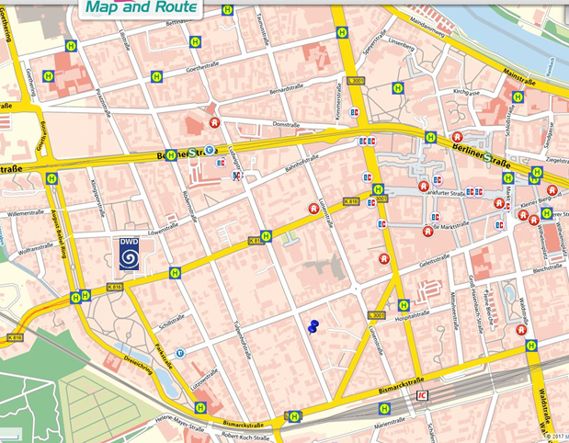
 | Hotel |  | Rapid-transit railway station |  | Cash-machine |  | Pharmacy |  | Bus stop
RMV (Rhein-Main-Verkehrsverbund(transport association)) suburban railway map

