WORLD METEOROLOGICAL ORGANIZATION  COMMISSION FOR BASIC SYSTEMS  -----------------------------  SECOND MEETING OF  INTER-PROGRAMME EXPERT TEAM ON  CODES MAINTENANCE  OFFENBACH, GERMANY, 28 MAY - 1 JUNE 2018 |  | IPET-CM-II / Doc. 7.3(3)  31.05.2018  -------------------------  ITEM 7.3  ENGLISH ONLY

MIGRATION TO TABLE-DRIVEN CODE FORMS

TAC2BUFR Check at DWD – follow-up
Submitted by Andreas Gerth(DWD), Markus Heene(DWD)

_______________________________________________________________________

Summary and Purpose of Document

The purpose of the document is to demonstrate the current status of DWD’s TAC2BUFR Check. Furthermore we are interested in the feedback of the team and typical usage scenarios.

_______________________________________________________________________

ACTION PROPOSED

None

ANNEXES:
1.

DISCUSSIONS

DWD presented the “TAC2BUFR Check” at the IPET-DRMM IV 2016 in Geneva. The tool is available under the following URL:

http://www.deutscher-wetterdienst.de/TAC2BUFR/SV/webt2b_main.html

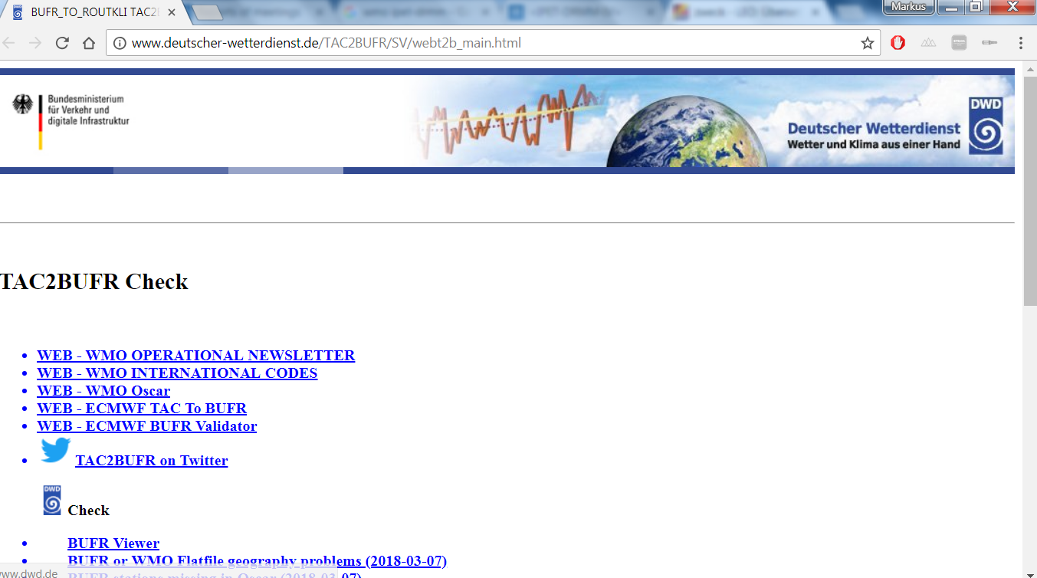

In case of questions please get in touch with us: t2b.chk@dwd.de

We are interested to hear you feedback.

PROPOSAL

The meeting noted the paper.

