WORLD METEOROLOGICAL ORGANIZATION  COMMISSION FOR BASIC SYSTEMS  -----------------------------  SECOND MEETING OF  INTER-PROGRAMME EXPERT TEAM ON  CODES MAINTENANCE  OFFENBACH, GERMANY, 28 MAY - 1 JUNE 2018 |  | IPET-CM-II / Doc. 7.3(2)  25.05.2018  -------------------------  ITEM 7.3  ENGLISH ONLY

MIGRATION TO TABLE-DRIVEN CODE FORMS

DWD’s online BUFR Viewer
Submitted by Markus Heene (DWD), Gregor Schnee (DWD)

_______________________________________________________________________

Summary and Purpose of Document

This document demonstrates DWD’s online BUFR Viewer. Furthermore it introduces a machine interface to the BUFR Viewer which can be easily used for automated testing of BUFR encoders/decoders.

_______________________________________________________________________

ACTION PROPOSED

None

ANNEXES:
1.

DISCUSSIONS

Recently DWD released an online BUFR Viewer https://kunden.dwd.de/bufrviewer
The purpose of the BUFR Viewer is to provide users with an online tool to examine BUFR with the tools which DWD uses internally to decode BUFR.

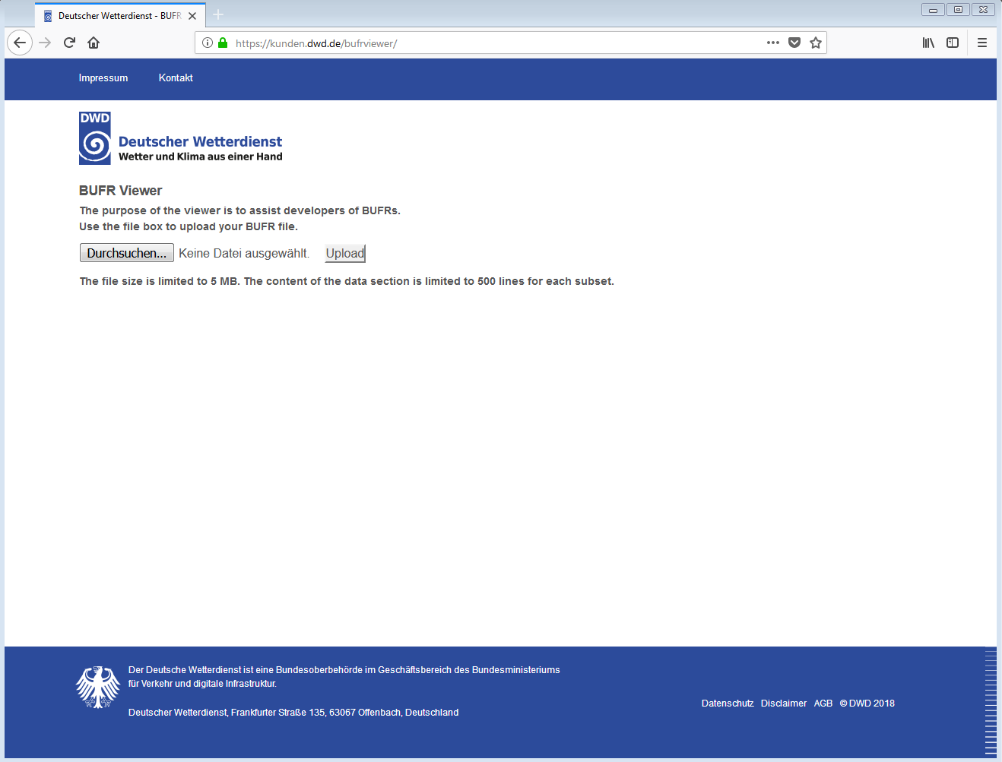

You can upload a file by clicking “Durchsuchen” (it should be localized to your language setting of the browser). After you selected a file press the “Upload” button.
Please note that the maximum file size for an upload is limited to 5 MB and that the viewer truncates the output after 500 lines for each subset.

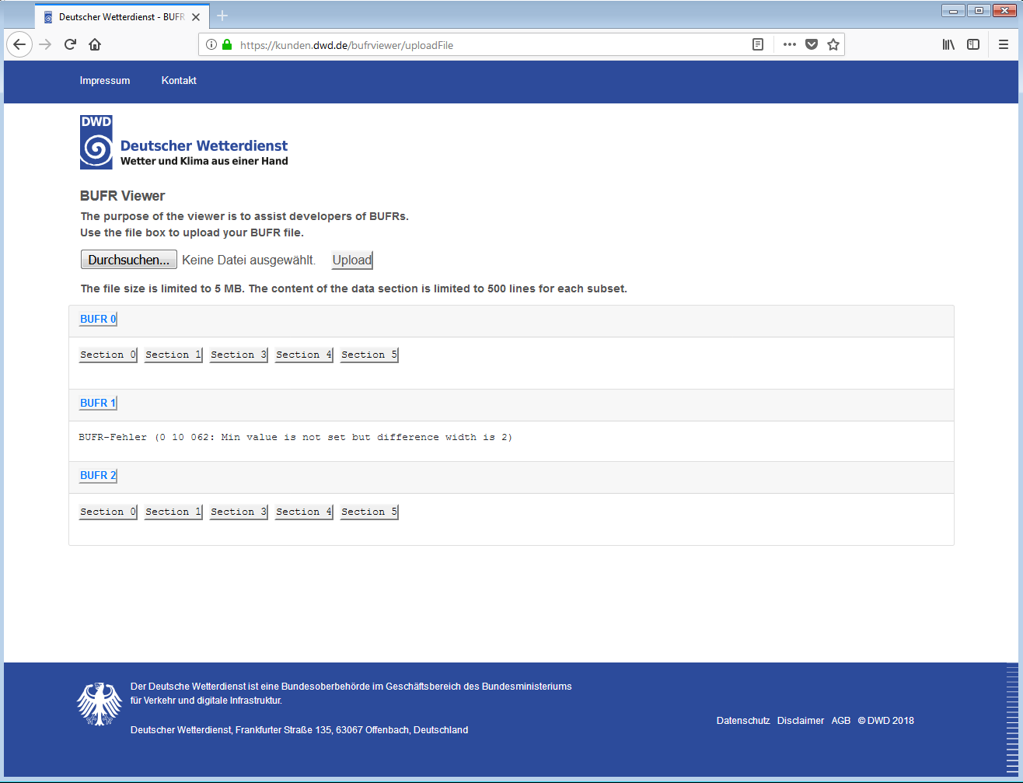
In the example above the BUFR files contains 3 messages while message no. 1 contains an error. By clicking on the section buttons you can unfold the contents of the section.

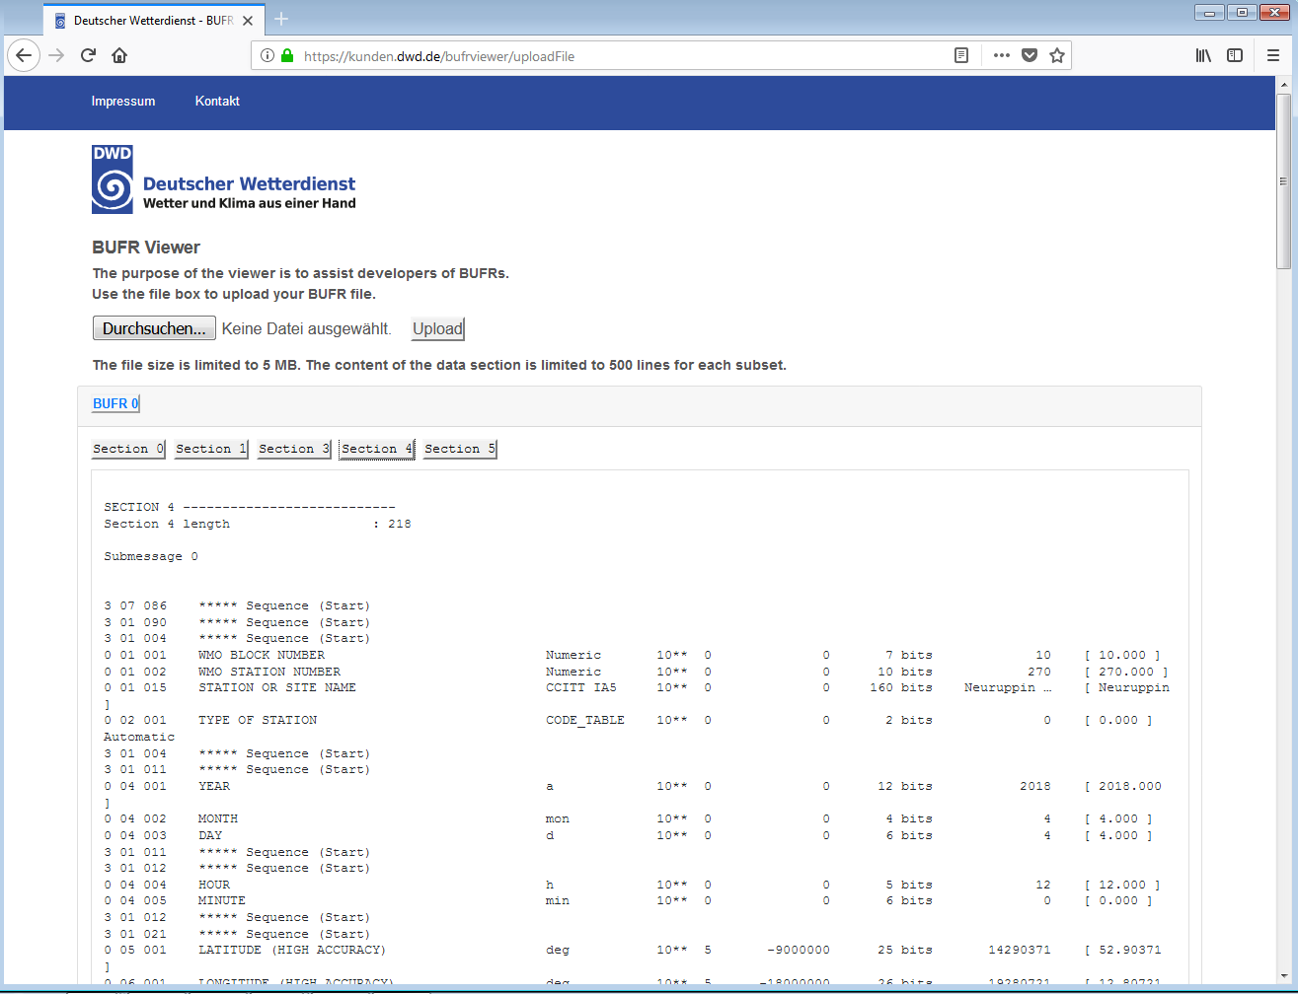

Note: We do not store your uploaded files.

Your feedback is highly welcomed in particular if you find unexpected decoding results. Please send your feedback to t2b.chk@dwd.de if possible with your file attached.

Machine Interface
While the latter example is intended for interactive usage the following example is intended more for a machine to machine communication. A typical use-case could be the integration of the machine interface into a test case of a BUFR decoder/encoder.

HTTP-endpoint of the service: https://kunden.dwd.de/bufrviewer/validatorFile

You can upload your BUFR file with an HTTP-POST request to the service. The services response is in JSON.

Example:

curl -X POST https://kunden.dwd.de/bufrviewer/validatorFile --form "fileupload=@6bufr.bin"

Response:
{
"bufrviewerVersion": "1.0",
"fileName": "6bufr.bin",
"fileSizeInBytes": 2892,
"md5CheckSum": "d4e27e455a61ba873fb3856d67beacfb",
"messageCounter": 6,
"errors": true,
"decodingTimeInMilliSeconds": 39,
"encounteredErrorsInMessagesArray": [
{
"messageID": 1,
"errorText": "BUFR-Fehler (0 10 062: Min value is not set but difference width is 2)"
},
{
"messageID": 4,
"errorText": "BUFR-Fehler (0 10 062: Min value is not set but difference width is 2)"
}
]
}
The output should be self-explanatory.

Notes: The machine-interface is currently still under development and not yet released on our production system. Furthermore the same upload limit of 5 MB for each file applies to this service.

In case you have suggestions (e.g. improvement of the JSON response to better fit your needs) your feedback is highly welcomed.

PROPOSAL

The meeting noted the document.

