WORLD METEOROLOGICAL ORGANIZATION  COMMISSION FOR BASIC SYSTEMS  -----------------------------  SECOND MEETING OF  INTER-PROGRAMME EXPERT TEAM ON  CODES MAINTENANCE  OFFENBACH, GERMANY, 28 MAY - 1 JUNE 2018 |  | IPET-CM-II / Doc. 7.3(1)  25.05.2018  -------------------------  ITEM 7.3  ENGLISH ONLY

MIGRATION TO TABLE-DRIVEN CODE FORMS

BUFR Validation Dashboard
Submitted by Peng WANG (CMA), Abbas NIAZALIZADEH (IRIMO), Yang WANG (Private Sector, Australia), Gregor Schnee (DWD), Markus Heene (DWD)

_______________________________________________________________________

Summary and Purpose of Document

This document highlights the idea of a BUFR Validation Dashboard which is realized as a web-service. The purpose of the dashboard is to show users the summarized output of various BUFR decoders. The BUFR Validation Dashboard is realized as an open source project hosted on github https://github.com/mheene/bufrValidationDashboard

_______________________________________________________________________

ACTION PROPOSED

None

ANNEXES:
1.

DISCUSSIONS

Motivation
The authors of the document realized in their daily work that they received some BUFRs which their decoding system marked as invalid BUFR while other decoders validated the BUFR successfully. At least the authors are not aware of a reference implementation of the BUFR specification. That means that each BUFR encoder/decoder implements its own “interpretation” of the specification. While some decoders implement very strict checks others decoders are more relaxed and emphasize more on the decoding part.

For a BUFR creator the situation could be pretty complex if he/she creates a BUFR and then validates it BUFR with a pretty relaxed decoder. In extreme cases the BUFR would be valid only for this one decoder.

With the help of the BUFR validation dashboard the user is now able to easily check the BUFR with different decoders and would receive warnings/errors of each decoder. The advantage for the NHMSs would be fewer un-decodable BUFR.

Technical realization
The implementation is planned in a phased approach. In the first phase a proof-of-concept is realized. In the proof-of-concept a web-application is realized where a user can upload a BUFR and the next step the application sends the BUFR to existing online BUFR validators. The responses of each validator are collected and the summary is presented to the user. Currently the following 3 online BUFR validators are included:

- ECMWF: http://apps.ecmwf.int/codes/bufr/validator/
- DWD: https://kunden.dwd.de/bufrviewer/
- PyBufrKit: http://aws-bufr-webapp.s3-website-ap-southeast-2.amazonaws.com/

The following picture shows a screenshot of the GUI.

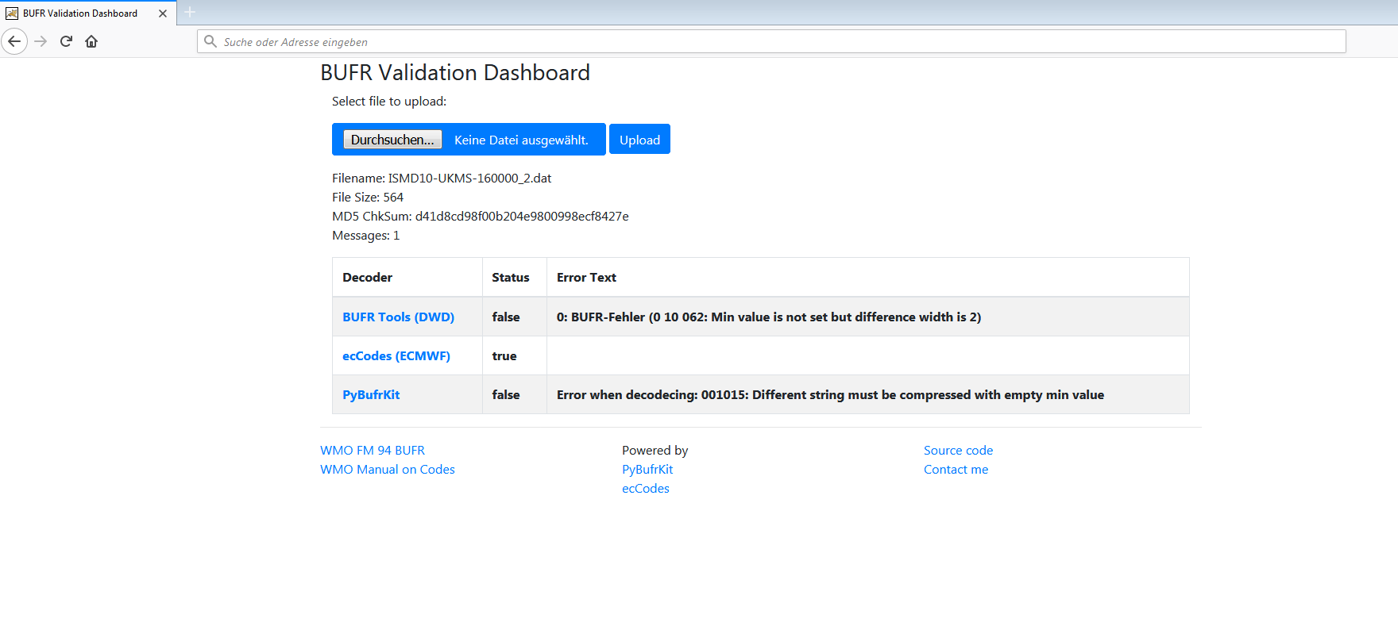

In a next step it is planned to wrap other freely available BUFR decoders (e.g. Geo::BUFR) into micro-services and to include those into the dashboard.

Outlook
Currently GISC Beijing and GISC Tehran plan to host the BUFR validation dashboard if it is sufficiently stable for operations. Furthermore it is intended to present the progress on the next TT-GISC meeting. Another option is to be hosted by a cloud-provider.

Your contributions are highly welcomed please simply contact us.

Online Resources
GIT repository: https://github.com/mheene/bufrValidationDashboard

PROPOSAL

None

