WORLD METEOROLOGICAL ORGANIZATION  COMMISSION FOR BASIC SYSTEMS  -----------------------------  SECOND MEETING OF  INTER-PROGRAMME EXPERT TEAM ON  CODES MAINTENANCE  OFFENBACH, GERMANY, 28 MAY - 1 JUNE 2018 |  | IPET-CM-II / Doc. 7.2(7)  25.05.2018  -------------------------  ITEM 7.2  ENGLISH ONLY

MIGRATION TO TABLE-DRIVEN CODE FORMS

Status of migration to TDCFs within JCOMM
Submitted by David Berry (on behalf of JCOMM)

_______________________________________________________________________

Summary and Purpose of Document

This document summarises the BUFR templates for reporting marine observations on the GTS

_______________________________________________________________________

ACTION PROPOSED

None, for information purposes.

ANNEXES:
1. (Title of annex)

DISCUSSIONS

Table 1 summarises the BUFR temapltes / table D sequences in use for marine data. Migration to BUFR for E-ASAP observations was completed in 2016. The distribution of TAC messages for Argo profiling float observations will cease in July 2018.

During April 2018 the majority of VOS observations were distributed in parallel in both TAC and BUFR (see Figure 1). Based on receipts at JCOMMOPS during March 2018 100 % of drifting buoys were reporting in BUFR with a small percentage (5%) reporting in both TAC and BUFR. During the same period 31 % of moored buoys reported in BUFR whilst 78 % reported in TACs. Similarly, 54 % of wave buoys reported using BUFR and 71 % using TAC.
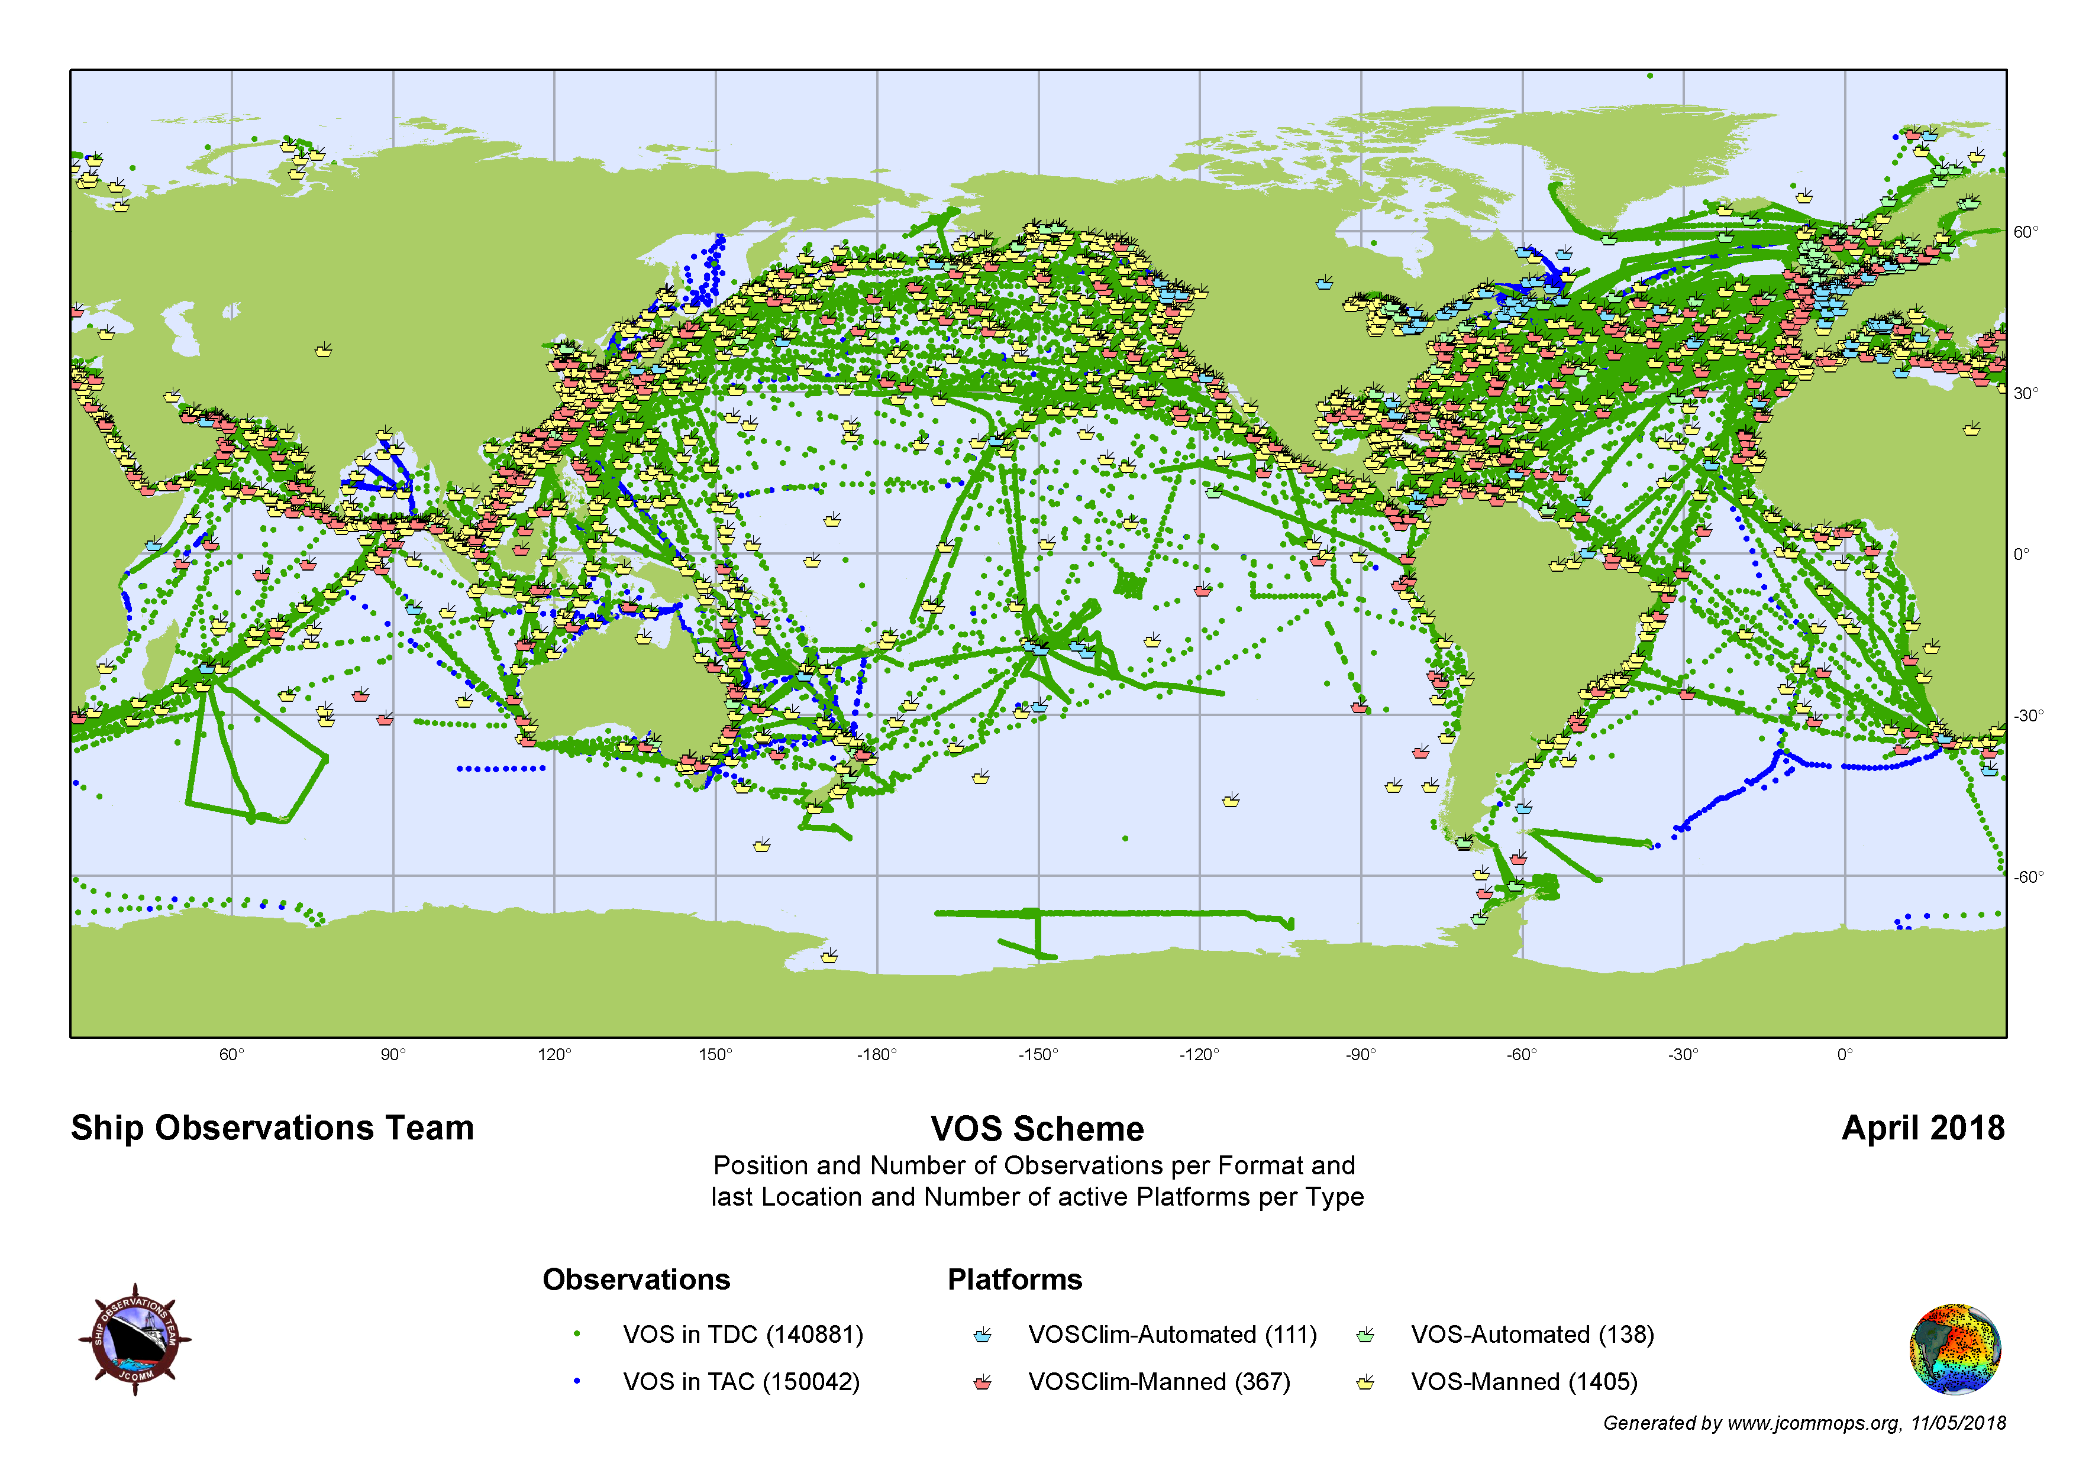
Figure 1: Format and spatial distribution of VOS observations on the GTS in April 2018.

PROPOSAL

None – for information only.

Table 1: Summary of Table D sequences / BUFR templates in use for marine data
TAC | Description | Current template(s) | Status | Plans/comments
FM13-XIV SHIP | VOS data | B/C10 - Regulations for reporting SHIP data in TDCF | Operational (TM308009) | Deprecated, use TM0308014
 | VOS data | Synoptic reports from sea stations suitable for SHIP observation data from VOS stations | Operational (TM308014) | Replaces / supersedes TM308009.  Simplified version under development for UK VOS AWS systems.
 | Offshore platforms | Template for the representation of observations from offshore platforms | Operational (TM308017)
FM18-XII BUOY | Drifting buoy data | Template for the representation from drifting buoys | Operational (TM315009) | Simplified template specific to drifting buoys
 | Moored buoy data | Template for the representation of data from moored buoys | Operational (TM315008) | Simplified template specific to moored buoys, including directional and non-directional wave data
 | Wave buoy data | Template for the representation of data from moored buoys | Operational (TM315008) | Sequence to report ‘first 5’ spectral wave coefficients in development
 | Argo data | Sub-surface profiling floats | Operational (TM315003) | Additional sequences defined to extend template and may be present in reports
FM36-XI Ext. TEMP SHIP | ASAP data | B/C25 - Regulations for reporting TEMP, TEMP SHIP, TEMP MOBIL data in TDCF | Operational (TM309052) | No specific plan for this template
 | ASAP data | UKMO template for representation of radiosonde data with geopotential height as the vertical coordinate | Operational (revisited in July 2010)
FM62-VIII Ext. TRACKOB | TRACKOB data | TRACKOB data – ThermoSalinoGraph (TSG) data and metadata | Operational (TM308010) | Plans to update template to include additional metadata.
FM63-XI Ext. BATHY | XBT data | New BUFR template for XBT Temperature Profile data | Operational (TM315004)
FM64-XI Ext. TESAC | CTD / TESAC | Template for the representation of data derived from a ship based lowered instrument measuring subsurface seawater temperature, salinity and current profiles. | Operational (TM 315007)
FM65-XI Ext. WAVEOB | Wave buoy data | Templates for the wave observations from different platforms suitable for WAVEOB data | Operational (TM308015)  and (TM308016)
N/A | Sea-level data | BUFR/CREX templates for tsunameter data and dart buoy system messages | Operational (TM306027) | No specific plan for this template
 | Sea-level  data | BUFR/CREX templates for reporting time series of tide data | Validation | Template should undergo validation

