WORLD METEOROLOGICAL ORGANIZATION  COMMISSION FOR BASIC SYSTEMS  -----------------------------  SECOND MEETING OF  INTER-PROGRAMME EXPERT TEAM ON  CODES MAINTENANCE  OFFENBACH, GERMANY, 28 MAY - 1 JUNE 2018 |  | IPET-CM-II / Doc. 7.2 (2)  16.05.2018  -------------------------  ITEM 7.2  ENGLISH ONLY

MIGRATION TO TABLE-DRIVEN CODE FORMS
Reports on status of migration

Status of the migration to TDCF in RA II
Submitted by Shuichi Ikeda and Jitsuko Hasegawa (Japan)

_______________________________________________________________________

Summary and Purpose of Document

The document describes the status of migration to Table-Driven Code Forms in RA II, highlighting monitoring results in April 2018 and related activities of Members since the last meeting.

_______________________________________________________________________

ACTION PROPOSED

The meeting is requested to note the information.

ANNEXES:
1. None

DISCUSSIONS

1 Background of this report
Following the decisions of the sixteenth session of Regional Association II (Abu Dhabi, February 12-16, 2017), the Management Group defined working structures and the terms of reference of Working Groups and Leaders. The Leader in Data Representation and Metadata, appointed under the Working Group on WMO Integrated Global Observing System (WIGOS) and WMO Information System (WIS) (WG-WIGOS/WIS), is responsible for:
(a) Keeping under review inter-programme data representation matters, including migration to Table Driven Code Forms and regional codes, and make recommendations.
(b) Keeping under review the status of implementation of the WIS DAR metadata catalogue and migration from WMO Catalogue of Meteorological Bulletins (Volume C1) to DAR metadata.
In accordance with this mandate, the leader monitors and gives technical assistance as well as conducts survey on migration status on a regular basis. This document summarizes the monitoring results of migration status of RA-II Members as of April 2018 and related activities by RA-II Members during the period between July 2017 and May 2018.

2 RA-II Member activities related to TDCF
Several activities related to TDCF were reported by RA-II Members since the last meeting in July 2017:
2.1 Hong Kong
Hong Kong started dissemination of dropsonde observation data in BUFR format in October 2017 with GTS headings of IUDC[01-10] VHHH (when available). They also started to disseminate high-resolution radiosonde data in December 2017 with GTS heading IUSC02 VHHH (00 and 12 UTC).
2.2 Republic of Korea
Republic of Korea started dissemination of VOS (Voluntary Observing Ships) data in BUFR format in December 2017 with GTS headings of ISSX[01-02] RKSL (manual), ISSX[11-12] RKSL (automatic).
2.3 Vietnam
Vietnam started dissemination of TEMP and PILOT data in BUFR format in February 2018 with GTS headings of IUSC01 VNNN (00 and 12 UTC), IUJC01 VNNN (00 UTC).
2.4 Kazakhstan
Kazakhstan started SYNOP data in BUFR format in April 2018 with GTS headings of ISID[20, 30, 31] UAST (03, 09, 15, 21 UTC) and ISMD[01, 20, 21] UAST (00, 06, 12, 18 UTC).
2.5 Japan
Japan ceased drifting buoy data in the old format with GTS headings of IOB[A-D,I-L]0[1-3] RJTD in April 2018. Japan will start dissemination of high resolution native upper-air data in BUFR format in a few months, replacing BUFR reports converted from TEMP. GTS headings are as follows:
TTAAii | CCCC | WMO Station Index Number
IU[K,S]C60 | RJTD | 47401 | (WAKKANAI)
IU[K,S]C61 | RJTD | 47412 | (SAPPORO)
IU[K,S]C62 | RJTD | 47418 | (KUSHIRO)
IU[K,S]C63 | RJTD | 47582 | (AKITA)
IU[K,S]C64 | RJTD | 47600 | (WAJIMA)
IU[K,S]C65 | RJTD | 47646 | (TATENO)
IU[K,S]C66 | RJTD | 47678 | (HACHIJOJIMA)
IU[K,S]C67 | RJTD | 47741 | (MATSUE)
IU[K,S]C68 | RJTD | 47778 | (SHIONOMISAKI)
IU[K,S]C69 | RJTD | 47807 | (FUKUOKA)
IU[K,S]C70 | RJTD | 47827 | (KAGOSHIMA)
IU[K,S]C71 | RJTD | 47909 | (NAZE/FUNCHATOGE)
IU[K,S]C72 | RJTD | 47918 | (ISHIGAKIJIMA)
IU[K,S]C73 | RJTD | 47945 | (MINAMIDAITOJIMA)
IU[K,S]C74 | RJTD | 47971 | (CHICHIJIMA)
IU[K,S]C75 | RJTD | 47991 | (MINAMITORISHIMA)

2.6 New satellite products (out of scope of TDCF migration)
India began to disseminate Radio Occultation Sounder of the Atmosphere (ROSA) data in BUFR format in October 2017, with the GTS headings of IUT[A-L]14 DEMS. Republic of Korea started dissemination of Clear Sky Radiance (CSR) data in BUFR format in March 2018 with GTS heading of IURX01 RKSL (hourly).
3 Monitoring and Analysis of Migration Status
3.1 Monitoring method
Statistics were collected for the monitoring period (January, April, July and October 1 through 15). Resources were derived from the results of Special MTN Monitoring (SMM) pre-analysis and Integrated WWW Monitoring (IWM) created by WMC Melbourne/RTH Tokyo and from the latest version of the surface and upper-air station list of Regional Basic Synoptic Networks (RBSN) at the time of analysis.
In addition to WWW monitoring, the status of TDCF data communication is also monitored based on a catalogue created by GISC Tokyo (available at http://www.wis-jma.go.jp/csv/catalog.csv).
3.2 Migration progress and status
(1) SYNOP, TEMP and PILOT reports
The figures below show numerical representations of the progress of stations issuing BUFR-format bulletins equivalent to SYNOP and TEMP reports over the past three years. In the latest monitoring period from April 1 to 15, 2018, RTH Tokyo received (i) at least one surface synoptic observation report (excluding NIL reports) in BUFR format from 75% of RA-II observation stations registered as part of RBSN (TAC format from 94%), and (ii) at least one upper-air sounding report in BUFR format from 54% of registered stations (TAC format from 91%). Twelve BUFR reports equivalent to PILOT reports were received by RTH Tokyo in the monitoring period, while TAC bulletins were received from eight stations.
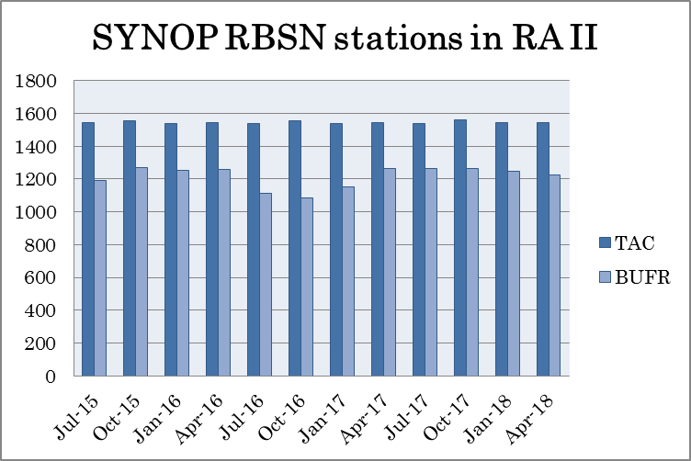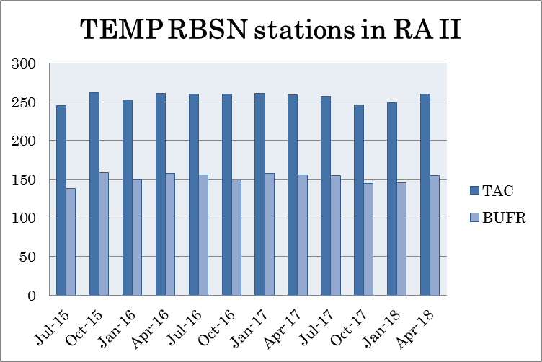
Number of RA-II RBSN stations issuing surface synoptic observation (SYNOP) and upper-air sounding (TEMP) reports in TAC and BUFR format from July 2015 to April 2018

(2) CLIMAT reports
As of May 2018, 13 Members out of 35 Members who have Regional Basic Climatological Network (RBCN) stations were reporting CLIMAT data in BUFR format: China; India; Mongolia; Saudi Arabia; Pakistan; Japan; Bangladesh; Hong Kong, China; Macao, China, Republic of Korea, Myanmar, Thailand and Lao PDR.
(3) Marine reports
As of May 2018, India (TESAC), Hong Kong, China (SHIP), Japan (TESAC, TRACKOB, SHIP) and Republic of Korea (TESAC, VOS) were routinely disseminating marine observation data in BUFR format. Adoption of new templates for TESAC and BATHY is limited.

