WORLD METEOROLOGICAL ORGANIZATION  COMMISSION FOR BASIC SYSTEMS  -----------------------------  SECOND MEETING OF  INTER-PROGRAMME EXPERT TEAM ON  CODES MAINTENANCE  OFFENBACH, GERMANY, 28 MAY - 1 JUNE 2018 |  | IPET-CM-II / Doc. 7.1 r  (22.05.2018)  -------------------------  ITEM 7.1  ENGLISH ONLY

MIGRATION TO TABLE-DRIVEN CODE FORMS
Comparison of the number of reports received in TDCF and TAC during January 2018
Submitted by Secretariat

_______________________________________________________________________

Summary and Purpose of Document

IPET-CM is requested to note the status of migration from TAC to TDCF as measured by the receipt of reports on the Main Telecommunication network during 1-15 January 2018.
_______________________________________________________________________

ACTION PROPOSED

Note the progress made in migrating to TDCF. Consider actions to assist Regions 1, 2 and 3 with migration.

DISCUSSION

The Special Main Telecommunication Network Monitoring (SMM) is carried out four times a year. This report is based on the results from the monitoring period 1-15 January 2018. The values quoted in this document are based on the information in the SMM processed files; there were days in January 2018 when not all upper air BUFR reports were recorded in the files, so for some regions the number of upper air BUFR reports was under-reported. However, statistics were gathered on enough days for a qualitative assessment of progress to be made. Additional charts have been added to this revised document to show the results from the independent analysis for the IWM.

The SMM records all messages containing observations for stations in the RBSN and RBCN that pass through participating Regional Telecommunications Hubs (RTHs) on the Main Telecommunications Network. The summaries produced by these RTHs are sent to processing centres that produce lists of the times for which observations were available during the monitoring period. In January 2018, the processing of CLIMAT reports by the RTHs was incomplete, so statistics are not available for those reports.

The tables compare the percentage of required reports received from stations in TDCF and in TAC broken down by WMO Region (four reports a day are required from surface stations, two are required each day from upper air stations).

Table 1. Percentage of required surface observations received in Table Driven Code format (TDCF) and in Traditional Alphanumeric Code (TAC).
WMO Region | Average % of TDCF | Average % of TAC
1 | 30 | 48
2 | 74 | 91
3 | 54 | 55
4 | 12 | 82
5 | 73 | 73
6 | 93 | 89
Antarctica | 43 | 40

Table 2. Percentage of required upper air observations received in Table Driven Code format (TDCF) and in Traditional Alphanumeric Code (TAC).
WMO Region | Average % of TDCF | Average % of TAC
1 | 10 | 14
2 | 47 | 79
3 | 41 | 44
4 | 38 | 90
5 | 48 | 64
6 | 53 | 80
Antarctica | 4 | 7

Table 3. Comparison of percentage of required surface reports received in TAC (left-pointing arrow) and TDCF (right pointing arrow) in the period 1-15 January 2018. The key is in Table 5.
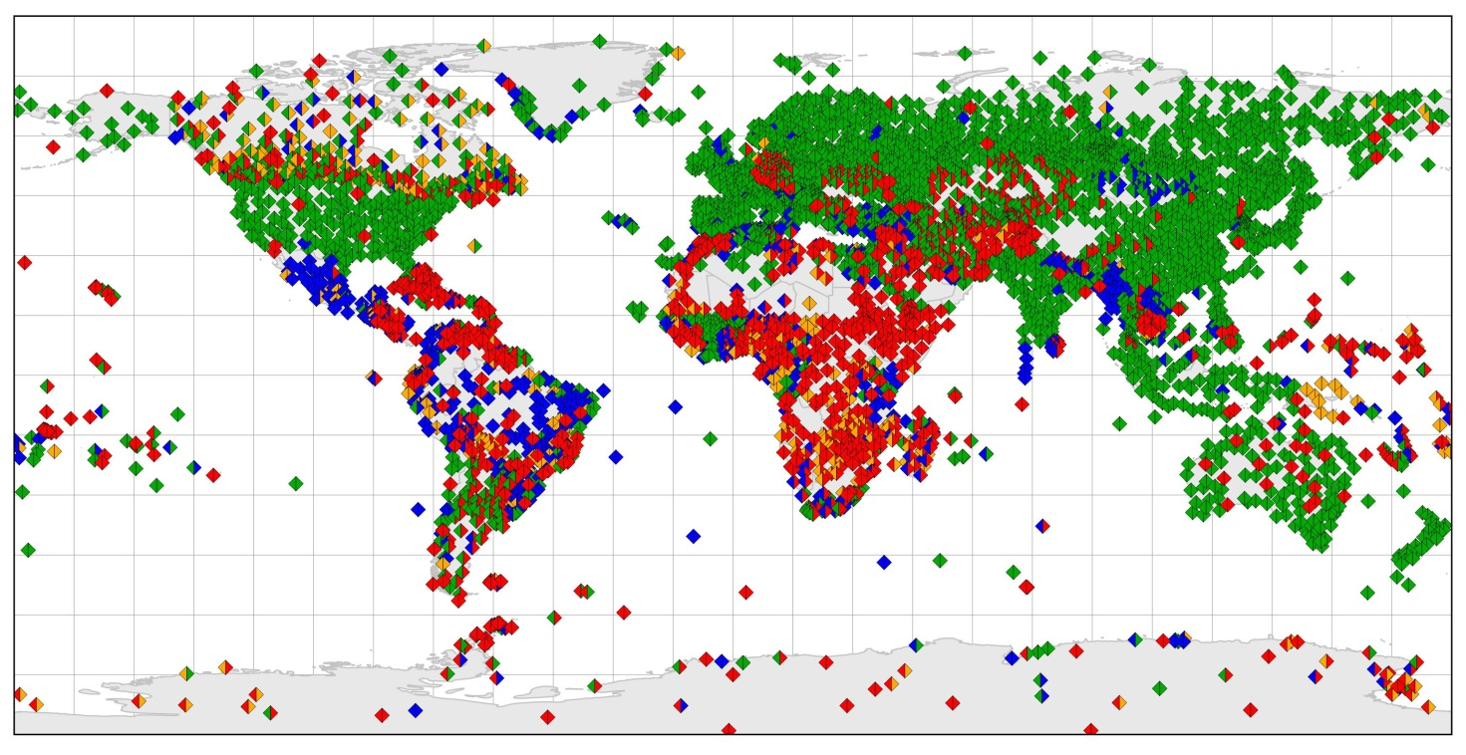

Table 4 Comparison of percentage of required upper air reports received in TAC (left-pointing arrow) and TDCF (right pointing arrow) in the period 1-15 January 2018. The key is in Table 5.
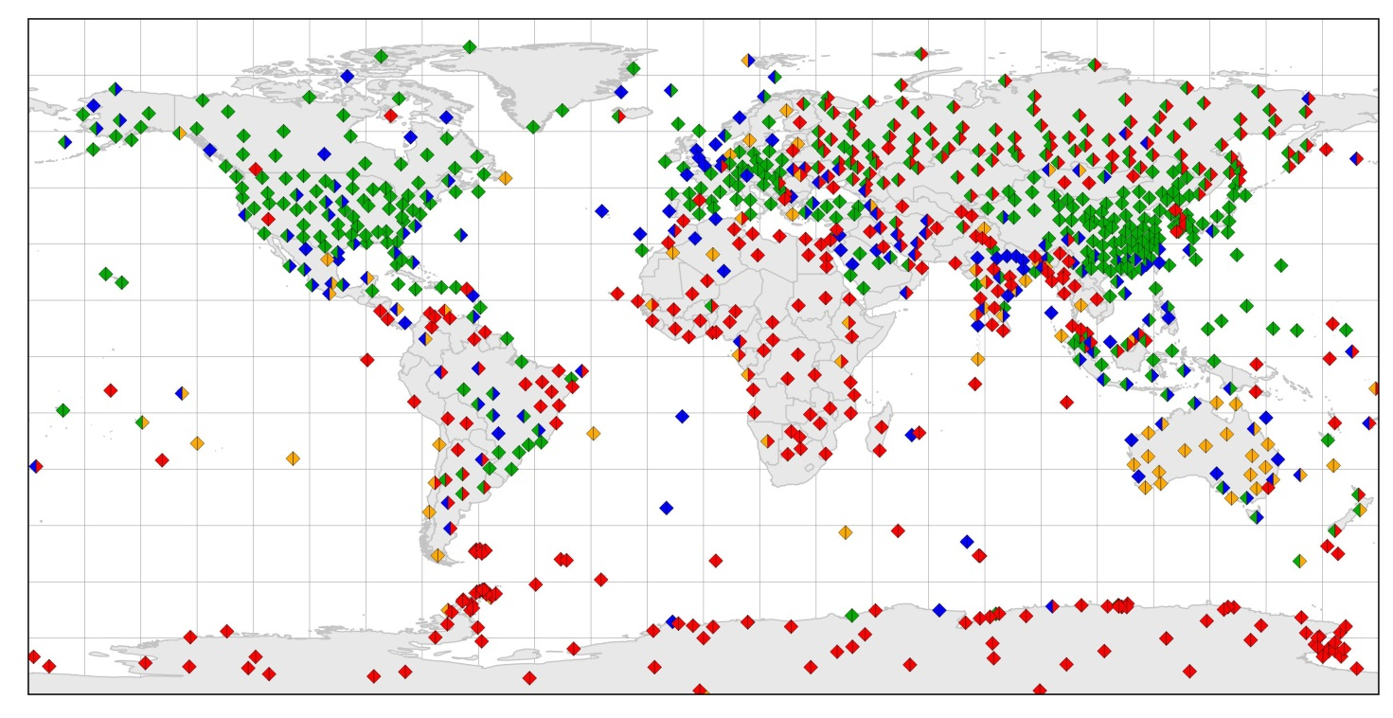

Table 5. Key for Table 6 and 4
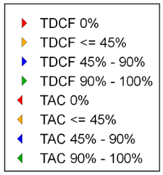

Availability of TAC TEMP reports from RBSN stations (as recorded by IWM)
Monitoring period: 1-15 January 2018
(the percentage of reports received is based on Part A for 0000 and 1200 UTC)
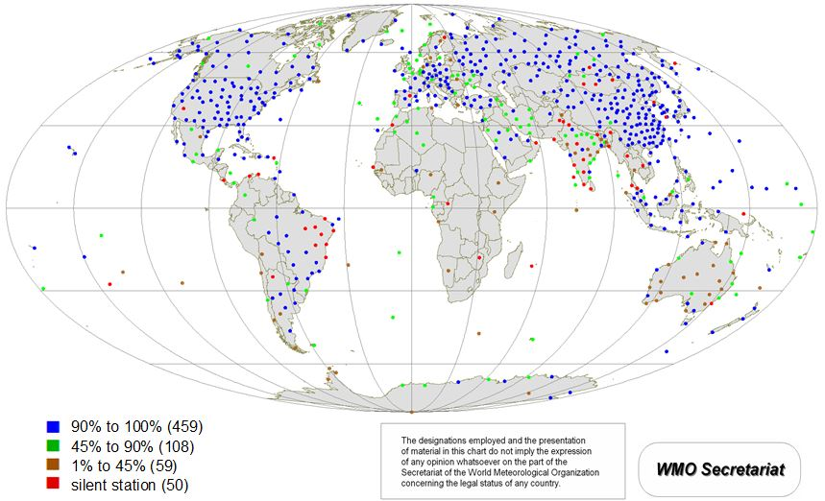

Availability of BUFR TEMP reports from RBSN stations (as recorded by IWM)
Monitoring period: 1-15 January 2018
(the percentage of reports received is based on Part B for 0000 and 1200 UTC)
