Third meeting of IPET-CM
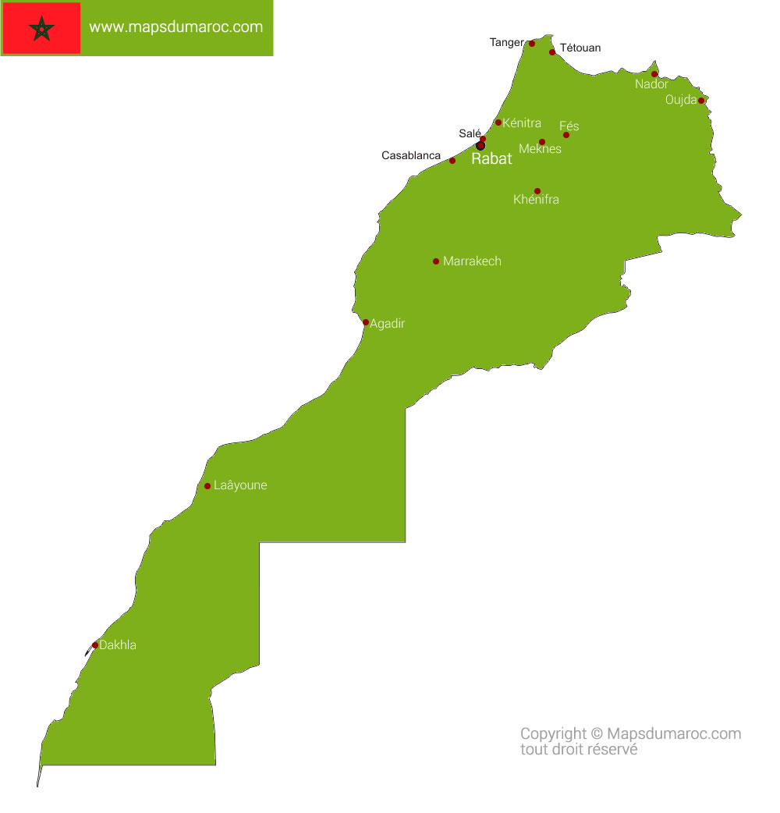

15-19 April 2019

Marrakech, Morocco

Information for Participants

- Venue and Dates
The meeting will be held in Marrakech, Morocco, at the below given address of the “ATLAS ASNI HOTEL” from 15 to 19 April 2019:

Address : Boulevard Mohamed VI, Marrakech 40000
MOROCCO
Telephone : +212 (0) 524 339 900
Website : http://hotelatlasasni-marrakech.h-rez.com

- Coordination
The contact details of the local meeting coordinator are given below:

Name : Mr Moulay Driss ELHACHIMI
Direction de la Météorologie Nationale DMN, Casablanca, Morocco
Tel : +212 (0) 5 22 65 48 64
GSM : +212 (0) 6 73 72 28 13
E-mail : m.d.elhachimi@gmail.com

WMO Coordinator:

Name : Atsushi Shimazaki
DRMM Division, WIS Branch, OBS Department, WMO
Tel: (+41 22) 730 8313
Fax:(+41 22) 730 8021
E-mail: ashimazaki@wmo.int

- Accommodation & Logistics
A block reservation has been done for participants, from 14 to 20 April 2019, at special rates, below the pricing conditions:

The night of 14/04/19:
767 Dhs (Around 77 EUR) including taxes / Pax: single room in half board (dinner)

From 15 to 20/04/2019 (5 nights)
1000 Dhs (Around 100 EUR) including taxes / Pax: single room BB + full day seminar (catering services: breakfast + 02 coffee breaks + Lunch with soft drink package)

Accompanied participant should pay a supplement of 300 MAD (around 30 EUR) for double room BB per night.

In order to confirm reservation, participants are kindly requested to fill the credit card authorization form, in attachment, at your earliest convenience but no later than 24 March, 2019. Please return this form to Mrs. Karima Houari ( commercialasni@hotelsatlas.com) with m.d.elhachimi@gmail.com in copy.

- Entry Visa for Morocco
It is recommended that international participants start the process for getting an entry visa for Morocco, if it is required. The local organizer can be contacted at m.d.elhachimi@gmail.com in case of any questions regarding visas. For more information please visit: https://www.consulat.ma/en/consular-services .
Below a List of countries whose citizens are exempted from entry visa into Morocco:

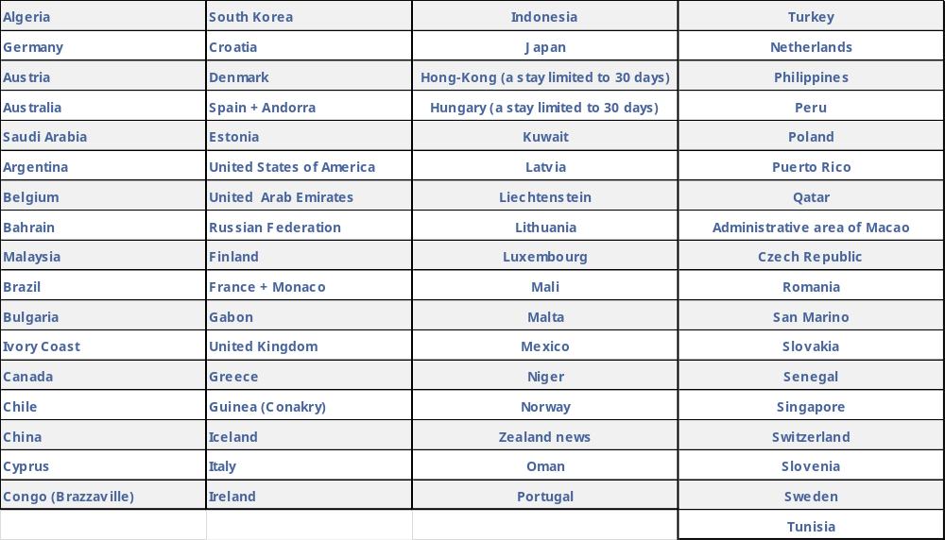

Participants, who do not have the Moroccan embassy or consulate in their country, should contact the local organizer to assist him to have a visa on arrival. Note that this kind of request has to be done at least 2 weeks before the arrival of participant.

- Transportation Between Airport and the Hotel
The participants will be responsible of their local transportation & expenses between airport and the hotel. All international participants are expected to arrive at Marrakech Menara Airport. To get from the Marrakech Menara Airport to the hotel, take a taxi. The taxi ride will cost between 10 and 20 € ( 100 to 200 MAD). Please agree on the fare with your driver before you begin the journey.

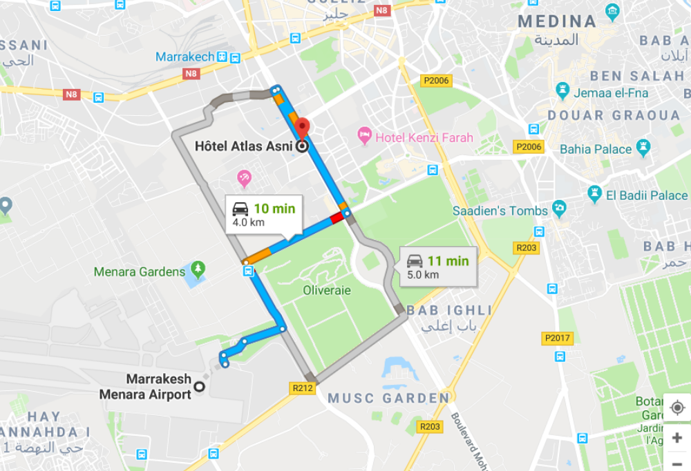
- Currency Exchange
The official currency of Morocco is the Moroccan Dirham, denoted as MAD or Dhs. The Moroccan Dirham is composed of 100 centimes; notes are available in denominations of (Dhs) 200, 100, 50, 25, and 20, all in new and old varieties and coins are available in denominations of (Dhs) 10, 5, 2 and 1, or 50, 20, 10 and 5 centimes. There are several types of 10 and 5 Dirham coins in circulation. Below are the approximate exchange rates for Euro and US Dollars.

1 USD ≈ 9.50 MAD
1 EUR ≈ 10.50 MAD

- Climate
The mean conditions in Marrakech in April are as follows:

Max Daytime Temperature °C | : 25°C (77°F)
Min Night-time Temperature °C | : 15°C (59°F)
Hours of Sunshine (Daily) | : 8.6 Hours per day
Days with some Rainfall | : 2 Days
Monthly Rainfall (mm) | : 05 mm

- Time Zone
The local Time in Morocco is GMT+1.

- Voltage
The voltage in morocco is 220-240V and the plug shape is French type, illustrated below. If your appliances plug has a different shape, you may need a plug adapter.

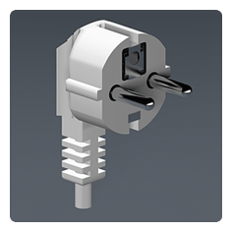 | 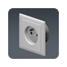 | 
 | 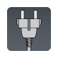

- Emergency Contact Person

Name : Mr Moulay Driss ELHACHIMI
Direction de la Météorologie Nationale DMN, Casablanca, Morocco
Tel : +212 (0) 5 22 65 48 64
GSM : +212 (0) 6 73 72 28 13
E-mail : m.d.elhachimi@gmail.com

