WORLD METEOROLOGICAL ORGANIZATION  COMMISSION FOR BASIC SYSTEMS  -----------------------------  THIRD MEETING OF  INTER-PROGRAMME EXPERT TEAM ON  CODES MAINTENANCE  MARRAKECH, MOROCCO, 15 - 19 APRIL 2019 |  | IPET-CM-III / Doc. 7.1(2)  02.04.2018  -------------------------  ITEM 7.1  ENGLISH ONLY

MIGRATION TO TABLE-DRIVEN CODE FORMS

Issues management process for upper air BUFR reports
Submitted by Secretariat

_______________________________________________________________________

Summary and Purpose of Document

A management process for the resolution of problems with upper air BUFR reports was implemented after proposal by TT-GISC. The process is based on the issues tracking system provided by GISC Brasilia and already used for the GISC watch activity. A significant number of issues has been entered and some progress has been done in their resolution.

_______________________________________________________________________

ACTION PROPOSED

IPET-CM to acknowledge the issues in the tracking system and to ask the representatives from the Regional Associations to facilitate the resolution of the outstanding problems.

ANNEXES:
1. Circular letter 31922/2018/0BS/WIS/DRMM/BUFR 30 November 2018

DISCUSSIONS

The migration from Traditional Alphanumeric Codes (TAC) to Table Driven Code Forms (TDCF) has not been fully completed yet. Progress of the migration is particularly slow for the upper air reports for which 25% of reports are still in TAC and 33% are not properly encoded (see fig. 1). This provides a total of 55% of reports that cannot be used in BUFR format for data assimilation purposes.

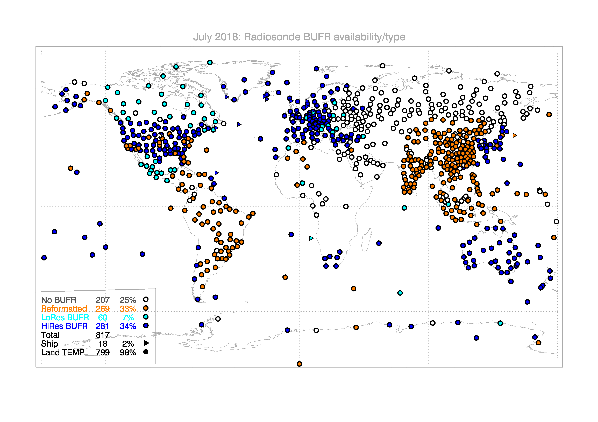

Figure 1: availability statistics for upper air observations courtesy of ECMWF

The main problems are the lack of radiosonde drift in the message and the problems related with incorrect composition of a single message from the different parts of TEMP.

With the aim to monitor the progress closely the issue was presented at the TT-GISC meeting in Casablanca in September 2018. It was proposed to leverage on the operational activities of the GISCs and their capacity to track and solve GISC related issues to address the issues related to the BUFR upper air migration. The GISCs are performing a GISC watch activity and using an issue tracking system provided by GISC Brasilia on which the GISCs are registering issues related to network, metadata and other GISC operational problems.
TT-GISC agreed that the use of the tracking system can be extended to the issue management of the problems related to BUFR upper air data and proposed a management process driven by the GISCs and supported by the issues tracking system provided by GISC Brasilia. A circular letter (see Annex 1) establishing the process and asking Members to collaborate in the resolution of the BUFR upper air issues was sent in November 2018.
At the time of writing of this document there are 46 issues related to BUFR upper air problems in the tracking system, two of them have been resolved and some of them have a resolution in progress.

