WORLD METEOROLOGICAL ORGANIZATION  COMMISSION FOR BASIC SYSTEMS  -----------------------------  THIRD MEETING OF  INTER-PROGRAMME EXPERT TEAM ON  CODES MAINTENANCE  MARRAKECH, MOROCCO, 15 - 19 APRIL 2019 |  | IPET-CM-III / Doc. 7.2(7)  13.04.2018  -------------------------  ITEM 7.2  ENGLISH ONLY

MIGRATION TO TABLE-DRIVEN CODE FORMS
Reports on status of migration

Status of migration to TDCF within JCOMM
Submitted by David Berry (on behalf of JCOMM)

_______________________________________________________________________

Summary and Purpose of Document

This document provides an update of the migration status within JCOMM.

_______________________________________________________________________

ACTION PROPOSED

None, for information purposes.

ANNEXES:
1. (Title of annex)

DISCUSSIONS

The list of previously used TAC forms and their BUFR replacements are given in Table 1. Migration to BUFR for E-ASAP observations was completed in 2016. The distribution of TAC messages for Argo profiling float observations ceased in July 2018. During January 2019 the majority of VOS observations were distributed in parallel in both TAC and BUFR (see Figure 1). Based on receipts at JCOMMOPS during March 2018 100 % of drifting buoys were reporting in BUFR with a small percentage (5%) reporting in both TAC and BUFR. As reported at the 34th Session of the Data Buoy Cooperation Panel [1], 41% of moored buoys reported in BUFR or BUFR and TAC. At the 10th Session of the JCOMM Ship Observations Team it was reported that the migration of the BATHY (XBT) data could be considered complete [2]

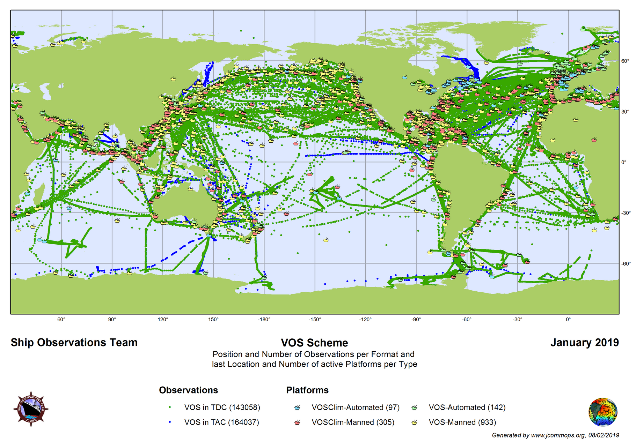
Figure 1: Format and spatial distribution of VOS observations on the GTS in 2019.

[1] Data Buoy Cooperation Panel, Thirty-Fourth Session, Cape Town, South Africa, 23 – 26 October 2018, JCOMM Meeting Report No. 142.
[2] Report of the JCOMM Ship Technical Coordinator on the Ship Of Opportunity Programme (SOOP) support activities, 10th Session of the JCOMM Ship Observations Team, Hong Kong,
1st – 4th April, 2019. (Report available from https://www.jcomm.info/index.php?option=com_oe&task=viewDocumentRecord&docID=23894)
Table 1: Summary of BUFR Table D sequences / BUFR templates in use for marine data
TAC | Description | Current template(s) | Status | Plans/comments
FM13-XIV SHIP | VOS data | B/C10 - Regulations for reporting SHIP data in TDCF | Operational (TM308009) | Deprecated, use TM0308014
 | VOS data | Synoptic reports from sea stations suitable for SHIP observation data from VOS stations | Operational (TM308014) | Replaces / supersedes TM308009.
 | VOS data |  | TM308018 | Simplified template for automatic weather stations
 | Offshore platforms | Template for the representation of observations from offshore platforms | Operational (TM308017)
FM18-XII BUOY | Drifting buoy data | Template for the representation from drifting buoys | Operational (TM315009) | Simplified template specific to drifting buoys
 | Moored buoy data | Template for the representation of data from moored buoys | Operational (TM315008) | Simplified template specific to moored buoys, including directional and non-directional wave data
 | Wave buoy data | Template for the representation of data from moored buoys | Operational (TM315008) | Sequence to report ‘first 5’ spectral wave coefficients in development
 | Argo data | Sub-surface profiling floats | Operational (TM315003) | Additional sequences defined to extend template and may be present in reports
FM36-XI Ext. TEMP SHIP | ASAP data | B/C25 - Regulations for reporting TEMP, TEMP SHIP, TEMP MOBIL data in TDCF | Operational (TM309052)
 | ASAP data | UKMO template for representation of radiosonde data with geopotential height as the vertical coordinate | Operational (revisited in July 2010)
FM62-VIII Ext. TRACKOB | TRACKOB data | TRACKOB data – ThermoSalinoGraph (TSG) data and metadata | Operational (TM308010) | Plans to update template to include additional metadata.
FM63-XI Ext. BATHY | XBT data | New BUFR template for XBT Temperature Profile data | Operational (TM315004) | Plans to update template to include additional metadata.
FM64-XI Ext. TESAC | CTD / TESAC | Template for the representation of data derived from a ship based lowered instrument measuring subsurface seawater temperature, salinity and current profiles. | Operational (TM 315007)
FM65-XI Ext. WAVEOB | Wave buoy data | Templates for the wave observations from different platforms suitable for WAVEOB data | Operational (TM308015)  and (TM308016)
N/A | Sea-level data | BUFR/CREX templates for tsunameter data and dart buoy system messages | Operational (TM306027)

