WORLD METEOROLOGICAL ORGANIZATION  COMMISSION FOR BASIC SYSTEMS  -----------------------------  THIRD MEETING OF  INTER-PROGRAMME EXPERT TEAM ON  CODES MAINTENANCE  MARRAKECH, MOROCCO, 15 - 19 APRIL 2019 |  | IPET-CM-III / Doc. 7.2(3)  01.04.2019  -------------------------  ITEM 7.2  ENGLISH ONLY

MIGRATION TO TABLE-DRIVEN CODE FORMS
Reports on status of migration

Report of the status of implementation of the BUFR code in the ARIII
Submitted by Luis A. Lazcano (Dirección Meteorológica de Chile)

_______________________________________________________________________

Summary and Purpose of Document

_______________________________________________________________________

ACTION PROPOSED

ANNEXES:
1. (Title of annex)

Índice de Contenido
1. Resumen 3
2. Countries of the Regional Association III 4
3. Bulletins in BUFR code published on the WIS portal 5
4. Survey sent to the ARIII Countries 6
4.1 Survey Text 6
4.1 Link to the Online Survey 7
4.2 Countries that respond 7
4.3 Answers 7
5. Annex 15
5.1 Bulletins in BUFR defined in WIS 15
5.1.1 Argentina 15
5.1.2 Chile 16
5.1.3 Brasil 17
5.1.4 Colombia 26
5.1.5 Paraguay 26
5.1.6 Venezuela 26
5.1.7 Uruguay 26
5.1.8 Perú 26

Resumen

The following report shows the information sent by the BUFR focal points of the ARIII countries, but much information has been obtained from the WIS portals of Argentina and Brazil as a normal user.
The biggest problem is the contact with the focal points of the countries, which has made it difficult to obtain data for a more detailed analysis.
Peru has requested support for the implementation of BUFR and creates its own capacities in the elaboration of its messages. The Chilean Meteorological Service has made video calls to provide guidance in this regard.
Some countries report BUFR bulletins in WIS, but the DCPC converts them to this code and have not developed their own capabilities.

Countries of the Regional Association III
The following table shows the name of the RA III focal points. The names in gray correspond to unconfirmed data.
 | PAIS | Confirmación de Puntos Focales
 |  | Nombre | correo
1 | Argentina | Lucas BERENGUA | lucasjb@smn.gov.ar
2 | Bolivia | Antonio Terán | webmaster@seramhi.fob.bo
3 | Brasil | José Mauro | Jmauro.rezende@inmet.gov.br
4 | Chile | Luis Lazcano | llazcano@dgac.gob.cl
5 | Colombia | Julio César FRANCO | jfranco@ideam.gov.co
6 | Ecuador | Edison Cruz | ecruz@inamhi.gob.ec
7 | Guyana | Ms. Haymawattie Danny | haymadanny@gmail.com
8 | Paraguay | Wilson Caballero | wilson.caballero@meteorologia.gov.py
9 | Perú | Jorge Dante Chira La Rosa | jchira@senamhi.gob.pe
10 | Suriname | WARSODIKROMO Truusje Soetinie | wtruus@yahoo.com
11 | Uruguay | Marcelo Chico Espinoza | mceuy@yahoo.com
12 | Venezuela | Antonio Espinoza | antonio.espinoza07@gmail.com

Bulletins in BUFR code published on the WIS portal
The following table shows the bulletins retrieved from the WIS portals of Argentina and Brazil.
 | País | Boletines | Total
1 | Argentina | IUAG01SABM,ISNI01SABM,IUKI05SAWB,ISCI03SABM,ISMI01SAWB,IUJI05SAWB,ISII03SABM,IUKI01SABM,IUKI02SABM,ISMI01SABM,IUJI02SABM,ISII01SABM,IUJI01SABM,ISCI01SABM,ISMI02SABM,ISNI02SABM,ISII02SABM,ISMI03SABM,ISNI03SABM | 19
2 | Bolivia | Sin Boletines | 0
3 | Brasil | Ver Tabla en Anexos… | 249
4 | Chile | ISMI03SCSC,ISII01SCSC,IUSJ01SCSC,ISAI01SCSC,ISCI60SCSC,IUSI02SCSC,ISCJ60SCSC,ISMI02SCSC,ISMI01SCSC,ISII02SCSC,ISCI01SCSC,ISCJ01SCSC,IUSI01SCSC | 13
5 | Colombia | ISAI01SKBO,ISME01SKBO | 2
6 | Ecuador | Sin Boletines | 0
7 | Guyana | Sin Boletines | 0
8 | Paraguay | ISII01SGAS | 1
9 | Perú | ISMI01SPIM | 1
10 | Suriname | Sin Boletines | 0
11 | Uruguay | ISMI01SUMU | 1
12 | Venezuela | ISME01SVMR,ISIE01SVMR,ISIE20SVMR | 3

Survey sent to the ARIII Countries

4.1 Survey Text
- Status of Migration to BUFR Code
  - Country
  - Name
  - Organization
  - E-mail
- Implementation of the BUFR code
  - Does your Service distribute BUFR reports via GTS (Global Telecommunications System)?
  - If applicable, ¿which GTS center converts its CAT messages in BUFR code?
  - What type of messages are converted to BUFR from CAT messages?
  - If applicable, indicate which categories of reports does your organization (or support center) emits in the BUFR code?
  - If applicable, what software tool does your Service use to produce messages in BUFR code?
  - Does your organization have a plan to discontinue the transmission of CAT messages?
  - What is the biggest challenge or obstacle in your organization for the migration to TDCF?
- Data use in BUFR Code.
  - Does your organization use BUFR reports to produce daily forecasts, numerical weather prediction systems and / or statistics?
  - What categories of TDCF data does your organization use (or plan to use)?
  - Is your Service prepared to continue with daily forecasts, numerical weather prediction and other operational activities without CAT reports?
- In your experience, what are the main benefits of using BUFR compared to traditional alphanumeric codes (TACs) in your organization?
- Write below any questions or comments about the migration to BUFR code

Link to the Online Survey
The survey can be answered by following the following link:
https://docs.google.com/forms/d/e/1FAIpQLSdVSrOZRkk9aCvrmVRD-k8ah42xXtIwjmfDTFLKgPQ09pxR9A/viewform?vc=0&c=0&w=1

Countries that respond
This survey was sent to the focal points indicated in point N ° 2, of which Argentina and Peru responded. It is estimated that the rest of the countries do not have the name of their focal point updated, which is a great difficulty when trying to rescue information. This is a point that should improve.

Answers
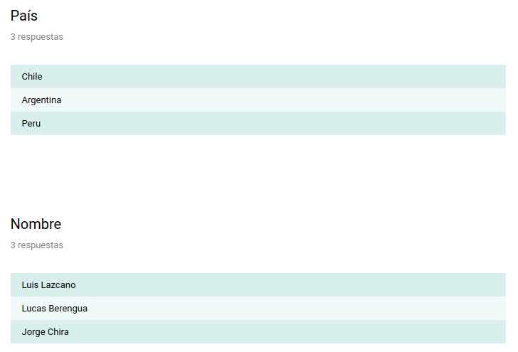

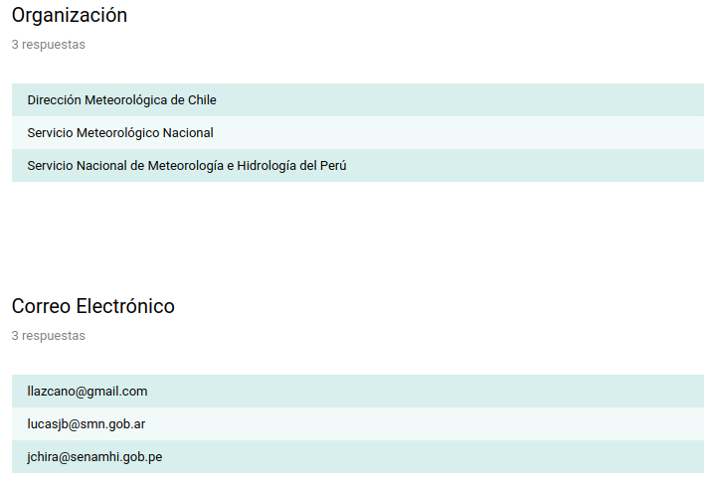
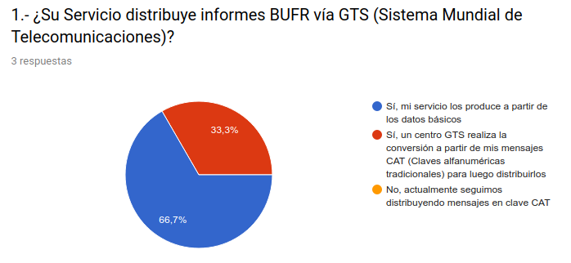
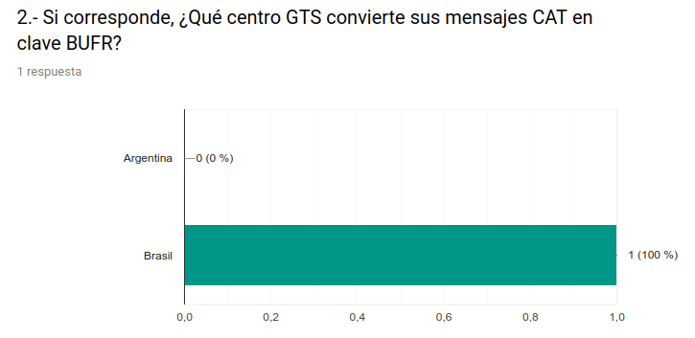
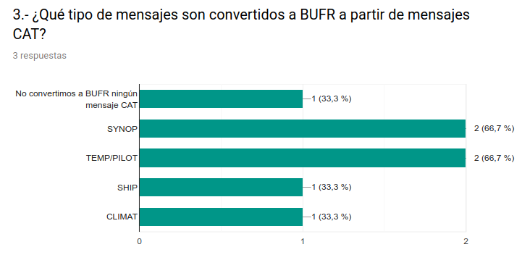

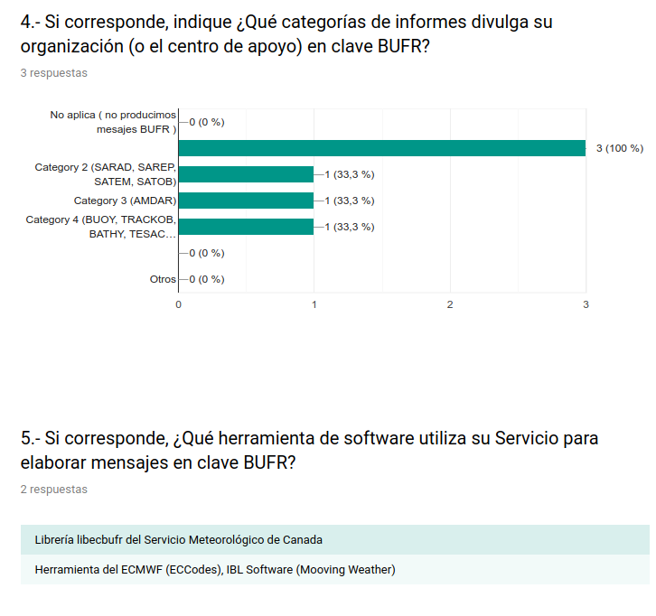
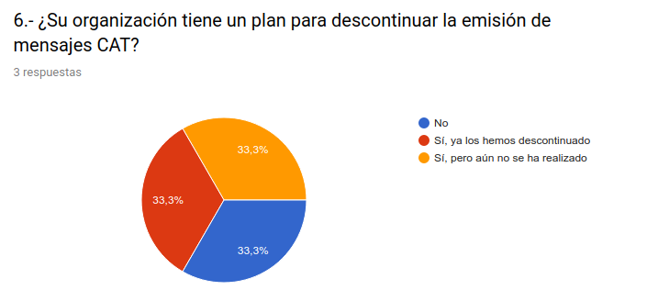
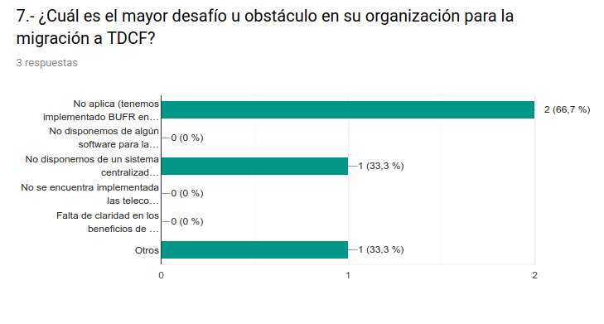

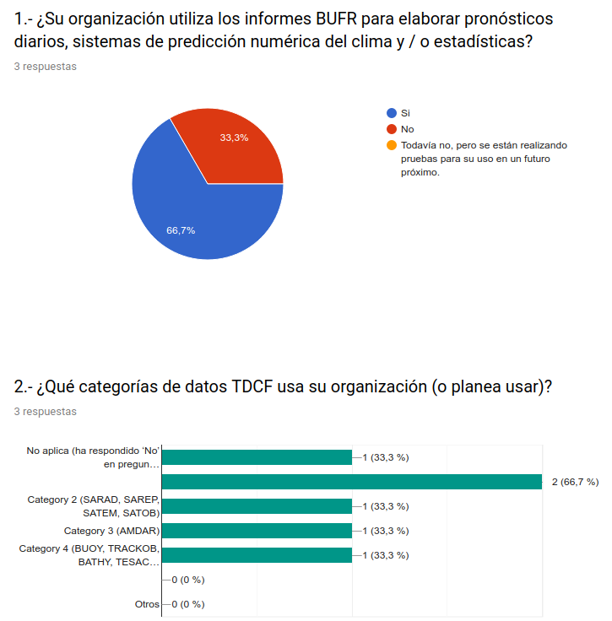

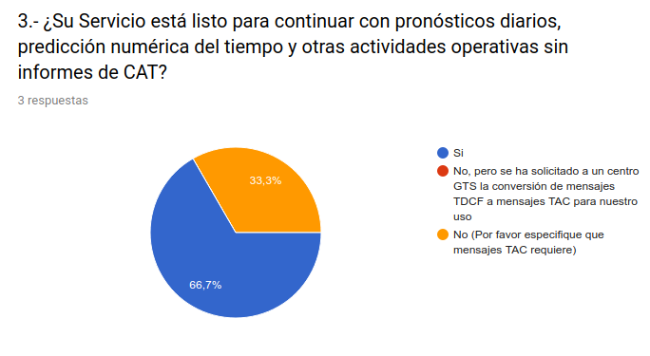

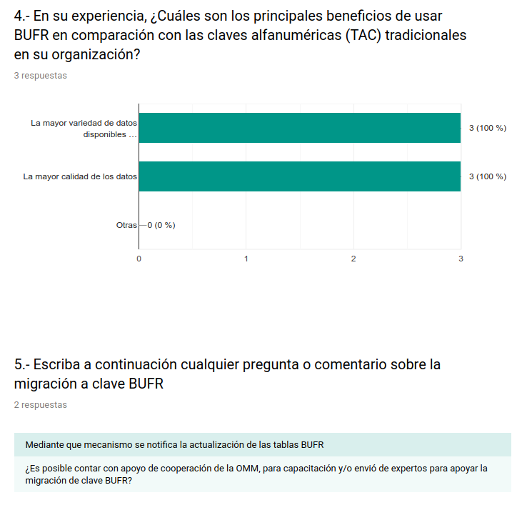

Annex

Bulletins in BUFR defined in WIS

Argentina
ID | Descripción
int.wmo.wis::IUAG01SABM | IUAG01 collection of AMDAR reports available from SABM (BUENOS AIRES (CENTRO REGIONAL MET.))
int.wmo.wis::ISNI01SABM | ISNI01 collection of SYNOP reports available from SABM (BUENOS AIRES (CENTRO REGIONAL MET.)) as BUFR at hourly UTC
int.wmo.wis::IUKI05SAWB | IUKI05 collection of TEMP reports available from SAWB (BASE MARAMBIO) as BUFR at 12 UTC
int.wmo.wis::ISCI03SABM | ISCI03 collection of CLIMAT reports available from SABM (BUENOS AIRES (CENTRO REGIONAL MET.)) as BUFR at MONTHLY
int.wmo.wis::ISMI01SAWB | ISMI01 collection of SYNOP reports available from SAWB (BASE MARAMBIO) as BUFR at 00, 06, 12, 18 UTC
int.wmo.wis::IUJI05SAWB | IUJI05 collection of PILOT reports available from SAWB (BASE MARAMBIO) as BUFR at 12 UTC
int.wmo.wis::ISII03SABM | ISII03 collection of SYNOP reports available from SABM (BUENOS AIRES (CENTRO REGIONAL MET.)) as BUFR at 03, 09, 15, 21 UTC
int.wmo.wis::IUKI01SABM | IUKI01 collection of TEMP reports available from SABM (BUENOS AIRES (CENTRO REGIONAL MET.)) as BUFR at 12 UTC
int.wmo.wis::IUKI02SABM | IUKI02 collection of TEMP reports available from SABM (BUENOS AIRES (CENTRO REGIONAL MET.)) as BUFR at 12 UTC
int.wmo.wis::ISMI01SABM | ISMI01 collection of SYNOP reports available from SABM (BUENOS AIRES (CENTRO REGIONAL MET.)) as BUFR at 00, 06, 12, 18 UTC
int.wmo.wis::IUJI02SABM | IUJI02 collection of PILOT reports available from SABM (BUENOS AIRES (CENTRO REGIONAL MET.)) as BUFR at 12 UTC
int.wmo.wis::ISII01SABM | ISII01 collection of SYNOP reports available from SABM (BUENOS AIRES (CENTRO REGIONAL MET.)) as BUFR at 03, 09, 15 and 21 UTC
int.wmo.wis::IUJI01SABM | IUJI01 collection of PILOT reports available from SABM (BUENOS AIRES (CENTRO REGIONAL MET.)) as BUFR at 12 UTC
int.wmo.wis::ISCI01SABM | ISCI01 collection of CLIMAT reports available from SABM (BUENOS AIRES (CENTRO REGIONAL MET.)) as BUFR at MONTHLY
int.wmo.wis::ISMI02SABM | ISMI02 collection of SYNOP reports available from SABM (BUENOS AIRES (CENTRO REGIONAL MET.)) as BUFR at 00, 06, 12, 18 UTC
int.wmo.wis::ISNI02SABM | ISNI02 collection of SYNOP reports available from SABM (BUENOS AIRES (CENTRO REGIONAL MET.)) as BUFR at hourly UTC
int.wmo.wis::ISII02SABM | ISII02 collection of SYNOP reports available from SABM (BUENOS AIRES (CENTRO REGIONAL MET.)) as BUFR at 03, 09, 15 and 21 UTC
int.wmo.wis::ISMI03SABM | ISMI03 collection of SYNOP reports available from SABM (BUENOS AIRES (CENTRO REGIONAL MET.)) as BUFR at 00, 06, 12, 18 UTC
int.wmo.wis::ISNI03SABM | ISNI03 collection of SYNOP report available from SABM (BUENOS AIRES (CENTRO REGIONAL MET.)) as BUFR at hourly UTC

Chile
ID | Descripción
ISMI03SCSC | ISMI03 collection of SYNOP reports available from SCSC (SANTIAGO DE CHILE (NATIONAL WEATHER CENTER )) as BUFR at 12 and 18 UTC
ISII01SCSC | ISII01 collection of SYNOP reports available from SCSC (SANTIAGO DE CHILE (NATIONAL WEATHER CENTER )) as BUFR at 03 and 09 UTC
IUSJ01SCSC | IUSJ01 collection of TEMP reports available from SCSC (SANTIAGO DE CHILE (NATIONAL WEATHER CENTER) as BUFR at 00 UTC
ISAI01SCSC | ISAI01 BUFR bulletin available from SCSC (SANTIAGO DE CHILE (NATIONAL WEATHER CENTER)) at 00, 01, 02, 03, 04, 05, 06, 07, 08, 09, 10, 11, 12, 13, 14, 15, 16, 17, 18, 19, 20, 21, 22 and 23 UTC
ISCI60SCSC | ISCI60 collection of DAILY CLIMAT reports available from SCSC (SANTIAGO DE CHILE (NATIONAL WEATHER CENTER )) in MONTHLY BUFR
IUSI02SCSC | IUSI02 collection of TEMP reports available from SCSC (SANTIAGO DE CHILE (NATIONAL WEATHER CENTER) as BUFR at 12 and 00 UTC
ISCJ60SCSC | ISCJ60 collection of DAILY CLIMAT reports available from SCSC (SANTIAGO DE CHILE (NATIONAL WEATHER CENTER )) as BUFR at MONTHLY
ISMI02SCSC | ISMI02 collection of SYNOP reports available from SCSC (SANTIAGO DE CHILE (NATIONAL WEATHER CENTER )) as BUFR at 06 UTC
ISMI01SCSC | ISMI01 collection of SYNOP reports available from SCSC (SANTIAGO DE CHILE (NATIONAL WEATHER CENTER )) as BUFR at 00 UTC
ISII02SCSC | ISII02 collection of SYNOP reports available from SCSC (SANTIAGO DE CHILE (NATIONAL WEATHER CENTER )) as BUFR at 15 UTC
ISCI01SCSC | ISCI01 collection of CLIMAT reports available from SCSC (SANTIAGO DE CHILE (NATIONAL WEATHER CENTER )) as BUFR at MONTHLY
ISCJ01SCSC | ISCJ01 collection of CLIMAT reports available from SCSC (SANTIAGO DE CHILE (NATIONAL WEATHER CENTER )) in MONTHLY BUFR
IUSI01SCSC | IUSI01 collection of TEMP reports available from SCSC (SANTIAGO DE CHILE (NATIONAL WEATHER CENTER) as BUFR at 12 UTC

Brasil
ID | Descripción
int.wmo.wis::INAX01SBBR | INAX01 SBBR BUFR bulletin ATOVS AMSU-A report available from SBBR (BRASILIA-BRAZIL)
int.wmo.wis::INAX02SBBR | INAX02 SBBR BUFR bulletin ATOVS AMSU-A report available from SBBR (BRASILIA-BRAZIL)
int.wmo.wis::INAX03SBBR | INAX03 SBBR BUFR bulletin ATOVS AMSU-A report available from SBBR (BRASILIA-BRAZIL)
int.wmo.wis::INAX04SBBR | INAX04 SBBR BUFR bulletin ATOVS AMSU-A report available from SBBR (BRASILIA-BRAZIL)
int.wmo.wis::INAX05SBBR | INAX05 SBBR BUFR bulletin ATOVS AMSU-A report available from SBBR (BRASILIA-BRAZIL)
int.wmo.wis::INAX06SBBR | INAX06 SBBR BUFR bulletin ATOVS AMSU-A report available from SBBR (BRASILIA-BRAZIL)
int.wmo.wis::INAX07SBBR | INAX07 SBBR BUFR bulletin ATOVS AMSU-A report available from SBBR (BRASILIA-BRAZIL)
int.wmo.wis::INAX08SBBR | INAX08 SBBR BUFR bulletin ATOVS AMSU-A report available from SBBR (BRASILIA-BRAZIL)
int.wmo.wis::INAX09SBBR | INAX09 SBBR BUFR bulletin ATOVS AMSU-A report available from SBBR (BRASILIA-BRAZIL)
int.wmo.wis::INAX10SBBR | INAX10 SBBR BUFR bulletin ATOVS AMSU-A report available from SBBR (BRASILIA-BRAZIL)
int.wmo.wis::INAX11SBBR | INAX11 SBBR BUFR bulletin ATOVS AMSU-A report available from SBBR (BRASILIA-BRAZIL)
int.wmo.wis::INAX12SBBR | INAX12 SBBR BUFR bulletin ATOVS AMSU-A report available from SBBR (BRASILIA-BRAZIL)
int.wmo.wis::INAX13SBBR | INAX13 SBBR BUFR bulletin ATOVS AMSU-A report available from SBBR (BRASILIA-BRAZIL)
int.wmo.wis::INAX14SBBR | INAX14 SBBR BUFR bulletin ATOVS AMSU-A report available from SBBR (BRASILIA-BRAZIL)
int.wmo.wis::INAX15SBBR | INAX15 SBBR BUFR bulletin ATOVS AMSU-A report available from SBBR (BRASILIA-BRAZIL)
int.wmo.wis::INAX16SBBR | INAX16 SBBR BUFR bulletin ATOVS AMSU-A report available from SBBR (BRASILIA-BRAZIL)
int.wmo.wis::INAX17SBBR | INAX17 SBBR BUFR bulletin ATOVS AMSU-A report available from SBBR (BRASILIA-BRAZIL)
int.wmo.wis::INAX18SBBR | INAX18 SBBR BUFR bulletin ATOVS AMSU-A report available from SBBR (BRASILIA-BRAZIL)
int.wmo.wis::INAX19SBBR | INAX19 SBBR BUFR bulletin ATOVS AMSU-A report available from SBBR (BRASILIA-BRAZIL)
int.wmo.wis::INCS01SBBR | INCS01 SBBR BUFR bulletin CrIS data report available from SBBR (BRASILIA-BRAZIL)
int.wmo.wis::INCX01SBBR | INCX01 SBBR BUFR bulletin CrIS data report available from SBBR (BRASILIA-BRAZIL)
int.wmo.wis::INHX01SBBR | INHX01 SBBR BUFR bulletin ATOVS HIRS report available from SBBR (BRASILIA-BRAZIL)
int.wmo.wis::INHX02SBBR | INHX02 SBBR BUFR bulletin ATOVS HIRS report available from SBBR (BRASILIA-BRAZIL)
int.wmo.wis::INHX03SBBR | INHX03 SBBR BUFR bulletin ATOVS HIRS report available from SBBR (BRASILIA-BRAZIL)
int.wmo.wis::INHX04SBBR | INHX04 SBBR BUFR bulletin ATOVS HIRS report available from SBBR (BRASILIA-BRAZIL)
int.wmo.wis::INHX05SBBR | INHX05 SBBR BUFR bulletin ATOVS HIRS report available from SBBR (BRASILIA-BRAZIL)
int.wmo.wis::INHX06SBBR | INHX06 SBBR BUFR bulletin ATOVS HIRS report available from SBBR (BRASILIA-BRAZIL)
int.wmo.wis::INHX07SBBR | INHX07 SBBR BUFR bulletin ATOVS HIRS report available from SBBR (BRASILIA-BRAZIL)
int.wmo.wis::INHX08SBBR | INHX08 SBBR BUFR bulletin ATOVS HIRS report available from SBBR (BRASILIA-BRAZIL)
int.wmo.wis::INHX09SBBR | INHX09SBBR BUFR bulletin ATOVS HIRS report available from SBBR (BRASILIA-BRAZIL)
int.wmo.wis::INHX10SBBR | INHX10 SBBR BUFR bulletin ATOVS HIRS report available from SBBR (BRASILIA-BRAZIL)
int.wmo.wis::INHX11SBBR | INHX11 SBBR BUFR bulletin ATOVS HIRS report available from SBBR (BRASILIA-BRAZIL)
int.wmo.wis::INHX12SBBR | INHX12 SBBR BUFR bulletin ATOVS HIRS report available from SBBR (BRASILIA-BRAZIL)
int.wmo.wis::INHX13SBBR | INHX13 SBBR BUFR bulletin ATOVS HIRS report available from SBBR (BRASILIA-BRAZIL)
int.wmo.wis::INHX14SBBR | INHX14 SBBR BUFR bulletin ATOVS HIRS report available from SBBR (BRASILIA-BRAZIL)
int.wmo.wis::INHX15SBBR | INHX15 SBBR BUFR bulletin ATOVS HIRS report available from SBBR (BRASILIA-BRAZIL)
int.wmo.wis::INHX16SBBR | INHX16 SBBR BUFR bulletin ATOVS HIRS report available from SBBR (BRASILIA-BRAZIL)
int.wmo.wis::INHX17SBBR | INHX17 SBBR BUFR bulletin ATOVS HIRS report available from SBBR (BRASILIA-BRAZIL)
int.wmo.wis::INHX18SBBR | INHX18 SBBR BUFR bulletin ATOVS HIRS report available from SBBR (BRASILIA-BRAZIL)
int.wmo.wis::INHX19SBBR | INHX19 SBBR BUFR bulletin ATOVS HIRS report available from SBBR (BRASILIA-BRAZIL)
int.wmo.wis::INHX20SBBR | INHX20 SBBR BUFR bulletin ATOVS HIRS report available from SBBR (BRASILIA-BRAZIL)
int.wmo.wis::INHX21SBBR | INHX21 SBBR BUFR bulletin ATOVS HIRS report available from SBBR (BRASILIA-BRAZIL)
int.wmo.wis::INHX22SBBR | INHX22 SBBR BUFR bulletin ATOVS HIRS report available from SBBR (BRASILIA-BRAZIL)
int.wmo.wis::INHX23SBBR | INHX23 SBBR BUFR bulletin ATOVS HIRS report available from SBBR (BRASILIA-BRAZIL)
int.wmo.wis::INHX24SBBR | INHX24 SBBR BUFR bulletin ATOVS HIRS report available from SBBR (BRASILIA-BRAZIL)
int.wmo.wis::INMX01SBBR | INMX01 SBBR BUFR bulletin ATOVS AMSU-B/MHS report available from SBBR (BRASILIA-BRAZIL)
int.wmo.wis::INMX02SBBR | INMX02 SBBR BUFR bulletin ATOVS AMSU-B/MHS report available from SBBR (BRASILIA-BRAZIL)
int.wmo.wis::INMX03SBBR | INMX03 SBBR BUFR bulletin ATOVS AMSU-B/MHS report available from SBBR (BRASILIA-BRAZIL)
int.wmo.wis::INMX04SBBR | INMX04 SBBR BUFR bulletin ATOVS AMSU-B/MHS report available from SBBR (BRASILIA-BRAZIL)
int.wmo.wis::INMX05SBBR | INMX05 SBBR BUFR bulletin ATOVS AMSU-B/MHS report available from SBBR (BRASILIA-BRAZIL)
int.wmo.wis::INMX06SBBR | INMX01 SBBR BUFR bulletin ATOVS AMSU-B/MHS report available from SBBR (BRASILIA-BRAZIL)
int.wmo.wis::INMX07SBBR | INMX07 SBBR BUFR bulletin ATOVS AMSU-B/MHS report available from SBBR (BRASILIA-BRAZIL)
int.wmo.wis::INMX08SBBR | INMX08 SBBR BUFR bulletin ATOVS AMSU-B/MHS report available from SBBR (BRASILIA-BRAZIL)
int.wmo.wis::INMX09SBBR | INMX09 SBBR BUFR bulletin ATOVS AMSU-B/MHS report available from SBBR (BRASILIA-BRAZIL)
int.wmo.wis::INMX10SBBR | INMX10 SBBR BUFR bulletin ATOVS AMSU-B/MHS report available from SBBR (BRASILIA-BRAZIL)
int.wmo.wis::INMX11SBBR | INMX11 SBBR BUFR bulletin ATOVS AMSU-B/MHS report available from SBBR (BRASILIA-BRAZIL)
int.wmo.wis::INMX12SBBR | INMX12 SBBR BUFR bulletin ATOVS AMSU-B/MHS report available from SBBR (BRASILIA-BRAZIL)
int.wmo.wis::INMX13SBBR | INMX13 SBBR BUFR bulletin ATOVS AMSU-B/MHS report available from SBBR (BRASILIA-BRAZIL)
int.wmo.wis::INMX14SBBR | INMX14 SBBR BUFR bulletin ATOVS AMSU-B/MHS report available from SBBR (BRASILIA-BRAZIL)
int.wmo.wis::INMX15SBBR | INMX15 SBBR BUFR bulletin ATOVS AMSU-B/MHS report available from SBBR (BRASILIA-BRAZIL)
int.wmo.wis::INMX16SBBR | INMX16 SBBR BUFR bulletin ATOVS AMSU-B/MHS report available from SBBR (BRASILIA-BRAZIL)
int.wmo.wis::INMX17SBBR | INMX17 SBBR BUFR bulletin ATOVS AMSU-B/MHS report available from SBBR (BRASILIA-BRAZIL)
int.wmo.wis::INMX18SBBR | INMX18 SBBR BUFR bulletin ATOVS AMSU-B/MHS report available from SBBR (BRASILIA-BRAZIL)
int.wmo.wis::INMX19SBBR | INMX19 SBBR BUFR bulletin ATOVS AMSU-B/MHS report available from SBBR (BRASILIA-BRAZIL)
int.wmo.wis::INMX20SBBR | INMX20 SBBR BUFR bulletin ATOVS AMSU-B/MHS report available from SBBR (BRASILIA-BRAZIL)
int.wmo.wis::INMX21SBBR | INMX21 SBBR BUFR bulletin ATOVS AMSU-B/MHS report available from SBBR (BRASILIA-BRAZIL)
int.wmo.wis::INMX22SBBR | INMX22 SBBR BUFR bulletin ATOVS AMSU-B/MHS report available from SBBR (BRASILIA-BRAZIL)
int.wmo.wis::INMX23SBBR | INMX23 SBBR BUFR bulletin ATOVS AMSU-B/MHS report available from SBBR (BRASILIA-BRAZIL)
int.wmo.wis::INMX24SBBR | INMX24 SBBR BUFR bulletin ATOVS AMSU-B/MHS report available from SBBR (BRASILIA-BRAZIL)
int.wmo.wis::INMX25SBBR | INMX25 SBBR BUFR bulletin ATOVS AMSU-B/MHS report available from SBBR (BRASILIA-BRAZIL)
int.wmo.wis::INMX26SBBR | INMX26 SBBR BUFR bulletin ATOVS AMSU-B/MHS report available from SBBR (BRASILIA-BRAZIL)
int.wmo.wis::INMX27SBBR | INMX27 SBBR BUFR bulletin ATOVS AMSU-B/MHS report available from SBBR (BRASILIA-BRAZIL)
int.wmo.wis::INMX28SBBR | INMX28 SBBR BUFR bulletin ATOVS AMSU-B/MHS report available from SBBR (BRASILIA-BRAZIL)
int.wmo.wis::INMX29SBBR | INMX29 SBBR BUFR bulletin ATOVS AMSU-B/MHS report available from SBBR (BRASILIA-BRAZIL)
int.wmo.wis::INMX30SBBR | INMX30 SBBR BUFR bulletin ATOVS AMSU-B/MHS report available from SBBR (BRASILIA-BRAZIL)
int.wmo.wis::INMX31SBBR | INMX31 SBBR BUFR bulletin ATOVS AMSU-B/MHS report available from SBBR (BRASILIA-BRAZIL)
int.wmo.wis::INMX32SBBR | INMX32 SBBR BUFR bulletin ATOVS AMSU-B/MHS report available from SBBR (BRASILIA-BRAZIL)
int.wmo.wis::INMX33SBBR | INMX33 SBBR BUFR bulletin ATOVS AMSU-B/MHS report available from SBBR (BRASILIA-BRAZIL)
int.wmo.wis::INMX34SBBR | INMX34 SBBR BUFR bulletin ATOVS AMSU-B/MHS report available from SBBR (BRASILIA-BRAZIL)
int.wmo.wis::INMX35SBBR | INMX35 SBBR BUFR bulletin ATOVS AMSU-B/MHS report available from SBBR (BRASILIA-BRAZIL)
int.wmo.wis::INMX36SBBR | INMX36 SBBR BUFR bulletin ATOVS AMSU-B/MHS report available from SBBR (BRASILIA-BRAZIL)
int.wmo.wis::INMX37SBBR | INMX37 SBBR BUFR bulletin ATOVS AMSU-B/MHS report available from SBBR (BRASILIA-BRAZIL)
int.wmo.wis::INMX38SBBR | INMX38 SBBR BUFR bulletin ATOVS AMSU-B/MHS report available from SBBR (BRASILIA-BRAZIL)
int.wmo.wis::INMX39SBBR | INMX39 SBBR BUFR bulletin ATOVS AMSU-B/MHS report available from SBBR (BRASILIA-BRAZIL)
int.wmo.wis::INMX40SBBR | INMX40 SBBR BUFR bulletin ATOVS AMSU-B/MHS report available from SBBR (BRASILIA-BRAZIL)
int.wmo.wis::INMX41SBBR | INMX41 SBBR BUFR bulletin ATOVS AMSU-B/MHS report available from SBBR (BRASILIA-BRAZIL)
int.wmo.wis::INMX42SBBR | INMX42 SBBR BUFR bulletin ATOVS AMSU-B/MHS report available from SBBR (BRASILIA-BRAZIL)
int.wmo.wis::INMX43SBBR | INMX43 SBBR BUFR bulletin ATOVS AMSU-B/MHS report available from SBBR (BRASILIA-BRAZIL)
int.wmo.wis::INMX44SBBR | INMX44 SBBR BUFR bulletin ATOVS AMSU-B/MHS report available from SBBR (BRASILIA-BRAZIL)
int.wmo.wis::INMX45SBBR | INMX45 SBBR BUFR bulletin ATOVS AMSU-B/MHS report available from SBBR (BRASILIA-BRAZIL)
int.wmo.wis::INMX46SBBR | INMX46 SBBR BUFR bulletin ATOVS AMSU-B/MHS report available from SBBR (BRASILIA-BRAZIL)
int.wmo.wis::INMX47SBBR | INMX47 SBBR BUFR bulletin ATOVS AMSU-B/MHS report available from SBBR (BRASILIA-BRAZIL)
int.wmo.wis::INMX48SBBR | INMX48 SBBR BUFR bulletin ATOVS AMSU-B/MHS report available from SBBR (BRASILIA-BRAZIL)
int.wmo.wis::INMX49SBBR | INMX49 SBBR BUFR bulletin ATOVS AMSU-B/MHS report available from SBBR (BRASILIA-BRAZIL)
int.wmo.wis::INMX50SBBR | INMX50 SBBR BUFR bulletin ATOVS AMSU-B/MHS report available from SBBR (BRASILIA-BRAZIL)
int.wmo.wis::INMX51SBBR | INMX51 SBBR BUFR bulletin ATOVS AMSU-B/MHS report available from SBBR (BRASILIA-BRAZIL)
int.wmo.wis::INMX52SBBR | INMX52 SBBR BUFR bulletin ATOVS AMSU-B/MHS report available from SBBR (BRASILIA-BRAZIL)
int.wmo.wis::INMX53SBBR | INMX53 SBBR BUFR bulletin ATOVS AMSU-B/MHS report available from SBBR (BRASILIA-BRAZIL)
int.wmo.wis::INMX54SBBR | INMX54 SBBR BUFR bulletin ATOVS AMSU-B/MHS report available from SBBR (BRASILIA-BRAZIL)
int.wmo.wis::INMX55SBBR | INMX55 SBBR BUFR bulletin ATOVS AMSU-B/MHS report available from SBBR (BRASILIA-BRAZIL)
int.wmo.wis::INMX56SBBR | INMX56 SBBR BUFR bulletin ATOVS AMSU-B/MHS report available from SBBR (BRASILIA-BRAZIL)
int.wmo.wis::INQS01SBBR | INQS01 SBBR BUFR bulletin ATOVS AMSU-B/MHS report available from SBBR (BRASILIA-BRAZIL)
int.wmo.wis::INQX01SBBR | INQX01 SBBR BUFR bulletin ATOVS AMSU-B/MHS report available from SBBR (BRASILIA-BRAZIL)
int.wmo.wis::INSS01SBBR | INSS01 SBBR BUFR bulletin ATMS data report available from SBBR (BRASILIA-BRAZIL)
int.wmo.wis::INSX01SBBR | INSX01 SBBR BUFR bulletin ATMS data report available from SBBR (BRASILIA-BRAZIL)
int.wmo.wis::ISAI01SBBR | Brazilian AWS reports (INMET NATIONAL WEATHER CENTER) at 00, 01, 02, 03, 04, 05, 06, 07, 08, 09, 10, 11, 12, 13, 14, 15, 16, 17, 18, 19, 20, 21, 22 and 23 UTC
int.wmo.wis::ISAI01SKBO | Colombia AWS reports (IDEAM - NATIONAL WEATHER CENTER) at 00, 01, 02, 03, 04, 05, 06, 07, 08, 09, 10, 11, 12, 13, 14, 15, 16, 17, 18, 19, 20, 21, 22 and 23 UTC
int.wmo.wis::ISAI02SBBR | ISAI02 BUFR bulletin available from SBBR (BRASILIA (AERO)) at 00, 01, 02, 03, 04, 05, 06, 07, 08, 09, 10, 11, 12, 13, 14, 15, 16, 17, 18, 19, 20, 21 and 22 UTC
int.wmo.wis::ISCE01SBBR | WIS/GTS bulletin ISCE01 SBBR in FM94 BUFR/Edition 4 (CLIMAT)
int.wmo.wis::ISCE02SBBR | WIS/GTS bulletin ISCE02 SBBR in FM94 BUFR/Edition 4 (CLIMAT)
int.wmo.wis::ISCE03SBBR | WIS/GTS bulletin ISCE03 SBBR in FM94 BUFR/Edition 4 (CLIMAT)
int.wmo.wis::ISCE04SBBR | WIS/GTS bulletin ISCE04 SBBR in FM94 BUFR/Edition 4 (CLIMAT)
int.wmo.wis::ISCE31SBBR | WIS/GTS bulletin ISCE31 SBBR in FM94 BUFR/Edition 4 (CLIMAT)
int.wmo.wis::ISCE32SBBR | WIS/GTS bulletin ISCE32 SBBR in FM94 BUFR/Edition 4 (CLIMAT)
int.wmo.wis::ISII06SBBR | ISII06 SBBR main synoptic hour surface observations
int.wmo.wis::ISME02SBBR | ISME02 BUFR bulletin available from BRASILIA (SBBR) at 00, 06, 12 and 18 UTC
int.wmo.wis::ISME03SBBR | ISME03 BUFR bulletin available from BRASILIA (SBBR) at 00, 06, 12 and 18 UTC
int.wmo.wis::ISME04SBBR | ISME04 BUFR bulletin available from SBBR (BRASILIA (AERO)) at 00, 06, 12 and 18 UTC
int.wmo.wis::ISME05SBBR | ISME05 BUFR bulletin available from BRASILIA (SBBR) at 00, 06, 12 and 18 UTC
int.wmo.wis::ISME06SBBR | ISME06 BUFR bulletin available from SBBR (BRASILIA (AERO)) at 00, 06, 12 and 18 UTC
int.wmo.wis::ISME31SBBR | ISME31 BUFR bulletin available from SBBR (BRASILIA (AERO)) at 00, 06, 12 and 18 UTC
int.wmo.wis::ISME32SBBR | ISME32 BUFR bulletin available from SBBR (BRASILIA (AERO)) at 00, 06, 12 and 18 UTC
int.wmo.wis::ISME33SBBR | ISME33 BUFR bulletin available from SBBR (BRASILIA (AERO)) at 00, 06, 12 and 18 UTC
int.wmo.wis::ISME34SBBR | ISME34 BUFR bulletin available from SBBR (BRASILIA (AERO)) at 00, 06, 12 and 18 UTC
int.wmo.wis::ISME35SBBR | ISME35 BUFR bulletin available from SBBR (BRASILIA (AERO)) at 00, 06, 12 and 18 UTC
int.wmo.wis::ISME36SBBR | ISME36 BUFR bulletin available from SBBR (BRASILIA (AERO)) at 00, 06, 12 and 18 UTC
int.wmo.wis::ISMI01SBBR | ISMI01 BUFR bulletin available from SBBR (BRASILIA (AERO)) at 00, 06, 12 and 18 UTC
int.wmo.wis::ISMI02SBBR | ISMI02 BUFR bulletin available from SBBR (BRASILIA (AERO)) at 00, 06, 12 and 18 UTC
int.wmo.wis::ISMI03SBBR | ISMI03 BUFR bulletin available from SBBR (BRASILIA (AERO)) at 00, 06, 12 and 18 UTC
int.wmo.wis::ISMI04SBBR | ISMI04 BUFR bulletin available from SBBR (BRASILIA (AERO)) at 00, 06, 12 and 18 UTC
int.wmo.wis::ISMI05SBBR | ISMI05 BUFR bulletin available from SBBR (BRASILIA (AERO)) at 00, 06, 12 and 18 UTC
int.wmo.wis::ISMI06SBBR | ISMI06 SBBR buletin available from BRASILIA (SBBR) at 00, 06, 12 and 18 UTC
int.wmo.wis::ISMI31SBBR | ISMI31 BUFR bulletin available from SBBR (BRASILIA (AERO)) at 00, 06, 12 and 18 UTC
int.wmo.wis::ISMI32SBBR | ISMI32 BUFR bulletin available from SBBR (BRASILIA (AERO)) at 00, 06, 12 and 18 UTC
int.wmo.wis::ISMI33SBBR | ISMI33 BUFR bulletin available from SBBR (BRASILIA (AERO)) at 00, 06, 12 and 18 UTC
int.wmo.wis::ISMI34SBBR | ISMI34 BUFR bulletin available from SBBR (BRASILIA (AERO)) at 00, 06, 12 and 18 UTC
int.wmo.wis::ISMI35SBBR | ISMI35 BUFR bulletin available from SBBR (BRASILIA (AERO)) at 00, 06, 12 and 18 UTC
int.wmo.wis::ISMI36SBBR | ISMI36 BUFR bulletin available from SBBR (BRASILIA (AERO)) at 00, 06, 12 and 18 UTC
int.wmo.wis::ISNE06SBBR | ISNE06 BUFR bulletin available from BRASILIA (SBBR) at 00, 06, 12 and 18 UTC
int.wmo.wis::ISNE36SBBR | ISNE36 BUFR bulletin available from SBBR (BRASILIA (AERO)) at 03, 09, 15 and 21 UTC
int.wmo.wis::ISNI06SBBR | ISNI06 BUFR bulletin available from SBBR (BRASILIA (AERO)) at 03, 09, 15 and 21 UTC
int.wmo.wis::ISNI36SBBR | ISNI36 BUFR bulletin available from SBBR (BRASILIA (AERO)) at 03, 09, 15 and 21 UTC
int.wmo.wis::IUCI01SBBR | IUCI01 BUFR bulletin available from SBBR (BRASILIA (AERO))
int.wmo.wis::IUCI02SBBR | IUCI02 BUFR bulletin available from SBBR (BRASILIA (AERO))
int.wmo.wis::IUCI03SBBR | IUCI03 BUFR bulletin available from SBBR (BRASILIA (AERO))
int.wmo.wis::IUCI04SBBR | IUCI04 BUFR bulletin available from SBBR (BRASILIA (AERO))
int.wmo.wis::IUCI05SBBR | IUCI05 BUFR bulletin available from SBBR (BRASILIA (AERO))
int.wmo.wis::IUCI06SBBR | IUCI06 BUFR bulletin available from SBBR (BRASILIA (AERO))
int.wmo.wis::IUCI07SBBR | IUCI07 BUFR bulletin available from SBBR (BRASILIA (AERO))
int.wmo.wis::IUCI08SBBR | IUCI08 BUFR bulletin available from SBBR (BRASILIA (AERO))
int.wmo.wis::IUCI09SBBR | IUCI09 BUFR bulletin available from SBBR (BRASILIA (AERO))
int.wmo.wis::IUCI10SBBR | IUCI10 BUFR bulletin available from SBBR (BRASILIA (AERO))
int.wmo.wis::IUCI11SBBR | IUCI11 BUFR bulletin available from SBBR (BRASILIA (AERO))
int.wmo.wis::IUCI12SBBR | IUCI12 BUFR bulletin available from SBBR (BRASILIA (AERO))
int.wmo.wis::IUCI13SBBR | IUCI13 BUFR bulletin available from SBBR (BRASILIA (AERO))
int.wmo.wis::IUCI14SBBR | IUCI14 BUFR bulletin available from SBBR (BRASILIA (AERO))
int.wmo.wis::IUCI15SBBR | IUCI15 BUFR bulletin available from SBBR (BRASILIA (AERO))
int.wmo.wis::IUCI16SBBR | IUCI16 BUFR bulletin available from SBBR (BRASILIA (AERO))
int.wmo.wis::IUCI17SBBR | IUCI17 BUFR bulletin available from SBBR (BRASILIA (AERO))
int.wmo.wis::IUCI18SBBR | IUCI18 BUFR bulletin available from SBBR (BRASILIA (AERO))
int.wmo.wis::IUCI19SBBR | IUCI19 BUFR bulletin available from SBBR (BRASILIA (AERO))
int.wmo.wis::IUCI20SBBR | IUCI20 BUFR bulletin available from SBBR (BRASILIA (AERO))
int.wmo.wis::IUCI21SBBR | IUCI21 BUFR bulletin available from SBBR (BRASILIA (AERO))
int.wmo.wis::IUCI22SBBR | IUCI22 BUFR bulletin available from SBBR (BRASILIA (AERO))
int.wmo.wis::IUCI23SBBR | IUCI23 BUFR bulletin available from SBBR (BRASILIA (AERO))
int.wmo.wis::IUCI24SBBR | IUCI24 BUFR bulletin available from SBBR (BRASILIA (AERO))
int.wmo.wis::IUCI25SBBR | IUCI25 BUFR bulletin available from SBBR (BRASILIA (AERO))
int.wmo.wis::IUCI26SBBR | IUCI26 BUFR bulletin available from SBBR (BRASILIA (AERO))
int.wmo.wis::IUCI27SBBR | IUCI27 BUFR bulletin available from SBBR (BRASILIA (AERO))
int.wmo.wis::IUCI28SBBR | IUCI28 BUFR bulletin available from SBBR (BRASILIA (AERO))
int.wmo.wis::IUCI29SBBR | IUCI29 BUFR bulletin available from SBBR (BRASILIA (AERO))
int.wmo.wis::IUCI30SBBR | IUCI30 BUFR bulletin available from SBBR (BRASILIA (AERO))
int.wmo.wis::IUCI31SBBR | IUCI31 BUFR bulletin available from SBBR (BRASILIA (AERO))
int.wmo.wis::IUCI32SBBR | IUCI32 BUFR bulletin available from SBBR (BRASILIA (AERO))
int.wmo.wis::IUCI33SBBR | IUCI33 BUFR bulletin available from SBBR (BRASILIA (AERO))
int.wmo.wis::IUCI34SBBR | IUCI34 BUFR bulletin available from SBBR (BRASILIA (AERO))
int.wmo.wis::IUCI35SBBR | IUCI35 BUFR bulletin available from SBBR (BRASILIA (AERO))
int.wmo.wis::IUCI36SBBR | IUCI36 BUFR bulletin available from SBBR (BRASILIA (AERO))
int.wmo.wis::IUCI37SBBR | IUCI37 BUFR bulletin available from SBBR (BRASILIA (AERO))
int.wmo.wis::IUCI38SBBR | IUCI38 BUFR bulletin available from SBBR (BRASILIA (AERO))
int.wmo.wis::IUCI39SBBR | IUCI39 BUFR bulletin available from SBBR (BRASILIA (AERO))
int.wmo.wis::IUCI40SBBR | IUCI40 BUFR bulletin available from SBBR (BRASILIA (AERO))
int.wmo.wis::IUCI41SBBR | IUCI41 BUFR bulletin available from SBBR (BRASILIA (AERO))
int.wmo.wis::IUCI42SBBR | IUCI42 BUFR bulletin available from SBBR (BRASILIA (AERO))
int.wmo.wis::IUCI43SBBR | IUCI43 BUFR bulletin available from SBBR (BRASILIA (AERO))
int.wmo.wis::IUCI44SBBR | IUCI44 BUFR bulletin available from SBBR (BRASILIA (AERO))
int.wmo.wis::IUCI45SBBR | IUCI45 BUFR bulletin available from SBBR (BRASILIA (AERO))
int.wmo.wis::IUCI46SBBR | IUCI46 BUFR bulletin available from SBBR (BRASILIA (AERO))
int.wmo.wis::IUCI47SBBR | IUCI47 BUFR bulletin available from SBBR (BRASILIA (AERO))
int.wmo.wis::IUCI48SBBR | IUCI48 BUFR bulletin available from SBBR (BRASILIA (AERO))
int.wmo.wis::IUCI49SBBR | IUCI49 BUFR bulletin available from SBBR (BRASILIA (AERO))
int.wmo.wis::IUCI50SBBR | IUCI50 BUFR bulletin available from SBBR (BRASILIA (AERO))
int.wmo.wis::IUCI51SBBR | IUCI51 BUFR bulletin available from SBBR (BRASILIA (AERO))
int.wmo.wis::IUCI52SBBR | IUCI52 BUFR bulletin available from SBBR (BRASILIA (AERO))
int.wmo.wis::IUCI54SBBR | IUCI54 BUFR bulletin available from SBBR (BRASILIA (AERO))
int.wmo.wis::IUCI55SBBR | IUCI55 BUFR bulletin available from SBBR (BRASILIA (AERO))
int.wmo.wis::IUCI56SBBR | IUCI56 BUFR bulletin available from SBBR (BRASILIA (AERO))
int.wmo.wis::IUCI57SBBR | IUCI57 BUFR bulletin available from SBBR (BRASILIA (AERO))
int.wmo.wis::IUCI58SBBR | IUCI58 BUFR bulletin available from SBBR (BRASILIA (AERO))
int.wmo.wis::IUCI59SBBR | IUCI59 BUFR bulletin available from SBBR (BRASILIA (AERO))
int.wmo.wis::IUCI60SBBR | IUCI60 BUFR bulletin available from SBBR (BRASILIA (AERO))
int.wmo.wis::IUCI61SBBR | IUCI61 BUFR bulletin available from SBBR (BRASILIA (AERO))
int.wmo.wis::IUCI63SBBR | IUCI63 BUFR bulletin available from SBBR (BRASILIA (AERO))
int.wmo.wis::IUCI64SBBR | IUCI64 BUFR bulletin available from SBBR (BRASILIA (AERO))
int.wmo.wis::IUCI66SBBR | IUCI66 BUFR bulletin available from SBBR (BRASILIA (AERO))
int.wmo.wis::IUCI68SBBR | IUCI68 BUFR bulletin available from SBBR (BRASILIA (AERO))
int.wmo.wis::IUCI73SBBR | IUCI73 BUFR bulletin available from SBBR (BRASILIA (AERO))
int.wmo.wis::IUCI74SBBR | IUCI74 BUFR bulletin available from SBBR (BRASILIA (AERO))
int.wmo.wis::IUCI75SBBR | IUCI75 BUFR bulletin available from SBBR (BRASILIA (AERO))
int.wmo.wis::IUCI76SBBR | IUCI76 BUFR bulletin available from SBBR (BRASILIA (AERO))
int.wmo.wis::IUCI77SBBR | IUCI77 BUFR bulletin available from SBBR (BRASILIA (AERO))
int.wmo.wis::IUCI78SBBR | IUCI78 BUFR bulletin available from SBBR (BRASILIA (AERO))
int.wmo.wis::IUCI79SBBR | IUCI79 BUFR bulletin available from SBBR (BRASILIA (AERO))
int.wmo.wis::IUCI80SBBR | IUCI80 BUFR bulletin available from SBBR (BRASILIA (AERO))
int.wmo.wis::IUCI81SBBR | IUCI81 BUFR bulletin available from SBBR (BRASILIA (AERO))
int.wmo.wis::IUCI82SBBR | IUCI82 BUFR bulletin available from SBBR (BRASILIA (AERO))
int.wmo.wis::IUCI83SBBR | IUCI83 BUFR bulletin available from SBBR (BRASILIA (AERO))
int.wmo.wis::IUCI84SBBR | IUCI84 BUFR bulletin available from SBBR (BRASILIA (AERO))
int.wmo.wis::IUCI85SBBR | IUCI85 BUFR bulletin available from SBBR (BRASILIA (AERO))
int.wmo.wis::IUCI86SBBR | IUCI86 BUFR bulletin available from SBBR (BRASILIA (AERO))
int.wmo.wis::IUCI87SBBR | IUCI87 BUFR bulletin available from SBBR (BRASILIA (AERO))
int.wmo.wis::IUCI88SBBR | IUCI88 BUFR bulletin available from SBBR (BRASILIA (AERO))
int.wmo.wis::IUCI89SBBR | IUCI89 BUFR bulletin available from SBBR (BRASILIA (AERO))
int.wmo.wis::IUCI90SBBR | IUCI90 BUFR bulletin available from SBBR (BRASILIA (AERO))
int.wmo.wis::IUCI91SBBR | IUCI91 BUFR bulletin available from SBBR (BRASILIA (AERO))
int.wmo.wis::IUCI92SBBR | IUCI92 BUFR bulletin available from SBBR (BRASILIA (AERO))
int.wmo.wis::IUCI93SBBR | IUCI93 BUFR bulletin available from SBBR (BRASILIA (AERO))
int.wmo.wis::IUCI94SBBR | IUCI94 BUFR bulletin available from SBBR (BRASILIA (AERO))
int.wmo.wis::IUCI95SBBR | IUCI95 BUFR bulletin available from SBBR (BRASILIA (AERO))
int.wmo.wis::IUCI96SBBR | IUCI96 BUFR bulletin available from SBBR (BRASILIA (AERO))
int.wmo.wis::IUCI97SBBR | IUCI97 BUFR bulletin available from SBBR (BRASILIA (AERO))
int.wmo.wis::IUCI98SBBR | IUCI98 BUFR bulletin available from SBBR (BRASILIA (AERO))
int.wmo.wis::IUCI99SBBR | IUCI99 BUFR bulletin available from SBBR (BRASILIA (AERO))
int.wmo.wis::IUPE01SBBR | IUPE01 BUFR bulletin available from SBBR (BRASILIA (AERO)) at 00 and 12 UTC
int.wmo.wis::IUPE02SBBR | IUPE02 BUFR bulletin available from SBBR (BRASILIA (AERO)) at 00 and 12 UTC
int.wmo.wis::IUPE03SBBR | IUPE03 BUFR bulletin available from SBBR (BRASILIA (AERO)) at 00 and 12 UTC
int.wmo.wis::IUPE04SBBR | IUPE04 BUFR bulletin available from SBBR (BRASILIA (AERO)) at 00 and 12 UTC
int.wmo.wis::IUPE05SBBR | IUPE05 BUFR bulletin available from SBBR (BRASILIA (AERO)) at 00 and 12 UTC
int.wmo.wis::IUPI01SBBR | IUPI01 BUFR bulletin available from SBBR (BRASILIA (AERO)) at 00 and 12 UTC
int.wmo.wis::IUPI02SBBR | IUPI02 BUFR bulletin available from SBBR (BRASILIA (AERO)) at 00 and 12 UTC
int.wmo.wis::IUPI03SBBR | IUPI03 BUFR bulletin available from SBBR (BRASILIA (AERO)) at 00 and 12 UTC
int.wmo.wis::IUPI04SBBR | IUPI04 BUFR bulletin available from SBBR (BRASILIA (AERO)) at 00 and 12 UTC
int.wmo.wis::IUPI05SBBR | IUPI05 BUFR bulletin available from SBBR (BRASILIA (AERO)) at 00 and 12 UTC
int.wmo.wis::IUPZ01SBBR | IUPZ01 BUFR bulletin available from SBBR (BRASILIA (AERO)) at 00 and 12 UTC
int.wmo.wis::IUPZ02SBBR | IUPZ02 BUFR bulletin available from SBBR (BRASILIA (AERO)) at 00 and 12 UTC
int.wmo.wis::IUPZ03SBBR | IUPZ03 BUFR bulletin available from SBBR (BRASILIA (AERO)) at 00 and 12 UTC
int.wmo.wis::IUPZ04SBBR | IUPZ04 BUFR bulletin available from SBBR (BRASILIA (AERO)) at 00 and 12 UTC
int.wmo.wis::IUPZ05SBBR | IUPZ05 BUFR bulletin available from SBBR (BRASILIA (AERO)) at 00 and 12 UTC
int.wmo.wis::IUPZ06SBBR | IUPZ06 BUFR bulletin available from SBBR (BRASILIA (AERO)) at 00 and 12 UTC

Colombia
ID | Descripción
int.wmo.wis::ISAI01SKBO | Colombia AWS reports (IDEAM - NATIONAL WEATHER CENTER) at 00, 01, 02, 03, 04, 05, 06, 07, 08, 09, 10, 11, 12, 13, 14, 15, 16, 17, 18, 19, 20, 21, 22 and 23 UTC
int.wmo.wis::ISME01SKBO | ISME01 SKBO - BUFR bulletin available from Colombia - Bogota (00 -23 UTC)

Paraguay

ID | Descripción
int.wmo.wis::ISII01SGAS | ISII01 SGAS- BUFR bulletin available from Assuncion - Paraguay

Venezuela
ID | Descripción
int.wmo.wis::ISME01SVMR | ISME01 BUFR bulletin available from Venezuela - SVMR (00 -23 UTC)
int.wmo.wis::ISIE01SVMR | ISIE01 BUFR bulletin available from Venezuela - SVMR (00 -23 UTC)
int.wmo.wis::ISIE20SVMR | ISIE20 SVMR - BUFR bulletin available from Venezuela - SVMR (00 -23 UTC)

Uruguay
ID | Descripción
int.wmo.wis::ISMI01SUMU | ISMI01 SUMU - BUFR bulletin available from Montevideo - Uruguay

Perú
ID | Descripción
int.wmo.wis::ISMI01SPIM | ISMI01 BUFR bulletin available from PERU - SPIM (00 -23 UTC)

