WORLD METEOROLOGICAL ORGANIZATION  COMMISSION FOR BASIC SYSTEMS  -----------------------------  THIRD MEETING OF  INTER-PROGRAMME EXPERT TEAM ON  CODES MAINTENANCE  MARRAKECH, MOROCCO, 15 - 19 APRIL 2019 |  | IPET-CM-III / Doc. 7.1  20.03.2019  -------------------------  ITEM 7.1  ENGLISH ONLY

MIGRATION TO TABLE-DRIVEN CODE FORMS

Comparison of the number of reports
received in TDCF and TAC during January 2019
Submitted by the Secretariat

_______________________________________________________________________

Summary and Purpose of Document

This document is to review the current status of the migration to Table-Driven Code Forms (TDCF) by the Special Main Telecommunication Network Monitoring (SMM) on the receipt of TAC and TDCF messages conducted during 1-15 January 2019.

_______________________________________________________________________

ACTION PROPOSED

The meeting is invited to note the progress made in the migrating to TDCF and consider actions to facilitate and complete the migration.

ANNEXES:

DISCUSSIONS

The Special Main Telecommunication Network Monitoring (SMM) is carried out four times a year. This report is based on the results from the monitoring period 1-15 January 2019. The values quoted in this document are based on the information in the SMM processed files.

The SMM records all messages containing observations for stations in the RBSN and RBCN that pass through participating Regional Telecommunications Hubs (RTHs) on MTN. The summaries produced by these RTHs are sent to processing centres that produce lists of the times for which observations were available during the monitoring period.

The tables compare the percentage of required reports received from stations in TDCF and in TAC broken down by WMO Region (four reports a day are required from surface stations, two are required from upper-air stations).

In the tables 3 and 4, typical areas where the migration has not progressed are circled. There the availability of TAC is 90-100%, while that of TDCF is 0%. This may be confirmed by the regional reports in the agenda item 7.2.

Table 1 - Percentage of required surface observations received in
Table Driven Code format (TDCF) and in Traditional Alphanumeric Code (TAC)
WMO Region | Average % of TDCF | Average % of TAC
1 | 31 | 48
2 | 80 | 91
3 | 56 | 57
4 | 11 | 81
5 | 75 | 71
6 | 91 | 90
Antarctica | 53 | 55

Table 2 - Percentage of required upper air observations received in
Table Driven Code format (TDCF) and in Traditional Alphanumeric Code (TAC)
WMO Region | Average % of TDCF | Average % of TAC
1 | 10 | 14
2 | 51 | 81
3 | 14 | 52
4 | 32 | 91
5 | 53 | 70
6 | 53 | 68
Antarctica | 59 | 64

Table 3 - Comparison of percentage of required surface reports received in TAC (left-pointing arrow) and TDCF (right pointing arrow) in the period 1-15 January 2019. The key is in Table 5
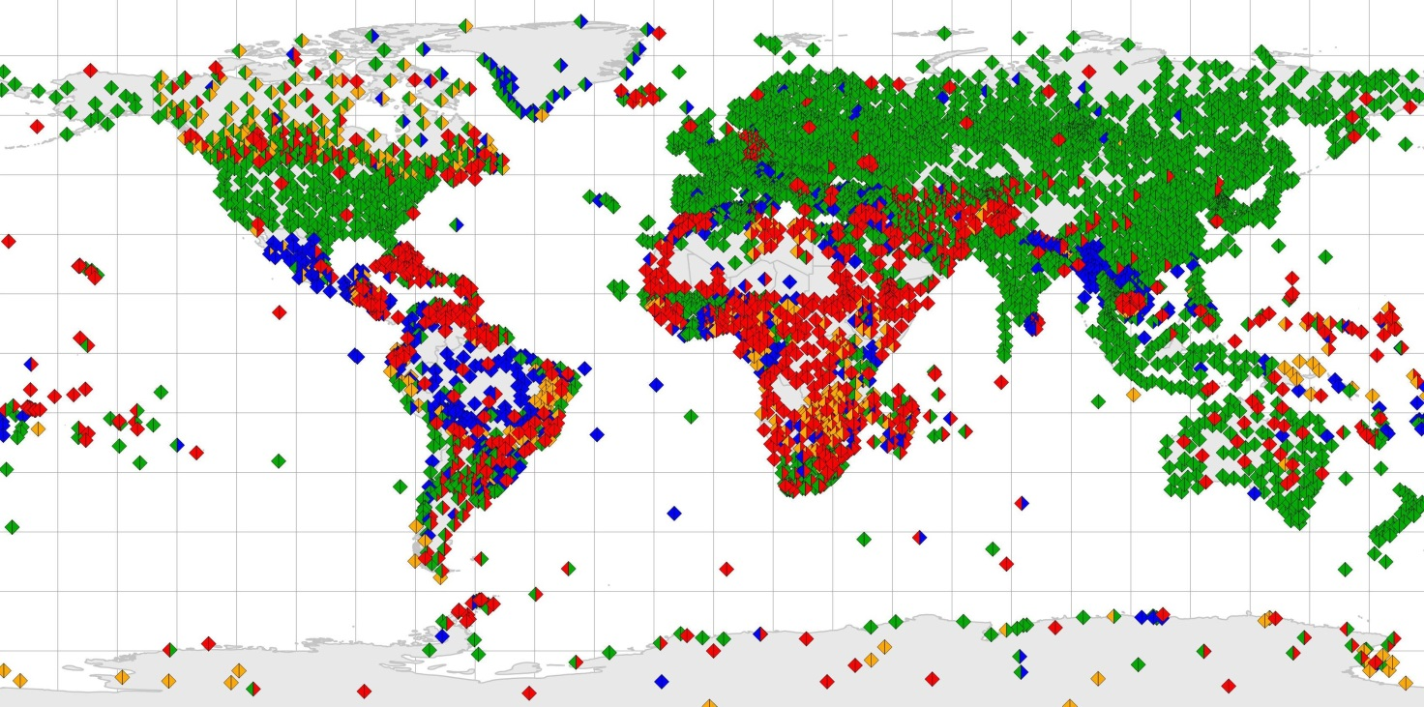

Table 4 - Comparison of percentage of required upper air reports received in TAC (left-pointing arrow) and TDCF (right pointing arrow) in the period 1-15 January 2019. The key is in Table 5
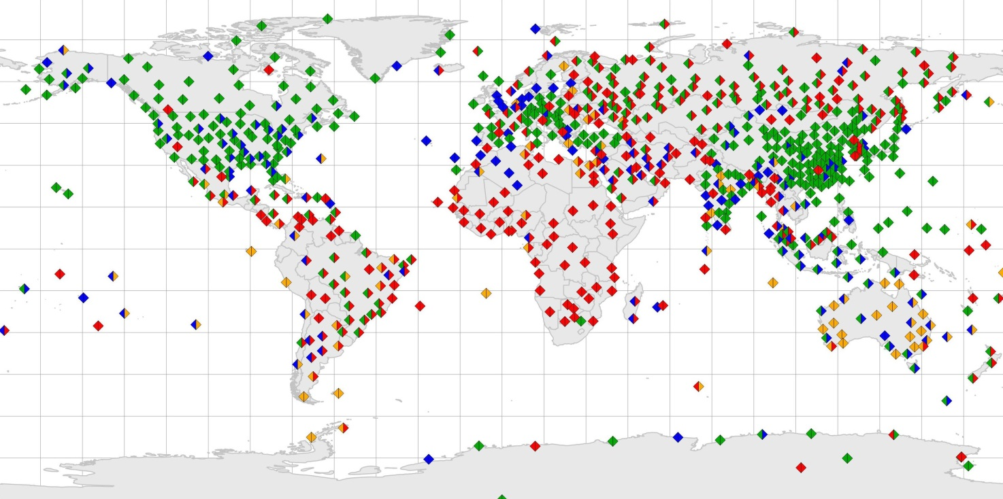

Table 5. Key for Table 3 and 4
