WORLD METEOROLOGICAL ORGANIZATION  COMMISSION FOR BASIC SYSTEMS  -----------------------------  THIRD MEETING OF  INTER-PROGRAMME EXPERT TEAM ON  CODES MAINTENANCE  MARRAKECH, MOROCCO, 15 - 19 APRIL 2019 |  | IPET-CM-III / Doc. 2.7(1)  10.04.2019  -------------------------  ITEM 2.7  ENGLISH ONLY

MANUAL ON CODES: TABLE-DRIVEN CODE FORMS
FM 94 BUFR/FM 95 CREX

Exploring GRIB3 as a Universal Data Representation Binary Code Form
Submitted by Yves Pelletier (Canada), Tom Kralidis (Canada), Markus Heene (Germany)

_______________________________________________________________________

Summary and Purpose of Document

The purpose of this document is to provide an example of data traditionally provided in BUFR using GRIB Edition 3. More examples may be added over time. The document presents an opportunity to discuss whether GRIB3 could provide the ISO compliant binary universal data representation framework that is currently offered separately by the BUFR code form.

_______________________________________________________________________

ACTION PROPOSED

The Team is requested to review the proposal and provide feedback and comments in support of the evolution of WMO formats.

ANNEXES:
1. (Title of annex)

DISCUSSIONS

Overview
Over time, WMO has defined (and NMHSs have provisioned) binary data formats in support of efficient meteorological data exchange. BUFR (Binary Universal Form for the Representation of meteorological data) has primarily been used for in situ and satellite observations. GRIB (General Regularly-distributed Information in Binary form) has typically been implemented for NWP model output. ASCII based formats such as CREX (Character form for the Representation and EXchange of data). These formats have been driven by requirements for terse and compact data representation driven by codes, tables, sequences and templates governed by the official WMO manuals.

In recent years, a number of factors have influenced the revolution of data exchange. The Internet, increased connectivity as well as the rise of computing power in general have provided the capability for self-describing data representation. Standards development organizations such as ISO, OGC and W3C, in addition to the WMO itself as a long-standing standards organization, have provided foundational standards on data formats and interfaces which various information communities can profile, extend, and/or restrict. Noting this development, the WMO is modernizing information exchange of weather, climate, and water data, with interoperability being an important goal. Examples include (but are not limited to), WIGOS Metadata, the WMO Information System (WIS), as well as the WMO Codes Registry.

GRIB Edition 3 (Geospatial Representation In Binary) provides the capability to represent more than NWP output, aligning with the models put forth in OGC Observations and Measurements (ISO 19156). This in turn allows us to consider the feasibility of representing data, traditionally assigned to BUFR, as a profile of GRIB3.

Scope
The example used below is intended as a demonstration and a model for technical investigation. This is not a proposal to migrate current BUFR TEMP to GRIB3.

BUFR profile of GRIB 3 Implementation

Canonical Example
Let’s use the common example of a moving instrument package (various measurements) on a 3D trajectory (say, a weather balloon). Here, the data describes:

- Exact location and time of ongoing measurements, at possibly irregular time intervals
- Instrument metadata
- Time and location of launch

Given the GRIB 3 section layout and ISO 19156, possible approaches are articulated below. Note that the example below does not constitute an official approach

Option 1: Repetition of Sections 3 - 10
Here, foreach measurement:

- Section 3 would define temporal instant
- Section 4 would define spatial property
- Section 5 would define overall vertical property
- Section 6 would provide the procedure (station/platform)
- Section 7 would define what is measured (i.e. weather elements)
- Section 8 would define the format of Section 10
- Section 10 would provide the measurement
  - i.e. value

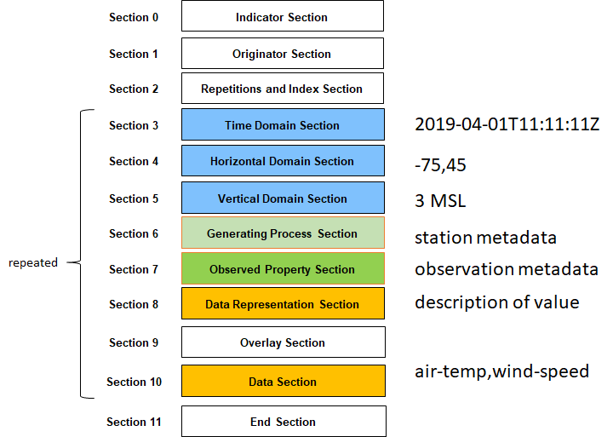

Option 2: Deep Repetition of Sections 3 - 10
In this approach, we expand repetition to the variable level and implement repeated data by reference/offset to a given section that is already defined:

Here, foreach measurement element:

- Section 3 would define temporal instant
- Section 4 would define spatial property
- Section 5 would define vertical property
- Section 6 would provide the procedure (station/platform) once in the first repetition, then refer to it by offset in subsequent repetitions
- Section 7 would define what is measured (i.e. weather elements) once in the first repetition, then refer to it by offset in subsequent repetitions
- Section 8 would define the format of Section 10 once in the first repetition, then refer to it by offset in subsequent repetitions
- Section 10 would provide the measurement
  - i.e. value

Option 3: No Repetition of Sections 3 - 10

In this approach, we refactor sections 3 - 8 as aggregated values and expand Section 10 to provide data using increased density:

- Section 3 would define overall temporal extent (min/max)
- Section 4 would define overall spatial extent (min/max)
- Section 5 would define overall vertical extent (min/max)
- Section 6 would provide the procedure (station/platform)
- Section 7 would define what is measured (i.e. weather elements)
- Section 8 would define the format of Section 10
  - i.e. t,x,y,z,value
- Section 10 would provide a data block/dump of the data per Section 8

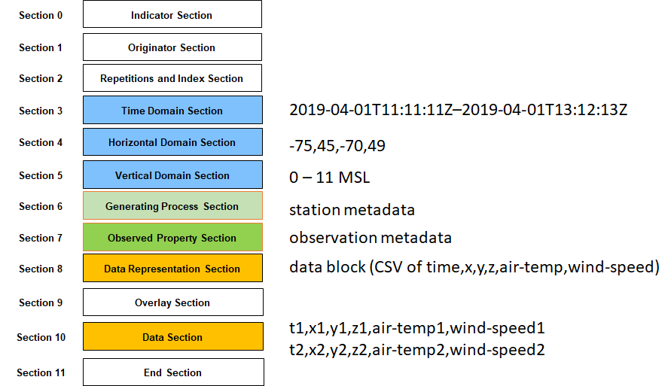

A similar XML implementation can be found at http://schemas.opengis.net/om/2.0/examples/weatherObservation.xml. Here we see the associated data representation as an external reference to http://schemas.opengis.net/om/2.0/examples/swe_weatherRecord1_t.xml. This approach is similar to the BUFR design pattern of external tables referenced by codes, using modernized data description approaches (XML). The same can be accomplished with JSON Schema.

Though the example and options above are not exhaustive (others may exist), options 2 and 3 provide the opportunity for less redundancy.

Value Proposition
Profiling BUFR within the framework of GRIB 3 with the WMO Codes Registry provides the following advantages:
- A unified WMO core format/container on which to build/profile/extend/restrict
- Reduced maintenance of software to read and / or write GRIB 3 primitives
- Reduced maintenance and simplification of codes which are now managed as web accessible resources, allowing for distributed processing (or downloading a version of same for performance)
- Alignment and reuse of GRIB Edition 3 as the container mechanism, providing the ability for streamlined

Change Management
If the proposed approach is deemed promising, further investigation and development will be necessary, but it should be noted that by using the existing GRIB3 container, the required development can focus on data representation and much less on the nuts and bolts of the container.

A potential change management strategy involves keeping BUFR Edition 4 as the long term release for stability while organizations gradually implement universal data representation in GRIB3 as a replacement for BUFR Edition 4.

Risks
The main risks associated with the abovementioned proposal are as follows:
- Backward incompatibility: documentation, working software and migration tools are critical to ensuring a BUFR profile of GRIB 3
- File size: the size of data / files need to be considered, tested and evaluated for impacts on infrastructure

It should be noted that developing BUFR Edition 5 as a completely separate code form is not itself risk-free, and particularly that backward compatibility of Table D would not in our opinion be possible if ISO compliance and machine-readability are to be implemented. We are therefore presented with an opportunity for a fresh start, and this document explores a path in that direction.

Future Work
Concrete examples (data file samples, parsers, serializers) are required to further assess ease of use, integration with industry tools, size as well as comparing various aspects (operational, transport). The Meteorological Service of Canada is working on proof of concept tooling that should be made available on GitHub in the coming weeks at https://github.com/wmo-cop/bufr5

References
BUFR in a Nutshell: https://confluence.ecmwf.int/download/.../eccodes_bufr_in_a_nutshell.pdf?.
GRIB Edition 3 https://www.wmo.int/pages/prog/www/ISS/Meetings/IPET-DRMM_Geneva2016/Documents/IPET-DRMM-IV_Doc2-3-1_GRIB3.pptx
WMO Codes Registry: http://codes.wmo.int/ui/about
OGC Observations and Measurements: https://www.opengeospatial.org/standards/om
OGC Observations and Measurements Examples: http://schemas.opengis.net/om/2.0/

PROPOSAL

We propose to continue and expand the experimental use of GRIB3 as a universal binary data format to determine its fitness as an operational replacement for BUFR. This should be reported upon at IPET-CM IV for further consideration.

