WORLD METEOROLOGICAL ORGANIZATION  COMMISSION FOR BASIC SYSTEMS  -----------------------------  FIRST MEETING OF  INTER-PROGRAMME EXPERT TEAM ON  CODES MAINTENANCE  GENEVA, SWITZERLAND, 24 - 28 JULY 2017 |  | IPET-CM-I / Doc. 8.2 (3)  (21. 7. 2017)  -------------------------  ITEM 8.2  ENGLISH ONLY

Status of Migration
Region III
Submitted by Sergio Henrique S. Ferreira and Jose Mauro de Rezende - Brazil

_______________________________________________________________________

Summary and Purpose of Document

The document summarizes the findings of the RA-III (South America) towards the Migration to Table Driven Code
_______________________________________________________________________

ACTION PROPOSED

The meeting is requested to take notes.

Summary

The summary below contains information provided by experts and focal points in RA III following an email request to most of them as well as monitoring and verification of BUFR bulletins on GTS

Significant progress has been made by major national centres in Region III on the replacement of the Traditional Alphanumeric Codes into the Table Driven Code Form. The majority of the countries in Region III had an opportunity to attend a BUFR workshop in Montevideo and since than they are working on their implementation. Chile did it quite fast and Colombia has just finished their process.

The table attached is a summary of BUFR bulletin monitoring during 24 hours (only in the 16th July 2017 and CLIMAT on 4th July 2017). Observed that many countries are operationally providing data in BUFR. However the migration is not yet complete and some details in the given data need to be adjusted for correct coding and transmission.

The National Centre in Chile codes only BUFR bulletins to report surface observations. They are also reporting Upper air data from aircraft, coded as the ARINC centre.

GISC Brasilia was already generating BUFR bulletins for upper-air sounding, CLIMAT, TEMP, PILOT, SYNOP from automatic and manned weather stations as well as provides the same information in TAC bulletins. Recently the conversions from TEMP/PILOT into BUFR was stop in view of getting the BUFR report directly from the Air Force upper air network. The Air Force agree with this propose, but a technical solution to implement it was not found yet.

DCPC Argentina generates BUFR bulletins for upper-air sounding (TEMP, PILOT), CLIMAT and SYNOP from automatic and manned weather stations as well as provides the same information in TAC bulletins. Aircraft data are also being provided by Argentina in BUFR.

Chile do not report TAC bulletins any more. They are reporting BUFR bulletins from surface weather station with originating centre 45 (Santiago - Chile) and from aircraft data with generate centre 56 (ARINC Centre).

Colombia (Bogota) is already generate BUFR bulletin from surface weather station, using the originating center code 54, and inserting them into the GTS through Brasilia. Peru, Ecuador and Venezuela are also start to generates BUFR bulletin. Peru is very advanced in this task.

Satellite data has been generated by Brazil and Argentina. In the case of Brazil, the satellite data are generated by the Brazilian Space Agency (INPE / CPTEC) (originating centre 45) and ingested at the GTS in Brasilia. In Argentina, satellite data are generated by the National Commission for Space Activities (CONAE) (originating centre 147)

The National Centre in Venezuela informed some progress in the creation of BUFR bulletins but they are not producing at the operational level yet.

GISC Brasilia and DCPC Buenos Aires still converting TAC bulletins into TDCF for those centres which are not able yet to complete their migration work.

Other migration aspect is the use of BUFR bulletin in region III. At moment the information is that only INPE/CPTEC and very recently the Navy centre besides INMET/Brasilia are capable to use BUFR data internally for generates products or assimilate in modeling.

A training in the use of BUFR for two persons from Paraguay will be providing by Jose Mauro from INMET/Brasilia. Same thing regarding with Uruguay, Bolivia, Suriname and Guyana

Verifications were made by INMET / Brasilia and INPE / CPTEC on the BUFR data provided in region III. Some issues have been identified, such as the correct use of the originating centre code. José Mauro (Brasilia) is in contact with the respective centres to assist in solving these issues.

Tables 1 - Monitoring resume of BUFR bulletins available in region III by Abbreviation Heading, Generator Centre and BUFR Category
 | T1T2 | BUFR Generate Centre | Category - Description
SABM – Buenos Aires - Argentina | ISII | 41 – Buenos Aires (RSMC) | 0 - surface
 | ISC/ |  | 0- Surface (CLIMAT)
 | IUKI, IUJI |  | 2 - Radiosonde
 | IUAG |  | 4 - Aircraft
SBBR Brasilia – Brazil | ISAI  ISII  ISME | 43 – Brasilia(RSMC/RAFC) | 0 – Surface Land
 | ISC/ |  | 0 – Surface Land (CLIMAT)
 | IUKI, IUSI,  IUSE,IUSX,  IUWA,IUWE,IUWI,IUWX,  IUJE |  | 2 – Radiosonde
SEQU – Quito - Ecuador | ISME | 43- Brasilia (RSMC/RAFC) | 0 - Surface
SKBO – Bogota (Colombia) | ISME | 43 - Brasilia (RSMC/RAFC) | 0 - Surfece
 | ISII01 | 54 - Montreal (RSMC) | 0 - Surfece
SCSC - Santiago - Chile | ISAI | 45 - Santiago - Chile | 0 - Surfece
 | IUAI | 56 - ARINC Centre | 4 - Aircraft
SOCA - Cayenne/Rochambeau (Cayenne)- French Guiana | IUKE | 85 - Toulouse (RSMC) | 2 – Radiosonde
SPIM – Lima (Peru) | ISMI | 49 – Peru (NMC) | 0 -Surface (*)
(*) Bulletin previously reported but not reported as of the date of this verification.

Satellite information
 |  | BUFR Generate Centre | Type
SABM – Buenos Aires - Argentina | INAI | 147 - National Commission on Space Activities (CONAE) | 3 – Vertical Profile
SBBR Brasilia – Brazil | INAX | 46 - Brazilian Space Agency (INPE/CPTEC) | 3 – Vertical Profile
 | INCS |  | 21 – Radiance

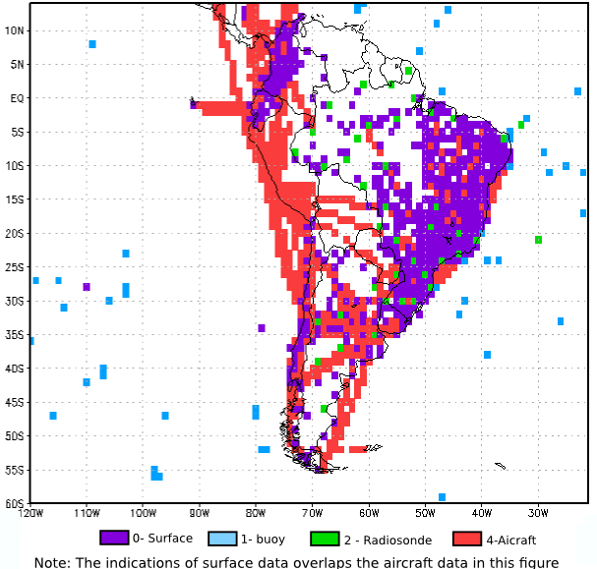

Figure 1:BUFR data in region III on 2017-07-16. Presence of BUFR data in the grid of 1 x 1 degrees (Except moored buoys and satellite data)

