WORLD METEOROLOGICAL ORGANIZATION  COMMISSION FOR BASIC SYSTEMS  -----------------------------  FIRST MEETING OF  INTER-PROGRAMME EXPERT TEAM ON  CODES MAINTENANCE  GENEVA, SWITZERLAND, 24 - 28 JULY 2017 |  | IPET-CM-I / Doc. 3.1 (1)  (12. 07. 2017)  -------------------------  ITEM 3.1  ENGLISH ONLY

Amendments to B/C Regulations
Regulations for radiosonde descent data.
Submitted by Tanja Kleinert (EUMETNET), Alexander Cress, Sibylle Krebber (DWD)

_______________________________________________________________________

Summary and Purpose of Document

This document proposes to add the new BUFR sequence 3 09 056 for radiosonde descent data reporting as Annex III to B/C25.

_______________________________________________________________________

ACTION PROPOSED

The meeting is requested to review and approve the contents for inclusion to the WMO Manual on Codes, Volume I.2 - Part C.

DISCUSSION

Several members currently are changing over to the new radiosonde Vaisala RS41 and sounding system MW41. RS41/MW41 offers the functionality to provide radiosonde descent data. A few members (e.g. DWD and FMI) started to exchange these descent data from their radiosonde stations internationally. The data are very interesting for users because the data provide additional information of the atmosphere without large financial impact for data providers and data users.

DWD and FMI started to report these radiosonde descent data by using BUFR template B/C26 – ‘Regulations for reporting TEMP DROP data in TDCF’ (BUFR309053). NWP users evaluated the radiosonde descent data from DWD and FMI, which lead to positive results, briefly described below. According to first feedback received from NWP users, the template B/C26 seems to be unsuitable for radiosonde descent data reporting because users would like to know at which radiosonde station the sounding was launched. Furthermore, it is essential to know whether the sounding equipment carried a parachute because the drop speed might have a significant impact on the quality of the data. Within an NWP system data users will want to treat ascent and descent data separately for duplicate checking, monitoring and blacklisting. Hence, it is proposed to add the new sequence <3 09 056> proposed in Doc 2.4(x) as Annex III to B/C25.

DWD evaluated radiosonde descent data of four German stations within the period 01.05.2017 – 20.05.2017 by comparing radiosonde data of descents (4 stations) and ascents (all German stations) with 3-h global model forecasts. DWD reported about the following results:

- Wind speed and relative humidity bias similar between ascending and descending data
- RMS of ascending and descending data very similar
- Larger temperature bias of descending data in stratosphere
- Resume so far: Radiosonde descending data are useful for data assimilation
- More information in BUFR format (parachute yes/no etc.) would be useful

The red curves in the plots below show the average over all data per pressure interval available in high resolution (e.g. 925 hPa to 850 hPa). The blue curves show the average over all active data per pressure interval used in first guess check (only mandatory levels).

Results regarding temperature
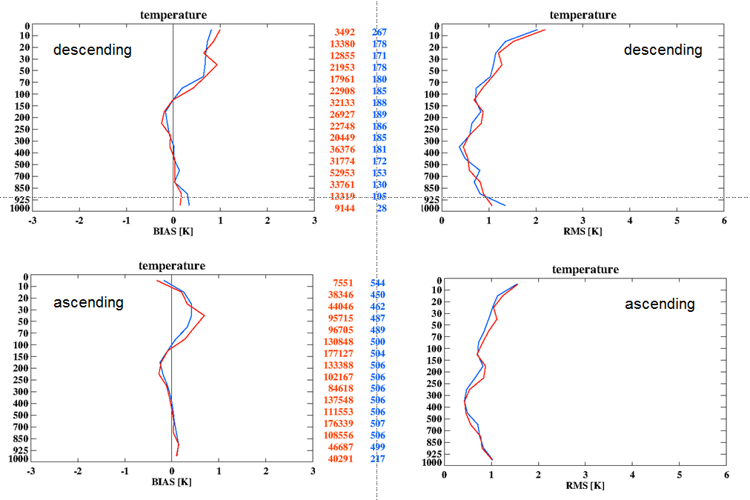

Results regarding wind speed
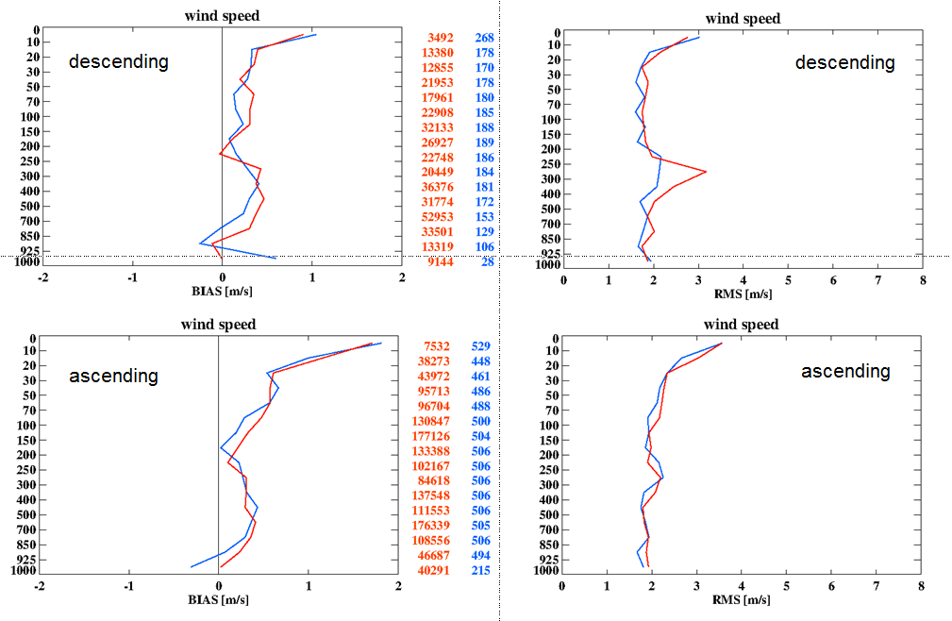

Results regarding relative humidity
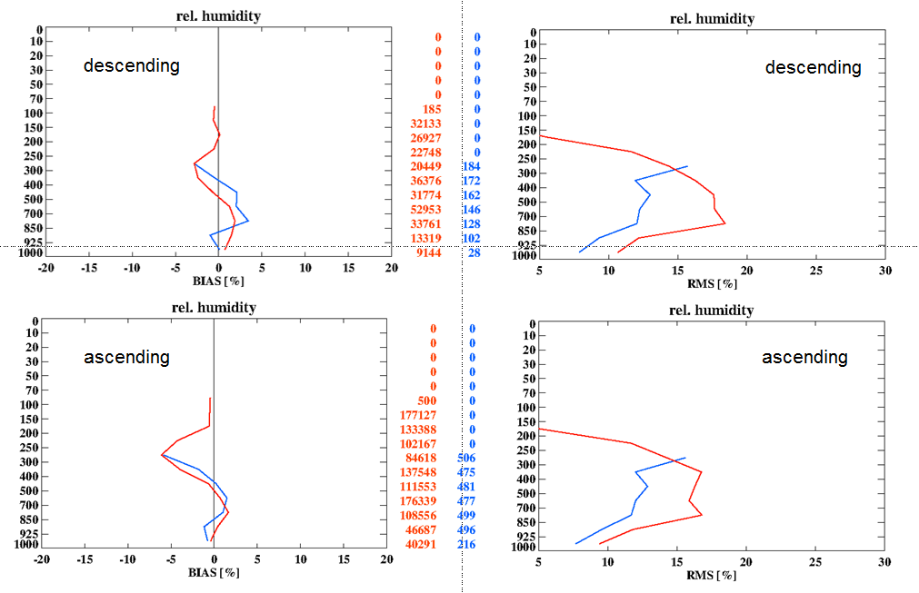

PROPOSAL

- Add new notes under B/C 25 Regulations:

(6) If the radiosonde and sounding system are capable to report data during the descent of the radiosonde, sequence <3 09 056> shall be used for reporting radiosonde descent data as outlined in Annex III.

- Add new Annex III to B/C 25 Regulation:

ANNEX III TO B/C25 – Regulations

TM 309056 – BUFR template for P, T, U and wind vertical profiles suitable for radiosonde descent data

 |  | (Sequence for representation of radiosonde descent data)
3 09 056 | 3 01 150 | WIGOS identifier
 | 0 02 011 | Radiosonde type
 | 0 02 013 | Solar and infrared radiation correction
 | 0 02 014 | Tracking technique/status of system used
 | 0 02 003 | Type of measuring equipment used
 | 3 01 128 | Additional information on radiosonde ascent | Valid also for radiosonde decent
 | 3 01 113 | Date/time of launch | Or drop respectively
 | 0 08 091 | Coordinates significance | = 2 Start of observation
 | 3 01 021 | Latitude/longitude (high accuracy)
 | 0 07 007 | Height | Begin of descending of radiosonde above mean sea level
 | 0 08 091 | Coordinates significance | Set to missing (cancel)
 | 1 01 000 | Delayed replication of 1 descriptor
 | 0 31 002 | Extended delayed descriptor replication factor
 | 3 03 054 | Temperature, dewpoint and wind data at a pressure level with radiosonde position
 | 1 01 000 | Delayed replication of 1 descriptor
 | 0 31 001 | Delayed descriptor replication factor
 | 3 03 051 | Wind shear data at a pressure level with radiosonde position

This BUFR template for P, T, U and wind profiles further expands as follows:
 |  | Identification of drop site and instrumentation
 |  | WIGOS identifier
3 01 150 | 0 01 125 | WIGOS identifier series | Numeric, 0
 | 0 01 126 | WIGOS issuer of identifier | Numeric, 0
 | 0 01 127 | WIGOS issue number | Numeric, 0
 | 0 01 128 | WIGOS local identifier (character) | CCITT IA5
0 02 011 |  | Radiosonde type | Code table
0 02 013 |  | Solar and infrared radiation correction | Code table
0 02 014 |  | Tracking technique/status of system used | Code table
0 02 003 |  | Type of measuring equipment used | Code table
 |  | Additional information on radiosonde ascent
3 01 128 | 0 01 081 | Radiosonde serial number | CCITT IA5
 | 0 01 082 | Radiosonde ascension number | Numeric, 0
 | 0 01 083 | Radiosonde release number | Numeric, 0
 | 0 01 095 | Observer identification | CCITT IA5
 | 0 02 015 | Radiosonde completeness | Code table
 | 0 02 016 | Radiosonde configuration (3 = Parachute) | Flag table
 | 0 02 017 | Correction algorithms for humidity measurements | Code table
 | 0 02 066 | Radiosonde ground receiving system | Code table
 | 0 02 067 | Radiosonde operating frequency | Hz, scale -5
 | 0 02 080 | Balloon manufacturer | Code table
 | 0 02 081 | Type of balloon | Code table
 | 0 02 082 | Weight of balloon | kg, scale 3
 | 0 02 083 | Type of balloon shelter | Code table
 | 0 02 084 | Type of gas used in balloon | Code table
 | 0 02 085 | Amount of gas used in balloon | kg, scale 3
 | 0 02 086 | Balloon flight train length | m, scale 1
 | 0 02 095 | Type of pressure sensor | Code table
 | 0 02 096 | Type of temperature sensor | Code table
 | 0 02 097 | Type of humidity sensor | Code table
 | 0 02 103 | Radome | Flag table
 | 0 02 191 | Geopotential height calculation | Code table
 | 0 25 061 | Software identification and version number | CCITT IA5
 | 0 35 035 | Reason for termination | Code table
 |  | Date/time of drop
3 01 113 | 0 08 021 | Time significance (= 18 Launch time) | Code table
 | 3 01 011 | Year | Year
 |  | Month | Month
 |  | Day | Day
 | 3 01 013 | Hour | Hour
 |  | Minute | Minute
 |  | Second | Second
 |  | Horizontal and vertical coordinates of drop site
0 08 091 |  | Coordinates significance (= 2 Start of observation) | Code table
 |  | Latitude/longitude (high accuracy)
3 01 021 | 0 05 001 | Latitude (high accuracy) | Degree, scale 5
 | 0 06 001 | Longitude (high accuracy) | Degree, scale 5
0 07 007 |  | Height
0 08 091 |  | Coordinates significance (Set to missing (cancel))
 |  | Temperature, dewpoint and wind data at pressure levels
1 01 000 |  | Delayed replication of 1 descriptor
0 31 002 |  | Extended delayed descriptor replication factor | Numeric
 |  | Temperature, dewpoint and wind data at a pressure level with radiosonde position
3 03 054 | 0 04 086 | Long time period or displacement (since launch time) | Second
 | 0 08 042 | Extended vertical sounding significance | Flag table
 | 0 07 004 | Pressure | Pa, scale –1
 | 0 10 009 | Geopotential height | gpm
 | 0 05 015 | Latitude displacement since launch site (high accuracy) | Degree, scale 5
 | 0 06 015 | Longitude displacement since launch site (high accuracy) | Degree, scale 5
 | 0 12 101 | Temperature/air temperature | K, scale 2
 | 0 12 103 | Dewpoint temperature | K, scale 2
 | 0 11 001 | Wind direction | Degree true
 | 0 11 002 | Wind speed | m s^{–1}, scale 1
 |  | Wind shear data
1 01 000 |  | Delayed replication of 1 descriptor
0 31 001 |  | Delayed descriptor replication factor | Numeric
 |  | Wind shear data at a pressure level
3 03 051 | 0 04 086 | Long time period or displacement (since launch time) | Second
 | 0 08 042 | Extended vertical sounding significance | Flag table
 | 0 07 004 | Pressure | Pa, scale –1
 | 0 05 015 | Latitude displacement since launch site (high accuracy) | Degree, scale 5
 | 0 06 015 | Longitude displacement since launch site (high accuracy) | Degree, scale 5
 | 0 11 061 | Absolute wind shear in 1 km layer below | m s^{–1}, scale 1
 | 0 11 062 | Absolute wind shear in 1 km layer above | m s^{–1}, scale 1

Regulations:
- Regulations B/C25.1 shall apply with following ammendments:
  - Bufr edition 4 is required
  - The international data sub-category shall be included at all observation times as follows:
= 014 for radiosonde descent data,
= 015 for radiosonde descent data from ships,
= 016 for radiosonde descent data from mobil stations.
- Regulations B/C25.3 shall apply
- Regulations B/C25.7 to B/C25.9, inclusive, shall apply.

Notes:
- If a parachute is used, the descriptor <0 02 016> ‘Radiosonde configuration’ in sequence <3 01 128> shall be encoded with bit no. 3 set to 1.

