WORLD METEOROLOGICAL ORGANIZATION  COMMISSION FOR BASIC SYSTEMS  -----------------------------  FIRST MEETING OF  INTER-PROGRAMME EXPERT TEAM ON  CODES MAINTENANCE  GENEVA, SWITZERLAND, 24 - 28 JULY 2017 |  | IPET-CM-I / Doc. 2.4 (2)  (12. 07. 2017)  -------------------------  ITEM 2.4  ENGLISH ONLY

Additions to BUFR tables
New BUFR entries for radiosonde descent data
Submitted by Tanja Kleinert (EUMETNET), Alexander Cress, Sibylle Krebber (DWD)

_______________________________________________________________________

Summary and Purpose of Document

This document proposes a new BUFR sequence and additional entries for data category 2 in Common code Table C-13 for radiosonde descent data.
_______________________________________________________________________

ACTION PROPOSED

The meeting is requested to review and approve the contents for inclusion within the November 2017 fast-track (FT2017-2) update to the WMO Manual on Codes.

DISCUSSION

Several members currently are changing over to the new radiosonde Vaisala RS41 and sounding system MW41. RS41/MW41 offers the functionality to provide radiosonde descent data. A few members (e.g. DWD and FMI) started to exchange these descent data from their radiosonde stations internationally. The data are very interesting for users because the data provide additional information of the atmosphere without large financial impact for data providers and data users.

DWD and FMI started to report these radiosonde descent data by using BUFR template B/C26 – ‘Regulations for reporting TEMP DROP data in TDCF’ (BUFR309053). NWP users evaluated the radiosonde descent data from DWD and FMI, which lead to positive results, briefly described below. According to first feedback received from NWP users, the template B/C26 seems to be unsuitable for radiosonde descent data reporting because users would like to know at which radiosonde station the sounding was launched. Furthermore, it is essential to know whether the sounding equipment carried a parachute because the drop speed might have a significant impact on the quality of the data. Within an NWP system data users will want to treat ascent and descent data separately for duplicate checking, monitoring and blacklisting. Hence, it is proposed to add a new sequence <3 09 056> to BUFR Table D and new entries in Common Code table C-13.

According to the discussions among radiosonde data users about the recently introduced radiosonde descent data provided by DWD and FMI it seems there is a need both to separate ascent and descent data and to have a firm link between them. If simply the same WIGOS identifier is used for reporting radiosonde descent data in future users might encounter problems if the position reported at balloon burst is referred to the radiosonde launching station at ground. Hence, it is proposed to link the radiosonde descent data to the launching radiosonde station by using the same local identifier in the WIGOS identifier but to use a separate ‘Issuer of identifier’ than for radiosonde stations.

Consideration:
If possible, WMO Secretariat is asked to provide a suitable ‘Issuer of identifier’ to allocate radiosonde descent data to the launching radiosonde station.

Results of first evaluation of radiosonde descent data:
DWD evaluated radiosonde descent data of four German stations within the period 01.05.2017 – 20.05.2017 by comparing radiosonde data of descents (4 stations) and ascents (all German stations) with 3-h global model forecasts. DWD reported about the following results:

- Wind speed and relative humidity bias similar between ascending and descending data
- RMS of ascending and descending data very similar
- Larger temperature bias of descending data in stratosphere
- Resume so far: Radiosonde descending data are useful for data assimilation
- More information in BUFR format (parachute yes/no etc.) would be useful

The red curves in the plots below show the average over all data per pressure interval available in high resolution (e.g. 925 hPa to 850 hPa). The blue curves show the average over all active data per pressure interval used in first guess check (only mandatory levels).

Results regarding temperature
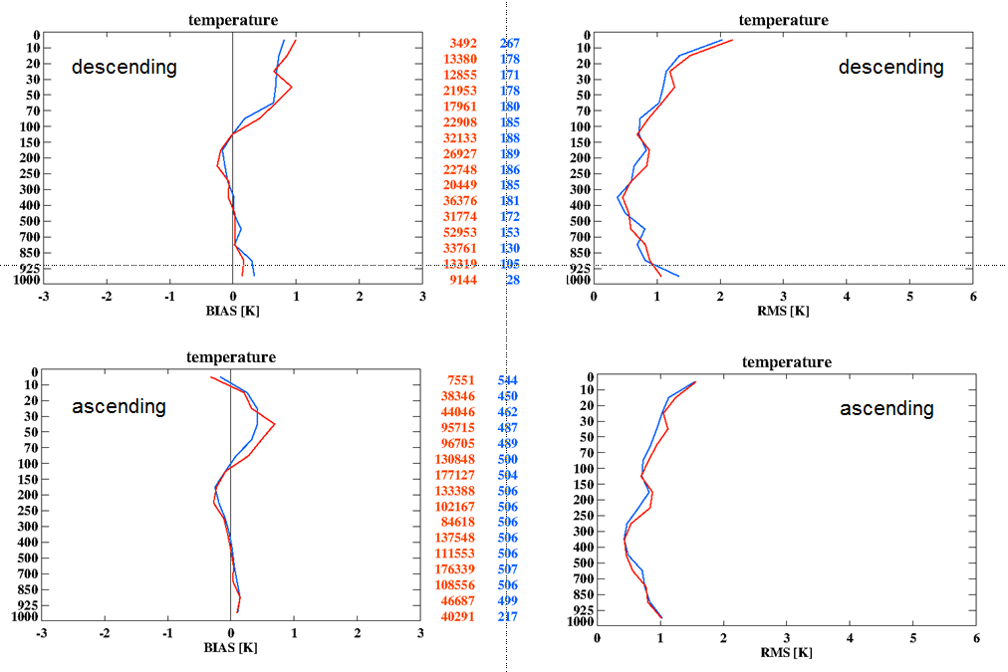

Results regarding wind speed
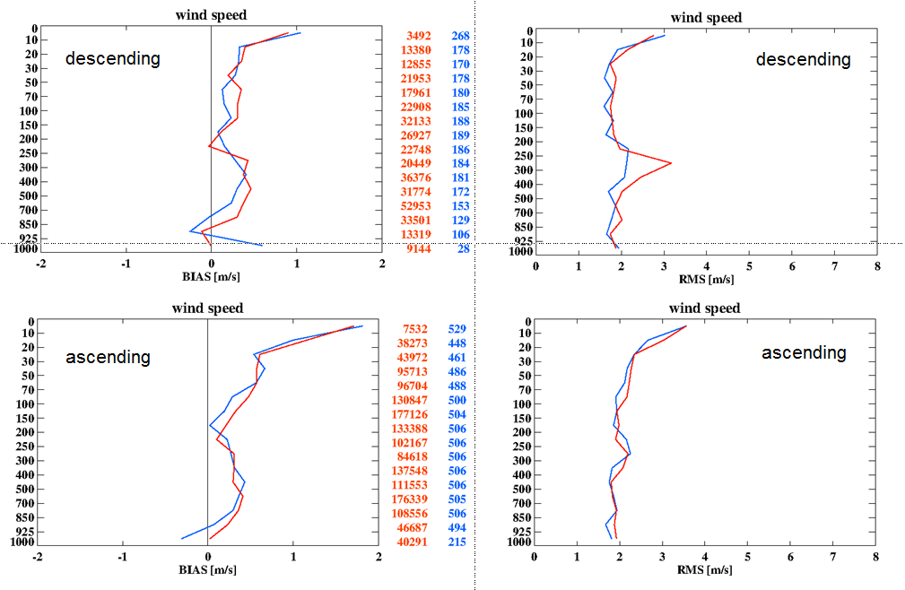

Results regarding relative humidity
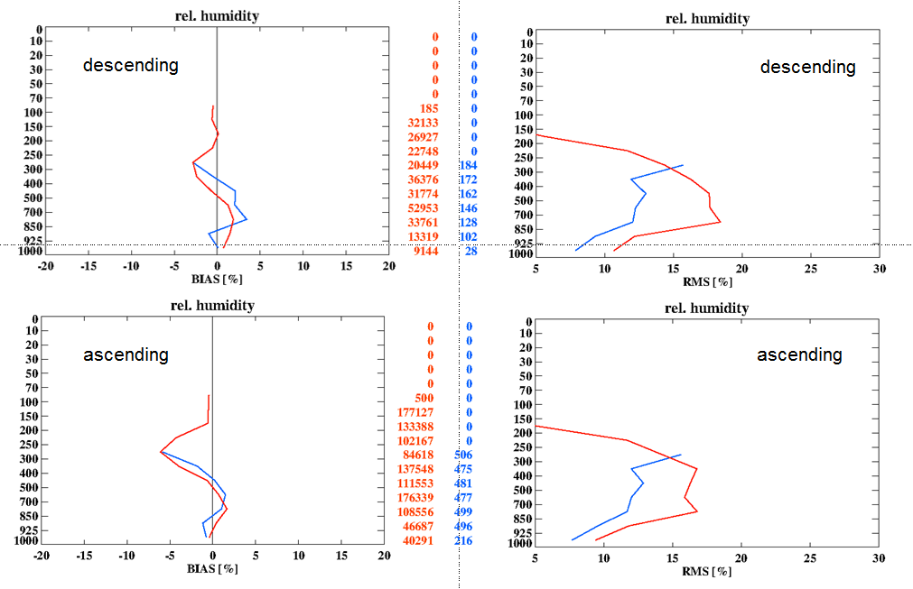

PROPOSAL

- Add new entry to BUFR Table D:

 |  | (Sequence for representation of radiosonde descent data)
3 09 056 | 3 01 150 | WIGOS identifier
 | 0 02 011 | Radiosonde type
 | 0 02 013 | Solar and infrared radiation correction
 | 0 02 014 | Tracking technique/status of system used
 | 0 02 003 | Type of measuring equipment used
 | 3 01 128 | Additional information on radiosonde ascent | Valid also for decent
 | 3 01 113 | Date/time of launch
 | 0 08 091 | Coordinates significance | = 2 Start of observation
 | 3 01 021 | Latitude/longitude (high accuracy)
 | 0 07 007 | Height | Begin of descending of radiosonde above mean sea level
 | 0 08 091 | Coordinates significance | Set to missing (cancel)
 | 1 01 000 | Delayed replication of 1 descriptor
 | 0 31 002 | Extended delayed descriptor replication factor
 | 3 03 054 | Temperature, dewpoint and wind data at a pressure level with radiosonde position
 | 1 01 000 | Delayed replication of 1 descriptor
 | 0 31 001 | Delayed descriptor replication factor
 | 3 03 051 | Wind shear data at a pressure level with radiosonde position

- Add new entries in Common code table C-13

COMMON CODE TABLE C–13: Data sub-categories of categories defined by entries in BUFR Table A
DATA CATEGORIES INTERNATIONAL DATA SUB-CATEGORIES
BUFR Edition 4, Octet 11 in Section 1 BUFR Edition 4, Octet 12 (if = 255, it means
other sub-category or undefined)
CREX Edition 2, nnn in Group CREX Edition 2, mmm in Group Annnmmm
Annnmmm of Section 1 of Section 1
Code figure Name Code figure Name (corresponding traditional alphanumeric
codes are in brackets)
2 Vertical soundings (other 14 Upper-level temperature/humidity/wind reports from
than satellite) descent radiosondes originally launched from
fixed-land stations
15 Upper-level temperature/humidity/wind reports from
descent radiosondes originally launched from ships
16 Upper-level temperature/humidity/wind reports from
descent radiosondes originally launched from
mobile land stations

