WORLD METEOROLOGICAL ORGANIZATION  _________________________  REGIONAL ASSOCIATION II  IMPLEMENTATION - CO-ORDINATION MEETING ON THE WIS AND GTS IN RA II  KHABAROVSK, 10 –12 SEPTEMBER 2007 |  | RA II/ICM-WIS&GTS Doc. 4.2 (1)  (27.VIII.2007)  ____________  ITEM 4.2  ENGLISH only

Report on WIS VPN Pilot Project in Regions II and V

(Submitted by Atsushi Shimazaki (Japan))

Summary and the Purpose of the Document

This document is to report the status and plans of the WIS VPN Pilot Project in Regions II and V.

Action proposed: The meeting is invited to review this report and to provide comments.

1. BRIEF OVERVIEW
The WIS VPN Pilot Project in Regions II and V (Hereinafter referred to as Project) was launched in 2003 as one of the WIS related projects aiming at developing and evaluating technologies required by the WMO Information System (WIS), in particular, evaluating accessibility and effectiveness of the Internet VPN (Virtual Private Network).

The first phase of the Project, which specifically intends to evaluate the VPN technology itself, was successfully completed in September 2004 and is highly appreciated by WMO because a number of developing countries actively participated in the Project.
The advanced (second) phase of the Project started in August 2005 to evaluate stability and availability of the VPN technology through application level tests assuming operational data exchange within WIS.

In 2006, an experiment for evaluating effectiveness of web ingests for reporting observation data was conducted, and distribution of satellite images and NWP products by FTP and HTTP started as one of the activities in the advanced phase.

2. CURRENT STATUS
2.1 Participants
Sixteen NMHSs are participating in the Project at present. The current participant list is shown in Table 1. The number of participants has been increasing steadily from 11 in the first phase with the support to the Project by WMO.

Table 1. Participants in the advanced phase
Country, terriroty | Organization | Site
Region II
China | China Meteorological Administration | Beijing
Hong Kong, China | Hong Kong Observatory | Hong Kong
India | India Meteorological Department | New Delhi
Isramic Republic of Iran | Isramic Republic of Iran Meteorological Organization | Teheran
Japan | Japan Meteorological Agency | Tokyo
Oman | Meteorological Department | Muscat
Republic of Korea | Korea Meteorological Administration | Seoul
Saudi Arabia | Presidency of Meteorology & Enviroment | Jeddah
Vietnam | National Hydrometeorological Service | Hanoi
Region V
Australia | Bureau of Meteorology | Melbourne
Brunei Darussalam | Brunei Meteorological Service | Bandar Seri Begawan
Fiji | Fiji Meteorological Service | Nadi
Malaysia | Malaysian Meteorological Service Department | Kuala Lumpur
New Caledonia | Meteo-France, New Caledonia | Noumea
New Zealand | MetService | Wellington
Republic of Singapore | National Environment Agency | Singapore

2.2 Status of establishing the VPN links
Almost all participants have permanent connections to the Internet at a speed of over 512kbps as shown in Figure 1.
Hong Kong
India
Iran
Korea
Oman
Saudi Arabia
Vietnam
Australia
Brunei
Malaysia
New Zealand
China
Japan
Singapore
Fiji
Table 2 Result of the Survey
New Caledonia
10Mbps(MAX)
2Mbps
4Mbps
512Kbps
2Mbps
1Mbps
100Mbps(MAX)
3Mbps
2Mbps
2Mbps
1Mbps
100Mbps(MAX)
100Mbps(MAX)
128Kbps
Kbps
256M(MIN)-
440Mbps(MAX)

Internet
Figure 1. Internet connectivity for the WIS VPN Pilot Project
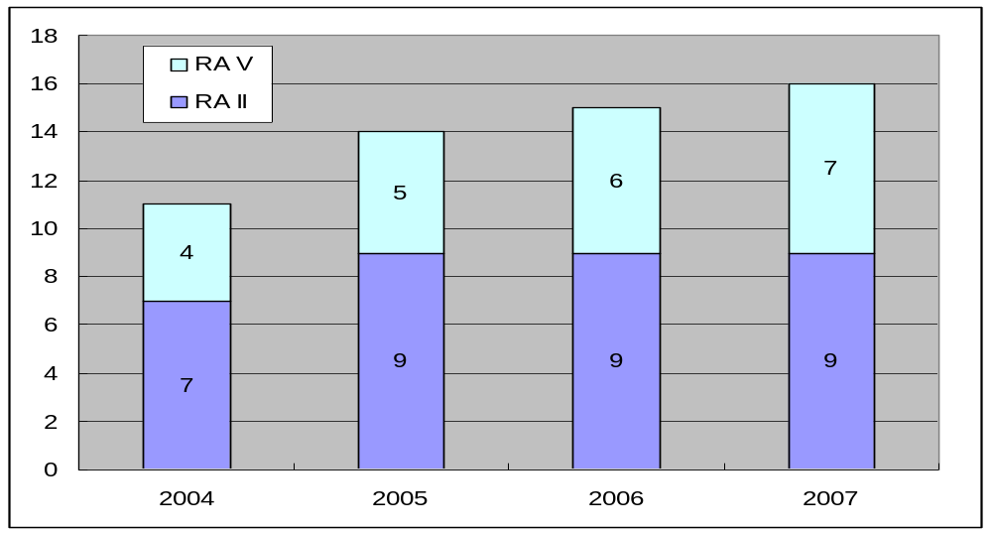
Figure 2. Increase of participants

2.3 Project website
The project website established in July 2005 to share information among participants has gradually improved in its contents. Especially the discussion room on the website has played an important role in promoting exchange of opinions and mutual understanding. The website basically allows the participants and authorized users to access through the VPN (IPsec, PPTP and SSL).

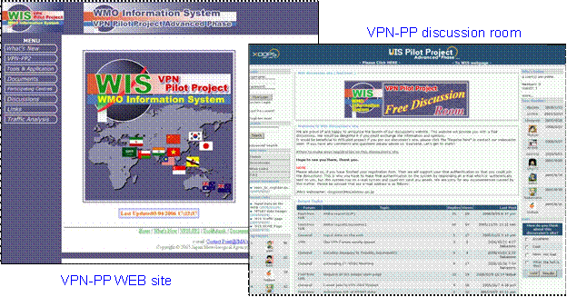

Figure 3 Top page of the project website and its discussion room

Some tools to observe the Internet access conditions are available in the project website. Each participant can analyze its own Internet conditions such as traffic throughput, round trip time and statistics. The information is useful for each participant to evaluate its Internet environment.

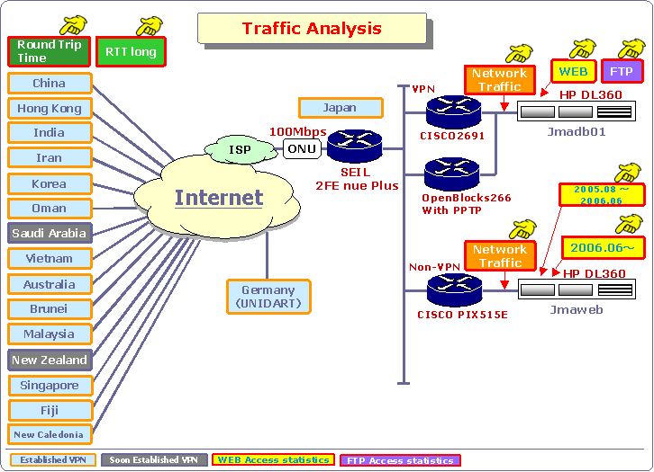

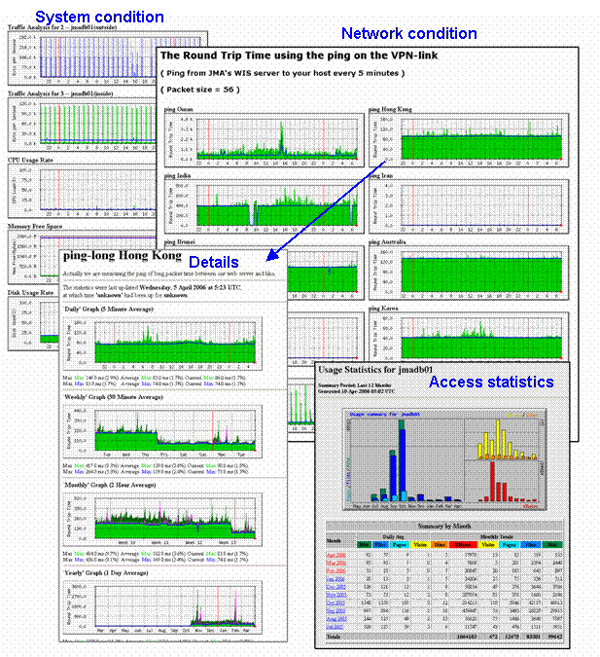
Figure 4 Instruction and monitoring views by a traffic analysis tool
3. EVALUATION IN THE FIRST PHASE AND PROGRESS IN THE ADVANCED PHASE
3.1 Evaluation in the First Phase
Evaluation tests have been continued for practical studies on optimized VPN installation and troubleshooting of implementation problems. Latest examples are shown below.

(1) Evaluation of implementation of a VPN link with PPTP.
PPTP (Point-to-Point Tunneling Protocol) is a simplified VPN technique available for mobile and PC users without any VPN products. JMA established a PPTP server and tested VPN with PPTP in cooperation with some participants. It was confirmed that authorized Windows-PC users could access easily to JMA servers through the PPTP server shown in Figure 5.

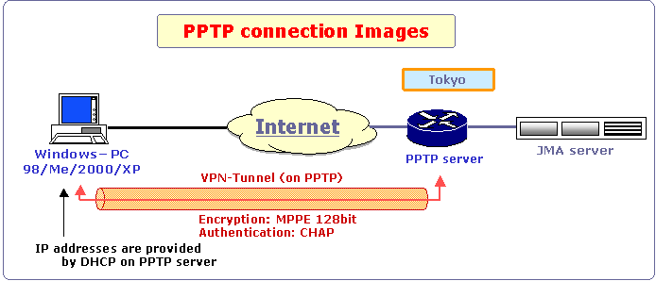

Figure 5 Evaluation test for VPN with PPTP

(2) Troubleshooting on MTU size problem
Unexpected browsing errors were observed in case of web access to a large size page through IPsec tunnel. As the result of investigation and evaluating test for troubleshooting by the Hong Kong Observatory and JMA, it was found that the packet loss could be caused by a default MTU (Maximum Transmission Unit) size of 1500 octets on Ethernet interface at the server side. Reducing the MTU size to 1350 octets solved the problem.
MTU sizing affects fragmentation of IPsec packets to the destination. A large size over 1400 octets can increase fragmentation. Fragmentation of a 1500 octet packet with DF (Don’t fragment) bit or reassemble of segmented packets at the destination causes packet loss or slower tunnel performance. Using 1400 or smaller usually prevents fragmentation. This is known as “MTU size problem”.

(3) Adjustment for higher throughput.
FTP throughput tightly relates to round trip time (RTT) and TCP window-size. There are two ways to realize higher throughput, that is, reducing RTT and expanding TCP window-size. The former is not easy though a change of Internet Service Providers (ISPs) would be a possible option. Therefore the latter is main interest. Monitoring RTT, adjusting an appropriate window-size and verifying improvement of throughput are basic procedures. Figure 6 shows an example of throughput evaluation.

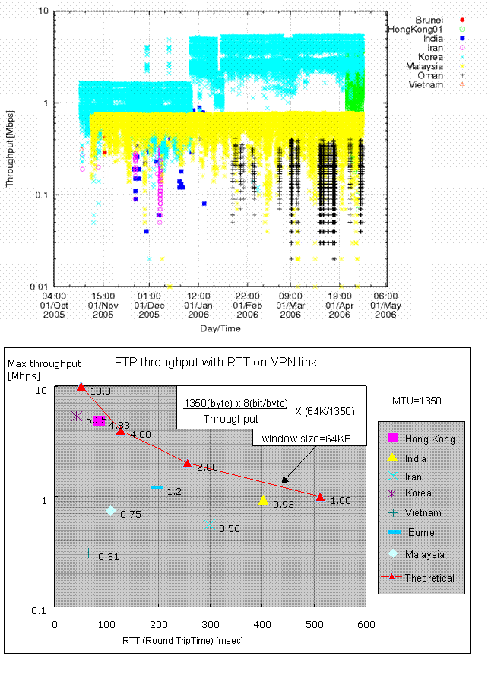
Figure 6 Example of Throughput evaluation

3.2 Progress in the Advanced Phase
In the first thematic sub-phase of the advanced phase, JMA started to provide prototype application software named SATAID and the data and products formatted for it in October 2006. The SATAID is a sophisticated stand-alone program for visualization and manipulation of satellite imagery and NWP products.

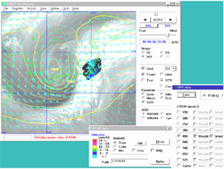


NWP products
Satellite data
Updated
Application software
Prototype application
NC
Internet
Application portal
Data portal
Satellite data
Reference information
Data sources
VPN
Software updating
Windows PC
HTTP server
FTP servers
GISC/DCPC
SATAID
Gathering data from
different data sources

Figure 7. Long-term evaluation test for a prototype application in advanced phase

During the evaluation test, a survey was conducted in March 2007 and replies to the questionnaire have been returned from nine out of sixteen participants (see below) and the result is summarized in the Table 2.

Brunei, China, Fiji, Hong Kong, China, India, Malaysia, New Zealand, Oman, Viet Nam.

According to the result of the survey, five respondents made positive assessment and all respondents requested continuance of the service. Taking into account the favorable comments, the service has been operational as from May 2007 as one of the WIS Prototype Services by JMA.

Table 2 Result of the Survey

Questions | Answers | Number of respondents | Comments
Q1. Did you use or are you using the application software (so called SATAID) in this pilot project? | Yes | 5
 | No | 3 | - Due to slow bandwidth speed.  - Unable to allocate internal resources.  - just images where downloaded.
 | Other | 2 | - SATAID used independently.  - In progress of setting up for usage around April 2007.
Q2. Did you have any problems in downloading the SATAID software from the pilot project server operated by Japan Meteorological Agency (JMA)? | No problem | 5
 | Yes | 0
 | Other | 0
Q3. Did you have any problems in obtaining data from the pilot project server using SATAID? | No problem | 5
 | Yes | 0
 | Other | 0
Q4. Do you think whether the tested mechanism is efficient to obtain and use data as one of WIS services? | Very effective | 4
 | Effective | 1
 | Not effective | 0
Q5. Did you have any problems in using VPN? | No problem | 9
Q5. Did you have any problems in using VPN? | Yes | 0
Q5. Did you have any problems in using VPN? | Other | 0
Q6. Did you satisfy with assistance provided by JMA? | Yes | 8 | - Will seek assistance when needed.
Q6. Did you satisfy with assistance provided by JMA? | No | 0
Q6. Did you satisfy with assistance provided by JMA? | Other | 1 | - Did not request assistance.
Q7. Do you think provision of data be needed to continue in this pilot project? | Yes | 9 | - We would like to use SATAID in the future.  - We plan to use SATAID as part of our routine operation.
 | No | 0
Q8. Please specify if you have any idea about a new theme to be focused in the pilot project. |  |  | - It would be useful to test the exchange of GTS data through this VPN tunnel.  - Proposing to consider sharing of wave model products.
Q9. Please comment, if any. |  |  | - JMA has done an excellent job in applying new technology and facilitating participation in this pilot project. Maybe we could go a bit further and see if the existing prototype could be evolved into a backup or supplementary channel for operational data exchange.

4. FUTURE ACTIVITIES
Taking into account importance of the Project for evaluating WIS related developments and providing developing countries with an occasion to participate in WIS development, the Project needs to be continued, at least, until the time when specifications of operational WIS are fixed. In the advanced phase, it is planed to promote the thematic sub-phases further, which are still behind schedule because of lack of human resources, as well as to broaden the reach of the project as before.

4.1 Thematic sub-phases
(1) Reporting observation data
A web input experiment for reporting observation data was conducted in October 2005. The experiment proved that web input can be securely conducted using VPN or HTTPS links. Planned works are development of software for metadata creation and BUFR conversion, and improvement of input forms and interfaces considering comments from participants through a forum in the discussion room.

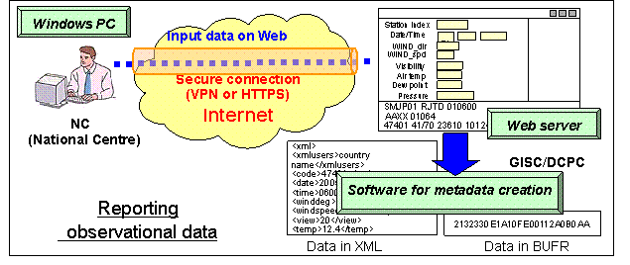

Figure 8 Outline of reporting observation data

(2) Cooperation with UNIDART (Data Portal)
The EUMETNET programme UNIDART is aiming at the development of services to access meteorological data and products provided by distributed data sources in an interactive way through a Web portal. The UNIDART software is a set of web services currently running in a pre-operational environment at Deutscher Wetterdienst (DWD), the Norwegian Met Service (Met No), and the Korean Meteorological Administration (KMA). The installation at further met services in Europe is under way. At present, web services exist for the access of climate time series, gridded climate data sets and forecast data. A central metadata catalogue used by UNIDART is hosted at DWD.

The Web portal is accessible at http://werdis-cbs.dwd.de/bvbw/bvbwDWD.portal

In cooperation with DWD, JMA accessed the UNIDART portal, established VPN link with the portal and installed UNIDART software on JMA data server. JMA and the Korea Meteorological Administration (KMA) data servers have been prepared to join the DATA GRID environment of UNIDART since February 2006. It is expected that JMA and KMA would prepare some datasets with metadata catalogue and provide them for UNIDART users.

The EUMETNET Council decided that the UNIDART software is available for met services outside of the European Community. It has to be decided whether the cooperation should be extended to further partners of the VPN Pilot Project in RA II and V.

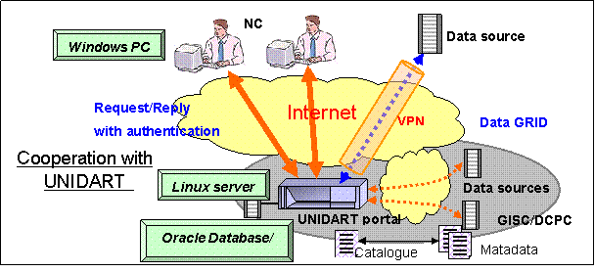
Figure 9 Outline of cooperation with UNIDART

4.2 Contribution of the Project for WIS implementation
The Project is expected to contribute to the WIS implementation through the following activities:

(1) Technical consulting body on VPN
The Project will play the role of a technical consulting body on VPN data communications for WIS semi-operation components in all Regions. The Project continues to provide empirical outcomes and technical tips to WIS community.
In this regard, the Project will make a recommendations based on the outcome from the first phase and discussions among participants on how to apply the VPN technology to the WIS telecommunication structure. One possible recommendation would be as follows.
"VPN over the Internet should be used as a secure and assured telecommunication means when the Internet is only realistic and available option for an NC."

(2) Prototype mechanisms at WIS application level
The Project will develop WIS prototype services at an application level and verify them through participants’ trial use. Some of the WIS prototype services developed by this Project may be applied to services in other Regions.

(3) Capacity building for participants in WIS semi-operation
The Project will provide the participants with better environment so that they can gain experiences on use of VPN and WIS services on a trial basis, and consequently, it would contribute to the early migration to the operational WIS.

5. Further enhancement of the Project
The RA II Technical Conference on the Management of Meteorological and Hydrological Services, held in Islamabad, Pakistan from 5 to 9 February 2007, recommended that NMHSs in RA II should participate in the VPN pilot project in RAs II and V and WMO should provide assistance for their participation. It is desirable that more WMO Members are to be involved in the WIS related activities, such as several Pilot Projects. The WIS VPN Pilot Project also welcomes new participants!

