WORLD METEOROLOGICAL ORGANIZATION  _________________________  IMPLEMENTATION COORDINATION MEETING ON THE IMPROVED MAIN TELECOMMUNICATION NETWORK (CLOUD I)  WASHINGTON, 27-29 NOVEMBER 2007 |  | ICM-IMTN (CLOUD I)/Doc. 3.2(1)  (21.XI.2007)  ____________  ITEM 3.2 & 3.3  ENGLISH only

Consideration of administrative aspects
for the next generation IMTN

(Submitted by Hiroyuki ICHIJO (Japan) in cooperation with experts of ET-CTS)

Summary and Purpose of Document

The document contains an outline of administrative aspects for the plan of the next generation IMTN.

Action Proposed: The meeting is invited to discuss about administrative aspects and to make a consensus of opinions.

Annex 1: Example of WMO official letters to promote the IMTN project in August 2002

Annex 2: Document submitted to ISS/ET-IMTN 2001 ; “CONSIDERATION ON ADMINISTRATIVE ASPECTS FOR THE IMPLEMENTATION OF THE IMPROVED MTN”

Foreword
ET-IMTN in 1999 concluded that Improved MTN (IMTN) would consist of a small number of “clouds” and that each “cloud” could be supplied by a single provider. According to the conclusion, the IMTN comprised of “two clouds” has been implemented under the IMTN project as innovative collaboration. Although the current “Cloud I” supplied by BT and “Cloud II” by “OBS (former EQUANT”) are functioning well as GTS trunk circuits, further evolution is expected to enhance capability of data exchange and to provide functionality as a WIS core network. The smooth collaborative evolution requires careful consideration of the administrative aspect as well as the technical one.

- Current contractual framework
There are differences in contractual frameworks between the “Clouds”.
Simply saying, the “Cloud I” case is a multi-end-contract based on a collaborative agreement. As an individual contract with BT local office at each end is similar to the traditional bilateral framework for a leased circuit and NNI (Network-Network-Interconnection) based Frame Relay, this approach could bring administrative benefits for “Cloud I” participants such as easiness of migration from bilateral to collaborative multilateral world, flexibility in local contract conditions and possibility of face to face consultation with the local supplier.


Local tariff
Local bill / payment
Agreement between Cloud I participants

Provider:
BT

Service:
Frame Relay on SLA

Cost sharing:
Charge for Incoming CIR and access circuit

Contract manner:
Individual contract
with BT local office

Contract period:
3 years from Jan 2003
1 year extension as from Jan 2006

BT group inside arrangement

Seamless network service based on SLA

Help desk network with a common trouble ticket system

Balancing local tariffs
UKMO BT
Local tariff
Local bill / payment
NOAA BT Americas
Local tariff
Local bill / payment
BoM BT Australia
Local tariff
Local bill / payment
JMA BT Japan
WMO official letters to promote the IMTN project in Aug 2002
(Annex 1)

Local bill/payment procedures in Japan
Monthly invoice (bill) on a later payment basis
Rebate reflected in next invoice
Contractual charge in US$
Invoice (bill) and payment in Japanese Yen
Consideration on FY boundary
IMTN Cloud I
Figure 1 An outline of the “Cloud I” contractual framework

On the other hand, the “Cloud II” framework is based on a so-called one stop concept. The IMTN “Cloud II” contract is an extension of the RMDCN one-stop-contract between ECMWF and OBS. Each “Cloud II” participant makes a secondary contract named “Accession Agreement” with OBS under the RMDCN contract. A difference from a typical one-stop is that the “Cloud II” framework allows multi-end-billing and multi-end-payment options. This innovative and future-oriented approach would become the mainstream of collaborative projects to seek homogeneous global systems. Although all participants must overcome their own administrative difficulties, once the one-stop-contract is introduced, it would bring long-term benefits in reducing contractual and management workload.



Extension
of RMDCN contract
Primary contract on RMDCN (ECMWF/F(98)166) with its supplements (amendment agreement)

Provider:
Orange Business Services (OBS)
(Former EQUANT)

Service:
MPLS on SLA
(migration from Frame
Relay in July 2007)

Cost sharing:
Charge for IP plug and
CE router at a user site,
and management

Contract manner:
One stop contract

Contract period:
Until 31 March 2009,
thereafter extended for
additional periods of 12
months

Bill/payment procedures:
Common procedures
Quarterly invoice on an advanced payment basis
Invoice and payment in UK pound
IMTN Cloud II
Non-MTN centers in RA VI
WMO official letters to promote the IMTN project in Aug 2002
(Annex 1)

Individual local conditions and negotiation issues including minor changes from master contract
ECMWF OBS
Accession agreement
MTN centers in RA VI
Accession agreement
MTN centers in
other Regions
Accession agreement
RMDCN in RA VI
Figure 2 An outline of the “Cloud II” contractual framework

Consideration points towards the next generation IMTN
Each NMHS has administrative conditions and restrictions due to each governmental and internal policies, domestic laws and customary procedures in contract and payment activities. It is essential to seek a possible approach towards the next generation IMTN, understanding the administrative aspect of all participants. This section shows general consideration points in the administrative aspect.

  - Consensus in contractual framework
It is desirable to make a decision of contractual framework under consensus of all possible participants. From the practical view based on experiences, necessary coordination items are summarized in Table 1. The table is on the presupposition that a new contractual framework would be developed. If either existing framework is extended and revised, coordination on some items may be skipped to a certain extent.

Table 1 Coordination items connected with contractual framework
Framework  Items | One-stop-contract | Multi-end-contract  on a collaborative agreement
Representative of participants | Designation process to evaluate capability as a responsible representative | Unnecessary
Specifications | How to develop a specification document (e.g. ITT (Invitation To Tender) )
Languages | Languages for contract documents, explanatory notes and help desk
Contractor | # Official competitive procurement or not  # Selection process to evaluate capability as a global supplier to meet IMTN requirements in both technical and administrative aspects
Governmental policy and guidelines | Study of governmental procurement policy and restrictions on multinational contract, scope of fairness (e.g. WTO) and domestic laws at all participation sites
Internal policy and procedures | Study of internal policy on confidentiality, security and cost-effectiveness, required documentation and customary contract procedures at all participation sites
Bill and payment | # Multi-end-billing/payment or one-stop-billing/payment with participants’ cost-recovery mechanism on MoU  # Common or local currency in agreed tariff and payment  # Exchange rate manner in case of difference in currency between agreed tariff and payment  # Advanced or later payment  # Invoice procedures and intervals  # Rebate procedures  # Consideration on FY boundary | # Multi-end-billing/payment  # Common or local currency in agreed tariff and payment  # Exchange rate manner in case of difference in currency between agreed tariff and payment  # Advanced or later payment  # Invoice procedures and intervals  # Rebate procedures  # Consideration on FY boundary
Contract periods | Review of benefit and demerit of long-term contract, and decision making acceptable to all participation sites | Feasibility study of different terms appropriate for individual portions, and decision making acceptable to all or partial participation sites
Lead time | Lead time at each participation sites from collaborative decision to signature on a contract
Supplementation | # Secondary contract (e.g. Accession agreement) under the primary contract  # Supplement to the primary contract in clause changes | # Supplement to individual contract in clause changes
Other contract conditions | Conditions on cancellation, payment non-fulfilment, price review mechanism, clause and/or schedule (e.g. appendix) changes and new participants

  - Collaboration commitment
The current collaboration frameworks were effectively initiated by WMO endorsement, especially WMO official letters to promote commitment to the IMTN collaboration in August 2002 (see Annex 1). Such WMO endorsement could facilitate participants’ internal coordination work to get individual approval from their countries/regions. For collaboration commitment to the next generation IMTN, similar WMO official procedures should be considered even if it is realized through consolidation approach of two existing “Clouds”.

An administrative working group should be established to practically coordinate administrative issues, and to sort out individual difficulties, and then to oversee every contract process. Furthermore, establishing a specific steering group could be effective for decision-making. The groups might be supported by WMO. The following items should be included in TOR of the groups.
- Develop a reasonable Memorandum of Understanding (MoU)
- Charge rules, cost-sharing manner, possibility and necessity of a relief fund for risk management
- Risk assessment in economical market aspect such as bankruptcy and unreasonable amalgamation (what if the single service supplier could not perform its function. Participants lost their connections may be able to join the other supplier’s cloud shortly as long as one of two suppliers survives. )
- Audit mechanism and organization
- Operational management framework such as a specific committee/group, an operational management memorandum and periodical conferences and workshops

.
Annex 1

From: | Secretary-General | To: | Dr K. Yamamoto  Permanent Representative of  Japan with WMO
Date: | 18 July 2002 | City: | Tokyo
Our ref.: | WB/SY/T.5-IMTN | Country: | Japan
No. pages: | 2 | Fax No.: | +81 332 112 032
Same fax also being sent to Dr J.W. Zillman, Permanent Representative of Australia with WMO;
Mr Peter Ewins, Permanent Representative of the UK with WMO; and
Brigadier General John J. Kelly, Permanent Representative of the USA with WMO

Subject: Improved MTN project

Dear Dr Yamamoto,

The Executive Council, at its fifty-third session (June 2001), endorsed the principles and concepts of the improved MTN project, as agreed upon by CBS-XII. The improved MTN would be implemented through data-communication network services from a small number of providers. A first implementation phase would mix network services and point-to-point circuits; a second phase would provide the full MTN connectivity through the network services. The project facilitates a progressive implementation, which could be adapted to the needs and resources of the Members concerned and could respond to changing requirements.

The Improved MTN project was agreed to be the best solution taking into account MTN requirements, technical efficiency, cost-effectiveness, implementation feasibility and early benefits for the whole GTS; it was also expected to permit savings for most centres on recurrent costs in comparison with the current leased circuits, while enabling capacity upgrades.

The Executive Council, at its fifty-fourth session (June 2002), emphasized the importance of pursuing the development and upgrade of the regional and global components of the GTS in order to meet the increasing data exchange requirements. It noted that the Improved MTN project was making some progress, and it encouraged Members concerned to facilitate effective multilateral cooperation, with the assistance of the Secretariat as necessary, in particular with respect to the procurement, contractual and financial framework to foster its early implementation.

The CBS Expert Team on the Improved MTN and GTS (ET-IMTN), which includes an expert from your country, conducted extensive consultations by correspondence and held two meetings since CBS-XII. At its last meeting (May 2002), the ET-IMTN confirmed the suitability of the IMTN implementation plan for:

- 2 -

- The implementation of a "cloud" providing the interconnectivity between the RTH/WMCs Washington and Melbourne and the RTHs Tokyo, Bracknell, Brasilia and Buenos Aires, including RTH/WMC Moscow in a further step;

- The implementation of a "cloud" as an extension of the RA VI-RMDCN, providing the interconnectivity between the RTHs Bracknell, Toulouse, Offenbach, RTH/WMC Moscow and other adjacent RTHs, i.e. RTHs Nairobi, Dakar, Algiers, Cairo, Jeddah, New Delhi and Beijing. The inclusion of the Tokyo-Beijing and Tokyo-New Delhi circuits would also provide an effective interconnectivity between both "clouds".

With respect to "cloud I" that includes the RTH operated by your Service, the ET-IMTN consolidated the technical requirements, analysed the competitive quotations obtained from potential providers, and identified the best offers. It agreed that individual contractual and billing arrangements should be provided to each RTH, and that sharing between RTHs of the recurrent cost of respective links should be based on the inbound data-communication capacity.

The ET-IMTN reached the conclusion that all required pre-conditions were met towards implementation of the part of "cloud I" interconnecting RTH/WMCs Washington and Melbourne and the RTHs Tokyo and Bracknell. The inclusion of RTHs Brasilia and Buenos Aires, and of RTH/WMC Moscow in a further step, should be further analysed.

In the light of the conclusions of the Executive Council and the CBS, and in view of the findings of the ET-IMTN, I should like to encourage you to consider the possibility of proceeding with the implementation of the part of the IMTN project relevant to your RTH, as a collaborative effort that would contribute to the upgrade of the World Weather Watch GTS as a whole.

Yours sincerely,

(Hong Yan)
for the Secretary-General

WORLD METEOROLOGICAL ORGANIZATION  _________________________  COMMISSION FOR BASIC SYSTEMS  OPAG ON  INFORMATION SYSTEMS & SERVICES  EXPERT TEAM ON THE IMPROVED  MAIN TELECOMMUNICATIONS NETWORK AND GTS  GENEVA, 20-23 JUNE 2001 |  | ANNEX 2  ISS/ET-IMTN 2001/Doc. 6(1)  (18.VI.2001)  ____________  ITEM 6  ENGLISH only

CONSIDERATION ON ADMINISTRATIVE ASPECTS FOR THE IMPLEMENTATION OF
THE IMPROVED MTN

(Submitted by Hiroyuki Ichijo)

Summary and Purpose of Document

The document contains an outline of administrative aspects for the implementation of the Improved MTN.

ACTION PROPOSED

The meeting is invited to discuss about what difficulties in administrative aspects are and to consider the solution for the difficulties.

Appendix A : Table of feasibility - Possibility of one-stop contractual framework

Appendix B : Table of feasibility - Possibility of payment and rebate procedures

Appendix C : Case study - RMDCN in Region VI

Prologue

ET-IMTN in 1999 concluded that Improved MTN would consist of a small number of “clouds” and that each “cloud” could be supplied by a single provider. The conclusion shows that the essence of the IMTN project is innovative collaboration. To realise the project, it is indispensable to dig into the administrative aspects.

- Contractual framework
  - Traditional method to one-stop concept
So far most of MTN links have been established on a bilateral basis under a contract between a customer (NMHS) and a supplier (carrier in charge of international communications in a country) at each end, so-called multi-end-contract and multi-end-billing. In this traditional approach, there is no difficulty in the administrative aspect such as in-house procurement procedures, contract arrangement, billing and payment.
On the other hand, the use of managed network services supplied by a global-wide provider introduce a one-stop concept. The concept is suitable for a company’s intranet connecting branches world-widely. However the use for networking among independent bodies brings difficulties in the administrative aspect. Since the IMTN project will progress on the one-stop concept, a new contractual framework should be considered.
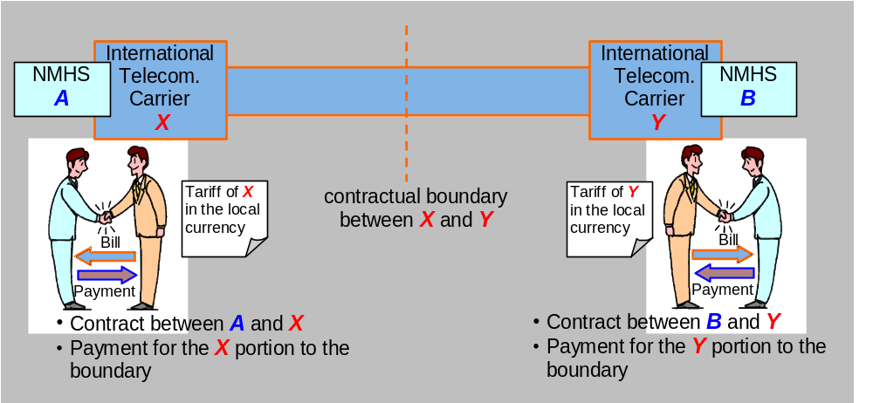
Figure 1 Traditional contract

  - One-stop-contract and one-stop-billing
A typical style is on the one-stop-contract and one-stop-billing. In general, the typical style is suitable for an international company having overseas branch offices. The head office makes a contract with a global provider and pays the total bill including all branch office charges.

In case that this style would be adopted in the IMTN project, one of NMHSs becomes a customer. The customer contracts with the provider on behalf of the others and pays the total bill. The payment should be recovered from the others under an agreement (e.g. MoU) which specifies sharing rules and payment procedures among the NMHSs,
it must be indispensable to find a possible collaborative framework for temporal payment on others’ behalf and cost recovery procedures. There could be difficulties in governmental conditions in procurement and accounting systems of each HMHS.
Figure 2 One-stop-contract & one-stop-billing (typical style)
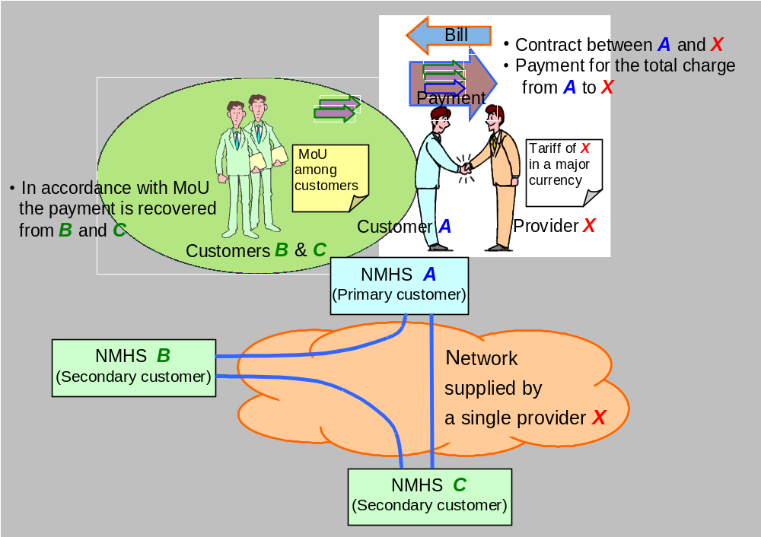

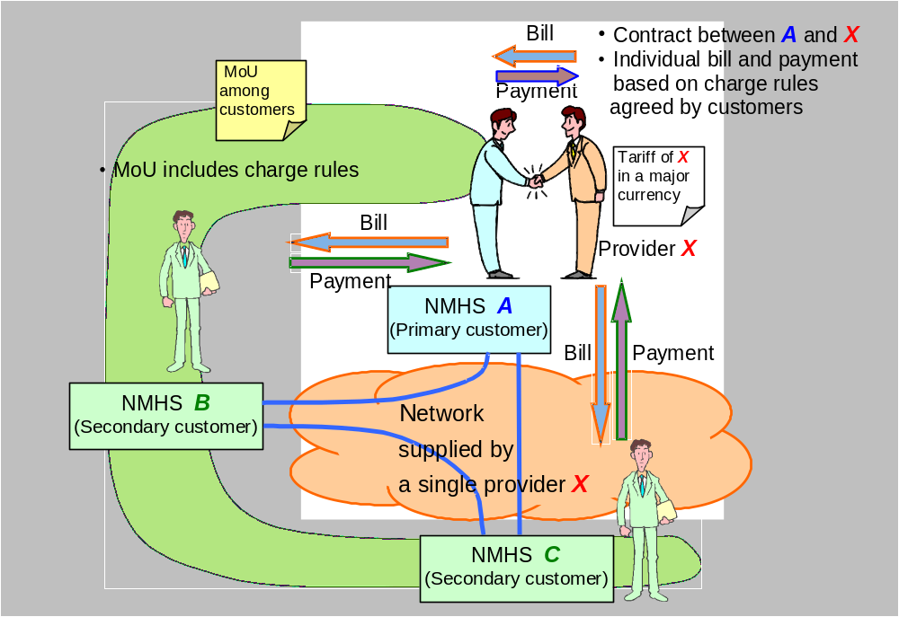
  - One-stop-contract and multi-end-billing
In spite of indispensability of one-stop-contract, some providers may allow multi-end-billing on condition that a primary customer assures other secondary customers’ payment without any delay.
Figure 3 One-stop-contract & multi-end-billing (Possible option)

In the IMTN project, one of NMHSs becomes a primary customer to make a contract with a provider and the others are secondary customers. Each customer pays individual bill in accordance with charge rules agreed by customers. The charge rules should be included in MoU among customers even though there are Clauses of charges and billing in contract agreement with the provider.
Since temporal payment on others’ behalf and cost recovery procedures would be unnecessary, the option of multi-end-billing could permit an easier arrangement in a collaborative framework.

  - Payment and rebate procedures
There are differences among NMHSs in necessary conditions for payment and rebate. Items to be studied are as follows:
- Advance or later payment, and bill intervals
In the advanced payment case, there are options of bill intervals such as monthly, quarterly, and half-yearly. On the other hand, in the later payment case, most of providers generally allow until quarterly bills, though it depends on each provider’s policy.
In some countries, there is no accounting system for payment in advance under the fiscal law. In the sense, the later payment could be feasible. Each NMHS may have a desirable and/or inconvenient bill interval. Except for monthly bill, it may be difficult to settle flexibly a few of months for payment because of a fiscal year boundary which differs with countries. The quarterly bill with period boundaries in January, April, July and October could be practical.

Table 1 Example of non-flexibility in payment month
 | Jan. | Feb. | Mar. | Apr. | May | Jun. | Jul. | Aug. | Sep. | Oct. | Nov. | Dec.
Japan, UK |  |  |  | ← boundary (a fiscal year is from April 1 to next March 31)
Possible  Quarterly bill | 4th quarter |  |  | 1st quarter |  |  | 2nd quarter |  |  | 3rd quarter
 |  |  | Impossible?
 |  | Impossible?
USA | (a fiscal year is from October 1 to next September 30) |  |  |  |  |  |  |  |  | ← boundary
Possible  Quarterly bill | 2nd quarter |  |  | 3rd quarter |  |  | 4th quarter |  |  | 1st quarter
 |  |  |  |  |  |  |  |  | impossible?
 |  |  |  |  |  |  |  | impossible?

- Currency
In a general way, a global provider prepares a tariff and/or actual charges in a common currency such as US dollars and UK pounds. Some NMHS may prefer payment in their own local currencies, in spite of the exchange rate fluctuation. Negotiations with a provider would be necessary.

- Rebate
The rebatable situation possibly occurs on the ground of the less performance than the SLA. Since revenue procedures for unexpected rebate apart from a bill are usually complicated, the rebate should be calculated within the next bill.

  - Contractual period
It is not easy to find appropriate contractual period. Because a long period would lead to not only an amazing discount but also a risk of obsolete technologies and missing better opportunity. Considering an incredible speed of change in IT fields, the initial contractual period should be less than 5 years.

  - Tables of feasibility
To seek possible way, some tables of feasibility in administrative items should be completed by information from every NMHS operating an MTN centre. Examples are attached as appendixes A and B.

- Procurement procedures (way to the competitive procurement)
To obtain the maximum benefit in cost-saving, the procurement should be on the principle of competition. In most cases, there is considerable difference between a tariff based quote and a bid price because of discounts due to fierce competition in the market.
In case of simple bidding without any evaluation by criteria, the final price in the successful bid is rarely predictable. In most cases of the smaller players in the Frame Relay market, the discount range may be from 15 to 30 percent. Furthermore in their private IP network services, the discount sometimes reaches 60 percent as long as the contract is big enough.

However the lowest bid provider does not always satisfy user requirements. In fact, it is said that half of business users who chose a provider by only price regretted their decision. They overlooked provider’s hidden aspects. For both cost-saving and meeting requirements, in addition to comparison with competitive quotes, comprehensive evaluation by criteria is indispensable. The RMDCN Project in Region VI could be the touchstone of such procurement. One of success elements of the project might be international status (name value) of ECMWF with WMO backing. Global providers sometimes accept an unprecedented contractual condition as long as the customer of international status would require it. Furthermore even the government might ease the restrictions on a national law.

Following the RMDCN way, a potential IMTN group like Network B should tackle the procurement procedures of Invitation To Tender and then evaluation of Tenders. If possible, WMO status could be useful for better contracts.

- Collaboration work for agreement among NMHSs
  - Memorandum of Understanding (MoU)
It is expected that an MoU would be used to have an internal consensus of each NMHS. Technical person could explain reasonableness of the IMTN project to budget, procurement and accounting people based on the MoU.
Designated experts from Participating NMHSs should develop a reasonable MoU in collaboration with WMO Secretariat in a short period, although it would still on draft status. Then representatives for the NMHSs would agree to the draft and sign it.

  - Charge rules (Cost-sharing manner)
Designated experts from Participating NMHSs should discuss on charge rules, which might be based on beneficiary payment manner. The rules could be described in a contract paper with the Provider and the MoU by NMHSs.
In a reasonable cost-sharing manner, each NMHS could pay for the charge for access line, FR port and incoming CIRs.

  - Steering group
Establishing a specific group consists of a small designated experts could be effective to steer a shorter way for the implementation. The group might be supported by WMO.

(Appendix A)

Possibility of one-stop contractual framework
Style |  | One-stop-contract & one-stop-billing |  |  | One-stop-contract & multi-end-billing |  |  | Remarks and conditions
Representative for contract with a provider |  | WMO | Other NMHS | Own-NMHS | WMO | Other NMHS | Own-NMHS | Remarks and conditions
Centre | Network group
(example) |  | Conditional Possible (*1) | Impossible | Impossible | Possible | Conditional Possible (*2) | Impossible | (*1) Payment as a Member contribution to WMO  (*2) Contractual details should be agreed by participating NMHSs and be described in MoU.
Algiers | C
Beijing | D
Bracknell | B, RMDCN
Brasilia | A
Buenos Aires | A
Cairo | C
Dakar | C
Jeddah | D
Melbourne | B
Moscow | D, RMDCN
Nairobi | C
New Delhi | D
Offenbach | C, D, RMDCN
Prague | RMDCN
Sofia | RMDCN
Tokyo | B, D
Toulouse | C, RMDCN
Washington | A , B

(Appendix B)

Possibility of payment and rebate procedures
Representative for contract with a provider |  | Advance Payment | Later Payment | Foreign Currency | Fiscal year | Intervals in priority order | Rebate apart from bills | Rebate within the next bill | Remarks and conditions
Centre | Network group
(example) |  | Difficult | Possible and preferable | Possible in US$ (*1) | April 1 to March 31 | Half-yearly, Quarterly, Monthly (*2) | Difficult | Possible | (*1) Local currency is preferable  (*2) Only later payment case
Algiers | C
Beijing | D
Bracknell | B, RMDCN
Brasilia | A
Buenos Aires | A
Cairo | C
Dakar | C
Jeddah | D
Melbourne | B
Moscow | D, RMDCN
Nairobi | C
New Delhi | D
Offenbach | C, D, RMDCN
Prague | RMDCN
Sofia | RMDCN
Tokyo | B, D
Toulouse | C, RMDCN
Washington | A , B

(Appendix C)
Case study : RMDCN in Region VI (this appendix was summarised by Ichijo in 1998)

(a) Partnership between WMO and ECMWF in the RMDCN project




General Agreement between WMO and ECMWF

@ ECMWF provides a transport network service to its Members to carry GTS and related traffic.
@ ECMWF extends the service to RA VI Members who are not Members of ECMWF.
@ ECMWF concludes an appropriate framework contract with a service provider.
@ The underlying transport layer is not changed for at least 5 years after implementation of the RMDCN.
@ ECMWF provides functions of network manager for the RMDCN, and all costs relating to this activity are covered by participating Members.
...

Contract Advisory Committee (CAC)
Purposes are:
(a) to compile RA VI requirements;
(b) to advise on the contents of the ITT and the procurement contract;
(c) to advise on the selection of the service provider;
(d) to liaise with WMO RA VI Members;
(e) to advise on future developments of the transport service of the RMDCN.

Membership is:
(a) RA VI co-ordinator of the Sub-Group on Regional Aspects on the GTS;
(b) Experts from 2 RTHs (one of which comes from non-Member State of ECMWF);
(c) Experts from 2 NMCs (one of which comes from non-Member State of ECMWF);
(d) ECMWF;
(e) Secretary - WMO Secretariat.

Already established

RMDCN Operations Committee (ROC)
Purposes are:
(a) Co-ordination between all RMDCN participants;
(b) Troubleshooting;
(c) Performance review;
(d) Interaction with the GTS.

Membership is:
(a) ECMWF (Chair and secretary);
(b) Experts from RTHs in the RMDCN;
(c) Experts from 2 NMCs in the RMDCN;
(d) RA VI co-ordinator of the Sub-Group on Regional Aspects on the GTS.
Proposed to establish

(b) Contracts

There will be two types of contracts, namely:
(i) Framework Contract to be concluded between ECMWF and the Service Provider containing:
- provision and condition for ECMWF's network
- the Provider's commitment to cover all RA VI Members
- the ceiling cost for access to the RMDCN by each RA VI Member
- the ceiling costs for additional services like higher bandwidth, service level, etc
- the possible service charge for the ECMWF network management
- a specification of the guaranteed service level (see "SLA" paragraph)

(ii) Individual contract between a Member and the Service Provider which should contain:
- RMDCN bandwidth to be provided and other technical features
- service level to be provided
- payment modalities including possible service charge for ECMWF's network
- management

(c) Service Level Agreement (SLA)

Service levels as detailed are agreed between ECMWF and the Service Provider.
Final agreement will be called as "SLA" The SLA includes "Service Rebates" criteria.

(d) Cost Sharing

ECMWF Members receive a service of 128kbps which is covered by the ECMWF budget. The ECMWF traffic in the RMDCN takes priority on a 64kbps part of the bandwidth and symmetrically the GTS and related traffic on the other 64kbps part of the bandwidth.
The connections and services for non-Members of ECMWF, and the additional connections and services for ECMWF Members would be contracted with the Service Provider under the umbrella of the framework contract.
Noting the present cost-sharing arrangements and the mutual benefit for RA VI Members to co-ordinate the discontinuation of the present GTS dedicated circuits, RA VI Members would be encouraged to consider arrangements for sharing the real costs.

The funding of the activities of the CAC and ROC has not been solved. The envisaged options for the funding are:
(i) Each Member has to fund the participation of its expert;
(ii) Funding from RMDCN overhead collected through individual contracts;
(iii) WMO budget contributions.

Service Level Agreement (SLA)
The SLA will be agreed by Customer and Provider in the eventual contract.

1. Scheduled Hours of Service

The Service shall be operational 24 hours a day, 7 days per week, irrespective of any public holidays.
.

2. Scheduled Maintenance

Scheduled down-time, for routine maintenance of the Network, must not exceed 40 hours measured over any 12 month period and must not exceed 6 hours per calendar month. In addition no single scheduled outage must exceed two hours. The User must be given at least 10 working days notice prior to any scheduled maintenance, including details of the

3. Guaranteed Repair Time

(a) The Contractor commits to repair any Severity 1 fault in less than 4 hours after the start of the Service Interruption.
(b) Any Severity 1Fault should be restored to a minimum of 25 % of contracted throughput within 10 minutes of failure.
(c) The

4. Service Availability

The targets for Service Availability for each User Site are specified in relevant Service Particulars. However, the following figure is assumed to be the baseline for all Use Sites.
Service Availability : 99.5%

5. Service Degradation
5.1 Round trip time

The

5.2 Throughput
The measured average throughput over a two-hour period should not fall below 80 % of guaranteed throughput contracted for between two specific User Sites.

Draft example
5.3 Backup Service

A backup service must be available for a minimum of 90 % of the time in any one calendar month. Any greater unavailability

...

...

...

Service Rebates
Service Availability | Rebate on the relevant monthly fee |  | Number of days in a calendar month on which the committed performance levels are not met | Rebate on the relevant monthly fee
98.5 % to 99.5 % | 30 % |  | 1 to 3 | 20 %
96.5 % to 98.5 % | 60 % |  | 4 to 9 | 50 %
less than 96.5 % | 100 % |  | more than equal to 10 | 100 %

[ Global Network Degradation Case ]
When more than 20 % of User Sites experience the same or related Service Degradation (i.e. reduced throughput, round trip time or backup service unavailability), it is deemed that the whole Network experiences this degradation and the rebates will be calculated as performance degradation in all User Sites.

 | Problem Resolution
Severity | Guaranteed Repair time | Rebate on the relevant monthly fee
1 | 4 hours | 1 % for each 4-hour period when problem resolution is late
2 | 24 hours | 1 % for each 24-hour period when problem resolution is late
3 | 10 working days | 1 % for each week when problem resolution is late
4 | 20 working days | 1 % for each 2-week period when problem resolution is late

