WORLD METEOROLOGICAL ORGANIZATION  _________________________  INTER-COMMISSION COORDINATION GROUP ON THE WMO INFORMATION SYSTEM  FIFTH SESSION  Seoul, Korea, 22-26 February 2009 |  | ICG-WIS VI/Doc. 4.5(1)  (16.II.2010)  ___________  ITEM 4.5  ENGLISH only

GISC development in JMA
(Submitted by Hiroyuki Ichijo (Japan))

Summary and Purpose of Document

This document briefly describes the development of WIS, especially GISC Tokyo, in JMA

ACTION PROPOSED

The meeting is invited to note the report.

APPENDIX:

Report of investigation of blog technologies (originally submitted to ET-WISC-III (Geneva, 2-5 February 2010))

- Introduction

One year has passed since the WIS Compliance Specification was published, and the WIS Demonstration Process Procedures and Guidelines were issued in December 2009.

Japan Meteorological Agency (JMA) offers one of GISC and seven DCPCs. It will continue and improve its operation for international responsibilities in WIS Part A (such as RTH Tokyo, RSMCs, satellite and long-range forecast) and is actively working towards the development and implementation of WIS Part B.

This document describes the current status of the development of WIS. Section 2 and 3 briefly describe the development of WIS part A and part B at GISC Tokyo, respectively. Section 4 introduces cooperative activities with other NMHSs, including its capacity building aspects.

- Development of WIS Part A
  - RTH on IMTN

In its position as RTH Tokyo, JMA acts as a node between the RA II Regional Meteorological Telecommunication Network (RMTN), and the GTS MTN, and plays a very important role on the GTS. JMA has developed and maintains high-fault-tolerance systems that are operated and monitored by well-trained JMA experts on a 24/7 basis.

  - Migration to IPVPN MPLS

One of the important factors of WIS Part A is the continued consolidation and further improvements of the GTS. In addition to participating in the migration of the RMDCN to IPVPN MPLS in 2007, JMA coordinated and successfully completed the migration of three RMTN circuits connected with RTH Tokyo from Frame Relay services to an MPLS based IP-VPN in March 2009. Significant improvement of traffic throughput with cost-effectiveness was confirmed through the operational evaluation of the MPLS based IP-VPN

- Development of WIS Part B

WIS Part B will introduce new functionalities, thus new technologies and infrastructure are required. JMA is actively working to develop and establish integrated infrastructure of WIS Part B, according to WIS requirements. This section describes the development of WIS part B mainly focusing on new technologies for WIS Part B. The system components are illustrated in Figure 1.

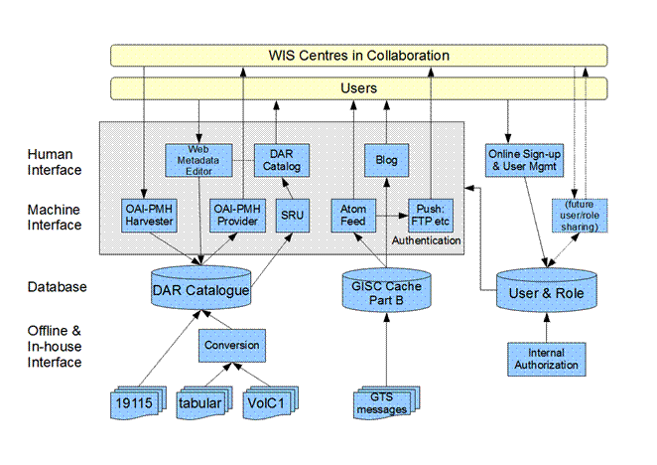
Figure 1: Schematic illustration of WIS Part B system components planned for GISC Tokyo. Note: arrowheads indicate direction of information flow, not direction of connection (push or pull).

  - Metadata handling
    - Creation and Synchronisation

Metadata is created/edited via web interface or uploaded by the originator, before synchronised among collaborating GISCs. JMA will support all those modes of metadata transportation.

JMA considers OAI-PMH [1] as the primary candidate for synchronisation protocol. Several tabular forms will be supported for metadata uploading in addition to direct submission of ISO 19139 XML document form.

    - Catalogue and Search

Metadata collected to GISC Tokyo will be stored in a database for catalogue search.

The primary interface of the catalogue search is SRU [2] as required in WIS. Ongoing design work fully considers compatibility with SRU extension of GeoNetwork. It is under consideration to implement gateway to support CSW [3] and ASN.1 Z39.50 protocols.

    - Browsing Structure of Catalogue

It is important from practical viewpoint that the metadata catalogue provides some interface to browse (list) all its metadata without entering search keys. Many centres are working with structured (hierarchical) keywords for browsing structure.
Our observation is that the hierarchical keywords best suites with observational data, while grid data often has many equally-important search keys (such as forecast time, vertical level, or physical quantity) that does not fit with hierarchical structure. Tabular listing looks promising for this purpose, and we will continue study.

  - Data Handling

The WIS Part B system of JMA receives data feed from GTS and will provide the data by both push and pull protocols.

    - Blog-related technologies

As reported in ET-CTS meeting in 2008, JMA is performing experiments to demonstrate the fitness of blog-related technologies as standards for both push and pull protocol. Details are described in the document submitted to ET-WISC-III, which is reproduced and attached as Appendix to this document.

    - WIS prototype service in operation

WIS Part B is expected to handle huge amount of various data. In this regard, JMA has developed a new data provision system based on a pull mechanism to provide large amounts of data/information via the Internet using a hosting service. This service was introduced to NMHSs in 2007, as JMA's WIS prototype service, and has already been implemented on a semi-operational basis through a system in which regular users can retrieve satellite and numerical prediction data through a dedicated web site.

  - User Management

WIS Part B requires ad-hoc registration and management of users through web interface. DCPCs in JMA will share the same interface for unified user experience of WIS as a system.

Sharing user and role information among many organisations is another challenge. In order to avoid the risk of sharing raw or hashed passwords, distributed authorisation technology is desirable. Standardisation will require careful examination including applicability with many data/metadata transfer protocols.

- Collaboration with NMHSs
  - Collaboration with other potential GISCs

As reported to the past WIS related meetings including the ICG-WIS sessions, JMA has been in collaboration with the China Meteorological Administration (CMA) on the WIS development to implement interconnection and interoperation, including metadata exchange and synchronization, remote data request and access between the GISC prototypes at both organizations. The most recent meeting (Beijing, September 2009), which was also attended by the Deutscher Wetterdienst (DWD), had detailed discussion on DAR metadata and metadata synchronization. Recognizing that some guidelines for WMO core profile is necessary for the effective function of DAR databases, the meeting submitted a report to IPET-MDI and other related bodies for their consideration.

The coordinated investigation of blog-based technologies (see para 3.2.2 and Appendix) is another example of JMA's collaboration with other potential WIS centres.

  - RAII/RAV VPN Pilot Project
Towards the secure exchange of data/products/information through the Internet using VPN technology, JMA has being taking a leading role in the RA II/RA V VPN Pilot Project, an initiative to which a number of WMO Members – including developing countries – have contributed. The project provides participants with an opportunity to step into WIS implementation, and is expected to .contribute to the WIS implementation through i) Technical consulting body on VPN, ii) Prototype mechanisms at WIS application level, and iii) Capacity building for participants in WIS semi-operation.

  - Capacity Building
    - Training courses and technical support

JMA has been providing expert services and training programs to developing countries for decades. In particular, the series of Japan International Cooperation Agency (JICA) group training courses on meteorology includes lectures on telecommunication and data management, and has received more than 250 meteorologists from the National Meteorological Services of developing countries since 1973. In addition, through the implementation of the Japanese government’s aid programs in the field of meteorology, JMA provides a range of technical support in cooperation with JICA and other national authorities.

    - International workshop

JMA well recognizes the needs to build capacity in all WMO Members to participate in this important effort, and wishes to further cooperate with the NMHSs for the successful implementation of WIS. In this regard, JMA will hold an international workshop: "Towards the successful implementation of the WMO Information System in Asia", in Tokyo on 9 -11 March 2010, inviting 15experts in Asian NMHSs. The main purpose of the workshop is to share with the participants the WIS vision, the technical specifications, the current status of WIS development, etc., to help those NMHSs in contributing to and benefiting from WIS. It is also expected that this workshop will facilitate the identification and consolidation of the requirements related to WIS in Asian countries.

JMA fully recognizes that GISCs should be responsible for education and training with regard to WIS in their areas of responsibility, and the Agency will plan related training courses, technical support, etc. as appropriate.

References
[1] OAI-PMH : The Open Archives Initiative Protocol for Metadata Harvesting, Protocol Version 2.0. Documentation dated 2008-12-07 available at <URL:http://www.openarchives.org/OAI/openarchivesprotocol.html>.
[2] SRU : Search/Retrieval via URL. Version is 1.2 documentation dated 2009-08-05 available at <URL:http://www.loc.gov/standards/sru/index.html>.
[3] CSW : Catalogue Services for the Web. Documentation (part of OpenGIS® Catalog Services Specification version 2.0.2) available at <URL:http://www.opengeospatial.org/standards/cat>.
[4] OpenID : OpenID Authentication 2.0. Specification available at <URL:http://openid.net/specs/openid-authentication-2_0.html>.
[5] OAuth : "The OAuth Core 1.0 Protocol ". E. Hammer-Lahav, Ed., 2009. IETF Internet-draft draft-hammer-oauth-08. Available at <URL:http://tools.ietf.org/html/draft-hammer-oauth-08>
WORLD METEOROLOGICAL ORGANIZATION  _________________________  CBS Expert Team on WIS GISCs and DCPCs  FOURTH SESSION  Geneva, 2-5 February 2010 |  | ET-WISC/Doc. 3.5  (2.II.2010)  ___________  ITEM 3.5  ENGLISH only

Report of investigation of blog technologies
(Submitted by Tatsuya Noyori (Japan))

Summary and the Purpose of the Document
The document is to report the empirical results of the investigation of blog technologies which ET-CTS recognized as a promising mechanism complementary to the GTS for notification and dissemination of priority messages. This document reviewed by ET-CTS includes their suggestions.

Action proposed: The team is invited to consider the suggestion for review and rearrangement of the future work programme.

Report of investigation of blog technologies

1. Background
At its meeting in 2008, ET-CTS concluded that blog-based technologies may be quite promising as a mechanism complementary to the GTS for notification and dissemination of priority messages such as tsunami warnings, and recommended Japan to continue empirical study of the technologies in cooperation with volunteers for testing. Japan has been investigating their usability for notification of priority messages and also GISC synchronization of global data/products in cooperation with Brazil and China.
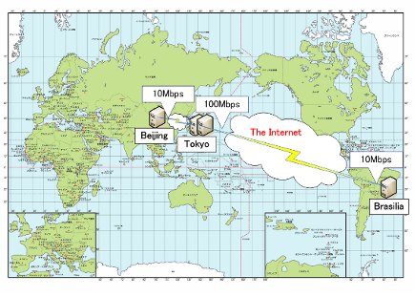
This document briefly reports the result of the investigation.

2. Blog technologies
The following blog technologies have been investigated.

- File synchronization like podcast using a pull-based protocol for getting web feed of Atom and RSS
- Notification of priority messages using a push-based protocol of the Atom Publishing Protocol (AtomPub) for posting blog

(1) File synchronization using a pull-based protocol
The procedures are described in Annex II. The file synchronization mechanism has the following advantages.

- Data providers do not need to manage data distribution tables to provide users with data.
- Data providers can provide only authorized users with data by using OpenID authentication or the basic access authentication.
- Users can get only newly created data that they want on a near-real-time basis by checking for updates of an Atom at short intervals.
- Users can get better download transfer rates by using multiple parallel downloads and download acceleration instead of using an ordinary single download.

On the other hand, a sole disadvantage is polling delay in the nature of a pull-based protocol.

(2) Notification of priority messages
The procedures are described in Annex III. The notification of priority message has the following advantage.

- Priority messages can be published on blog server connected to the Internet.
- Users can receive priority message over the Internet using feed reader.
- Both of blog software and feed reader are general-purpose software.

The disadvantage is as follows.

- There is practically limitation on the number of entries of messages at a time.

3. Customization of blog software for the test
Regarding the number of entries in an Atom, ordinary blog software replies the fixed number of entries in an Atom. Therefore, the replied Atom includes not only newly created entries but also previous entries. In order to make our blog software effectively reply an Atom including only newly created entries, some parts of our blog software have been customized. Similarly, some parts of our blog software have been customized so that our blog software can reply an Atom including only entries requested by HTTP request parameters of category (e.g. SYNOP) and tag (e.g. Japan).
The customized blog software has been installed in Brazil, China and Japan.

4. Test Results
(1) File synchronization using pull-based protocols
The results of the tests of the file synchronization between Tokyo and Brasilia over the Internet are as follows:

- The maximum transfer rate was 9Mbps.
- Messages (SYNOP, SHIP, BUOY, TEMP, TEMP SHIP and PILOT) generated on a routine basis were synchronized within 60 seconds by checking for updates of an Atom at intervals of 30 seconds.
- A product of numerical weather prediction (The total size is 70Mbytes, the number of files is 9116) was synchronized within 150 seconds by checking for updates of an Atom at intervals of 30 seconds.
- A large file of 100Mbytes was synchronized within 150 seconds by checking the update of an Atom at intervals of 30 seconds.

The test was conducted at a polling interval of 30 seconds. For much shorter delay, it is possible to change the interval from 30 seconds to 15 seconds, but this change would have little meaning. If data providers can classify messages, the data providers should use the notification mechanism for the priority message classified.

(2) Notification of priority messages using a push-based protocol
The result of the investigation of the priority message notification between Tokyo and Brasilia over the Internet is as follows:

- It was confirmed that the notification of test tsunami warnings generated on a routine schedule was completed within 20 seconds.

5. Future Plan
Regarding the notification of priority message, there is a problem of the password sharing between poster and blog server owner. If the poster posts an entry to a blog server that is managed by other owner, the password would be shared by the poster and the blog server owner. But, the password should be changed on a regular basis for ensuring Internet security. But, How can the new password be synchronized between the poster and the blog server owner? This is the problem of the password sharing.
PubSubHubbub have one of the solutions to the problem. PubSubHubbub uses blog ping to notify updates of blog. Therefore, PubSubHubbub does not have the problem of the sharing password. Japan will investigate PubSubHubbub as a possible solution of the problem.

A member of ET-CTS suggested that the scalability of blog technologies should be assessed. Therefore, Japan will assess the scalability of blog technologies.

6. Conclusion
WIS implementation plan consists of the following Part A and B.

- Part A: the continued consolidation and further improvements of the GTS for time-critical and operation-critical data, including its extension to meet operational requirements of WMO Programmes in addition to the World Weather Watch (including improved management of services);

- Part B: an extension of the information services through flexible data discovery, access and retrieval services to authorised users, as well as flexible timely delivery services.

Blog technologies are mainly useful for WIS Part B. The reasons are as follows:

- The file synchronization enables data providers to provide unspecified number of users with data without managing data distribution tables.
- Posting priority message to data provider’s blog server enables data providers to publish the priority data to unspecified number of users. The users can easily get the priority data by using feed reader.
- Blog software has been used on the Internet, and related services have been increasing on the Internet. Combining blog software and the related services on the Internet enable data providers to bring the most value to users.

But, it would be difficult to adopt blog technologies for WIS part A. The reason is as follows:

- It would be difficult to introduce sharply new technologies like blog technologies into the existing GTS.

Also, the blog technologies investigated would not be suitable for GISC synchronization. The reasons are as follows:

- The file synchronization has a polling delay.
- The notification of priority messages is not suitable for sending a lot of messages.

But, the blog technologies investigated would be suitable for the following usage.

- Data providers provide users with data on a near-real-time basis over the Internet.
- Data providers provide users with data at intervals over the Internet.
- Data providers receive a priority message from the GTS, and then post the priority message to their blog server on the Internet

Next, WIS fundamental services have the following type.

- Timely delivery service for data and products: This service is based on delayed mode “push” mechanism; it would be implemented through a combination of dedicated telecommunication means and of public data-communication networks, especially the Internet.

Timely delivery service can also be implemented by “pull” mechanism using the file synchronization of blog technologies. Therefore, I would like to suggest that the above-quoted sentence is revised like the following sentence.

- Timely delivery service for data and products: This service is based on delayed mode “push or pull” mechanism; it would be implemented through a combination of dedicated telecommunication means and of public data-communication networks, especially the Internet.

Annex I

Blog websites for the investigation

Tokyo:
Data File: http://www.shiken.kishou.go.jp/roller/tokyofile/
Decoded Data: http://www.shiken.kishou.go.jp/roller/tokyomicrodata/
Metadata Extension : http://www.shiken.kishou.go.jp/roller/tokyometadata/

Brasilia:
Data File: http://akira.inmet.gov.br/roller/brasilfile/
Decoded Data: http://akira.inmet.gov.br/roller/brasilmicrodata/
Metadata Extension : http://akira.inmet.gov.br/roller/brasilmetadata/

Tokyo 2:
Data File: http://server.shiken.kishou.go.jp/roller/japanfile/
Decoded Data: http://server.shiken.kishou.go.jp/roller/japanmicrodata/
Metadata Extension : http://server.shiken.kishou.go.jp/roller/japanmetadata/

Data File:
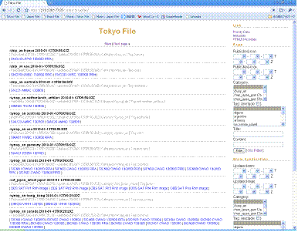

Decoded Data:
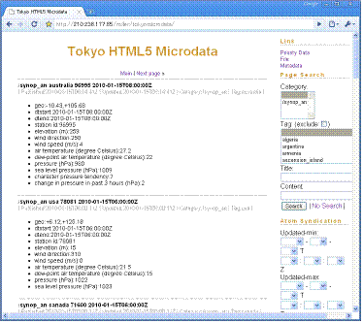

Metadata Extension
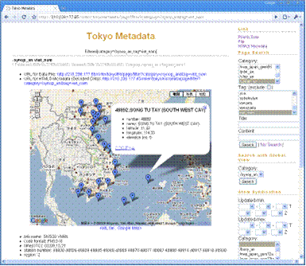
Data file and Decoded data and Metadata extension is being synchronized from Japan to Brazil.

Data flows for the file synchronization

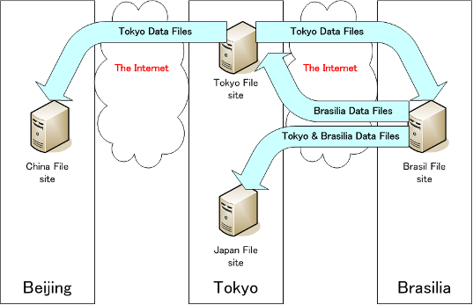
Annex II
File synchronization
- Data provider puts data files on his blog server.
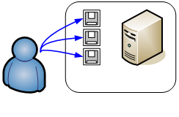
- Data provider inserts entries into database in his blog server. The entries include links to the data files.
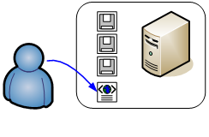
- Data provider’s blog server is ready to reply an updated Atom that includes newly created entries.
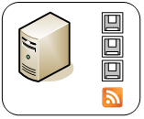
- User periodically run a shell script to gets the Atom that includes only the newly created entries by using If-Modified-Since HTTP request header. User can also get a specific Atom that includes only entries requested by HTTP request parameters of category (e.g. SYNOP) and tag (Japan or Brazil or China) as follows.
http://kishou.go.jp/atom?site=tokyofile&category=/synop_an&tag=japan|brazil|china
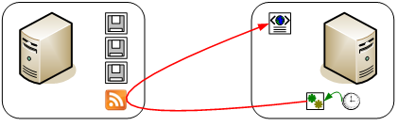

- User’s shell script parallel downloads the linked data files that are included in the downloaded Atom.
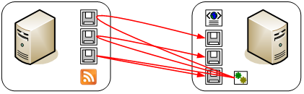

Annex III

Notification of priority message

- Poster posts an entry to a blog server using AtomPub.
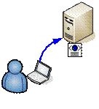
- The blog server is ready to reply an updated Atom that includes a newly created entry.
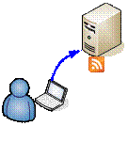
- Users who subscribe to the Atom by using feed reader are notified of the newly created entry.
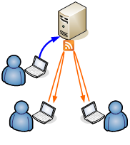
Annex IV

Related Open Standards of blog technologies

Open Standard Formats
The Atom Syndication Format (Atom) (RFC 4287)
http://www.ietf.org/rfc/rfc4287.txt
HTML 4.01 Specification
http://www.w3.org/TR/html401/
OGC KML:
http://www.opengeospatial.org/standards/kml

Open Standard Communication Protocols
PubSubHubbub Core (RFC Draft)
http://pubsubhubbub.googlecode.com/svn/trunk/pubsubhubbub-core-0.2.html

The Atom Publishing Protocol (AtomPub) (RFC 5023)
http://www.ietf.org/rfc/rfc5023.txt

HTTP Over TLS (RFC 2818)
http://www.ietf.org/rfc/rfc2818.txt

Hypertext Transfer Protocol -- HTTP/1.1 (RFC 2616)
http://www.ietf.org/rfc/rfc2616.txt

Open Standard Authentication and Authorization Protocols
The OAuth Core 1.0 Protocol (RFC Draft)
http://tools.ietf.org/html/draft-hammer-oauth-08

OpenID Authentication 2.0 - Final
http://openid.net/specs/openid-authentication-2_0.html

HTTP Authentication: Basic and Digest Access Authentication (RFC 2617)
http://www.ietf.org/rfc/rfc2617.txt

