Services Oriented Architecture Concepts Applied to
Specific WMO Systems
Introduction 2
Purpose of this Document 2
GEOSS, WIS, and the Specific WMO Systems 2
Overview of Services Oriented Architecture 3
Interoperable Interfaces of GEOSS, WIS and the WMO Systems 4
Global Earth Observations System of Systems (GEOSS) 4
WMO Information System (WIS) 5
World Weather Watch Global Observing System (WWW GOS) 6
Global Atmosphere Watch (GAW) 7
World Hydrological Cycle Observing System (WHYCOS) 8
World Climate Programme (WCP) 9
Global Climate Observing System (GCOS) 10
Global Ocean Observing System (GOOS) 12
Global Terrestrial Observing System (GTOS) 13
Defining SOA Services for the WMO Systems 14
GEOSS Components Registration 14
From Component Descriptions to Service Definitions 14
Service Definitions at Interfaces 15
Identifying Services in GEOSS Components 16
Discovery Mechanisms for Services 17
Appendix 1: Descriptions of Specific WMO Systems 18
WMO Information System (WIS) 18
Global Observing System of the World Weather Watch (WWW GOS) 19
Global Atmosphere Watch (GAW) 20
World Hydrological Cycle Observing System (WHYCOS) 21
World Climate Programme (WCP) 22
Global Climate Observing System (GCOS) 23
Global Ocean Observing System (GOOS) 24
Global Terrestrial Observing System (GTOS) 25
Appendix 2: The Concept of a GEOSS Component 26
Appendix 3: Alternative Approaches to Interoperability 27
Master System with Subordinate Components 27
Applications Programming Interface (API) 28
Structured Query Language (SQL) 28
Appendix 4: Defining Services in a Services Oriented Architecture 29
The Concept of a Service 29
Services and Protocols 29
Making a Service Definition 30
Run-time versus Design-time 30
Syntax and Semantics of Structured Messages 31
An Example of SOA: Spatial Data Infrastructures 31
Appendix 5: Interoperable Search Standard 33
End Notes 36

Introduction

Purpose of this Document
This document provides technical guidance on how Services Oriented Architecture concepts may be applied to several particular systems managed by or especially significant to the World Meteorological Organization (WMO). The particular systems are: the Global Observing System of the World Weather Watch, the Global Atmosphere Watch, the World Hydrological Cycle Observing System, the World Climate Programme, the Global Climate Observing System, the Global Ocean Observing System, and the Global Terrestrial Observing System. All of these systems are being converged in various ways, and they will utilize the WMO Information System (WIS) as the main data collection and exchange system.

GEOSS, WIS, and the Specific WMO Systems
The WMO Information System (WIS) and each of the seven WMO systems addressed herein are also viewed as contributed systems to the Global Earth Observations System of Systems (GEOSS), overseen by the Group on Earth Observations (GEO). [ ]
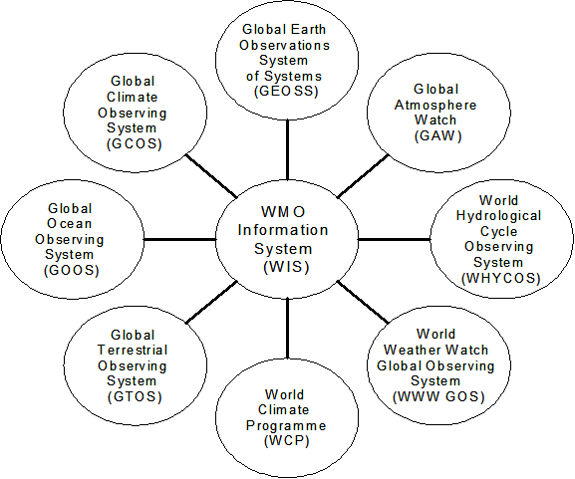
Figure 1. GEOSS, WIS, and other systems
Appendix 1 contains the "GEOSS Component Registration" for each of these systems.
Figure 1, right, shows one way to view relationships among these systems plus GEOSS.
From a systems design perspective, a fundamental tenet of GEOSS is the commitment of GEO Members and Participating Organizations to embrace Services Oriented Architecture as the common approach to enhance interoperability across the diverse component systems that comprise GEOSS. This document describes how WMO can meet that commitment in the context of these seven particular systems and WIS.

Overview of Services Oriented Architecture
The primary objective of a Services Oriented Architecture (SOA) is to enable "interoperability", here understood as the ability to perform a task that spans discrete components implemented with information and communications technology. The thrust of SOA is that interoperability is most readily enabled by focusing on the interfaces among system components. (Appendix 2 provides a brief introduction to the concept of a GEOSS Component and to the expectations that accompany designation of a system as a contributed GEOSS Component.)
The accepted GEOSS 10-Year Implementation Plan Reference Document [ ] (hereinafter "GEOSS Reference Document") states:
Interoperability will be focused on interfaces, defining only how system components interface with each other and thereby minimizing any impact on affected systems other than where such systems have interfaces to the shared architecture. [ ]
A key concept here is that the SOA approach to interoperability treats interfaces as active points of contact where structured messages are communicated between discrete system components. Again, as explained in the GEOSS Reference Document:
interoperability arrangements are to be based on the view of complex systems as assemblies of components that interoperate primarily by passing structured messages over network communication services. [ ]
This network-centric orientation is one among several approaches to information systems interoperability that have been popular over the last few decades. (For a discussion of some of the alternative approaches, see Appendix 3.) Although SOA principles might be superseded at some future point in the evolution of information systems technology, the SOA approach will likely dominate for at least the next decade.
Of course, the effort involved in achieving interoperability among systems is only justified to the extent that the resulting combination of systems is greater than the sum of the systems as operated separately. To exploit such opportunities for synergy, it is essential that system designers can easily find descriptions of available components and associated resources. In GEOSS, the mechanism for sharing such descriptive information and so enabling interoperability across the components of a system of systems is called "GEOSS Clearinghouse".
GEOSS Clearinghouse itself is a system of systems, encompassing many other clearinghouses, catalogs, data directories, and service registries wherein hundreds of thousands of resources relevant to Earth Observations are documented. These include the Global Spatial Data Infrastructure, the 50+ National Spatial Data Infrastructures, the CEOS International Directory Network, and the Global Change Master Directory, among many others. Because GEOSS adopted the international standard for their interoperable search service, all of this existing information is already incorporated.
The next section provides Clearinghouse information concerning GEOSS, WIS and the other seven systems addressed in this document. This descriptive information is cast in terms of "interoperable interfaces", shown by a high-level architectural view of each component as it would interact with other components. This descriptive information is useful for discovering whether any one particular system could leverage relevant resources available through other systems. Later sections will suggest useful ways to further elaborate technical details about the interfaces, even to the point of providing a degree of automated linking through the SOA technique of "service definitions".

Interoperable Interfaces of GEOSS, WIS and the WMO Systems

Global Earth Observations System of Systems (GEOSS)
GEOSS reflects a global scientific and political consensus that information vital for societies requires comprehensive, coordinated, and sustained Earth observations.
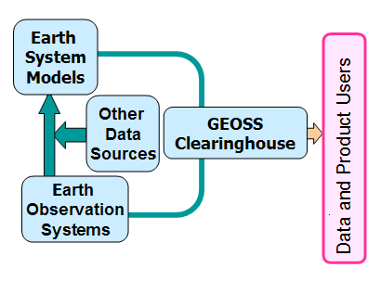
Figure 2, right, shows a high-level architectural view of major parts of GEOSS. The GEOSS Clearinghouse is the primary external interface providing opportunities for interoperability, especially for functions of information discovery.
Figure 2. High-level architectural view of GEOSS interoperable interfaces

WMO Information System (WIS)
WIS will be a coordinated, distributed, global infrastructure for the collection and sharing of data and information for all WMO and related international programs. Building on the WMO Global Telecommunications System (GTS) and supporting different user groups and access policies, WIS will provide for: routine collection and automated dissemination of observed data and products; timely delivery of data and products, including ad-hoc requests; and, interoperability among diverse data management systems and datasets.
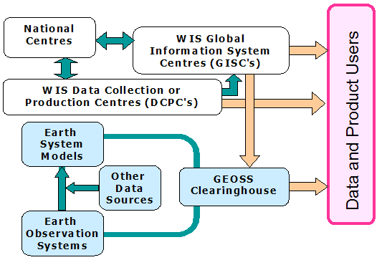
Figure 3. High-level architectural view of WIS interoperable interfaces
Figure 3, right, shows a high-level architectural view of major parts of WIS. Opportunities for external interoperability are at the WIS Global Information System Centres (GISC's) and at the WIS Data Collection or Production Centres (DCPC's), which includes Programme- designated centres such as Regional Climate Centres.
The GEOSS Clearinghouse will have catalog entries for WIS and GISC's as GEOSS components contributed by WMO, and for DCPC's, such as ECMWF and EUMETSAT.

World Weather Watch Global Observing System (WWW GOS)
Observations of the state of the atmosphere and ocean surface as observed from the Earth and from outer space are provided by WWW GOS. These observations are used for the preparation of weather analyses, forecasts, advisories and warnings, and for climate monitoring and environmental activities carried out under programmes of WMO and of other relevant international organizations. WWW GOS is operated by National Meteorological Services, national or international satellite agencies, and involves several consortia dealing with specific observing systems or specific geographic regions.
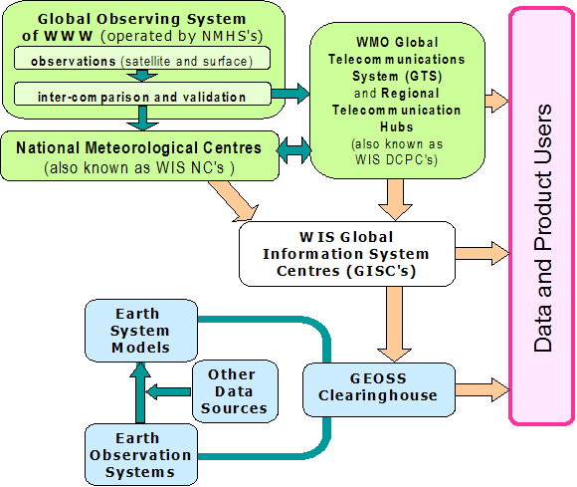
Figure 4, right, shows a high-level architectural view of major parts of WWW GOS. The Global Telecommunications System (GTS) is part of WIS. The Regional Telecommunications Hubs interface with WIS and can support external interfaces. The National Meteorological Centres interface via WIS to support interoperability with external systems.
These WIS interfaces will be described through catalog entries in WIS and in the GEOSS Clearinghouse, as noted above.
Figure 4. High-level architectural view of WWW GOS interoperable interfaces

Global Atmosphere Watch (GAW)
The mission of the Global Atmosphere Watch, taking into account the Integrated Global Atmospheric Chemistry Observations (IGACO) strategy, is to: Reduce environmental risks to society and meet the requirements of environmental conventions; Strengthen capabilities to predict climate, weather and air quality; Contribute to scientific assessments in support of environmental policy; Through: Maintaining and applying global, long-term observations of the chemical composition and selected physical characteristics of the atmosphere; Emphasizing quality assurance and quality control; Delivering integrated products and services relevant to users.
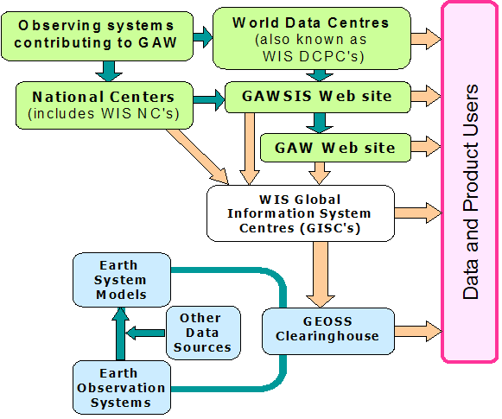
Figure 5, right, shows a high-level architectural view of major parts of GAW. The primary points where external interfaces provide opportunities for interoperability are at the GAW Web site, the GWASIS Web site, and the World Data Centres: WOUDC (Ozone & UV), WDCGG (Greenhouse Gases), WDCA (Aerosols), WRDC (Radiation)
These interfaces will be described through catalog entries in WIS and in the GEOSS Clearinghouse.
Figure 5. High-level architectural view of GAW interoperable interfaces

World Hydrological Cycle Observing System (WHYCOS)
WHYCOS is a WMO programme primarily focused on strengthening technical and institutional capacities of National Hydrological Services, improving their cooperation in the management of shared water resources, and promoting free exchange of data in the field of hydrology. Implemented through various components at the regional and/or basin scale, the WHYCOS Programme coordinates measurement and collection of basic hydrological elements from networks of hydrological and meteorological stations, including quantity and quality data of surface and ground water. Provision of such data supports planning and operations of water resources projects, and of hydrological forecasting systems.
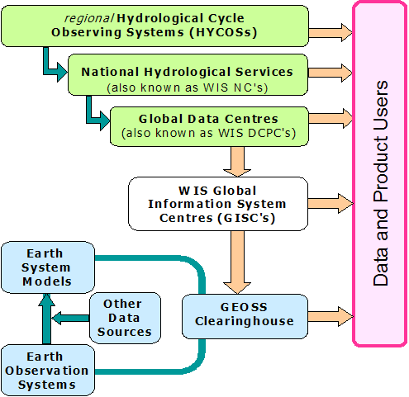
Figure 6, right, shows a high-level architectural view of major parts of WHYCOS. Points where external interfaces provide opportunities for interoperability include: Reqional HYCOS's, National Hydrological Services, and Global Data Centres such as the Global Runoff Data Center.
These interfaces will be described through catalog entries in WIS and in the GEOSS Clearinghouse.
Figure 6. High-level architectural view of WHYCOS interoperable interfaces

World Climate Programme (WCP)
The World Climate Program (WCP) is an integrating and catalytic Programmme for initiating and coordinating, nationally and regionally, activities in the areas of Climate data collection, monitoring, research, prediction, applications and training. The WCP long-term goal is to assist WMO Members and relevant international organizations in using climate information to reduce negative impacts of climate variability and change, and to obtain optimal benefits from climate as a resource, in order to enhance public safety, health and welfare, to alleviate poverty and to promote sustainable development.
WCP coordinates its activities in climate data and climate services amongst its two sub-programmes: WCDMP and WCASP, and with other relevant WMO programmes and relevant Regional and Global Climate Data Centers and Climate Forecast Producing Centers. The Programme facilitates climate data and metadata collection through various global climate observing systems, and ensures that the data is readily available to and among Members, through the international exchange of climate data. It assists WMO Regional associations to implement Regional Climate Centers as future major regional Centers in producing, managing and disseminating climate information, including data and prediction products.
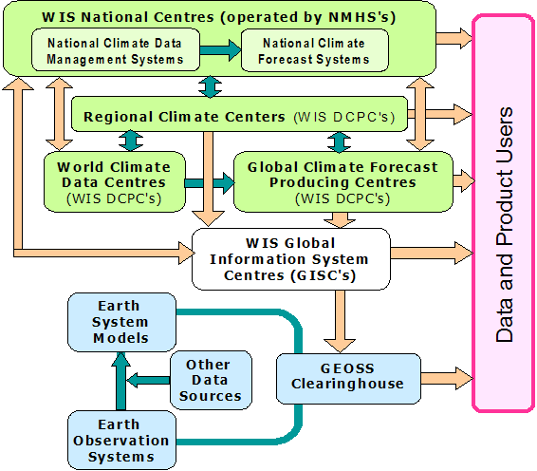
Figure 7, right, shows a high-level architectural view of major parts of WCP. Points where external interfaces provide opportunities for interoperability include: National Meteorological Services, Regional Climate centers, World Climate Data Centers and Global Climate Forecast Producing Centers.
These interfaces will be described through catalog entries in WIS and in the GEOSS Clearinghouse.
Figure 7. High-level architectural view of WCP interoperable interfaces

Global Climate Observing System (GCOS)
The Global Climate Observing System (GCOS) was established in 1992 to ensure that the observations and information needed to address climate-related issues are obtained and made available to all potential users. It is co-sponsored by the World Meteorological Organization (WMO), the Intergovernmental Oceanographic Commission (IOC) of UNESCO, the United Nations Environment Programme (UNEP), and the International Council for Science (ICSU).
GCOS is a long-term, user-driven operational system capable of providing the comprehensive observations required for monitoring the climate system, for detecting and attributing climate change, for assessing the impacts of climate variability and change, and for supporting research toward improved understanding, modelling and prediction of the climate system. GCOS addresses the total climate system including physical, chemical and biological properties, and atmospheric, oceanic, terrestrial hydrologic, and cryospheric components.
The GCOS programme stimulates, encourages, coordinates and otherwise facilitates the taking of the needed observations by national or international organizations in support of their own requirements as well as of common goals. It provides an operational framework for integrating, and enhancing as needed, observational systems of participating countries and organizations into a comprehensive system focused on the requirements for climate issues. The GCOS programme does not directly make observations nor generate data products.
GCOS builds upon, and works in partnership with, other existing and developing observing systems such as the WMO Global Observing System and Global Atmosphere Watch, the Global Ocean Observing System, and the Global Terrestrial Observing System. It includes in situ, airborne and space-based observational components.
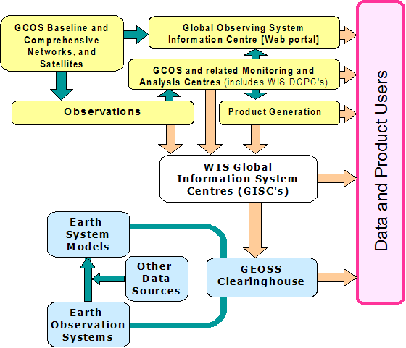
Figure 8, right, shows a high-level architectural view of major parts of GCOS. There are many external interfaces that are opportunities for interoperability, e.g., the Global Observing System Information Centre, the GCOS Monitoring and Analysis Centres, and a wide range of climate-relevant observation networks, data centres and archives.
These interfaces will be described through catalog entries in the GEOSS Clearinghouse.
Figure 8. High-level architectural view of GCOS interoperable interfaces

Global Ocean Observing System (GOOS)
GOOS is a global system of international cooperation for: sustained observations of the oceans; generation of oceanographic products and services; and, interaction between research, operational, and user communities. GOOS is designed to: monitor, understand and predict weather and climate; describe and forecast the state of the ocean, including living resources; improve management of marine and coastal ecosystems and resources; mitigate damage from natural hazards and pollution; protect life and property on coasts and at sea; and, enable scientific research. GOOS is implemented by member states via their government agencies, navies and oceanographic research institutions, working together in a wide range of thematic panels and regional alliances.
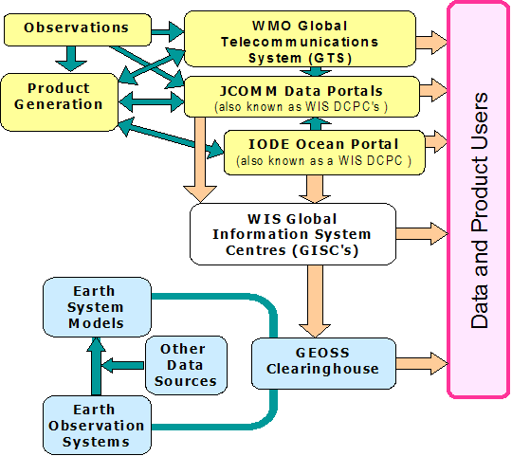
Figure 9, right, shows a high-level architectural view of major parts of GOOS. Key external interfaces providing opportunities for interoperability are: the WMO Global Telecommunications System, the Joint WMO/IOC Technical Commission for Oceanography and Marine Meteorology (JCOMM) Data Portal, and the International Oceanographic Data and Information Exchange (IODE) Ocean Portal.
These interfaces will be described through catalog entries in WIS and in the GEOSS Clearinghouse.
Figure 9. High-level architectural view of GOOS interoperable interfaces

Global Terrestrial Observing System (GTOS)
GTOS is a programme for observations, modeling, and analysis of terrestrial ecosystems to support sustainable development. GTOS facilitates access to information on terrestrial ecosystems so that researchers and policy makers can detect and manage global and regional environmental change.

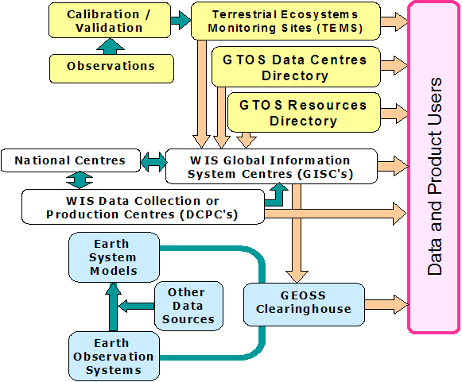
Figure 10, right, shows a high-level architectural view of major parts of GTOS. Points where external interfaces provide opportunities for interoperability include the Terrestrial Ecosystems Monitoring Sites (TEMS) database, the GTOS Data Centres Directory, and the GTOS Resources Directory.
These interfaces will be described through catalog entries in WIS and in the GEOSS Clearinghouse.
Figure 10. High-level architectural view of GTOS interoperable interfaces

Defining SOA Services for the WMO Systems

GEOSS Components Registration
Among the GEOSS Components listed in Annex 1 ("Table of Initially Identified Systems") in the GEOSS Reference Document, are the systems addressed in the present document, and described as in Appendix 1. In general, the process of registration provides that GEOSS Components may be designated at any time, initiated by a request from the principal representative of any GEO Member or Participating Organization. The GEO Secretariat then confirms the sender's representative status in GEO, and passes the request to the GEO Architecture and Data Committee for review of the GEOSS Component Registration information (e.g., see Appendix 1).
Once the registration information is complete, the contributed GEOSS Component is to be listed in the GEOSS Component Registry, which also supports interoperable search as part of the GEOSS Clearinghouse.

From Component Descriptions to Service Definitions
GEOSS components are committed to converge on interfaces that adhere to agreed "interoperability arrangements", a term that includes, but is not limited to, formal standards such as the kinds of service definitions referenced above. GEOSS will encompass at least four "registers" holding relevant descriptive information in support of convergence of component systems toward higher levels of interoperability:
Register of GEO Members and Participating Organizations
Register of GEOSS Components
Register of Services using GEOSS Interoperability Arrangements
Register of GEOSS Interoperability Arrangements

The preceding section provided high-level descriptions of several systems that are part of WIS and GEOSS. Using the descriptive information about one of these components, any system designer would have enough information to decide whether it makes sense to establish an interface to that component. As noted above, most of this information is likely to be findable already through the GEOSS Clearinghouse search mechanism.
Descriptive information is essential, but it does not really give a clear sense of how difficult would be the system engineering to establish a given interface, nor how robust and reliable would be the operational connection between the system components. Absent more definitive technical details, meetings are typically held among the persons responsible for technical and management aspects of the two systems to elaborate exactly how the systems are to be interconnected.
The SOA approach to interoperability goes to great lengths to precisely define the technical details for a service interface. Many of the most common service interfaces are already so well-defined that they can be used as system interconnections with a minimum of technical discussion needed. In fact, system designers often establish a connection to a published service without any discussion at all, especially during prototyping. (Note that before any significant operational system establishes dependency on an external interface, it is still necessary to negotiate a Service Level Agreement. This "lawyer-to-lawyer interface" has not yet become highly automated.)

Service Definitions at Interfaces
Those who implement system components using an SOA service interface are expected either to publish the particular "service definition" for that interface or to comply with the already published service definition. Such a service definition specifies precisely how the discrete components can interact, in terms appropriate for the system designer who actually implements each discrete component. (The concept of services in the SOA context is further elaborated in Appendix 4.)
Significant investments of engineering talent and management commitment are required to assure that a service definition is sufficiently detailed, robust, and reliable. Virtually any kind of communications interaction can be defined through an SOA service definition, and the most useful of these become widely implemented standards. To a great degree, the ongoing explosive growth of information technology is based on the worldwide deployment of such precisely defined standard service definitions.
Perhaps the most salient implication of the SOA focus on communicating components is the extraordinary scalability of this common interoperability approach. A service definition in the SOA sense may apply across the whole of the Internet. For instance, the Hypertext Transfer Protocol (HTTP) service interface defines communications between any Internet browser and virtually all Internet hosts. The international standard search service adopted for GEOSS Clearinghouse has been implemented at virtually every library in the world that has an online catalog. Yet other services may be defined to operate just within a single PC, such as an interface between word processor software and printing hardware. The GEOSS Reference Document notes:
By expressing interface interoperability specifications as standard service definitions, [...] system interfaces assure verifiable and scaleable interoperability, whether among components within a complex system or among discrete systems. [ ]
A key consideration is that GEOSS catalogues data and services with sufficient metadata information so that users can find what they need and gain access as appropriate. [...] Users searching GEOSS catalogues will find descriptions of GEO Members and Participating Organizations and the components they support, leading directly to whatever information is needed to access the specific data or service in a harmonized way, independent of the specific provider. In this sense, the interoperable GEOSS catalogues form the foundation of a more general ‘clearinghouse’. [ ]

Identifying Services in GEOSS Components
Although not strictly required for participation in GEOSS, it makes sense in the interest of interoperability for a GEOSS component contributing organization to provide more detail than what is available in the component registration form. It is most useful if the contributor makes known in some detail what contents or processing is available through the contributed system, and exactly what common services it exposes for external connection. After all, it takes an investment of time and effort to implement and maintain any system interface and designers need to evaluate where that investment makes sense.
Given the expansive scope of GEOSS, GEOSS Clearinghouse may be seen as a kind of "marketplace of services". The goal of this marketplace is to enable deals to be made between "sellers" (those who support offered services) and "buyers" (those who seek to leverage services offered by others).
The key to any efficient marketplace is a free flow of information between the sellers and the buyers. That information spans a wide range: from broad descriptions such as that in a GEOSS Component Registration form; to various metadata about data resources at the collection or data set level; to metadata about services, including performance commitments; to contextual information, including provider credentials, scientific credibility. At each of these points, a system designer might well need to consult the relevant scientific literature and experts as well. This need is greatly facilitated in GEOSS Clearinghouse by its adoption of the interoperable search standard already implemented by libraries worldwide.
It can be seen that the initial stages of design work in an interoperability task is quite similar to the initial "literature search" stage of any research project. It could be argued that every interoperability task should be treated quite literally as an instance of research. In many cases, the interoperability may be fairly routine, using well accepted techniques and combining data or services in ways that are fairly obvious. Yet, in many other cases, the interoperability may be more novel and should be peer-reviewed before being placed into an operational mode.

Discovery Mechanisms for Services
An SOA requires significant investment of time and other resources, especially in the development and maintenance of service definitions. That investment is justified insofar as systems designers are able to take advantage of common services in various ways: perhaps to lower their internal system development costs, to leverage needed resources available elsewhere, or to "future-proof" their systems in an era of rapid change, among others.
But, the SOA cannot succeed unless systems designers can discover what components and associated resources are available for re-use, and so decide which potential interfaces warrant further investigation. Various "registry services" are available to support this need, including: discovery mechanisms designed for SOA's that use ebXML, UDDI, or CORBA; as well as discovery mechanisms for finding services defined by Requests for Comments (RFC's) published by the Internet Engineering Task Force (IETF), specifications from the World Wide Web Consortium (W3C), the Open Geospatial Consortium (OGC), the Organization for the Advancement of Structured Information Standards (OASIS), or a range of ISO standards; among many others.
The GEOSS Clearinghouse can be viewed as a logically and physically distributed collection of information about relevant data and information resources, service definitions, component descriptions, interoperability arrangements, etc. This broad variety of information is accessible through a common search service that adopts the international standard for interoperable search. That standard search service is well designed to handle diverse catalogs and directories, and is interoperable with discovery mechanisms for some of the common service registries, such as ebXML and UDDI. (Further details about this interoperable search standard are given in Appendix 5.)

Appendix 1: Descriptions of Specific WMO Systems

WMO Information System (WIS)

GEOSS Component Name (required): WMO Information System

GEOSS Component Abbreviation (optional): WIS
GEO Sponsor:
[ X ] GEO Participating Organization: World Meteorological Organization (WMO)
GEOSS Component Category (required; include all that apply):
[ ] Observing System [ ] Modelling and Data Processing Center
[ X ] Data Exchange and Dissemination System [ ] Other: ________________________________
Catalogue: _________________________________________________________________________________
(catalogue name required if GEOSS Component is catalogued in a directory or clearinghouse, e.g. CEOS International Directory Network, Global Spatial Data Infrastructure)

GEOSS Component Status (required; select one):
[ X ] Continuously Operational [ ] Intermittently Operational [ ] Not Operational
GEOSS Societal Benefit Areas that may be relevant (required; include all that apply):

[ X ] Agriculture [ ] Biodiversity [ X ] Climate [ X ] Disasters
[ X ] Ecosystems [ ] Energy [ ] Health [ X ] Water [ X ] Weather
GEOSS Component Description (required):

The WMO Information System (WIS) will be a coordinated, distributed, global infrastructure for the collection and sharing of data and information for all WMO and related international programs. Building on the WMO Global Telecommunications System (GTS) and supporting different user groups and access policies, WIS will provide for: routine collection and automated dissemination of observed data and products; timely delivery of data and products, including ad-hoc requests; and, interoperability among diverse data management systems and datasets.

GEOSS Component Contact

Name (required): Jean-Michel Rainer

Organization (required): Information Systems and Services Division, World Weather Watch Department,, WMO

E-mail address (required): JMRainer@wmo.int

GEOSS Component Website (optional):

Global Observing System of the World Weather Watch (WWW GOS)

GEOSS Component Name (required): World Weather Watch Global Observing System

GEOSS Component Abbreviation (optional): GOS
GEO Sponsor:
[ X ] GEO Participating Organization: World Meteorological Organization (WMO)
Responsible Organization within GEO Participating Organization (optional): World Weather Watch

GEOSS Component Category (required; include all that apply):
[ X ] Observing System [ ] Modelling and Data Processing Center
[ ] Data Exchange and Dissemination System [ ] Other: ________________________________
Catalogue: _________________________________________________________________________________
(catalogue name required if GEOSS Component is catalogued in a directory or clearinghouse, e.g. CEOS International Directory Network, Global Spatial Data Infrastructure)

GEOSS Component Status (required; select one):
[ X ] Continuously Operational [ ] Intermittently Operational [ ] Not Operational
GEOSS Societal Benefit Areas that may be relevant (required; include all that apply):

[ ] Agriculture [ ] Biodiversity [ X ] Climate [ X ] Disasters
[ ] Ecosystems [ ] Energy [ ] Health [ ] Water [ X ] Weather
GEOSS Component Description (required):
The Global Observing System (GOS) provides from the Earth and from outer space observations of the state of the atmosphere and ocean surface for the preparation of weather analyses, forecasts, advisories and warnings, for climate monitoring and environmental activities carried out under programmes of WMO and of other relevant international organizations. It is operated by National Meteorological Services, national or international satellite agencies, and involves several consortia dealing with specific observing systems or specific geographic regions.

GEOSS Component Contact

Name (required): Alexander Karpov

Organization (required): Observing Systems Division, World Weather WatchDepartment, WMO

E-mail address (required): AKarpov@wmo.int

GEOSS Component Website (optional): http://www.wmo.ch/web/www/OSY/GOS.html

Global Atmosphere Watch (GAW)

GEOSS Component Name (required): Global Atmosphere Watch

GEOSS Component Abbreviation (optional): GAW
GEO Sponsor:
[ X ] GEO Participating Organization: World Meteorological Organization (WMO)
Responsible Organization within GEO Participating Organization (optional):
GEOSS Component Category (required; include all that apply):
[ X ] Observing System [ ] Modelling and Data Processing Center
[ ] Data Exchange and Dissemination System [ ] Other: ________________________________
Catalogue: _________________________________________________________________________________
(catalogue name required if GEOSS Component is catalogued in a directory or clearinghouse, e.g. CEOS International Directory Network, Global Spatial Data Infrastructure)

GEOSS Component Status (required; select one):
[ X ] Continuously Operational [ ] Intermittently Operational [ ] Not Operational
GEOSS Societal Benefit Areas that may be relevant (required; include all that apply):

[ ] Agriculture [ ] Biodiversity [ ] Climate [ X ] Disasters
[ ] Ecosystems [ ] Energy [ X ] Health [ ] Water [ ] Weather
GEOSS Component Description (required):

The mission of the Global Atmosphere Watch, taking into account the Integrated Global Atmospheric Chemistry Observations (IGACO) strategy, is to: Reduce environmental risks to society and meet the requirements of environmental conventions; Strengthen capabilities to predict climate, weather and air quality; Contribute to scientific assessments in support of environmental policy; Through: Maintaining and applying global, long-term observations of the chemical composition and selected physical characteristics of the atmosphere; Emphasizing quality assurance and quality control; Delivering integrated products and services relevant to users.

GEOSS Component Contact

Name (required): Leonard Barrie

Organization (required): Atmospheric Research and Environment Programme Department, WMO

E-mail address (required): Lbarrie@wmo.int

GEOSS Component Website (optional): http://www.wmo.ch/web/arep/gaw/gaw_home.html

World Hydrological Cycle Observing System (WHYCOS)

GEOSS Component Name (required): World Hydrological Cycle Observing System

GEOSS Component Abbreviation (optional): WHYCOS
GEO Sponsor:
[ X ] GEO Participating Organization: World Meteorological Organization (WMO)
GEOSS Component Category (required; include all that apply):
[ X ] Observing System [ ] Modelling and Data Processing Center
[ ] Data Exchange and Dissemination System [ ] Other: ________________________________
Catalogue: _________________________________________________________________________________
(catalogue name required if GEOSS Component is catalogued in a directory or clearinghouse, e.g. CEOS International Directory Network, Global Spatial Data Infrastructure)

GEOSS Component Status (required; select one):
[ X ] Continuously Operational [ ] Intermittently Operational [ ] Not Operational
GEOSS Societal Benefit Areas that may be relevant (required; include all that apply):

[ ] Agriculture [ ] Biodiversity [ ] Climate [ ] Disasters
[ ] Ecosystems [ ] Energy [ ] Health [ X ] Water [ ] Weather
GEOSS Component Description (required):

The World Hydrological Cylce Observing System (WHYCOS) is a WMO programme primarily focused on strengthening technical and institutional capacities of National Hydrological Services, improving their cooperation in the management of shared water resources, and promoting free exchange of data in the field of hydrology. Implemented through various components at the regional and/or basin scale, the WHYCOS Programme coordinates measurement and collection of basic hydrological elements from networks of hydrological and meteorological stations, including quantity and quality data of surface and ground water. The provision of such data supports planning and operations of water resources projects and hydrological forecasting systems.

GEOSS Component Contact

Name (required): Avinash Tyagi

Organization (required): Hydrology and Water Resources Department, WMO

E-mail address (required): ATyagi@wmo.int

GEOSS Component Website (optional): http://www.whycos.org/

World Climate Programme (WCP)

GEOSS Component Name (required): World Climate Programme

GEOSS Component Abbreviation (optional): WCP
GEO Sponsor:
[ X ] GEO Participating Organization: World Meteorological Organization (WMO)
GEOSS Component Category (required; include all that apply):
[ X ] Observing System [ ] Modelling and Data Processing Center
[ ] Data Exchange and Dissemination System [ ] Other: ________________________________
Catalogue: _________________________________________________________________________________
(catalogue name required if GEOSS Component is catalogued in a directory or clearinghouse, e.g. CEOS International Directory Network, Global Spatial Data Infrastructure)

GEOSS Component Status (required; select one):
[ X ] Continuously Operational [ ] Intermittently Operational [ ] Not Operational
GEOSS Societal Benefit Areas that may be relevant (required; include all that apply):

[ X ] Agriculture [ ] Biodiversity [ X ] Climate [ X ] Disasters
[ ] Ecosystems [ X ] Energy [ X ] Health [ X ] Water [ ] Weather
GEOSS Component Description (required):

The WCP long-term goal is to assists WMO Members and relevant international organizations in using climate information to reduce negative impacts of climate variability and change and to obtain optimal benefits from climate as a resource, in order to enhance public safety, health and welfare, to alleviate poverty and to promote sustainable development. Under its two major sub programs, WCDMP and WCASP, it facilitates the work of the WMO commission for climatology (CCl) in designing and running several projects such as Climate Data Management System(CDMS), Climate Data Rescue (DARE), Climate Information and Prediction services (CLIPS) and Climate Watches(CLW) an provide the international plate-form for coordinated efforts in Building Members Capacity with special attention given to NMHS in Developing and Least Developed Countries..

GEOSS Component Contact

Name (required): Buruhani Nyenzi

Organization (required): World Climate Programme Department, WMO

E-mail address (required): BNenzi@wmo.int

GEOSS Component Website (optional): http://www.wmo.ch/web/wcp/wcp-home.html

Global Climate Observing System (GCOS)

GEOSS Component Name (required): Global Climate Observing System

GEOSS Component Abbreviation (optional): GCOS
GEO Sponsor:
[ X ] GEO Participating Organization: World Meteorological Organization (WMO)
[ X ] GEO Participating Organization: International Council for Science (ICSU)
[ X ] GEO Participating Organization: United Nations Environment Programme (UNEP)
[ X ] GEO Participating Organization: UNESCO / Intergovernmental Oceanographic Commission (IOC)

GEOSS Component Category (required; include all that apply):
[ X ] Observing System [ ] Modelling and Data Processing Center
[ ] Data Exchange and Dissemination System [ ] Other: ________________________________
Catalogue: _________________________________________________________________________________
(catalogue name required if GEOSS Component is catalogued in a directory or clearinghouse, e.g. CEOS International Directory Network, Global Spatial Data Infrastructure)

GEOSS Component Status (required; select one):
[ X ] Continuously Operational [ ] Intermittently Operational [ ] Not Operational
GEOSS Societal Benefit Areas that may be relevant (required; include all that apply):

[ ] Agriculture [ ] Biodiversity [ X ] Climate [ ] Disasters
[ ] Ecosystems [ ] Energy [ ] Health [ ] Water [ ] Weather
GEOSS Component Description (required):
The Global Climate Observing System (GCOS) was established in 1992 to ensure that the observations and information needed to address climate-related issues are obtained and made available to all potential users. GCOS is a long-term, user-driven operational system capable of providing the comprehensive observations required for monitoring the climate system, for detecting and attributing climate change, for assessing the impacts of climate variability and change, and for supporting research toward improved understanding, modelling and prediction of the climate system. GCOS addresses the total climate system including physical, chemical and biological properties, and atmospheric, oceanic, terrestrial hydrologic, and cryospheric components. The GCOS programme stimulates, encourages, coordinates and otherwise facilitates the taking of the needed observations by national or international organizations in support of their own requirements as well as of common goals. It provides an operational framework for integrating, and enhancing as needed, observational systems of participating countries and organizations into a comprehensive system focused on the requirements for climate issues. The GCOS programme does not directly make observations nor generate data products. GCOS builds upon, and works in partnership with, other existing and developing observing systems such as the WMO Global Observing System and Global Atmosphere Watch, the Global Ocean Observing System, and the Global Terrestrial Observing System. It includes in situ, airborne and space-based observational components.

GEOSS Component Contact
Name (required): David Goodrich
Organization (required): GCOS Secretariat, c/o WMO (Geneva)
E-mail address (required): GCOSJPO@wmo.int
GEOSS Component Website (optional): http://www.wmo.ch/web/gcos/gcoshome.html

Global Ocean Observing System (GOOS)

GEOSS Component Name (required): Global Ocean Observing System

GEOSS Component Abbreviation (optional): GOOS
GEO Sponsor:
[ X ] GEO Participating Organization: World Meteorological Organization (WMO)
[ X ] GEO Participating Organization: International Council for Science (ICSU)
[ X ] GEO Participating Organization: United Nations Environment Programme (UNEP)
[ X ] GEO Participating Organization: UNESCO / Intergovernmental Oceanographic Commission (IOC)

GEOSS Component Category (required; include all that apply):
[ X ] Observing System [ ] Modelling and Data Processing Center
[ ] Data Exchange and Dissemination System [ ] Other: ________________________________
Catalogue: _________________________________________________________________________________
(catalogue name required if GEOSS Component is catalogued in a directory or clearinghouse, e.g. CEOS International Directory Network, Global Spatial Data Infrastructure)

GEOSS Component Status (required; select one):
[ X ] Continuously Operational [ ] Intermittently Operational [ ] Not Operational
GEOSS Societal Benefit Areas that may be relevant (required; include all that apply):

[ ] Agriculture [ ] Biodiversity [ X ] Climate [ X ] Disasters
[ X ] Ecosystems [ ] Energy [ ] Health [ ] Water [ X ] Weather
GEOSS Component Description (required):

GOOS is a global system of international cooperation for: sustained observations of the oceans; generation of oceanographic products and services; and, interaction between research, operational, and user communities. GOOS is designed to: monitor, understand and predict weather and climate; describe and forecast the state of the ocean, including living resources; improve management of marine and coastal ecosystems and resources; mitigate damage from natural hazards and pollution; protect life and property on coasts and at sea; and, enable scientific research. GOOS is implemented by member states via their government agencies, navies and oceanographic research institutions, working together in a wide range of thematic panels and regional alliances.

GEOSS Component Contact

Name (required): Keith Alverson

Organization (required): GOOS Project Office Director

E-mail address (required): k.alverson@unesco.org

GEOSS Component Website (optional): http://www.ioc-goos.org/

Global Terrestrial Observing System (GTOS)

GEOSS Component Name (required): Global Terrestrial Observing System

GEOSS Component Abbreviation (optional): GTOS
GEO Sponsor:
[ X ] GEO Participating Organization: World Meteorological Organization (WMO)
[ X ] GEO Participating Organization: UN Food and Agriculture Organization (FAO)
[ X ] GEO Participating Organization: International Council for Science (ICSU)
[ X ] GEO Participating Organization: United Nations Environment Programme (UNEP)
[ X ] GEO Participating Organization: UNESCO / Intergovernmental Oceanographic Commission (IOC)

GEOSS Component Category (required; include all that apply):
[ X ] Observing System [ ] Modelling and Data Processing Center
[ ] Data Exchange and Dissemination System [ ] Other: ________________________________
Catalogue: _________________________________________________________________________________
(catalogue name required if GEOSS Component is catalogued in a directory or clearinghouse, e.g. CEOS International Directory Network, Global Spatial Data Infrastructure)

GEOSS Component Status (required; select one):
[ X ] Continuously Operational [ ] Intermittently Operational [ ] Not Operational
GEOSS Societal Benefit Areas that may be relevant (required; include all that apply):

[ X ] Agriculture [ X ] Biodiversity [ X ] Climate [ ] Disasters
[ X ] Ecosystems [ ] Energy [ X ] Health [ X ] Water [ ] Weather
GEOSS Component Description (required):

GTOS is a programme for observations, modelling, and analysis of terrestrial ecosystems to support sustainable development. GTOS facilitates access to information on terrestrial ecosystems so that researchers and policy makers can detect and manage global and regional environmental change.

GEOSS Component Contact

Name (required): John Latham

Organization (required): GTOS Secretariat, Environment and Natural Resources Service, FAO (Roma, Italy)

E-mail address (required): gtos@fao.org

GEOSS Component Website (optional): http://www.fao.org/gtos/

Appendix 2: The Concept of a GEOSS Component
The term "GEOSS Component" refers to any of the distinct systems that collectively comprise the Global Earth Observations System of Systems:
GEOSS will be a “system of systems” with components consisting of existing and future Earth observation systems across the processing cycle from primary observation to information production. [ ]
The GEOSS Reference Document is very careful to describe how the term "system of systems" must be understood in the GEOSS context:
GEOSS does not mean an attempt to incorporate all Earth observing systems into a single, monolithic, centrally controlled system. It is intended to improve the data supply to users and not as a justification for annexing existing observation and data distribution systems into a new international organization. [ ]
The role of GEOSS vis-à-vis its component systems is further delineated in the GEOSS 10-Year Implementation Plan:
GEOSS will provide the overall conceptual and organizational framework to build towards integrated global Earth observations to meet user needs. [...] The established Earth-observation systems, through which many countries cooperate as members of the United Nations Specialised Agencies and Programmes and as contributors to international scientific programmes, provide essential building blocks for GEOSS. [ ]
There is also a specific recognition that many GEOSS Component systems have their own complex structure:
GEOSS systems are themselves often ‘systems of systems’. [ ]
There are specific expectations of GEOSS Components, including the following (as described in the Scope section of the GEOSS Reference Document):
The Earth observing systems that participate in GEOSS retain their existing mandates and governance arrangements, supplemented by their involvement in GEOSS. Through GEOSS, they will share observations and products with the system as a whole and take such steps as are necessary to ensure that the shared observations and products are accessible, comparable, and understandable, by supporting common standards and adaptation to user needs. [...]
GEOSS systems will abide by interface specifications with respect to the portion of their data systems that they agree to share, which will provide meaningful links between systems, and will help to make their products more compatible with those of other systems and thus of use to a wide community. [ ]

Appendix 3: Alternative Approaches to Interoperability
GEO adopted a Services Oriented Architecture for GEOSS in preference to various alternative approaches that have been pursued for various other "system of systems" initiatives. Four of these alternative approaches are briefly described here, primarily to contrast with distinctive characteristics of the Services Oriented Architecture approach.

Master System with Subordinate Components
In cases where centralized management exerts control, system designers are often tempted to define a "master" system that would be all-encompassing and subordinate its component systems. The manager of such a master system might then focus on "operability" issues that can be enforced through centralized control mechanisms, without needing to manage the complex relationships that occur among interoperable peers. Such a master system could yet be physically distributed while being logically centralized, with mechanisms for "pulling" or "pushing" information and coordination signals among its components.
From the perspective of GEOSS as overseen by GEO (the Group on Earth Observations), the idea of a centrally controlled system was considered but quickly rejected. Just as the various GEO Members and Participating Organizations cannot be subordinated to GEO, their contributed systems cannot be subsumed into GEOSS. Components of GEOSS must be able to co-exist as peers with no more central control than adherence to a few GEOSS interoperability arrangements.
Common Data Model - In the early days of mainframe computer systems, it was common to envision an enterprise-wide "management information system" that mandated a common data model applied to all enterprise information systems. This approach is less stringent than subordinating all systems into a master system, but it still does require central administration of an abstract and complex model shared by all interacting systems.
In practice, the Common Data Model approach suffers much the same difficulties found in the "master system" approach. Components contributed to GEOSS must remain under the purview of a great variety of in-house and external actors who evolve their component systems independently, including public and private sector providers of information and communications technology as well as relevant data and information. These largely independent systems and other actors already have their own data models, and are typically heavily invested in those data models. Unfortunately, disparate data models generally do not have mechanisms to support interoperability. This situation seems to be mostly the result of competitive pressures in the database technology market, but even when a single vendor has supplied the systems software it can be challenging to achieve interoperability at the data model level.

Applications Programming Interface (API)
Software is an integral part of GEOSS component systems, and software is implemented through programs. Designers of complex systems usually divide software into modules that are each provided with a published interface with well-defined entry points for application programmers. Such API's (applications programming interfaces) would seem to offer a design opportunity for achieving interoperability.
An API approach by definition must be tailored to each distinct programming environment. Yet, GEOSS encompasses many operating platforms and programming languages, with a consequence that the programming interfaces needed for broad interoperability would be too numerous to be manageable.
However, the "services oriented architecture" approach does build on the programming discipline of the API approach. The important difference between an SOA and an API approach is that an SOA service definition is based on the characteristics of a network interface between interacting systems, whereas an API is based on the characteristics of programming languages.

Structured Query Language (SQL)
SQL has a long history of use, starting with the first management information system efforts several decades ago. When combined with an appropriate network service such as ODBC (Open DataBase Connectivity), SQL can be used as part of a services-oriented architecture.
However, SQL by itself does not include the essential idea of search indexes as an abstract mapping against actual content structures. Also, SQL is oriented toward query of database tables rather than Information Retrieval against very large collections. An SQL query would result in a table having all records that satisfy the search constraints; Information Retrieval would build a "result set" giving a rank-ordered listing of records that satisfy a search request, any of which might be actually retrieved in a separate operation. Nevertheless, SQL is often used very effectively in combination with the ISO 23950 international standard search service recommended here.

Appendix 4: Defining Services in a Services Oriented Architecture

The Concept of a Service
In Services Oriented Architecture, the term "service" means a method of interaction between communicating software components that occurs at their common interface. For example, a standard service is defined on the Internet for moving files between systems, known as File Transfer Protocol (FTP). A different standard service is defined on the Internet for moving electronic mail, known as Simple Mail Transfer Protocol (SMTP). These and other common Internet services operate quite differently from each other. Yet, they are highly interoperable because they are precisely defined, they use common lower-level services that are broadly agreed for Internet communications, and they do not have dependencies on characteristics peculiar to any particular application.
In Services Oriented Architecture parlance, an SOA service is said to specify the "behavior" of software in communication with other software at the specific interface. That is to say, a service must specify data "being communicated" and not merely data "at rest". It is for this reason that services typically are associated with verbs, such as "get", "post", "delete", "authenticate", etc.
For the sake of completeness, it should be noted that there is a style of SOA services known as Remote Procedure Call (RPC). In contrast to the "message-passing" style of SOA services embraced in the accepted GEOSS documents and discussed here, the RPC style of interface is similar to an Application Programming Interface (API). As explained in Appendix 3, the API approach to interoperability has significant drawbacks. Accordingly, the RPC style of service is not encouraged for interoperability in GEOSS.

Services and Protocols
To assure orderly communication, it is important for the interacting systems to have a specific set of rules governing the exchange of messages. A communications "protocol" provides the rules for valid conversations that can occur at the service point. The protocol governs what messages are valid at different points in the conversation (known as "states"). A low-level protocol such as TCP/IP specifies the actual transport mechanisms for the communicating components. Higher-level protocols are closer to the application and may specify the roles (e.g., "client", "server", "peer") that can be assumed by the communicating systems.
Across the vast majority of applications currently deployed, there are a limited number of roles that the communicating components use in practice. There are also only a few common "communications models" defined for interactions at an application service interface. For example, consider the communications model known as "client-server", used with HTTP among others. In the client-server communications model, the component acting as a server is required to listen for conversations being initiated by requests from components acting as clients, and to respond immediately. This kind of "request/response" conversation between components is appropriate for applications that need to "pull" information from a network-accessible source. To enable "push" of information, the conversation would be modeled instead as "publish/subscribe". Other communications models not discussed here are common as well, including the "store-and-forward" mechanisms used in electronic mail applications.

Making a Service Definition
It is important that services in the SOA sense have a precise service definition that can be agreed by designers of systems that are to interoperate. The general term for the method used to document the defined service is an “interface definition language” (IDL). One example of an IDL is included within the systems architecture method known as Common Object Request Broker Architecture (CORBA). In the past few years, there has been a shift in favor of other IDL's such as Web Services Definition Language (WSDL) or Electronic Business Extensible Markup Language (ebXML) specifications. There remains a very large installed base of services based on Electronic Data Interchange (EDI) specifications as well. Each of these different interface description mechanisms has a separate mechanism to support discovery and access of service interfaces. Unified Modeling Language (UML) is also commonly used to document the interactions occurring at a service interface. Although UML by itself does not require great depth of technical specification, associated mechanisms can be used to achieve rigor in technical specification comparable to the other IDL's.
The GEOSS interoperability arrangement at present encourages participants to use any one of four standard mechanisms to describe service interfaces:
At present, the systems interoperating in GEOSS should use any one of four open standard ways to describe service interfaces: CORBA, Common Object Request Broker Architecture; WSDL, Web Services Definition Language; ebXML, electronic business Extensible Markup Language, or UML, Unified Modelling Language. [ ]
In those situations where a high degree of integration among discrete systems is the objective, it may be important that all components within the overarching SOA use the same IDL technique, and perhaps even a centralized registry of services. Although some sub-parts of GEOSS may embrace an objective for higher levels of integration, the whole of GEOSS specifically rejected systems integration as its objective. Accordingly, GEOSS does not expect that all components use the same IDL technology. Rather, the intent is that all components are documented well enough that the designers of systems components can build to the service interface as described. This point is explored further in the following discussion: "run-time versus design-time".

Run-time versus Design-time
Much of the excitement in the discipline of services oriented architecture is based on the notion that new linkages among components can arise during real-time operations, "on the fly". It has been demonstrated that two or more services independently developed and maintained can be linked together to achieve a composite function without human oversight. For instance, an automated process: launches one service to discover a relevant geospatial data source; links that data as input to a service that transforms the data and outputs a product in a different coordinate system; then, links that product to yet another service that performs an analysis and renders some final product as a visualization suitable for a human user. Such sophisticated "run-time" uses of the services oriented architecture are certainly supported and promoted by the GEOSS architecture. However, the GEOSS services oriented architecture does not demand that all components are linkable using sophisticated, run-time linkage mechanisms:
It should be understood that the GEOSS approach to interoperability does not require, for example, that all participating systems use the same data format. Rather, it is only necessary that participating systems provide a precise definition of their data formats and how the data is accessed. This access mechanism is called a ‘service’ and a precise service definition lets other systems designers know how to get the data appropriately. This is because the interoperability specification states exactly how the service and the data must be described. (These descriptions are ‘metadata’.) [ ]
The base requirement of GEOSS is simply that the contributed components are documented well enough that an interoperable interface is achievable at design-time.

Syntax and Semantics of Structured Messages
Given that a service definition is concerned with the passing of structured messages, it follows that there must be standards for how to specify in a precise manner exactly the syntax, structure, and semantics of the valid messages expected at a specific service. The following excerpts from the GEOSS Reference Document address this issue:
Systems interoperating in GEOSS agree to avoid non-standard data syntaxes in favour of well-known and precisely defined syntaxes for data traversing system interfaces. The international standard ASN.1 (Abstract Syntax Notation) and the industry standard XML (Extensible Markup Language) are examples of robust and generalized data syntaxes, and these are themselves interconvertible. [...]
It is also important to register the semantics of shared data elements so that any system designer can determine in a precise way the exact meaning of data occurring at service interfaces between components. The standard ISO/IEC 11179, Information Technology-Metadata Registries, provides guidance on representing data semantics in a common registry. [ ]

An Example of SOA: Spatial Data Infrastructures
A relevant example of the application of SOA concepts is to be found in the implementation of standard interfaces for geospatial data. In the realm of Earth Observations especially, data and information resources are often referenced to a place. Such “geospatial data” may be viewed in the form of a map but the underlying digital data is usefully applied in other forms as well.
International standards supporting discovery of and access to geospatial data and services are agreed upon through the various Spatial Data Infrastructure initiatives. The SOA concepts described here were embraced in these initiatives and are now widely used to describe the standardized application interfaces among components. The international standard service for information retrieval, ISO 23950, supports applications for the discovery and use of geospatial data and services, ranging from “yellow pages” and “product catalogs” down to “technical manuals”. Other key standards use these same SOA concepts as well, such as the Web Map Service and Web Feature Service interfaces developed through the Open Geospatial Consortium.

Appendix 5: Interoperable Search Standard
The GEOSS Reference Document notes the key role of the interoperable search standard in GEOSS (Section 5, "Architecture of a System of Systems"):
Many Earth Observation catalogues that require interoperability at the search service have adopted the international standard used for catalogue search (ISO 23950 Protocol for Information Search and Retrieval). This search service is interoperable with the broadest range of information resources and services, including libraries and information services worldwide as well as the Clearinghouse catalogues supported across the Global Spatial Data Infrastructure now implemented in more than 50 countries. This standard search service also has demonstrated interoperability with services registries using either an ebXML metadata model or UDDI (Universal Description, Discovery, and Integration). [ ]
The particular international standard search service definition, ISO 23950 [ ] includes the Geospatial Profile [ ]. The standard also now includes a profile defining how the search protocol operates over HTTP so that searches can be simply embedded in a URL or sent via the SOAP mechanism for Web services. [ ]
Any information index is designed to help a searcher to find resources. Often, a single index covers just one collection of information, yet searchers often want to search across multiple collections of information. The ability to search multiple, separately operated indexes is called "search interoperability".
Virtually all libraries worldwide have implemented ISO 23950 interoperable search across their many thousands of collections, including abstracts and information services as well as books, digital resources, and physical items. This standard is also used extensively for searching geospatial data, and is required in the U.S. for government acquisition of software in support of geospatial applications. [ ]
The ISO 23950 international standard has been negotiated over many decades and is supported by the major vendors of information retrieval technology. This search standard addresses far more than mere "word in text" search; the standard includes sophisticated methods needed for precise searching of collections holding millions of diverse resources as well as indexes and directories of Web pages, databases, and a diverse range of specialized services across the sciences and engineering disciplines. These include searching for chemicals by their atomic configuration, genetic sequences, faces, and musical passages, among many others.
Because discovery of data and information resources is essential to meeting the objectives of WIS and GEOSS, standards-based interoperability of search facilities is a foundational requirement. Adoption of the existing ISO 23950 search service standard leverages the vast amount of existing resources and ensures that Earth Observations data and information are readily accessible through the diverse community of libraries and related information providers (e.g., museums, archives, news media) worldwide.
Search interoperability also generates community-wide efficiencies such as increased information sharing and lowered costs of merging information from multiple sources. Efficiencies accrue within each individual participating organization, as well. For instance, a search service standard provides some "future-proofing" against changes in search technology. With standards-based search, the periodic migration to new search technology is not so disruptive, and it is easier to maintain access to legacy holdings.
It should be noted that GEOSS and WIS participants at all levels worldwide are themselves major producers and consumers of data and information, encompassing many communities of practice and types of data and information holdings. Because these participants both depend upon and foster a competitive intermediary market for information dissemination and service delivery, their mutual support of broad scale, standards-based search interoperability is essential. By acquiring and building products that support the international standard search service, participants in GEOSS and WIS help to encourage a fair and competitive market for products, maximize technology choice, and avoid "lock-in" to non-standard technologies.
Characteristics of the ISO 23950 interoperable search standard as given below are based on the 2004 Statement of Requirements for Search Interoperability ( http://www.search.gov/interop/requirements.html ). This aligned with the information search standard recommendation of the E-Government Technical Committee of the Organization for the Advancement of Structured Information Standards (OASIS, http://www.oasis-open.org/committees/download.php/5846/wd-egov-searchservice-CD.pdf ). The OASIS recommendation in turn was informed by, among others, a white paper titled "Interoperability Strategy: Concepts, Challenges, and Recommendations" ( http://www.search.gov/IAC-Interoperability.pdf ) by the Industry Advisory Council, Enterprise Architecture Shared Interest Group. (The Industry Advisory Council represents professionals from over 400 leading information technology companies.)
Among the salient characteristics of the ISO 23950 standard are the following:
- Supports different levels of access control, such as restrictions by service, session, distributed resource, database, record, or data element
- Supports authentication of user identity through an ancillary service (e.g., e-Authentication)
- Supports verification of the integrity of delivered data, metadata, or other information
- Supports the library standard for catalog records, Machine-Readable Cataloging
- Supports access to data without mandating proprietary technologies, nor proprietary vocabularies or thesauri
- Can be readily accommodated by leading search products, including all major Internet search engines
- Supports search of information that may be unstructured ("full-text"), semi-structured (typically represented with inline "markup"), or structured (sometimes known as "fielded")
- Supports search of HTML meta element contents and other varieties of metadata embedded within particular types of files (e.g., PDF, e-mail, etc)
- Supports customizable search of other varieties of structured data or metadata through common mechanisms such as SQL and LDAP
- Implementable over the Internet using TCP/IP, HTTP/HTTPS, HTTP GET and HTTP POST
- Precisely defined as to how searches are expressed and communicated between a client component and a server component, including a query language, a query syntax, and standardization of a result set schema
- Specified in an interface definition language (specifically, WSDL, Web Services Definition Language)
- Supports searching of structured information using a nested Boolean query, e.g., (date > '20040101') AND ((subject = 'earthquake') OR (subject = 'temblor'))
- Supports commonly used data structures (word, phrase, date, URL.) and relations (equal, greater than, less than)
- Includes a query evaluation function to handle "abstract concepts" (e.g., name, category, date) according to what they mean semantically rather than merely how they are labeled syntactically
- Supports abstract concepts that are produced by semantic mapping, but without mandating any one particular semantic mapping technique
- Adopts readily to the underlying data model of named properties and property sets that is defined for objects addressable by software
- Already in production use for searching metadata variants such as Dublin Core Metadata Initiative, ISO 15836 Encoded Archival Description, and ISO 8879 Standard Generalized Markup Language (SGML)
- Compatible with many and diverse approaches to compiling collections of information, without mandating any particular approach
- Supports interoperable search of business and services registries, modeled on ISO 11179 Metadata Registries, ebXML, or the Universal Description, Discovery, and Integration (UDDI) model
- Scalable in terms of supporting arbitrarily complex searches
- Scalable in not foreclosing concurrent searches on multiple servers
- Extensible to search tasks with unusual data structures and relations, definable through profiles or equivalent
- Provides extension mechanisms to nurture innovation in areas not yet ready for the broadest level of standardization
- Has been in use worldwide in many languages
- Supports negotiation between client and server as to each other's language capabilities for the session
- Supports character set negotiation, with Latin-1 as a minimum for U.S. Federal Government applications

End Notes

[ ? ] GEOSS (the Global Earth Observation System of Systems) reflects a global scientific and political consensus that information vital for societies requires comprehensive, coordinated, and sustained Earth observations. The GEOSS 10-Year Implementation Plan is directed by the Group on Earth Observations, an international partnership among 66 countries, the European Commission, and 43 international organizations. (see http://earthobservations.org/ )
[ ? ] The GEOSS 10-Year Implementation Plan Reference Document is available at http://www.earthobservations.org/docs/10-Year Plan Reference Document (GEO 1000R).pdf
[ ? ] GEOSS 10-Year Implementation Plan Reference Document, 5.5 Interoperability Arrangements
[ ? ] GEOSS 10-Year Implementation Reference Document, 5.5 Interoperability Arrangements
[ ? ] GEOSS 10-Year Implementation Reference Document, 5.5 Interoperability Arrangements
[ ? ] GEOSS 10-Year Implementation Reference Document, 5.1 Functional Components
[ ? ] GEOSS 10-Year Implementation Reference Document, 3.2 Scope of GEOSS
[ ? ] GEOSS 10-Year Implementation Reference Document, 2 Scope of the GEOSS Implementation Plan
[ ? ] GEOSS 10-Year Implementation Reference Document, 3.2 Scope of GEOSS
[ ? ] GEOSS 10-Year Implementation Reference Document, 2 Scope of the GEOSS Implementation Plan
[ ? ] GEOSS 10-Year Implementation Reference Document, 2 Scope of the GEOSS Implementation Plan
[ ? ] GEOSS 10-Year Implementation Reference Document, 5.5 Interoperability Arrangements
[ ? ] GEOSS 10-Year Implementation Reference Document, 5.5 Interoperability Arrangements
[ ? ] GEOSS 10-Year Implementation Reference Document, 5.5 Interoperability Arrangements
[ ? ] GEOSS 10-Year Implementation Reference Document, 5.5 Interoperability Arrangements
[ ? ] International Standards Organization. 1995. ISO 23950 Information Retrieval (Z39.50): Application Service Definition and Protocol Specification. <http://lcweb.loc.gov/z3950/agency>.
[ ? ] Nebert, Doug. 2000. Z39.50 Application Profile for Geospatial Metadata. [U.S. Federal Geographic Data Committee]. <http://www.blueangeltech.com/Standards/GeoProfile/geo22.htm>.
[ ? ] United States. Library of Congress. 2004. SRU: Search/Retrieve via URL. <http://www.loc.gov/standards/sru/>.
[ ? ] United States. Federal Geographic Data Committee. 2005. NSDI Standards in Software Acquisitions. <http://www.fgdc.gov/fgdc-news/policyandplanning/ nsdi_standards_software_acquisitions.pdf>.

