WORLD METEOROLOGICAL ORGANIZATION  _________________________  INTER-COMMISSION COORDINATION GROUP  ON THE WMO INFORMATION SYSTEM  FOURTH SESSION  READING, UK, 4-7 SEPTEMBER 2007 |  | ICG-WIS IV/Doc. 5.4 (1)  (28.VIII.2007)  ____________  ITEM 4.1, 4.3, 5.4  ENGLISH only

Report on GISC Russia Pilot Project
(Submitted by Leonid Bezruk (Russian Federation))

Summary and Purpose of Document

This document is to report the status and plans of the WIS-related Pilot Project in Russian Federation

Action Proposed : The meeting is invited to review this report and to provide comments.

- INTRODUCTION

Presently Roshydromet is taking steps on the creation of GISCs at the WMC Moscow and DCPCs at other centres, first of all at the World Data Centre in Obninsk. Activities on implementing the GISCs/DCPCs and telecommunication environment in which they should work, are being conducted in three directions:
- investigation, planning and implementation of the telecommunication environment for WIS;
- investigation of technologies, preparation of technical requirements, hardware/software procurement as well as creation of application S/W for GISCs;
- arrangement of the cooperation of GISCs/DCPCs with NCs.

2. Investigation, planning and implementation of telecommunication environment
To provide assured collection/dissemination time-critical and operation-critical data and products two integrated communication technologies giving assured services (push mechanism) are being developed:
- satellite based data distribution system;
- dedicated data communication network and leased lines.

For data discovery, access and retrieval the services provided by Internet and the services within different projects oriented to Internet-2, in particular within the GLORIAD Project are being developed.
2.1 Satellite based data distribution system
It is envisaged that a telecommunication means providing timely delivery to users (both national and other) of the basic volume of products will be “Meteoinform” satellite system functioning on the MITRA technology the basis for which is the DVB-S standard use.
2.2 Actual METEOINFORM system
Now the METEOINFORM system is used by more than 200 subscribers over the territory of Russia and neighboring states: Kazakhstan, Tadjikistan, Armenia, Byelorus.
2.2.1 METEOINFORM satellites
Currently the METEOINFORM system uses C-band DVB-S transponders on four satellites, covering the whole territory of Europe and significant part of Asia. Footprints of the transponders are shown below.

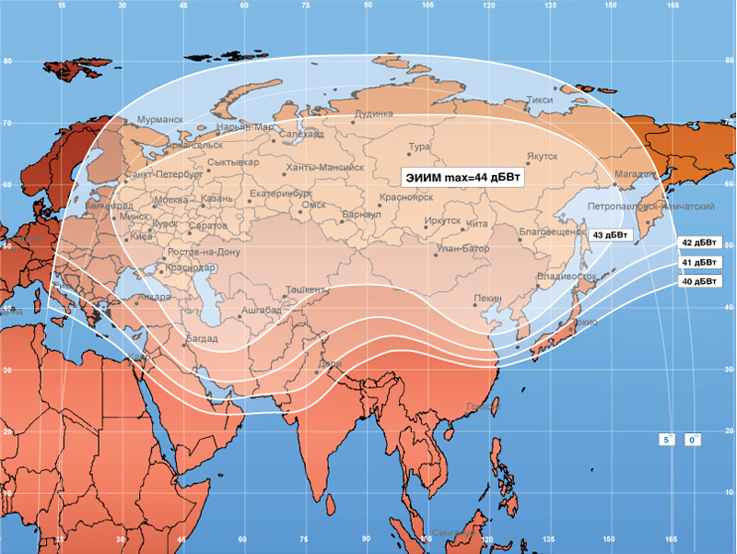

Yamal 200 #1 (90E)
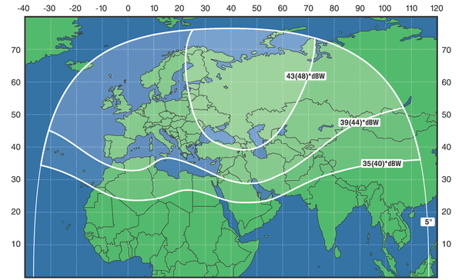

Express AM-1 (40E)

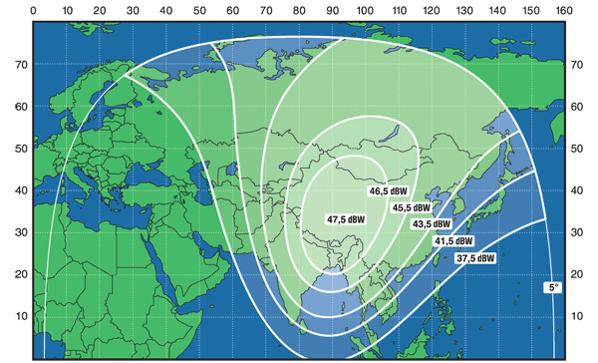

Express AM-2 (80E)

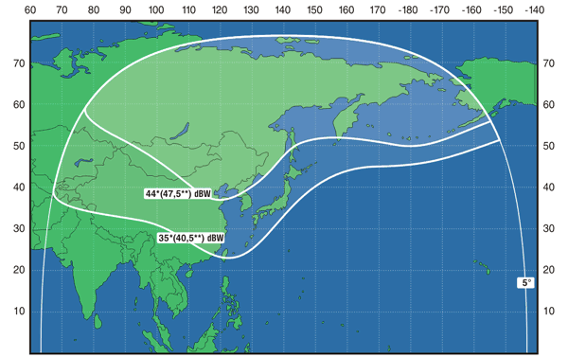

Express AM-3 (140E)

The Express satellites were decided for the purpose of regional area coverage as the overwhelming majority of users are interested in the products of a regional nature or the products (images) of high resolution, which are intended in general for local usage. The Yamal 200#1 satellite which belongs to another operator reserves the Express satellites.

    - Information transmitted

To be transmitted user’s content is to be presented as files, named according to a users’ requirements. Thereby, using MITRA technology, any type to information may be disseminated. As a matter of convenience, disseminated files are aggregated in file flows with predefined priority. Presently in METEOINFORM system the following file flows exist:

- Flow of files with data of the GTS (observed data, forecasts, maps in WMO code forms GRIB, BUFR and etc.)

- Images from satellites NOAA-12, NOAA-15, NOAA-17, NOAA-18

- Products from SRC "Planeta" (http://planet.rssi.ru/english/index_eng.htm) – images and montages from satellites METEOSAT-9, METEOSAT-7, NOAA, GOES-E, MTSAT-1R.

- System flow (for terminals software upgrade, technical support, users’ instruction transmission and etc.)

2.2.3 MITRA Terminal hardware

MITRA terminal is based on wide-spread personal computers with serial low-cost (200-500 USD) communication equipment:

- Satellite dish 1,2-2,4 meters (dish size depends on a terminal geographical position)
- DVB-S receiver card SkyStar 2 (PCI-internal or USB-external modification)

For unscrambling data and users addressing USB key with unique number for each METEOINFORM system subscriber is given.

2.2.4 MITRA Terminal Software

For data receiving special software developed by “RMC TRUST Ltd.” company is used. A connection of the terminal to the MSS on WMO standardized protocols is provided.

Software for presentation text messages and graphic (weather maps, satellite images and etc.) information in standard supply configuration is included.
For deeper processing and sophisticated presentation of various types of hydrometeorological data “GIS Meteo” software developed by MapMakers Group Ltd. (http://mapmak.mecom.ru) is used.

  - MITRA TECHNOLOGY ROBUSTNESS

Unfortunately, satellite broadcasting technologies often used for data transmission in the “push” mode do not assure the delivery of information to a user. There are many reasons for it – noises from active radio equipment, strong wind gusts, solar interference, receiving station overloading, etc. Therefore special care for the system robustness and provision of guaranteed content delivery was spared at the MITRA technology development.

2.3.1 Overlapping of the satellites covering maps

The most part of users of a system based on MITRA technology have a choice to receive data from two or three satellites depending on a signal quality. Using several antennas, adjusted to different satellites, it is even possible to receive data from two or three satellites simultaneously and see a few data flows as unique without duplication. It is also important that satellite Yamal and satellites Express belong to independent satellite operators.

    - Using additional Forward Error Correction (FEC)

For fight with possible data errors additional (in respect of DVB-S standard) FEC is used, which allows to restore a piece of lost information due to signal distortion caused, for example, by radars, GSM relay stations, meteorological factors, etc.

    - Using TCP/IP networks

When the additional FEC is not effective to restore all lost information, any available TCP/IP networks can be used to make sure the true content delivery. The MITRA technology allows a MITRA terminal to pool any number of lost data blocks from other terminals of a system accessible over a TCP/IP network. This method of communications is named “peer-to-peer” and widely is used in various content delivery networks (CDN). Use of this method allows restoring data even in cases of strong distortions of a signal received from a satellite or long breaches of the signal receiving.

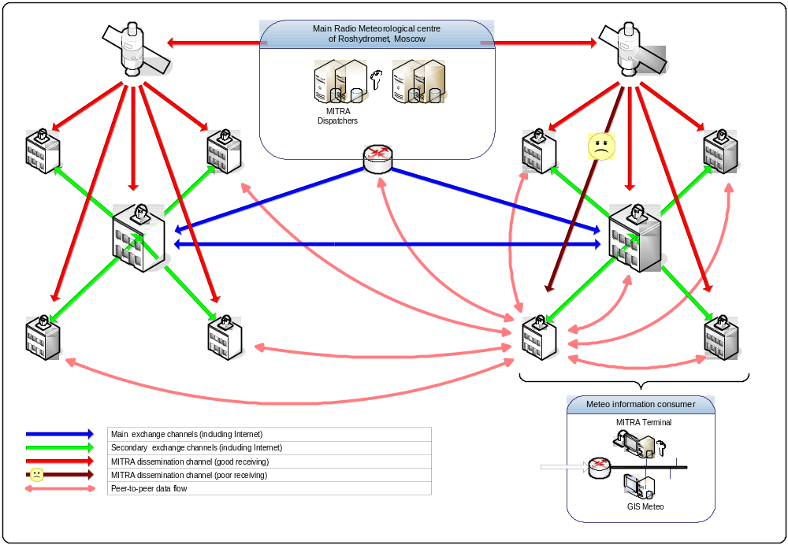

The model of interaction of the MITRA terminals using a “peer-to-peer technology for restoring lost data is shown in the following picture.
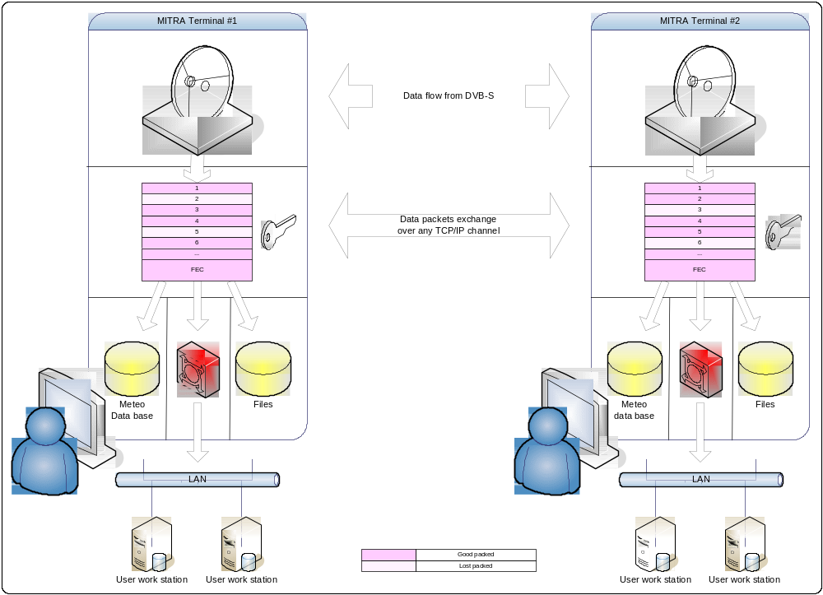
Let us suppose that as a result of the affect of strong noises on the DVB-S signal reception some data cannot be restored by FEC and it found lost. If the terminal shown in the picture are connected between each other by one or several TCP/IP networks, MITRA S/W of Terminal I receives from MITRA of Terminal 2 missing packets (2 and 3 in our picture) and MITRA S/W of Terminal 2 receives from MITRA of Terminal 1 missing packets 3 and 6.Thus, data on the both terminals is found completely restored. In case, when there appear not two but more terminals, information delivery assurance is provided. In such a manner the delivery assurance when transmitting data in the “push” mode is provided. An important feature of the “peer-to-peer” technology is the fact that the network nodes “find” each other themselves, define thee most optimal connections themselves and arrange cooperation `between each other themselves. It allows using simple and clear adjustments for the nodes even in case of a complicated network topology.
2..4 Advantages of MITRA Technology
The use of satellite broadcasting DVB-S technologies for data transmission in the “push” mode together with the “peer-t-peer” technology for the provision of the assurance of delivery has several important advantages over the technologies functioning in the GTS on the principle of message switching:
- Low cost of delivery of information of large volumes to a significant number of recipients;
- Low requirements for the land communication network capacity (surface network, in general, is used only for the restoration of lost data and the input of own content);
- High vitality of the system (outage of one or even several nodes and circuits will not lead to the failure of the rest nodes);
- The simplicity of the system adjustment even on the use of several TCP/IP networks of a complicated topology (the “peer-to-peer’ technology allows building self-organizing networks);
- The whole transmitted content is presented in the form of files and is accessible for the processing by any applications.

3. Dedicated Data Communication Network and Leased Lines
The WMC Moscow takes over all possible actions to move the GTS circuits connected to it to the RMDCN simultaneously increasing the access rate to the RMDCN. In the nearest future the use of VPN-network is envisaged instead of analogue and digital channels and in the national network. However, many of NCs connected to the WMC Moscow for reasons of economy have to use leased lines or VPN through Internet. In this connection the WMC Moscow will support the circuits of this kind arranging in them closed data transmission networks. To optimize the usage of circuit capacity and to reduce the GISC/DCPC server loading, the trials of network application optimization means were conducted.

3.1 Decisions on the Distributed Network Application Optimization

The main purpose of the solution suggested was the provision of efficient access to distant nodes using low speed links to the information of the WMC and adjacent nodes.
The use of traditional TCP created in 80s of the last century gives rise to the following problems of modern applications and protocols which do not allow network applications to function through the WAN with adequate cooperation factors;
- TCP uses the extra quantity of service messages;
- In TCP, repeated data blocks are used;
- In TCP, information is transmitted not in the compressed form;
- The majority of the TCP realizations use an available bandwidth inefficiently.
The solution of these problems and the application work interactivity increase is the main task of the solution of application optimization.

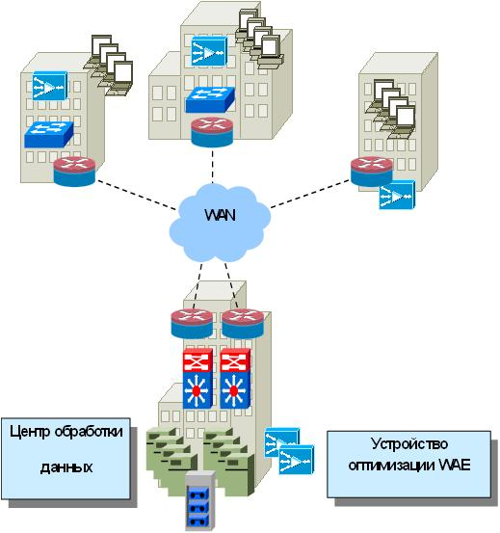

To implement the solution suggested the data processing centre is planned to be equipped with DCPC and GISC devices of application optimization – WAE which let the traffic going between GISC, DCPC and NC pass through itself.
The main functions carried out by this solution:
- Optimization of TCP – use of modern means of operation rate regulation (TFO – TCP Flow Optimization) provides minimum delay on transmitting traffic through the WAN and a minimum response of applications. The optimization device combines the set of the technologies overcoming the restrictions of standard realizations of TCP stacks;
- Efficient use of accessible bandwidth by means of manipulation of TCP Maximum Window Size;
- Large sizes of windows of transmission at the start moment resulting in the increase of primary data rate after installing a connection;
- Efficient discovery and retransmission of lost packets;
- Quick return to optimal data rate after reaching the channel overloading;

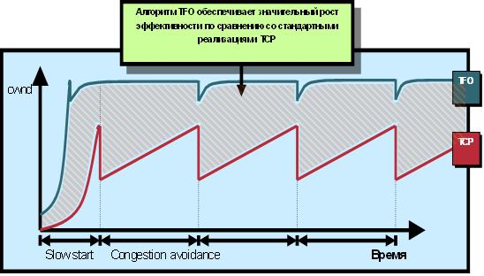
- Caching of application data – provides dissemination of particular popular files beforehand (before their publication on internal resources) on peripheral offices to exclude repeated data transmission through low-speed links;
- Reduction of the quantity of unimportant messages. The optimization devices allow processing the most part of unimportant messages locally without transmission through the WAN. In doing so the response time of network applications such as network printing, access to file servers, etc is reduced;
- Traffic compression - Besides of traditional mechanisms of traffic compression (Algorithm of Lempel – Ziv (LZ) Compression) the devices use an algorithm of the exclusion of repeated blocks (DRE – Data Redundancy Elimination.;
- Algorithm of exclusion of repeated blocks (Data Redundancy Elimination, DRE) is an independent from application transmission of repeated blocks of information in TCP connections, providing the compression of a factor up to 100:1. LZ –compression is session compression using the Lempel-Ziv algorithm provides additional compression up to 10:1 for messages already optimized by DRE.

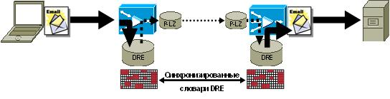

The combination of these two algorithms allows achieving the highest degree of compression without losses, providing thereby fast data transmission over low-speed channels. The advantages of these technologies over traditional solutions on the basis of caching proxy servers are as follows:
- Independence from applications – the same file transmitted by different protocols (for example, HTTP and FTP) in case of caching proxy servers will be transmitted twice and cached twice (the same is true for identical files on different web-pages), while it will be transmitted to the optimization device only once;
- In case of small changes in a file, in case of caching proxy servers the file will be transmitted completely again, only changes parts being transmitted to the optimization device;
- Transparent integration with transport IP network under the support of high accessibility and load sharing;
- Conservation of L3/L4 headers (IP/TCP);
- Conservation of all intellectual network functions – a policy of service quality, internetwork security, etc.

3.2 Outcome of Testing
The solution CISCO WAAS carried out the optimization of applications by means of the optimization of transport and session protocols, in this case it is integrated transparently into the existing infrastructure of the solutions on safety, IP telephoning, management, etc. The use of optimization devices in 64-256 kbps circuits allows achieving the following effects:
- Cost reduction on the data transmission services and support of distributed server part;
- Reduction of message exchange through the WAN;
- On using a 64-256 kbps circuit efficient capacity increases twice (64-256 kbps*2=128-512 kbps);
- Caching of data/metadata;
- Application proxy caching allows an intermediate caching device to process requests of a client to servers eliminating locally the main part of message exchange through the WAN;
- Increase of productivity of the joint server work;
- Increase of the rate of the concrete network application work.

3.3 The factors of the optimization device work:
- Possibility of introduction of “hard” network applications;
- Complex solution;
- Transparent integration to the existing network;
- Performance under real conditions;
- Underloading but not overloading of servers.

4. The Use of Internet
As a main task was the connection of functional and technological systems of Roshydromet telecommunication network of the WMC Moscow (as a structural unit of WIS) to high-performance scientific and educational networks incorporated into international projects such as GLORIAD, GEANT2, Internet-2 and forming of the infrastructure on arranging the internetwork cooperation of technological subsystems of WORLD Meteorological Centres Moscow, Washington, Melbourne and other centres with connections to those networks.
Besides the main task the challenge has been in reducing the costs on the information exchange with international meteorological centres through high-performance scientific-educational networks with the simultaneous increase of connection speed and traffic volume.

4.1 Russian Segment of International Network GLORIAD
The abbreviation GLORIAD means Global Ring Network for Advanced Application Development. An international project under such a name was arranged on the initiative of scientists for the joint solution of significant tasks requiring wide resources – elaboration of a strategy on the work with radioactive materials, planning of actions under the conditions of earthquakes and global disasters, conduction of space investigations, etc. On the part of the USA, the National Centre of Super-Computer Applications (NCSA) takes park in GLORIAD. The GLORIAD project implies in prospect the creation of a ring global network with the capacity of up to 10 Gbps built on the basis of switching technologies. It means that its main task is the arrangement of transport infrastructure for different projects requiring high capacity for the transmission of data of different structures as well as for the creation of virtual private networks (VPN). The details of this project are being finished.

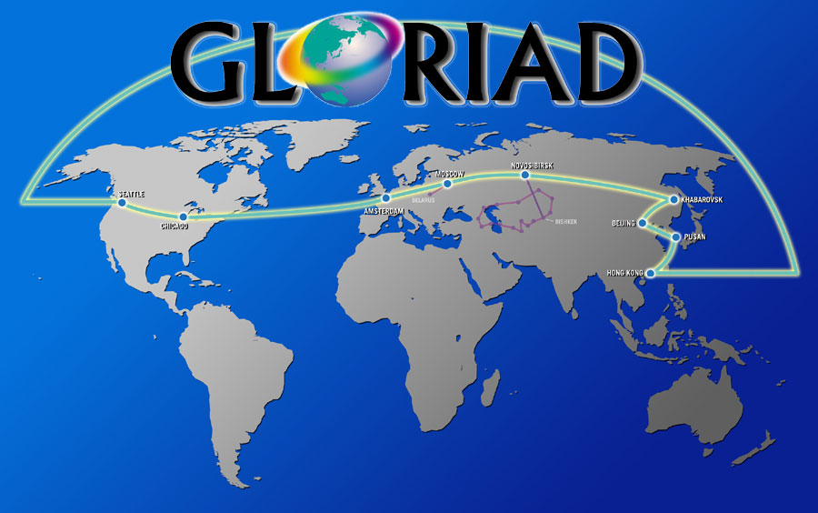

A technological model of the project is proposed in the form of san integrated international trunk within which several projects have been implemented, i.e. access to the Northern country network (NORDUNet), access to the whole-European network GEANT, access to the system of exchange by scientific-educational traffic StarLight, access to general-purpose Internet.

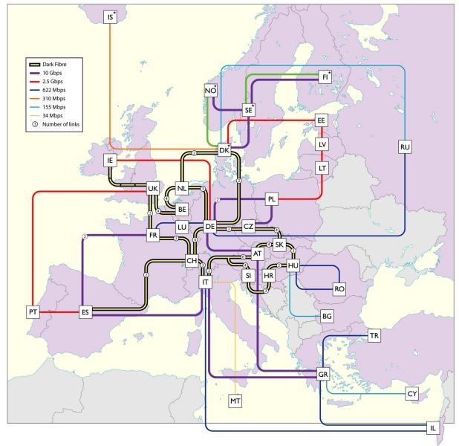

During the last months, in the part of the Russian segment of GLORIAD, there were several significant events related to the expansion of the new network technologies, which allow overcoming the restrictions, existing in the common Internet, and creating the high performance network infrastructure, dedicated particularly to the science projects, where the transmission of a huge volume of data between a geographically distributed databases during a short period of time is required.
In January of 2007, GLORIAD-RU has provided the creation of the 10 Gbps (STM-64) channel between Moscow and Amsterdam, which further is extended up to the USA with 2*10 Gbps+3Gbps channels of the GLORIAD partners from Netherlands and USA.
The current tendency in development of a new generation optical networks for science projects with use of GRID technologies is based on the creation of a global telecommunication centers, such as GOLE (Global Open Lambda Exchange). The MoscowLight, which has been created in 2006, is one of the GOLE centers, performing the distribution of the network resources today for a projects with highly intensive data exchange at the rate of tenth terabytes (petabytes in future).
At the same time there is the agreement (between all GLORIAD participants) of the creation and support of a specifically established channels (lightpaths) for the international science and educational projects.
In particular, national regional centres (Washington and Maryland metropolitan network area) have completed the connection of new equipment that allows the creation of the dedicated optical channels.
It means that there is real possibility for connection meteorological centers at Moscow and Washington WMC with its further extension (lightpath) to Melbourn (BoN) through
StarLight/TransLight/NLR/PNWGP/PacificWave in USA and AARnet in Australia.
Roshydromet takes an active part in the project GLORIAD and hopes that its use will allow implementing data synchronization between GISCs most efficiently.

5. Plans on Implementation of GISC Russia Pilot Project

Planning of the implementation of a GISC at the WMC Moscow provides the following phases.

Phases | Description | Terms
1. | Technical specifications  of the Pilot Project | iV quarter, 2007
2. | Supply and mounting of H/W, S/W | I quarter, 2008
3. | Development and adjustment of the pilot area software | 2 to 4 quarter, 2008
4. | Test operation, cooperation with other GISCs/DCPCs | I quarter, 2009
5. | Finishing of S/W of GISCs/DCPCs according to the outcome of the test operation | I quarter, 2009

The conduction of jobs will be correlated with the WMO plans on the WIS building:
- Consolidation of the WIS development plans: 2007 to 2008;
- Development of regulating the WIS documents: 2007 to 2008;
- Building of the first GISC: 2008;
- Building of the next GISCs: 2009 t0 2011.

As a result of the conduction of the GISC Russia Pilot Project the following activities will be subjected to testing:
- Service of collection/dissemination of data critical to the delay on the “push” technology, including broadcasting dispatches through dedicated telecommunication lines with the assured quality of service;
- Service of retrieval, access and data reception on the request/reply technology and the “pull” mechanism through Internet;
- Service of data/Products delivery on the subscription according to the “push” technology through dedicated telecommunication lines and Internet.

The GISC Russia Pilot Project anticipates, as it is prepared, demonstration of its potentials, namely:
- Collection and dissemination of data and updated metadata catalogues;
- Synchronization of catalogues with GISC-candidates;
- Policy of data access;
- Use of stand-by circuits (Internet);
- Interaction with DCPCs/NCs.

