WORLD METEOROLOGICAL ORGANIZATION  _________________________  INTER-COMMISSION COORDINATION GROUP ON THE WMO INFORMATION SYSTEM  FOURTH SESSION  READING, UK, 4-7 SEPTEMBER 2007 |  | ICG-WIS IV/Doc. 4.3 (1)  (31.VIII.2007)  ____________  ITEM 4.3  ENGLISH only

WIS data-communications functions and services, and implementation

(Submitted by Hiroyuki ICHIJO (Japan))

Summary and the Purpose of the Document

This document is a progress report on activity of Expert Team on WIS-GTS Communication Techniques and Structure (ET-CTS). It shows how ET-CTS will study and design the WIS data communication structure.

Action proposed: The meeting is invited to review this report and to provide comments.

The outcome of CBS/Expert Team on WIS-GTS Communication Techniques and Structure (ET-CTS) [Tokyo, 25-28 April 2006] and follow-up discussion on the WIS data communication structure was reported at ICG-WIS-3 [Beijing, 5-8 September 2006].
The team members are continuing to study and discuss further, and will finalize draft organization and design principles for the WIS data communication structure at ET-CTS 2nd meeting in 2Q 2008. In addition, informative outcome will be input to related meetings such as Implementation Coordination Meeting on Improved MTN (ICM-IMTN) (cloud I) [October 2007] , ICM-IMTN (cloud II, Africa) [1Q 2008] and CBS/Expert Team on WIS GISCs and DCPCs (ET-WISC) meeting [4Q 2007, 1Q 2008].
This document is to show what the team should discuss with a high priority and how the team will approach the solutions.

I Approach models to design for WIS data communication structure
ET-CTS presumed two approach models to seek the most feasible design for WIS data communication structure. One is a totality approach model from the generality to specific parts. The other is an assembling approach model from individual parts to synthesizing. The team will discuss how design principles could be developed by using the models.

1. Totality approach model
In this model, design principles will be considered according to the following steps:
i) create a global any to any network (e.g. Global MPLS Cloud);
ii) provide an IPVPN backup solution keeping any to any connectivity;
iii) on top of the any to any network connection map the needed application connection.

Consideration points are:
i) how to connect with WIS participants other than NMHSs;
ii) administrative aspects such as coordinated contract, management and governance;
iii) gateway issues such as responsibility, the expected number and technical requirement
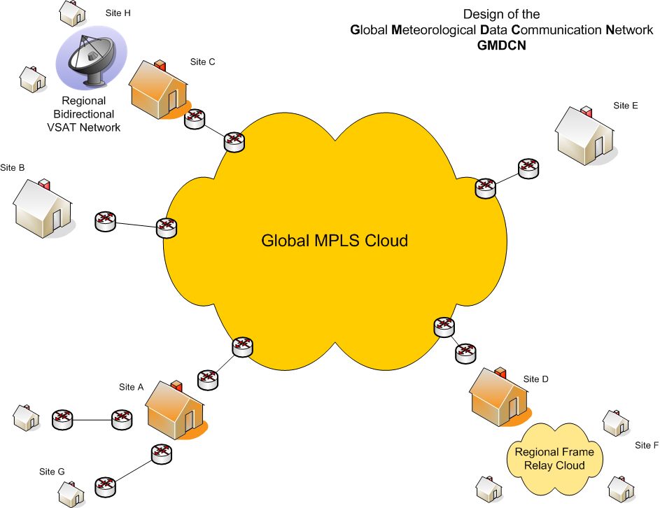
Site D acts as a gateway for Site F
Site A acts as a gateway for Site G

Figure 1 Example of a global any to any network with gateways
2. Assembling approach model
The team has been discussing design principles of individual components of WIS data communication structure based on this model so far. The reasons for adoption of the model are:
i) differences between components in migration target period, feasibility and accuracy of implementation plans, the number of related centers, required specifications, design flexibility and coordination difficulties in administrative aspects;
ii) importance and requirements of initial establishment of a WIS core network
iii) understandability and easiness of study on practical design and smooth evolution and migration.

Consideration points are:
i) how to harmonize all components as a WIS data communication structure;
ii) administrative aspects in each component;
iii) how to shorten long term migration period.
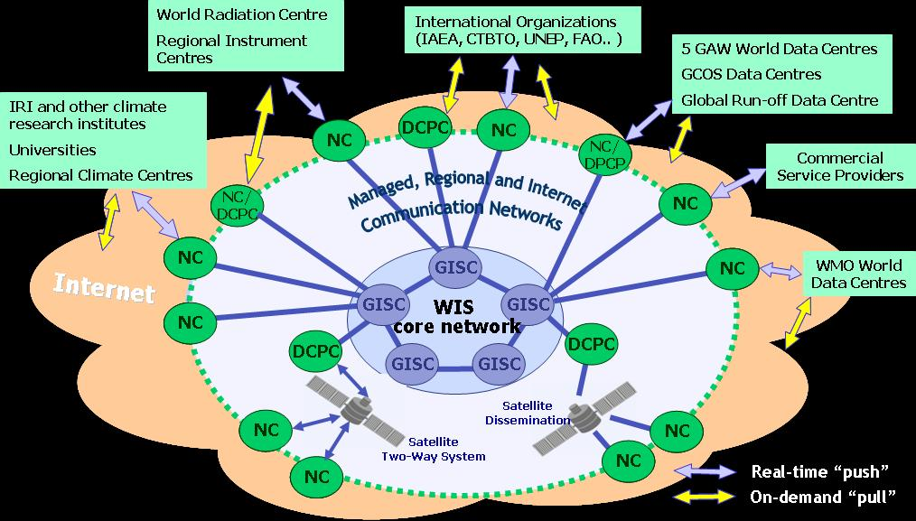
Figure 2 Conceptual structure of WIS networks

II Further study items with a high priority

1. Concepts for the WIS core network
The new WIS core network will be an evolution of the existing telecommunication facilites, with emphasis on somewhat general purpose functionality. This can be achieved through TCP/IP protocols, but requires careful planning.
An important part of this planning is the decision on a core network topology which takes into account the needs of WIS, the needs of the member countries and the diversity in geography, technical capability and administrative capabilities around the world. A key decision in this network topology is the use of a single or multiple core networks. Furthermore, procurement limitations need to be studied as they will greatly impact this decision.
1.1 Backup for a WIS core network
The team should consider the necessity of a backup network to the WIS core network, and the effects of multiple suppliers versus a single one. General risk management concepts and possible backup cases with frequency and duration should be studied.
And then if necessary the team should find possible option(s) from the views of their effectiveness, difficulty in implementation, security, backup control, traffic management and cost tolerance. At least the following two options should be considered.

(1) Internet backup
Although fallback/backup interim solutions via the Internet are already introduced into parts of the GTS, they are not comprehensively coordinated as a network-oriented solution.
On the other hand, RMDCN in RAVI has a comprehensive backup plan well-coordinated by RMDCN Operational Committee (ROC). The principles of the backup plan via the Internet are as follows:
i) the backup should be automatic;
ii) it should be able to carry all RMDCN traffic (even if the "link" is only established with ECMWF, the traffic for the country using Internet backup will "re-injected" into the RMDCN at ECMWF);
iii) it should use IPsec to secure the connection over the Internet.

As the MPLS migration of RMDCN has been completed in July 2007, the backup over the Internet will be established initially among volunteers countries in Q4-2007. The empirical outcome will be a good contribution to the study, especially guideline on the following points.
i) Backup control, automatic or manual
ii) Security requirements and sustainable level
iii) Limitation of backup traffic

(2) Dual network configuration for risk management and administrative reasons
Dual network configuration could be the most desirable from the view points of importance of the WIS core network and smooth migration from existing IMTN of two clouds. On the other hand, the running cost may be a serious problem. The team will study its possibility and appropriateness considering the following points:
i) Risk avoidance by two suppliers in the business view such as sudden economical change and bankruptcy
ii) Cost tolerable condition
iii) Usual traffic load balancing
iv) May be easier to implement administratively
v) May be more technically complex and not as flexible as required by WIS
GISC
WIS core network
Internet
GISC
GISC
GISC
GISC
WIS core network #1
WIS core network #2
GISC
GISC
GISC

Figure 3 Internet backup and dual network configuration of the WIS core network

1.2 Backup connections with alternate GISCs
The team could propose various traffic scenarios (such as in the following table) from an NC view point and should recommend necessary backup cases with appropriate options by alternate GISCs.

Backup traffic | Usual connection | Backup connection
Time-critical operational data | GTS connection with GISC#1 | - GTS connection with GISC#2  - Temporary Internet VPN with GISC#2  - Others, i.e. Web-reporting and e-mail report/distribution
Time-critical operational data | GTS connection with DCPC#1 in GISC#1 responsibility area | - GTS connection with GISC#2  - Temporary Internet VPN with GISC#1  - Temporary Internet VPN with GISC#2  - Others, i.e. Web-reporting and e-mail report/distribution
Near real-time products | GTS connection with GISC#1 | - GTS connection with GISC#2  - Temporary Internet VPN with GISC#2  - Others, i.e. IGDDS
Near real-time products | Permanent Internet VPN with GISC#1 | - Temporary Internet VPN with GISC#2  - Others, i.e. IGDDS
Near real-time products | GTS connection with DCPC#1 in GISC#1 responsibility area | - GTS connection with GISC#2  - Temporary Internet VPN with GISC#1  - Temporary Internet VPN with GISC#2  - Others, i.e. IGDDS
Near real-time products | Permanent Internet VPN with DCPC#1 in GISC#1 responsibility area | - Temporary Internet VPN with GISC#1  - Temporary Internet VPN with GISC#2  - Others, i.e. IGDDS
Near real-time products | IGDDS (satellite broadcast, Internet distribution) | - Temporary Internet VPN with GISC#2  - Temporary Internet VPN with GISC#1
Ad hoc request/reply | Internet access to GISC#1 portal | - Internet access to GISC#2 portal
Ad hoc request/reply | Internet access to DCPC#1 portal in GISC#1 responsibility area | - Internet access to GISC#1 portal  - Internet access to GISC#2 portal




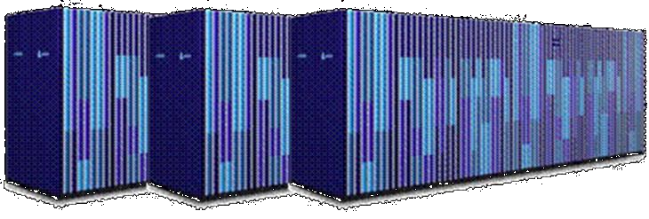
Figure 4Example configuration and backup case
Internet
GISC-NC connection components
GTS
for time-critical operational data
GISC
NC
Internet
Portal
Internet access to a portal
for ad hoc request/reply
Internet VPN link
for near real-time products
NC
GISC#1
GTS
Alternate
GISC#2
Internet VPN
Backup
case
VPN
VPN
2. Smooth evolution and migration scenario
Understanding that smooth evolution and migration from the GTS to WIS network is of particular importance, the team should do careful works from status analysis to feasibility of future vision.

2.1 Evolution process from the Improved MTN to the WIS core network
The ET should review the outcomes below carefully and provide an evolution guideline for upcoming meetings concerned such as ICM-IMTN (Cloud I) in October 2007 and ICM-IMTN (Cloud II, Africa).

(1) Consideration on WIS core network
The tentative outcomes of the ET-CTS follow-up activity and ICG-WIS discussion are:
- Use of closed network cloud(s) by SLA based service
Closed network cloud(s) can be established rather than using the Internet. These services would be contracted under Service Level Agreements (SLA). The Improved MTN currently consists of two closed network clouds governed by SLA based services. The existing networks should evolve into the WIS core network.

- Limitation of the number of GISCs for practical reasons
From a technical point of view, the introduction of the "Data Grid" concept could remove limitation of the number of GISCs. However from an administrative and organizational point of view, it is doubtful that a global Virtual Organization encompassing all the nodes connected to the "Data Grid" can be achieved at the present day. A large number of GISCs would be difficult to manage.

- Benefit of full-mesh topology in case of the small number of GISCs
Full-mesh topology will bring two benefits: (1) it brings maximum redundancy in the configuration of GISC backup channels, (2) it brings operational simplicity in data synchronization.
It may be sufficient for backup purposes to ensure 3 separate paths from one GISC to another in most cases. In this sense, it is not a MUST but a preferable method. On the other hand, from an operational view, it ensures very convenient and reliable data exchange with minimum delay. In this sense, it is strongly desirable. It should be noted that if the number of GISCs is large, it would burden each GISC with heavy load and extra costs.
Taking all the factors into consideration, it is estimated that full-mesh topology is possible as long as the number of GISCs is less than seven.

(2) Consideration on evolution
One of the most important factors in a WIS core network is data synchronization on "application" connections among GISCs. The technical view points in the implementation are to reduce system and network loads by multiple traffic of original data and to avoid switching delay. Considering these, it is desirable that the WIS core network would be designed on multicast-oriented architecture.
However there is a reality that all of available global network services are currently on unicast-oriented. Even MPLS providing any-to-any connectivity cannot support multicast transmission.
By reason of unicast network, necessity of full-mesh topology has been discussed. The full-mesh idea is that a GISC has "application" connections to all other GISCs and transmits the same data to them multiplicatively in spite of making traffic heavy. On the other hand, there is a different idea that the full-mesh topology is not always necessary as long as a sophisticated Data Grid application such as SIMDAT is used.

GISC
Unicast-oriented
network
GISC
GISC
GISC
Responsibility Area
GISC
Multicast-oriented
network
GISC
GISC
GISC
Responsibility Area
Multicast group

Figure 5 Unicast and multicast

IPv6 is a promising opportunity to migrate from unicast to multicast-oriented networks. Because IPv6 multicast has several advantages over IPv4 multicast. As IPv6 has its huge address space and originally designed specifications for multicast, we can use multicast more freely and easily. Furthermore multicast-enabled infrastructure is easier to build, as multicast is a natural requirement in IPv6 implementation. The problem is nobody knows when IPv6 based network services will become available for the WIS core network.

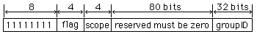
Figure IPv6 multicast address format
The first 8 bits in multicast address is always 1111 1111 (which is FF in hexadecimal format). Flag uses the 9th to 12th bit and shows if this multicast address is predefined (well-known) or not. If it is well-known, all bits are 0s. Scope ID occupies from 13th to 16th bit Scope ID=2, for example, is link-local scope.
Group ID is used to specify a multicast group. There are predefined group ID, such as Group ID=1 as all nodes. Therefore, if multicast address is ff02;;1, that means Scope ID=2 and Group ID=1, indicating all nodes in link-local scope. This is analogous to broadcast in IPv4.
Figure 6 IPv6 multicast address format

However in use of multicast, it is necessary to make sure it is reliable multicast. Otherwise receivers with slower or more loaded links or completely broken links will influence the whole transmission because of the necessary retransmissions.

Considering those, the following evolution processes may be one of scenarios studied by the team.
.
    - Initial WIS core network composed by related connections within existing two IMTN clouds
  - Unicast-oriented network
  - Cloud I : FR to MPLS in 2008 , Cloud II : already MPLS
  - Non-full-mesh with a sophisticated Data Grid application such as SIMDAT

    - Improved WIS core network by a single cloud
  - Unicast-oriented network
  - Consolidate related connections in two clouds within a single cloud
  - Complete full-mesh topology with additional connections in the single cloud

    - Final WIS core network
  - IPv6 infrastructure supporting unicast and multicast
  - Full-mesh topology with a simple data synchronization
Exeter
Sofia
Melbourne
Buenos Aires
Tokyo
Beijing
Nairobi
Washington
Cloud I
Jeddah
Prague
Toulouse
Dakar
Algiers
Offenbach
Brasilia
Cairo
New Delhi
Moscow
Cloud II

Figure 7 Current IMTN configuration consisting of two clouds
2.2 Adjustment of the current GTS configuration to WIS topology
Fifteenth Congress in May 2007 emphasized that the WIS implementation should build upon existing WMO information systems in a smooth and evolutionary process. It agreed that the WIS implementation plan has two parts that would be developed in parallel:
- Part A: the continued consolidation and further improvements of the GTS for time-critical and operation-critical data, including its extension to meet operational requirements of WMO Programmes in addition to the World Weather Watch (including improved management of services);
- Part B: an extension of the information services through flexible data discovery, access and retrieval services to authorized users, as well as flexible timely delivery services.

Congress emphasized that, in implementing Part A of the WIS implementation plan, highest priority should be given to overcoming the persisting shortcomings in the current GTS implementation.

The team should analyze the persisting shortcomings and their causes in the current GTS and consider how to overcome them strategically. Furthermore the ET should study what adjustment of the current GTS is necessary to WIS hierarchical topology.

Note) The ET-CTS meeting in April 2006 noted that there was apprehension about inheritance of the GTS deficiencies as follows:
- The WIS functional structure (i.e. GISC-DCPC-NC) is similar to the GTS one (i.e. [WMC] – [RTH] – [NMC] or [RTH on MTN] – [RTH not on MTN] – [NMC] ) in hierarchical design principle;
- Thus the WIS may inherit the deficiencies of the current GTS such as garbling bulletins, imperfect dissemination of global exchange data, undesirable message loop and serious delay.
However it should be clarified that the current GTS deficiencies are caused by not hierarchical design but defects of implementation and operation.

3. Standardization of protocols and procedures
Fifteenth Congress emphasized the need for appropriate regulatory documentation including organization and recommended practices and procedures (e.g. a Manual on WIS) as well as an implementation plan and guidance material for facilitating the implementation by Member countries at global, regional and national levels. It tasked CBS, in collaboration with the ICG-WIS, to develop regulatory documentation in phases based on the validation of preliminary organizational, functional and operational design.

The standardization of protocols and procedures need more attention at the early stage as this has implications on the feasibility of technical solutions as well as smoothness of the subsequent implementation.
In this context, the team should contribute technical recommendations to regulatory documentation. Possible technical contribution items are as follows:
- Comparison of VPN techniques (IPsec, PPTP, SSL and SSH)
- Differences between WMO standards in Attachment II-15 (Use of TCP/IP on the GTS) and industrial standards
- Standard VSAT
Furthermore, an important aspect is the definition of the governance structures to control data flows and growth of traffic. In the past, the nature of the GTS would organize the data flows and define the limits at the same time. The governance was therefore a matter left in many cases to the telecommunication managers. In a new WIS core network, telecommunications becomes ubiquitous and general purpose. The telecommunication managers may not be able to see and control data flows and growth. Governance of this aspect of the data exchanges may need to be redefined.

4. Administrative aspects
The following administrative items have not been studied and discussed by the team because of its difficulty and sensitiveness. However they should be studied in cooperation with other teams and/or groups such as ICM-IMTN groups and the IGDDS implementation group. It is recognized that these are important problems, in particular the fact that many governments have procurement rules that limit the possibilities for contracting telecommunication services with outside countries.

4.1 Hurdles in administrative aspect of the collaboration framework by multi-nations
4.2 Adaptability to contracts on SLA and agreement on MoU
4.3 Appropriate collaboration schemes for satellite-based communication systems (DVB-S)
4.4 Appropriate collaboration schemes for Internet-based distribution mechanisms

5. Technical solutions of key issues
The ET-CTS meeting in April 2006 touched on the following technical issues but did not yet arrive at solutions. The team is expected to propose solutions in this work term.

5.1 Complementary Internet VPN links for overflow traffic
This idea is worth studying its feasibility though it seems rather difficult to achieve at the network level. The team has not found a solution on how overflow traffic can be directed to another network. There is a simple concept of the "real-time operational critical data" through the private network and all other data through the Internet. It may be a practical solution.

GISC
DCPC
Closed network
Internet VPN

Figure 8 Image of complementary Internet VPN for overflow traffic

5.2 Effective load balancing on dual network configuration
From a network point of view, the team has not found a firm solution on load balancing.another network.

5.3 Possible services for mobile terminal users

