WORLD METEOROLOGICAL ORGANIZATION  _________________________  INTER-COMMISSION COORDINATION GROUP ON THE WMO INFORMATION SYSTEM  FIFTH SESSION  BRASILIA, BRAZIL, 14-17 JULY 2008 |  | ICG-WIS V/Doc. 4.2 (1)  (10.VII.2008)  ____________  ITEM 4.2  ENGLISH only

Report on WIS VPN Pilot Project in Regions II and V

(Submitted by Hiroyuki ICHIJO (Japan))

Summary and the Purpose of the Document

This document is to report the status and plans of the WIS VPN Pilot Project in Regions II and V.

Action proposed: The meeting is invited to review this report and to provide comments.

1. BACKGROUND
The WIS VPN Pilot Project in Regions II and V (Hereinafter referred to as Project) was launched in 2003 as one of the WIS related projects aiming at developing and evaluating technologies required by the WMO Information System (WIS), in particular, evaluating accessibility and effectiveness of the Internet VPN (Virtual Private Network).
The first phase of the Project, which specifically intends to evaluate the VPN technology itself, was successfully completed in September 2004. The advanced (second) phase of the Project started in August 2005 to evaluate stability and availability of the VPN technology through application level tests assuming operational data exchange within WIS.

This document briefly reports on the current status and progress since the last session of the ICG-WIS (August 2007).

2. CURRENT STATUS
2.1 Participants
Sixteen NMHSs are participating in the Project at present. The number of participants in the Project remains the same as in 2007. The current participant list is shown in Table 1. The number of participants has been increasing steadily from 11 in the first phase with the support to the Project by WMO (see Figure 2).

Table 1. Participants in the advanced phase
Country, terriroty | Organization | Site
Region II
China | China Meteorological Administration | Beijing
Hong Kong, China | Hong Kong Observatory | Hong Kong
India | India Meteorological Department | New Delhi
Isramic Republic of Iran | Isramic Republic of Iran Meteorological Organization | Teheran
Japan | Japan Meteorological Agency | Tokyo
Oman | Meteorological Department | Muscat
Republic of Korea | Korea Meteorological Administration | Seoul
Saudi Arabia | Presidency of Meteorology & Enviroment | Jeddah
Vietnam | National Hydrometeorological Service | Hanoi
Region V
Australia | Bureau of Meteorology | Melbourne
Brunei Darussalam | Brunei Meteorological Service | Bandar Seri Begawan
Fiji | Fiji Meteorological Service | Nadi
Malaysia | Malaysian Meteorological Service Department | Kuala Lumpur
New Caledonia | Meteo-France, New Caledonia | Noumea
New Zealand | MetService | Wellington
Republic of Singapore | National Environment Agency | Singapore

2.2 Status of establishing their VPN links
Almost all participants have permanent connections to the Internet at a speed of over 512kbps as shown in Figure 1.

Hong Kong
India
Iran
Korea
Oman
Saudi Arabia
Vietnam
Australia
Brunei
Malaysia
New Zealand
China
Japan
Singapore
Fiji
Figure 3Outline of reporting observation data
New Caledonia
10Mbps(MAX)
2Mbps
4Mbps
512Kbps
2Mbps
1Mbps
100Mbps(MAX)
3Mbps
2Mbps
2Mbps
1Mbps
100Mbps(MAX)
100Mbps(MAX)
128Kbps
Kbps
256M(MIN)-
440Mbps(MAX)

Internet
Figure 1. Internet connectivity for the WIS VPN Pilot Project

- RECENT PROGRESS

Taking into account importance of the Project for evaluating WIS related developments and providing developing countries with an occasion to participate in WIS development, the Project needs to be continued, at least, until specifications of operational WIS are fixed. In the advanced phase, it is planed to promote the thematic sub-phases.

(1) Prototype application software
As reported at ICG-WIS-IV, JMA started to provide prototype application software named SATAID and the data and products formatted for it in October 2006. The SATAID is a sophisticated stand-alone program for visualization and manipulation of satellite imagery and NWP products. JMA has developed an upgraded-version of the SATAID software. In June 2008, the upgraded-version was made available on the VPN server in addition to its old version. A long-term evaluation test by participants is under progress.

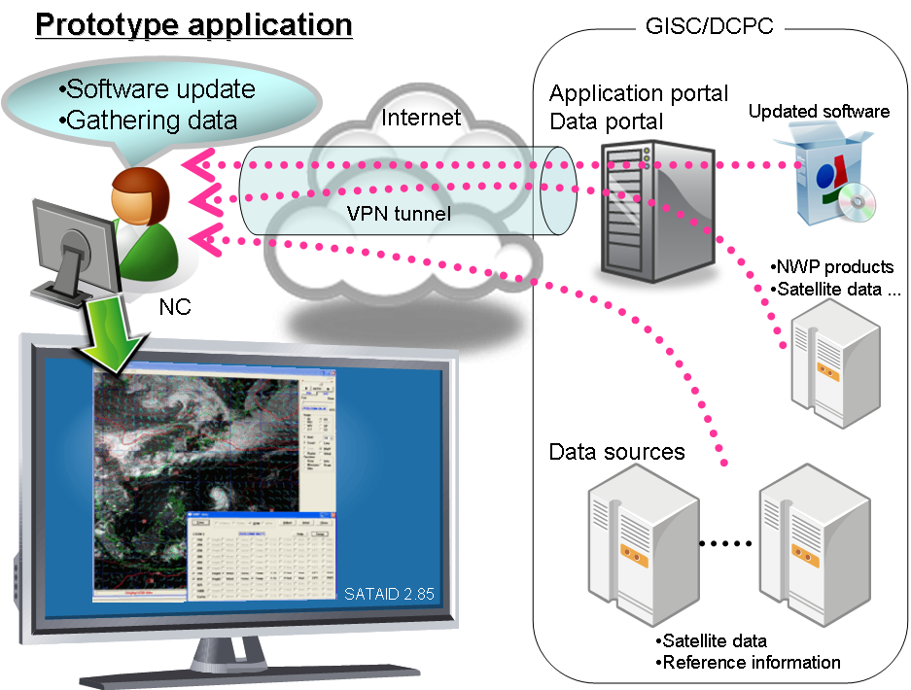
Figure 2. Long-term evaluation test for a prototype application in advanced phase

- Reporting observation data

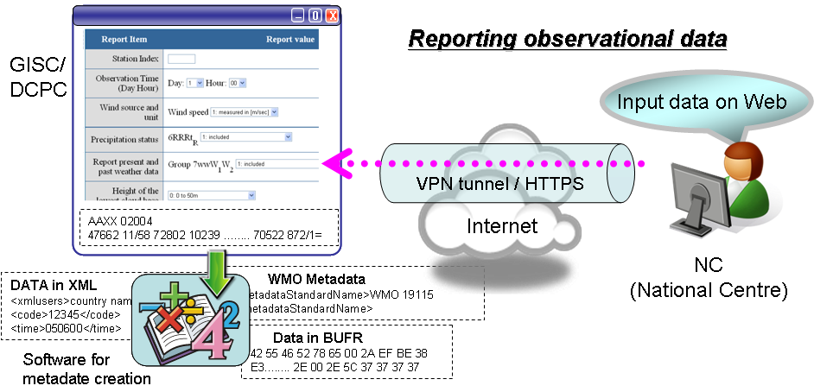
Figure 3 Outline of reporting observation data

CMA has developed a Web Data Ingest – WDI for reporting observation data through the Internet VPN setup in RA II and RA IV in 2008. It is designed as follows with the view of scalability and reusability.
- Portal Layer: It is a part of the Beijing WIS portal, and provides the web interface of collecting observations via HTML form or file upload.
- Service Layer: It includes HTML form service, file upload service, user service and management service.
- Provider Layer: It provides the basic data management service, including BUFR encoding, data storage based on file system and database.

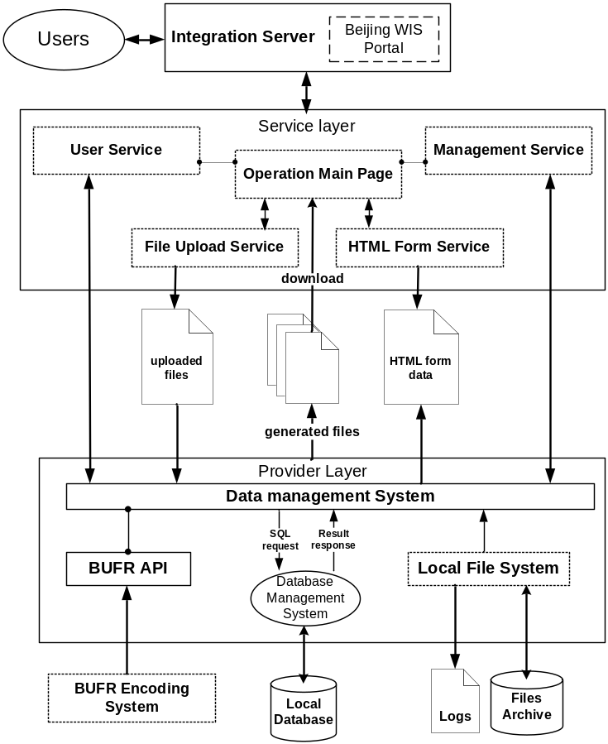
Figure 4. The architecture of Web Data Ingest

The WDI and its User Guide can be accessed via the URL of http://wisportal.cma.gov.cn/web_ingest.jsp. In current phase, the implemented functions include:
- Collecting GTS observations via HTML form and downloading the ingested data files;
- Collecting GTS data and products via file upload interface;
- Converting the ingested SYNOP, TEMP, CLIMAT, CLIMAT TEMP messages in A/N codes to BUFR messages;
- Checking the AHL and message format for the ingested observation data;
- User registration and management interface;
- Logging and querying user activities and data ingesting status.
And, the metadata generation function is being developed.
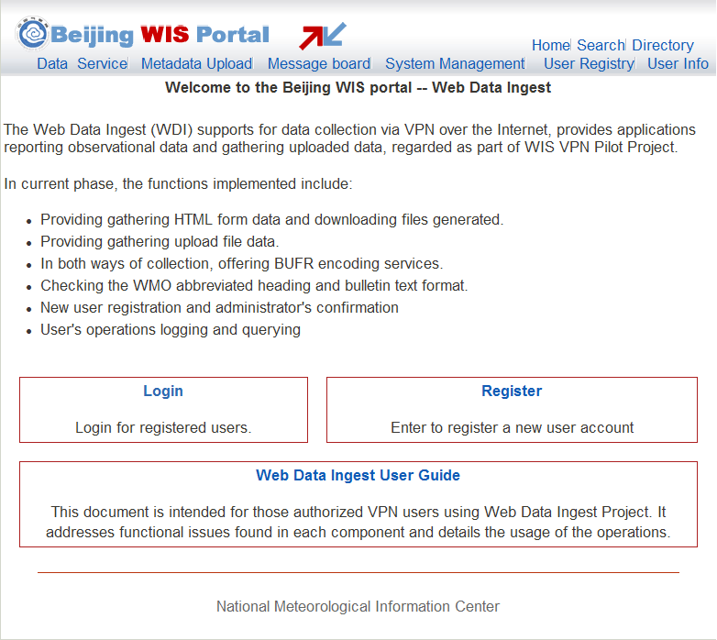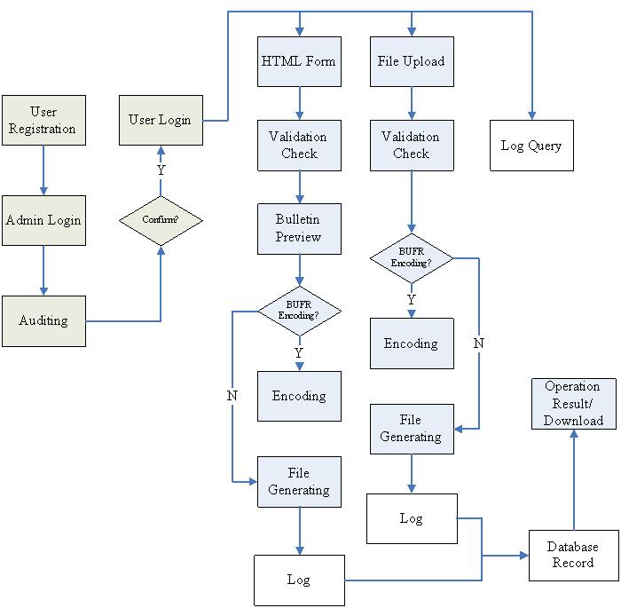
Figure 5. WDI and its function flow

4. Contribution of the Project for WIS implementation
The Project is expected to contribute to the WIS implementation through the following activities

(1) Technical consulting body on VPN
The Project will play the role of a technical consulting body on VPN data communications for WIS semi-operation components in all Regions. The Project continues to provide empirical outcomes and technical tips to WIS community.

RA I, at its 14th session (Ouagadoudou, Burkina Faso, February 2007), approved establishment of RA I WIS pilot projects. One of them is a VPN Pilot Project in RA I (RAI Project, hereinafter) coordinated by Mr William Nyakwada from Kenya (RA I WG-PIW Chair). Participants of the Project agreed with pleasure that the Project would support technical aspects of the RAI Project. It is expected that core centers in RA I would acquire technical knowledge and capability to establish and manage their own RA-I Project through their participation in the VPN Pilot Project in RAs II and V.

(2) Prototype mechanisms at WIS application level
The Project will develop WIS prototype services at an application level and verify them through participants’ trial use. Some of the WIS prototype services developed by this Project may be applied to services in other Regions. The previously-mentioned recent progress in web input experiment for reporting observation data could be an example.

(3) Capacity building for participants in WIS semi-operation
The Project will provide the participants with better environment so that they can gain experiences on use of VPN and WIS services on a trial basis, and consequently, it would contribute to the early migration to the operational WIS.

