WORLD METEOROLOGICAL ORGANIZATION  _________________________  INTERCOMMISSION COORDINATION GROUP ON THE WMO INFORMATION SYSTEM  SECOND SESSION  BOULDER, USA, 24-27 OCTOBER 2005 |  | ICG-WIS II/Doc. 3(3)  (21.X.2005)  ____________  ITEM 3  ENGLISH

Status of WIS VPN Pilot Project in Regions II and V

( Submitted by Hiroyuki ICHIJO (Japan) )

Summary and the Purpose of the Document

The document provides the present status of the VPN Pilot Project in Regions II and V with a tentative road map towards WIS initial implementation.

Action Proposed :
The meeting is invited to review the information presented in the document.

Appendix :
Detailed information document “FWIS VPN Pilot Project in Regions II and V - Considering the role of the GTS as a communication component of the FWIS” submitted to ICG-FWIS First Session (Geneva, 12-14 January 2005)
1. Fundamentals of the Project
Executive Council-LVII (June 2005) agreed with CBS-XIII and the ICG-FWIS to use the name "WMO Information System (WIS)" instead of "Future WMO Information System (FWIS)", because the qualifier "Future" in the name was no longer adequate at the progressing stage to the implementation phase. According to the agreement, "FWIS VPN Pilot Project in Regions II and V" started in 2003 has been renamed "WIS VPN Pilot Project in Regions II and V". The project is in progress steadily incorporating new subjects into its advanced phase. To keep motivation and the direction towards WIS implementation, it is worth recalling the following fundamentals of the project.
a) Contribution to WIS development through empirical and practical study
b) Regional collaboration supported by voluntary participation of centers under various conditions such as enough or insufficient expertise, and excellent or poor facilities
c) Bottom-up scheme by participants’ opinions and ideas

Positive activities based on these fundamentals are as follows:
a) To report the outcome from the feasibility tests and evaluation to Expert Teams and conferences concerned
b) To invite potential NMCs/RTHs widely to participate in the project with WMO invitation letters
c) To promote exchanging opinions and sharing information among participants preparing mailing-list and the project web site with discussion room

2. Current Status
(1) Expansion of participants
In addition to eleven participants in the fundamental phase, Iran and Oman were willing to participate in the project from the advanced phase.

Participants in the advanced phase
Country, terriroty | Organization | Site
Region II
China | China Meteorological Administration | Beijing
Hong Kong, China | Hong Kong Observatory | Hong Kong
India | India Meteorological Department | New Delhi
Isramic Republic of Iran | Isramic Republic of Iran Meteorological Organization | Teheran
Japan | Japan Meteorological Agency | Tokyo
Oman | Meteorological Department | Muscat
Republic of Korea | Korea Meteorological Administration | Seoul
Saudi Arabia | Presidency of Meteorology & Enviroment | Jeddah
Vietnam | National Hydrometeorological Service | Hanoi
Region V
Australia | Bureau of Meteorology | Melbourne
Brunei Darussalam | Brunei Meteorological Service | Bandar Seri Begawan
Malaysia | Malaysian Meteorological Service Department | Kuala Lumpur
New Zealand | MetService | Wellington

(2) Preparations for the advanced phase
The participants have prepared facilities and human resources necessary for evaluation tests in the advanced phase. Each of them has prepared individual facilities required for each sub-phase and each role in simulated configurations, in addition to the Internet access environment through permanent connection with a VPN router and/or a VPN product/box.

[Sub-phase 1 - Reporting observational data]
Simulating NC : Windows PC with browser

Simulating GISC/DCPC : Web server for data injection with software for metadata creation and conversion from the injected data to BUFR
Data in XML
2132330E1A10FE00112A0B0AA
Data in BUFR
<xml>
<xmlusers>country name</xmlusers>
<code>47401</code>
<date>20050101</date>
<time>0600</time>
<winddeg>360</winddeg>
<windspeed>10</windspeed>
<view>20</view>
<temp>12.4</temp>
<dew_point>9.7</dew_point>
<pressure>1002.5</pressure>
</xml>
Reporting
observational data
NC
(National Centre)
Secure connection
(VPN or HTTPS)
Internet
Input data on Web
47401
01
01
0600
360
10
20
12.4
9.7
1002.5
Station index
SMJP01 RJTD 010600
AAXX 01064
47401 41/70 23610 10124 20097 40025 ....=
Dew point
Date/Time
WIND_dir
WIND_spd
Visibility
Air temp
Pressure
Windows PC
Web server
GISC/DCPC
Software for metadata creation and BUFR conversion

[Sub-phase 2 – Cooperation with UNIDART (Data Portal)]
Simulating NC : Windows PC with browser
Simulating GISC/DCPC : Server with Linux OS (Red Hat or SuSE) for provision of data/products with metadata. Oracle client software and globus or UNICORE are also required.


Data sources
Data GRID
VPN
Data source
Request/Reply
with authentication
Matadata
Internet
Cooperation with
UNIDART
Windows PC
Linux server
Oracle client
Globus / UNICORE
GISC/DCPC
NC
UNIDART portal
Catalogue

[Sub-phase 3 – Prototype application]
Simulating NC : Windows PC with Internet Explorer
SATAID* and other software provided by JMA
*) a prototype application tool for visualization and manipulation of satellite and synoptic data and numerical products
Simulating GISC/DCPC : FTP server for provision of data/products with metadata
HTTP server as a portal site
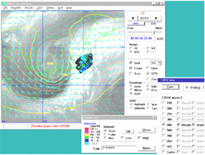


NWP products
Satellite data
Updated
Application software
Prototype application
NC
Internet
Application portal
Data portal
Satellite data
Reference information
Data sources
VPN
Gathering data from
different data sources
Software updating
Windows PC
HTTP server
FTP servers
GISC/DCPC
SATAID

(3) Establishment of the project web site with discussion room
The project web site established in July 2005 to share information among participants is gradually improving in its contents. Especially it is expected that a discussion room would promote exchanging opinions and mutual understanding.

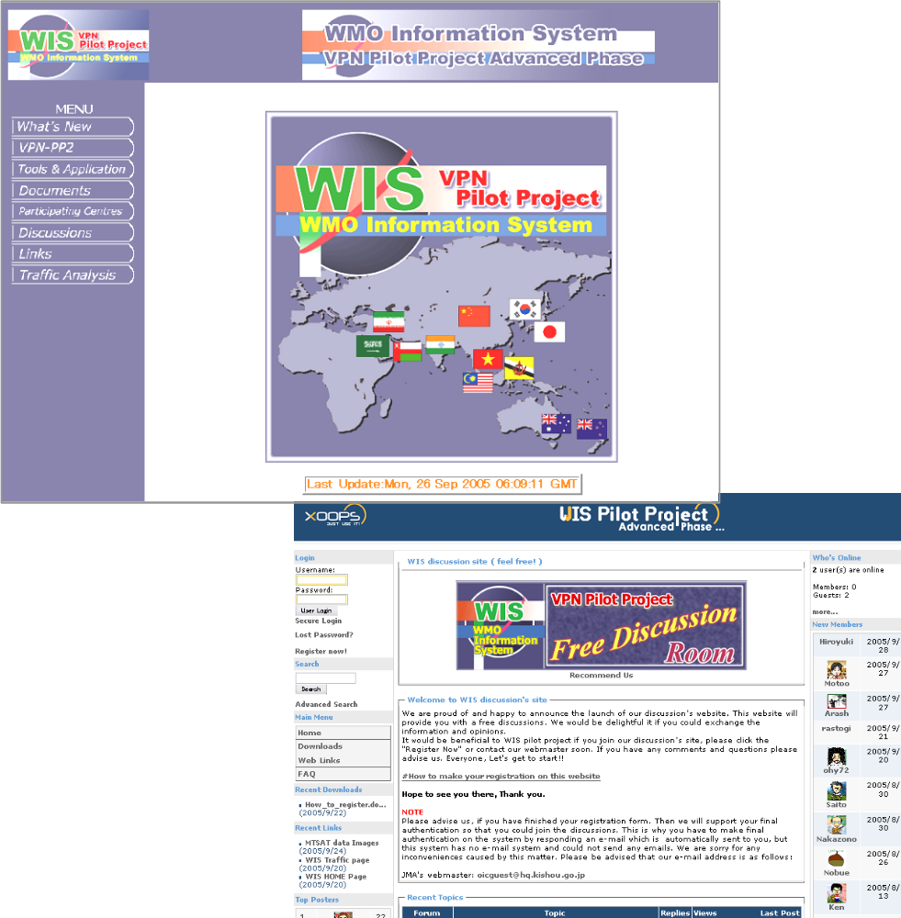

(4) Analysis of access ability through the Internet
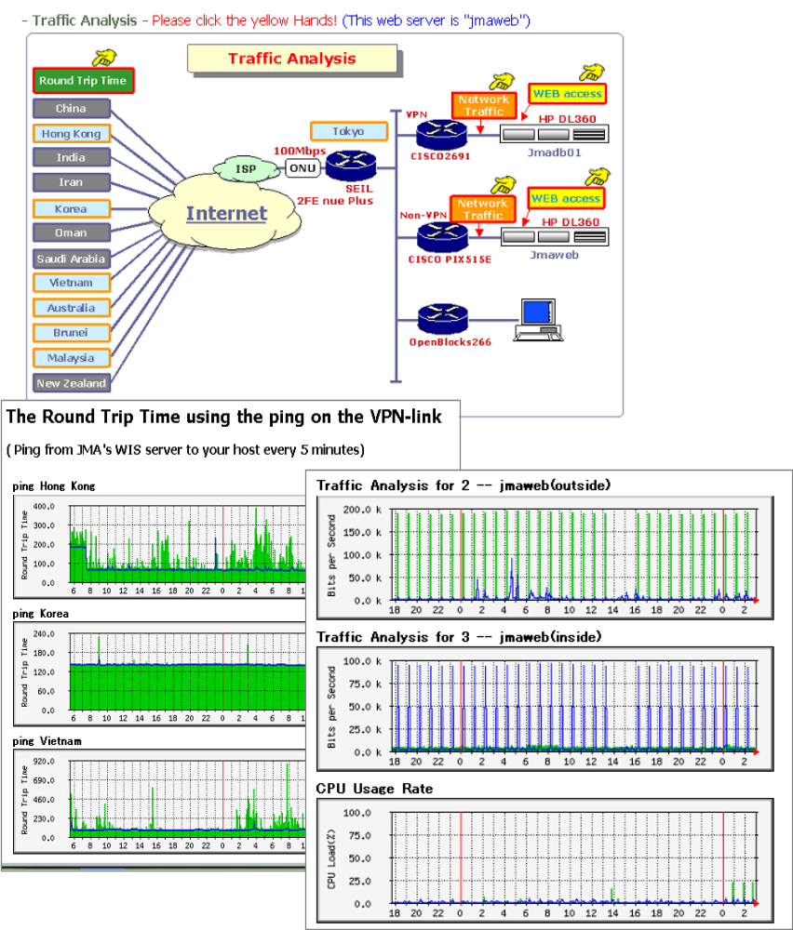
Some tools to observe the Internet access conditions are available in the project web site. Each participant can analyze its own Internet conditions such as traffic throughput, round trip time and statistics. The information is useful for each participant to evaluate its Internet environment.

3. Tentative Road Map

The current advanced phase will continue till its completion in 2006 as scheduled. During the phase, participants will conduct various evaluation tests. For example, PPTP (Point-to-Point Tunneling Protocol) test is planned as an evaluation of simplified VPN techniques available for mobile and PC users without any VPN box including very small NCs. Since a PPTP server has already been established, authorized Windows-PC users are able to access easily to the WIS-VPN Web site. IPv6 test is also coordinated by Australia (BoM), Korea (KMA), China (CMA) and Japan (JMA).

As the fruits of project activity, the following contributions are expected:
a) Specific technical outcomes be reported to Expert Team on WIS-GTS Communication Techniques and Structure (ET-CTS) and Expert Team on WIS GISCs and DCPCs (ET-WISC) by the third quarter of 2006.
b) A comprehensive summary of the project be submitted to the CBS-Ext.06 Technical Conference on WIS in late 2006.

According to an implementation timetable for the WIS provided by Prof. Geerd-R. Hoffmann, after the CBS, pilot projects could become semi-operational to gain valuable experience with the WIS concept. However configuration and facilities of the VPN Pilot Project could be originally temporary basis because of feasibility tests and evaluation in example cases. Before entering the semi-operational phase, all project participants must discuss on how to steer the project.

1. Status on the improvement of GTS
The Global Telecommunication System (GTS) is one of essential components in WMO activities, especially the World Weather Watch (WWW) Programme, to provide a private network function for global exchange of meteorological, oceanographic and related data and products. In the last 10 years the GTS has been improved radically with technical breakthroughs such as development of multiplexing and switching technologies at a great rate, emerging managed data communication services and the evolution of the Internet. There are two points of the improvement. One is reforming transport level for high-performance and cost-effectiveness. Actual strategies are migration from least circuits to network services such as Frame Relay and changeover from low/medium speed analogue circuits to high speed digital ones. The other is introducing Internet oriented techniques such as TCP/IP protocol suite, FTP and dynamic routing by BGP-4.
The Improved Main Telecommunication Network (IMTN) project is a successful example in collaborative improvement of the GTS. The IMTN consists of two clouds managed by two global network suppliers. The cloud provides a guaranteed quality of service, an easy connectivity and scalability of capacity. Each participating centre establishes permanent logical connections to partner centres through the cloud(s) with a very high reliability and full security. The configuration of the IMTN is shown in Figure 1.

On the other hand, the use of the Internet and satellite-based communication systems has been making progress within the framework of the GTS and/or its complement. There are GTS links via the Internet and data serving systems by Internet servers as a convenient and cost-effective solution. In some RTHs (Regional Transmission Hubs), promising satellite-based technologies such as DVB (Digital Video Broadcast) and DAB (Digital Audio Broadcast) are used for data distribution as the complement of the GTS.

Exeter
Sofia
Cloud II
Melbourne
Buenos Aires
Tokyo
Beijing
New Delhi
Nairobi
Cairo
Toulouse
Algiers
Moscow
Washington
Brasilia
Offenbach
Jeddah
Prague
Figure 1 Configuration of the Improved MTN (IMTN) as of November 2004
Frame Relay
by BT Ignite
Frame Relay
by Equant
Cloud I
Implemented
Plan
2. Role of the GTS and potentiality of the Internet VPN in the FWIS
The Fourteenth WMO Congress (May 2003) emphasized that the implementation of FWIS should build upon the most successful components of existing WMO information systems in an evolutionary process. It stressed that the FWIS development should pay special attention to a smooth and coordinated transition. In particular, the FWIS would build upon the GTS with respect to the requirements for highly reliable delivery of time-critical data and products, and the Improved MTN would be the basis for the core communication network.

To review the role of the GTS in the FWIS, analysis of required communication functions and evaluation of possible options such as the Internet, satellite-based communication systems and private networks are necessary. Although details on these will be studied by appropriate CBS/OPAG/ISS Expert Teams, this section shows an outline of the conceptual direction for the further study. Communication functions of the FWIS are generally classified into four categories of data collection, routine dissemination, ad hoc request/reply and data synchronization in the core network. Items to specify requirements are timeliness (severity in time), traffic volume, reliability, security and cost-effectiveness. From the view of configuration, items of segment in FWIS and connection type are studied. Taking account of a comprehensive study on the items, possible options are listed.
To understand the study process easily, an example of required communication functions from a stereotype outlook is shown in Table 1. It is noted that Internet VPN would be one of potential solutions as well as the GTS.

Table 1 Example of required communication functions in FWIS
Categories  Items | Data collection | Routine dissemination | Ad hoc request/reply | Data synchronization in the core network
Timeliness | Time-critical | Time-critical | Near real-time | Time-critical
Traffic volume | - Not much  - Predictable | - More than data collection  - Predictable | - Uneven from little to much  - Unpredictable | - Enormous  - Predictable
Reliability | Highly required | Highly required | Required | Extremely required
Security | Required | Desirable | Highly required in most cases | Extremely required
Cost-effectiveness | Highly required | Highly required | Indispensable | Preferable
Segment | - NC to DCPC  - NC to GISC  - DCPC to GISC | - GISC to NC  - GISC to DCPC  - DCPC to NC  - DCPC to GISC | - Between any and a portal site  - Between a portal site and data sources | Among GISCs
Connection type | Point-to-point | - Point-to-point  - Multicast  - Broadcast | Point-to-point | - Point-to-point  - Multicast
Possible options | - GTS  - Internet VPN  - Internet non-VPN (e.g. HTTPS Web data ingest, e-mail collection) | - GTS  - Internet VPN  - Internet non-VPN  - Internet distribution system  - Satellite-based communication system | - GTS  - Internet VPN  - Internet non-VPN | - GTS (IMTN)  - Internet VPN for backup

3. FWIS VPN Pilot Project in Regions II and V
.As Table 1 shows, there is no doubt that the Internet will be one of indispensable elements for the FWIS. The use of Internet, however, has its pros and cons. Inappropriate security policy might lead to serious problems. Investment in security for a countermeasure against threats, and its cost-effectiveness could be the major consideration. VPN (Virtual Private Network) technique is one of the promising investments, especially Internet Protocol Security (IPsec) is coming into wide use recently.

Noting that the further development and implementation of FWIS would be pursued through relevant pilot and prototype projects, Regions II and V launched a collaborative pilot project of Internet VPN just after Implementation Coordination Meeting on the GTS and ISS in Region V (Wellington, 8-12 December 2003) as a trigger. The purpose of the project is contribution to the FWIS development through a feasibility study from the specific views to realize FWIS concepts. The project is to evaluate of the Internet VPN practically in cooperation with centers under various conditions such as enough or insufficient expertise, and excellent or poor environment accessing to the Internet.
In 2004, fundamental study and technical tests on Internet VPN were performed from the view of transport level. Furthermore a draft plan to expand the project is under consideration as an advanced phase.

3.1 Fundamental phase (2004)

(1) Participants and coordination procedures
In support of the collaboration project of two Regions for contribution to FWIS, eleven WMO Members were willing to participate in the project on a voluntary basis. To further the project smoothly, two groups for project management and technical coordination were established in the early stage. Each participant nominated a main contact person for project management (PM) and contact person(s) on technical issues including test procedures (TC). Furthermore a steering group of four PMs were formed to complete the project plan.

Table 2 Participants in the project
Country, terriroty | Organization | Site
Region II
China | China Meteorological Administration | Beijing
Hong Kong, China | Hong Kong Observatory | Hong Kong
India | India Meteorological Department | New Delhi
Japan | Japan Meteorological Agency | Tokyo
Republic of Korea | Korea Meteorological Administration | Seoul
Saudi Arabia | Presidency of Meteorology & Enviroment | Jeddah
Vietnam | National Hydrometeorological Service | Hanoi
Region V
Australia | Bureau of Meteorology | Melbourne
Brunei | Brunei Meteorological Service | Darussalam
Malaysia | Malaysian Meteorological Service Department | Kuala Lumpur
New Zealand | MetService | Wellington

(2) Scope of the project
NC
NC
NC
NC
National users
National users
NC
NC
NC
NC
NC
NC
NC
NC
NC
NC
NC
NC
DCPC
DCPC
DCPC
DCPC
Test for Data Collection & Routine Dissemination
1. Internet Data Distribution (IDD) Pilot Project by
DWD, UKMO and South African Weather Service
2. FWIS VPN Pilot Project in Regions II & V
3. “Procedures for observational data collection
using E-mail over the Internet” being revised
by Expert Team on Enhanced Utilization of Data
Communication Systems (ET-EUDCS)
4. Test for HTTP based data entry input form by
ET-EUDCS
Test for Collaboration among GISCs through
a core network
1. FWIS VPN Pilot Project in Regions II & V
Feasibility Study of Virtual GISC
with Data Grid
1. VGISC/SIMDAT Pilot Project in RA VI
Portal site
for data request
DCPC
GISC
GISC
GISC
VGISC
Development and Verification of Request/Reply Mechanism with Metadata Standards
UNIform DAta Request InTerface (UNIDART) Pilot Project
by EUMETNET
2. CliWare Pilot Project with test of the WMO Core Metadata
standard by Roshydromet (Russian Federation)
3. Further development of the WMO Metadata standards
by Expert Team on Integrated Data Management (ET-IDM)
4. FWIS VPN Pilot Project in Regions II & V
Figure 2 Scope and location of pilot projects in FWIS communication structure
(3) Evaluation items
Baselines for evaluation were as follows:
a) Empirical feasibility to use the Internet VPN for:
- branch links among a GISC, DCPCs and NCs on routine basis
- ad hoc request/reply between a portal site for data request and each requesting center or each data source center
- backup and/or complement links of a core network among GISCs
b) Practical views on VPN implementation
- Geographical features
- Extraction of difficulties
- Cost consideration
- Impact evaluation of technical gaps between centers
- Future prospect
Table 3 shows main items evaluated through the analysis of test results and feasibility survey.

Table 3 Main evaluation items in the fundamental phase
Evaluation items | Analyzing details
Compatibility between different VPN products | Verification of the compatibility between Defacto standard (Cisco), Worldwide major products (NetScreen and WatchGuard security boxes) and local products
Coexistence of connections on different IPsec conditions | Verification of connectivity on various conditions in parameters such as Key Encryption, Key Hash, Key Lifetime, IPsec Encryption, IPsec Hash, IPsec Lifetime and so on
Impact of VPN connections in GISC | Evaluation of concentration impact of VPN connections such as throughput and CPU load in VPN equipment, computer start-up and simulataneous setup of all Security Associations, and impact of setup interruption on data exchange
Continuity of routine connections to exchange data | Verification of random data exchange on TCP socket with continuous file distribution by FTP to all sites without any troubles for 6 hours
Comparison between VPN and non-VPN | Comparison between VPN and non-VPN in information transfer rate in cases of FTP and TCP socket
Implementation difficulties | Evaluation of implementation difficulties in procurement of VPN products, VPN setups and collaborative configuration with partners by remote maintenance

(4) Outcome
(i) Use of the Internet VPN
Since Internet VPN based on IPsec technology was well standardized, all sites except one were able to establish a VPN connection, in spite of cross platform and unknown vendor configurations. A reasonable amount of different sets of IPsec parameters and IKE types were tested with great success. Also it was confirmed smooth data exchange without any unexpected tunnel teardowns and re-negotiations. Although VPN overhead definitely existed especially in high throughput cases, it seemed not always be critical.
Internet VPN on IPsec is feasible for use to establish a secure FWIS branch link. With appropriate assistance, even a small NC will be able to overcome the implementation difficulty.

(ii) Required performance in GISCs
It is expected that a GISC will have many branch links with NCs and DCPCs. If most of them are VPN connections, the concentration impact on the GISC is not negligible. The GISC may need to install and maintain some of highest-performance VPN products, needless to say they are very expensive even if performance of products in market is being improved year by year. It may be a burden to the GISC in cost and human resources to maintain.
Impact of concentration of VPN connections on a GISC should not be underestimated.

(iii) Technical assistance and remote maintenance
Although IT innovation has been improving worldwide availability of network technology, there are still technical gaps in practical aspects among WMO Members. If a GISC can be a technical sponsor in its responsible zone and provide assistance, this will be enough to get an operation network up and running within a reasonable timeframe.
In this project, some sites were more familiar with the technology than others as well. According to a technical sponsor theory, Melbourne (Simulating GISC) provided assistance where it was needed using “remote maintenance” effectively.
It is worth studying possibility of a technical sponsor system using remote maintenance.

(5) Consideration items for further development
- Variable factor of ISP (Internet Service Provider)
- Necessity of encryption in meteorological data
- Necessity of any-to-any connectivity through VPN
- Necessity of VPN for ad hoc request/reply scheme
- Appropriate responsible zone and the number of VPN branch links for each GISC
- Models of remote maintenance depending upon technical resources available at NCs
- Coordination of policy issues of the individual security restrictions and the operational management

3.2 Advanced phase (2005 – 2006)
It is required that the pilot project be expanded to the FWIS application level in cooperation with other pilot projects for FWIS application components such as request/reply portal and metadata standards. Participants in the project are willing to participate in the advanced phase of the project and to contribute to FWIS development further. In this context, a draft plan for next two years is under development from the following viewpoints.
- Possible cooperation with UNIDART and VGISC projects
- Comprehensive tests from transport level to application level
- Simulation of NC operation with prototype applications
- Data management such as WMO metadata standard, code migration
- Study of authorization and authentication methods for secure data reporting and providing
- Expansion of participants

The advanced phase will consist of a few thematic sub-phases. Figure 3 shows examples of conceptual images in the sub-phases.
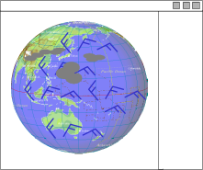

NWP products
Satellite data
Updated
Application software
Prototype application
NC
(National Centre)
Gathering data from
different data sources
Internet
Software updating
Application portal
Data portal
Satellite data
Reference information
Data sources
VPN
XML metadata
2132330E1A10FE00112A0B0AA
BUFR
<xml>
<xmlusers>country name</xmlusers>
<code>47997</code>
<date>20050101</date>
<time>0100</time>
<winddeg>360</winddeg>
<windspeed>10</windspeed>
<view>9999</view>
<temp>12</temp>
<dew_point>09</dew_point>
<pressure>1002</pressure>
</xml>
Reporting
observational data
NC
(National Centre)
RJTD
01
01
0100
360
10
9999
12
09
1002
Office code
Metadata creation
Conversion to BUFR
Secure connection
(VPN or HTTPS)
Internet
Input data on Web
SNJP70 RJTD 010100
SYNOP
36010KT 9999 12/09 1002=
Dew_temp
Date/Time
WIND_deg
WIND_sp
View
Temp
Pressure
Data sources
UNIDART portal
Data GRID
VPN
Data source
Request/Reply
with authentication
Matadata
Catalogue
Internet
Cooperation with
UNIDART project
in RA VI
Figure 3 Examples of thematic sub-phases in the advanced phase

