WORLD METEOROLOGICAL ORGANIZATION

COMMISSION FOR INSTRUMENTS AND
METHODS OF OBSERVATION

Executive Summary of the
WMO Intercomparison of GPS Radiosondes

Alcantâra, Maranhão, Brazil
20 May - 10 June 2001



Executive Summary of the
WMO Intercomparison of GPS Radiosondes //

Alcantâra, Maranhão, Brazil
20 May to 10 June 2001

Reinaldo B. da Silveira –INMET
Gilberto Fisch – CTA
Luiz A.T. Machado – CTA
Alaor M. Dall´Antonia Jr. – INMET
Luiz F. Sapucci – UNESP
David Fernandes – CTA
John Nash – UK Met Office

1. Introduction

This report summarizes the results of the WMO Intercomparison of GPS Radiosondes (RSO), which was carried out at Alcântara, Maranhão, Brazil, from 20 May to 10 June 2001. The goals of this RSO, as agreed by the International Organizing Committee for the WMO Intercomparison of GPS Radiosondes (Brasilia, Brazil, 21-25 August, 2000) were:

- To improve the accuracy of radiosonde measurements and the associated methods of observation;
- To test the accuracy and availability as well as the general performance of the GPS wind measuring systems;
- To evaluate the performance of the radiosonde humidity sensors widely used in the tropics against the newly developed higher performance sensors;
- To investigate differences between day and night time measurements;
- To measure the differences between temperature and pressure sensors from widely used radiosondes against newly developed high performance sensors.
- To investigate the practices used in the preparation of radiosondes for launching, operator in-flight interventions, as well as in reporting and encoding;
- To improve Brazil’s operational upper-air practices through recommendations derived from the intercomparison;
- To publish the executive summary report of the intercomparison in the WMO Instruments and Observing Methods Report series (IOM) containing only the main results and as a comprehensive full report with detailed information on the test on the WMO CIMO Web page and on CD-ROM.

Participants and contributors were:

- National Meteorological Institute of Brazil (INMET);
- World Meteorological Organization (WMO);
- Brazilian Air Force;
- Satellite and Rocket Launching Centre of the Brazilian Air Force (CLA);
- Aerospace Technical Centre (CTA);
- Brazilian Navy;
- Maranhão State University (UEMA);
- US National Weather Service;
- UK Met Office;
- MétéoFrance;
- Institute de Recherche et Developpment (IRD) (France);
- Dr. Graw Messgeräte GmbH & Co (Germany);
- Modem (France);
- InterMet Systems (USA);
- Sippican Inc. (USA);
- Vaisala (Finland);
- Meteolabor (Switzerland).

2. Participating manufactures and equipment

Table 2.1 shows the radiosonde types (column 1) used by the manufactures as well as other equipment available during the experiment. The table also identifies (column 4) the parameters measured.

3. Operational procedures

3.1 Launching schedule

The experiment was carried out from 21 May to 7 June 2001. Forty-three flights were carried during this period. The launch times were 00, 06, 12 and 18 UTC. Four additional flights were carried out on 30 May, 14 UTC; 31 May, 02 UTC and 14 UTC; and on 1 June, 02 UTC. The various flight configurations are given in the full report. (See Figures 3.2.a and 3.2.b) //

4. Available data

In addition to the data generated by the radiosondes, environmental data were measured and archived, such as surface temperature, precipitation, relative humidity, clouds, pressure and wind, as well as a C-Band radar data for evaluating the GPS data. Also, satellite images, synoptic observations, and high-resolution NWP products were made available by INMET.

5. Data processing

The data archive of the RSO was built by sampling all flights every two seconds. GL-98 and MKII measurements, which sampled at a rate of one second, were linearly interpolated.

5.1 Time adjustment procedure

An objective technique was used to adjust the time setup of all sets of radiosondes (see full report). A mean squared error algorithm in the temperature profile was applied for each flight, with about 20 seconds time lag between RS-80 and each other radiosonde participating of the flight.

5.2 Tracking radar data
A tracking radar was used to generate the wind reference for GPS measurements. The available ADOUR radar is commonly used for rocket tracking. Its sampling rate was therefore very high and had to be adjusted through a Kalman filter to make it appropriate for the tracking of radiosondes (see full report).

6. Analysis of results

6.1 Relative humidity (RH)

The Snow White humidity sensor was used to obtain humidity reference values at temperatures warmer than –50°C. At temperatures lower than –50°C, a modification introduced by the manufacturer caused instability in the Snow White output, and on most flights the Snow White could not be used as a reference at these temperatures. Figure 6.1.2 shows the RH average of the radiosondes versus ascent time, and depicts the relatively large dispersion at high levels.

A RMSE trend and dispersion analysis was carried out to verify the accuracy of the RH measurements. The analysis was based on the three vertical layers:
- Surface to 600 s of ascent time;
- 600 to 1600 s of ascent time;
- 1600 s of ascent time to the top.

Table 6.1.1 gives the mean bias and RMSE for each layer for all possible combinations of radiosondes, except GL-98 and DFM-97 that were not flown together. Figures 6.1.7 to 6.1.9 show RH differences with respect to the RS90 as a function of RH for daytime and nighttime flights for different temperature ranges. RS90 was chosen as an arbitrary reference and not as standard reference.

In general, all measurements were close together at temperature higher than -25°C in these plots. However, the MKII had a positive bias at high RH values and a negative bias at low RH values. The Snow White measurements at high RH values showed a significant day-night difference relative to the RS90. This would require further investigation. At the lower temperatures (see Table 6.1.1), the dispersion between the different RH sensors increased. This resulted in the systematic differences shown in Figure 6.1.9.

One important parameter for operational use is the Integrated Water Vapor (IWV) that describes the total water vapour in an atmosphere column. Figure 6.1.10 shows the dispersion diagram of the IWV (computed with RS 90) against the others IWV radiosondes. There is a very good agreement among the different systems and the correlation was very high.

The sensitivity of humidity sensors to solar radiation was also analyzed and is given in the full report.

6.2 Pressure/height

The MKII, DFM-97 and GL-98 derived the height data from GPS measurements. They generated geometric height data with a reproducibility of 6 m at 900 hPa and better than 20 m at 20 hPa. At the time of the experiment, there were systematic differences between the height measurements of the participating GPS systems, because GL-98 and DFM-97 directly reported geometric height, while the MKII had errors in the conversion from geometric heights to geopotential heights for the Alcântara location. The typical bias between the geometric and the RS90 geopotential height was 220 m at 20 hPa.

6.3 Temperature

The average profile over all flights is shown in Figures 6.3.1.a and b. Although the number of the radiosondes was not the same, the RS90 presented the warmest readings up to the tropopause and the coolest ones above this level. The DFM-97 showed a reversed pattern. For daytime and nighttime flights, the range of the temperature differences in the troposphere between the radiosondes was mostly between –0.5°C and 0.5°C, with RS80 used as reference. At night the GL-98 had a negative bias of up to –1°C in the stratosphere. The MKII temperature in daytime flights had a positive bias of about 1.5°C in the stratosphere.

6.4 GPS wind

The wind vector was computed by using the “codeless” (Vaisala) and decoded (others) Differential GPS Technique. The wind vector analysis methodology is given in the full report.

The GPS wind data were generated for different weather conditions and for day and night time (see Figure 6.4.1.). Figure 6.4.2 shows the duration of the measurements for each flight. The recent WMO review of operational GPS performance indicated that 10 to 15% missing wind data were typical. In this test, RS90, GL-98 and DFM-97 had less than 6% missing wind data up to 5000 s of ascent time.

The different types of radiosondes produced wind data in excellent agreement. For instance, Flight 36 (day, rain, RS80, RS90, MKII and GL-98) demonstrated this. In Flight 18 (day, dry, RS80, RS90, MKII and GL-98) similar agreement was found most of the time, but some anomalies occurred for short periods in the RS80 measurements (Figures 6.4.10 and 6.4.11).

6.4.1 Radar comparison

The horizontal wind components were derived from the radar azimuth, range and elevation coordinates. For detailed explanation refer to the full report.

The radar was only available for 14 of the 43 flights. Figure 6.4.16 shows a typical comparison between radar measurements and the GPS wind data for Flight 9. The radiosondes and the radar agreed well, resulting in small differences only in the comparison of the wind components.

-----------------------

Executive Summary of the
WMO Intercomparison of GPS Radiosondes
Tables and Graphics

Table 2.1: Equipment Description

EQUIPMENT | TYPE | MANUFACTURER | PARAMETER
RS80 | Radiosonde | Vaisala Oyj, Finland | P, T, RH, GPS wind
RS90 | Radiosonde | Vaisala Oyj, Finland | P, T, RH, GPS wind
MKII | Radiosonde | Sippican, USA | T, RH GPS wind and heights
GL-98 | Radiosonde | Modem, France | T, RH, GPS wind and heights
DFM-97 | Radiosonde | Dr. Graw, Germany | P, T, RH, GPS wind
SNOW WHITE | Humidity sensor | MeteoLabor, Switzerland | Relative Humidity
CEILOMETER  Laser CT75K | Cloud detector | Vaisala Oyj, Finland | Cloud height and cover
RADAR | Doppler Radar C-Band (5.8 GHz) | Thomson, France | Balloon tracking  wind components
MILLOS 500 | Meteorological automatic station | Vaisala Oyj, Finland | P,T,RH, wind, solar radiation and rain
THYGAN | Humidity check sensor | MeteoLabor, Switzerland | Relative humidity

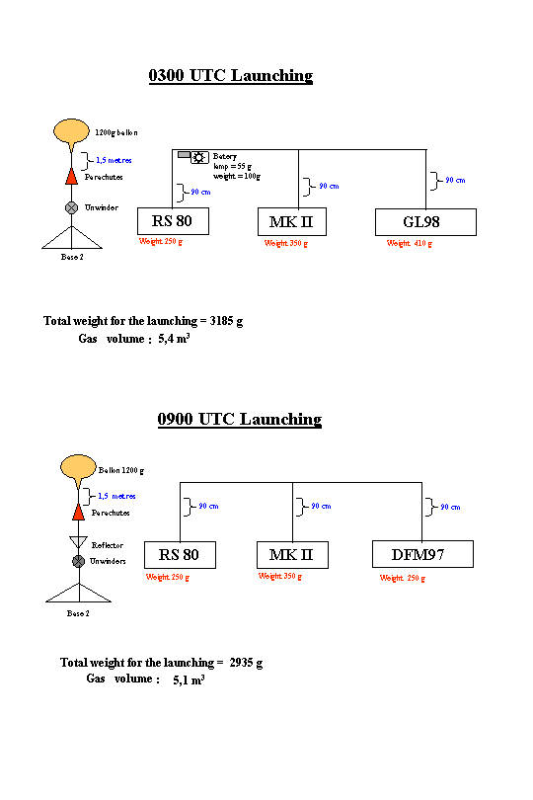

Figure 3.2a: The 0300 LST and 0900 LST flight configuration

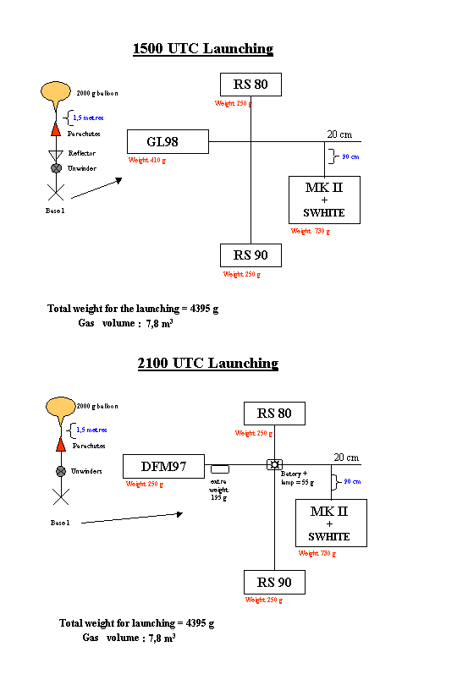

Figure 3.2b: 1500 and 2100 LST flight configuration

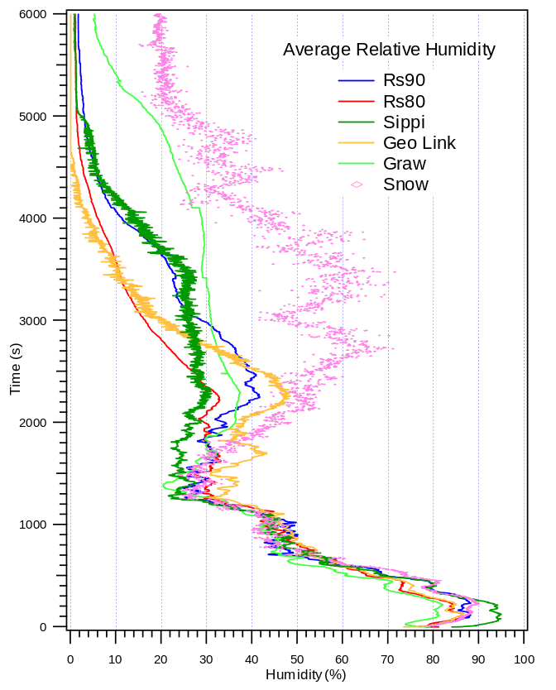
Figure 6.1.2. Average vertical profiles of relative humidity

Table 6.1.1. Average of bias and RMSE for the RH for the three vertical layers

Comparison | Average figures
Comparison | BIAS (%) |  |  |  | RMSE (%)
Comparison | 1st layer | 2nd layer | 3rd layer |  | 1st layer | 2nd layer | 3rd layer
RS80-RS90 | -1.52 | +1.04 | -5.14 |  | 3.42 | 4.58 | 7.76
MKII-RS90 | +7.25 | -1.99 | +1.29 |  | 9.27 | 13.61 | 13.42
GL98-RS90 | -1.42 | +1.17 | -4.58 |  | 3.85 | 5.38 | 8.37
DFM97- RS90 | -4.39 | +0.40 | +10.86 |  | 6.16 | 7.52 | 17.09
Snow –RS90 | +0.61 | -1.28 | +24.11 |  | 4.81 | 12.40 | 34.40
MKII –RS80 | +7.17 | -2.62 | +2.91 |  | 10.08 | 13.97 | 13.25
GL98-RS80 | +1.20 | +1.66 | +1.92 |  | 5.25 | 7.48 | 6.93
DFM97–RS80 | -3.84 | -0.98 | +13.58 |  | 5.74 | 6.21 | 17.93
Snow –RS80 | +2.37 | +0.60 | +28.19 |  | 5.70 | 13.01 | 39.34
GL98-MKII | -6.79 | +3.90 | -0.52 |  | 9.89 | 12.87 | 15.43
DFM97–MKII | -9.65 | +2.55 | +6.97 |  | 12.40 | 16.52 | 15.31
Snow –MKII | -6.79 | +3.27 | +24.07 |  | 8.01 | 11.46 | 35.74
Snow –GL98 | +3.10 | -1.81 | +28.02 |  | 5.41 | 9.74 | 36.98
Snow-DFM97 | +3.28 | +0.07 | +12.92 |  | 6.83 | 13.20 | 27.43

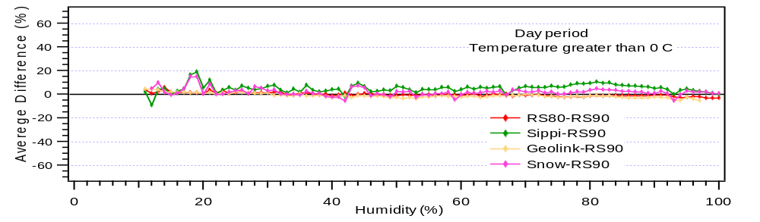
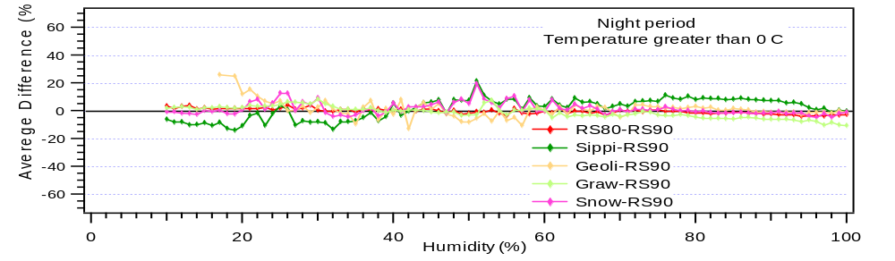

Figure 6.1.7 Average difference for day and night periods with RS90 as reference at temperatures above 0°C

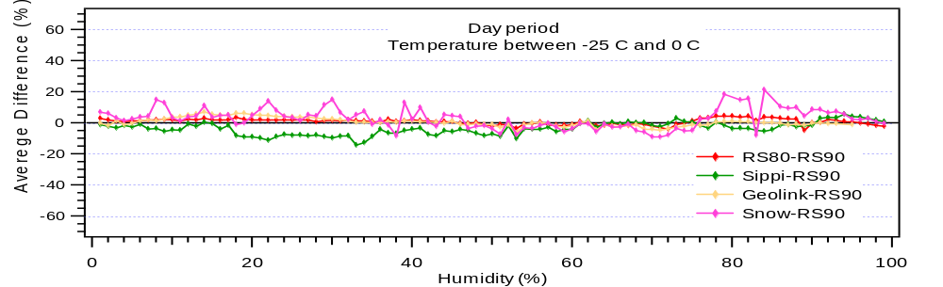
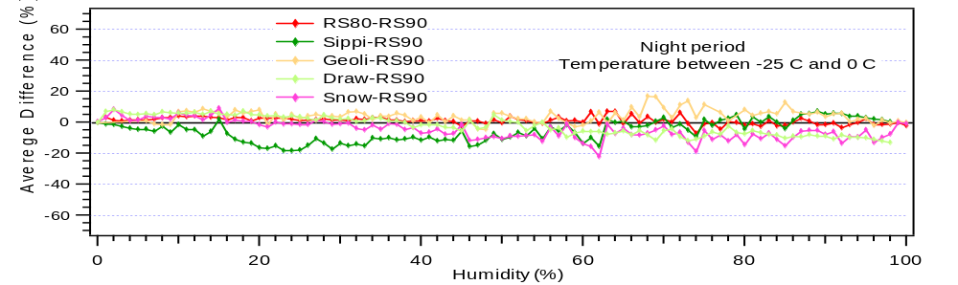

Figure 6.1.8 Same as the previous figure, but for temperatures from –25°C to 0°C

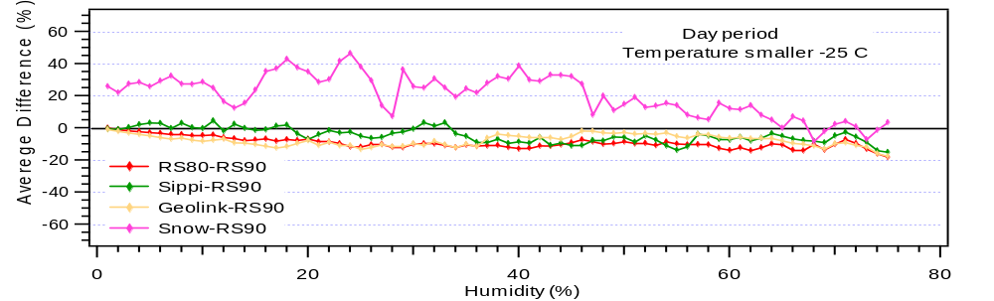
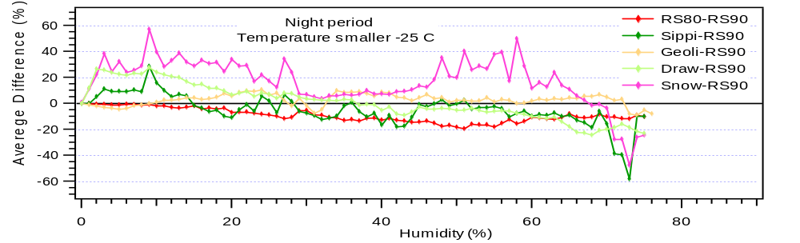

Figure 6.1.9 Same as previous figure, but for temperatures below –25°C.

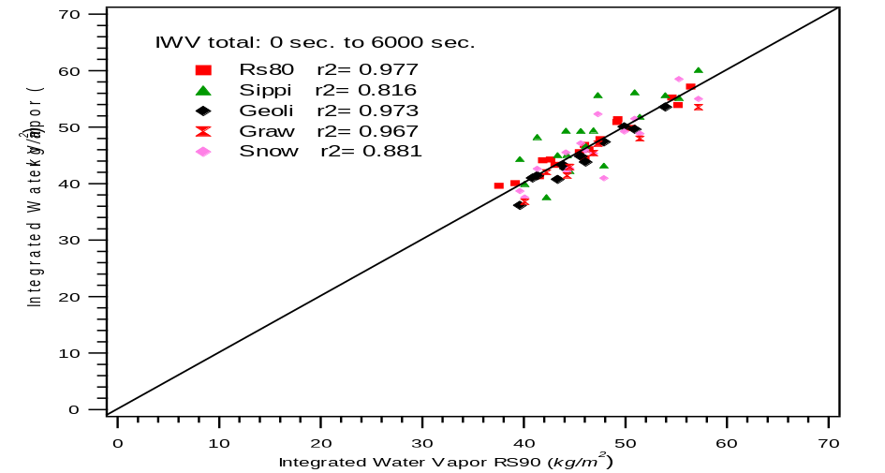

Figure 6.1.10 Dispersion diagram of the IWV - RS 90 and the others radiosondes, and the correlation coeficient.

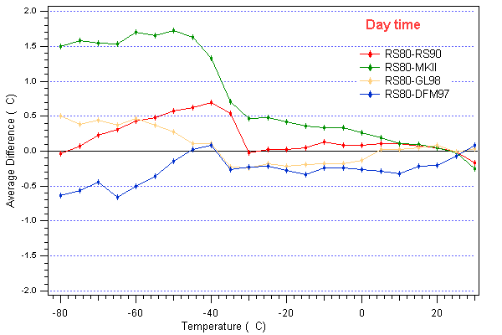
Figure 6.3.1.a Average profiles of temperature for daytime conditions

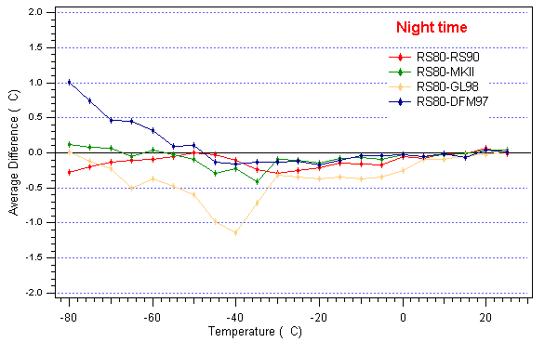
Figure 6.3.1.b Average profiles of temperature for nighttime conditions
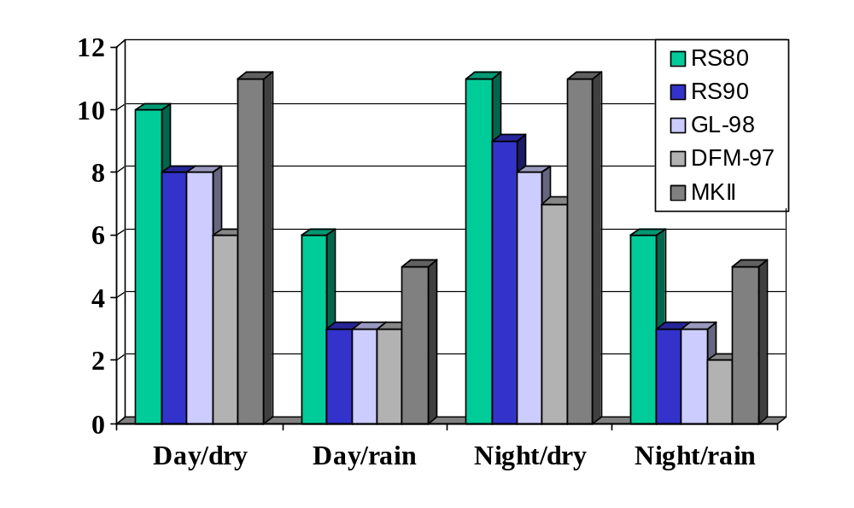Figure 6.4.1 Histogram of number of flights according to the environmental conditions.

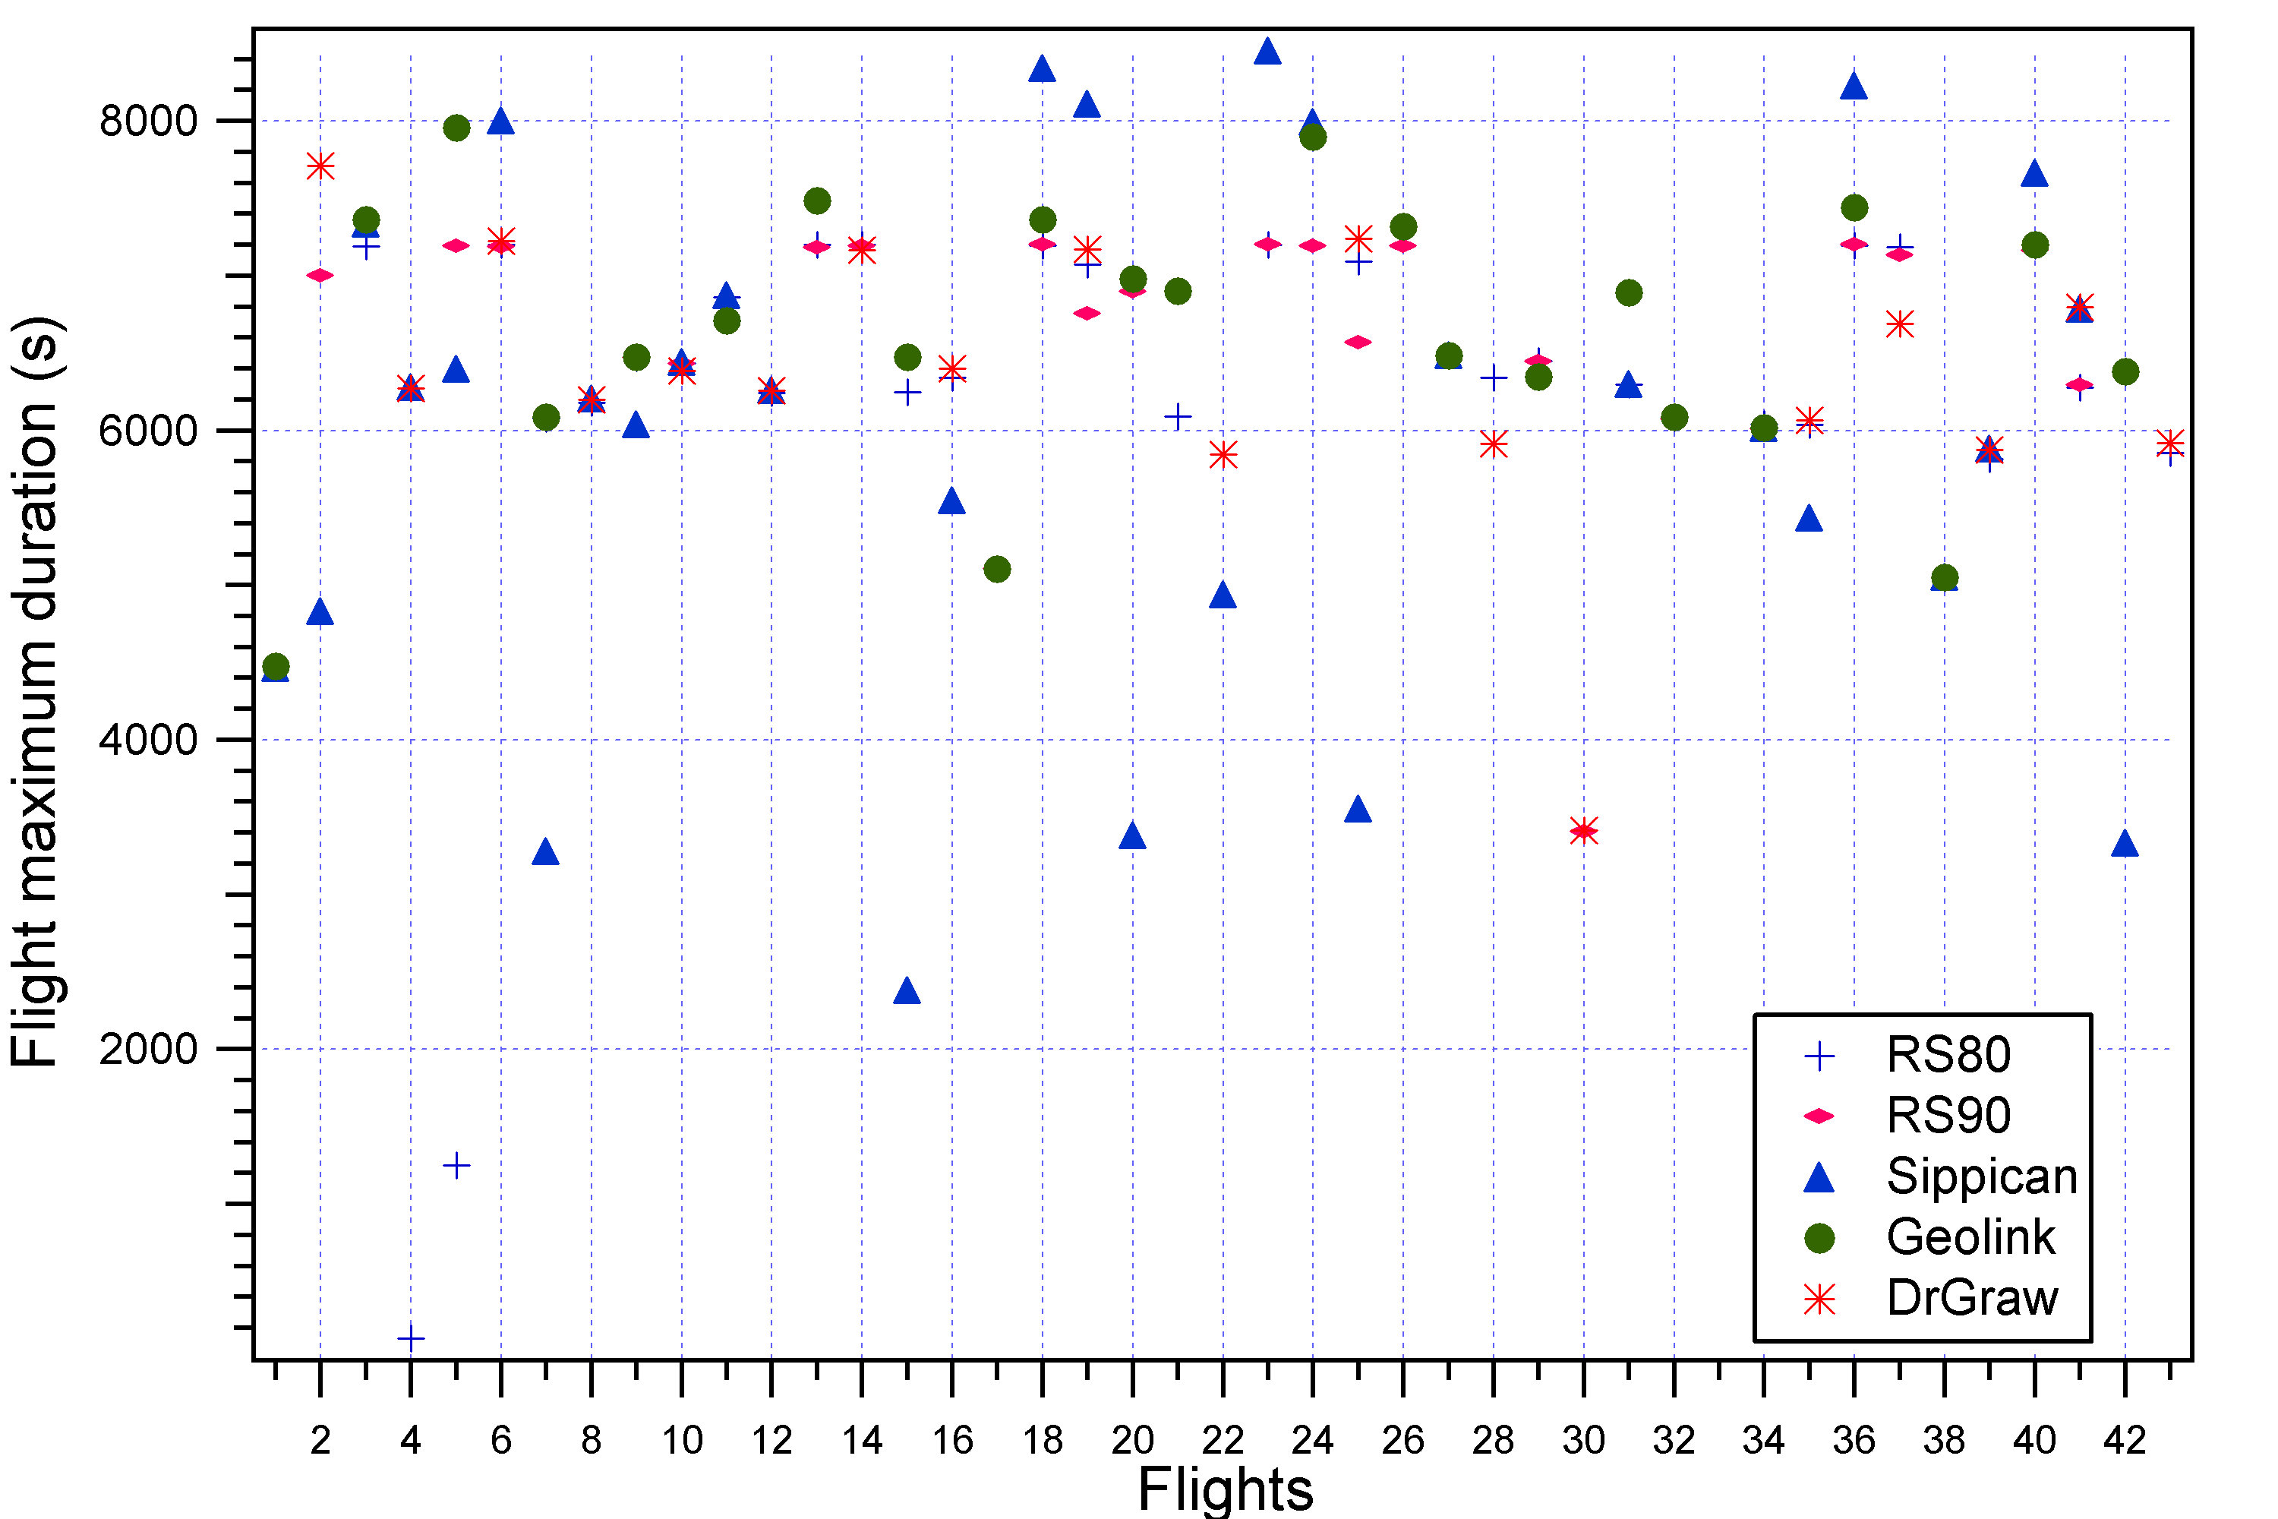

Figure 6.4.2 Duration of the radiosonde measurements considering all flights

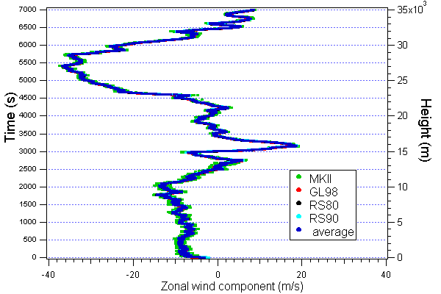
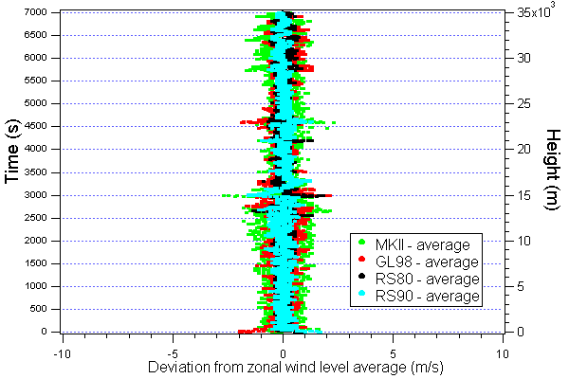

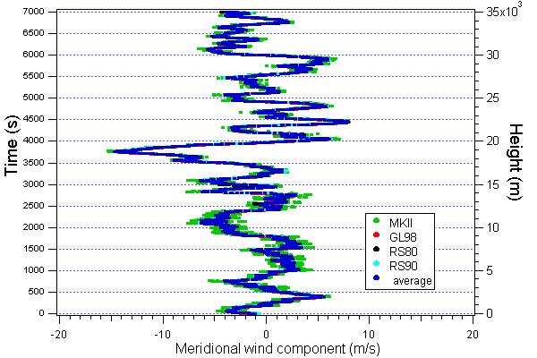
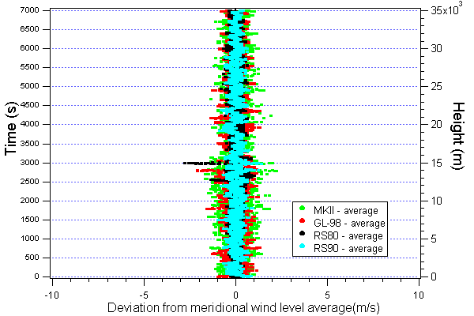

Figure 6.4.10 Wind components computed by sondes, which participated in the Flight 36.

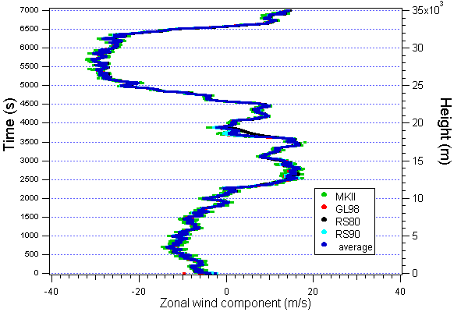
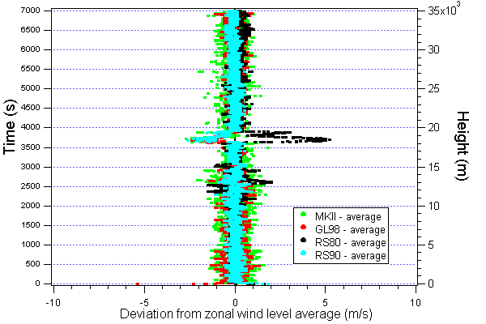

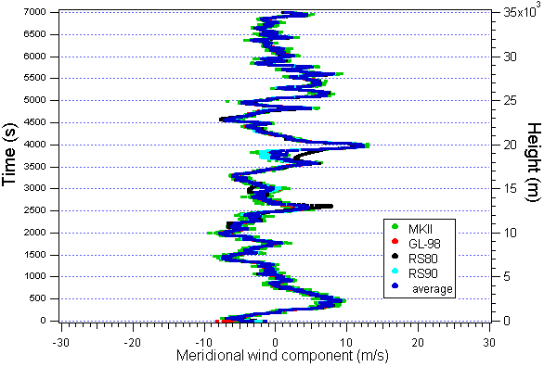
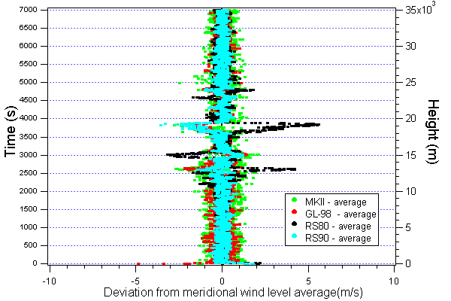

Figure 6.4.11 Wind components computed by sondes, which participated in the Flight 18.

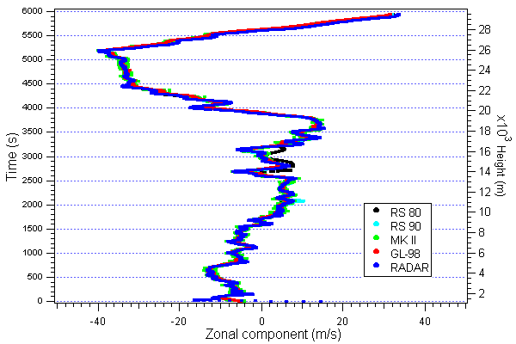
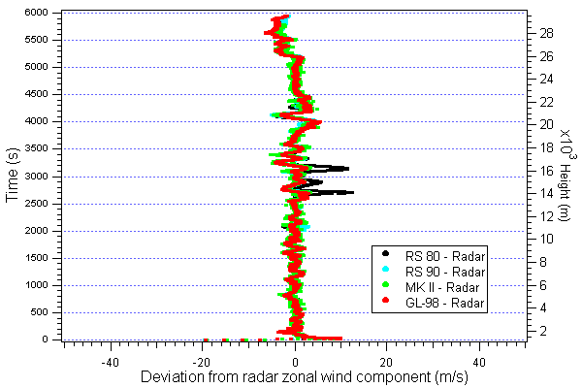

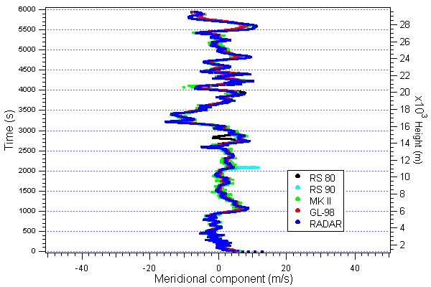
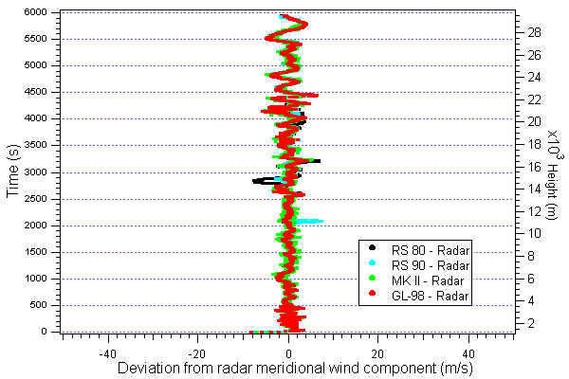

Figure 6.4.16 Wind component computed by sondes and the radar, which participated in the Flight 9.

The Executive Summary was reviewed and coordinated at an expert meeting held in the INMET premises in Brasilia, Brazil on 17-18 March 2003. The meeting was attended by the authors, and Carlos A.T. Moura, CLA, Brazil as well as by Dieter C. Schiessl, Director, WWW Basic Systems Department, WMO.
The numbering of the figures is taken from the full report

