OperatIng of AWOS network In all clImate condItIons In Turkey

Soner Karatas
Turkish State Meteorological Service (TSMS), Electronic Observing Systems Division,
DMI GM Ankara, Turkey
skaratas@meteor.gov.tr
Under four season conditions, operating an Automatic Weather Observing System network is very hard and difficult study. Many subjects must be considered correctly before installing stage of network. If it is not considered exactly, climate conditions may directly affect data of Automatic Weather Observing System.

We may list weather and climate conditions which most encountered and affect AWOS in Turkey as;
- Lightning
- Freezing
- Storm
- Heavy Rain
- High Humidity
- Flood

MOST ENCOUNTERED CONDITIONS IN TURKEY

AWOS NETWORK IN TURKEY

LIGHTNING

FREEZING

STORM

HEAVY RAIN

HIGH HUMIDTIY

FLOOD

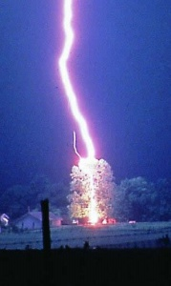
Lightning is an atmospheric discharge of electricity, which typically occurs during thunderstorms. It is so hazardous that sensors or subunits of AWOS may not properly operate its functions after lightning. In Turkey Turkish State Meteorological Service has encountered many problems because of lightning. TSMS has been trying to decrease lightning damage with taking some precautions like;
- Using Lightning Rod
- Using Surge Protection
- Strengthening of grounding infrastructure

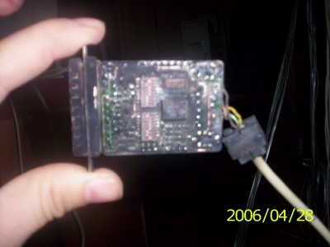
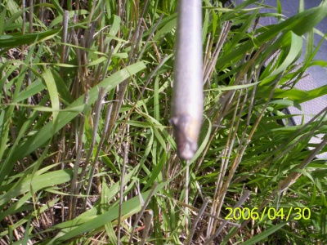
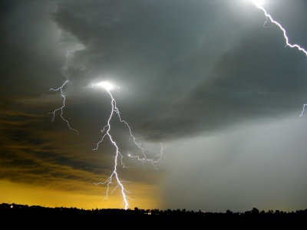

Freezing is the withdrawal of heat to change something from a liquid to a solid. Turkey has robust winter conditions and freezing incidents arise frequently. Therefore TSMS generally prefers sensors with heating for Turkeys cold locations like east part. Especially freezing is dangerous for wind sensors and tipping bucket type rain gauge. For wind sensors heated shaft can prevent bearings from freezing. On the other hand TSMS has been encountered frozen problem of bucket at rain gauges. TSMS experts applied several types of methods to solve the problems to get reliable data within the limits of the acceptable tolerances. One of the solutions was to use two
different heaters which shall be designed to be active in different temperatures. The other one, to
separate the heater from the inside surface of the collecting funnel and mounted in a position
between bucket and the surface of the funnel. After those modifications frozen problem of bucket disappeared.

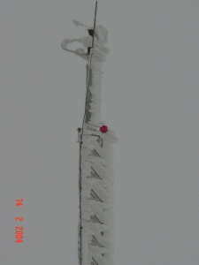
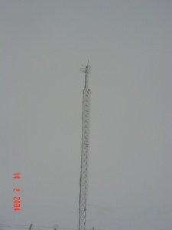
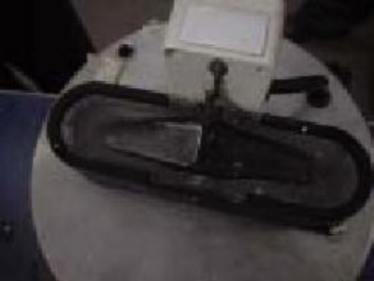

Storm is any disturbed state of an astronomical body's atmosphere, especially affecting its surface, and strongly implying severe weather. We observed and came across destroyed influence of heavy wind, storm in our observation network. Particularly wind sensors, mast and temperature humidity sensor are mostly exposed to hazardous effect of its. Therefore all connection points of sensors, subunits of AWOS are performed carefully and tightly to prevent any detachment. On the other hand guy wires are used to fix the mast.

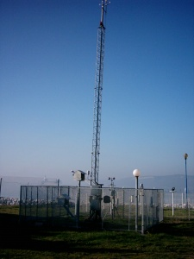
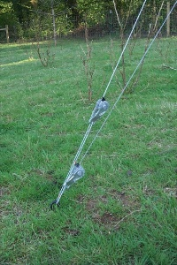

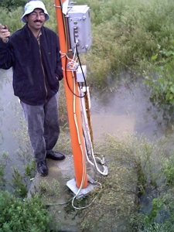
Heavy Rain: Because of the rainy climate conditions TSMS takes precautions for heavy rain. TSMS has taken care to use waterproof equipment in its AWOS network. Enclosures were chosen as watertight and seals were used at the connection points. All energy and signal cables furnished from meteorology office to AWOS station using cable channels.

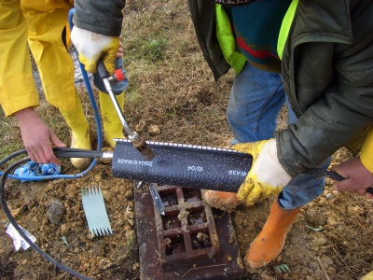
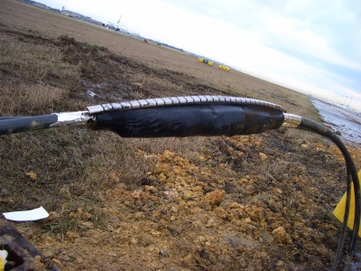
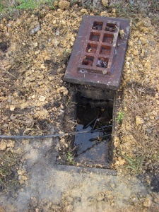

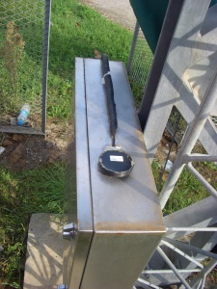
High Humidity cause to corrosion at the connection points of cables at the terminal boxes. When corrosion occurs, reliable data transfer can not be provided using cables. To prevent this risk anti corrosion sprays are generally used during maintenance operations. While planning period of AWOS network, anti corrosion equipments must be preferred to minimize effect of humidity.

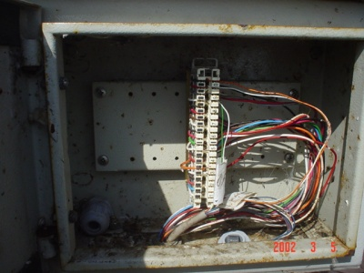

Flood is the rising of a body of water and its overflowing onto normally dry land. There were happened many floods in Turkey last decade. Therefore 206 AWOS stations were installed to early warning of this disaster in the scope of TEFER Project. When we operate AWOS network, we took required precaution to minimize the effects of flood. TSMS installed energy panel box 1 meter height from surface. All mounting operations were carried out tightly and using firm materials. Waterproof equipments were used for enclosures.

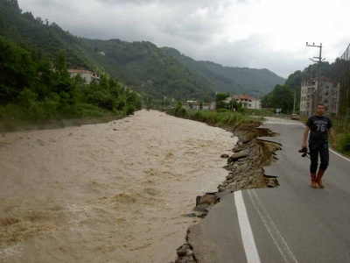
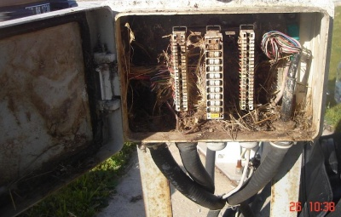

 | CONDITIONS | PRECAUTIONS
1- | Lightning | Use Lightning Rod
2- |  | Use Surge Protection
3- |  | Strengthen of grounding infrastructure
4- | Freezing | Use sensor with heating
5- |  | Use quality control algorithm to detect any frozen sensor
6- | Storm | Use guy wires to fix wind mast
7- |  | Use robust materials at the connection points
8- |  | Robust infrastructure for wind mast
9- | Heavy Rain | Use waterproof equipments
10- |  | Install energy and data enclosure at the high level from surface
11- | High Humidity | Prefer anticorrosive equipments for all parts
12- |  | Use anti corrosion spray at the connection terminals
13- | Flood | During mounting to take care about robustness and fixedness
14- |  | Use waterproof equipments
15- |  | Install energy and data enclosure at the high level from surface

OperatIng of AWOS network In all clImate condItIons In Turkey

REFERENCES
World Meteorological Organization, 1996: Guide to Meteorological Instruments and Methods of Observation WMO-No. 8, Geneva.
S. KARATAS, Operational applications of AWOS network in Turkey , TECO-2006 - WMO Technical Conference on Meteorological and Environmental Instruments and Methods of Observation Geneva, Switzerland, 4-6 December 2006
l. YALCIN, Site selection criteria and sensor park requirements for automated weather observing systems, TECO-2006 - WMO Technical Conference on Meteorological and Environmental Instruments and Methods of Observation Geneva, Switzerland, 4-6 December 2006
M. YIGIT, F. ERGUN, S. CAKIL, Deficiencies in solid precipitation measurements by tipping bucket type rain-gauges, TECO-2006 - WMO Technical Conference on Meteorological and Environmental Instruments and Methods of Observation Geneva, Switzerland, 4-6 December 2006
E. BUYUKBAS, Modernization of Observation Network in Turkey, TECO-2005- WMO Technical Conference on Meteorological and Environmental Instruments and Methods of Observation Bucharest, Romania, 4-7 May 2005

