THE NEW AUTOMATED METEOROLOGICAL OBSERVATION AT FOUR MAJOR AIRPORTS IN NIGERIA

Samuel Aderinto, Ibukun Dahunsi

Nigerian Meteorological Agency, No 33 Pope John Paul II Street, Maitama District, Abuja, Nigeria

Tel. (234) 9 413 0709, Fax. (234) 9 4130710,

E-mail:Samuel_adesoji@yahoo.com

ABSTRACT

The country witnessed frequent air accident between 2004 and 2005 which led to lost of hundreds of lives. This prompted the Federal Government of Nigeria to carry out a thorough investigation into the entire aviation industry in Nigeria. As a result, the Government of President Olusegun Obasanjo released the sum of Nineteen Billion Naira (N19B) only in December 2006 to fully equip the Airports in Nigeria so as to prevent future occurrence to waste of human lives and properties through air accidents.
Automation of Aeronautical meteorological observation was introduced in Nigeria in February 2003 with the first implementation at the Nnamdi Azikiwe International Airport, Abuja, the Federal capital city of Nigeria. Before the introduction of the new system, observations were taken from the manually observed stations by the observers and visibility measurements were visual observations, this information is then forwarded to the Traffic Services providers. With the new system in place, a fully automated METAR including algorithms for cloud and weather and the AUTO TREND is achieved. The MIDAS IV System (Vaisala Product) deployed at the Airport is providing all the basic AWOS parameters with Transmissometers, Ceilometers and Present Weather Sensors for visibility measurements. At present Low Level Wind Shear Alert System (LLWAS) is being added to the System in Abuja in order to conform to the request made by the government of Nigeria.
Installation of this System had been completed in Abuja and Lagos International Airports. It is expected that before the end of year 2008, Avsatel Communications Limited, the company handling the project, will complete similar installation at Port Harcourt and Kano International airports. Detailed implementation of this system and its performance will be given in this work.

1.0 BACKGROUND
The government set up a Presidential Task Force committee on Aviation Industry (PTFA) to look into the immediate and remote causes of air accidents in Nigeria and the committee submitted its findings and recommendations to the federal Government of Nigeria. Part of its findings is poor state of infrastructural facilities at the airports.
As a follow up to the report, the government released fund to the concerned parastatals in the industry to provide all necessary infrastructure in the airports. These parastatals are Nigerian Airspace Management Agency (NAMA), Federal Airport Authority of Nigeria (FAAN), Nigerian College of Aviation Technology (NCAT) and the Nigerian Meteorological Agency (NIMET).
Part of this fund was used to implement a project named ‘’Safe Tower’’ that was contracted to Messrs Avsatel Communications Limited. The project combines modern Control Tower Communication Equipment with Aviation Automatic Weather Observing System (AWOS). In February 2006, a team comprising representatives from Federal Ministry of Transportation, Nigerian Airspace Management Agency (NAMA), Nigerian Meteorological Agency(NIMET) and the Nigerian Air Force was sent to Austria and Finland on inspection visit to Frequentis and Vaisala facilities in Vienna and Helsinki, the companies producing the equipment to be used in the safe tower project. While in Vienna and Helsinki, the team visited the airports where these equipment are in use.
The safe Tower project was finally awarded to Avsatel Communications Limited before the end of 2006. Factory Training was organized for both engineers and operational staff of Nigerian Meteorological Agency and Nigeria Airspace Management Agency in Vienna and Helsinki between the first and third week of November, 2006. During the Training period, the equipment meant for the Safe Tower Project in Abuja was ready for Factory Acceptance Tests (FAT) before it was dispatched to Nigeria. The Factory acceptance Tests were carried out both in Finland and Austria before the end of factory training exercise.
The actual implementation of Safe Tower Project commenced towards the end of year 2006 in Abuja. All the engineers from NAMA and NIMET who were trained on these equipment joined the Avsatel,Vaisala &Frequentis experts during the installation of Equipment. The Site Acceptance Test was conducted in February 2007 after Abuja installation is completed.

1.1 INTRODUCTION
Before the introduction of the new system, we relied on manually observed stations to take in situ measurements. Between 2003 to 2005, Automatic Weather Observing systems were installed in most of our stations including the four major airports to complement measurements from conventional instruments, but these AWOS produces the basic weather parameters such as Air Temperature, Relative Humidity, Pressure, Precipitation, Wind Speed, Wind Direction and Solar radiation.

1.2 MIDAS IV AWOS
The new Vaisala MIDAS IV Automatic Weather Observing System (AWOS) being implemented at the four major Airports in Nigeria is a system designed for the needs of air traffic controllers, observers, forecasters, and other airport personnel. It collects, processes, monitors, distributes and archives meteorological data measured by a dedicated set of meteorological sensors located along the runway(s). Observations performed by the system provides all necessary meteorological data required in operations at the airport and to optionally provide detailed observation data to the regional and national meteorological information networks.
The following meteorological observations and calculations are performed automatically:
- Wind Speed & Direction
- Pressure (QFE, QNH, QFF)
- Temperature
- Humidity (Dew Point Temperature)
- Meteorological Visibility
- Runway Visual Range Assessment
- Rain Amount
- Present Weather
- Cloud Height
- Solar Radiation
All the observations and calculations listed above are displayed on MIDAS IV Central Data Units (CDUs) and workstations as well as Frequentis ATC display terminals. Reporting interval is adjusted from 3s to 60s depending on the importance of the weather parameter. Weather parameters having sudden changes, such as wind, have more frequent reporting interval.
Both measured and derived weather information can be displayed in different kind of formats and by various means in relevant locations around the airport.
Based on the automated weather observations, routine weather messages like a METAR/SPECI, METREP/SPECIAL, SYNOP and TAF are generated and distributed in a fixed time. Whereas reports for significant weather changes, for example a SPECI report, are issued at the time of occurrence according to the relevant criteria recommended by ICAO in Annex 3.
The system measures, processes, displays, stores, and distributes meteorological information. It consists of sensors located along the runway, two Central Data Unit computers (CDUs), and four workstations.
The sensors are located along the runways at specific measurement sites and communicate with the central data units (CDUs), which distribute the data to the workstations. The system had been successfully installed in three of the four major Airports in Nigeria, namely; Abuja, Lagos and Port Harcourt International Airports. There is a delay with in implementation of the project in Kano International Airport. This delay has to do with the tower building which need to be rebuilt before new communication equipment can be installed. The reason given also affects the installation of MIDAS IV AWOS because; the Central Data Units are being installed in the tower buildings for reason of security and power stability.

1.2.1 System Layout for Abuja International Airport Field Instruments and Locations

The figure below describes the meteorological system field sensors.

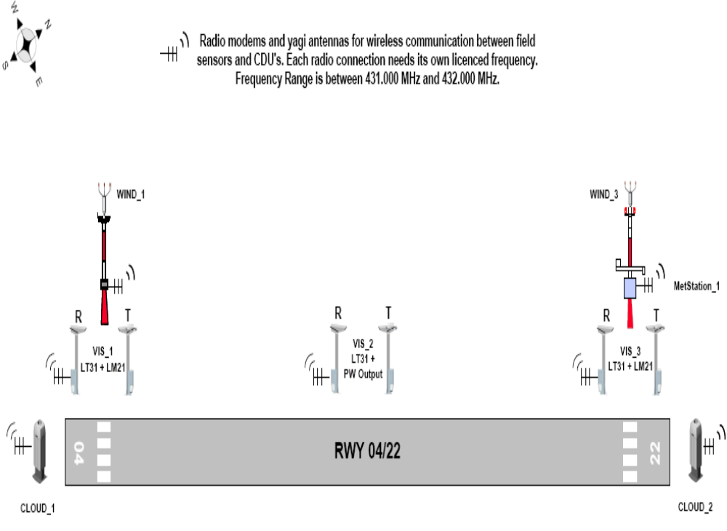Figure 1 Showing Sensors and data collection system at Abuja International Airport

The table below indicates the type of field instruments required at Abuja International Airport. The table shows also how the sensors are distributed along the measurement sites and total amount of each sensor/module type applied.
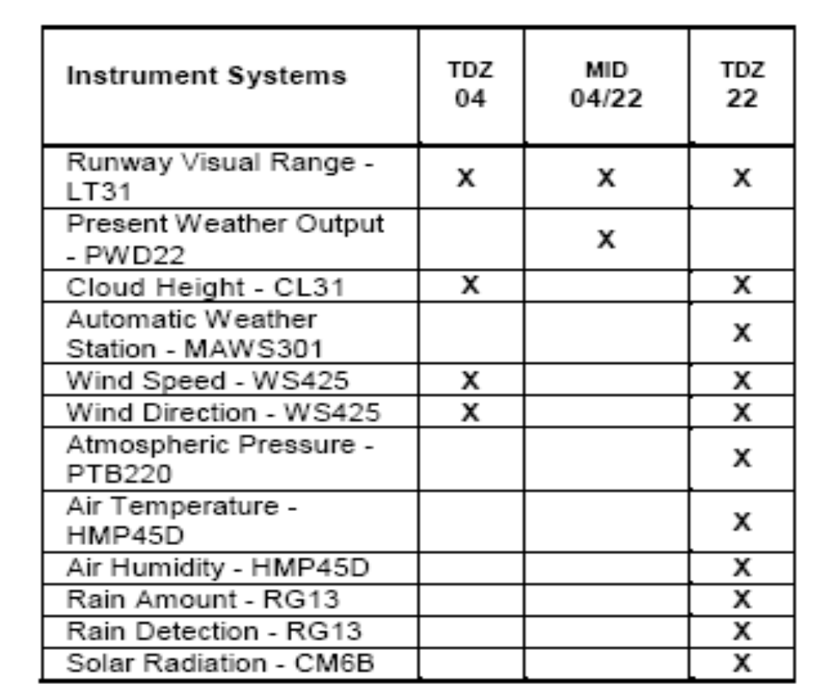
Table 1 Field equipment at Abuja International Airport RWY 04/22

1.2.2 Central Data Unit (CDU) and Workstations
Meteorological data from the runways and field sensors is fed to the duplicated MIDAS IV Central Data Unit (CDU) installed in the airport facilities. All optical sensors, wind sensors and the Automatic Weather Stations (AWS), which collects PTU data, are connected to the MIDAS IV CDU via point-to-point UHF radio modems. Indoors MIDAS IV equipment are supplied with two radio boxes including receiving UHF radios and two portservers, which are equipped with the RS485 ports to receive data from the radio modems. The portserver transfers the serial data to the ethernet LAN. The CDU receives the all sensor data with user datagram protocol (UDP). The CDU servers, portservers and two ethernet switches are installed to 19 inches equipment rack. The rack includes also UPS with extra batteries, giving approximately 35 minutes running time when AC power is not available.
The CDU processes data from the sensors and distributes it to workstations and other users of AWOS information e.g. Frequentis displays in ATC tower. The system includes two MIDAS IV workstations: Observer and Forecaster workstation. The raw data from the field sensors is also possible to transmit to the other systems whenever needed.
Both CDUs (CDU A and CDU B) receive the same data from the sensors and perform the same parameter calculations, independently of each other. One of the CDUs is active (online) while the other is passive (offline). The active CDU provides the data for end-user applications. The passive CDU monitors the active CDU. This way, the passive CDU can replace the active CDU without delay if the active CDU reports that a system program (ROASERVER.EXE) is missing. In such situations, the system automatically switches the passive CDU as the active CDU, and data processing continues without any disruption to system.
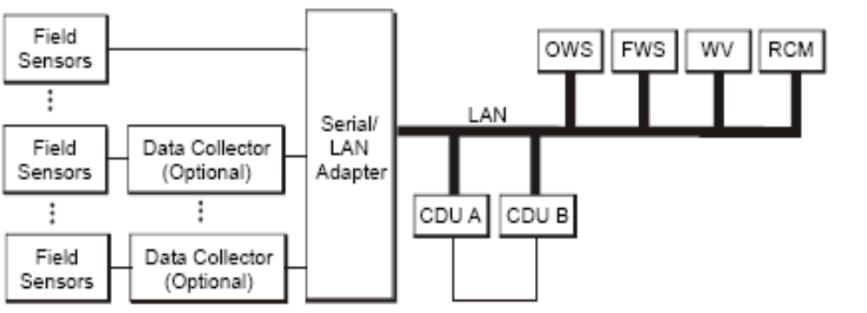
Fig.2 showing duplicated Central Data Display Unit (CDU)

The CDU validates the measurement data, calculates the values based on the data, and distributes the weather data and alarms to user workstations. In user workstations, users can view weather data and alerts with the Weather View application. The values are being stored in the ASCII Log View application. Event Monitor and Actual applications are for monitoring and handling system error situations. Weather reports can be edited and sent with METAR/MET REPORT and other weather report applications.
The Central Data Unit (CDU) of the system’s dual hot-standby configuration provides increased reliability and uptime. It has additional fans, diagnostic and maintenance tools.
The Central Data Unit (CDU) carry out the following tasks:
- sensor data acquisition and validation,
- Meteorological Calculations
- Sensor Service Interface
alarm services.

Figure 3 shows the data connection principles and indoor equipment installed in the Abuja International Airport.

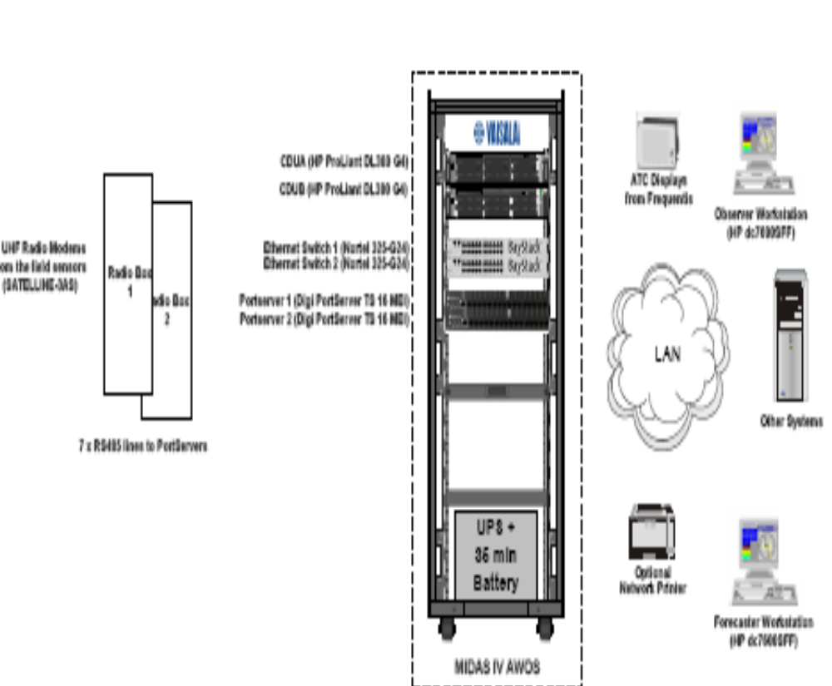

Fig. 3 Indoor equipment at Abuja International Airport

1.2.3 Data Processing Units
The Central Data Units (CDU) are the main computers of the MIDAS IV system. The both CDUs are high Mean Time Between Failure (MTBF) rack mountable server computers that are equipped with additional communication hardware to connect to the field sensors, workstations and other systems. For additional reliability, the CDU is powered by a UPS and extra batteries, also mounted in the same rack. The CDUs, running under Windows 2000 operating system, execute numerous data acquisition, calculation, storage and distribution processes in the background as Windows services and requires no user interaction.

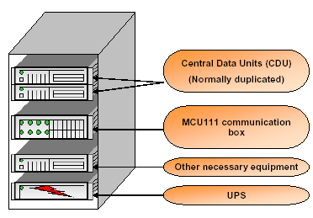
Fig. 4 MIDAS IV CDU Server Rack
The MIDAS IV CDUs are being installed in the rack as shown in the figure above.

1.2.4 Hardware and Operating Environment
The CDU hardware consists of two (2) industry standard, rack mountable server computers. The MIDAS IV CDU hardware is installed in a 19" Cabinet together with the 35 minutes UPS and two portservers (Digi PortServer TS 16 MEI). The portserver includes 16 x RS-232/RS-485 ports which can be used either receiving data from the field sensors or sending data, for example, to the AFTN. Also two ethernet switches are installed to the cabinet to provide all necessary LAN-connections.

1.2.5 Application in CDU
The MIDAS IV software on the CDU is divided into numerous Windows services. These services are background processes, which start automatically when the operating system is started, so there is no need for user to login to start the MIDAS IV system. MIDAS IV end-user software applications run on the MIDAS IV workstations. The same applications can also be run on the Central Data Unit.
The CDU display contains applications that are typical for Remote Control and Maintenance workstation (RCM profile). These applications are only for technical maintenance personnel allowing them to view the events generated by the CDU, acknowledge alarm conditions, monitor the field sensor communications, and then establish a direct connection to a sensor or a weather station for maintenance or troubleshooting.
Generally, different applications can be accessed by provided User profiles. Depending on what user one logs on to a CDU or workstation it will get a certain set of applications.

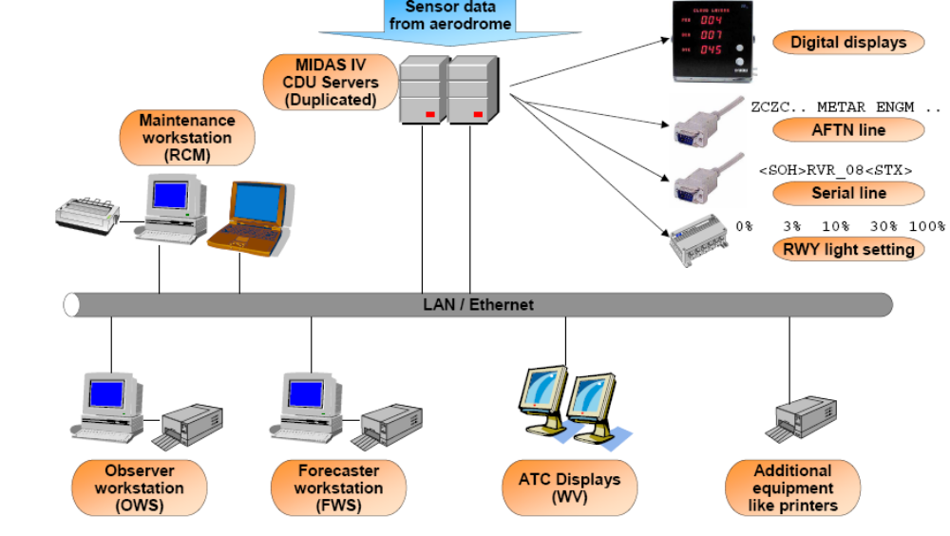

Fig. 5 showing MIDAS IV Architecture

1.2.6 Workstations
The MIDAS IV system typically includes different workstations for the following groups of users:
- Air traffic controllers (Weather View Workstation, WV)
- Observers (Observer Workstation, OWS)
- Forecasters (Forecaster Workstation, FWS)
- System maintenance personnel (RCM Workstation)
Each workstation type has a preconfigured workstation environment. Vaisala configures the user profiles (for example, OWSUSER, FWSUSER, WVUSER, and RCM user) for the workstations.
MIDAS IV software applications. are installed in end-user workstations:
- Operating system; Windows® XP Workstation or Windows® 2000 Workstation. Each workstation includes a different set of applications depending on the configuration of the system.
The CDUs work independently of the workstations. Workstations and applications on them can be freely used with no adverse effects on the rest of the system. An application specific toolbar is configured to be started automatically at when user logs in to the workstation.

1.2.7 Observer Profile
The meteorological observer operates the system via workstation. Typically, the observer fills in required manual observations, such as cloud amount, and verifies the automatically generated data for the METAR report. Other variables and weather reports (such as METAR/SPECI and METREPORT/SPECIAL) are distributed further to other users at the airport (Met-Office, Briefing, ATC, observers and forecasters) and via an AFTN switch (RS232 interface) to other airports and users as well. measured and calculated data, as well as transmitted reports, are stored on the CDU's hard disk for later use.
The Observer workstation software has following functions:
- Edit of semi-automatic (or automatic) messages (METAR/SPECI and METREP/SPECIAL, SYNOP and TAF templates).
- Graphical presentation of data (Weather view).
- Time series of pre-selected values. This data is located in CDU or database computer (ASCII log view).
- Tables for instrument data and possibility to override the sensor data with manually input values.
- Software to display operational alarms (results of SPECI condition checks).

1.2.8 Forecaster Profile
Forecaster Workstation software(FWS) is provided by the manufacturer of the system (Vaisala). With Forecaster profile, the user can view weather data, send TAF reports and view stored data. In FWS, the METAR/SPECI application is configured to receive a TREND request from the observer and sending a TREND to the observer. No other METAR/SPECI functions are available in FWS.
FWS contains the following MIDAS IV end user applications:
- Weather View
- METAR/SPECI
- ASCII Log view
- AFTN Monitor
- Message templates TAF
FWS also contains the system maintenance application Event Monitor.

1.2.9 ATC Profile
ATC and other air traffic control facilities is equipped with monitors, which display weather and other system data in both textual and graphical form. The data will is displayed both on a workstation screen, and possibly on digital displays (DD50 and WD50). The primary target of the Weather Data Monitor workstation is to provide weather data to the other users of the weather observing system.
ATC contains the following MIDAS IV end user applications:
- Weather View

1.3.0 Maintenance Profile
The system also comes with the maintenance profile which is intended for maintenance purposes. It includes the following system maintenance applications:
- Event Monitor
- Diagnostic Monitor
- Sensor Terminal
- SensorIO Monitor

The MIDAS in AWOS applications in workstations are as shown in the table below:

Application | OWS | FWS | WV | RCM
Weather View | x | x | x
Event monitor | x | x |  | x
ASCIILog View | x | x
METAR/MET REPORT | x | x²
Actuals | x
METAR/MET REPORT MANAGER | x |  |  | (x)
Diagnostic Manager |  |  |  | x
Sensor Terminal |  |  |  | x
Sensor IO monitor |  |  |  | x
Data Source Manager | x |  |  | (x)
AFTN Monitor | x | x
AFTN Viewer | x | x
AFTN addressee Manager | x |  |  | (x)
Runway in use Manager |  |  |  | x
History monitor (Optional) | x
SYNOP (optional) | x
Climax (Optional) | x
TAF(Optional) |  | x
SIGMET(Optional) |  | x
GAMET(Optional) |  | x
AIRMET(Optional) |  | x
AD WRNG(Optional) |  | x
WS WRNG(Optional)
SNOWTAM(Optional) | x³
Dial - up manager(Optional) | x4 |  |  | x4
Database RecordingTool(Optional) |  | x

Table 2 MIDAS IV AWOS Applications in Workstations

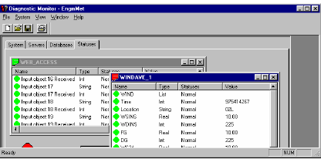
Fig.6 MIDASIV Diagnostic Monitor
Diagnostic monitor provides access to all data in MIDAS IV, view running services, view applications connected to the system ,view contents of ROA objects and select active CDU in duplicated System.

End-user Software Applications
The MIDAS IV software consists of two sets of applications: end-user applications and system maintenance applications, which are the tools needed for system troubleshooting.
The following sections include brief descriptions of what each end-user application is used for.
The MIDAS IV AWOS software focuses on the following aspects of airport weather observation:
- Displaying current weather data (Weather View)
- Sending weather reports (report applications, for example, METAR/MET REPORT)
- Ensuring the validity of weather data by monitoring the operation of the system (Event Monitor).
- In exceptional situations, replacing automatic sensor data with manual input (Actuals, Data Source Manager).
- Viewing past weather data (ASCII Log View, History Monitor).
In addition, there are applications for managing the report and weather data contents, source, and sending.

Weather View
The Weather View application is used for viewing current meteorological data in numerical and graphical format. It can also display the status of sensors and the status of the data. Optionally, the Weather View application can include the audiovisual alarm function.
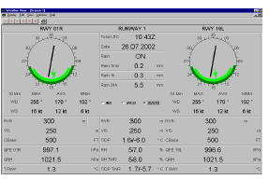

Fig.7 showing current meteorological data in digital form

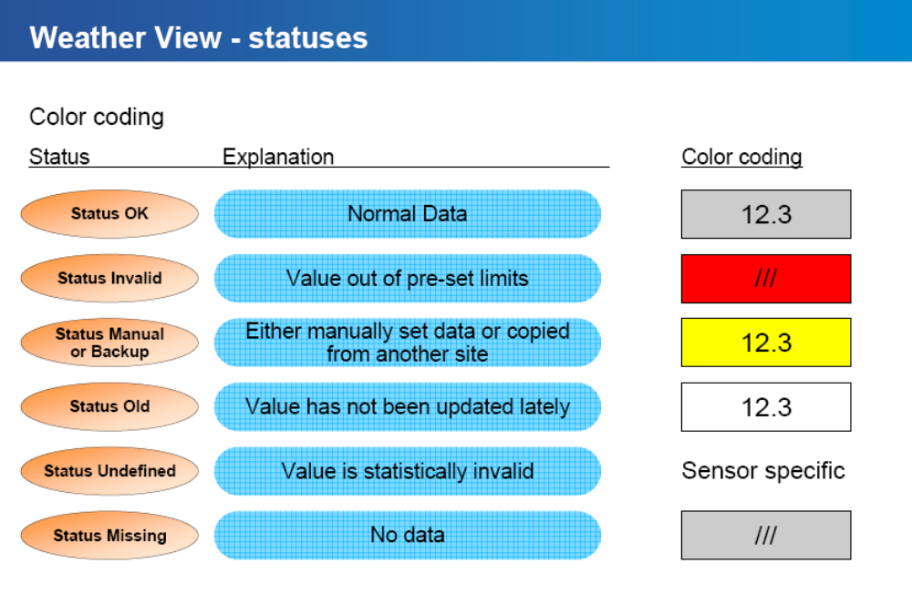
Fig. 8 showing the statuses of the weather view.

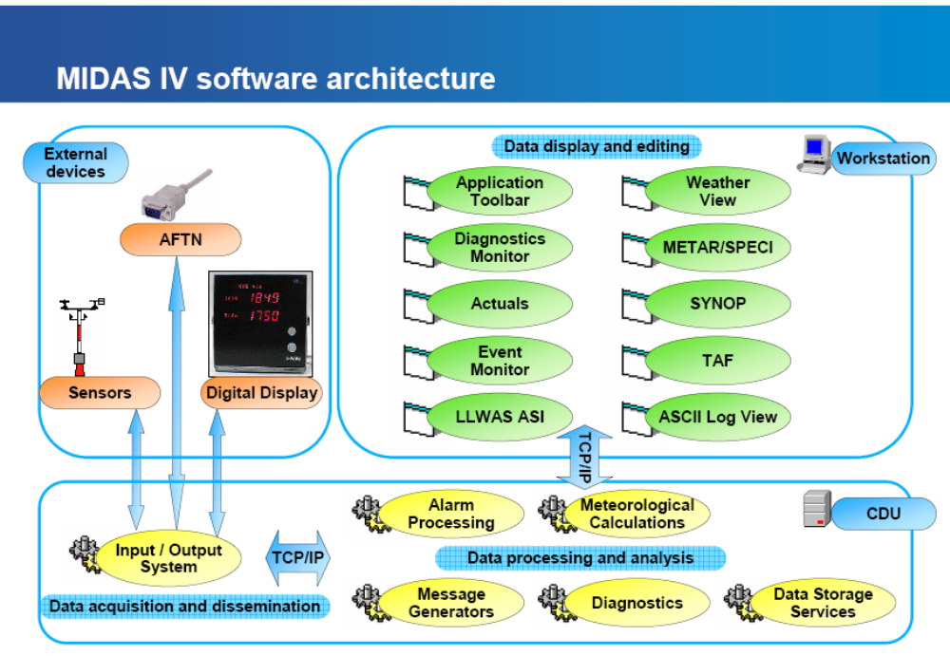
Fig. 9 showing MIDAS IV software architecture
Sensor Terminal
The Sensor Terminal application is used for viewing the sensor and field device data. It can also be used for sending commands to sensors and other field devices

2.0 Low Level Wind Shear Alarm System(LLWAS)
The Nigerian Meteorological Agency felt that safety of lives could not be guaranteed with the implementation of MIDAS IV AWOS without Wind Shear Alert System. After the completion of MIDAS IV AWOS installation, the contractor handling the safe tower project commenced the installation of low level wind shear alert system (LLWAS) at Abuja International Airport. The installation has just been completed this August. There is budgetary provision in 2008 for additional installation of LLWAS in two of the three remaining Airports.

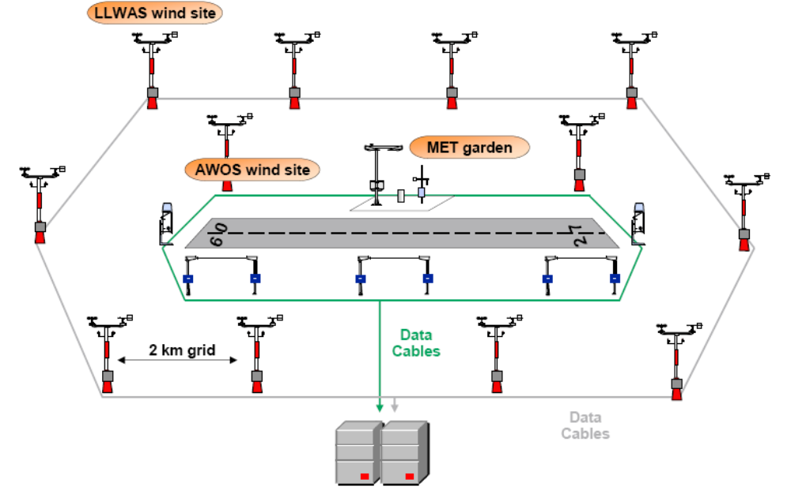
Fig. 10 MIDAS IV with Low Level Wind Shear Alert (LLWAS) System

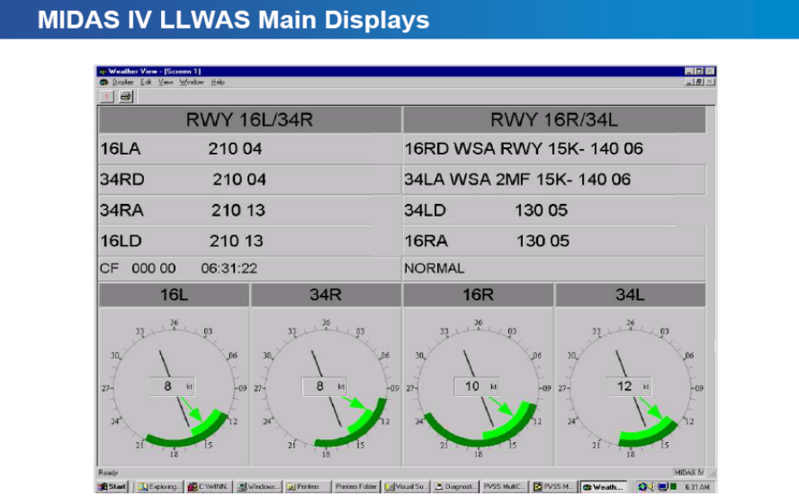

Fig.11 showing the wind force at different wind sites.

3.0. Conclusions
The introduction of a new automated system for Airports in Nigeria has indeed improved the quality of aeronautical information being provided to users due to availability of state of the earth weather instruments installed along the runways to take measurements at the airside as well as the algorithms used to obtain information. The conventional measurements still continue to serve as backup to the automated measurements. Abuja Airport installation is similar to other airports because apart from Lagos International Airport with two runways, the other three have one runway each, hence the number of weather sensors installed in Lagos Airport is twice that of Abuja and Portharcourt International Airports.
.

.

