A quality management system for the station network department at the Norwegian meteorological institute.

Merete Larre
The Norwegian Meteorological institute
Observation Department
P.O.Box 43 Blindern, 0313 Oslo, Norway
Tel. +47 22963000
Fax. +47 22963050
e-mail: merete.larre@met.no

Abstract

The station network department is responsible for collecting surface observations and maintenance of the stations. The stations are owned by the Norwegian meteorological institute (met.no), but met.no has also agreements with co-operate partners. All together the station network department is responsible for over 600 stations.

Partners are asking more often for documentation for how we do our work and how our quality management is. In addition this has also been a theme within the WMO. Met.no decided to implement a web based quality management system in 2007 for the station network department. The work started autumn 2007 and is still going on.

In the beginning of 2009 the station network department plans to obtain a certificate following the standard ISO 9001:2000.

The poster will describe the background for implementing a quality management system, how we have developed and implemented the system and a small description of the system.

The Process approach and The ISO 9001:2000 Standard

The ISO 9001:2000 standard promotes the adoption of a process approach when developing, implementing and improving effectiveness of a quality management system.

For an organization to function effectively, it has to identify and manage numerous linked activities. An activity using resources, and managed in order to enable the transformation of inputs to outputs, can be considered as a process. Often the output from one process directly forms the input to next.

The application of a system of processes within an organization together with the identification and interactions of these processes, and their management, can be referred to as the “process approach”.

An advantage of the process approach is the ongoing control that it provides over the linkage between the individual processes within the system of processes, as well as their combination and interaction.

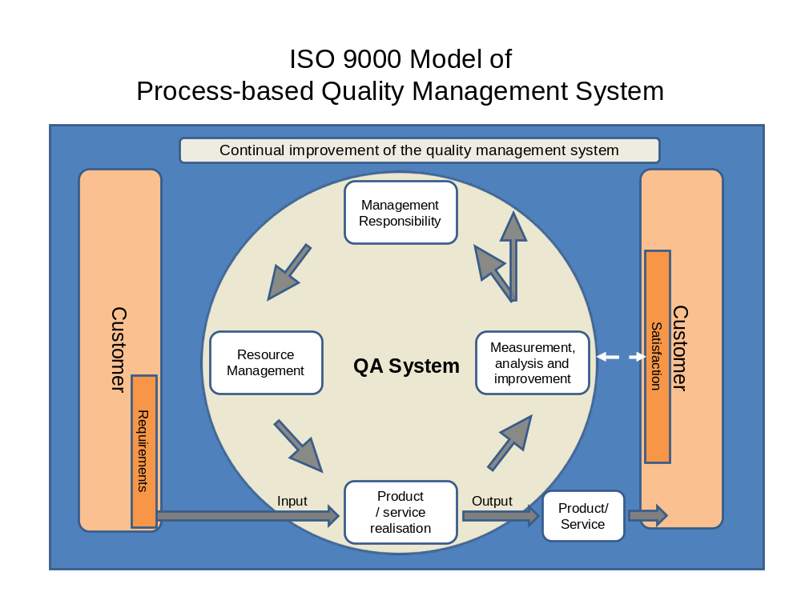The model of a process-based quality management system is shown in figure 1. This illustration shows that customers play a significant role in defining requirements as inputs. Monitoring of customers satisfaction requires the evaluation of information relating to customer perception as to whether the organization has met the customer requirements. The model shown in figure 1 covers all the requirements if the International standard ISO 9001:2000.

Figure 1. ISO 9000 model of Process-based Quality Management System
The Quality management system at the Station network department at The Norwegian Meteorological Institute

When implementing a quality management system (QA) at met.no we started by defining our main processes. The processes are:
1) Develop the observation net
2) Maintain the observation net
3) Collecting observations and quality assurance of the observations
4) Evaluate.
In addition we described the supporting processes and management processes. Each main process has several sub-processes. All processes are described and important documentations are linked up in the system. The system must all the time be improved and updated. In the system there is a feedback link where all users can report improvements. Figure 2 shows the organization of the main processes, management processes and supporting processes.

The quality management system is on web and supports both windows and Linux.

One requirement in the ISO standard is a management review. This is something we have implemented in our organization. At planned intervals the top management reviews the quality management system to ensure its continuing suitability, adequacy and effectiveness. This includes assessing opportunities for improvement and the need for changes to the quality system, including the quality policy and quality objectives.

Another requirement is internal audit. We have made an audit programme where status and importance of the processes and areas to be audited has been taken into consideration. Internal audits are conducted regular and shall determine whether the quality management system conforms the ISO standard and to the quality management system requirements established by the organization.

Management processes


Develop the observation net
Evaluate
Maintain the observation net
Collecting obs. QA of the observations
Supporting processes

Figure 2. The processes in the quality management system at the Station network department at met.no

Reference: Quality management systems. Requirements (ISO 9001:2000)

