Automatic icing probe
Kurov A., Okorenkov V., Sinkevich A., Sokolenko S., Stepanenko V., Volkov N.
State Institute Voeikov Main Geophysical Observatory
Research Center for Atmospheric Remote Sensing
Tel.: (+7 812) 297 8673
Fax: (+7 812) 297 8661
E-mail: sinkev@main.mgo.rssi.ru
Abstract
A new instrument (IO-1) to measure icing was developed in Main Geophysical Observatory. The instrument consists of 2 metallic rods, which are installed perpendicular each other. A camera is located at some distance to take pictures of the rods. Pictures of the rods and icing located at them are taken periodically and archived. Special software was developed to fix ice located on the rods and to measure its depth and velocity of icing.
Laboratory and field experiments were carried out to study possibilities to measure icing and to assess main characteristics of the instrument. Results of these experiments had shown that an accuracy of the instrument is better than 0.1 mm of icing depth.
Description
In 2006 the authors started development of a new automatic icing probe. Ice measurements are based on optical method of image registration. This method enables to capture images of glaze-ice and rime deposition, which forms on the rods of the detector. The camera is working in automatic mode. Similar method of measurements is used in well-known instruments which measure concentration and sizes of cloud particles (e.g. 260X, 2D-C, 2D-P, CPI). Captured images are used further as a basis to extract icing characteristics. A main feature of these measurements is that they are carried out in remote mode, so they provide rather accurate results. Figure 1 presents the detector.

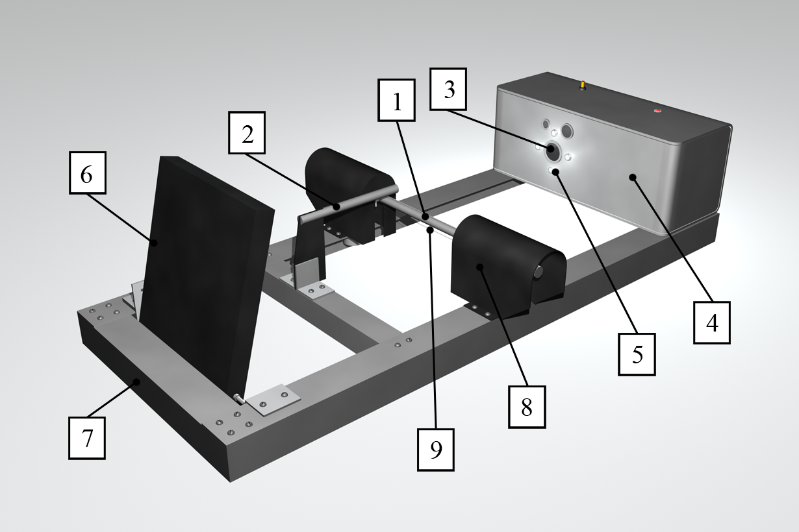 | - first test rod  - second test rod  - photorecoder objective  - photorecorder unit  - light sources  - screen  - base frame  - dynamometer props  - reference thread
Figure 1. Automatic icing probe
Two perpendicular metallic rods are used as icing probes. A photorecoder (digital camera) is located at some distance from them. It captures images of the rods. Due to good spatial resolution a digital camera is well suited for such task. Examples of captured images are presented in Fig. 2.
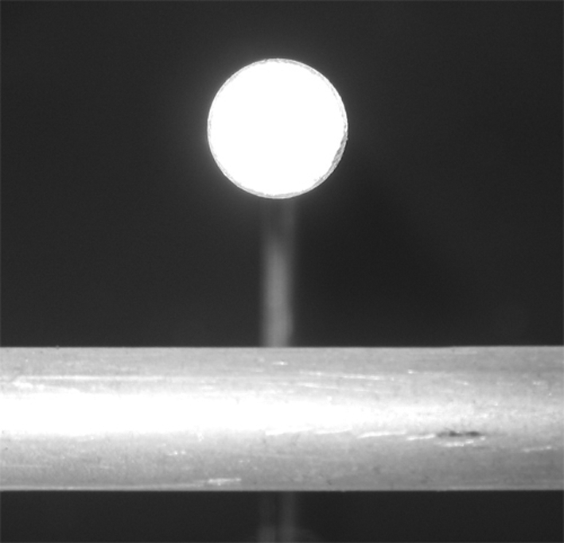 | 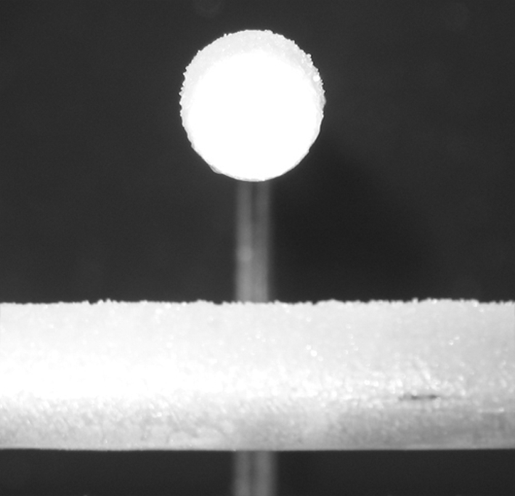
a) without ice | b) with ice
Figure 2. Examples of captured images
Captured images are transferred to a computer for the following processing.
The instrument enables to measure the following parameters:
- initial and final time of ice appearance
- thickness of ice
- velocity of icing
- ice mass
The use of digital camera provides also possibility to monitor ice formation visually. Figures 3 and 4 illustrate the process of rime growth.
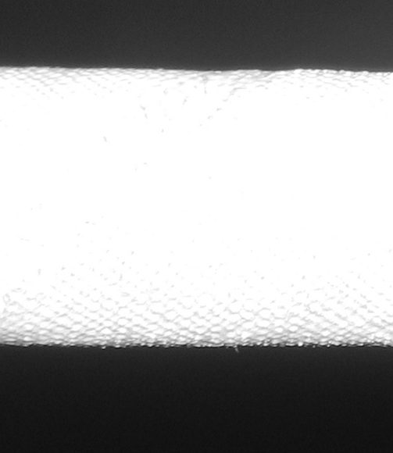 | 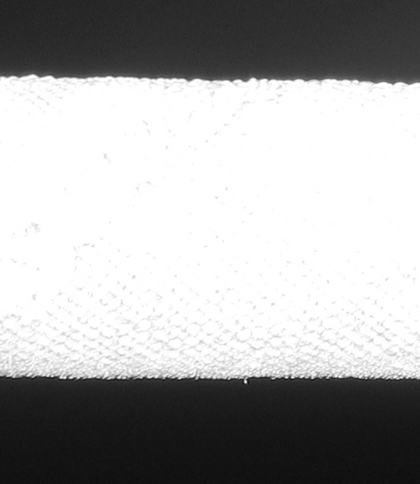 | 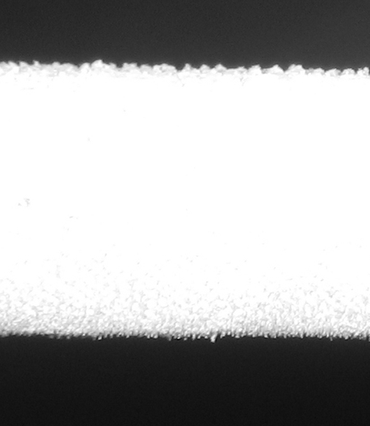
13:00:00 | 13:17:00 | 13:26:00
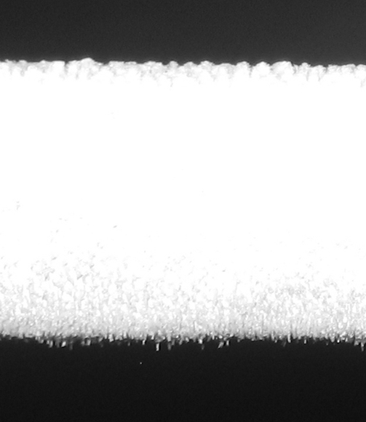 | 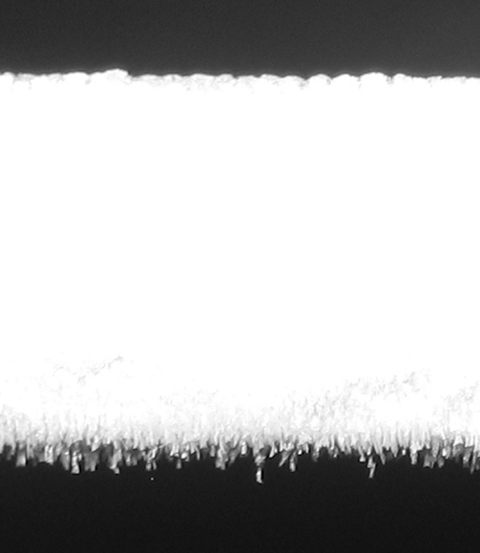 | 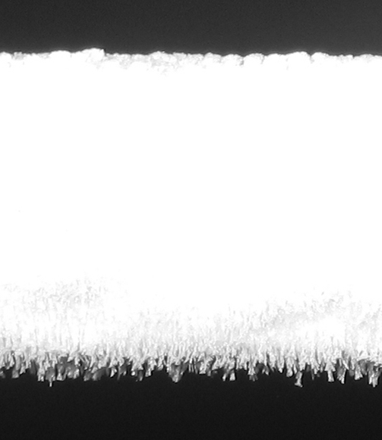
13:33:00 | 13:44:00 | 13:55:00
Figure 3. An example of rime growth during a laboratory experiment.
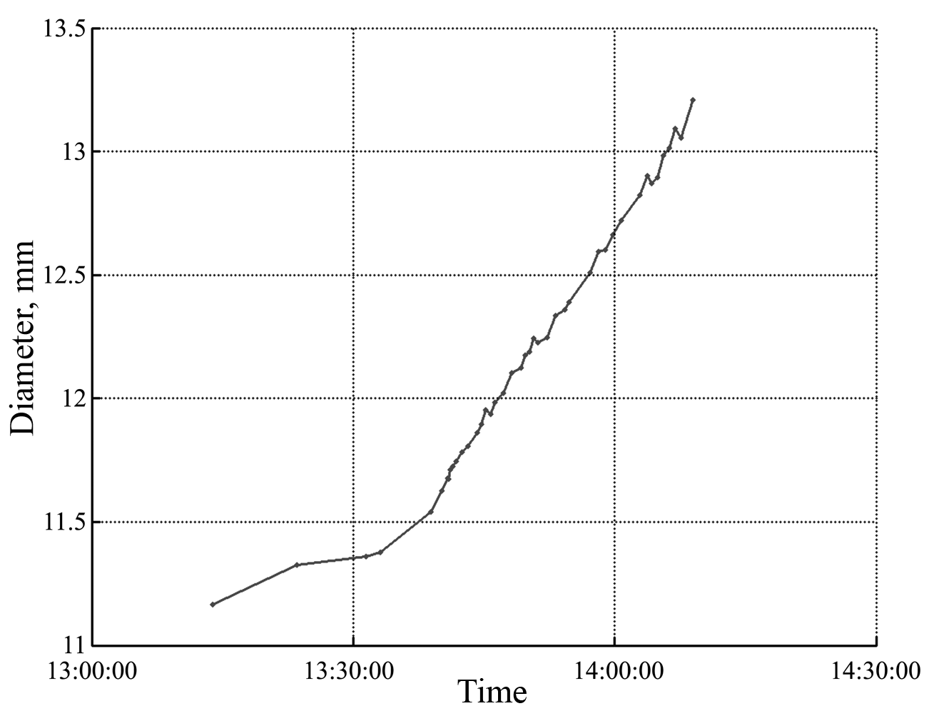
Figure 4. Change of first test rod diameter due to icing during the laboratory experiment.
One can clearly see an increase in icing during laboratory experiment when a flow of coolant was running through a test rod, cooling it down, and hence riming ice appeared on its surface. Developed application software provided main characteristics of icing. One of the plots which presents changes in the rod diameter due to icing is presented in Fig. 4. Here, formation of ice started at 13:13:54 and finished at 14:08:58. A mean velocity of ice growth was equal to 3.1 mm per hour. An accessed accuracy of the detector was near 0.1 mm. The accuracy is limited by digital camera resolution.
Field experiments
Field experiments to study reliability of icing measurements were carried out during last two years. The probe was installed on a roof of a building alongside with a set of meteorological instruments at the Voeikov meteorological station (Leningrad Region).
Chosen images obtained during field experiments are presented in the Fig. 5. Here, one can see images with drops and snow on the rods (upper images). Fig. 5(c) presents images with different types of icing.
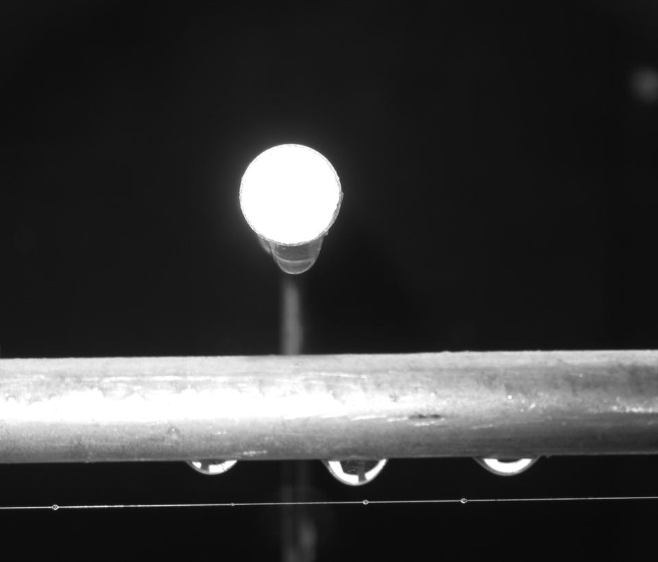 | 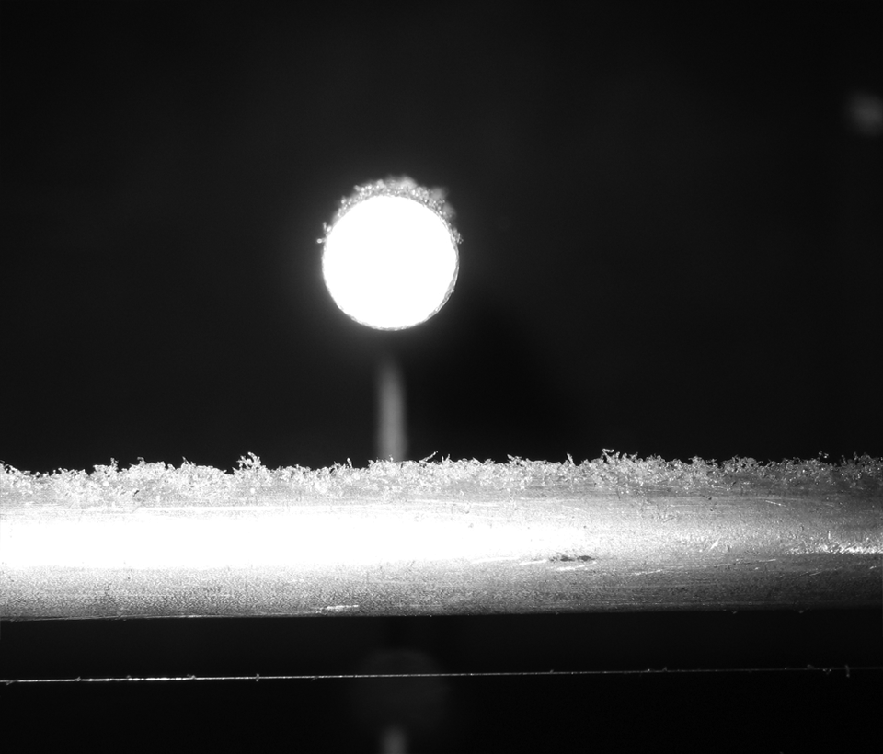
a) Rain water drops on the rods | b) Snow on the rods
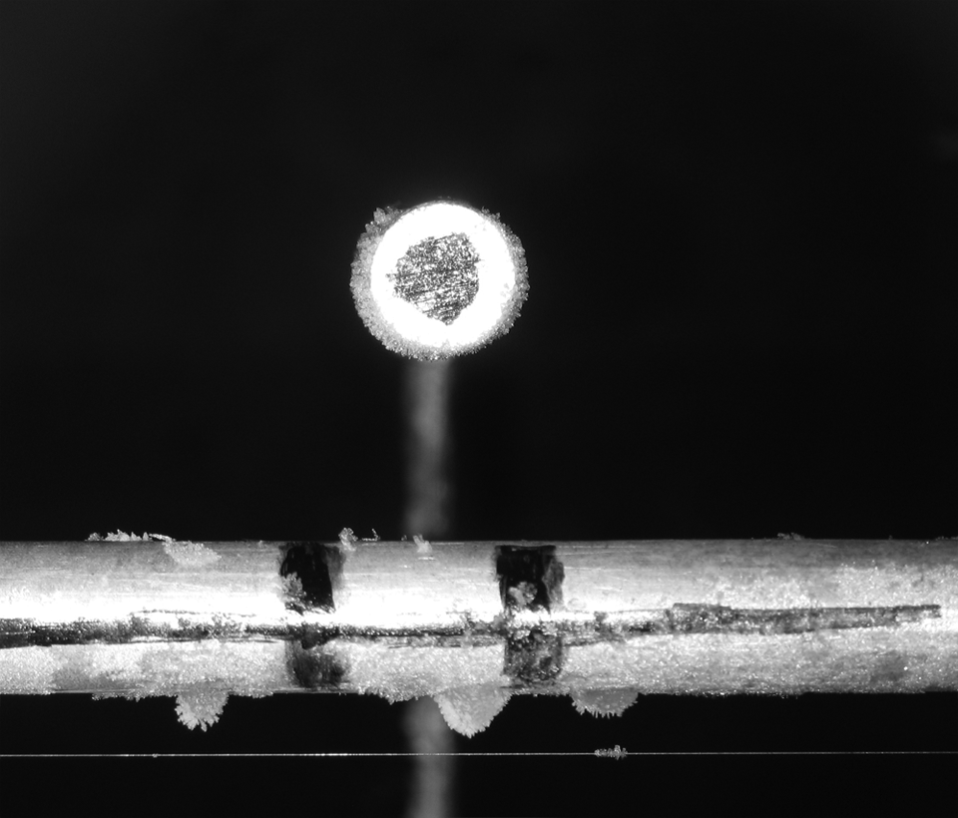 | 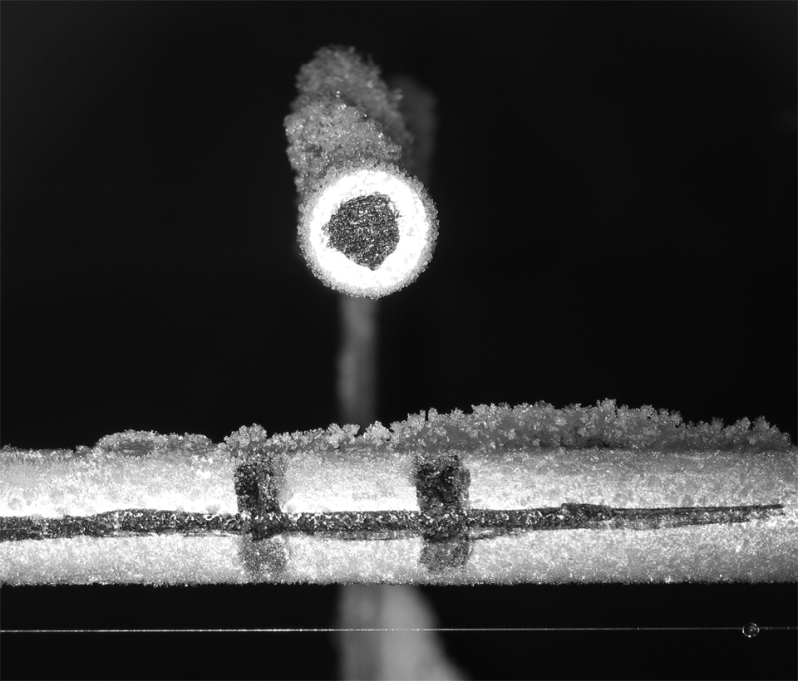
c) Rime deposition on the rods
Figure 5. Examples of images captured during field experiments.
During some days rather severe icing was observed. Below we present a data of one experiment when icing was observed during rather long period of time (Fig. 6). On the 28th of January 2008 a temperature was –3.5°C, wind direction was southwest, its velocity was 2m/s, relative humidity was 93%. Rime ice deposition is seen on upper rod. Frozen drops were located at the second rod.
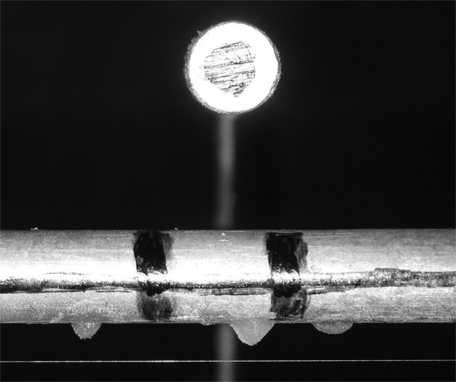 | 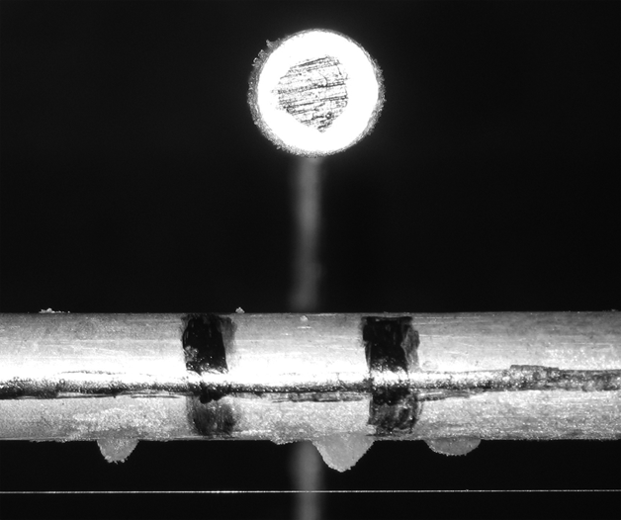 | 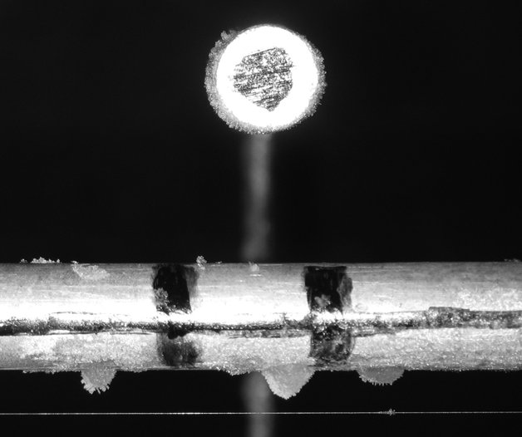
19:55:00 | 20:55:00 | 21:55:00
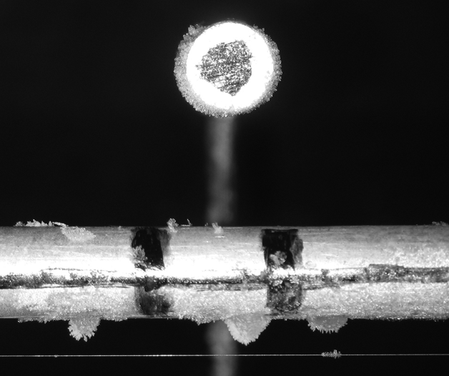 | 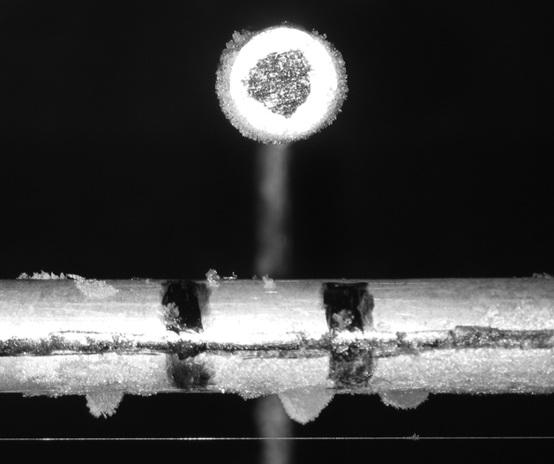 | 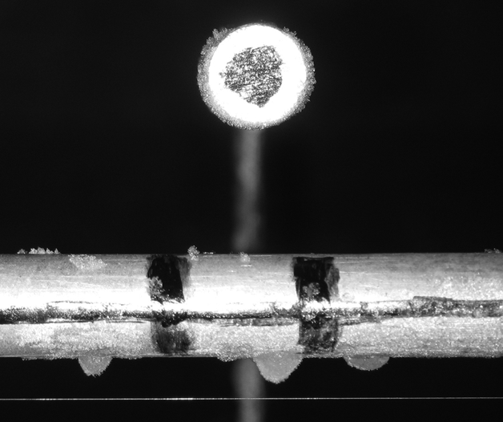
22:55:00 | 00:55:00 | 02:55:00
Figure 6. An example of rime growth during the field experiment performed on 28th January, 2008.
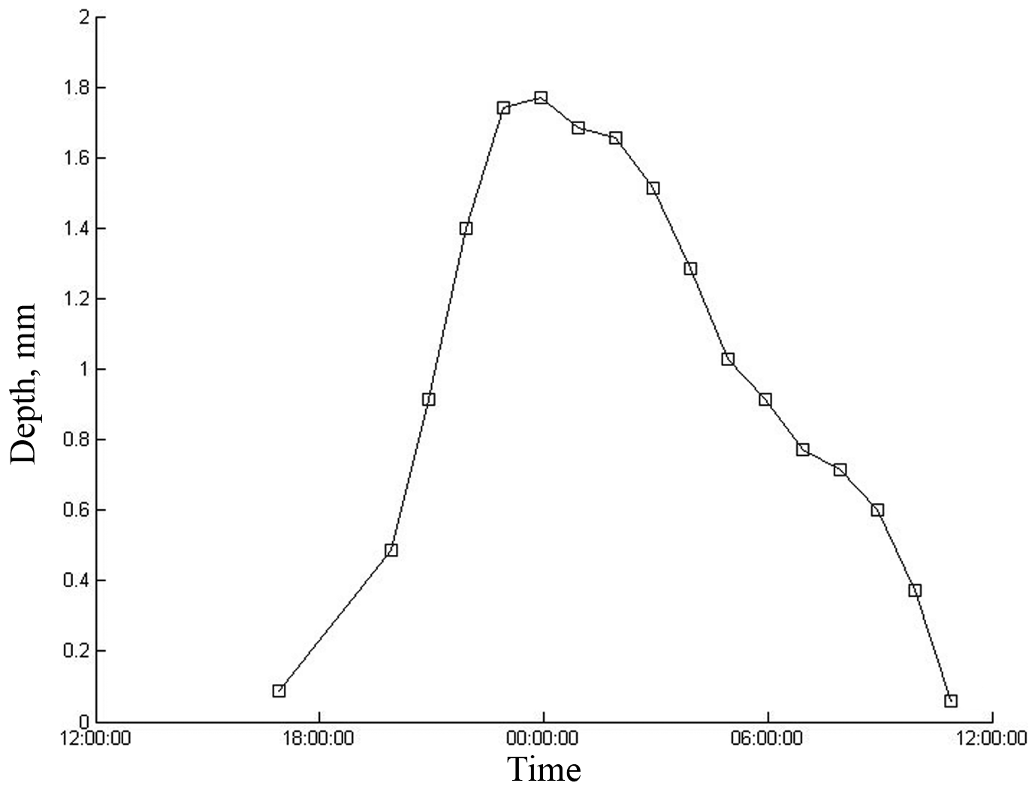
Figure 7. Temporary changers in ice and rime mean depth on the first test rod
during the field experiment, performed on 28th January, 2008.

Results of calculations of the ice depth deposited on upper rod are presented in Fig. 7. Maximum depth of ice on the rod was equal to 1.8 mm, a velocity of its deposition and evaporation was consequently 0.26 and 0.16 mm per hour.
The probe provides to get detailed characteristics of ice including information on ice structure. Some pictures which illustrate this important feature of the instrument are presented below (measurements on the 5th of February, 2008). An inhomogeneous structure of ice deposition is clearly seen.
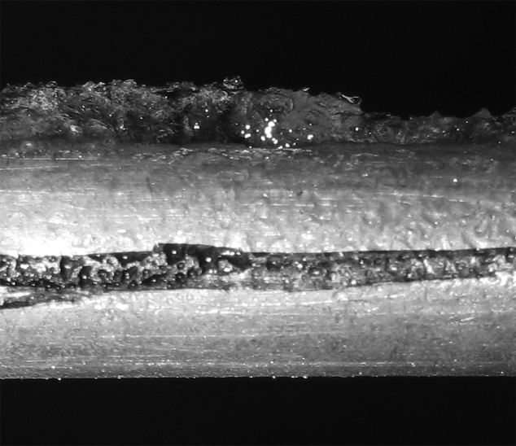 | 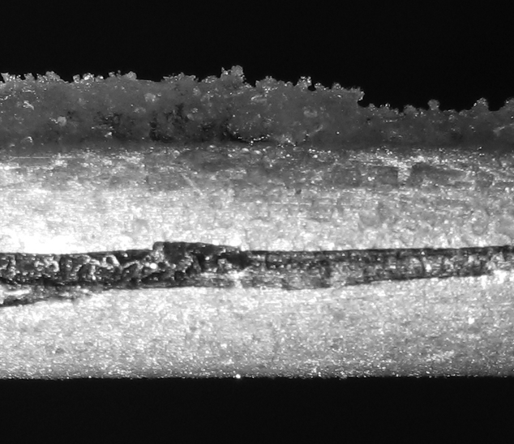 | 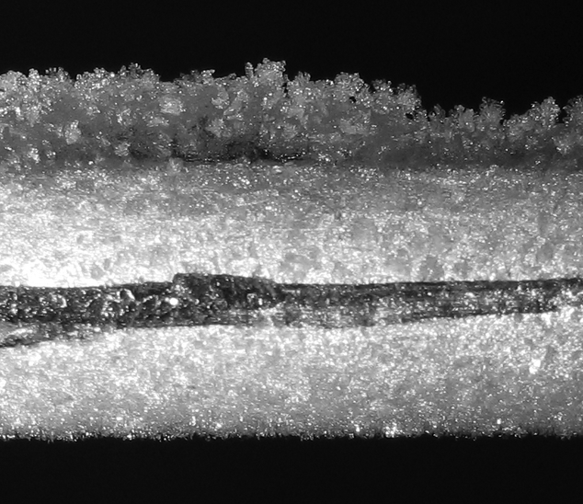
23:46:54 | 03:46:54 | 07:46:54
Figure 8. An example of icing process on 5th of February, 2008
Conclusions
A new instrument to measure icing, based on image processing, was designed in the Main Geophysical Observatory.
It can be used for different purposes:
- automatic registration of glaze-ice and rime deposition and automatic registration of precipitation type (snow, rain, hail etc.) at meteorological stations;
- to assess ice formation on different surfaces, e.g. road icing, airport runaway icing etc.
- to measures icing intensity of electrical power lines, telecommunication lines etc.

