Turkey Emergency Flood and Earthquake Recovery (TEFER) Project
Kemal DOKUYUCU
Head Of Weather Forecasting Department
Turkish State Meteorological Service

INTRODUCTION
Due to geographical location, topography, plant cover and precipitation regime, Turkey undergoes many different types of natural disasters like eartquake, flash floods, landslides, forest fire and snow avalanches. Flash floods are second important natural disaster after earthquakes with more than 20 flood events causing at least 30 deaths per year.

Western Black Sea Region of Turkey was affected by the floods that occurred as
a result of the unusual amount of rainfalls corresponding to the reoccurrence periods of 200- 1000 years on May 21st- 25th, 1998 and the landslides that occurred in the subsequent weeks.

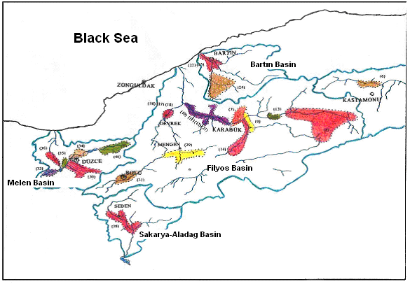

In response to these floods , the Government of Turkey with the assistance from the World Bank has identified an Integrated Flood Management programme, named TEFER (Turkey Earthquake and Flood Emergency Recovery) Project to develop flood management and to reduce or eliminate long-term risk and damage to people and their property from natural hazards. With TEFER, the urgent need in the flood prone area; which has been presented as case study from Turkey; the establishment of all kinds of structural and non-structural measures as flood control alternatives are being realized.

MAIN SIDES OF THE PROJECT

State Hydraulic Works (Devlet Su İşleri - DSI)
The Works including repairing and enhancing damaged infrastructure in urban and rural areas, Assessment of Basin Flood Hydrology, Efforts to relocate sediments, Rehabilitation and improvement of flood protection infrastructure were undertaken by DSI and local municipalities. DSI also was responsible to run planned flood forecasting system including flood forecasting models and installation of 129 automatic real-time hydrometric stations.

Turkish Meteorological Service (Devlet Meteoroloji İşleri – DMI)
Installation Works containing of 206 Automated Weather Stations, 3 Doppler Radar, VSAT systems for data transfer and High Performanced Computer systems to run local numerical models to produce required forecast products like amount of precipitations for both flood forecasting models and weather forecasting was undertaken by DMI. DMI was also responssible to transfer observations from synoptic and airport stations and forecasted NWP data to DSI.

General Directorate of Electric Power Resources Survey and Administration (EIEI)
EIEI mainly took responsibility as data supplier for some surveys needed for TEFER Works.

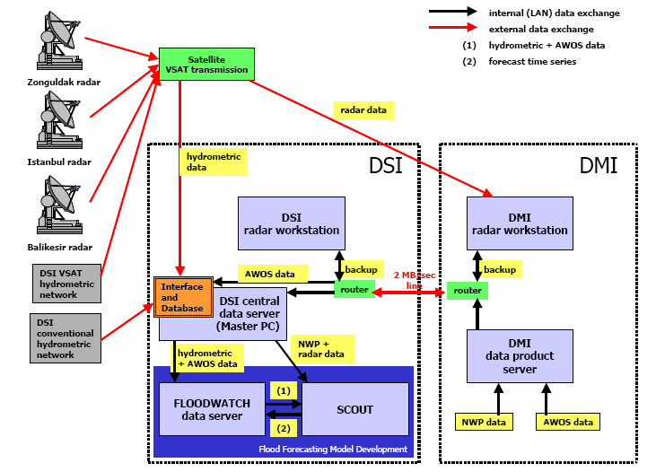
Data flow diagram for flood forecasting model

PLANNED AND COMPLETED WORKS
a)Assessment of hydrology and flood analyses in the project area (DSI)
b) Mapping (EIEI)
c) Construction Works of reinforced concrete stake walls in river beds (DSI)
d) Hydrometric stations (DSI)

e) VSAT Systems (DMI)
GILAT company supplied VSAT systems for both DSI and DMI. Two Hubs are installed in DSI and DMI centers separately and a terrestrial backup data line was built between the centers.
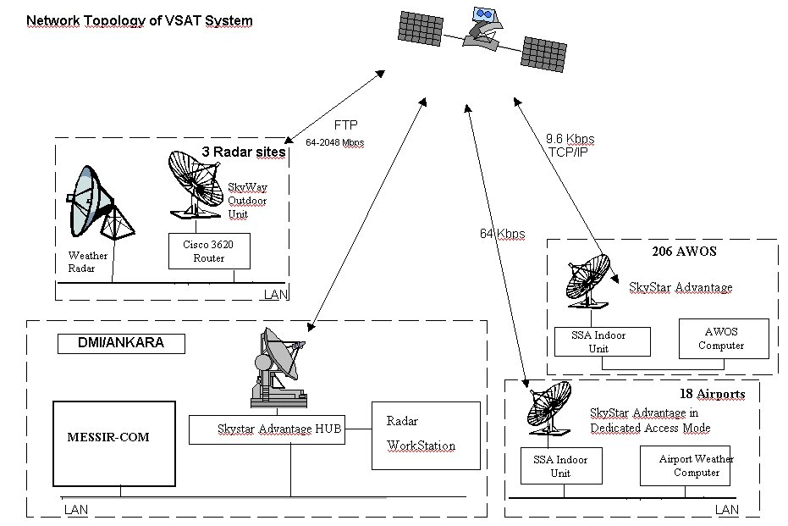

f) Radar Systems (DMI)
DMI bought and Installed three Doppler Weather Radar systems from Japan Mitsibushi Company. These radar systems installed in İstanbul, Zonguldak and Balıkesir regions. DMI uses these radar systems for determining, following and forecasting severe weather event such as heavy rain, thunderstorm, snow and tornado and creating early warning reports for risky areas. All data received from radars are instantly transfered to DSI .

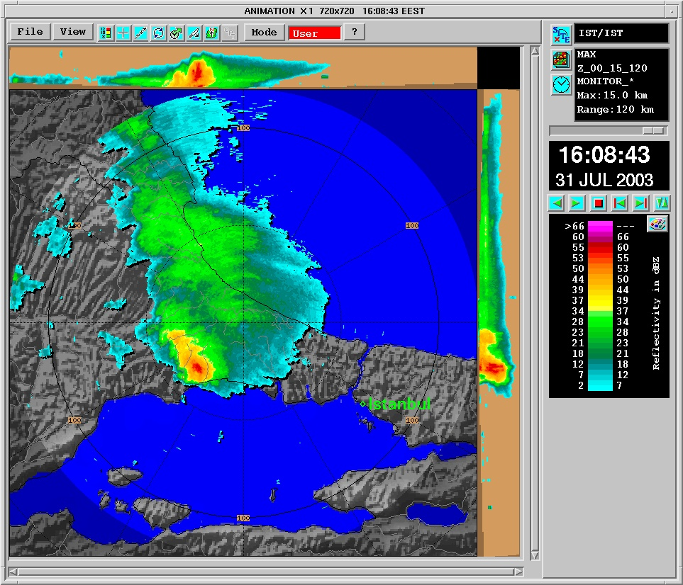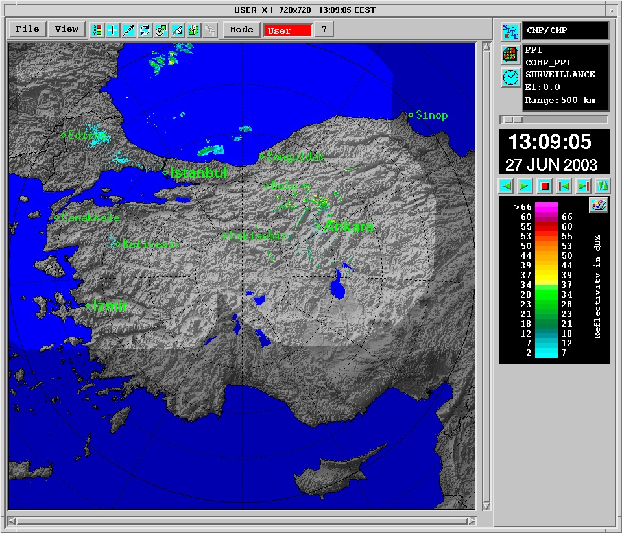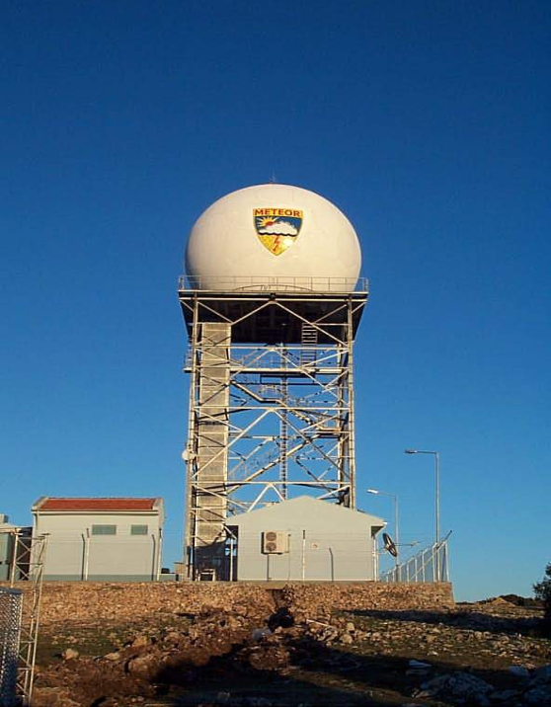

g) AWOS systems (DMI)
DMI rehabilitated its existing manned weather stations with AWOSs and enhanced its observation network by installing new stations to the places where there were no meteorological stations in Western Turkey. Flood Forecasting Model at DSI also uses these data as input.

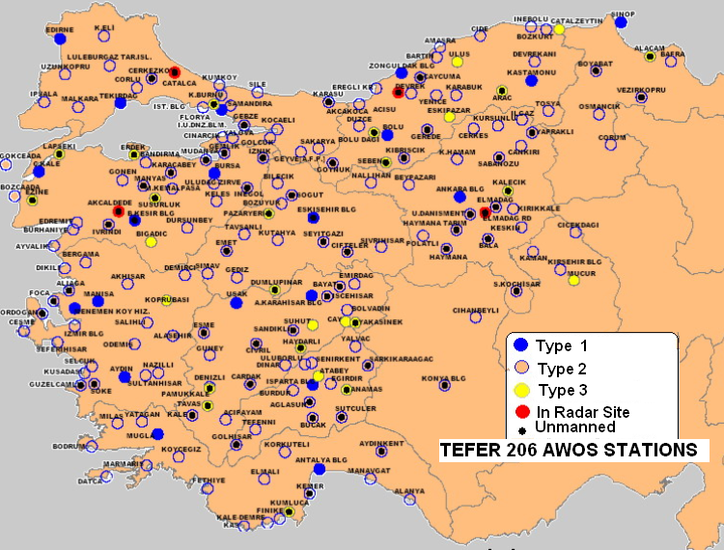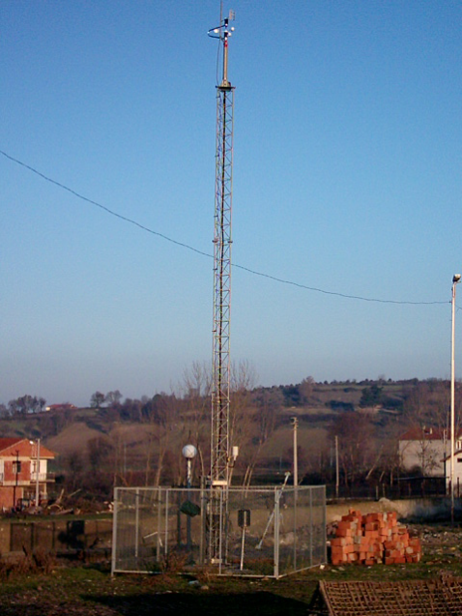

h) High Performance Computer systems
Turkish Met Service bought a High Performance Computer from IBM. MM5 numerical Weather prediction model was installed on the system to produce numerical weather prediction products for both weather forecasting at DMI,and flood forecasting model at DSI. 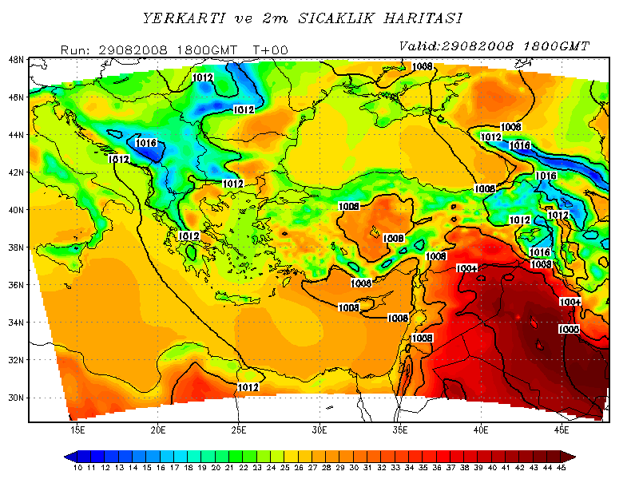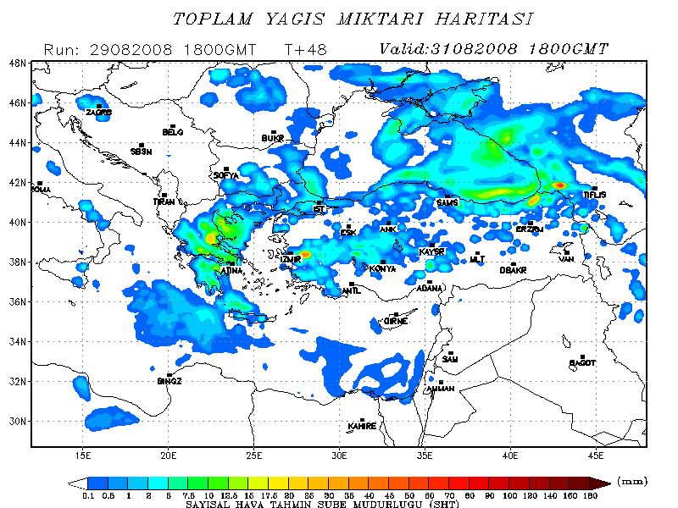

i) Flood Forecasting Model At DSI
The contract for the TEFER, Flood Forecasting Model Development project was signed between the DSI and Danish Hydraulic Institute(DHI) Water and Environment,
Denmark on 30th November 2001. Sub consultants to DHI for the project are Einfalt & hydrotec GbR, Germany, and from Turkey Arti Proje Ltd and UBM United International Consultants Inc (Tefer, 2002).

The flood forecasting system takes real time monitoring hydrological and meteorological data of the catchment, and produces forecasts up to 48 hours of the flood state (in stage and runoff rate) of the catchment.

The forecasting system is based on MIKE FLOODWATCH and SCOUT. SCOUT makes rainfall forecasts for each subbasin with combining real time meteorological data, radar and NWP. The system combines the compilation of real time data with rainfall and flood forecasting and presentations of the information and results. It is the first time in the world that a combination of NWP data, radar data, raingauge data and a hydrological hydrodynamic model has been combined and used for real-time operation. The forecasting process is automated, and adjusted to run every hour with the possibility of manual check and control. The hydrological model used in the system is MIKE11-NAM Module which considers the moisture content in four interrelated storages(Snow layer, surface zone, root zone and ground water) representing the physical elements of the catchment . The flood state in the basins can be mapped by the flood mapping module named as MIKE 11 GIS and is ideally suited as a spatial decision support tool for river and flood plain management by merging the numerical river modeling and GIS.

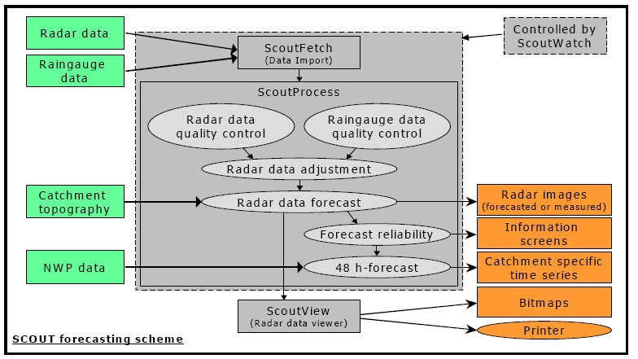

This module is used to represent the possible inundated areas in case of big flood events. The warnings can be disseminated through internet as maps, bulletins and graphs by the flood warning module. The possible flood warnings are disseminated through the intranet of DSI for the use of Regional Directorates of DSI in the basins.

