Observing lightning from the ground over large areas of the globe

²C. Gaffard, ¹ A. Bennett, ¹N.C. Atkinson, ¹J. Nash, ¹E. Hibbett, ¹G. Callaghan,
¹P.L. Taylor, and ¹P. Odams,

¹ Met Office, FitzRoy Road, Exeter, EX1 3PB, UK
Tel 44-1392885649: e.mail: john.nash@metoffice.gov.uk
² Met Office, Meteorology Building, University of Reading, Reading, RG6 6BB, UK
Tel 44-1183787831: e.mail:catherine.gaffard @metoffice.gov.uk

Operational performance of the ATDNET long range lightning detection system is examined. Data from this system are now available from the Met Office over the GTS. The system regularly reports stroke locations from storms in Europe, western Asia, Africa, the Atlantic Ocean and south and Central America. The accuracy and coverage available from the system will be discussed. Work in progress to improve the system will also be described, and potential for further expansion of the system considered.

1. Introduction

The electromagnetic emissions from cloud to ground lightning discharges in thunderstorms are usually high between 10 and 14 kHz. The emissions originate from the rapid neutralisation of charge in the lowest few hundred meters of cloud to ground (C-G) strokes. Atmospheric attenuation at these frequencies is very low and the electromagnetic emission (SFERIC) from the lightning stroke can propagate over thousands of kilometres within the earth-atmosphere wave guide. So lightning discharges can be received from a very large area even with a limited sensor network, see Fig.1.2 and Fig.2.2.

In January 2008, ATDNET [Arrival Time Difference NETwork] operations commenced in the UK Met Office. Testing had started in 2006 with a limited number of outstations and the system was brought close to operational configuration by April 2007. Fig.1.1 shows the rates of reporting achieved each month over the current service area since testing of the new system commenced and Figure 1.2 shows a typical distribution of stroke locations at mid afternoon UK time. Figure 1.3 shows an ATDNET climatology showing the number of locations in a 1 degree longitude. latitude boxes showing boxes with more than 500 stroke locations reported in a month.Superimposed on this is an estimate of the useful area of ATDNET stroke detection for two 3 month periods compared to Lightning Imaging Sensor [LIS] climatology over the same period.

Expected useful products for forecasting include superimposing the cloud to ground locations on satellite infrared cloud observations, see Fig.1.4. These plots are also useful for identifying anomalous locations. ATDNET long range observations often show the presence of lightning early in the development of storms and so show the lightning before the cloud anvil for isolated storm cells can be seen when storms are developing rapidly, so a full check of location validity needs to check against later cloud cover.

The ATDNET system is fully supported by the Met Office and does not rely on any external manufacturer to sustain operations. The system is a low-cost innovation that has grown out of a requirement placed on the Met Office to locate thunderstorms for general weather prediction [public safety], the national Electricity supply Grid and Defence operations. The outputs find many applications, for instance, to verify occasions of very intense rainfall detected by the weather radar network.

In this paper we describe the lightning detection net work, and the accuracy of the lightning location. Then an explanation for the decrease in detection efficiency observed at night, and solutions to improve the detection are proposed. Future works to improve the coverage and the accuracy are presented.

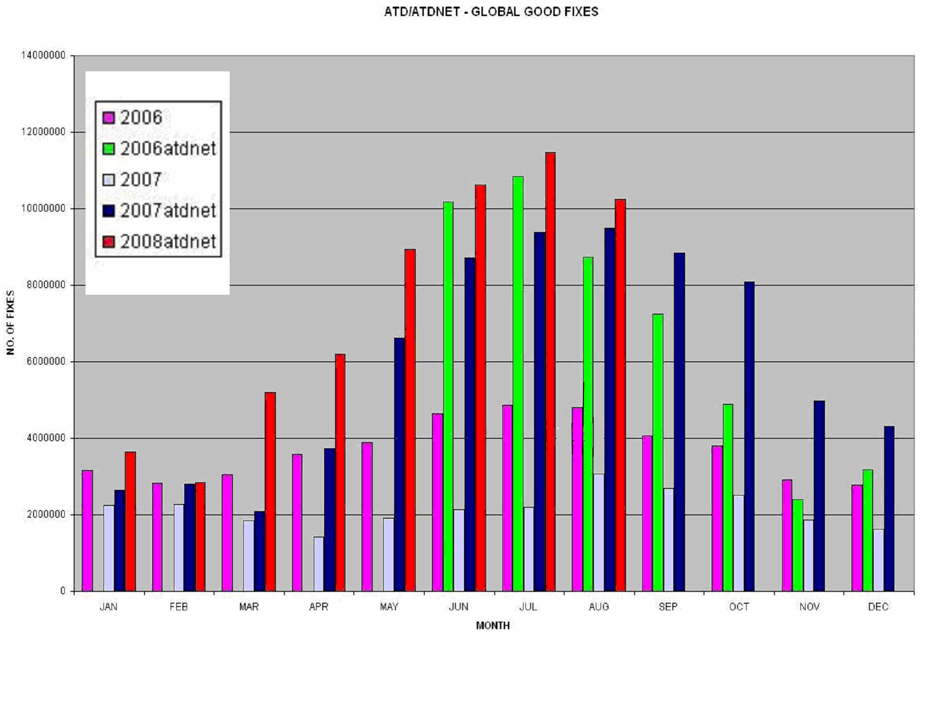

Figure 1.1 Number of good locations reported per month since 2006 for the previous ATD system and for ATDNET .In March 2007 the old system was switched to using less efficient sensors and the best sensors used for ATDNET.

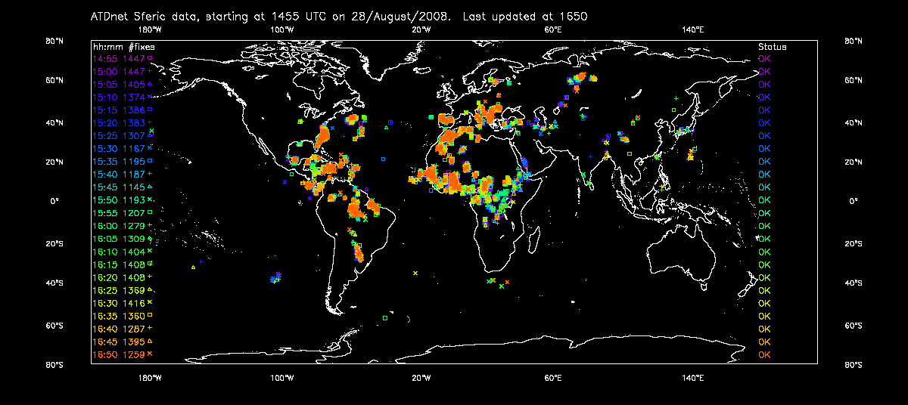

Figure 1.2 Monitoring plot for ATDNET output, samples in 5 minute batches for 2 hours on 28 August 2008.Storms located in Europe, Africa, western Asia, south America and across the Atlantic and limited information in north eastern Asia.
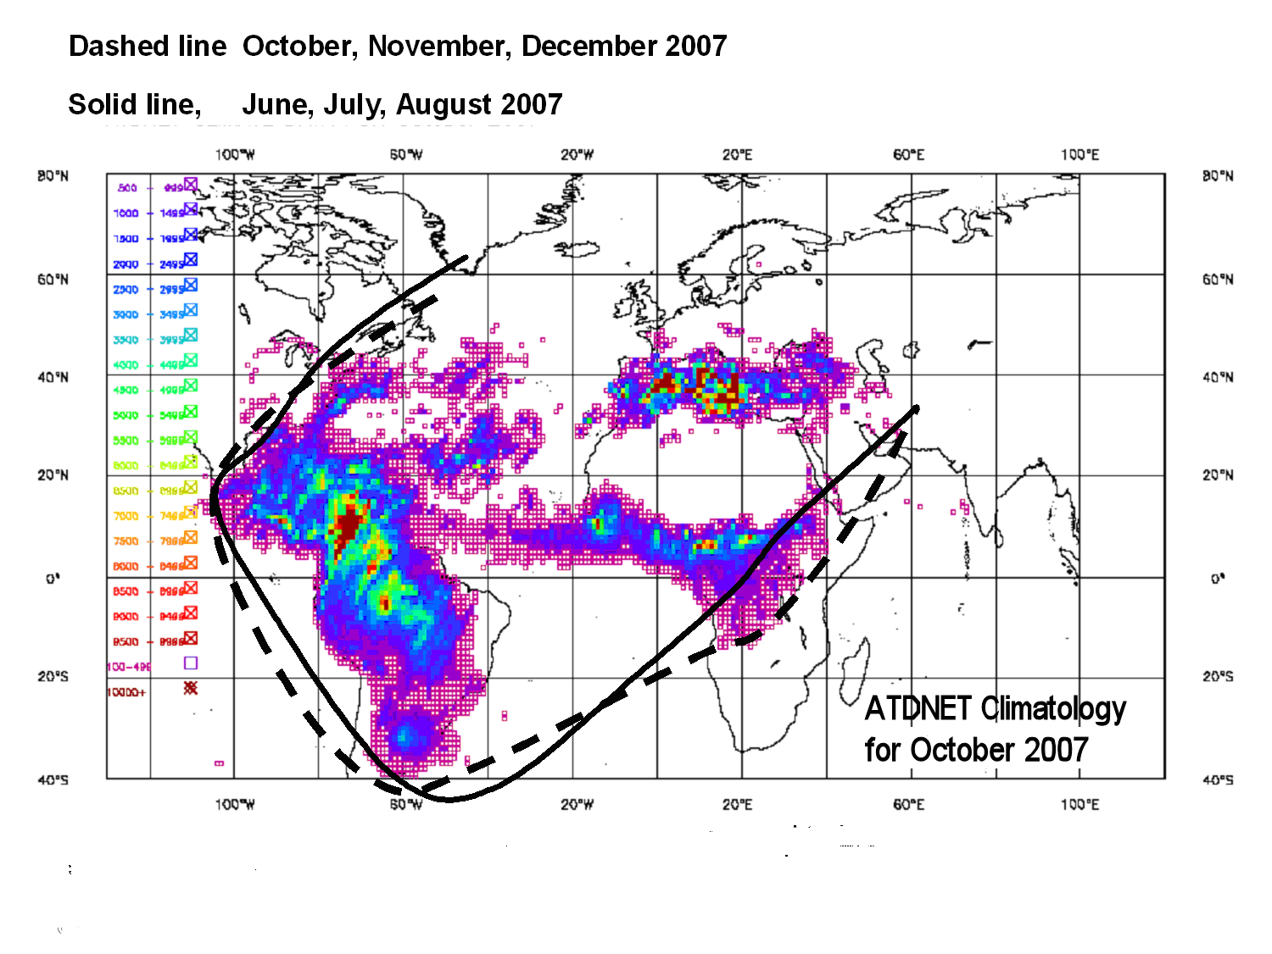
Figure 1.3 ATDNET System network coverage. Limits of useful coverage determined for 3 month periods by comparison with climatologies of satellite observations for the same periods.

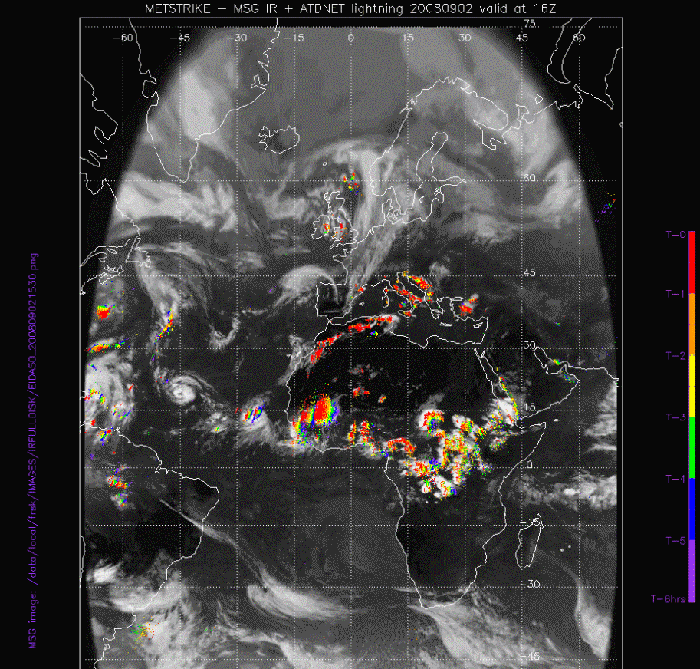
Fig1.4 ATDNET stroke locations superimposed on MSG infrared satellite cloud observations. Red dots within the last hour, purple dots 6 hours earlier. The hour preceding 16.00UTC on 02 September 2008.
2. ATDNET description

The ATDNET system locates flashes from the vertical component of the electromagnetic field generated by a lightning discharge in a narrow frequency band [narrow bandpass software filter:- 3 dB bandwidth 2.5 kHz] centred within the range 10 to 14 kHz. The antenna used is a V-polarisation, omni-directional whip, see Fig. 2.1. Actions are being taken to gain recognition for the ATDNET system in the ITU Radio Regulations so that a permanent radiofrequency allocation can be identified for the service. ATDNET is currently operated at 13.7 kHz, but would be more efficient near 10 kHz , if interfering signals could be eliminated near 10 kHz. The sensors primarily observe emissions from cloud to ground strokes, but there are also intracloud discharges in the vertical that will produce emissions of sufficient strength that they can be detected by the system.

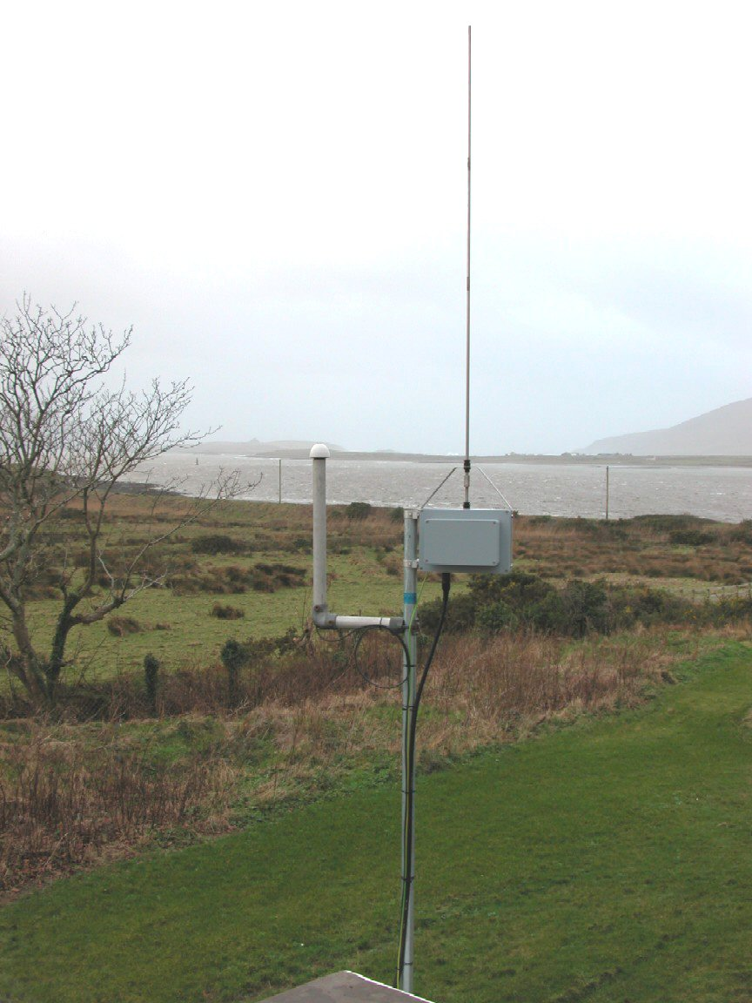

Fig.2.1 ATD whip antenna used for observations at 10 kHz or 13.6 kHz
[frequency can be changed using software]. Now most sensors are mounted on masts, if possible, since this seems to give better sensitivity.

At the moment nearly all the sensors are deployed in Europe, as shown in Fig.2.2, but there is one at La Reunion in the Indian Ocean, currently used to develop the capability of linking long range sensors to the European sensors. The sensors at Camborne and Exeter are too close together and work is in hand to move the Camborne system to a location in southern Scotland, about halfway between Exeter and Lerwick.

The sensitivity to very low amplitude discharges less than 10 kA will be low in the areas of Europe where spacing between ATDNET sensors is large. If this poses a problem to the users of the system than a few more sensors would need to be used to fill the gaps within Europe [ two or three at most], and it is probable that at least one more sensor will be installed in the immediate future, and the sensor in the Azores will be relocated .

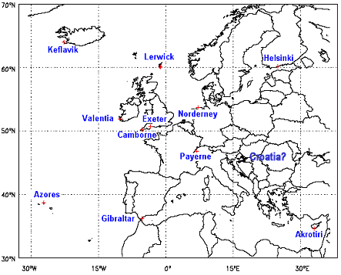
Figure2.2 Map of current ATDNET sensors. Site surveys have been performed in Croatia and a sensor is expected to be installed soon.

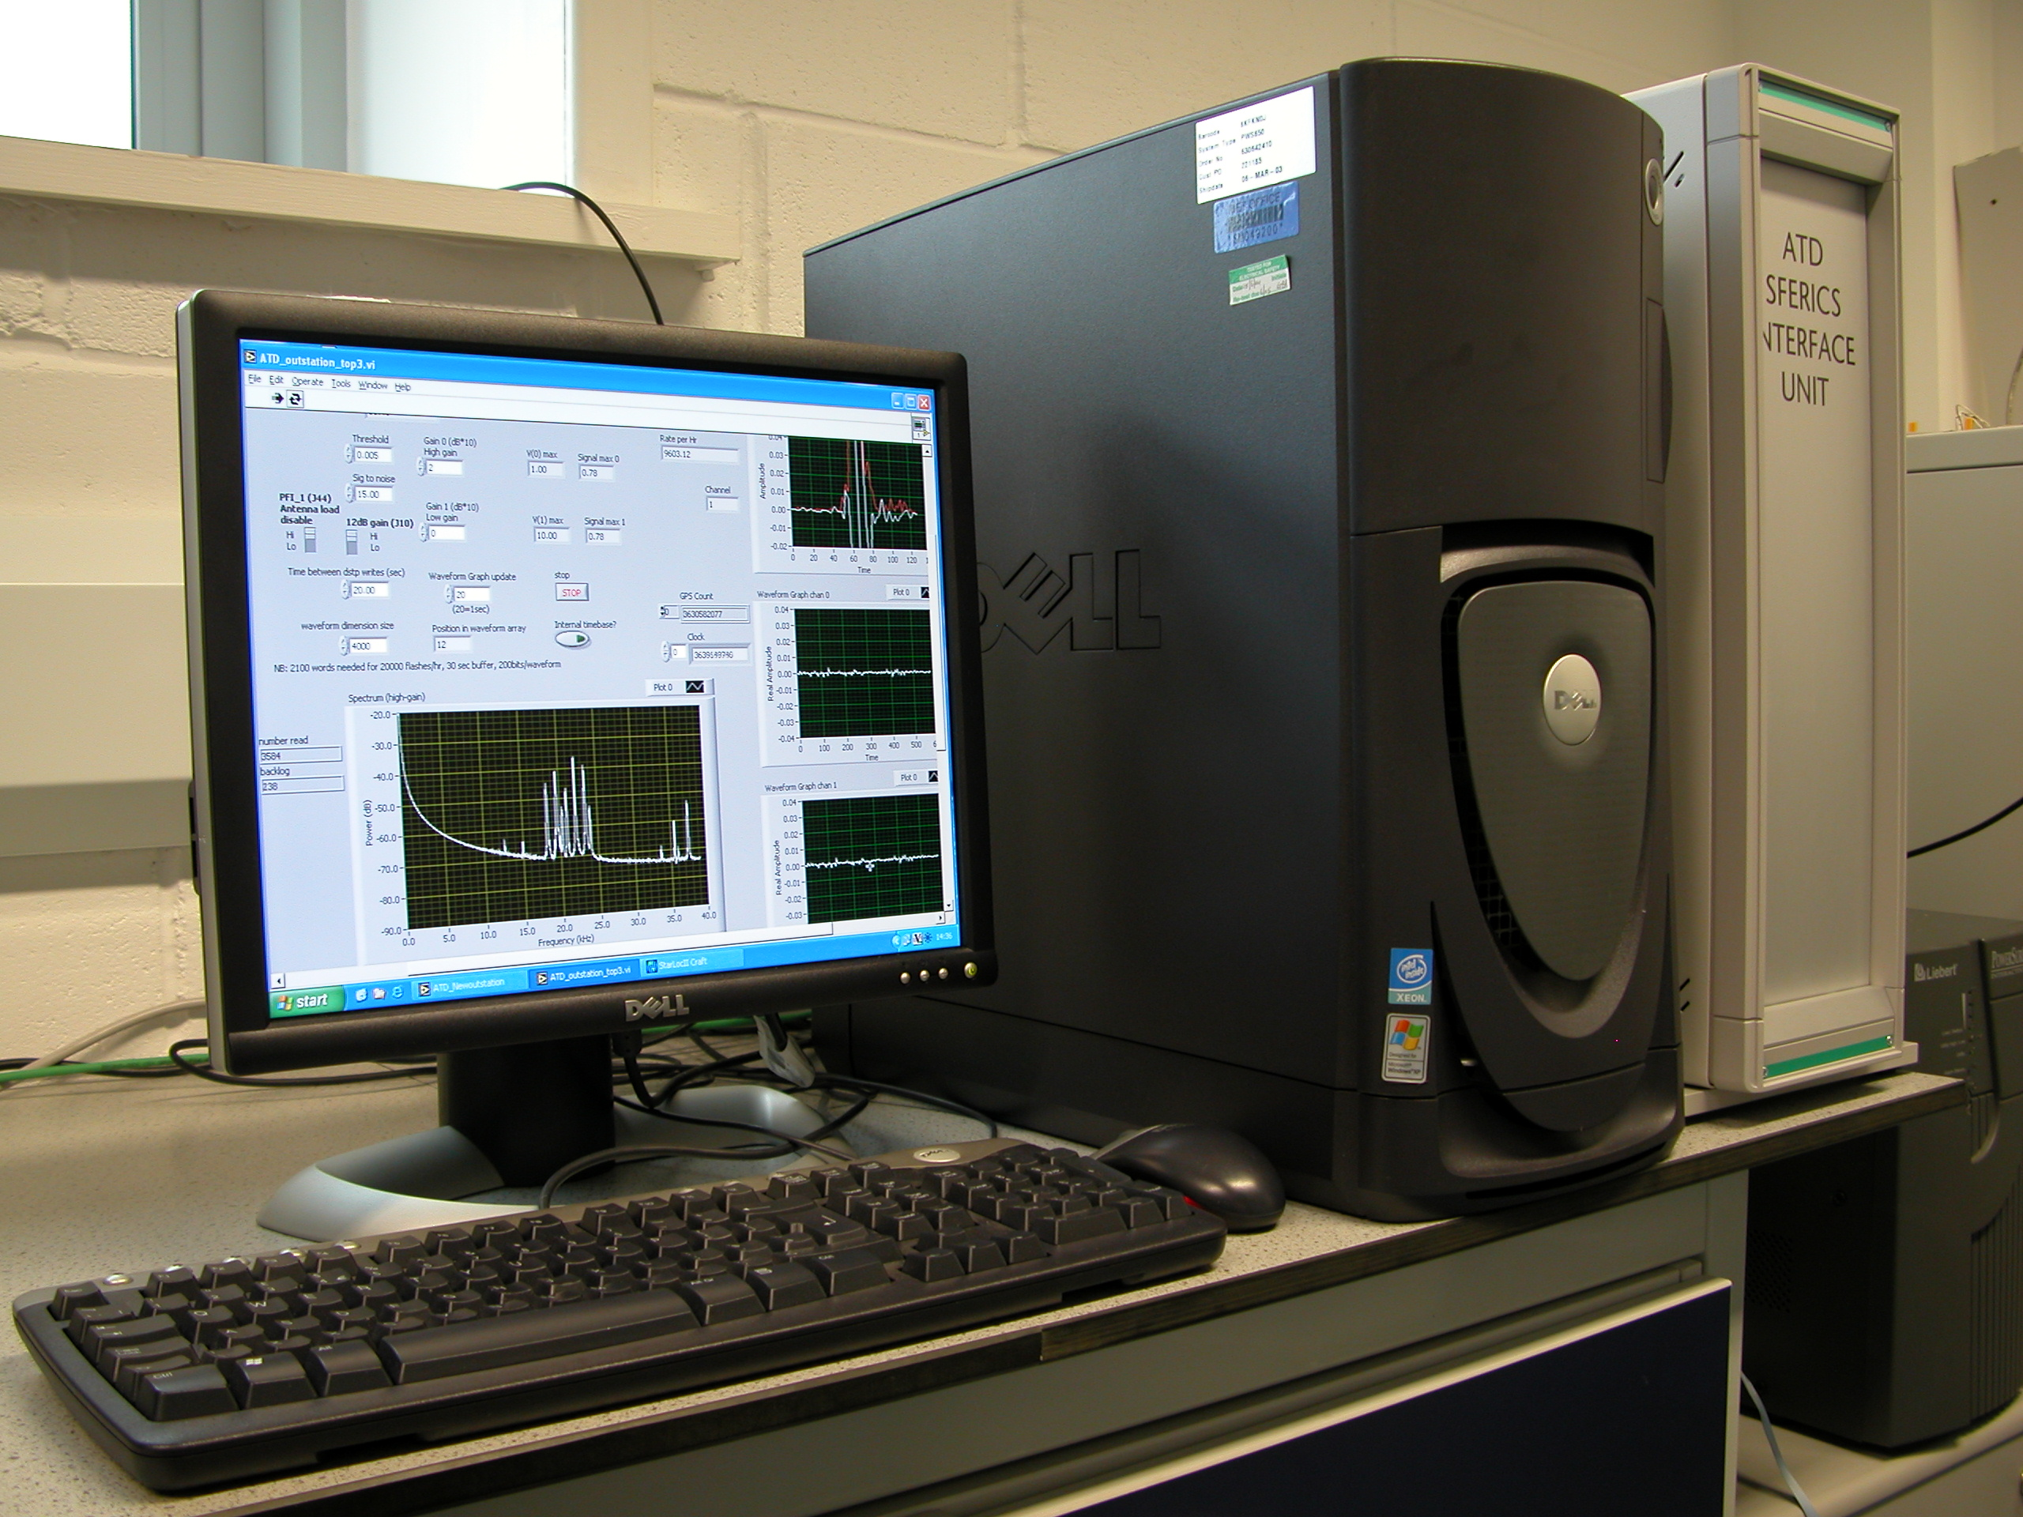

Fig.2.3 New Outstation [NOS] allow throughput of detected SFERICS of at least 100, 000 flashes per hour, with usual rates normally in the range 10,000 to 60,000 depending on the time of day in Europe.

ATDNET outstations Fourier analyse the SFERIC waves received and the data are compressed, so that the waveform information is sent to the central processor using Internet based communications. The increased use of Internet communications means that large numbers of outstations can be deployed without an increase in operational communication costs compared to earlier detection systems operated by the UK Met Office. Most other commercial lightning detection systems observe the radio emissions from lightning over a much wider bandwidth and do use waveform correlation. These other systems produce time differences from identifying the time and/or shape of the peak in the broadband emission.

A typical sky wave received at the ATDNET sensor in Helsinki from a stroke off the coast of Morocco is shown in Fig. 2.4(a). The waves from different outstations are correlated in the central flash location processor to produce the time differences used for flash location. For this stroke the correlation with the reference waveform [Exeter chosen automatically by the software on this occasion] can be seen in Fig,2.4(b).

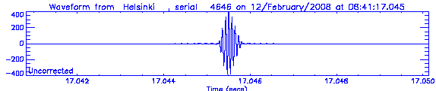
Fig. 2.4(a) Amplitude(arbitrary) of a SFERIC wave received at Helsinki from a stoke off the coast of Morocco.

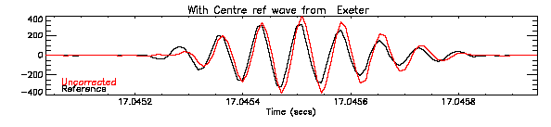
Fig. 2.4(b) Correlation of the Helsinki waveform with the reference waveform from Exeter, (reference waveform chosen automatically from all the available waveforms).

Gibraltar was relatively close to this stroke, but the waveform was still a relatively simple structure, see Fig. 2.5(a) and the waveform correlated quite well with the reference at Exeter in the central part of the waveform, see Fig. 2.5(b).

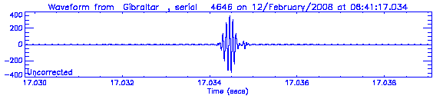
Fig. 2.5(a) Amplitude(arbitrary) of a SFERIC wave received at Gibraltar from a stoke off the coast of Morocco, at a range where sky wave and ground wave could be expected to interfere to some extent with the sky wave.

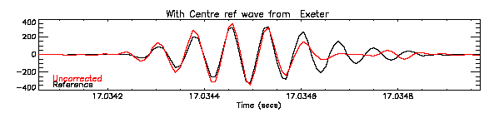
Fig. 2.5(b) Correlation of the Gibraltar waveform with the reference waveform from Exeter.

In Fig.2.5(b) the Sferics pulse received at Gibraltar was shorter than that at the reference and at Helsinki.

So, the correlation technique used by ATDNET allows time differences to be obtained from flashes a long way away from the network utilising the sky waves and does not rely on having network sensors close enough together to observe only ground wave emissions from the lightning. At the start of the flash location process the waves from the different sites are grouped together, taking into account the travel time of light from the sensor site plus some tolerance to accommodate the time differences and the effects of spectral differences on the propagation of waves within the waveguide. The time difference between two sites defines a hyperbola of possible stroke locations. 3 pairs of time differences are required to obtain an unambiguous location, but it is preferable to have at least 4 if possible, to guard against error in one of the individual time differences.

The solution for the flash location is found by minimising the cost function J, where
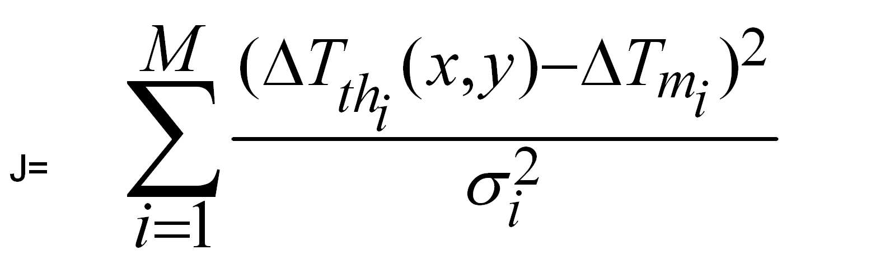 (2.1)
J =
And ΔT_{thi} is the theoretical time difference for a stroke at location (x,y) for the sensor pair i.
ΔT_{mi} is the measured time difference for the sensor pair i.
σ_{i} is a theoretical weighting, chosen to match estimates of the location accuracy from early development tests.
σ_{i} increases by about a factor of 8 if there is a high probability of a 1/f ambiguity in the correlation between the waveforms[i.e. if when the waveform is shifted one cycle in either direction from the estimated time difference, the correlation coefficient is very similar to the correlation achieved with the initial time difference estimation]
σ_{i} increases by about a factor of 50 if there is poor correlation between the reference waveform and the waveform measured at sensor site, i.

A complete set of time difference hyperbolae are shown in Figure 2.6 for the stroke off the coast of Morocco

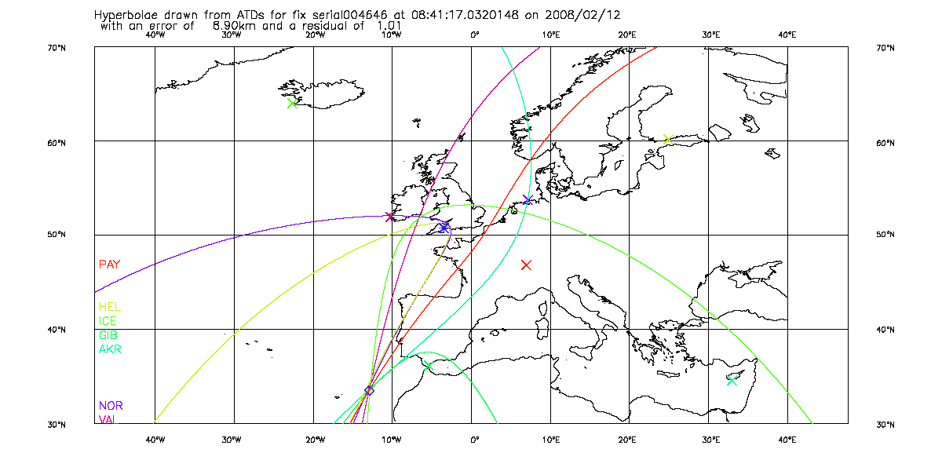
Fig.2.6 Time difference hyperbolae for the stroke off the coast of Morocco. Time difference were computed against the waveform measured at Exeter. There were six pairs of time differences and it can be seen how well these intersect at the solution for the flash location,

3 Location accuracy of ATDNET system

The location accuracy of ATDNET flash locations is estimated using L, half of the inverse of the Hessian (2nd derivative of J)
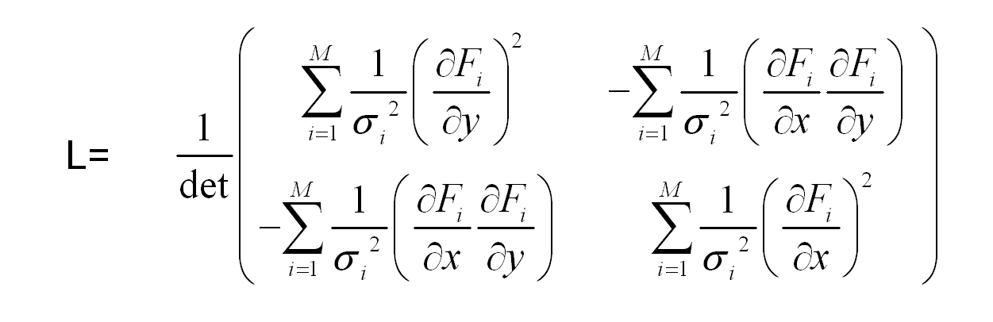 (3.1)

Where F_{i}(x,y) = ΔT_{thi} (x,y)…, see equation (2.1).

L is computed by finite differences around the solution. Eigenvector diagonalisation is used to compute the ellipse axis and orientation for each fix, with the square root of the squares of the minor and major axes used to define the error reported with each stroke location.

The realism of these computations in the centre of the network was tested by comparing ATDNET locations with locations from the Meteo-France Meteorage system for selected days in summer 2007, see Fig. 3.1.

From this sample it would seem that the theoretical estimate is slightly pessimistic and underestimates the accuracy of some of the best locations. On the other hand the theoretical estimates can be used to give a general indications of the accuracy being achieved.
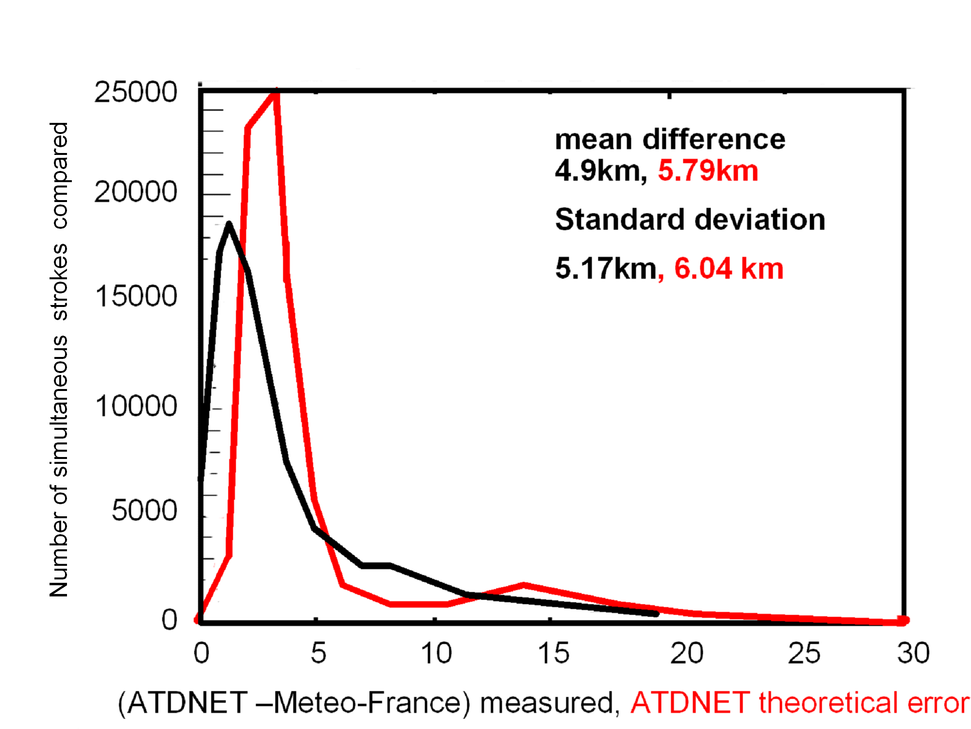
Figure 3.1 Results of comparisons between simultaneous stroke locations by ATDNET and Meteo France systems over mainland France for selected periods in summer 2007. The black line is the measured differences between the two systems, the red line is the results of the ATDNET error calculations for the same strokes.

Fig.3.2 shows a summary of the estimated location accuracies achieved by ATDNET in July 2008, for various areas required by Met Office Operations.

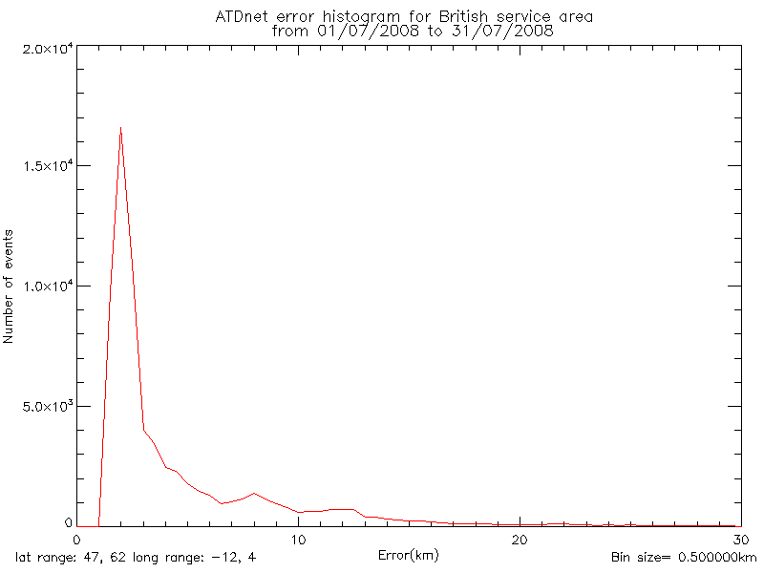
Fig. 3.2(a) Summary of reported errors from ATDNET, latitude range 47 to 62 ºN, longitude range, 12º W to 4ºE for July 2008. These seem better than was being achieved in France in summer 2007.
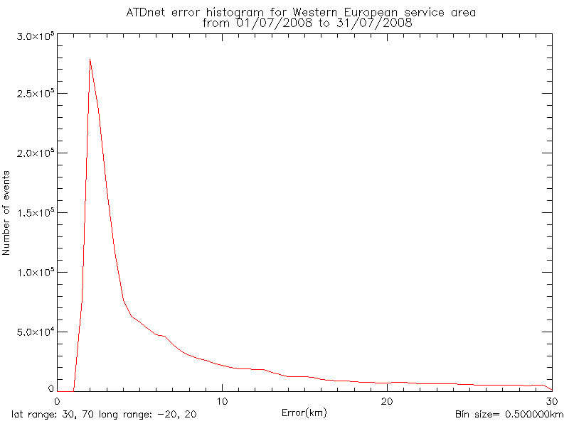
Fig. 3.2(b) Summary of reported errors from ATDNET, latitude range 30to 70 ºN, longitude range, 20º W to 20ºE for July 2008.

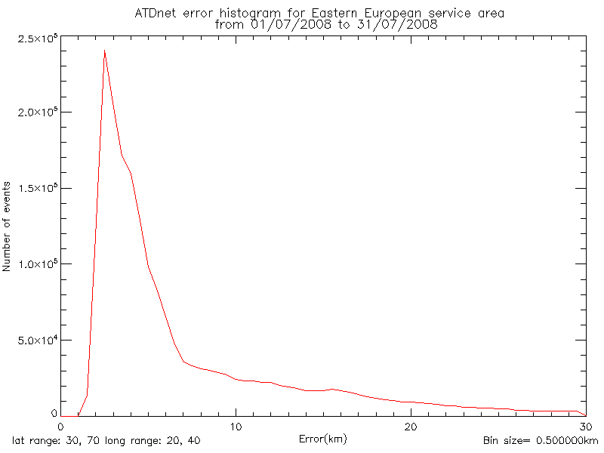
Fig. 3.2(c) Summary of reported errors from ATDNET, latitude range 30to 70 ºN, longitude range, 20º E to 40ºE for July 2008.

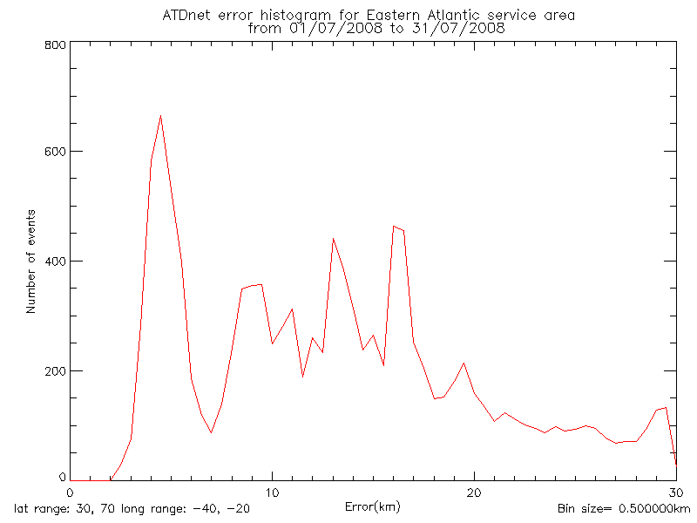
Fig. 3.2(d) Summary of reported errors from ATDNET, latitude range 30to 70 ºN, longitude range, 40º W to 20ºW in the eastern North Atlantic for July 2008
So the errors in the Atlantic service area are significantly higher than the rest of Europe, probably because the sensor in the Azores is currently not providing information , because of problems with the radiofrequency interference at the site chosen.

In each of the histograms in Fig.3.2 , there is a tail of reports with poor errors and one development aim must be to try and reduce the magnitude of this tail for the future, if possible.

The ATDNET accuracies estimates in northern Africa in October 2007 are shown in
Fig.3.3(a), and the increased number of stroke locations with errors around 20 km, suggests that cycle slip errors in the correlation process are more common at longer ranges, since an error of 1 cycle in the correlations corresponds to a spatial error of about 21 km.
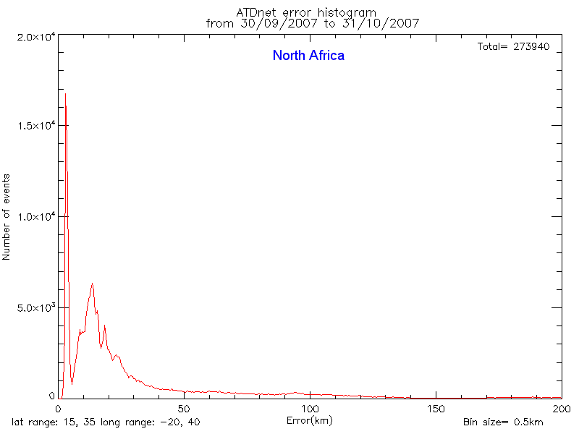

Figure 3.3(a) Summary of reported errors from ATDNET, latitude range 15 to 35 ºN, longitude range, 20º W to 40ºE for October 2007.

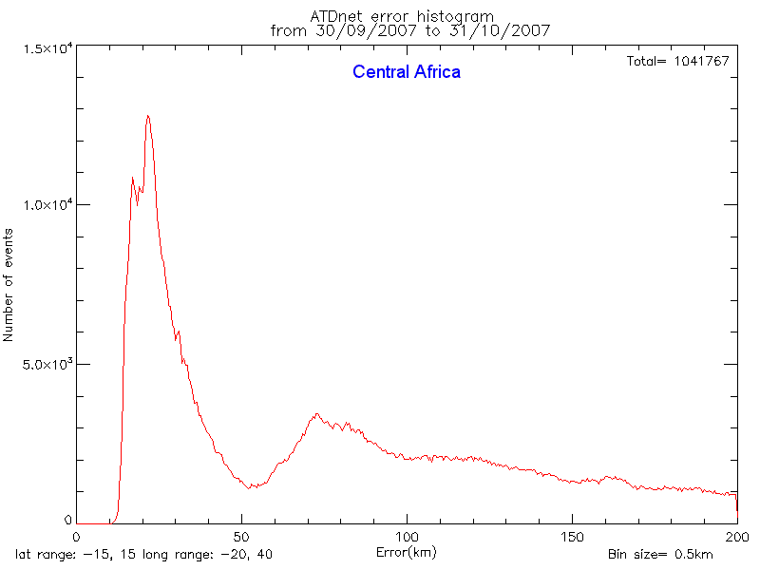
Figure 3.3(b) Summary of reported errors from ATDNET, latitude range 15 ºN
to 15 ºS, longitude range, 20º W to 40ºE for October 2007

Further south , centred on the equator, the location accuracy estimates are all higher than in North Africa and Europe, with a best location accuracy of 10 km and a high percentage with errors higher than 50 km. If these estimates are realistic it suggests that the long range quality control should be tightened to keep errors of reported locations to less than about 50 km, and for the future more sensors need to be deployed in central and southern Africa to bring the location accuracies down to those found in north Africa, for instance.

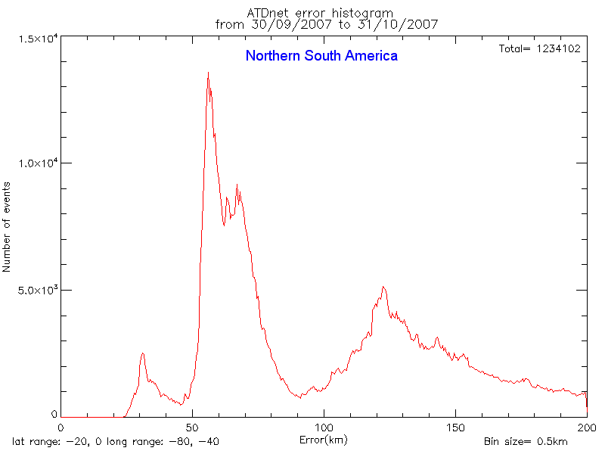
Figure 3.3(c) Summary of reported errors from ATDNET, latitude range 0 º to 20 ºS, longitude range, 40º W to 80ºW for October 2007

In South America, the errors tend to be even larger and it is probable that reports with errors greater than 100km should not be reported with the current system configuration, but this needs to be checked against simultaneous locations from the existing lightning detection systems in Brazil.

4. Problems at night

Detection efficiency characteristics of the ATD system that preceded ATDNET were presented in Nash et al (2005). At night the ATD system had low detection efficiencies relative to daytime for most of the year. A possibility was that the throughput of the ATD system was limiting what could be reported at night, because of the large numbers of flashes being reported from South America, but when ATDNET was introduced with a much higher throughput of the outstations the problem remained. The total number of locations produced by ATDNET at night was about correct, but very high numbers were failing to be reported as valid stroke locations. When the detection efficiencies of ATDNET and Meteo France were compared over France ATDNET clearly did not report as many good locations as Meteo-France during the night, see Fig. 4.1 (Gaffard et al 2008). During the day ATDNET reports more strokes than Meteo-France probably because the UK system is also sensitive to some intra-cloud discharges, whilst Meteo-France only reports cloud to ground strokes.

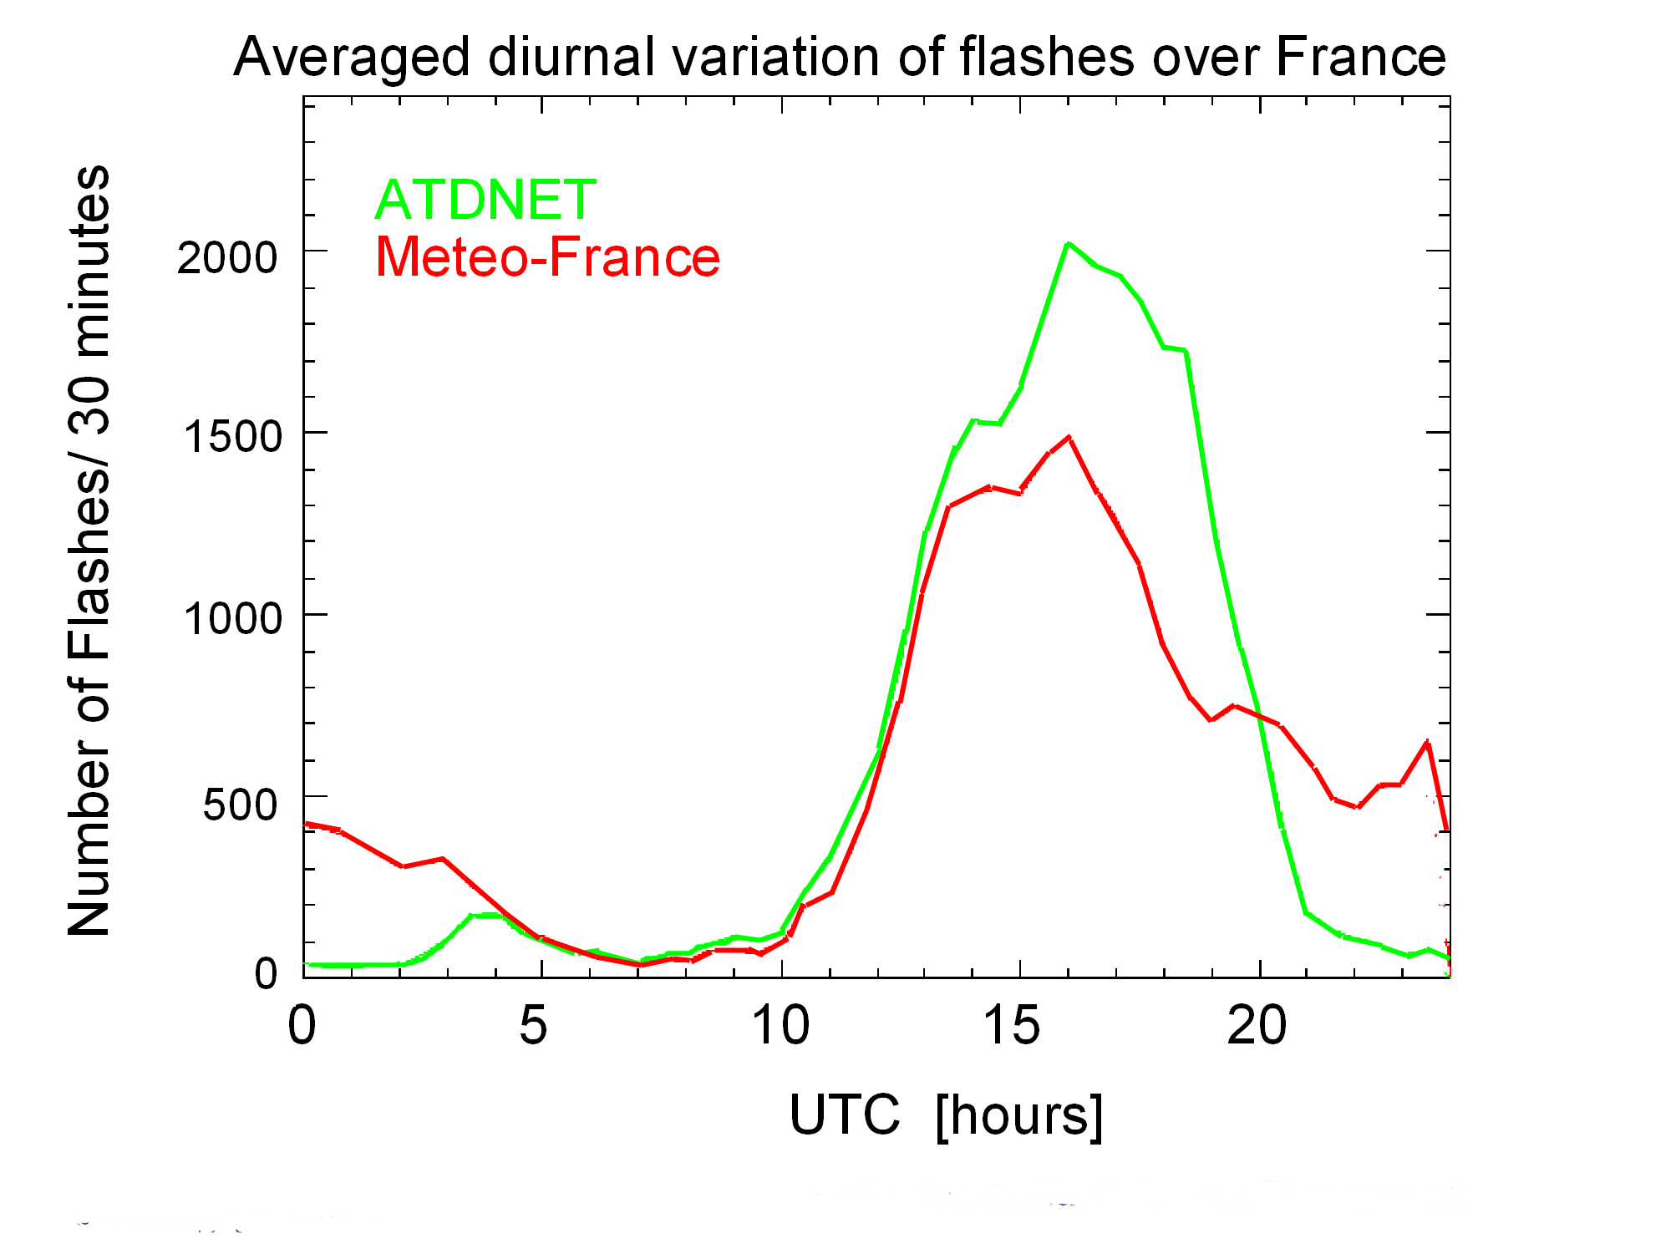
Fig.4.1. Comparison of the diurnal variation of ATDNET and Meteo-France lightning locations over France for selected days in summer 2007.

The origin of the problem at night has now been identified as the result of modal interference in the atmospheric wave guide. At night this causes the shape of the pulses receieved at certain ranges to be very different from the pulse shape of the reference for the flash location process. For instance, Fig. 4.2(a) shows the waveform received from a lightning stroke in central France in the middle of the night at Lerwick in the north of the British Isles, and Figs. 4.2(b) and (c) shows the waveforms receieved from the same stroke at Camborne and Exeter [about 170 km apart] in the south. The modal interference has led to radical differences in pulse shape and so the measure of the correlation between the flashes is very much lower than with a daytime flash in the same circumstance.

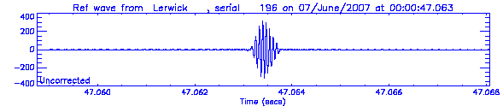
Fig. 4.2(a) Amplitude (arbitrary) of a SFERIC wave received at Lerwick from a stoke in central France , at night at a range of about 1500 km.

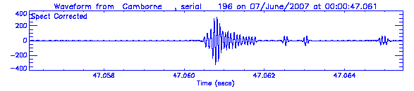
Fig. 4.2(b) Amplitude (arbitrary) of a SFERIC wave received at Camborne from the same stoke in central France , at night at a range of about 600 km.

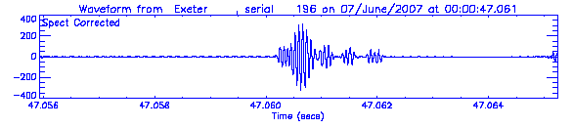
Fig. 4.2(c) Amplitude (arbitrary) of a SFERIC wave received at Exeter from the same stoke in central France , at night at a range of about 600 km.
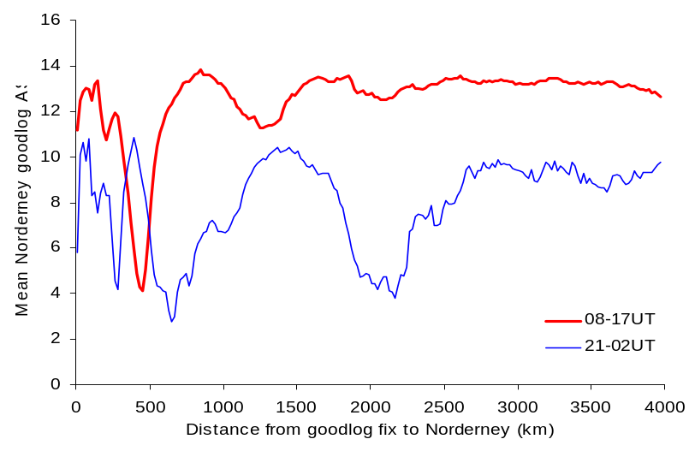
Figure 4.3: Mean absolute signal to noise ratio (ASN) of the waveform correlogram [Nordeney v reference] with distance from lightning stroke location during the day and night for signals received at Norderney

The absolute signal to noise of the waveform correlogram is a measure of how well the pulse shape received at the sensor compares to the reference waveform. This is plotted for Nordeney as a function of distance of the stroke from the sensor, see Fig. 4.3. At night the interference causes very poor correlation between received waveforms at a range of about 600 km, but good correlations when about 1500km from the stroke, whereas in the day time when the ionosphere is lower, the poor correlations occur at a shorter range and most of the daytime observations have good waveform correlations. Further investigations at night on 6 August 2008 for a storm in eastern England again showed large numbers of reports in the poor log with location accuracies much higher than 20 or 30 km.

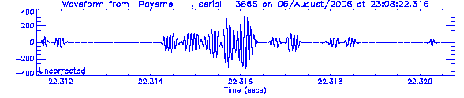
Fig. 4.4(a) Lightning discharge received at Payerne from a severe storm at night over the UK

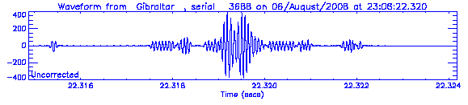
Fig. 4.4(b) Amplitude[arbitrary scale] of Lightning discharge received at Gibraltar from the same severe storm at night over the UK

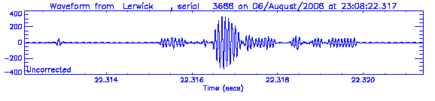
Fig. 4.4 (c) Lightning discharge received at Lerwick from the same severe storm at night over the UK

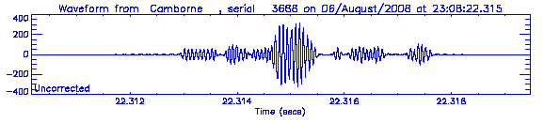
Fig. 4.4(d) Lightning discharge received at Camborne from the same severe storm at night over the UK

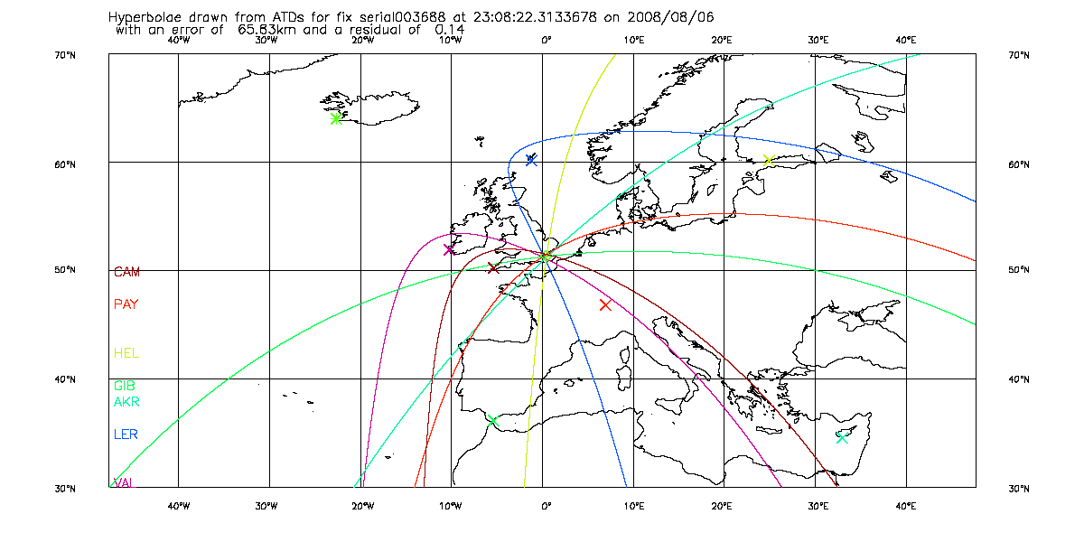
Fig. 4.5 Hyperbolae from the flash location process showing that even with the poor correlation in shape between the pulses received at different sites, the location achieved does not seem anomalous, and the error calculation in this case seems much too pessimistic.

Fig.4.4(a) to (d) show the very complex waveforms received from one stroke in this storm. The location derived from the time differences is shown in Fig. 4.5 along with the associated time difference hyperbola. The residual, (normalised value of the cost function at the minimum) associated with this estimate is well within the range of acceptable values for a valid location and there is little ambiguity in the fix position, but the location accuracy was estimated as 66 km. Thus it appears the use of the very high weightings in the location process when the absolute signal to noise ratio of the waveform correlogram is low [ see notes on equation (2.1)] is often leading to quite unrealistic location accuracy estimates, and a more reliable method of weighting low absolute signal to noise ratio is required.

5. Future plans

The Met Office is currently issuing the locations from ATDNET as a CSV message on the GTS and enquiries about access to the information should be forwarded to john.nash@metoffice.gov.uk or paul.odams@metoffice.gov.uk. The intention is to issue the information in BUFR code within the next year.

A new operational software build will be developed in 2009 to rectify problems with quality evaluation [especially the night time problem] and linking sensor sites at very long ranges.

Network changes in hand include moving the sensor at Camborne to Eskdalemuir, relocating the sensor in the Azores, installing a new sensor in Croatia, installing several sensors in southern and Eastern Africa and west Asia to improve network detection efficiency and location accuracy in Africa and western Asia.

The Met Office is willing to consider collaboration in expanding the coverage of the ATDNET network, or improving the location accuracy in parts of the service area in order to improve the service offered to the customers. The first priority will be to consolidate the performance of the system in western Asia and Africa. Currently coverage over most of mainland North America is poor, and also in eastern Asia, Australasia and most of the Pacific. The current system is now at a state that it could be replicated to provide coverage over other areas, although some introduction of new technology into the outstations will be necessary for any serious expansion of the network further than that indicated above.

REFERENCE(S):

- J. Nash et.al, Progress in Introducing New Technology sites for the Met Office long range lightning detection system, Paper 2.9 WMO Technical Conference on Meteorological and Environmental Instruments and Methods of Observation (TECO-2005), Instruments and Observing Methods Report No. 82, WMO/TD-No.1265
- C. Gaffard , John Nash, Alec Bennett, Greg Callaghan, Myles Turp, Paul Taylor, Eric Hibbett. “Observing from the Ground Lightning Around the Globe”, 20th International Lightning Detection Conference (ILDC): 21 - 23 April 2008, Tuscon, AZ, USA.

ACKNOWLEDGMENTS

Thanks to Francoise Honoré who supplied the observations from Meteo France used for the Meteo France ATDNET comparisons.

