The Metrology Laboratory
of
National Direction of Meteorology in Morocco:
A New RIC in RA I

M. Rabia. Merrouchi
Direction de la Météorologie Nationale du Maroc
Division technique et d'Equipement
B.P: 8106
Casablanca-Oasis, Maroc
Phone +21265012298
Fax +21222908593
www.marocmeteo.ma
merrouchi@engineer.com

Dr Jérôme DUVERNOY
Météo-France
DSO/LM
7 Rue Teisserenc de Bort
78195 TRAPPES France
Phone +33130136350
Fax +33130136020
www.meteo.fr
jerome.duvernoy@meteo.fr

Abstract:

The National Direction of Meteorology in Morocco had become a new Regional Instrument Center (RIC) for the World Meteorological Organization (W.M.O.) RA I (Africa) through its Metrology Laboratory. This means that this new RIC will become a reference concerning calibration, advice and training for the other RA I members. Terms of Reference (TOR) are detailed and some solutions are found through collaboration with Météo-France Metrology Laboratory (RA VI RIC) to achieve this ambitious goal.

Introduction

Since February 2007, the National Meteorological Service of Morocco) has been recognized as a new Regional Instrument Centre (RIC) of RA I (Africa) [1]. The Metrology Laboratory should respect the new Terms of Reference [2]. The Terms of Reference have been updated during the very end of 2006 by the XIVth session of the CIMO in Geneva. They are expressed in term of capacity and corresponding functions.
These TORs have requirements into equipments, environment, competency and memberships within Region.

Capacity

Morocco is among the first countries in the region (AR I) that have had equipment of calibration. Indeed, the first test chamber for sensors measuring temperature, humidity and pressure was acquired in 1967 (SAPRATIN chamber).

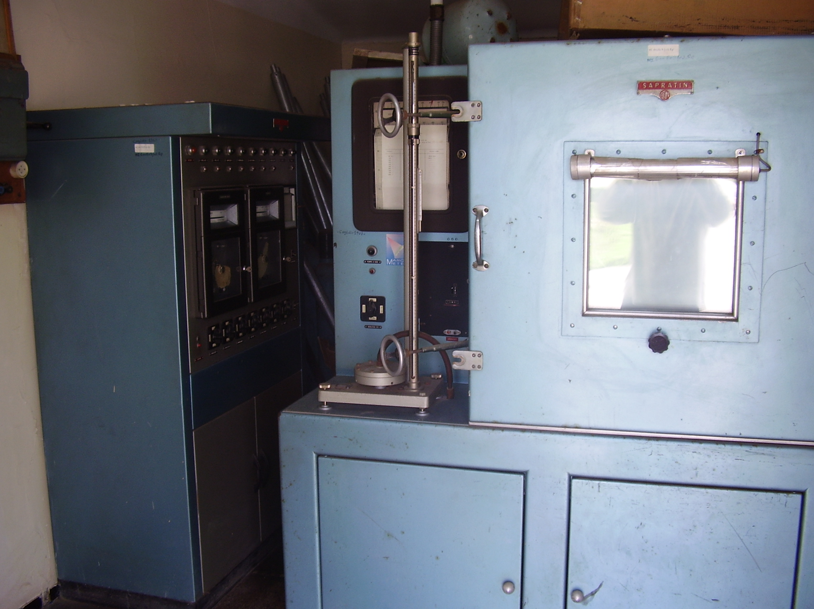

Point by point the new RIC in Morocco will try to answer to all Terms Of Reference.

Facilities

A RIC must have, or have access to, the necessary facilities and laboratory equipment to perform the functions necessary for the calibration of meteorological and related environmental instruments.

The update of Laboratory has been separated into two phases. The first one has been the refreshment of the old building and this phase was achieved in 2007. The second phase, scheduled in 2009, is the set up of new building near the headquarters.

Standards

A RIC must maintain a set of meteorological standard instruments and establish traceability of its own measurement standards and measuring instruments to the SI,

• The National barometric reference was recognized Regional barometric reference (WMO Global Observing System Guide - 1989).
• The laboratory barometric and temperature standards was calibrated in 2007 at the metrology laboratory of Meteo-France. Traceability is insured within the CRI of AR IV.
• An upgrade of the existing calibrating equipments (figure below) was achieved in 2007.
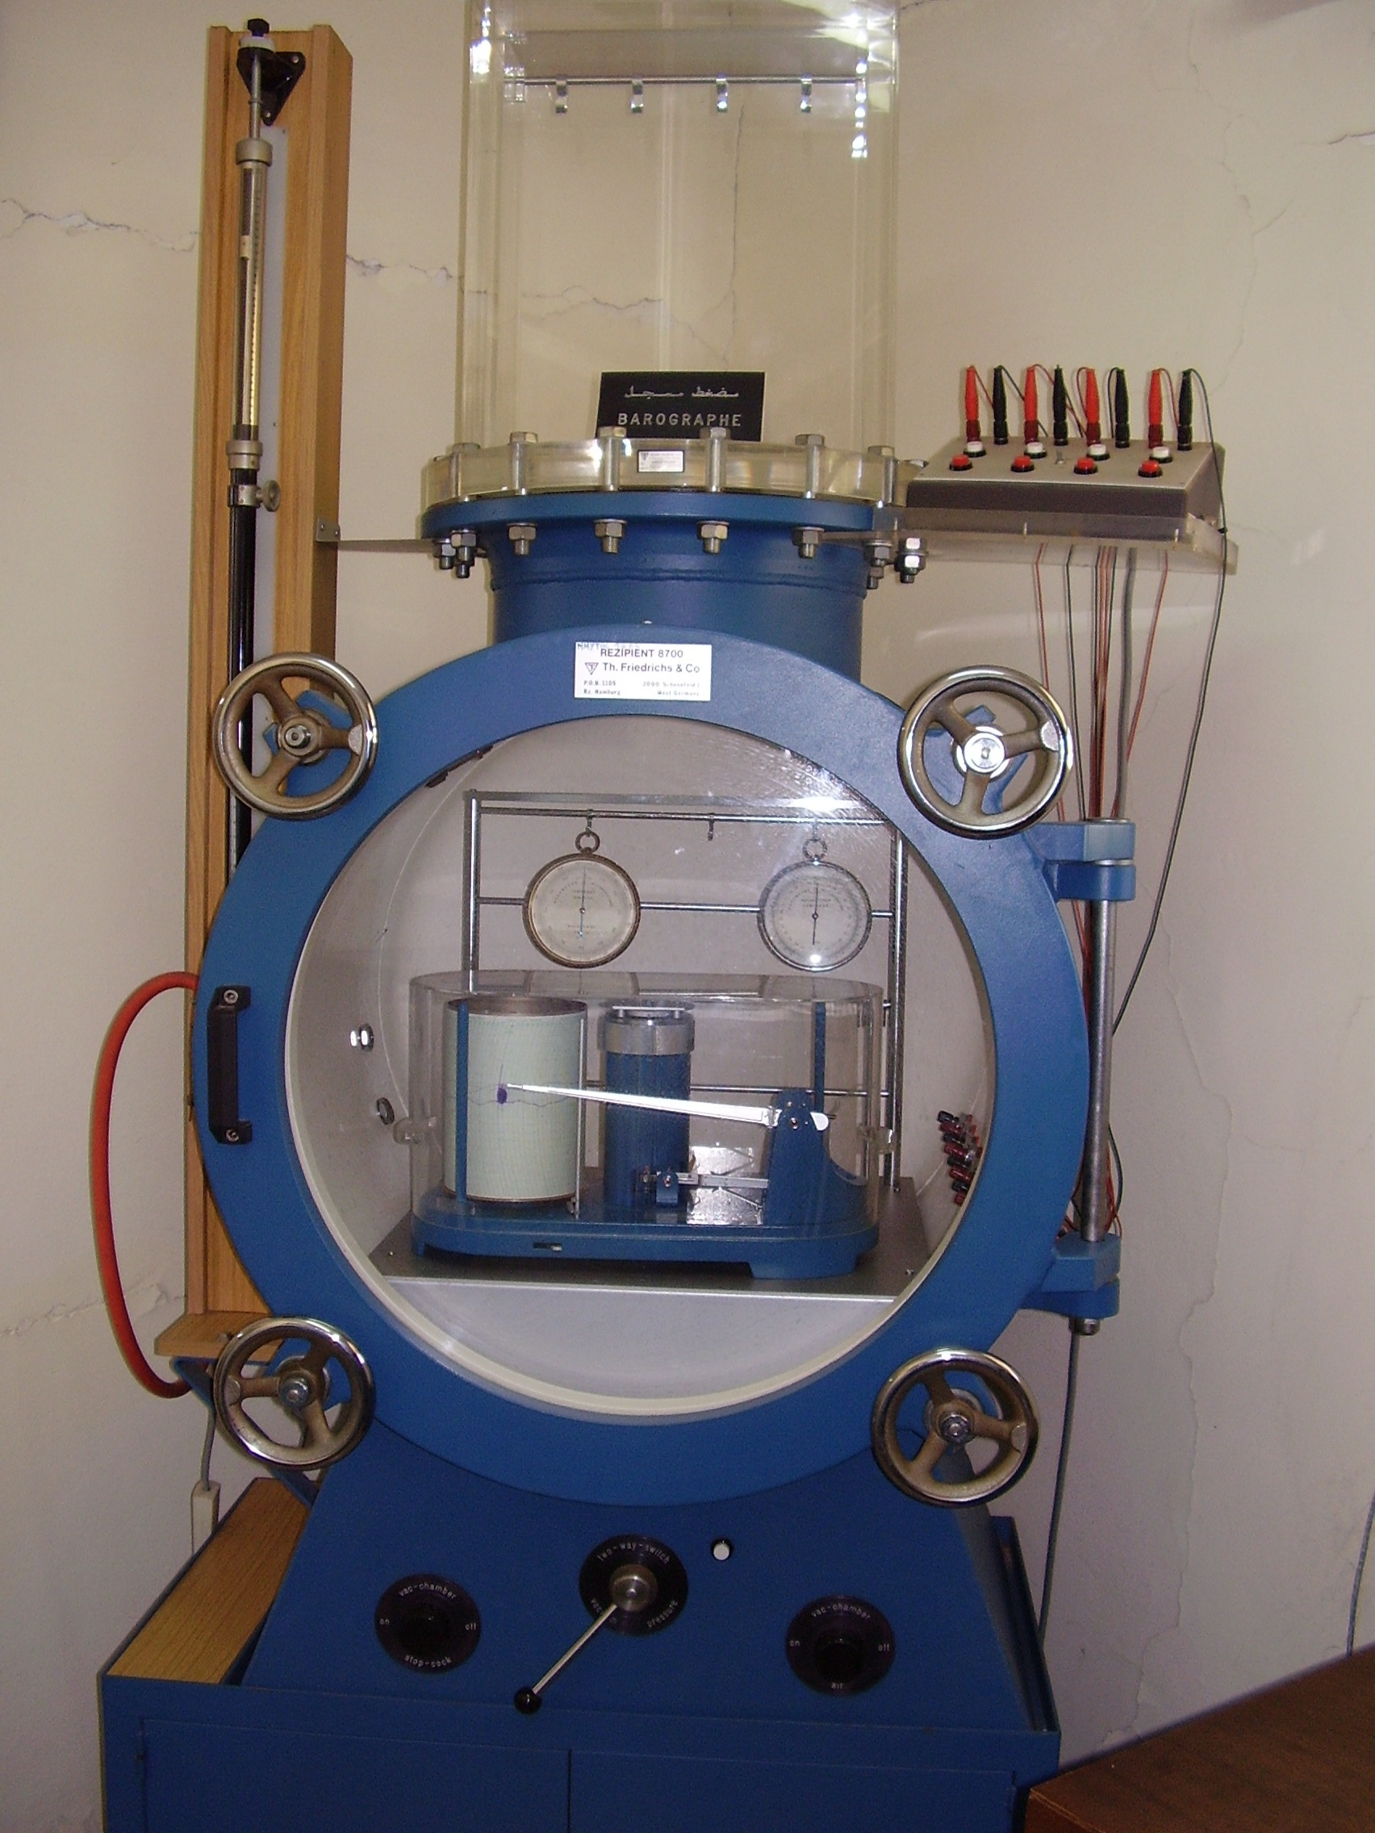 | 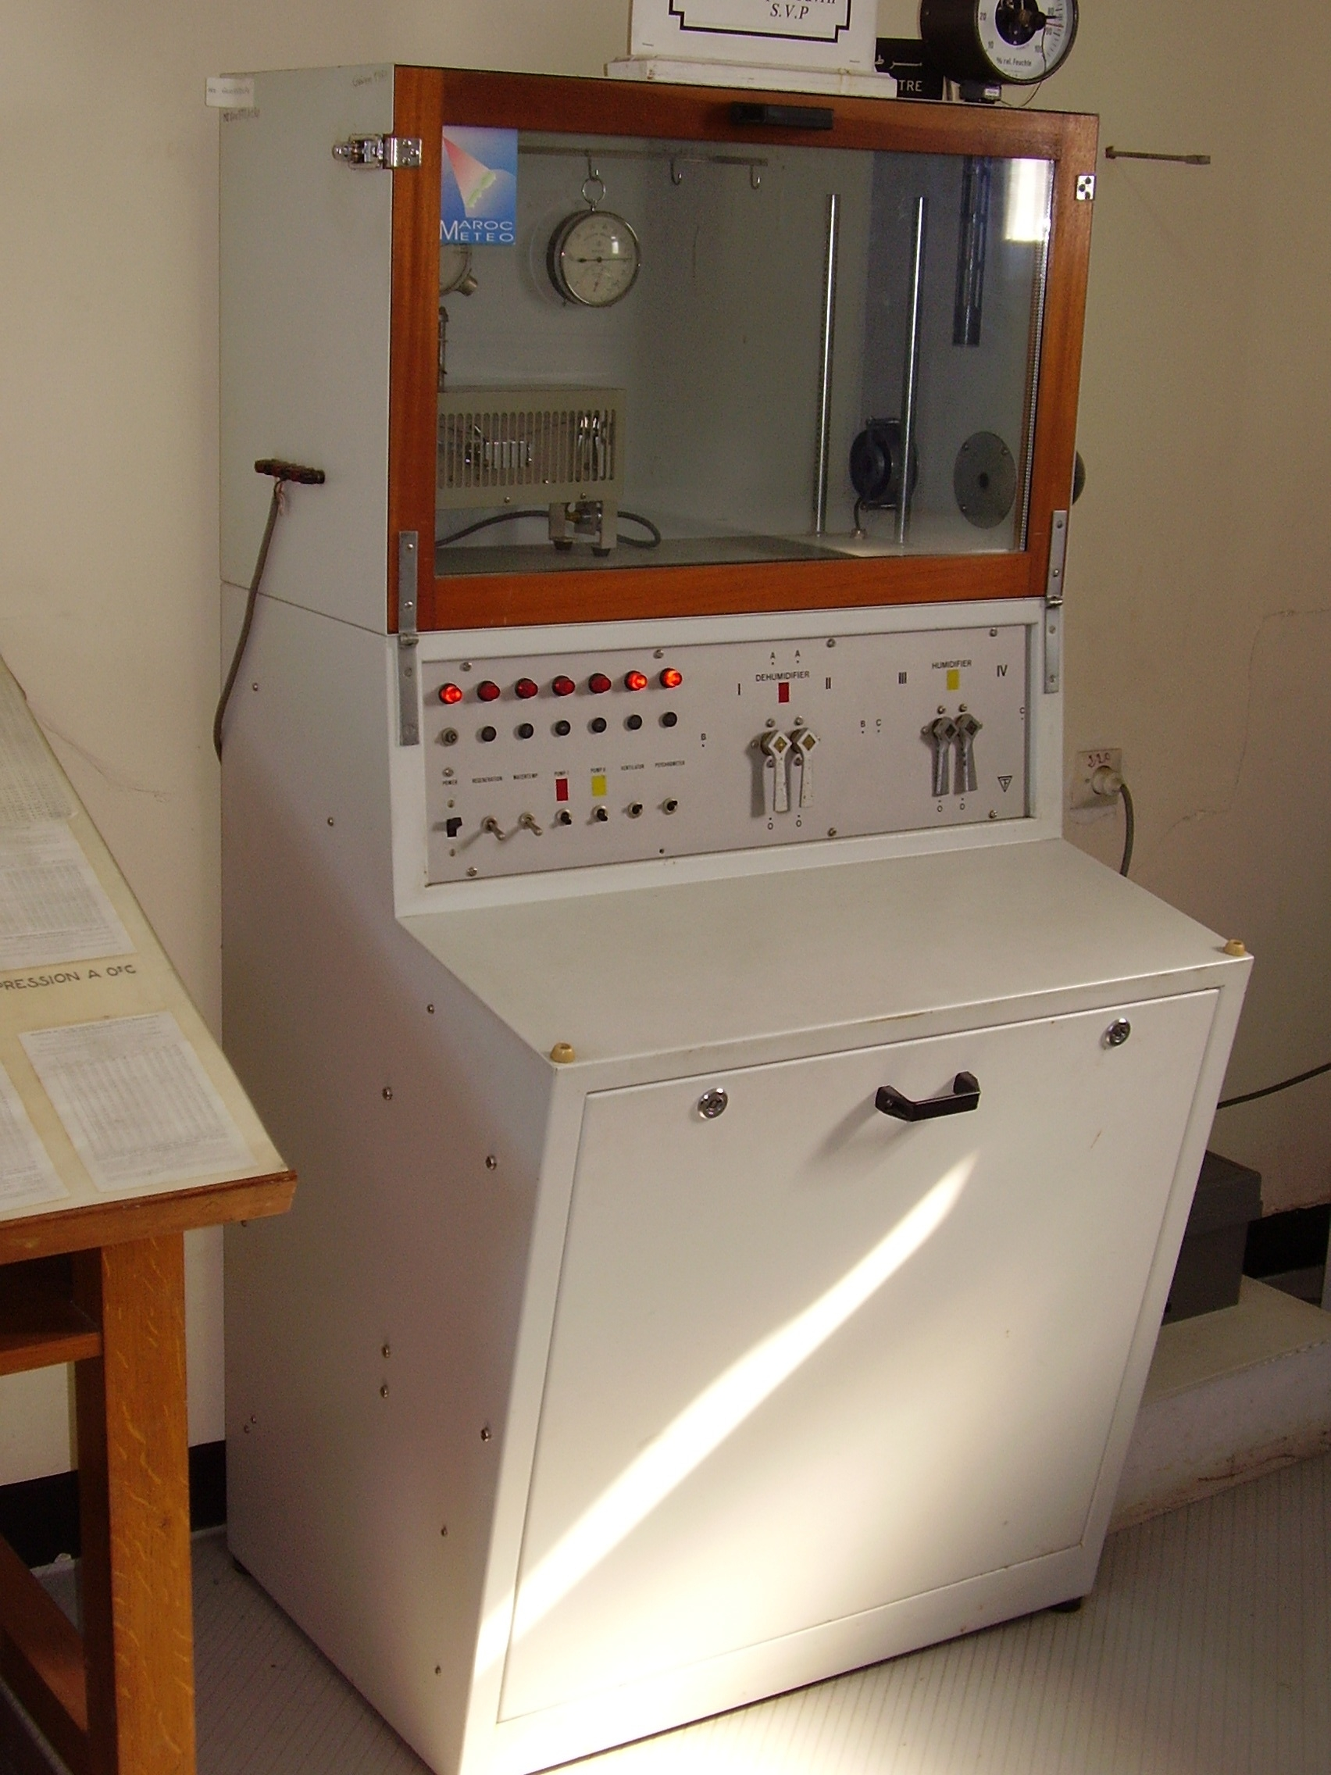 | 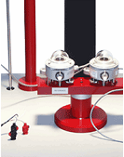
Pressure test chamber | Humidity chamber | Kip & zonen Calibrating facilities
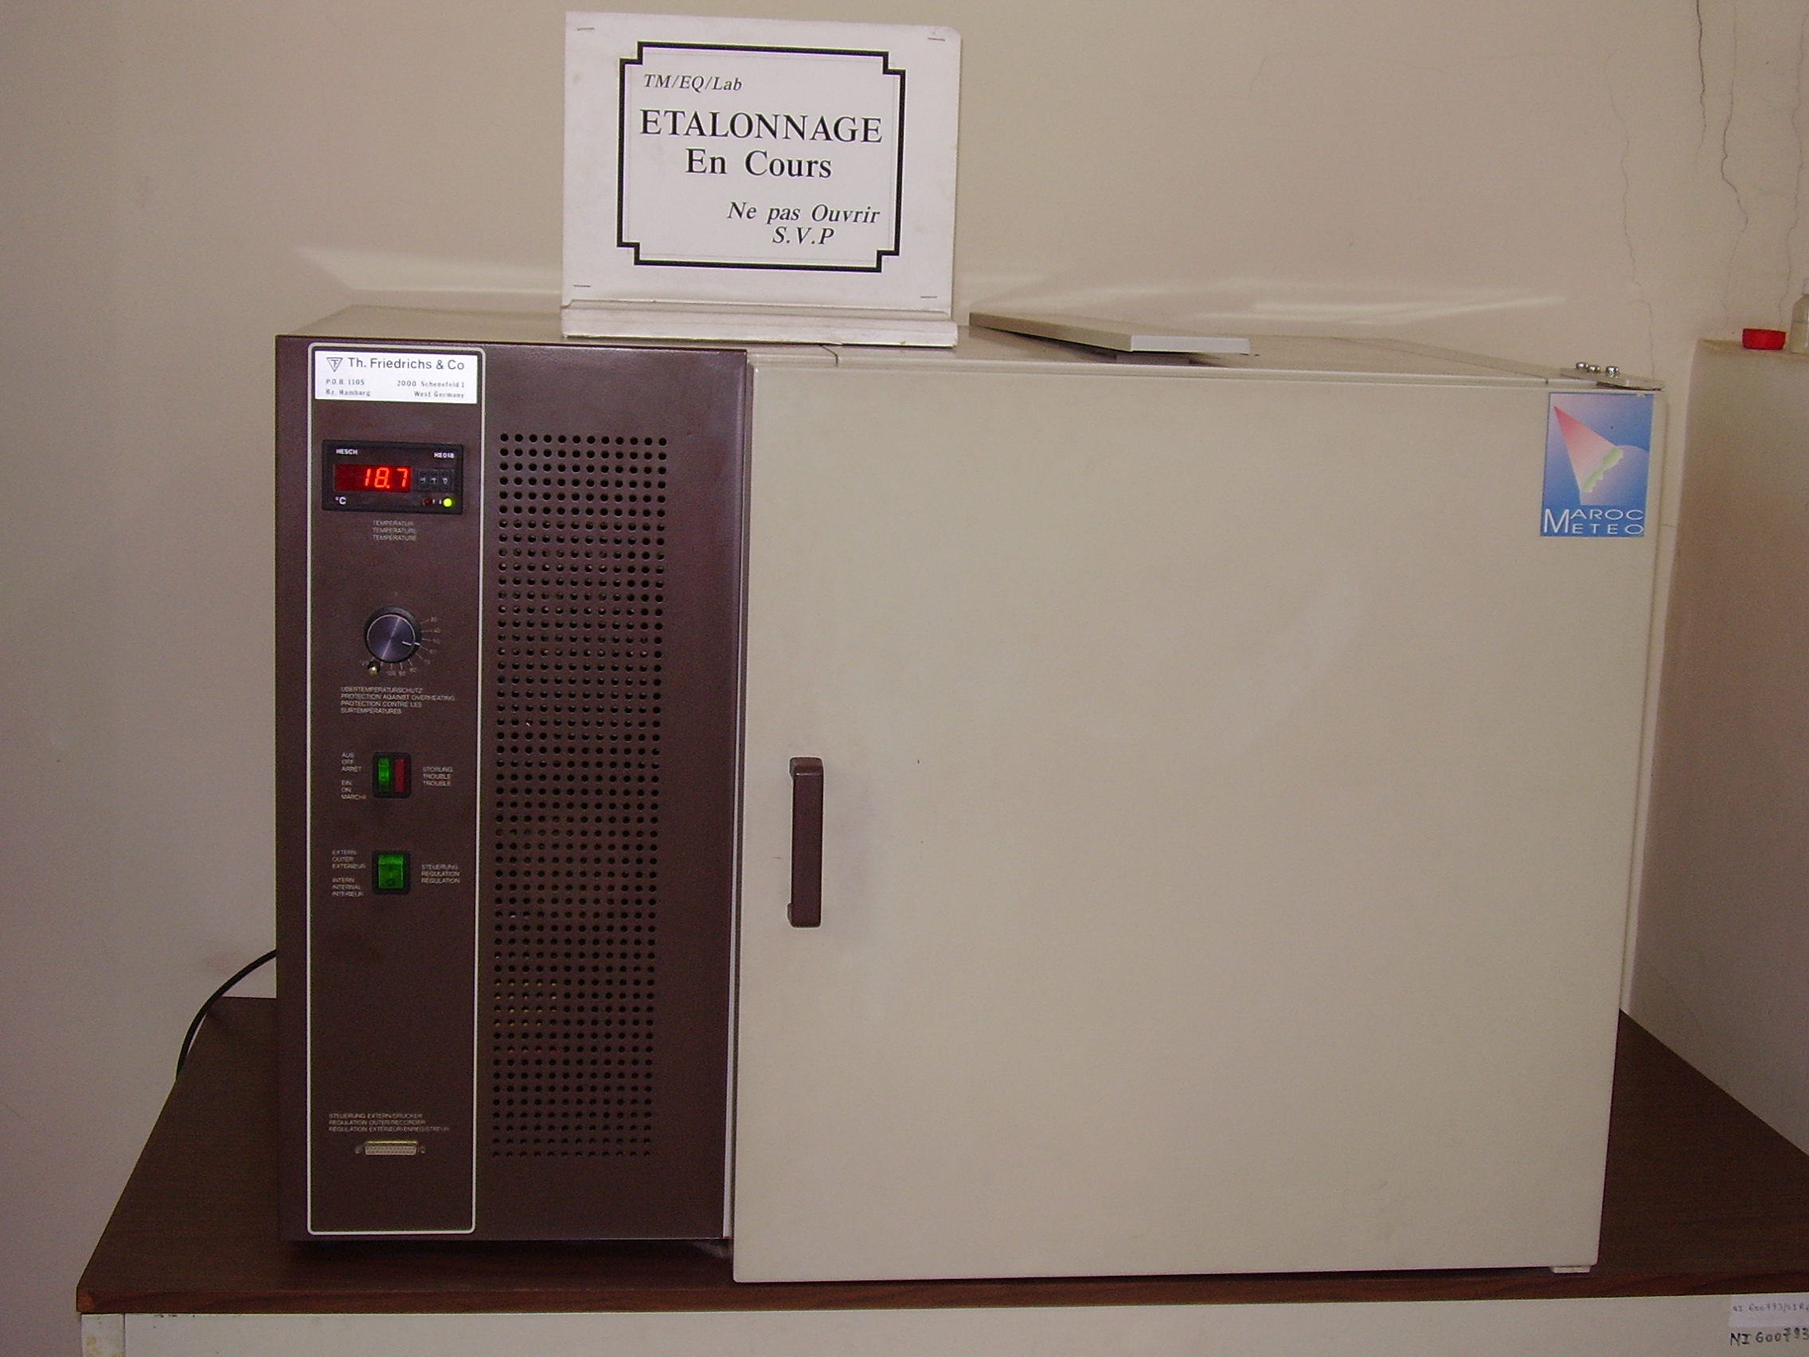 | 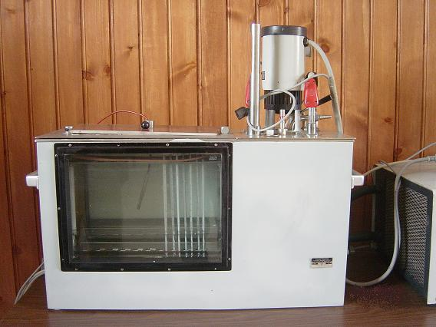 | 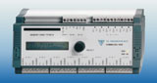
Temperature test chamber | Temperature bath | Datalloger to collect measurements

A plan for acquisition of new equipment and standards was set up:
• Phase1: Acquisition of equipment for the calibration of sensors that measure air pressure. The equipments acquired in 2008 include two automatic pressure generators for laboratory and on-site calibrating operations, dedicated software using COFRAC standards for uncertainty determination and two digital pressure standards.

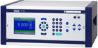 | 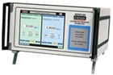 | 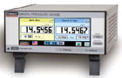
Laboratory automatic pressure generator | Automatic pressure generator for site calibrations | Pressure Standard

• Phase2: Acquisition of equipment for the calibration of sensors measuring air temperature including, among others: a liquid bath controlled by computer, reference sensors covering fixed points and digital recorders for the monitoring of ambient conditions during calibrating operations (scheduled for the end of 2008).
• Phase3: Acquisition of equipment for the calibration of sensors measuring relative humidity including a climatic chamber, a hygrometer standard and a calibration bench based on saturated saline solution (scheduled for 2009).

Staff

A RIC must have qualified managerial and technical staff with necessary experience in fulfilling its functions,

• The staff of the laboratory includes two engineers in meteorology (WMO Class 1) and five technicians in meteorology.

• In 2008, a special training in metrology was conducted for the staff in France and also in the laboratory.

• Practical courses can be organized within the Metrology Laboratory of Météo-France (bilateral cooperation between the DMN and Météo-France) as it was already done in 2007.

Procedures

A RIC must develop its individual technical procedures for calibration of meteorological and related environmental instruments using calibration equipment employed by the RIC,

A RIC must develop its individual quality assurance procedures,

Technical instructions on the use of existing calibrating equipment in the laboratory for calibration purposes are present and practiced. However, under the accreditation process, a reference manual will be prepared.
In 2009, accreditation process ISO 17025 will begin and will concern, as first stage, the parameter: air pressure.

Collaboration

A RIC must participate in, or organize inter-laboratory comparisons of standard calibration instruments and methods,

The DMN is quite susceptible to organize inter-laboratory comparisons both within the AR I region or at inter-regional level in the context of data exchange and knowledge transfer between RIC of developed and developing countries as recommended during the fourteenth session of the CIMO.

A first intercomparison with the metrology laboratory of France has been performed in July.

A RIC must, as appropriate, utilize the resources and capabilities of the Region to the best interest of the Region,

The DMN participates actively to achieve this goal in matter of meteorology (numerical modeling, weather modification, marine forecast and training…) with some countries of the area like Senegal, Burkina Faso and Mauritania… DMN wishes to enlarge cooperation with those countries to metrology activities.

A RIC must, as far as possible, apply international standards applicable for calibration laboratories, such as ISO 17025,

DMN start, since 2007, a quality approach for several processes of its activity like general and aeronautical forecast process and observing process using ISO 9001 standards.
In 2009, accreditation process ISO 17025 will begin and will concern, as first stage, the parameter: air pressure.

A recognized authority must assess a RIC, at least every five years, to verify its capabilities and performance,

The DMN encourages and fully supports this decision and expresses its wish that its calibration laboratory will be evaluated regularly by recognized authorities.

Conclusion and foreseen

The Metrology Laboratory of the National Meteorological Service of Morocco is on way to quality since many years. It came into a renewal phase and in the same time an opening to the other Region members.

When the update of equipment, staff training and procedures validation will be finished, the new RIC will be ready to fulfill completely its corresponding functions.
The communication of the capacities of the laboratory in terms of calibration and advice will be done for WMO and Region’s members.

Références

[1] World Meteorological Organization, N°8 GUIDE TO METEOROLOGICAL INSTRUMENTS AND METHODS OF OBSERVATION, rev 7: http://www.wmo.int/pages/prog/www/IMOP/IMOP-home.html

[2] Duvernoy J. and J. Gorman: A REVIEW OF THE UPDATED TERMS OF REFERENCE FOR RIC; TECO 2008

[3] International Organization for Standardization: General requirements for the competence of testing and calibration laboratories. ISO/IEC 17 025:2005

