INTERCOMPARISON MEASUREMENTS BY THE GROUND LEVEL AND ELEVATED DISDROMETER

Branislav Chvíla¹ and Boris Sevruk²
¹ Slovak Hydrometeorological Institute, Jeséniova 17, 833 15 Bratislava, Slovakia,
tel. +421 2 5941 5162, fax. +421 2 5477 4419, e-mail: branislav.chvila@shmu.sk
² Former: Swiss Federal Institute of Technology ETH, Institute of Climate Research, Winterthurerstr. 190, CH-8057 Zürich, Switzerland, tel. + 41 1 635 5235, fax. + 41 1 362 5197, e-mail: boris.sevruk@env.ethz.ch

Abstract

The number of raindrops of various sizes was measured using ground level and elevated disdrometers during the summer season 2007 at the experimental station of the Slovak Hydrometeorological Institute in Jaslovske Bohunice. The number of raindrops registered by disdrometers in 1-minute intervals varied from a few units up to the several thousands of raindrops per minute, which corresponds to the precipitation intensity between trashes and as much as 2.62 mm.min⁻¹ respectively. The ground level instrument protected again in-splash showed systematically a greater number of raindrops. The average difference for a total of 615 15-minute intervals related to the elevated gauge measurements was about 9 %. The difference between the corresponding precipitation amounts was 33 mm, i.e. more than 16 %. In spite of losses due to wind, the disdrometers still seem to overestimate the rain amounts, particularly during higher intensities, as resulted from the intercomparison measurements using other ground level and elevated, Hellmann and automated weighing gauges installed at the site. They showed smaller differences (4-6%) between the corresponding precipitation amounts. The effect of wind speed is evident either in the increasing difference of the recorded number of raindrops and precipitation amounts between the paired disdrometers with the increasing wind speed. The relative difference increases with wind speed from about 13 % up to
22 %. The preliminary results show that in the case of rains composed of smaller raindrops the wind effect is greater than in the case of rains with bigger raindrops, which agrees well with the theory.

Keywords: disdrometer, intercomparison, precipitation measurement, wind effect.

INTRODUCTION

The Slovak Hydrometeorological Institute (SHMI) continues with intercomparison measurements of precipitation recording systems by comparison of a new laser-optical disdrometers. This paper follows the previous works of both authors in the field of study of systematic and random errors of new recording precipitation gauges [1,2,3,4,5]. The aim of this study was to check the operational reliability and accuracy of the new system, particularly the influence of the ambient meteorological conditions (wind and temperature).

METHODS

The intercomparison measurements have taken place at the experimental station in Jaslovské Bohunice (Figure 1), which is located at the plain field about 60 km northeast from Bratislava, Slovakia, since July 2007. The site is equipped by the disdrometers Parsivel by Ott Messtechnik (Figure 2), the recording weighing gauges TRwS500 by MPS System Ltd., and the reference manual standard gauges of Hellmann, which is measured with the resolution of 0.1 mm three times per day. All of the gauges are installed in the pair, one with the orifice rim at ground level protected again in-splash as recommended by the WMO, and the other at the 1 m height above the ground, which is the standard for precipitation measurements in Slovakia.

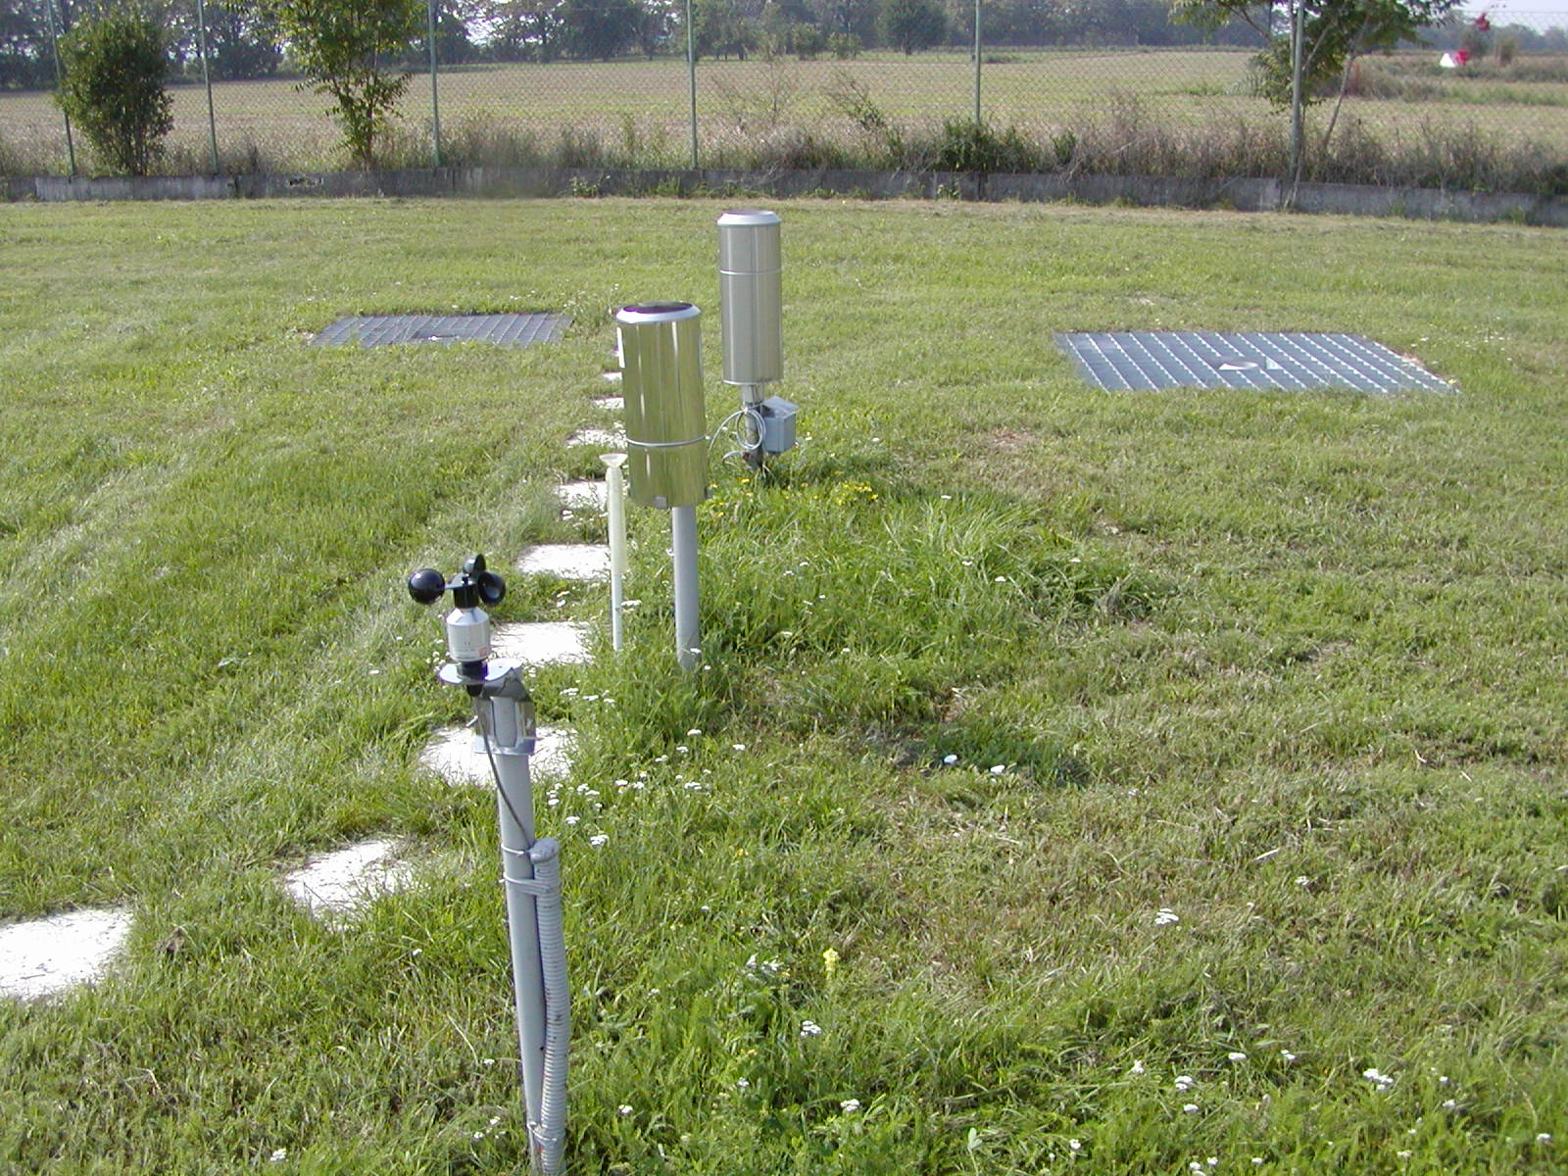
Figure 1. The pit and elevated precipitation gauges and the wind speed sensor at the experimental station at the observatory of SHMI in Jaslovské Bohunice, Slovakia.

Parsivel is a modern, laser-based optical system for measuring and classifying all types of precipitation. Baseline are measured the size and velocity of the fallen precipitation elements, from which are derived the compared amount of precipitation and the particle’s size spectrum [6]. The resolution of the weighing gauge is 0.001 mm.

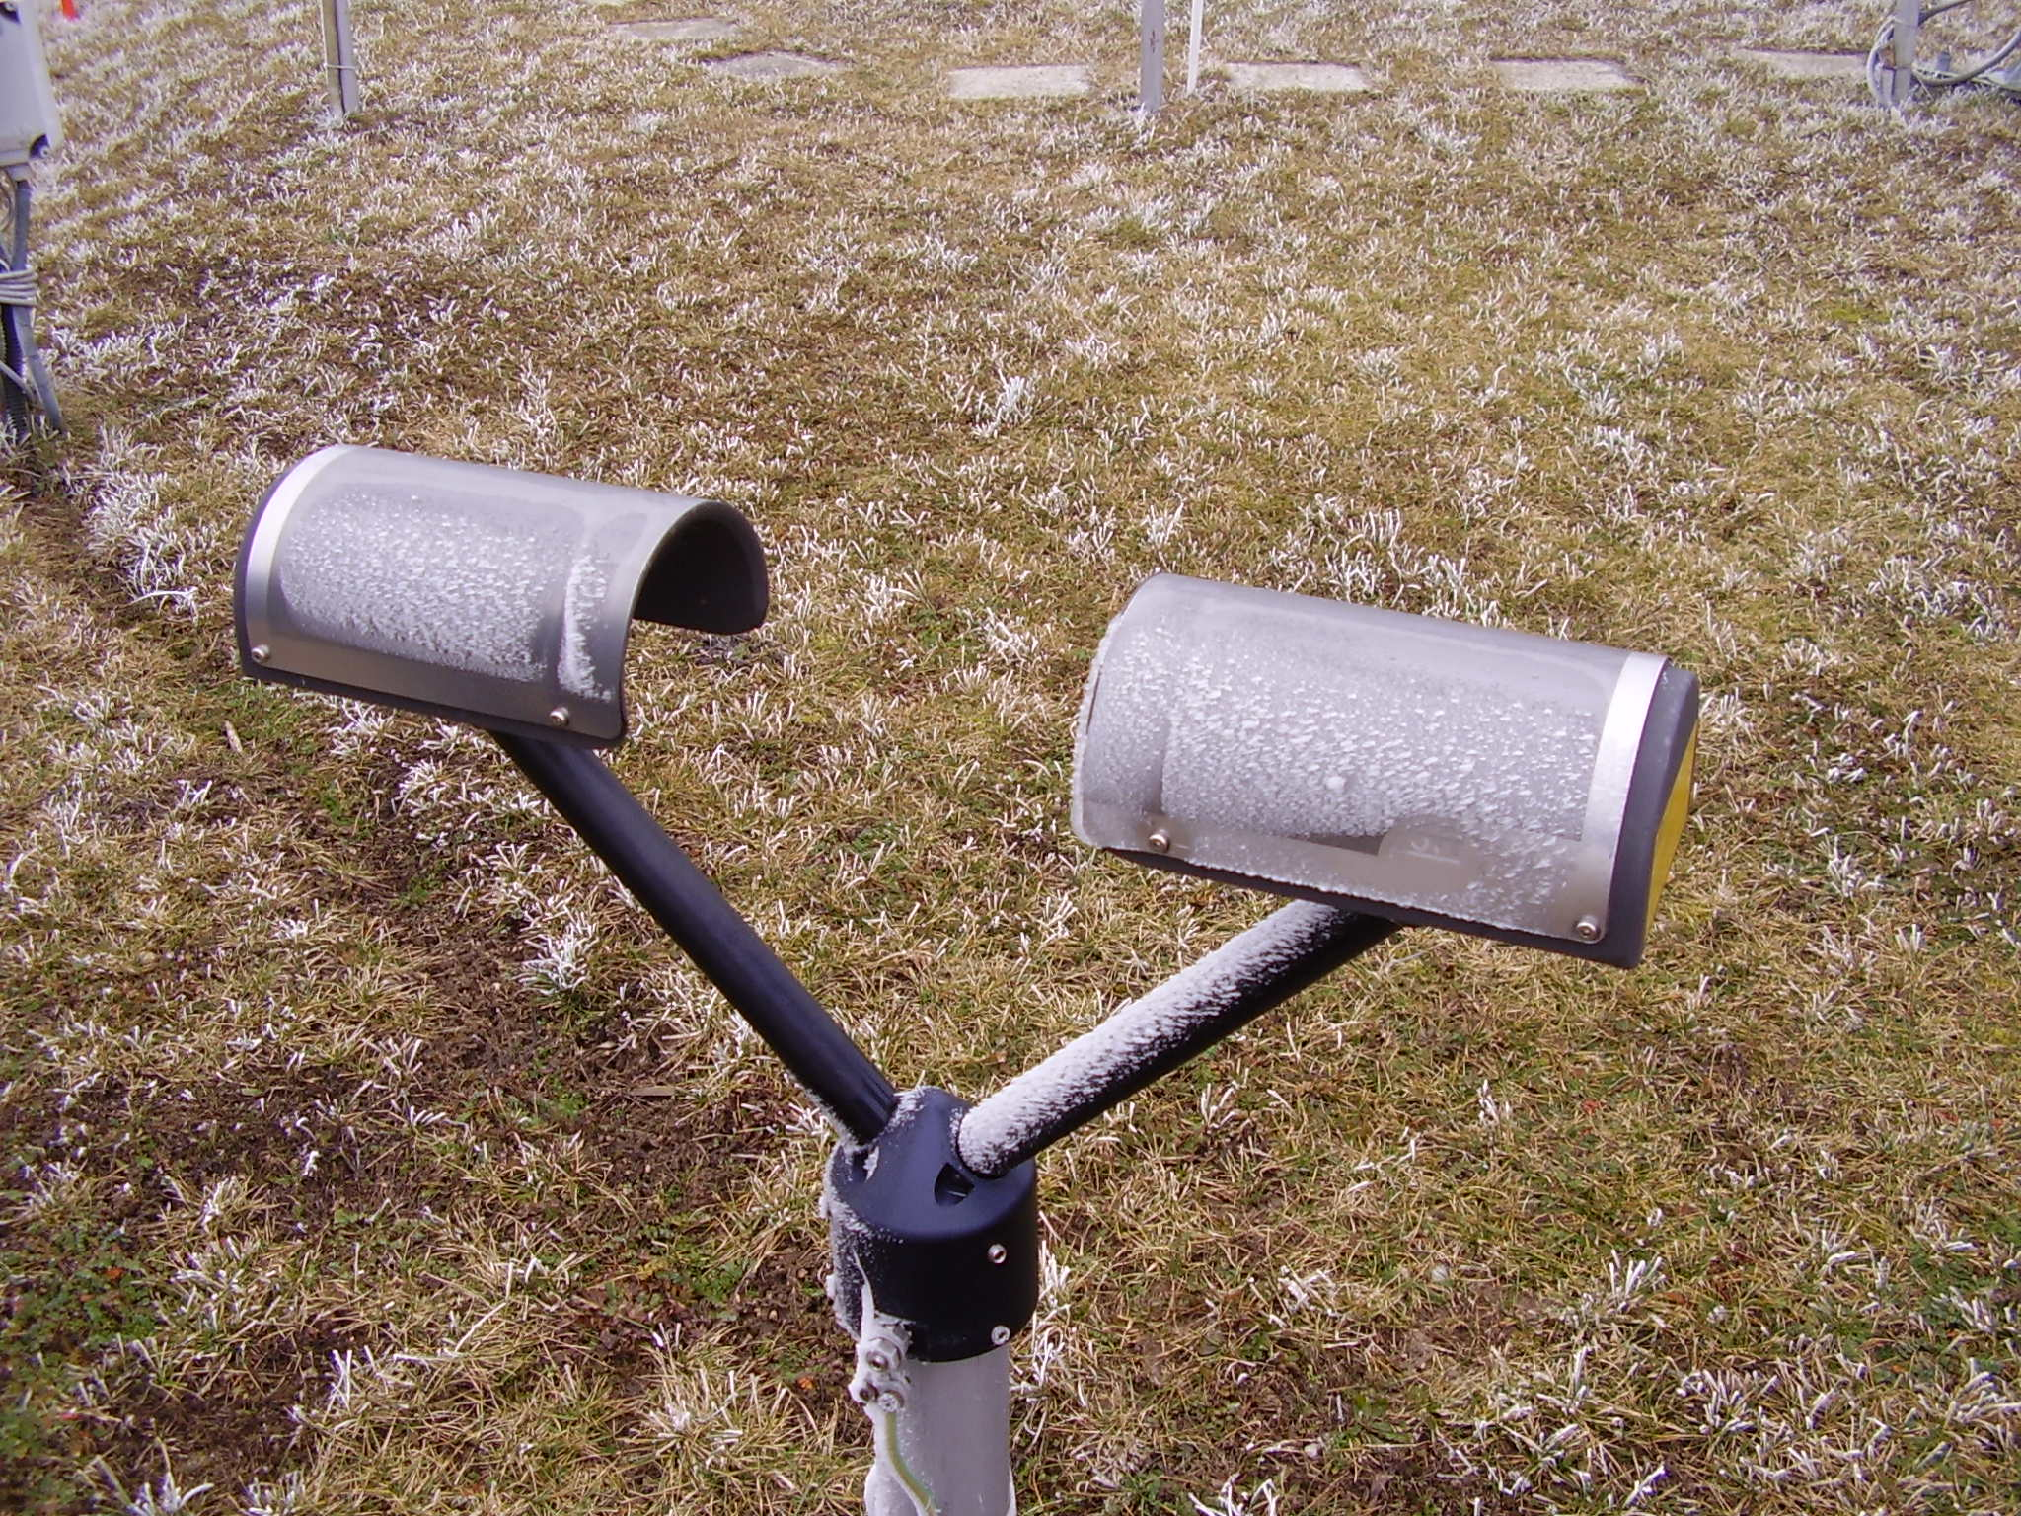
Figure 2. The elevated disdrometer installed at the experimental polygon in Jaslovské Bohunice.

The wind speed was measured using the instrument installed also at 1 m height above the ground. The weather phenomena and clouds observations from SYNOP messages were used to separate between the convective and non-convective precipitation as well as between liquid and solid ones.
The analysis was based on 15-minute intervals each consisting of (i) the total number of recorded precipitation particles, (ii) corresponding precipitation amounts for distrometers and weighing gauges, (iii) average wind speed and wind direction, (iv) mean ambient air temperature. In addition, the type of precipitation genesis, stratiform or convective, was assessed. Events with recorded precipitation at times when no precipitation was observed were eliminated. The specific cases when the difference between the number of recorded particles by the pit and elevated distrometers did not agree with the computed precipitation totals will be separately analyzed.
The differences between the pit and elevated disdrometers were subdivided according to the wind speed, wind direction, air temperature and the type of precipitation genesis. They were compared with precipitation amounts as recorded at the same time by weighing precipitation gauges.

RESULTS AND DISCUSSION

The number of registered rain drops in the one minute recording intervals varied from few units up to several hundreds, in the extremes up to thousands of raindrops. It corresponds to the precipitation intensities from trashes to more than 2.5 mm.min⁻¹. The comparison of the total number of rain drops and related precipitation amounts between both disdrometers showed that the ground level instrument gave usually a greater number of rain drops as elevated one. This difference increased with increasing wind speed as is shown in Table 1. The relative difference of the registered number of raindrops varied from 4.5 % for the group of calm up to approximately
14 % for the group of the strongest winds. The relative difference of the precipitation totals varied from 13 % to 22 %. It agrees well with the theory, that the falling precipitation particles are more affected by stronger winds like by the breeze and consequently, the elevated instrument registered less precipitation than that in the pit. Evidently, the difference is generally great for the calm group too. This could be explained either by still possible in-splash or due to the failure of one of the instruments.

Table 1. The increase of the percentage difference of the recorded number of raindrops and the corresponding precipitation amounts between the ground level and the elevated disdrometer, related to the elevated one, with increasing wind speed. Jaslovské Bohunice, Slovakia, July-October 2007.
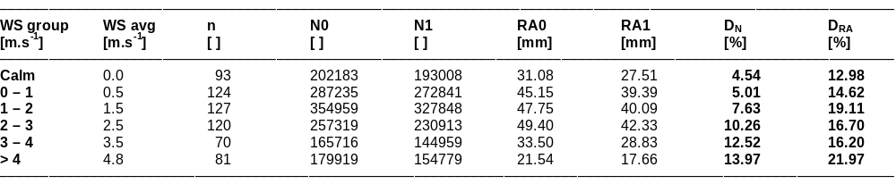
WS = wind speed
avg = average
n = number of considered cases
N0 = number of rain drops registered by disdrometer at ground level
N1 = number of rain drops registered by disdrometer at 1 m height
RA0 = rain amount of disdrometer at ground level
RA1 = rain amount of disdrometer at 1 m height
D_{N} = difference between registered rain drops number of disdrometer 0 and disdrometer 1 (relative related to elevated gauge)
D_{RA} = difference between rain amount of disdrometer 0 and disdrometer 1 (relative related to elevated gauge)

The similar comparison was made also for the non-convective and convective precipitation. The results are showed in Tables 2a and 2b. Overall there are not significant differences in the results between these two groups of precipitation genesis, nevertheless in the cases of light winds the difference is smaller for the convective precipitation. It can be interpreted in a way that the bigger and heavier drops of convective precipitation are less affected by the wind. However, number of considered events in the group of convective precipitation was not statistically significant.

Table 2. The increase of percentage difference of the recorded number of raindrops and the corresponding precipitation amounts between the ground level and elevated disdrometer, related to the elevated one, with increasing wind speed. Jaslovské Bohunice, Slovakia, July-October 2007.

a) Stratiform precipitation only.
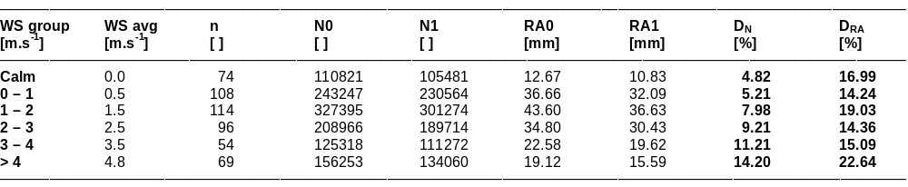

b) Convective precipitation only.
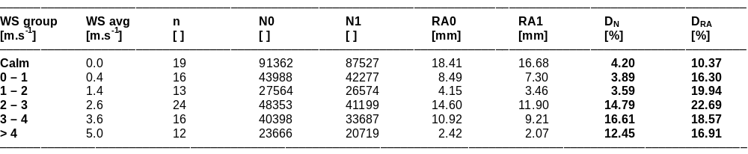
WS = wind speed
avg = average
n = number of considered cases
N0 = number of rain drops registered by disdrometer at ground level
N1 = number of rain drops registered by disdrometer at 1 m height
RA0 = rain amount of disdrometer at ground level
RA1 = rain amount of disdrometer at 1 m height
D_{N} = difference between registered rain drops number of disdrometer 0 and disdrometer 1 (relative related to elevated gauge)
D_{RA} = difference between rain amount of disdrometer 0 and disdrometer 1 (relative related to elevated gauge)

Because the disdrometer has not symmetric construction in circle (like the conventional rain gauge orifice) the effect of wind direction on the results of the elevated instrument was also analyzed (see Table 3). The major differences of the registered number of raindrops between the pit and elevated disdrometers occurred in two quadrants oriented across the lengthwise axial line of the instruments. The greater precipitation totals were measured in these two quadrants. Though, the difference of the rainfall amounts is about 3 – 5% smaller in these quadrants than in the upright ones. This can be explained by the splashing of the drops on the covers of the sensor’s arms and the effect of eddies around them. If the wind flows across the lengthwise axis the smaller splashed drops are going out of the measuring area in contrast to the splashed drops in the case of the parallel wind direction. The reverse difference in the precipitation amounts can be explained with the same principle. The sensor’s arms create obstruction for the falling particles, and during the precipitation events when wind flows along the lengthwise axis of the instrument, the windward arm keeps some portion of these precipitation particles and therefore sensor records smaller amount of precipitation.
The effects of ambient air temperature on differences are presented in Table 4. The relative difference in the registered precipitation particles varied between 2.3 % and 5.5 % in the precipitation amounts between the different air temperature groups. There is not apparent relation between the magnitude of the differences and the magnitude of the air temperature.

Table 3. The effect of wind direction on the number of registered rain drops and respective rain amounts and the relative differences of them, all between the pit and elevated disdrometer, related to the elevated one. Jaslovské Bohunice, Slovakia, July-October 2007.
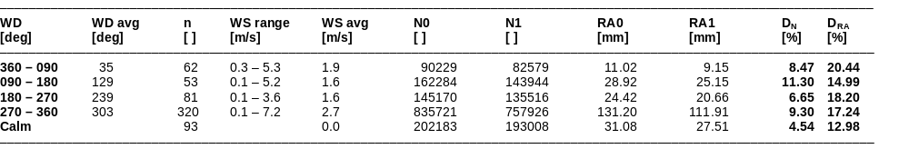
WD = wind direction
WS = wind speed
avg = average
n = number of considered cases
N0 = number of rain drops registered by disdrometer at ground level
N1 = number of rain drops registered disdrometer at 1 m height
RA0 = rain amount of disdrometer at ground level
RA1 = rain amount of disdrometer at 1 m height
D_{N} = difference between registered rain drops number disdrometer 0 disdrometer 1 (relative related to elevated gauge)
D_{RA} = difference between rain amount of disdrometer 0 and disdrometer 1 (relative related to elevated gauge)

Table 4. The effect of ambient air temperature on the number of rain drops and respective rain amounts registered by pit and elevated disdrometer. Jaslovské Bohunice, Slovakia, July-October 2007.
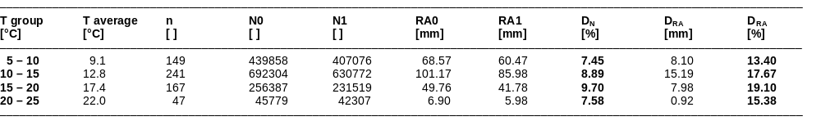
T = ambient air temperature at 2 m height
n = number of considered cases
N0 = number of rain drops registered using disdrometer at ground level
N1 = number of rain drops registered using disdrometer at 1 m height
RA0 = rain amount of disdrometer at ground level
RA1 = rain amount of disdrometer at 1 m height
D_{N} = difference between registered rain drops number of disdrometer 0 and disdrometer 1 (relative related to elevated gauge)
D_{RA} = difference between rain amount of disdrometer 0 and disdromerer 1 (relative related to elevated gauge)
Wind speed average in all groups varied between 1.8 and 2.3 m.s⁻¹.

The intercomparison of the registered precipitation amounts between the disdrometers and weighing rain gauges showed that disdrometers systemically overestimate the precipitation totals. Significantly overestimation is obvious for the pit disdrometer as is shown in Table 5.

Table 5. The dependence of the relative difference of rain amounts registered by disdrometers and weighing raingauges on the wind speed. Jaslovské Bohunice, Slovakia, July-October 2007.
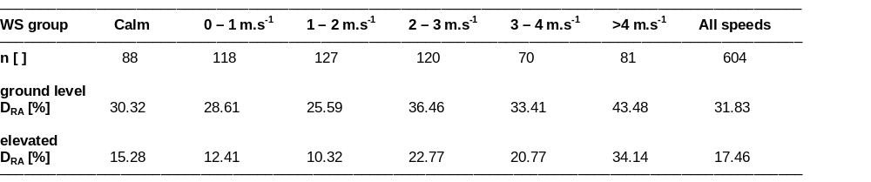
WS = wind speed
n = number of considered cases
D_{RA} = relative difference between rain amount of disdrometer

CONCLUSIONS

The effect of wind speed and direction on the measurements using disdrometers was evident in the increasing difference of the recorded number of raindrops and precipitation amounts between the paired ground level and elevated disdrometers with the increasing wind speed. In the case of rains composed of smaller raindrops the wind effect was greater than in the case of rains with bigger raindrops, which agrees well with the theory. Differences occurred also between different quadrants of wind directions, the oriented across the lengthwise axial line of the instruments and other ones parallel to it. The greater precipitation totals were measured in both of the quadrants oriented across the lengthwise axial line. The difference of totals in these quadrants is about 3 – 5 % smaller than in the upright ones. In spite of losses due to wind, the disdrometers still seem to overestimate the rain amounts, particularly during higher intensities, as resulted from the intercomparison measurements using other ground level and elevated, Helllmann and automated weighing, gauges installed at the site. The effect of type of precipitation, convective or stratiform, on differences was small.

ACKNOWLEDGEMENT

Many thanks to Ott Messtechnik company for lending the Parsivel disdrometers to Slovak Hydrometeorological Institute in order to provide the intercomparison measurements and study of reliability and accuracy of these equipment.

REFERENCES

[1] Chvíla, B., Ondráš, M., Sevruk, B., 2002: The wind-induced loss of precipitation measurement of small time intervals as recorded in the field. In: WMO/CIMO Technical conference 2002. WMO Instrument and Observing Methods Rep. No. 75, WMO/TD-No. 1123, Geneva. CD ROM edition.
[2] Chvíla, B., Sevruk, B., Ondráš, M., 2005: The wind induced loss of thunderstorm precipitation measurements. Atmospheric Research, 77: 29-38.
[3] Chvíla, B., Sevruk, B., Ondráš, M., 2005: Intercomparison measurements of recording precipitation gauges in Slovakia. In: WMO/CIMO Technical Conference 2005. WMO IOM Report No.82, WMO/TD-No. 1265, Geneva. CD ROM Edition.
[4] Chvíla, B., Sevruk, B., 2006: Effect of small intensity precipitation on wind induced error of precipitation measurement. In: Proceedings of 7th international workshop on precipitation in urban areas, St. Moritz, Switzerland, 7-10 December 2006.
[5] Sevruk, B., Chvíla, B., 2003: Error sources of precipitation measurement using electronic weight systems. Atmospheric Research, 77.
[6] Nemeth, K., Hahn, J.M., 2005: Enhanced precipitation identifier and new generation of present weather sensor by OTT Messtechnik, Germany. In: WMO/CIMO Technical Conference 2005. WMO IOM Report No.82, WMO/TD-No. 1265, Geneva. CD ROM Edition.

