A CHEAPER PRECISION RAIN GAUGE TESTER FOR NMHS AND RICs
John Gorman
Bureau of Meteorology, 700 Collins Street Docklands Melbourne, Australia
Phone: + 61 39669 4508,
Fax: +61 3 9669 4736.,
Email: j.gorman@bom.gov.au

ABSTRACT

The Australian Regional Instrument Centre has developed a precision rain gauge tester suitable for the testing of both tipping bucket and weight meter type rain gauges. The system is capable of continuous operation at any rainfall rate from 0.2 to 1000mm/h and is fully automated. The uncertainty of the system has been determined and extensive trials performed to confirm its suitability for use in NMHS.
The system has been designed to be cheaper and easier to maintain than existing systems. It is modular and can be expanded to calibrate several rain gauges at once. An overview of the system and its performance are presented. Due to its low cost and ease of maintenance the system is considered suitable for less developed NMHS.

TEXT
The FMI pump is a ceramic piston which does not require lubrication this is accomplished by the synchronous rotation and reciprocation of the ceramic piston in the precisely mated ceramic cylinder liner. One complete piston revolution is required for each suction/discharge cycle. Moving the pump head position changes the piston stroke length and, in turn, the flow rate. Infinite fine flow adjustments between 0-100% flow rate.
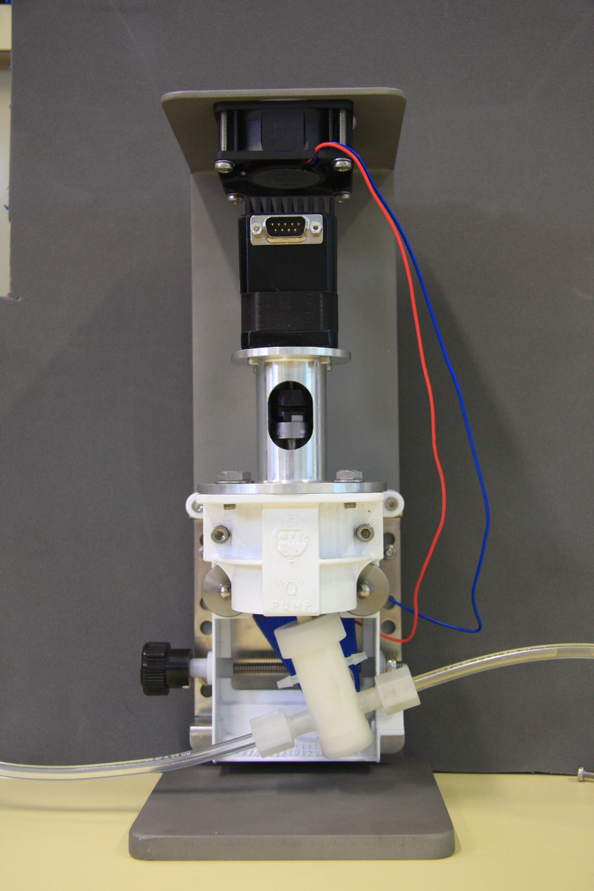
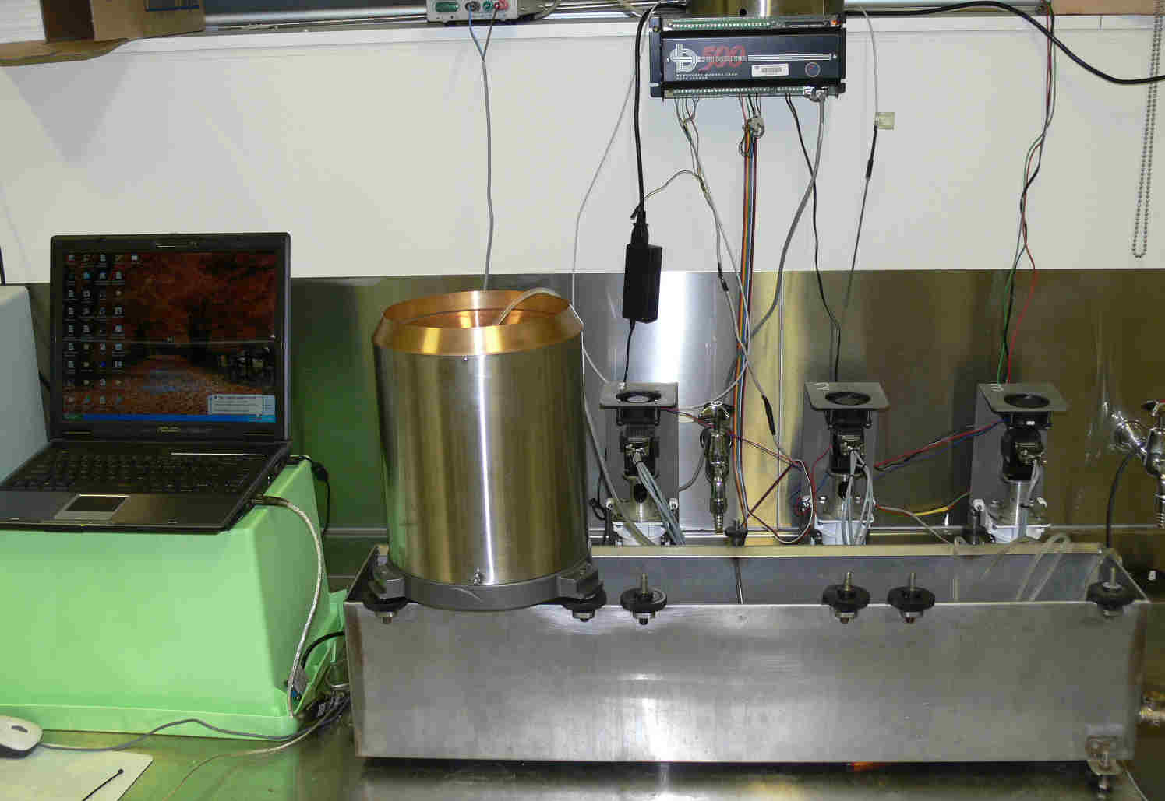
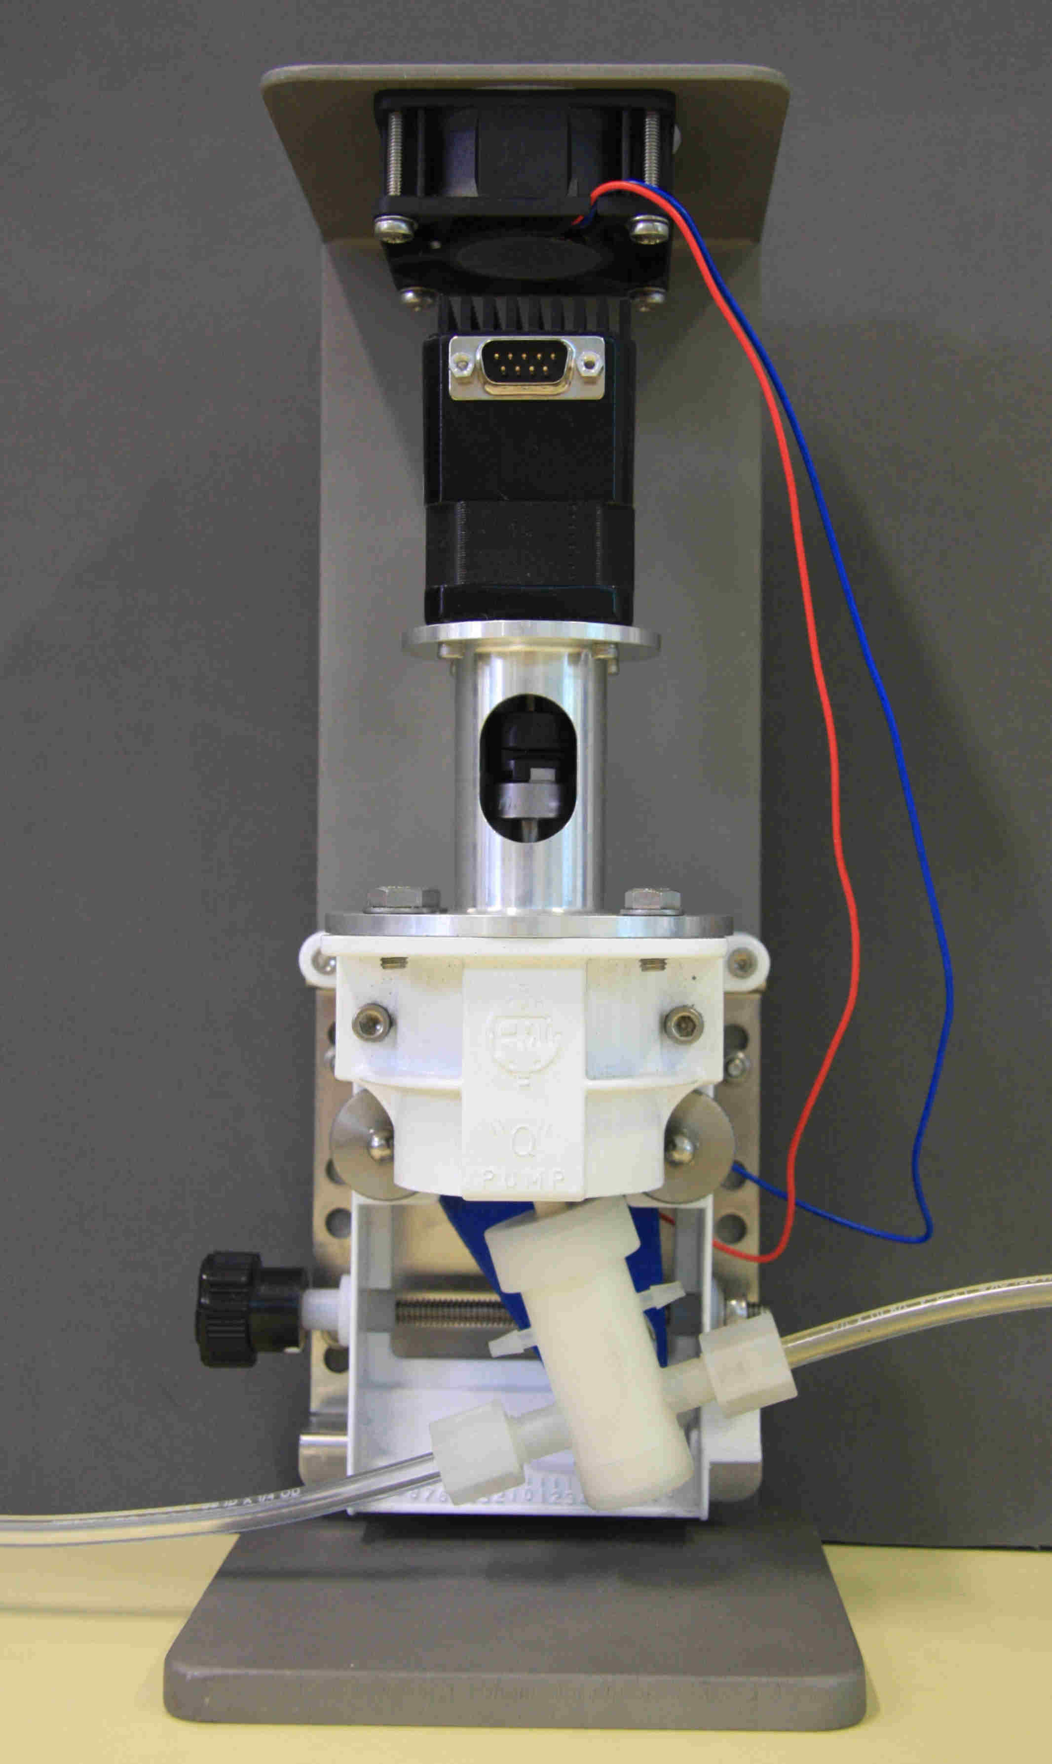 Figure 1. Left – assembled pump and stepper motor. Right – Rain gauge testing bench showing 3 pumps, DT 500 counter and controlling PC.
The flow rate can be changed while pump is operating or at rest. The principle of operation is shown in figure 2. The action of the piston means that the water is delivered in very precise doses. Precise control of the rate of rotation by the stepper motor determines the pumping rate and therefore the simulated rainfall rate. The outflow of the pump is initially pulsed and a 'water slide' is used to even the flow of water.

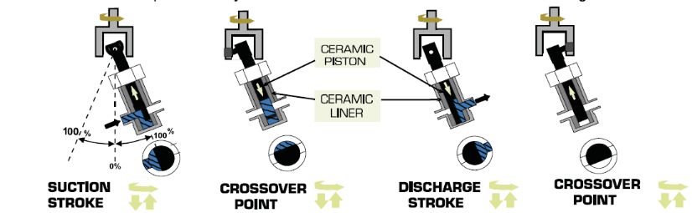
Figure 2. Schematic of the FMI pump operation principle.

The pump stroke angle can be adjusted (see Figure 3) to change the amount of water delivered per rotation of the drive shaft.

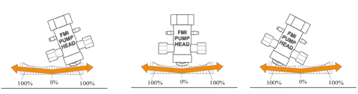
Figure 3. Schematic of the FMI pump adjustment (calibration).

Micro stepper motor
The stepper motor is a NEMA 17 pattern motor with an incorporated driver, controller and power supply. The motor is controllable via RS485 communications protocol allowing up to 64 motors to be controlled simultaneously. Shown in Figure 1 is the Bureau's rain gauge tester which employs 3 units to simultaneously test 3 tipping bucket rain gauges. The Bureau design allows water recycling giving better water temperature stability and reduced water wastage.

The pump/motor unit developed her has a number of advantages over previous designs. They are:
- infinitely variable rainfall rates from 0 to 1000 mm/h;
- changing rainfall rates or delivered volumes only involves changes to software;
- all the components are commercially available;
- the pump speed can changed 'on-the-fly' enabling simulated rainfall events;
- larger pistons sizes are available for higher pumping rates;
- the unit accepts are wide range of power from 12 – 40V DC.

The disadvantages of the system are:
- the motor units are not water proof meaning care must be taken;
- the output of the pump is a pulse of water which may need smoothing for some applications;
- the pump delivers a 'set volume' - not mass of water so water temperature must be accounted for;
- a separate counter is required to capture the output of the rain gauge.

Performance
The use of a micro stepper motor capable of 1/256 step allows unprecedented accuracy in water delivery. This step size equates to 51,200 steps per pump cycle. Figure 4 shows the results of a number of repeated runs at at rainfall rate of 125 mm/h. Of the 45 runs all data is contained within +/- 0.2 tips out of 300 or put another way +/-1/1500. This level of repeatability is more than adequate from rain gauge testing.

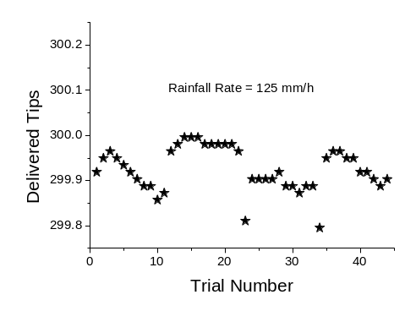
Figure 4. Scatter plot of the repeatability of the pump at 125 mm/h

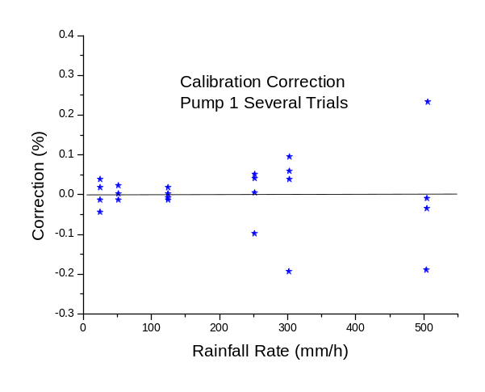
Figure 5. Calibration corrections for a number of trials at different rainfall rates.

Figure 5 shows the calibration corrections for a typical pump versus rainfall rate. It can be seen that the repeatability of the device is worse at high rainfall rates – possibly due to the acceleration/deceleration of the pump and stepper motor. These results should be compared to those in Figure 6 which show the correction for a typical tipping bucket rain gauge (TBRG). It can be seen that the repeatability of the pump is insignificant compared to the variability of a typical rain gauge.
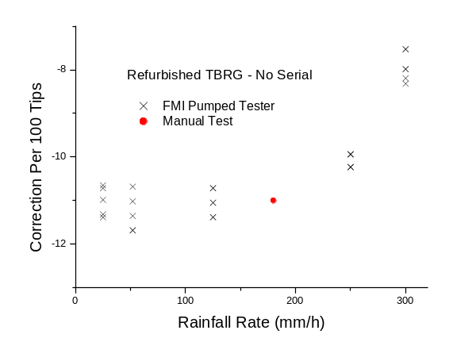
Figure 6. Typical test results for the characterization of a tipping bucket rain gauge.

During use in the Bureau the pump units have operated continuously for periods of up to 5 weeks without the need for attention. This allows the user to fully characterize rain gauges at various rainfall rates and perform multiple repeats to reduce measurement uncertainty.
Since it is a pumped system it can reuse water that has passed through a gauge allowing recycling and little loss of water.

Uncertainty
The uncertainty for these pumps is calculated as per the ISO Guide to Uncertainty in Measurement 1996. The uncertainty was calculated for a calibrated pump with the determined corrections applied and appears in a separate document.
The combined uncertainty of the delivered water mass at 125mm/h rainfall rate is 1.0 g with a coverage factor of 2.1 for a delivered mass of 1942 g. This could also be stated as 0.05%.

Operation
A number of programs have been developed by the ARIC to:
- characterize the performance of rain gauges (see Figure 6);
- test the repeatability of rain gauges;
- calibrate the pumps (see Figure 5)

Control of the pumps is via RS-485 protocol and involves simple ASCII commands to control all aspects of the stepper motor. Alternatively, programs can be written into the motor which will execute on powering up the device.
A typical command string is: /1j256V3000P2400040R
which is interpreted as: pump 1, set 256 micro steps, speed of 3000 micro steps per second, take 2400040 steps, do it now.
The step size and number of steps determines the delivered volume of water, the steps per second determines the pumping speed. Therefore it is a trivial matter to calculate the parameters required for any arbitrary rainfall rate and amount.

The operation of the pump and stepper motor is virtually maintenance free. Care should be taken to kept the water used free of debris as this will cause jamming of the pump.
The amount of water pumped is determined by the number of micro steps made by the stepper motor (for any fixed pump angle). The rainfall rate is determined by the number of steps per second and the micro step size.

Conclusions
  - The rain gauge tester based on the FMI ceramic pump produces are range of rainfall rates suitable for NMHSs and RICs.
  - The design is simple and requires little or no maintenance.
  - The design is cheap with a total cost of approximately $US 1000
  - The design can be automatically calibrated reducing traceability costs.

