METADATA TO DOCUMENT SURFACE OBSERVATION
Michel Leroy
Météo-France, BP202, 78195 Trappes Cedex, France
Tel : +33 130135405 Fax : +33 130136020 michel.leroy@meteo.fr

ABSTRACT

Metadata are necessary information to use at best all types of measurements. Detailed metadata are important to understand the characteristics and the limits of the measurements, especially for climatology. But detailed metadata, due to their complexity, may greatly reduce their operational use.
Météo-France defined and is using two complementary classifications, to describe the close environment of an observing station (“siting” classification) and the operational characteristics of the instrument, taking into account its preventive maintenance and calibration (“maintained performance” calibration). These classifications, already described during TECO98 and TECO2006, are recalled. This paper mainly shows the implementation of these classifications by Météo-France and some results.

INTRODUCTION

Metadata are necessary to use the measurements. The minimum set of metadata is the location of the measurement site! Additional information is the type of instruments used, their characteristics, calibration facts, the environment of the station, etc. See for example the Manual of GOS and annexes 5 and 6 of the final report of the Expert Team on requirements for data from Automatic Weather Stations ET/AWS4.
This paper deals with metadata defined and documented by Météo-France about the quality of surface observations: short description of the location by a site classification; short description of the performance limits of the measurement; results of calibration.
For such subjects, it is obviously possible to fully document the site, the instruments, and each value of calibration. But the danger is that a fully documentation of all these aspects would stay a target never reached and that the complexity of detailed metadata would often restrict their operational use. That is why Météo-France has defined classifications to condense the information and facilitate the operational use of this metadata information.
Météo-France uses two classifications. The first one ranges from 1 to 5 and is intended to shortly document the narrow site environment. The second one ranges from A to E and is intended to shortly document the maintained performance of the instruments. These classifications have already been presented during TECO98 and TECO2006. Therefore this paper will deal mainly with the management of this metadata, the status of their use in Météo-France and France and the corresponding view of the status of the surface observation networks in France.

DESCRIPTION OF THE CLASSIFICATIONS

The classifications have been defined by considering the following analysis of quality factors influencing a measurement. We have considered that the following factors have an influence on the « quality » of a measurement:
- The intrinsic characteristics of sensors or measurement methods.
They are coming from technical specifications, emitted by technical services, users or manufacturers. These characteristics are commonly described by the manufacturers, sometimes controlled during intercomparisons and are generally well known and mastered, at least for the classic measurements which we are dealing with. Météo-France has been traditionally dealing with this aspect.
- The maintenance tasks (including calibration) needed to maintain the system in nominal conditions.
These operations are often expensive and necessitate a continuous effort. Preventive maintenance is the best guaranty to maintain a system close to its nominal performance, allowing final measurements to be close to the « intrinsic » performances of the sensor. Our experience shows that this maintenance is not always well mastered in case of a dense network.
- The site representativeness and therefore the measurement representativeness.

Siting Classification
Traditionally, instruments characteristics are more considered than the site environment. People selecting a site know the exposure rules, but numerous logistic constraints exist. For cost and availability considerations, the measurement system can be hosted on a site not belonging to the owner (or the administrator) of the network. The access to the site, its supervision, and the availability of telephone and power lines are important elements. These logistic aspects, and also the orography, may surpass the strict application of exposure rules, quite restricting, especially for wind measurements (at least 10 times the height of nearby obstacles, which exclude nearby trees or buildings). A compromise is often selected. But when the rules are not applied, there may be no limits. Who have not ever seen anemometers close to high trees?
That is why Météo-France defined a classification for some basic surface variables to document the nearby environment of a site. This siting classification ranges from 1 to 5. By convention, a class 1 site follows the WMO recommendations. A class 5 site is a site where nearby obstacles create an inappropriate environment for a meteorological measurement that is intended to be representative of a wide area (at least tenths of km²) and where measurements must be avoided. For some classes, an estimation of the possible associated errors or perturbations has been indicated. This estimation is coming from bibliographic studies and/or some comparative tests.
Separate classifications are defined for air temperature measurement, relative humidity, wind, precipitation, and solar radiation. The wind classification is also accompanied with the terrain classification from Davenport (1960) adapted by Wieringa (1980b) in terms of aerodynamic roughness length (see chapter 5 of WMO CIMO Guide, doc 8), by sectors of 90°.
Recently, CBS and CIMO, both technical commissions of the World Weather Watch program, decided to work on this Siting Classification with the objective to be validated by CBS and then included in the Manual of the Global Observing System (WMO-No. 544) and Guide to Meteorological Instruments and Methods of Observation (WMO-No. 8). Following approval by CBS, a joint ISO/WMO standardization would be explored. This work will use the Météo-France classification as a starting point, which can be found in the following link.

Just as an illustration, an extract of this classification is shown below for radiation.

5˚
No projected shade

No obstacles > to 5˚
Shading from reflected radiation

Class 1
- No shade projected onto the sensor when the Sun is at an angular height of over 2° (except from the natural landscape of the region).
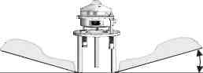
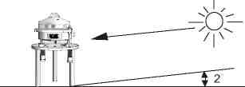
- No obstacles with an angular height of over 5°.
Class 2
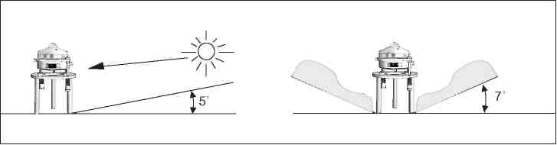
- No shade projected onto the sensor when the Sun is at an angular height of over 5°.
- No obstacles with an angular height of over 7 °.
Class 3
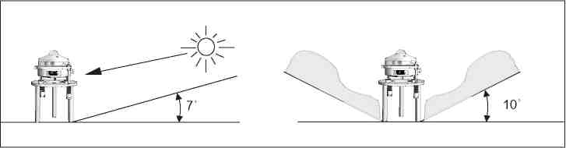
- No shade projected onto the sensor when the Sun is at an angular height of over 7°.
- No obstacles with an angular height of over 10°.

Météo-France has developed several procedures, using either very simple tools or more sophisticated instruments and methods, depending on the site and the obstacles, to classify each of our observing sites (more than 4000 with the numerous climatologic cooperative observing stations).

Maintained performance classification
Another primary quality factor of a measurement is the set of “intrinsic” characteristics of the equipment used. They are the characteristics related to the design of the instrument. They are known from the manufacturer documentation and/or from laboratory or field tests.
Once an instrument is selected and its performance characteristics known, it is necessary to maintain the level of performance during its operational period. Preventive maintenance and calibration are therefore necessary and must be identified to maintain the desired measurement uncertainty.
When delivering observations for various applications (mainly forecasts and climatology), it should be possible to state the “guaranteed” (for example with a 95% level of confidence) accuracy of a measurement. But it is not always done, the observations may come from several networks with different characteristics and considering “by default” the “achievable measurement uncertainty” of WMO n°8, Annex 1B could be a mistake.
The required accuracy of the main surface-observing network of Météo-France, named Radome, has been stated, the instruments were selected and the maintenance and calibration are organized accordingly. Doing this, the performances are known and documented. They are generally less stringent than the WMO operational measurement uncertainty requirements.

In addition to his proprietary Radome network, Météo-France also uses observations from other AWS networks (not belonging to Météo-France) and from manual climatologic sites (cooperative network). The instruments used in such networks are often not the same that the instruments specified and selected for Radome. Therefore, their performances are different, often lower. Nevertheless, their data have been used for climatological and forecasting applications, generally without considering the “quality” of the network. This may not be satisfactory and the “quality” of the observations has sometimes to be taken into account, mainly for the climatology.

In order to document the performance characteristics of the various surface observing networks used, Météo-France defined another classification, called "maintained performance classification", including the uncertainty of the instrument and the periodicity and the procedures of preventive maintenance and calibration. This classification ranges from A (instrument following the WMO/CIMO recommendations, in particular table in chapter 1 of the CIMO Guide) to D (no maintenance and calibration organized), with an additional class E for unknown characteristics and maintenance. Class B and C are for instruments and maintenance/calibration procedures less stringent than for class A.
This classification is related to a network, considering the instruments used and the maintenance organization applied for this network. So, it is an “organization” classification. It doesn’t give the information of what has been made on a particular day on a particular site.
This classification covers the quality factors a) and b) listed above.
Some examples of this classification can be found in the presentation made during TECO2006.

In practice in our database

The reference database for the metadata is the climatological database. The classes associated to each observing station are recorded, with the historic of their changes. Every year, during a preventive maintenance visit to the site, the environment is visually checked to detect a possible change since last time and in case of doubt, the siting class is updated. Additionally, we have decided to update the siting classification of each site at least every 5 years. We are currently finishing the classification of our sites, more than 3200 sites being done.

For each parameter, additional comments are possible. Photos in at least the 4 directions are also available for the majority of sites. These photos have a time stamp and are all kept to record the possible changes of the surroundings. The instruments used on each site are also recorded, with their serial numbers. This information is an example of detailed metadata, which can be useful in case of specific questions about a site, but they are difficult to automatically process. The classes are more usable, for example to filter the “best” stations.
Apart for safety, environmental, military and aeronautic purposes and except for essential data (in the sense of the WMO resolution 40), the current policy of France is to sell the meteorological data. This commercial use of data is a part of the Météo-France budget’s equilibrium. So the question was raised to adjust or not the commercial value of data, depending on the quality classes of the parameter and the site. The decision was that the commercial price is fixed and doesn’t depend on the associated classes. The siting and maintained performance classes are made public and it is the choice of the customer (user) to select or not a site depending on the associated classes. Therefore, both the definition of these classes and the result of the classification of our networks are made public. A large publicity has been done in France about these classifications to push the various meteorological network managers to use them. It begins to be the case with several of them: “Electricité de France”, owning many rain gauges in mountainous area; The “Office National des Forêts” owning 28 AWS in or close to forests. Several hydrologic and flooding forecast centers, owning numerous rain gauges.

Let’s take an example for one station. The following screen shots were generated with an interactive software to consult and update the central (and unique) climatological database.
“Pluie” stands for “rain”; “Rugosité_x” stands for “roughness in direction x”, using the Terrain classification from Davenport; “Température et Humidité” stands for “(air) temperature and (relative) humidity”; “Vent” stands for “Wind”.
“REF_CLASSE” indicates the reference of the document defining the classification. This is done in case of change of something in the definition of the classification, which could be the case if the classification is modified during a standardization process by WMO.

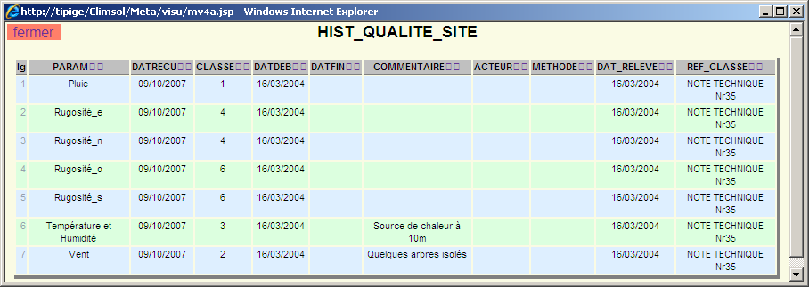
Siting classes for one station.

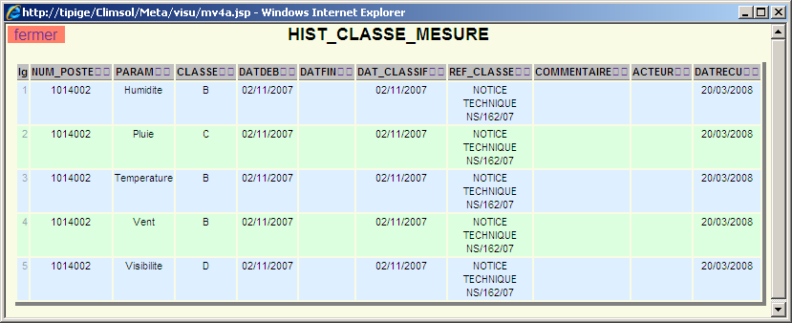
Maintained performance classes for the same station

For each station, more detailed metadata are also available, such as the meteorological equipments used, pictures of the station. See an example below

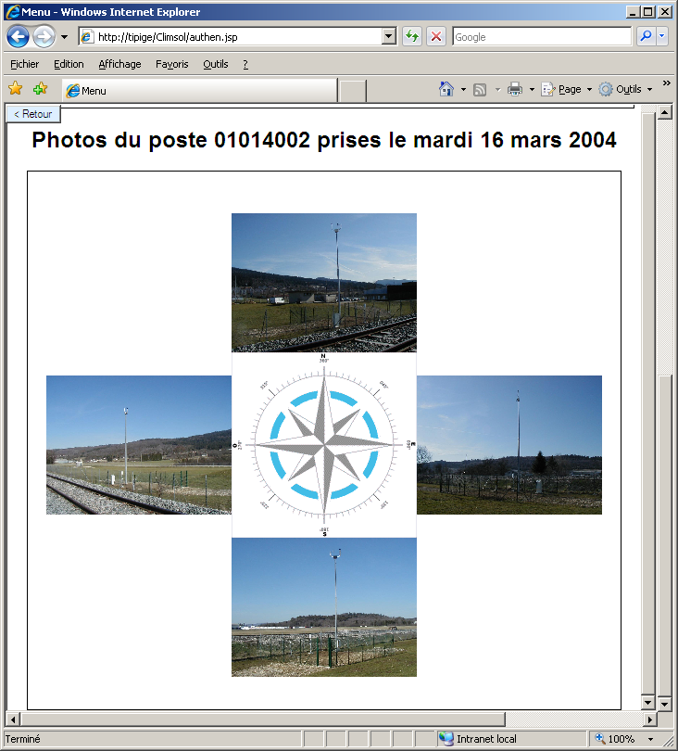

Status of the Radome network

With these two classifications, a letter and a number therefore describe a measurement on a given site. So, it is possible to have a general view of the classes of a network. The following graphs show the result of the classification of the Radome network.

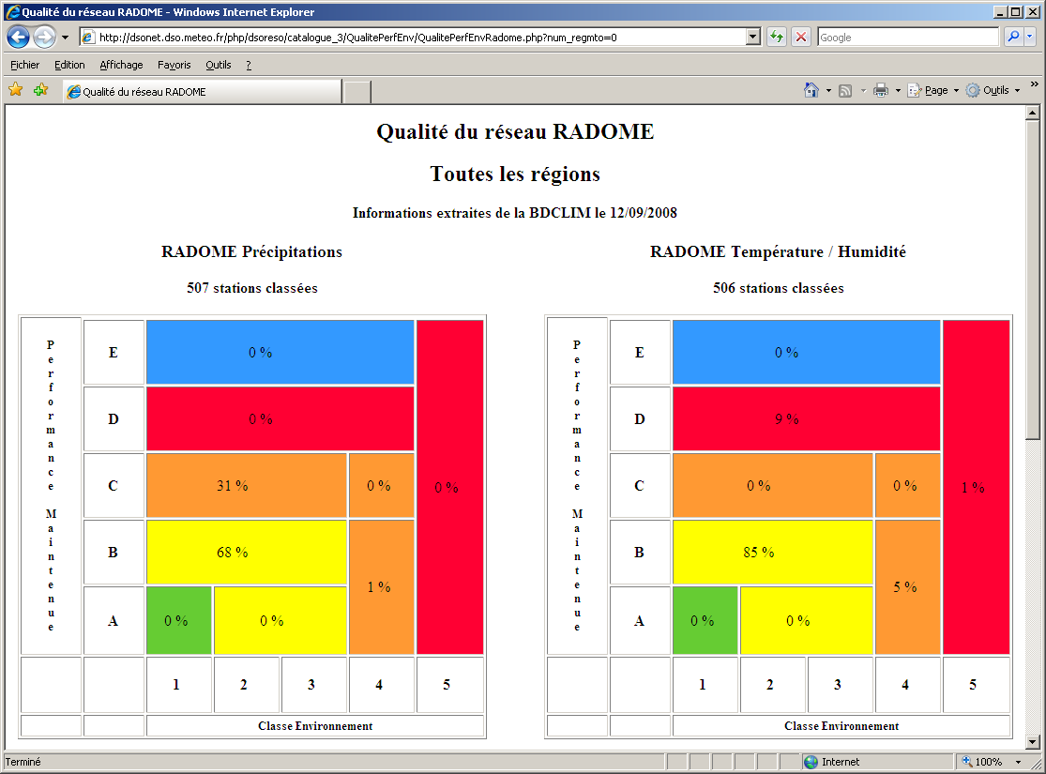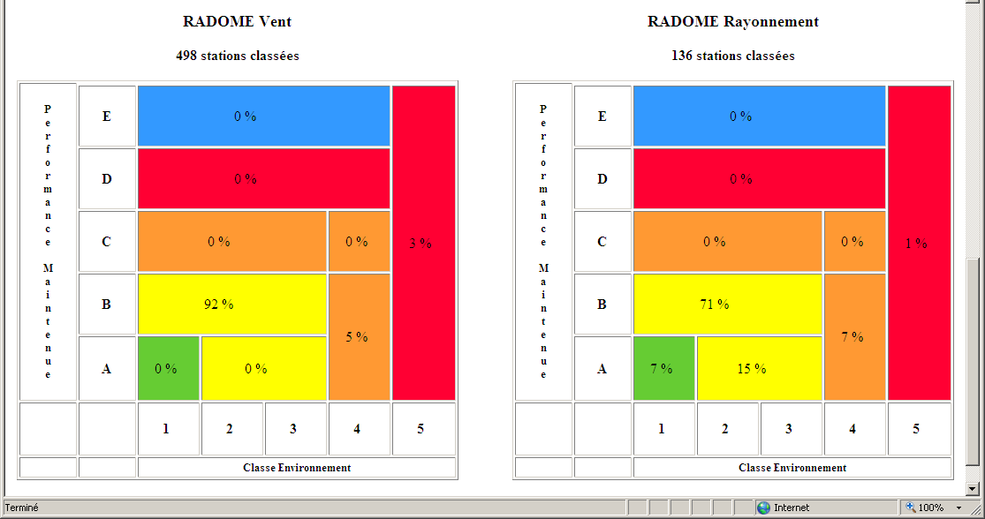

For each diagram, the siting class is horizontal; the maintained performance class is vertical. The color is a little bit related to the “quality” of the combination of the two classes. A1 (green) is the best; the yellow zone is still a good compromise; the usefulness of a measurement in the orange zone begins to be questionable; no points should be in the red zone; the blue one is for the unknown maintained performance class.
We have some values in the red zone:
- We currently have some electronic drifts with some acquisition modules for temperature, leading to an uncertainty that we have flagged with a class D. We are finishing to solve this problem.
- Some sites have a bas environment for some sensors, mainly wind sensors. For such sites, the installation was accepted with derogation, registered in our quality system.
The C class for precipitation is related to the use of a rain gauge model that exhibits quite large evaporation errors. We work also on this problem to minimize it, the full change of the rain gauge model being the ultimate solution that would be costly, but may-be necessary.

This objective presentation of our Radome network shows that it is not perfect. But it is an honest presentation, which may also brings arguments to improve it.

Analog diagrams are also available for the other networks that Météo-France uses.

LAC, an additional metadata related to calibration

The sensors are regularly calibrated. During this process, each sensor is first calibrated. The results are checked against acceptable limits. Two sets of limits exist. If the first limits are reached, the sensor is adjusted and recalibrated. If the second limits, larger than the previous ones, are reached, we consider that the sensor has drifted outside a “Limit to Alert the Customer” (LAC). In this case, we inform the climatological service that this occurred and this fact, a drift between two periodic calibrations, is recorded as a metadata. For example, a hygrometer is adjusted in laboratory, when a control point differs more than 2.5% from the reference. A hygrometer is considered has being outside the LAC, when a control point differs more than 5% from the reference. Our knowledge of the drifting process of the hygrometers doesn’t allow us to correct the data, because it is impossible to know when the drift occurred and our experience is that a drift is not something constant with time.
Such LACs have been defined for thermometers (calibrated every 5 years, LAC = 0.25°C), hygrometers (calibrated every year, LAC = 5%), barometers (calibrated every 2 years, LAC = 0.4 hPa), bearings of cups’ anemometers and wind vanes (controlled every year, LAC = 10 s, time to stop from an initial rotating speed of 3 m/s), rain gauges (every 6 months, LAC = 6%), solar radiation (calibrated every 2 years, LAC = 3%).

Apart the individual information for each sensor, the percentage of sensors reaching these LACs gives a global overview of the stability of the different types of sensor used in the network. Yearly statistics are done. The percentage of barometers having reached the pressure LAC is < 1%. The percentage of thermometers is about 5%. The percentage of hygrometers ranges between 7 and 10%.

When a sensor reaches a LAC, this fact and its date are recorded in the climatologic database. The data measured during the period between the last calibration and the preceding one are not flagged as doubtful. It has been a choice of the climatological service to not do so. But The LAC fact is recorded for possible use.
An example is given below.

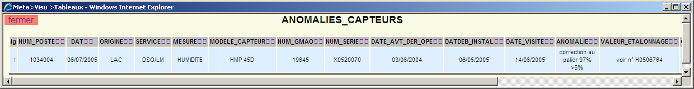
For this hygrometer, the control at 97% has shown a difference greater than 5% compared to the reference. For additional information, the reference of the calibration certificate is given.

Conclusion

The two classifications described have the advantage of being simple and therefore, easy to use. Unfortunately, the siting classification as it is defined, doesn’t allow to correct the measurements. Correction methods remain possible, but independently of the siting classification. It is a clear limitation, but these classifications allow to easily documenting the “quality” of the design of a network. Another advantage is that it is also a didactic approach, both for network designers, financing authorities and final users. It gives a clear and honest view of a network status. The Météo-France experience is that the implementation of these classifications brought and still bring improvements in the networks’ design, thus optimizing their value, not necessarily at an extra cost.

Quality is the ability to satisfy implicit or explicit needs. For meteorological measurements, this is often translated to a statement of operational accuracy requirements.

