GPS Water Vapour – Operational Implementation and Recent Developments

Jonathan Jones
Met Office, Exeter, United Kingdom
Tel +44 (0) 1392 885646 , Fax +44 (0) 1392 885681, Email jonathan.jones@metoffice.gov.uk

Abstract
Since 1998 the Met Office has been evaluating the potential of extracting humidity information from the time delays in Global Positioning System (GPS) signals received at the surface. In 2002 it was decided to develop a UK Met Office GPS processing capability with the main objective being to process as many GPS sites as possible in the British Isles delivering the results with the minimum time delay possible. Since this time the Met Office has worked in partnership with the Institute of Engineering, Surveying and Space Geodesy (IESSG) at Nottingham University to develop an automated processing system operated by met Office staff. This system was successfully rolled-out for operational use in May 2007.

This paper will highlight the transition of the GPS project from research to operations, including the interfaces and partnerships which are essential for a cost effective GPS Water Vapour (GPSWV) programme.

Background
Requirement
The distribution of water vapour in the horizontal and vertical is required fro the development of numerical weather prediction (NWP) in the UK. The information from the GPS signals at different sites constrains the horizontal distribution of water vapour in the model analyses. Since 2002 trials have been carried out by the NWP Satellite Applications team at the Met Office to assess the impact on NWP models by the assimilation of ground based GPS data. The conclusions suggest that in almost all cases neutral or positive impact is achieved with up to a 4% reduction in the standard deviation of model humidity, cloud cover and surface temperature by the assimilation GPS data.

The second main customer of the GPSWV data is the very short-term forecasting or nowcasting community. Conditions which typically have high levels of water vapour are often associated with extreme weather events such as thunderstorms or very heavy rainfall. These conditions potentially can have a huge impact on infrastructure as well as the risk to life, and as such any additional information on the location and structure of humidity fields is of great value to forecasters.

Water vapour is one of the most important greenhouse gases. GPS sensors could potentially be an excellent source for providing a long term water vapour data for climate change studies. However, the data need to be processed by one processing method, whereas there have been several changes with time to the operational processing system. Thus, at this time all raw GPS data are stored at the British Isles GPS Archive Facility (BIGF), hosted by IESSG, Nottingham University and are available for reprocessing in the future.

Technique
The path delay between a GPS satellite and a ground based GPS receiver depends, after elimination of ionospheric effects, on the integrated effect of the densities of dry air and water vapour along the signal path. The total delay in the signal from each satellite is known as the slant delay as the path is most likely to be non-azimuthal. The slant paths are then transferred into the vertical (or zenith) by an elevation mapping function in the processing algorithms, and this parameter is known as the Zenith Total Delay or ZTD. With knowledge of surface meteorological parameters ZTD may then be converted into Integrated Water Vapour or IWV. The solution for the time delays requires a very accurate knowledge of the satellite transmitters, the accuracy of their clocks, and a very accurate knowledge of the position of the GPS sensor on the surface (Bevis et al, 1992).
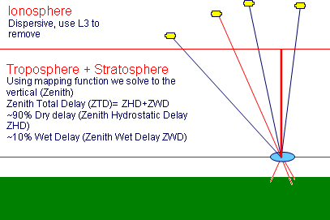
Figure 1 Schematic illustrating basic GPS technique

ZTD and IWV are vertical approximations which are essentially averages taking into account a cone of atmosphere above the GPS antenna of approximately 30-50km in radius and between 3km and 5km in height. This geometry of the cone is dependant on satellite geometry and the height of the water vapour in the atmosphere which varies seasonally. From previous work (Nash et al, 2006) it has been shown that it is possible to estimate the IWV with an accuracy of around 1.5 kg/m² which is equivalent to about 3% relative humidity - comparable with radiosondes and other remote sensing instruments such as microwave radiometers. Therefore, as GPS water vapour can be thought of as a vertical measurement, the greater the number of GPS sites, the greater the detail in the water vapour field information for the forecaster.

Transition to Operations – Processing Servers
In 2003 IESSG, Nottingham University were contracted to carry out an investigation into the optimum processing strategy for providing ZTD estimates for near real-time (NRT) meteorological applications (Orliac et al. 2003). The conclusions suggested that the optimum processing strategy would consist of running the Bernese processing software (developed by the University of Bern, Switzerland) utilising the double-difference (DD) processing technique combined with two post processing strategies used as a quality check for the NRT solution. For the NRT processing the predicted part of the International GNSS Service Ultra Rapid products were to be used for the satellite orbit parameters. With GPS processing a more accurate solution is obtained the further you go past the time of satellite observation. Nottingham found that these orbit products were more than adequate for NRT meteorological applications.

The quality of the NRT processing was checked using the same DD network approach but using a more accurate first update of the Ultra rapid orbit product (known as IGU06) which was available with a 6 hour delay. Finally a Precise Point Positioning (PPP) strategy was also implemented as a final quality check solution using the most accurate IGS Final products, but with a time delay of 17 days. Meteorological surface information would be retrieved from the Met Office Database (MetDB) for the ZTD to IWV conversion and the conversion would be according to the ‘Saastamoinen’ method (Saastamoinen, 1973).

In 2004 the first development servers were delivered to the Met Office known as GPSMET1 and GPSMET2 respectively. The main aim of these servers was to investigate the optimum processing strategy and the reliability of the processing. At this time automated NRT GPS processing was only being trialled by a small number of European Geodetic institutes and the limitations of running such a system on an operational automated basis were largely unknown. A balance had to be found between the number of stations processed and the processing time so that time delays in delivering the NRT products to NWP were acceptable.

Resumé

By 2005 the Met Office had decided on an optimum processing strategy and proved the reliability of processing in NRT. At this point a further contract was placed with IESSG, Nottingham to develop and deliver a pair of operational processing servers by mid-2006. The new servers, GPSWV1 and GPSWV2, were substantially different from the development servers in that they were much less complicated but as a result much more reliable. The main changes between the GPSMET and GPSWV servers was the dropping of the IGU06 check solution, so relying on the hourly NRT solution along with the 20-day delay daily PPP solution for the generation of a-priori sensor coordinates used as the starting point for the NRT processing. By December 2006 the new servers were installed in the Met Office for testing and by May 2007 had gained full operational status.

Since 2007 the GPSWV1 and 2 the servers have evolved further taking into account more up to date processing models and GPS reference systems. The servers are now running on a fully operational basis and process data from up to 400 European GPS sites on an hourly basis. In reality however only about 250 of these sites are processed at any one time due to lack of available data. Figure 2 shows the Met Office (METO) processed network as of August 2008.

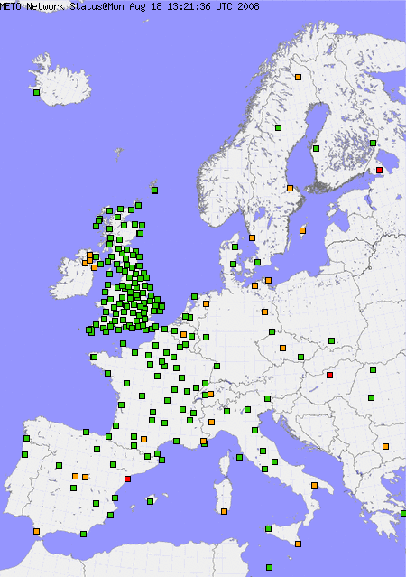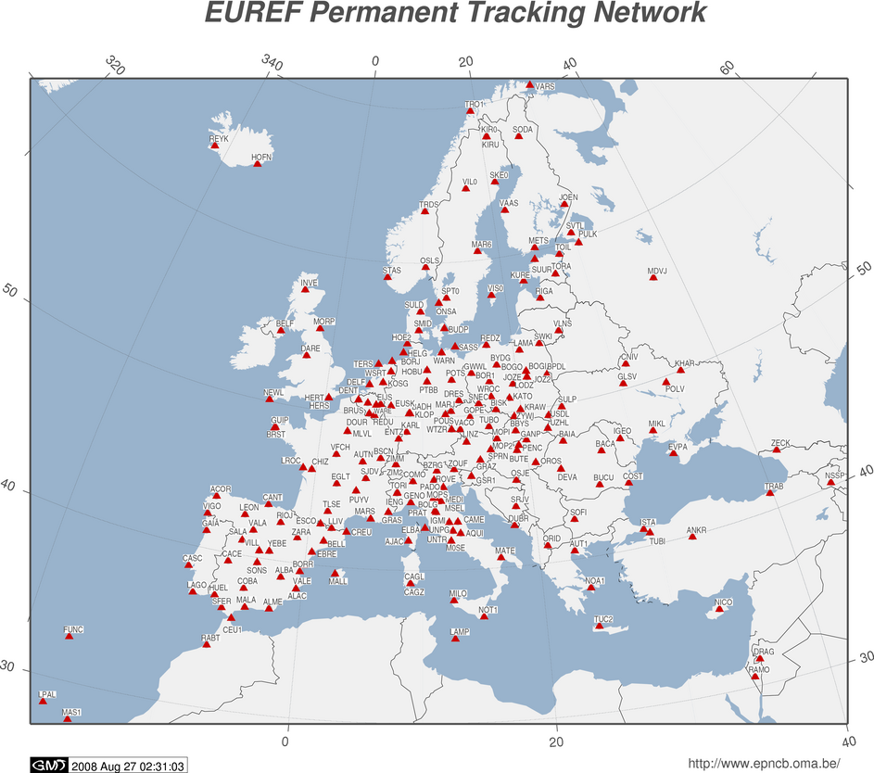
Figure 2 GPS network processed by the Figure 3 The EUREF Permanent Network (EPN)
UK Met Office as of 18th Aug 2008

In some European countries (Switzerland and the Netherlands) GPS processing for NRT meteorological applications has been taken further with the processing being carried out in 15min batches as opposed to hourly as in the UK. This can provide the forecasting community with humidity information with a far smaller time delay than is currently possible with the Met Office system. Data quality is a little poorer but is still well within the requirements for assimilation into NWP models. In the near future the UK Met Office hopes to implement such a system processing data in much smaller batches than previously.

Transition to Operations – Networks and Partnerships
The vast majority of GPS sites in the UK and Europe are not owned by National Met Services, but are owned by other government and private networks. In order to achieve a cost-effective solution to raw (unprocessed) data access both in the UK and on a European scale, a number of agreements have been established to secure long term data access. Only with such agreements in place can National Met Services invest in GPS meteorology safe in the knowledge that the data access will still exist in the future.

In the UK, memoranda of understanding have been established between the UK Met Office and the national mapping agencies, Ordnance Survey of Great Britain, the Ordnance Survey of Northern Ireland and the Ordnance Survey of the Republic of Ireland. The basis of all the agreements is that the mapping agency in question can install a number of their GPS sites on any of the Met Office surface network sites around the UK where practicable, and in return the mapping agency will grant the Met Office free access to the GPS data stored on their server. The only restriction in the use of the GPS data stipulates that the data may only be used for non-profit activities by the Met Office and should not under any circumstances be passed on to any third parties without the express written consent of the mapping agency. This is a cost effective solution for both parties as the mapping agency does not have any ongoing cost associated with housing its GPS site (e.g. land rent) and the Met Office gets access to data from a GPS network which would otherwise be too costly for the Met Office to install by itself.

When processing GPS data for a national network the most consistent solutions are obtained if the national network is centred in a larger network. As such it is essential to guarantee long term data access from a wider, European scale network of GPS receivers. The EUREF Permanent Network (EPN) is a network of continually operating, high quality GPS sites around Europe which acts as a backbone for the geodetic and positioning communities. In 2007 a memorandum of understanding was agreed between the European Meteorological Network (EUMETNET) and the European Reference Frame (EUREF) permitting data exchange between the two communities. EUMETNET would grant the EUREF community access to meteorological data which would be used for the improvement in positioning accuracy and in return EUREF would guarantee the meteorological community access to raw GPS data from the EPN for processing to ZTD and IWV. A map of the EPN is given in Figure 3.

Operational Monitoring in Near Real Time
Tivoli Systems Management
Effective monitoring of the GPS network, the processing servers and the processed data quality is essential for an operational system, which has been handed over from development. The Met Office has a number of systems in place to ensure that these parameters are monitored for a variety of operational systems in accordance with the operational acceptance criteria.

Tivoli is an IBM software package employed by the Met Office for automated system event collection and system monitoring applications. Tivoli Enterprise Console is installed on the GPS servers and is configured to send automated error reports to the support staff for any number of faults ranging from high processor usage or low disk space to lack of available GPS raw data or the GPS software itself crashes. This is then used as a basis for system support and maintenance.

GPS processing is a relatively complex procedure with anywhere between 300 and 400 files being transferred hourly. The vast majority of these are the raw GPS files in RINEX (Receiver Independent Exchange) format, but another series of downloads must be carried out on an hourly basis to ensure all the necessary data and model updates are available for processing. Figure 4 is a schematic of the data flow to and from the GPS servers.

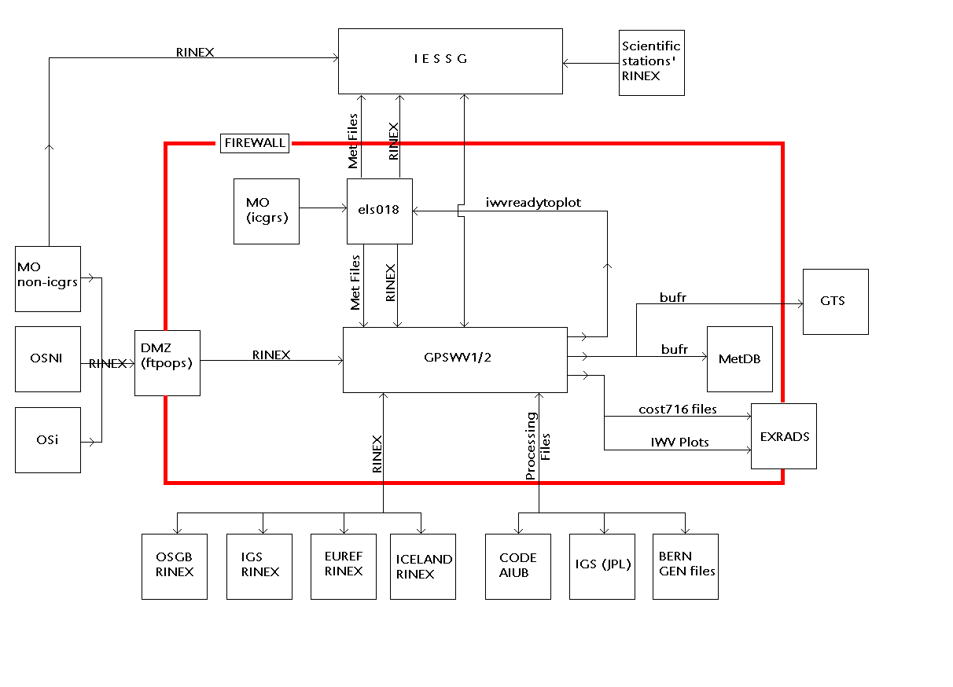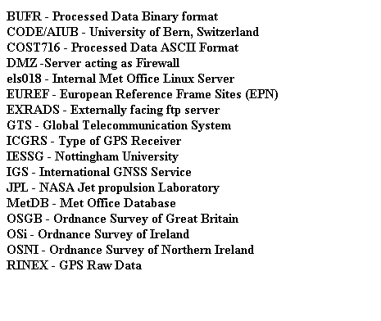
Figure 4 GPS processing data flow

NWP Monitoring
As the customer for the data, the Satellite Applications Team at the UK Met Office has their own independent monitoring tools in place to quality check the processed data (vs. NWP data) and for data flow monitoring. Figures 5 to 7 are examples of plots containing information on ZTD bias produced by the Satellite Applications team.

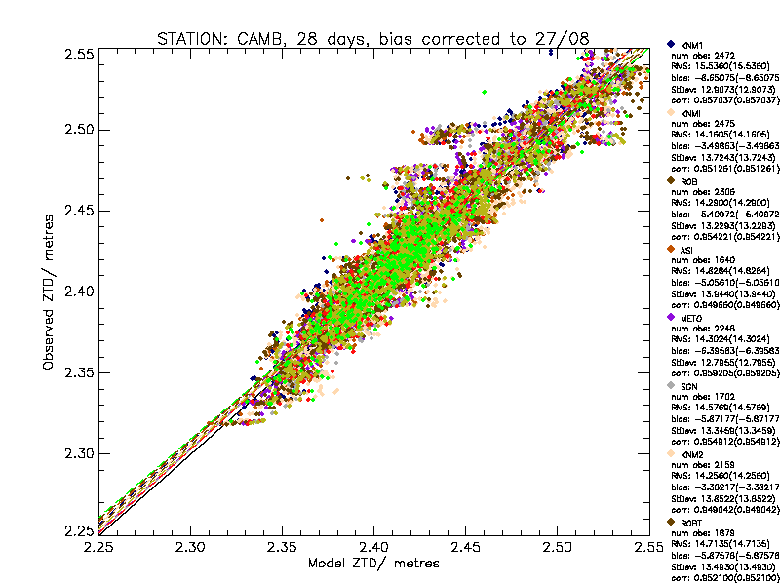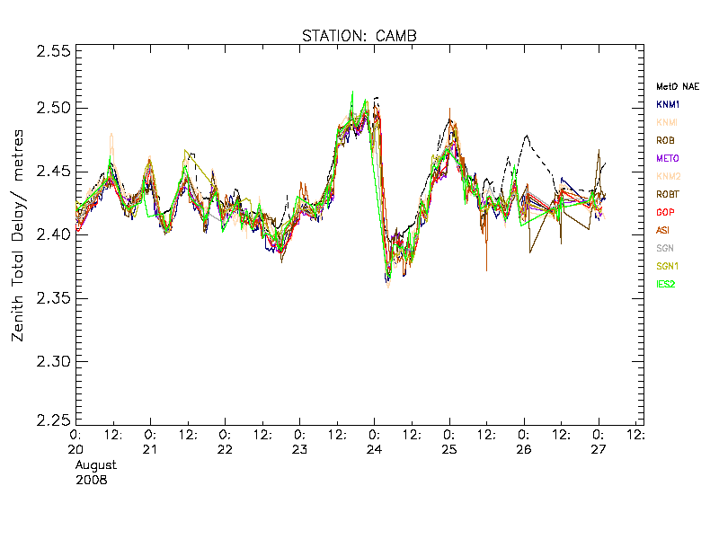
Figure 5 Scatter plot of ZTD from the different Figure 6 Time series of ZTD from the different
GPS processing centres vs. MetO NAE ZTD GPS processing centres vs. MetO NAE ZTD

With such monitoring as illustrated in figures 5 and 6 it is very simple for NWP to set alarms based on ZTD diverging by a set amount from the NWP model to flag up either spurious data (not to include for assimilation) or to monitor examples of when the NWP models do not forecast the ZTD very accurately. When GPSWV1 and 2 were installed initially it was noted from such data analysis that the quality of the processed ZTD data was too poor for assimilation. From this feedback the problem was traced back to the relative constraints used in the GPS processing being too loose. Subsequently the relative constraints were tightened, the quality improved accordingly and the data was then suitable for operational assimilation.

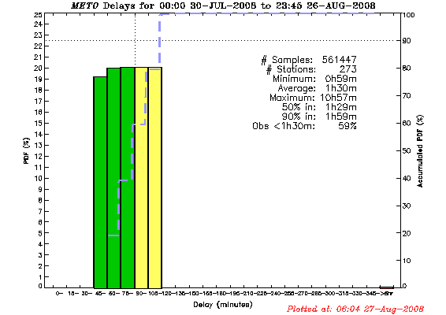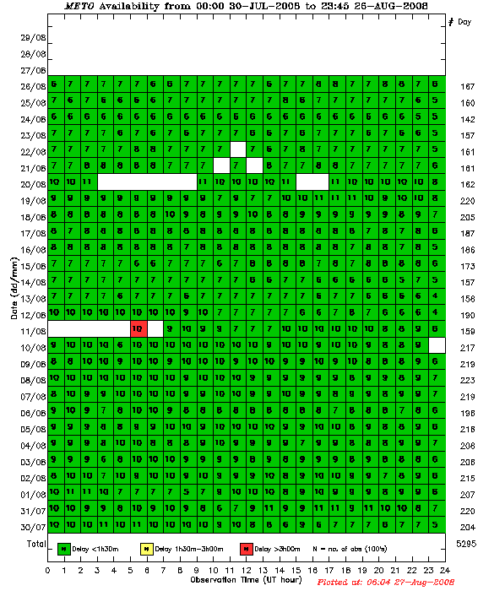
Figure 7 Timeliness of processed data delivery to NWP Figure 8 Processed data availability

NWP also monitor the delay between time of observation and time of ingestion of data into NWP as well as processed data availability. These are an indirect measure of processing reliability and are useful tools to monitor system performance and reliability, examples are shown in figures 7 and 8.

Monitoring through the E-GVAP Project
E-GVAP is the EUMETNET (European Meteorological Network) GPS Water Vapour Programme and is set up to provide European GPS delay and water vapour measurements to its European partners for use in operational meteorology. E-GVAP carries out routine independent monitoring of data quality and quantity (data flow). Figure 9 is a plot of all the sites in Europe which have contributed processed GPS data within the previous 2 days, the colour coding relates to data availability with green being current data is being received ranging to black showing no data has been received in the last 48 hours. Figure 10 is another example plot showing Met Office ZTD bias versus the European High Resolution Local Area Model (HIRLAM). From this it is possible to identify if any processing centres or any individual stations have a bias in their processed ZTD.

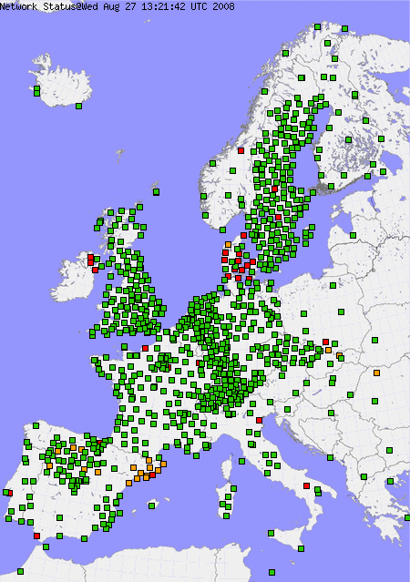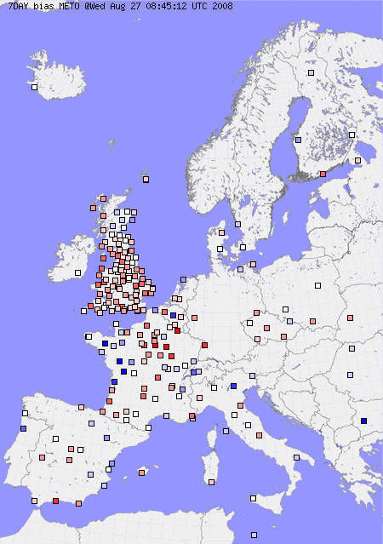
Figure 9 Processed data delivery 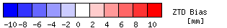
Figure 10 Individual station ZTD bias
for MetO vs. HIRLAM NWP model

The E-GVAP project also produces time series statistics for all GPS sites and processing centres against the HIRLAM model, similar to that performed by the Met Office NWP team (Figure 5). Also plotted where available is water vapour calculated from radiosonde ascents for comparison. Time series such as these are extremely valuable to the processing centre for validation purposes as both individual site and processing centre problems can be easily identified and the information passed onto the data provider. Further details on the E-GVAP project can be found at http://egvap.dmi.dk/.

Offline Monitoring and Validation Studies
In addition to near real-time monitoring systems highlighted above there is still a requirement for validation of GPSWV against other remote sensing instruments capable of measuring water vapour, namely radiosondes and microwave radiometers. Radiosondes are used globally for providing retrievals of atmospheric profiles and humidity measurements. Humidity measurements can be converted into a column total measurement of water vapour, known as Total Water Equivalent (TWE) which is equal to GPS water vapour column total, both measured in kg/m².

Between 2001 and present routine comparisons between radiosonde TWE and GPS IWV have been carried out using data from operational radiosonde ascents in the UK. In the UK there are 4 suitable collocated sites for such comparisons, namely Lerwick on Shetland, Watnall near Nottingham, Herstomonceux in Kent and Camborne in Cornwall. From the comparisons between 2001 and 2006 (based on over 10,000 observations) it can be shown that a bias of approx 1.2 kg/m² of water vapour exists (Stdev. of 1.4 kg/m²) with radiosondes measuring consistently lower than GPS but with the bias more pronounced in the daytime. The daytime increase in bias results from solar radiation heating up the radiosonde humidity sensor, so the sensor reports a relative humidity that corresponds to a temperature higher than that reported by the radiosonde, {Guide to Meteorological Instruments and Methods of Observation, WMO-No.8).

Figure 12 shows IWV difference (radiosonde – GPS) plotted as a function of solar elevation. The bias increases with increasing solar elevation, as might be expected if the negative bias in the radiosonde increases with solar elevation. However, if the day and night biases are considered as a function of the IWV being measured, Figure 13, the biases at night are not independent of the magnitude of the IWV. This means that the differences between the two systems were smaller when it was very dry than when humidity was high. A contribution to this would be the errors introduced by chemical contamination of the Vaisala RS80 radiosonde [errors of -2 to -3 per cent relative humidity in the radiosondes] as used at Camborne, which are not present in subsequent years with the introduction of the Vaisala RS92 radiosonde in 2005.

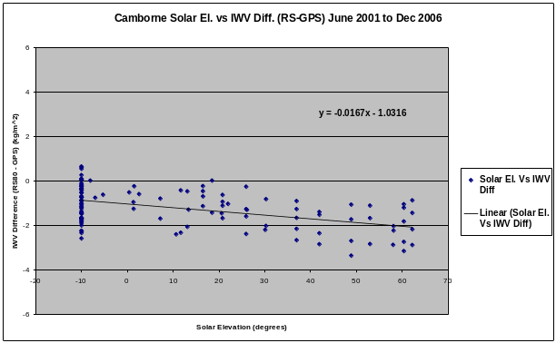
Figure 12 Solar Elevation vs. Radiosonde-GPS IWV Difference, Camborne UK 2001-2006

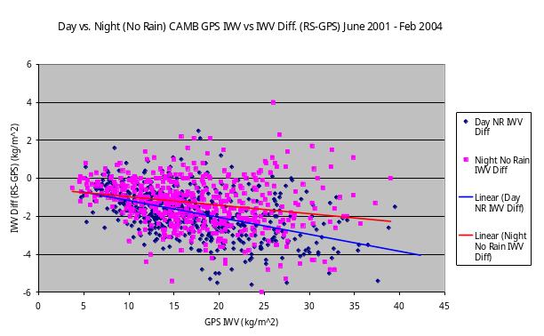
Figure 13 Illustration of the day/night bias differences at Camborne during periods of no rain from 2001 to 2004

Until late 2006 the bias between radiosondes and GPSWV was largely accepted (as above), however, since the introduction of new GPS processing models and standards in late 2006, the bias appears to have been reversed. Since the introduction of the new models radiosondes appear to have a dry bias with respect to GPS in the order of –0.63 kg/m2 for June 2006 compared to a wet bias of 0.35 for June 2007, Figure 14. NB) Vaisala RS92 radiosondes were in use at both times with no design alterations of the RS92 radiosondes used. The implications are that either the previously established magnitude of the error in solar heating of the humidity sensor has changed or it is an artefact of new models applied to GPS processing. This is a relatively new observation and further study needs to be carried out to validate this apparent bias reversal.

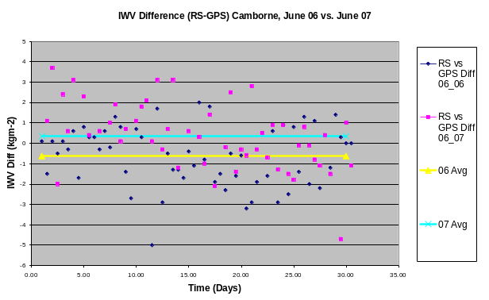
Figure 14 Bias differences between RS and GPS for June 2006 vs. June 2007

Integrated Observing and Case Studies
GPSWV as a stand-alone instrument is only of certain value to forecasters and NWP in terms of humidity information. However, when combined with other remote sensing instruments it is possible to gain a far greater understanding of atmospheric processes as well as of course validating the GPSWV measurement.

Within the UK the Met Office has established the FUND (Future Upper air Network Design) project which is designed to provide optimum options for a future integrated upper-air observing network in the UK by 2012. Over the next year a series of test-bed experiments will be established around the South East UK to assess the most effective combination of instruments to provide the maximum amount of information possible for future high resolution NWP. Even though much work has already been completed on the validation of GPSWV, biases between instruments do remain. Figure 15 is a recent time series of water vapour taken from GPS, a Radiometrics TP/WVP-3000 microwave radiometer as well as against 2 Radiometer Physics RPG-HATPRO microwave radiometers. It can be seen that biases exist between all 4 instruments and this is a source for study in the future. Similar work is being carried out by the E-GVAP project also in terms of the validation of instruments.

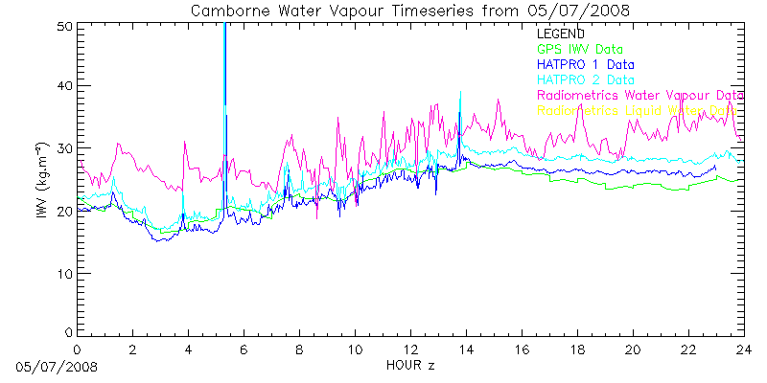
Figure 15 Water Vapour time series, GPS vs. microwave radiometers at Camborne, UK, July 2008.

On a European scale the COST EG-CLIMET project has been established to specify, develop and demonstrate cost-effective ground-based integrated profiling systems suitable for future networks providing essential atmospheric observations for both climate and weather. GPSWV is an integral part of any future upper air observing network and only from projects such as FUND and EG-CLIMET will the full value of near real-time humidity measurements be fully realised by integration with other remote sensing instruments.

Case Study Work
Atmospheric case studies are essential to improving the understanding of atmospheric processes. The case study below is an example of work carried out by the Met Office Upper Air Development team, (Gaffard et al - publication pending). The main phase of CSIP ran during the summer 2005 with the primary goal of improving the understanding of the mechanisms responsible for convection initiation over southern England.

June 24th 2005 Case Study
Between 12:00 and 18:00 UTC on 24 June 2005 an upper-air trough moved across the central and southern UK with associated thunderstorms and heavy rainfall which led to flash-flooding and the potential risk to life. The synoptic situation is illustrated in Figure 16 and the GPSWV map is shown in Figure 17.

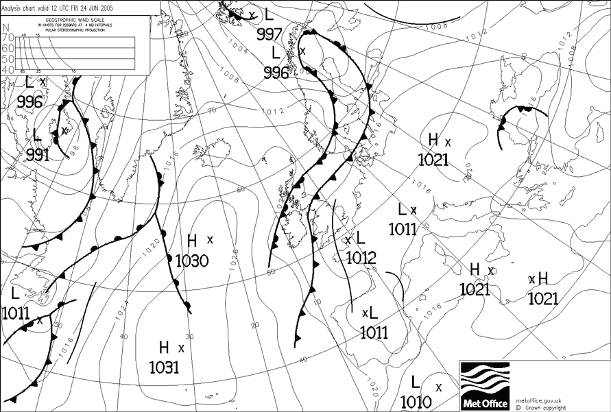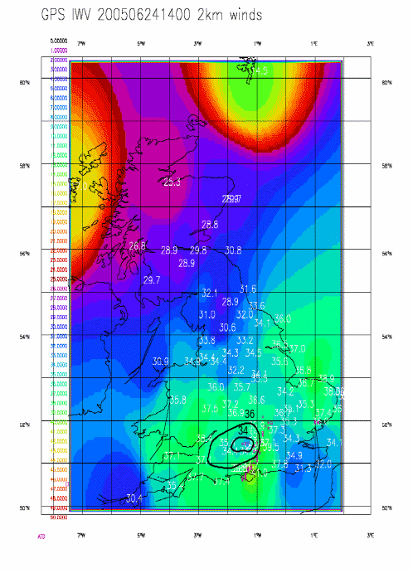
Figure 16 Synoptic chart for 12:00 UTC, 24th June 2005, Figure 17 GPSWV, 14:00UTC, 24/06/05,
taken from Met Office North Atlantic Area (NAE) model. taken from Met Office GPS system

By 14:00 the convective cells had passed over the CSIP area, as shown by the rain rate measured by the UK weather radar network shown in Figure 18. At this time the GPSWV shows a small, relatively low IWV (~34 kg/m² compared with ~39 kg/m²) trailing to the west of the main area of convection, as highlighted in Figure 17. This drier/colder area behind the leading convection may be attributed to down welling, colder air descending from the convective cells due to drag and evaporation of precipitation. In the case of a relatively fast moving storm such as this example, with the winds near the surface in quite a different direction to those driving the position of the storms at 4 km down-welling was allowed to spread out at the surface. Hopefully in the future improved timeliness of GPSWV maps will allow the forecasters to view such features in the very near real-time and thus improve the forecasts accordingly.

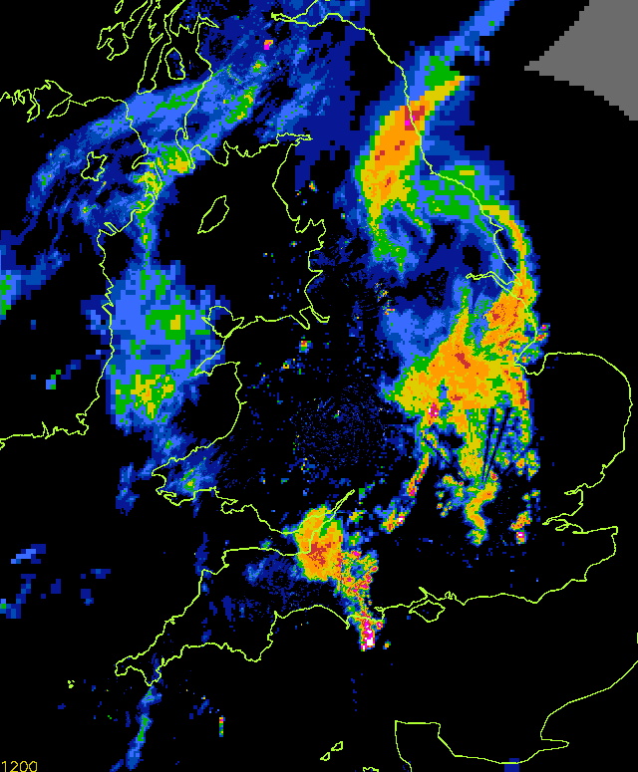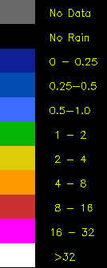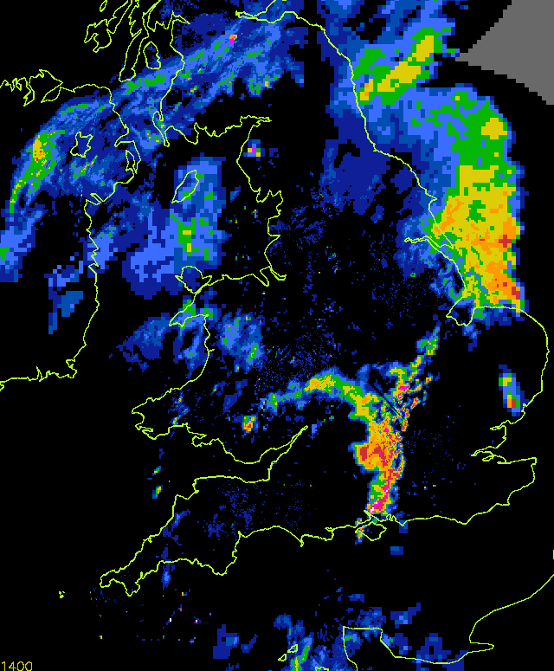
Figure 18 Weather radar returns for 12:00UTC and 14:00 UTC, June 24th 2005.
Taken from Met Office RADARNET, weather radar network

Summary and Conclusions
The UK Met Office has been researching and developing a near real-time GPSWV system since 1998 and in 2007 the system gained full operational acceptance and subsequent assimilation into numerical weather prediction models. Only in the UK and France at this point is GPSWV data used operationally and this reflects the amount of time each country has spent on data processing and validation as well as on NWP assimilation trials. GPS infrastructure is developing in all European countries and this represents an opportunity for National Met Services to gain a very effective and relatively cheap data source with very limited outlay. The most cost effective solution, as demonstrated in the UK is by utilising the expertise of academic institutions to research the optimum processing strategy whilst at the same time agreeing partnerships with data providers. The agreement between EUMETNET and EUREF provides a backbone for future Europe-wide GPS processing guaranteeing long term data access. This should give European national met services the confidence to invest in GPSWV as a cost effective observing system for the future.

References
Bevis M., Businger S., Herring T.A., Rocken C., Anthes R.A., Ware R.H., (1992) Journal of Geophysical Research, Volume 97, Issue D14, p. 15787-15801

de Haan S., (2002), COST716 Derivation Routines. COST 716 Working Group 3 internal report

Gaffard C., Nash J., Walker E., Hewison T. J., Jones J., Norton E. G., High time resolution boundary layer measurements using combined instruments. Ann. Geophysics [to be published]

J.Nash, C.Gaffard, T.Hewison, E.Norton, J.Agnew, E.Walker, J.Jones, M.Smees, M.Ramatschi, G.Dick, 2006: Humidity Evaluation using GPS, Radiometer, Wind Profiler and UV Lidar During CSIP Associated with Thunderstorms, Proceedings of COST720 Final Symposium, MeteoFrance, Toulouse, May 2006

Orliac E. J., Bingley R. M., Dodson A. H., (2003), An Assessment of Near Real-Time and Post-Processing Strategies for Tropospheric Delay Estimation from a Planned CGPS Network in the UK. Institute of Engineering, Surveying and Space Geodesy, Nottingham University internal report

Saastamoinen J. (1973), Contributions to the Theory of Atmospheric Refraction, In three parts, Bulletin Geodesique, 105, 279-298; 106, 383-397; 107, 13-14.

