Improved methods for monitoring the accuracy of temperature measurements at remote meteorological sites
David Moore

Met Office, Fitzroy Rd, Exeter, EX1 3PB
+44 (0) 1392 885805 (Tel), +44 (0) 870 9005050 (Fax)., david.moore@metoffice.gov.uk

1 Abstract

Existing techniques for monitoring the accuracy of Stevenson Screen dry bulb temperatures in our observing network require regular comparisons against inspectors mercury in glass thermometers. With these methods we are only able to identify errors ≥ 0.2˚C, but using a Tinytag Plus 2 temperature (Tinytag) logger, most errors were found to be less than this.
A Calserv, portable ice bath has been purchased which provides a stable water, ice cube temperature of 0.00˚C ± 0.01˚C and is small enough to fit inside the screen. In conjunction with a Vaisala HMP155 temperature and humidity measuring instrument, we are able to monitor the ice point of our dry bulb plus another temperature, which adds to the robustness of our quality control process.
A small Tinytag logger which we can post to various sites has also enabled us to measure the temperature of our screen dry bulb temperatures to an uncertainty of 0.05˚C, for a period of several weeks, over a range of temperatures. The mercury in glass comparisons are only made at a spot value, hence they may well miss errors at other temperatures.

2 Introduction

Accurate temperature measurements within Stevenson screens are particularly important for climatological purposes. The highest accuracy required for climatological temperature measurements within the screen is 0.1˚C. In order to achieve this, the UK Met office has various procedures in place to monitor performance.
These comprise:-

- The use of an inspector’s thermometer, immersing it and the dry bulb platinum resistance thermometer (PRT) in a flask of water and comparing the temperatures.
- Daily checks made at 09 GMT between the PRT and the mercury thermometer if they are still used at manned sites.

Identified issues with these techniques are:-

Method 1 only requires checks being made at a spot temperature so if errors are temperature dependant they may not be found.

Method 2 requires that the mercury thermometer calibration correction card needs to be used. Care must be taken as there is often a temperature rise at this time of day and this can introduce a systematic offset in the results. There is also the difficulty of reading the thermometer accurately and the possible limitation of the PRT temperature only being displayed to a resolution of one decimal place. For these reasons temperature differences are flagged for action to be taken, only if they are >0.2˚C.

Method 2 should find temperature dependent errors but in both methods 1 and 2 only if they are >0.2˚C.

Tinytag loggers have been used to investigate temperature errors at a number of our sites and they found that errors were <0.2˚C. They could also be temperature dependant depending upon the site in question. The implication is that if they are to be spotted, improved techniques are required.

3 New Technique 1 - Calserv portable ice point calibration bath

A Calserv Icero 0˚C Ice Point Bath has been bought and tested in our quality assurance laboratory. It is a simple but effective device manufactured by Calserv Calibration Services in a UK accredited calibration laboratory.

It consists of a metal thermos flask fitted with a hollow copper tube. One end is immersed inside the flask with a filter at the bottom. The other end is outside the flask attached to the outlet of a small air pump. The flask sits inside a plastic beaker seated in a small casing that houses the pump. The whole unit is housed in a robust carrying case which weighs a few kilograms.

The field portable unit is powered by a 12v gel type lead acid 6AH battery and current consumption is low. It settles to the ice point in approximately 15 minutes. It has a rubber bung with 4 holes which is suitable for inserting a temperature probe, a mercury thermometer and 2 PRT’s. (A mains powered unit is also available which has a reduced air flow rate, therefore the water ice mixture should last longer). These units are not suitable for calibrating multiple mercury thermometers simultaneously without the bung, since temperature errors could be introduced.

The manufacturers claim the unit can maintain 0.0˚C ± 0.01˚C for several hours using distilled water, making it suitable for checking the calibration of PRT’s and mercury thermometers if required.

Units have been tested in our quality assurance laboratory at air temperatures of 10˚C, 20˚C, and
30˚C. The water ice mixture continued to maintain the ice point within 0.01˚C according to the following table:-

Air temperature (˚C) Water, ice mixture useable lifetime (mins)
10 >1200
20 550
30 130

The reference PRT was longer than the ice bath so some heat conducted down the stem. Even so, at an air temperature of 20˚C the mean temperature of the bath was measured to be 0.014˚C with a standard deviation (over the first hour of measurements) of 0.0015˚C. It is most likely that if the PRT completely fitted inside the ice bath then the mean temperature would be much closer to the ice point. The use of soft tap water did not change the accuracy of results within the limits of experimental error.

A detailed product description is available at:-

http://www.calserv.co.uk/icero.htm

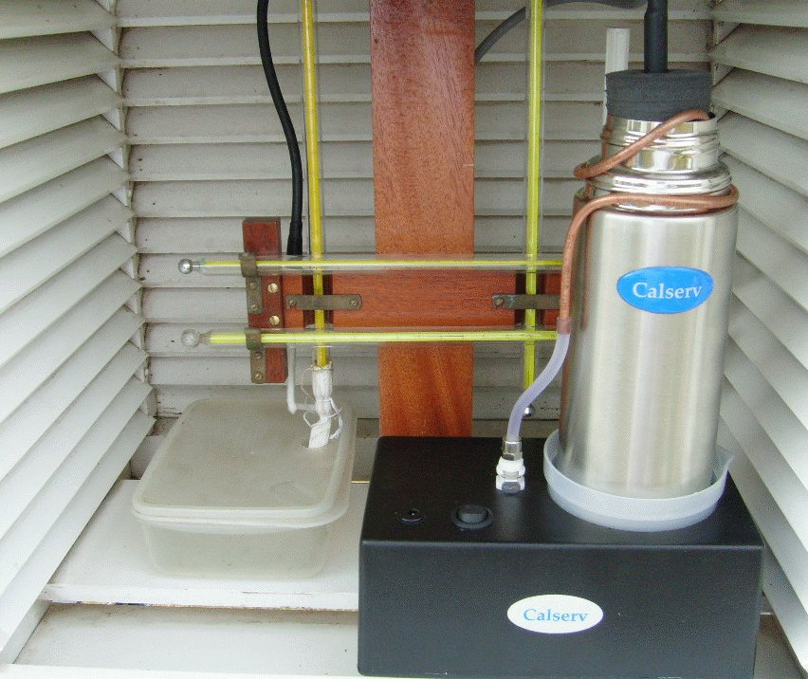

The flask should be filled with approximately 600ml of water and ice cubes, so that the ice is approximately 50mm below the top of the flask.
The flask fits inside a Stevenson Screen and has been used to evaluate the accuracy of the dry bulb PRT. It required the slight boring out of one of the holes in the rubber bung that fits as a stopper to the flask.

Testing was also carried out on a Vaisala HMP155 heated humidity instrument with separate temperature probe. It measured the ice point as +0.01˚C. The HMP155 has a resolution of 0.01˚C, making temperature checking much simpler than with a 1 decimal place instrument.

Two of these units were calibrated and the proposal is to use them and the Calserv in the field to conduct regular checks of Stevenson screen dry bulbs temperatures, at the ice point and at ambient temperature. Other instruments are available on the market but the separate temperature probe makes calibration and insertion in the ice bath a simple process. The inclusion of a humidity probe means that relative humidity checks may also be conducted.

4 New technique 2 - Tinytag Plus 2 Temperature Logger

One of the problems of temperature checking at field sites is that usually only a spot reading is taken. In an attempt to overcome this limitation a number of small temperature data loggers were tested. These are manufactured by Gemini Data Loggers. They are approximately 6cm*5cm*3cm in size and fitted with an external thermistor temperature probe. They are fitted with their own internal battery and are waterproof.

A link to Gemini Data Loggers is http://www.tinytag.info/products/Product_type.asp?0,0,1,0,0

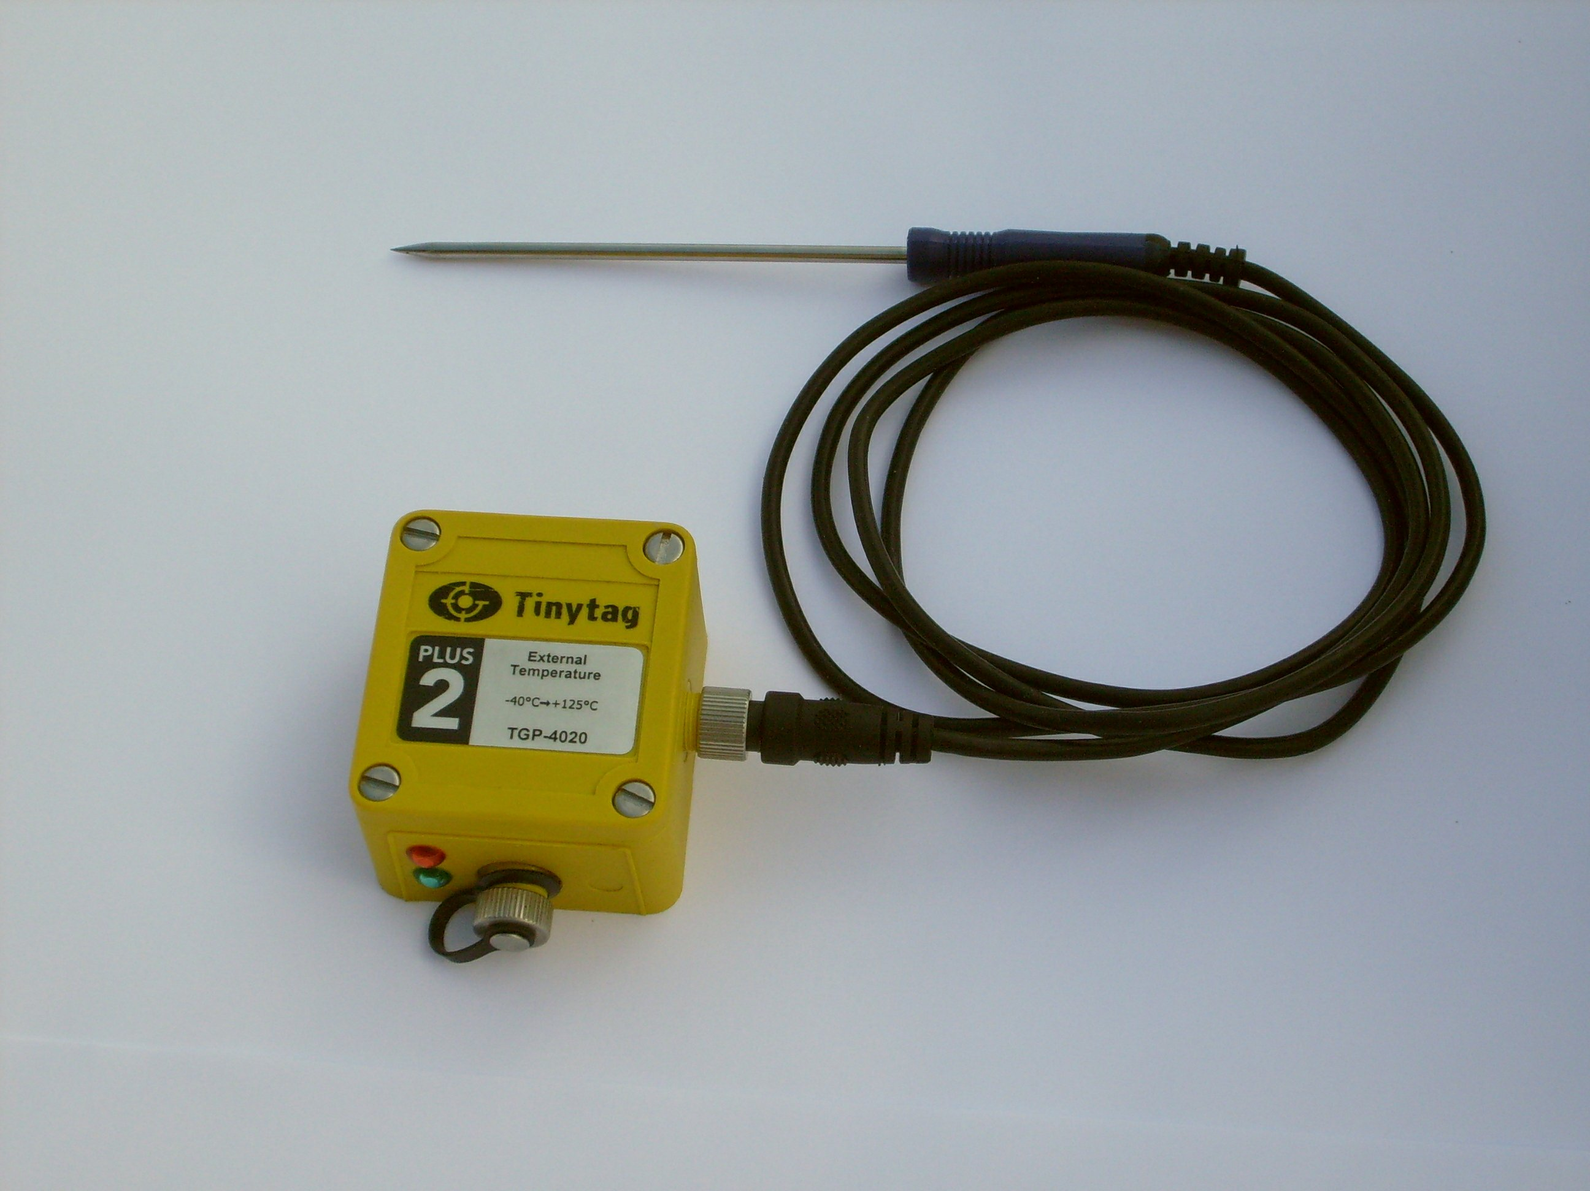

Loggers were installed in the Stevenson screens at a number of our sensor sites, as part of the testing process for the new Meteorological Monitoring System (MMS).

5 Calibration and Deployment Procedures

The loggers can be set to start recording at a particular time or after a defined time lapse. They can be set to log in degrees Fahrenheit which increases their resolution to 0.56˚C. The logging period can be selected but was set to 1 minute intervals to match that of our MMS system. They will log for 23 days in this mode before stopping as the memory is filled up.

These units have been calibrated several times over a number of years in our quality assurance laboratory. This has been done at various temperatures and we have produced first order polynomial calibrations for each logger. The maximum drift observed between one calibration and the next was 0.04˚C at any temperature but it is usually much less, so temperature errors less than 0.1˚C could be detected with confidence.

In addition, the thermistor probe was replaced with a precision resistor and left logging inside a screen when the diurnal change of temperature was 25˚C. No change in output was observed, indicating that the stability was less than an equivalent of 0.0016˚C, which appears to be the resolution limit of the logger. We deduced this by looking at the smallest temperature change observed in real data. The manufacturers claim the resolution to be <0.02˚C.

6 Results

Some time ago the logger was sent to Aberporth, which at the time was a Semi Automatic Meteorological Observing System (SAMOS) site. The probe was attached to the dry bulb with a slight gap and left logging for a few weeks at 1 minute intervals. Fig 1 shows the results. There is good agreement between the logger and the screen dry bulb over a 10˚C temperature range. However, a slight variation with temperature can be seen. The sudden increase in temperature differences between 12˚C and 14˚C was due to driving rain affecting both the dry bulb and the logger probe, causing them to alternatively behave like wet bulbs to some extent.

This demonstrates that the Tinytag technique can be used to quickly gather accurate temperature comparison data in a cost effective method. Further, by collecting for a number of days it is possible to gather comparisons at a range of temperatures and importantly during periods when the air temperature is not changing rapidly. This makes a considerable improvement to the limitations described in the introduction. There is the added advantage that it can be posted to a site for a caretaker to install and then it can be posted back after the logging period has ended.

Fig 1 Aberporth – Temperature Comparison

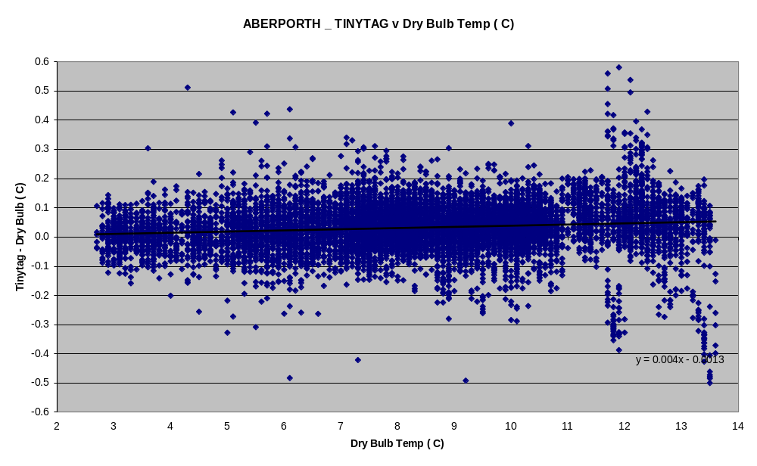

7 Conclusions

1 A Calserv Icero portable ice bath has enabled us to reproduce the ice point inside a Stevenson screen and thereby detect temperature errors in dry bulbs of <0.1˚C with confidence. Temperature errors should also be detectable with the use of a calibrated temperature measuring instrument at temperatures other than the ice point.

2 With the deployment of a small Tinytag temperature logger we have been able to monitor Stevenson screen temperatures over several weeks and thereby confirm dry bulb performance and detect temperature and temperature dependent errors <0.1˚C.

