Comparison of the measurements of wind And TEMPERATURE PROFILES by means of commercially available SODAR and the ALTITUDinal meteorological mast in Obninsk
Novitsky M.A., Mazurin N.F., Kulizhnikova L.K., Kalinicheva O.Y., Tereb L.A.,
Nechaev D.R., Safronov V.L.
State Institution "Research and Production Association "Typhoon", Obninsk

ABSTRACT

The altitudinal meteorological mast with a height of 310 m in Obninsk is often used for testing of various remote devices for meteorological measurements. Test measurements of SCINTEC MFAS sodar and the anemometers placed on the mast started in April 2008. In April 2009 sodar was added by RASS system of radio acoustic sounding of atmosphere. The purpose of the experiment is to study the features of the instrument for production recommendation on its use for various practical purposes.
The analysis of the measurements data shows that good coincidence of winds speed and directions exists under neutral stratification of atmosphere and growth wind speed with height to 18-20 m/s. For these data correlations factor for winds speed measurements by acoustic anemometers and sodar is 0,94, correlations factor between wind directions - 0,99. Simultaneously, the group of the events was chosen with low height of the sodar measurements: much below 300 m. All of these existed in evening, night and morning time. As a rule, that are cases of temperature inversion. Thus, the more intensive the inversion, the lower is sounding height. Poor coincidence of the wind speed and directions profiles is also noted when the wind speed is small on height of 8 m and in condition of the intensive precipitation. From analysis of the daily statistics of the comparisons the mast and RASS temperature profiles it is seen that the most significant differences exist at night (radiant cooling ground, inversions of the temperature). The least divergences are in the afternoon when smooth change of temperature is restored in a surface layer of atmosphere.

INTRODUCTION

The altitudinal meteorological mast (AMM) in Obninsk, besides its usual appointment – experimental researches of temperature-wind mode of the atmosphere boundary layer – is even more used for testing of various remote devices for meteorological supervision [4]. At the same time, remote devices which do not demand using of expensive altitudinal masts for carrying out measurements in atmospheric boundary layer, has become more applicable in the last years. The most proven remote-sensing instruments of atmosphere are acoustic locators named sodars. Many foreign companies produce such equipment in lots. It is known to be used for risk areas monitoring or air quality forecast in cities. At the same time the methodology of definition of metrological characteristics of such devices is not determined, also there are no conventional reference methods of their checking and calibration. As sodar measure wind speed and direction in a considerable range of the heights inaccessible to usual measuring instruments, the technique of their calibration and testing should differ from that which is used for commonly used anemometers. By preparation of the specified techniques, except self-testing of some technical characteristics by sodar software, comparisons of sodar data with data of radiosondes or with cylinders of neutral buoyancy can be used. All the above listed ways cannot provide full and reliable sodar checking and calibration. The most effective way for this purpose is verification of the measurements of such devices with anemometers data (mechanical or acoustic), placed on masts or towers.
SI "RPA"Typhoon” has a unique research measuring complex on the basis of the altitudinal meteorological mast of 310 metres height and has possibility to find out real characteristics of various remote methods of measurements. The purpose of the present work is a research of characteristics of one of commercially available sodars with radio acoustic sounding extension and possibility of its use for deciding of various scientific and applied problems. The advantage of the given work, as compared to ones published before, is widened range of heights, thanks to AMM height of 310 m, and the long-term and practically continuous testing during various weather conditions.
SODAR SPECIFICATION

In March 2008 MFAS sodar produced by "Scintec" (Germany) [2] started to be used on the site of SI "RPA "Typhoon” altitudinal meteorological mast. The sodar aerial is a type of the flat phased lattice with 64 ceramic piezo-electric transducers. The aerial can be completed with several types of acoustic protection; for carrying out the present work the small standard protection was used. In April 2008 the sodar was established on a roof of the building of 30 m height at a distance about 600 m from AMM. Such a distance is necessary to exclude possible influence of the mast reflexion on sodar measurement results.
In April, 2009 sodar was added with RASS extention for radio acoustic sounding of the atmosphere. The general view of the system is presented on fig. 1.
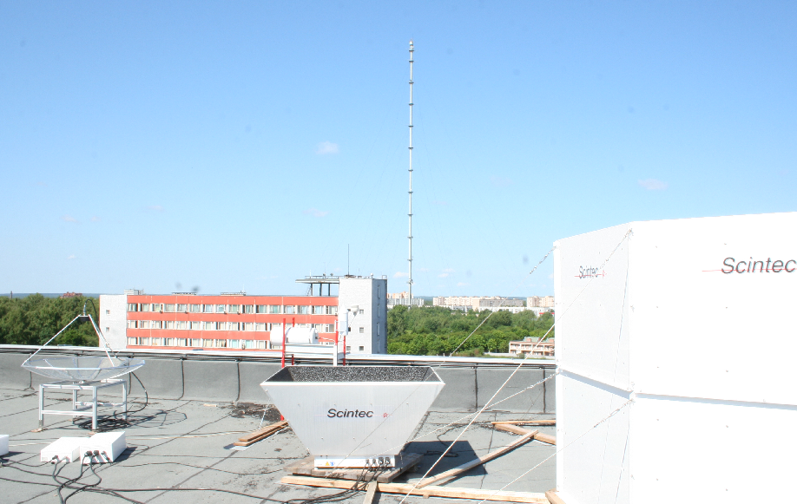

Fig.1 "Scintec" acoustic radar with RASS extension
Main technical features of the sodar according to the manufacturer information are shown in table1.

Table 1. Main technical features of "Scintec" sodar

Name of the parameter | Value
Frequency range | 1650 - 2750 Hz
Maximum Number of frequencies per sequence | 10
Maximum Number of frequencies per cycle | 100
Acoustic output power | 7,5 W
Emission/Reception angles | 0°, ±22°, ±29°
Vertical resolution | 10 m
Range | 500 - 1000 m
Shortest averaging time | Single pulse/sequence
Longest averaging time | 180 min
Accuracy of horizontal wind speed | 0,1 - 0,3 m/s
Range of horizontal wind speed | ± 50 m/s
Accuracy of vertical wind speed | 0,03 - 0,1 m/s
Range of vertical wind speed | ± 10 m/s
Accuracy of wind direction | 2° - 3°

RASS extension

Name of the parameter | Value
Frequency | 1290 МHz
Vertical resolution | 10 m
Altitude range sounding | 40 - 800 m
Averaging time | 1 – 60 min
Accuracy | 0,2 °С
Measurement range | от -50 °С to +60°С
Operating temperature | от -35 °С to +50°С

Sodar allows us to measure directly high altitude profiles of the basic values for the certain average period of time:
- the module of wind speed and direction for horizontal wind;
- vertical wind speed and its dispersion;
- wind vector longitudinal and cross-section components and their dispersions;
– profiles of reflective ability of atmosphere, etc.

THE TECHNIQUE OF COMPARISON OF SODAR AND AMM RESULTS
AND THE ARRAY OF MEASUREMENTS

Sounding is carried out 8 times a day every 3 h of 30 min long - three cycles of measurement with 10-minutes averaging each. The AMM measuring complex works continuously with step-type behaviour t = 1 s. For comparison, the data of М-47 wind vanes located at five levels of AMM (25, 73, 121, 217 and 301m) [1], and Wind Observer (WO) acoustic anemometres by Gill company [3] (121, 265 and 301m) are used. The mechanical sensors are placed on the yards of 6 m in length in northern and southern directions of AMM, and acoustic anemometers - on yards of the western direction. Mechanical sensors accuracy is (0,5 + 0,05V) m/s for speed measurement, where V – wind speed, and 2-3° for direction measurements. For acoustic anemometers, accordingly, accuracy is 0,02V m/s and ± 2°. For comparison purposes the sodar data was taken at the same levels. Estimating of condition of the atmospheric layer stability were carried out according to measurement of temperature profiles on AMM. For comparison in the present work measurements data from July till November 2008 were chosen (in winter it was difficult to arrange long series of observations on AMM because of icing of the sensors).

COMPARISON RESULTS OF SODAR AND AMM MEASUREMENTS

On fig. 2 the time course of wind speed and direction at the height of 120 m is shown as an example of comparison of continuous measurements for October 1st -10th, 2008. For that data, correlation factor for wind speeds measured by acoustic anemometer and by sodar is 0.94, correlation factor for wind directions – 0.99. The analysis of the measurements shows, that good coincidence of wind speed and direction is observed at neutral stratification of atmosphere and smooth increase of wind speed with height to 18-20 m/s. The typical example for the given case is resulted on fig. 3a and 3b. Wind speed was 15-17 m/s at the height of 300 m. Wind turn with the height is quite large (approximately 50°).
The group of cases with low height of sodar sounding (much below 300 m) was noticed . All of them were observed in evening (after 18 h), night and morning time (before 10 h). As a rule, these are cases of temperature inversion with its low border (fig. 3c and 3d), so-called ground inversions (more often from 25 to 120 m). Thus, the more intensive is inversion (the maximum intensity is 7°С in the layer of 2-120 m), the lower is sounding height. It points that on inversion border the big gradient of temperature causing reflection of acoustic signals takes place. Above inversion the wind stream is characterised by laminar movement with no whirlwinds, with temperature heterogeneity from which echo-signals should be reflected.
The case of unstable convection conditions is presented on fig. 3e and 3f. These conditions are characterised by the big gradients of wind speed in the layer to 70-100 m. So, in the layer from 8 to 73 m the wind increased by 3 m/s, and in the layer from 73 to 300 m only on 1 m/s. Turn of a wind with height to 500 m is practically absent. The sounding height in convection conditions changes within 300-500 m.
Fig. 2. A time course of speed (a) and wind directions (b) at the height of 120 metres

Time
Time
Time
Time
Fi,degree
V, m/s
b)
- Sodar, - an acoustic anemometer

Poor coincidence of speed and wind direction profiles is marked at the height of 8 m and low wind speed (<1 m/s). The example of such a situation is resulted on fig. 3g and 3i. In some cases wind speed was small in all 300 m layer. It was not marked low overcast, clouds were of the bottom and average circle with height of the bottom border not below 700 m. There was no precipitation in these cases also.
As an example, results of comparison measurements of wind speed and direction by sodar and AMM sensors at the height of 300 m are shown on fig. 4.
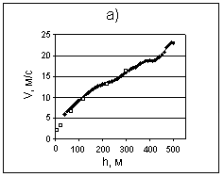  Fi,degree  V, m/s  Fi,degree  Fi,degree  Fi,degree  V, m/s  V, m/s  V, m/s  h,m  h,m  h,m  h,m  h,m  h,m  h,m  b)  a)  d)  c)  e)  i)  f)  g)  h,m | 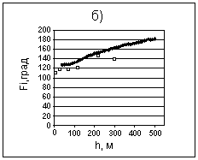
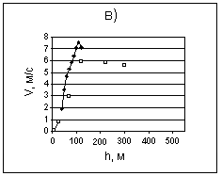 | 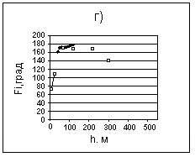
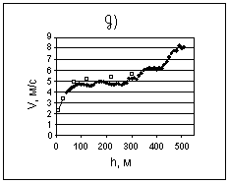 | 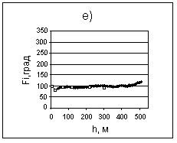
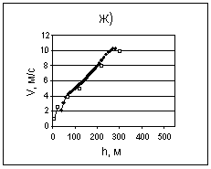 | 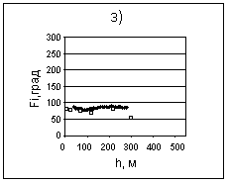
Designations:
- Measurements by sodar
- Measurements on AMM
V - wind speed, Fi - wind direction

Fig. 3. Vertical profiles of wind speed and direction

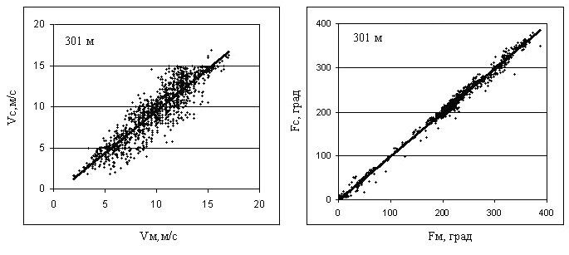
Fm, degree
Vm, m/s
Vs, m/s
Fs,degree

Fig. 4. Comparison of wind speed and direction measured by sodar and AMM anemometers at the height of 301 meter

Note, that as data of wind parameters on acoustic and mechanical sensors of the high-rise mast at one height are close among themselves, they are united in one general file. The continuous line in the drawings represents the equation of linear regress for the data. For other considered heights the results of comparison look similarly.
In tab. 2 the quantity of pairs of compared values at each height and correlation factors for wind speed (R_{V}) and direction (R_{N}), measured by sodar and anemometers is resulted.
Tab. 2 shows, that correlation for wind directions is higher, than for wind speeds, and it is practically identical on height. The inclination of regression line is close to 1.

Table 2. Correlation factors for wind speed and direction,
measured by sodar and AMM anemometers

Height, m | Number of cases | R_{V} | R_{φ}
301 | 1288 | 0,904 | 0,996
217 | 1291 | 0,962 | 0,995
121 | 1746 | 0,940 | 0,998
73 | 1324 | 0,821 | 0,996

Table 3. Correlation factors for wind speed and direction measured by sodar and anemometers at different stability of atmosphere at the height of 121 m

Stratification | Number of cases | R_{V} | R_{φ}
Unstable | 77 | 0,849 | 0,994
Neutral | 535 | 0,929 | 0,999
Steady | 746 | 0,957 | 0,998

In tab. 3 factors of correlation of wind speed and direction according to sodar and mast sensors at the height of 121 m are resulted at unstable, neutral and steady stratification of the 300-metre layer of atmosphere. Factors of correlation for wind speed increase with increase in stability of atmosphere. For wind direction, correlation factors are large at all types of stratification. At other heights dependence on stratification is similar.
On fig. 5 dependence of differences of wind speeds (a) and wind directions (b) according to sodar and AMM sensors depending on wind speed on AMM, for the height of 121 m is shown. It is clear, that the less wind speed is, the more is a range of direction differences. The similar kind of dependence is observed at the other heights. At the height of 73 m and wind speeds lower then 5 m/s, direction deviation of the wind measured by sodar and AMM sensors reaches to ± 50°.
In tab. 4 and 5 average values of deviations Δ_{S-W} are shown for wind speed measured by acoustic anemometer (V _{WO}) from the wind speed measured by sodar (V _{Scinteс}) depending on a range of wind speed
Δ_{S-W} = (V _{Scinteс} - V _{WO}).

Confidential intervals are specified for confidential probability of 95 %. As it is possible to see from tab. 4, an average deviation between measurements of wind speed by both devices at the height of 121 metre is close to zero. Deviations between separate measurements, proceeding from the values of standard deviation resulted in the same table, can reach 2 m/s.
V, m/s
V, m/s
b)

Fig. 5. An example of dependence of difference of wind speed (a) and wind directions (b)
on sodar and mast measurements at the height of 121 m.

At the height of 300 m the average deviation for all ranges of wind speed has regular displacement, i.e., on the average, sodar measurements are increased as compared with the acoustic anemometer ones. At stronger winds (more then 10 m/s) the displacement is less. Deviations between separate measurements, proceeding from the values of standard deviation resulted in the same table, can reach 4 m/s.
The greatest distinction between measurements of wind directions by different devices at the heights of 121 m and 300 m exists at small wind speeds, basically at the speeds as low as 3 m/s.

Table 4. Average deviation of wind speed data measured by sodar, comparative to acoustic anemometer data at the height of 121 m

Range of wind speed instability, m/s | Number of measurements | Average deviation  Δ_{S-W}, m/s | Root-mean-square deviation, m/s
0-3 | 215 | 0,056 ± 0,054 | 0,404
3,1 - 6 | 676 | 0,000 ± 0,044 | 0,593

Table 5. Average deviation of wind speed data measured by sodar, comparative to acoustic anemometer data at the height of 300 m

Range of wind speed instability, m/s | Number of measurements | Average deviation  Δ_{S-W}, m/s | Root-mean-square deviation, m/s
0 - 3 | 69 | 0,683±0,289 | 1,273
3,1 - 6 | 167 | 1,143±0,203 | 1,311
6,1 - 10 | 390 | 0,887±0,125 | 1,237
>10 | 488 | 0,219±0,092 | 1,017

RESULTS OF COMPARISON OF RASS AND AMM DATA

Radio acoustic sounding of atmosphere by means of RASS extension started in RPA"Typhoon” in April, 2009. For technical reasons, comparative supervision by means of RASS was conducted only from May till September, 2009. The results are presented below.
As an example of daily measurements, the typical picture of comparison of RASS data with temperature sensors of AMM on May 4th, 2009 is shown. It was cloudless day with anti-cyclonic type of weather and no precipitations. Wind speed in a layer of 8-301 m was weak: at night the calm was marked above the ground, wind speed was 3-5 m/sec at the height of 300 m. That weather conditions caused development of radiating inversion at night. The inversion height grew within night and by the morning reached the top level of measurements - 301 m. After sunrise and warming up of underlying surface, inversion began to collapse in the layers adjoining the surface. To 10 a.m. inversion became raised and was observed only in a layer of 121 - 301 m. On fig. 6 average 10-minute profiles of air temperature, measured by AMM sensors at the heights of 73, 121, 217 and 301 m are shown. In the same drawing profiles of air temperature, measured by RASS each 10 m during the same moments of time (0, 3, 9 and 12 h) are shown.
It is clear from fig. 6 that values of air temperature, measured by RASS, are in satisfactory accordance with temperature measured on AMM at 0 and 12 o'clock. At midnight radiating inversion started to develop, but at noon temperature decrease according to the height, which is characteristic for a cloudless day, was observed. During development of radiating inversion (at 3 and 9 a.m.) distinction between air temperatures measured by sodar and AMM, is large because the temperature profile measured by sodar at 3 a.m., does not show inversion at all. On the temperature profile according to sodar at 9 a.m. inversion is visible, but its capacity is much less, than follows from measurements of air temperature on AMM. In tab. 6 air temperature differences according to sodar and AMM for 4 heights during May 4th, 2009 are resulted. According to the data resulted in tab. 6 it is possible to notice, that at inversion understating of temperature by sodar is maximum at top levels and can reach there 6 ºC. At the same time at 12 a.m. - 21 p.m. the profiles of temperature measured by sodar coincide well with the profiles received during the same time on AMM.

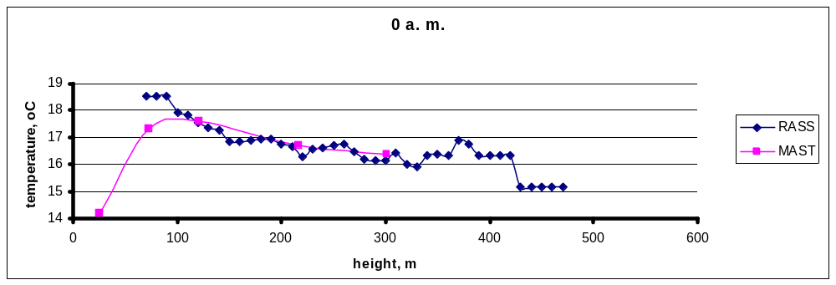
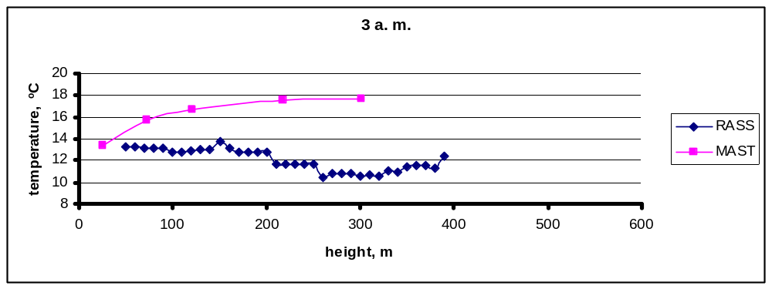
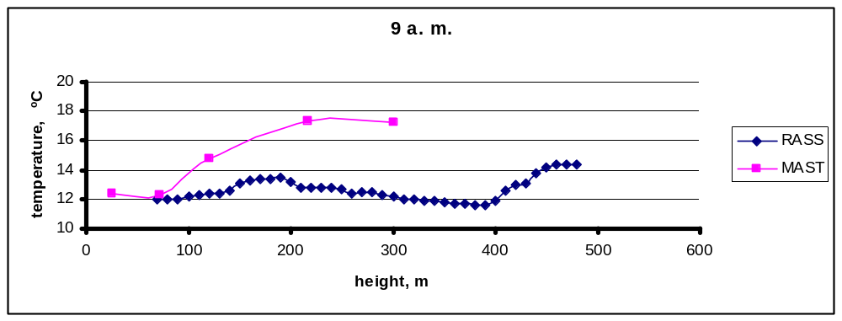
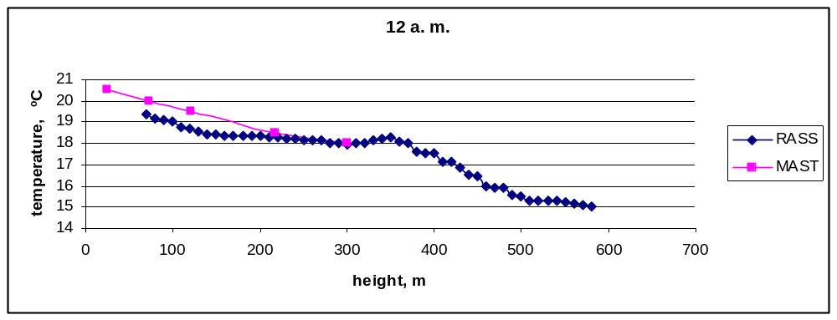
Fig. 6. Profiles of air temperature, measured by AMM sensors
and RASS on May 4th, 2009

Table 6. Air temperature difference for measurements of sodar and
AMM sensors (°С) for 8 terms of measurements on May 4th, 2009

z, m | Time, h
z, m | 0 | 3 | 6 | 9 | 12 | 15 | 18 | 21
301 | -0,2 | -5,5 | -6,0 | -4,1 | 0,6 | -0,6 | 0,8 | 1,1
217 | -0,4 | -3,5 | -3,8 | 0,6 | 0,6 | -0,4 | 0,2 | 0,9
121 | 0,0 | -2,4 | -3,2 | -3,1 | 0,1 | -0,6 | -0,1 | 0,6
73 | 1,3 | 1,7 | 2,8 | 0,8 | 0,2 | -0,7 | -0,1 | 1,0

Statistical results of comparative supervision of sodar and the high-rise mast from July 1st till August 31st 2009, confirming conclusions made on May, 4th are given below. The experiment lasted for 56 days and 1247 profiles at various times were obtained. The average deviation of temperature is considered as the sum of deviations of RASS indications from AMM ones divided by number of the profiles measured. Apparently from fig. 8, a difference of indications with height increases, while RASS decreases the temperature. Considering the daily statistics (fig. 7) where the average deviation of temperature of all measured profile depends on time of days is shown, the greatest distinctions are observed in the morning (a radiating cooling of soil, temperature inversions). The least divergences were in the afternoon when the surface layer of atmosphere got warm and smooth change of atmospheric variables with height was restored.
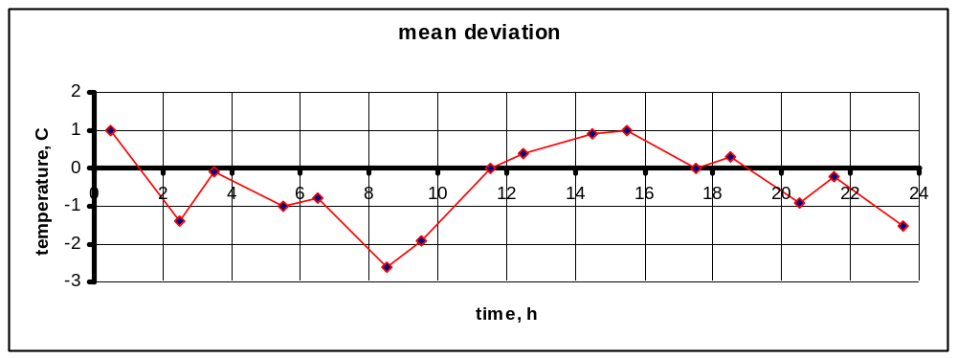
Fig. 7. Daily course of temperature profiles divergence for AMM and RASS
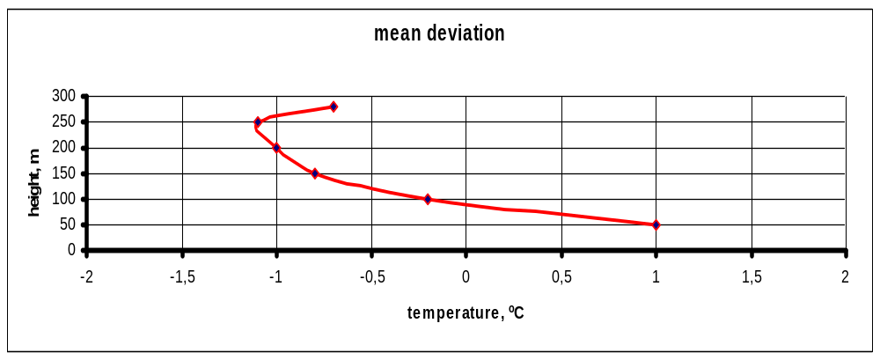
Fig. 8. Divergence of the temperature difference for AMM and RASS profiles
depending on the height

CONCLUSIONS
Comparison of wind speed measured by sodar and anemometers located on the meteorological mast at four heights shows, that in 30-50 % of cases the divergence between them is in the range of 0,4-0,5 m/s. At comparison of wind speed by WO acoustic anemometer and sodar it is clear, that deviations between separate measurements at the confidential interval of 95% can reach 2 m/s at the height of 121 m and 4 m/s at the height of 300 m. At low wind speeds (lower then 6 m/s) wind speed according to sodar is more than according to AMM sensors at the same height. On the contrary, from about 10-14 m/s wind speed by sodar becomes less then measured on AMM. As the number of cases of the big wind speeds increases with height, the number of cases with negative value of difference between wind speed by sodar and by AMM sensors increases also. So correlation factor for wind speed is 0.950, for direction – 0.994. An average deviation for all ranges of wind speed is close to zero.
Wind directions measured by sodar and by AMM anemometers coordinate better, than wind speeds. In 55-65 % of cases these differences are in a range from -5º to +4^{о}.
As a whole, the data comparison of acoustic sounding and contact measuring methods confirms, that the tested sodar provides reliable data about vertical profiles of average wind speed in the studied range of heights as height as 300 m, except the cases of heavy rains and low wind speeds.
At radio acoustic sounding for construction of air temperature profile, the greatest divergences with AMM data were observed at deep morning surface inversions, that is necessary to take into account while sodar operating. For the whole observation period the average square mean deviation of RASS data as compared to AMM ones is 1,45. When the sun is absent, RASS decreases the temperature measured (as much as 6 ^{о}С at the level of 300 m). In the afternoon at sun light RASS and AMM data are similar (or RASS insreases the temperature as much as 1 ^{о}С).

References

1. Altitudinal meteorological mast. Set of equipment (under the editorship of N.F.Mazurin). IEM, 1988, №10 (131), p.104.
2.<http://www.scintec.com>
3.<http://www.gill.com>
4. Kadygrov E.N., Miller E.A. Result of comparisons of the temperature profiles received by means of remote instrument and sensors of high-rise meteorological masts. The all-Russia scientific conference «Research of processes in the low atmosphere by means of high-rise constructions. Obninsk, October 8-10th, 2008, p. 61-64.
5. Antoniou I., Jurgensen H. E., Hunerbein S. et al. Inter-comparison of commercially available SODARs for wind energy applications//Proceeding of 12-th International Symposium on Acoustic Remote Sensing, Cambridge, UK, 2004, p.136-139.
6. Berg L.K., Reynolds R.M., Allwine K.J. et al. Comparison of measurements made using two sodars in an urban environment//Proceeding of 12-th International Symposium on Acoustic Remote Sensing, Cambridge, UK, 2004, p.140-143.
7. Comparison of Metek sodar and tower instruments. <http://www.biral.com>, 2007.
8. Crescendi, H.G., 1997, “A look back of two decades of Doppler sodar comparison studies”, Bulletin of the American Meteorological Society, 78, 651-673
9. Stuart Bradley, Ioannis Antoniou, Sabine von Hünerbein, Detlef Kindler, Manuel de Noord, Hans Jørgensen. SODAR calibration procedure. Final reporting on WP3, EU WISE project NNE5-2001-297, The University of Salford, Greater Manchester, UK, March 2005. ISBN 0-9541649-1-1.
10. S. von Hunerbein I. Antoniou, S.G.Bradley, H.E.Jorgensen, D.Kindler. Calibration of SODARs for wind energy applications. International Symposium for the Advancement of Boundary Layer Remote Sensing. Garmisch-Partenkirchen, Germany, July 18 - July 20, 2006. Extended Abstracts. Editor Stefan Emeis. Forschungszentrum Karlsruhe, 2006, pp. 168-170.

