IMPROVEMENTS ON TURKISH WEATHER
RADAR NETWORK

İsmail TEMİR1, Cihan GÖZÜBÜYÜK2
1Turkish State Meteorological Service, Keçiören, Kalaba, Ankara,itemir@dmi.gov.tr
2Turkish State Meteorological Service, Keçiören, Kalaba, Ankara,cgozubuyuk@dmi.gov.tr

1. Introduction
One of the most important and critical instruments developed and offered by the modern technology for observing weather and early warning systems are weather radars. Turkish State Meteorological Service (TSMS) has four C-Band Doppler weather radars which were established in Ankara, Istanbul, Zonguldak and Balıkesir.
The first radar of TSMS was installed as with C- Band dual polarization capability in Ankara in 2001. Then the network was formed by adding three C-Band single polarization weather radars in 2003. The project for the installation of six (6) C- Band radars is still under implementation. Four of them will have the dual polarization capability while two of them will have the single polarization capability. It has been planned that the network will have ten (10) C-Band radars by 2011 with new features. TSMS is planning to purchase one X- Band radar by the end of 2011.

2. The Abstract
TSMS’s new radars will be capable of performing intensity and velocity calibration. Automatic multi point receiver calibration should be realized by using the signal generator which shall be mounted at each radar system. It will be possible to make the intensity check and to measure the phase noise by means of the maintenance software. Also, the maintenance software shows where the faulty part is. TSMS’s new polarimetric radars will produce dual polarization products such as: Rainfall Accumulation Product and Hydrometeor Classification Product. These products shall be generated by using the hydrometeor classification algorithms based on Fuzzy Logic and/or Artificial Neural Network.

3. Improvements on Turkish Weather Radar Network
We have lots of improvements on radar systems including different radar equipments as well as on radar network since 2001. The number of our radars will be ten until the end of 2011. Also our radar coverage area will become larger including especially all coastal area. There are three types of improvements on radar systems. These are mainly hardware, software, radar infrastructure and other improvements.

3.1- Hardware Improvements:
3.1.a-) Dual Type: Switch or Simultaneous
TSMS's all radars are C-Band Doppler weather radars with klystron tube. Our first radar has switch type dual polarization capability (Pict.1). The radar can only transmits electromagnetic wave (RF signal) either in horizontal or in vertical channel by means of a dual polarization switch. Therefore the transmitted peak power does not split and is always 250 kW because of switch type dual polarization. After the first radar, three radars have single polarization with 250 kW peak power.
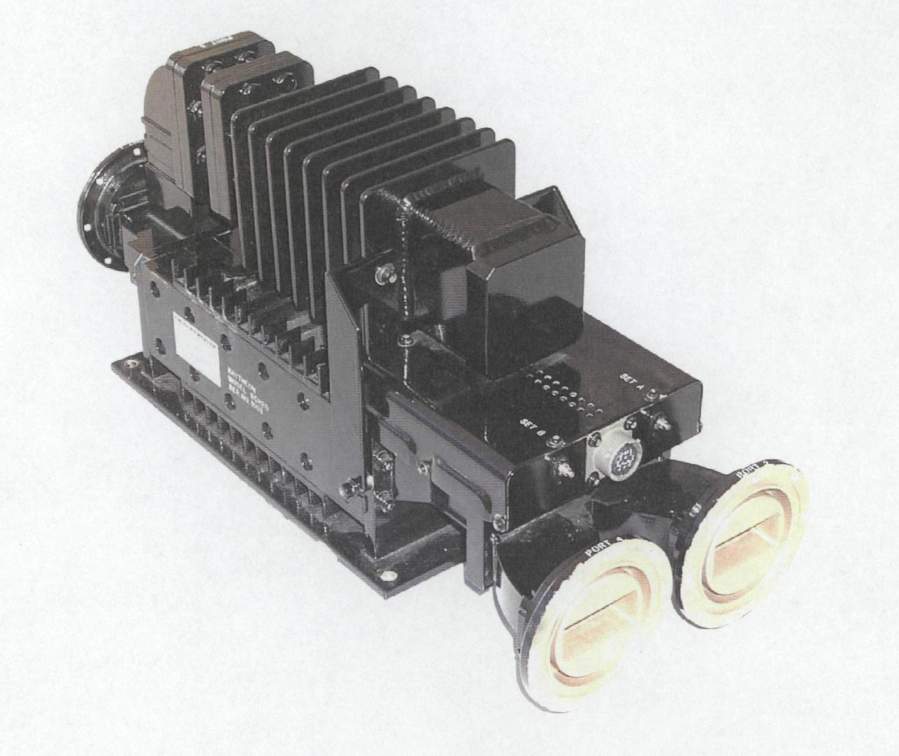
Pict. 1- Dual Polarization Switch
In TSMS's 6 radar project, four of them will have the dual polarization capability while two of them will have the single polarization capability. In the operation of these four dual polarization radars, they are different from our first radar’s operation for dual polarization. In TSMS’s new four polarimetric radars, Simultaneous Transmitting and Receiving (STAR) mode shall be used (Pict. 2). Also only horizontal or only vertical or both horizontal and vertical polarization capability will be available. Although the transmitter’s peak power is 250kW at first, the transmitted power is sent half of the peak power (125kW) to atmosphere in STAR mode after RF signal passes from power splitter for simultaneous transmitting. Thus radar can receive RF signals reflected from targets in both horizontal and vertical channel. So in this type of dual polarization the transmitted peak power decreases half of power but much more information can be obtained from the targets in the atmosphere at the same time.
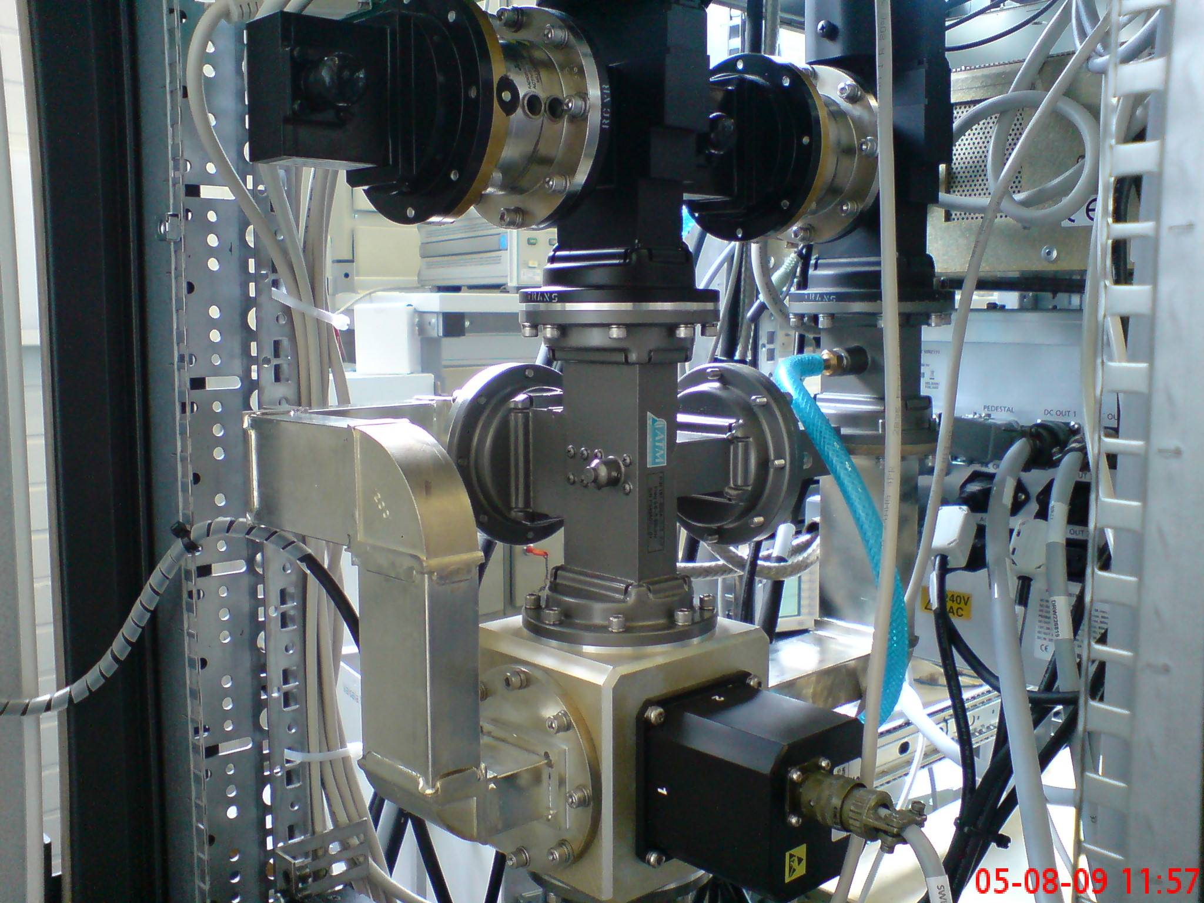
Pict. 2 Simultaneous Dual Polarization Channel
3.2- Software Improvements
3.2.a-) Dual Polarization Products
TSMS’s new polarimetric radars will produce dual polarization products such as: Rainfall Accumulation product, Hydrometeor Classification Product, Precipitation Efficiency Rate Products. In these products Z- Reflectivity, Z_{DR-} Differential Reflectivity, KDP- Specific Differential Phase, LDR- Linear Depolarization Ratio, ØDP- Differential Phase Shift, ρ_{HV}- Polarimetric-Correlation Coefficient parameters have been used. These products shall be generated by using the hydrometeor classification algorithms based on Fuzzy Logic and/or Artificial Neural Network.

3.2.b-) Receiver Calibration
In our first radar which was started operation in 2001, there is anolog receiver. In our three radars which were installed in 2003, we changed from analog to digital receivers by improving new technologies. Also for our new project for six radar installation, receivers are digital and dynamic ranges are better than the other three radars. We are also planning to upgrade analog receiver to digital receiver of our first radar.
Calibration is very important issue for the receiver to measure radar reflectivities accurately. For the first radar, receiver calibration is carried out as single point calibration internally by using maintenance software (Pict.3). In single point calibration receiver response is obtained only for one point. So we can not get an idea for other points.
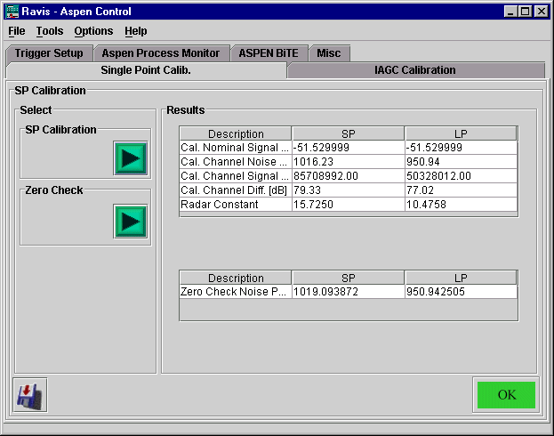
Pict.3- Single Calibration of TSMS’s first radar

Except the first radar, all radars have automatic multi-point receiver calibration tool in their maintenance software. Automatic signal generator (Pict.4) should be installed in the radar system for automatic multi-point calibration. The signals from noise level to saturation level are applied automatically by using signal generator for multi-point calibration. So a receiver response curve is plotted by calibration tool (Fig. 1) and calibration results are saved. Receiver calibration must be done at least in every 6 months periodical maintenance.

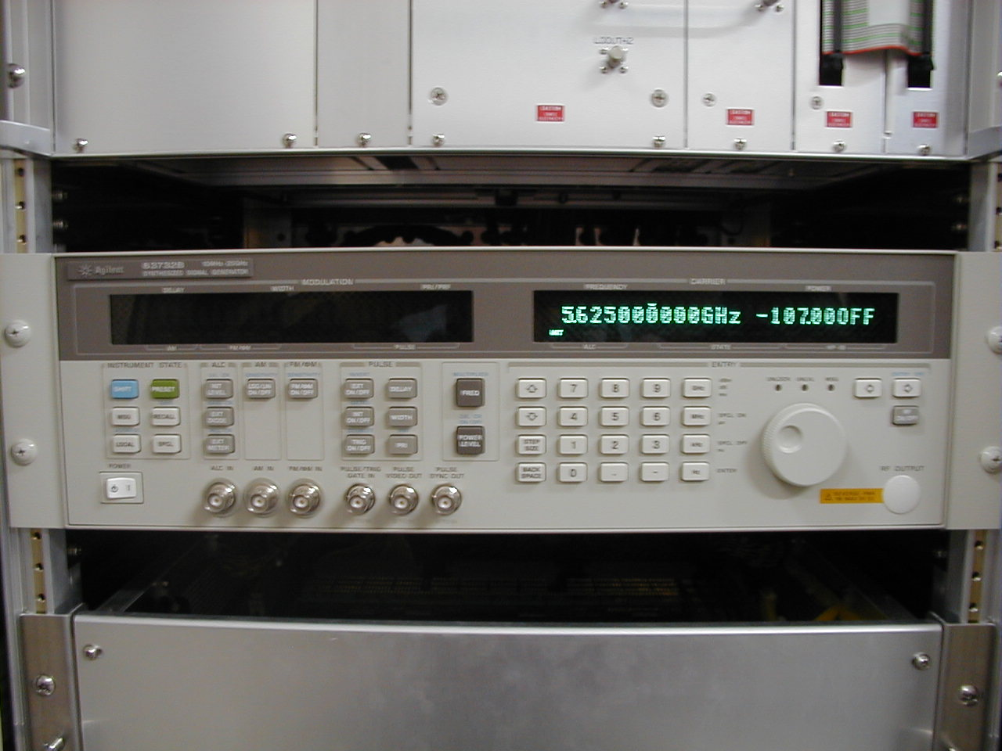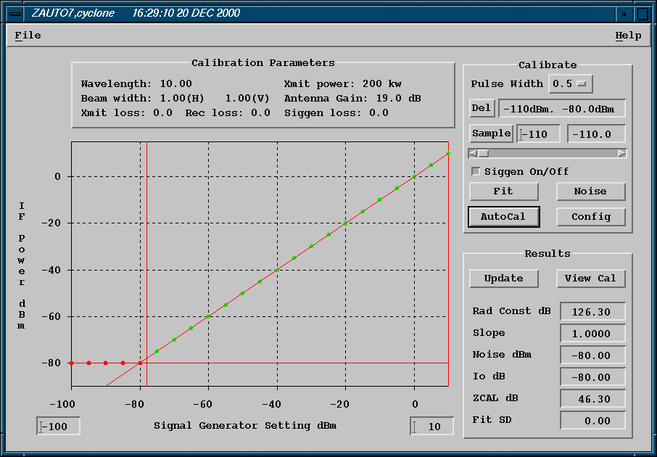
Pict. 4- Automatic Signal Generator mounted to Fig. 1- Receiver Calibration Tool
the radar system

3.2.c-) Sun Calibration
The sun may serve as an external radiation source for calibration of the radar systems. The sun’s position can be calculated from any point on earth at any given time provided that accurate time and lat/lon information is known. This provides a convenient check for antenna pointing accuracy. The sun’s power can also be useful technique for monitoring the calibration of the receive chain of the radar when used in conjunction with independent measurements of solar flux density. The sun radiates not only visible light but also electromagnetic energy at all frequencies. The amount of energy emitted by the sun at radar frequencies is sufficient to be detectable by most modern radar receivers. It is simply a matter of aiming the antenna at the sun and measuring the power received. Note that we do not use the transmitter for this. We are not bouncing an echo of the sun; we are using the sun as a “calibrated” signal generator at a known position.
In our first radar, sun calibration tool shows the position of the sun, correct time and longitude-latitude of the radar. We can compare and the actual antenna position according to the values from sun cal tool.
However in three radars sun calibration is done manually by using sun cal tool. If we get correct time and correct position of the sun then we do sun tracking. If any error of the antenna position occurs during sun tracking test (Pict.5), we do some adjustment. First we do adjustments electrically (Pict.6) to make the error zero, the second stage may be needed by sliding the angle measuring bar mechanically (Pict.7). After these adjustments sun calibration is done again. If the errors don’t exceed the given limit values, sun calibration becomes ok. Otherwise it is not ok.

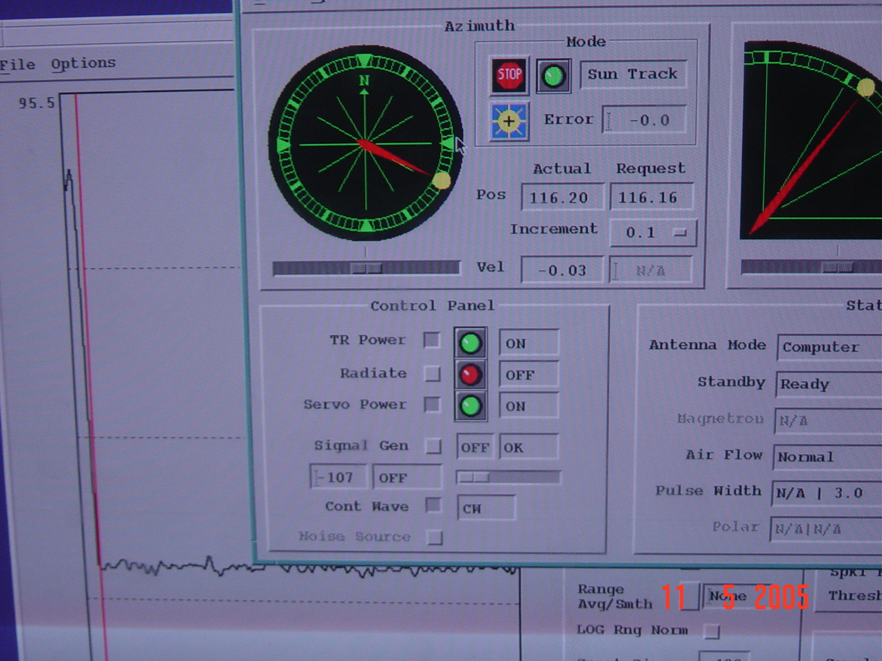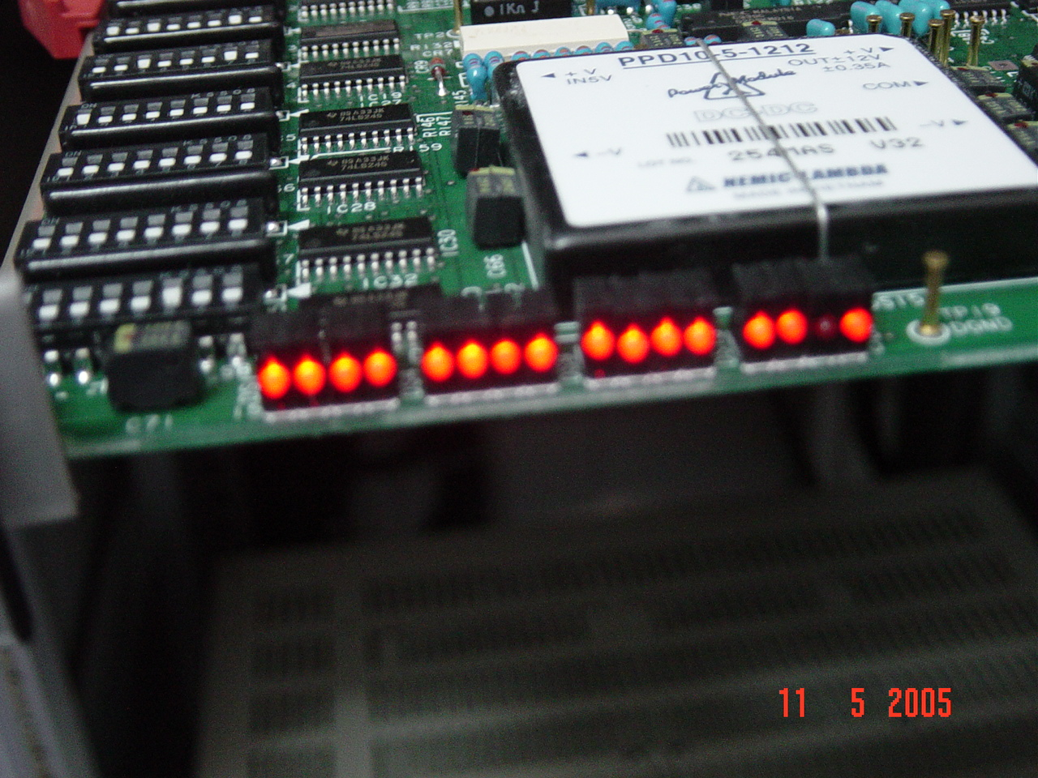
Pict. 5- Sun Calibration Tool Pict. 6- Electrically adjustment by using dip switch

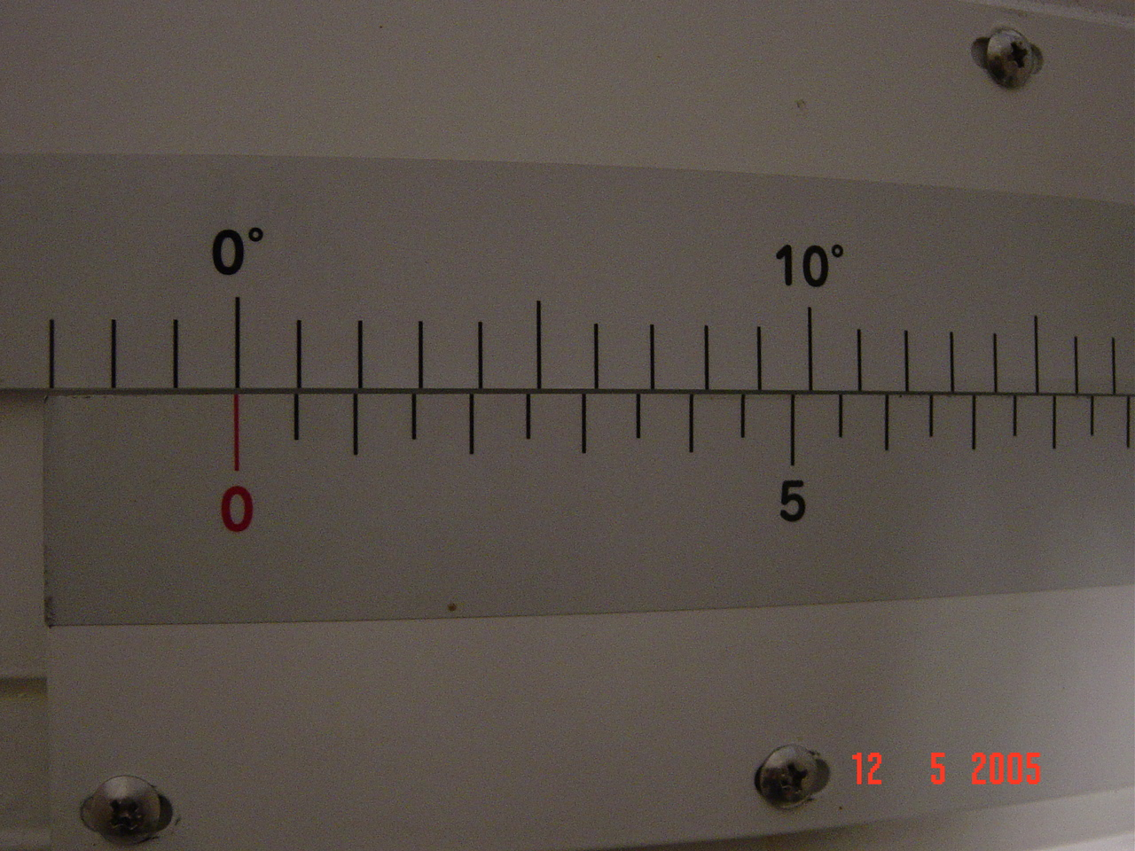
Pict. 7- Mechanical adjustment by using antenna scale

In six radars project there is automatic sun cal utility. The sun calibration is carried out automatically and angle errors during the calibration are ignored and corrected values for angles are stored automatically by using software. The sun cal utility can be run interactively from a command line and does not use a graphical interface. The sun cal utility outputs a BEAM product (Fig.2). The BEAM product will contain SNR (Signal to Noise Ratio) data with no thresholding and can be viewed on an IRIS system, but is not automatically inserted into an IRIS product dictionary. The BEAM product is then processed to produce a final calibration results file. The calibration results file produced contains lots of information derived from the calibration such as the time, location and the site name. Also there are radar calibration numbers such as the noise level and the receiver bandwidth. Finally there are the numbers calculated from the sun. This includes the observed position of the sun, the pedestal angle errors, the area of the sun above threshold, the beam widths and the peak power of the sun.
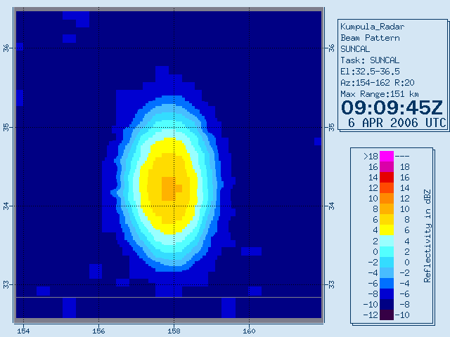
Fig. 2- BEAM Product from SUNCAL Utility showing sun

Also some methods shall be provided for the calibration of dual polarization. For example, ZDR calibration shall be fulfilled and recorded by the values which are received after the antenna shall positioned upwards full vertical position and turned on horizontal position at least once per day.
Also radar system shall measure the sun energy daily and record the values for purpose of checking the data quality.

3.3- Radar Infrastructure Improvements
3.3.a-) UPS, AVR, Generator, Towers and Building
In first radar site (Pict.8), there is a personnel building but it is small and looks as a container. The radar equipment room is on top of the 32 m. steel tower. There is no elevator to reach the equipment room and to carry spare parts to the equipment room. Since electricity cut happens sometimes, generators are used in radar sites. Generators were installed in two separate container and they have only 4000 liters oil tank.
But in three radar sites (Pict.9), buildings were installed as reinforced concrete and rooms were installed separately. Radar equipment room was under the steel tower. Radar tower has an elevator to carry the equipment and peoples. Two generators were installed in two separate buildings and they have 30.000 liters oil tank. Both the first and three radars have only one Uninterrupted Power Supply (UPS), one Automatic Voltage Regulator (AVR) and two communication lines which have one terrestrial line and one satellite for each radar. The satellite communication line is used mainly and the terrestrial line is used as backup. In case of any faulty or breaking of the main line, terrestrial line starts working. So radar understands the actual communication working line and radar makes mod-switching in case of any line changing due to the line cut.

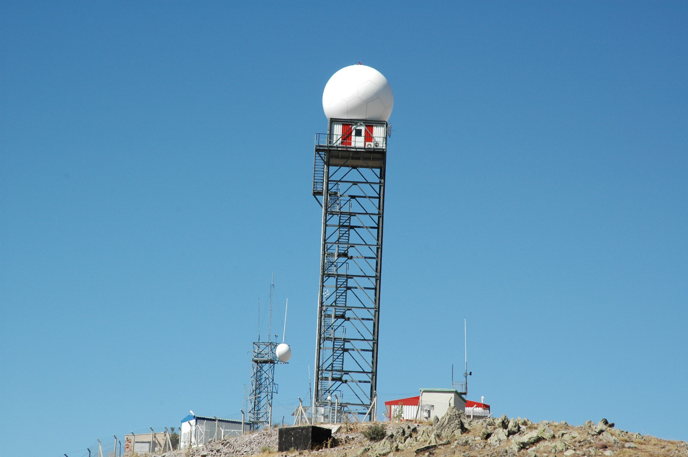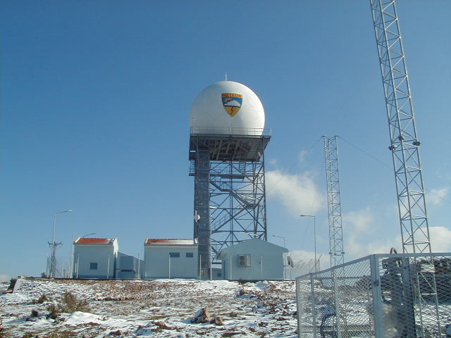
Pict. 8- TSMS’s first radar site Pict. 9- TSMS’s one of three radar site
In new project for six radars (Pict.10-11), the buildings will be compact reinforced concrete and rooms will be separated. All radar infrastructures such as UPS, AVR, Generators, communication lines support the radar to work and to send the radar raw data from radar to the data center for product generation. UPS, AVR and Generators will be doubled in case of any faulty or breaking down. There will be two Uninterruptable Power Supply (UPS) for each radar site, with the feature of parallel connection and to back-up each other, to be able to feed system components. Automatic voltage regulator (AVR) shall regulate the whole (overall) power coming to the all equipment in the system room. Two AVR for each radar site will operate back up of other one. The AVR connected to the system shall be put into the service manually. The spare AVR shall be provided as integrated into the system to be ready to be put into the service manually. Generators will be installed with a 30.000 liters oil tank. Two generators as a back-up system of the mains shall be installed at each radar site with a sufficient power to supply the power required for operating all systems continuously in case of the interruption of the mains. These generators shall operate as back-up of each other according to the failure and working time. The generators shall be able to step in manually and automatically and to make switching (passing).
Steel towers will be installed between 20 and 40 meters height. The ground level of the tower and concrete building shall be connected by a tunnel. This tunnel shall be separated from the tower and concrete building by dilatation. It will be possible to reach inside the radome from the concrete building in a covered place (medium) by making a connection between the tower entrance gate and the tunnel passing. The equipment room will be at the third floor of the building. At the end of this tunnel an elevator will be installed to carry the loads and people. Around of the elevator is covered to protect it due to severe weather conditions.
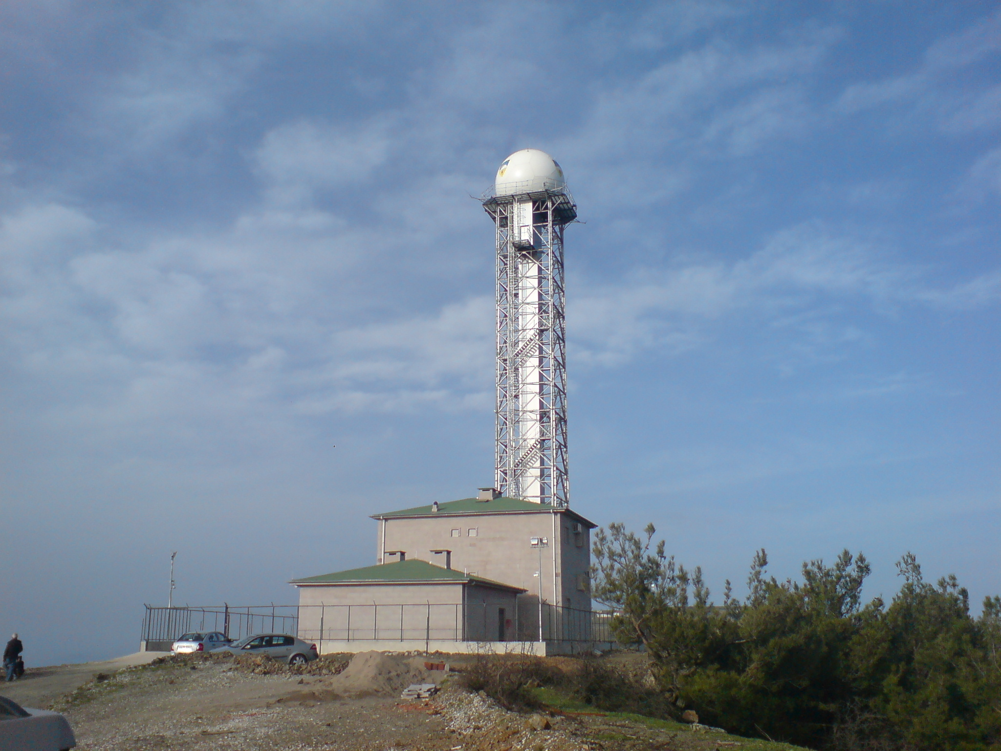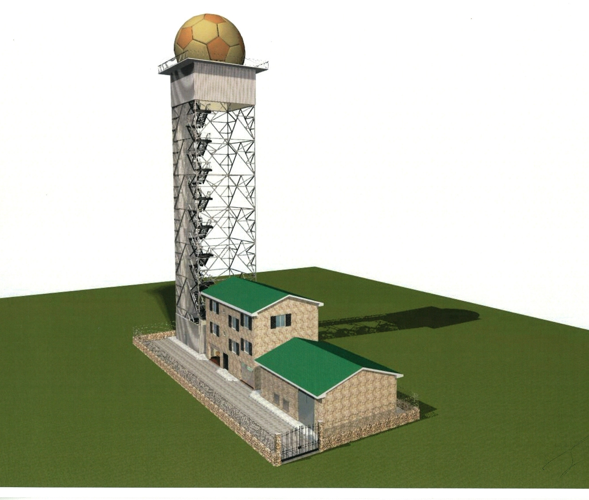
Pict.10- TSMS’s one of six radar sites from Pict.11- TSMS’s radar site model from
new project new project

3.3.b-) Communication
The prime communication media between radar sites and the operating center is satellite (Pict.12-13). The radio-link+ terrestrial line is used as back-up of satellite system for the continuous operation of radar network. Communication lines will be doubled and in case of any faulty or breaking down, the other one will provide radars to send the raw data to the data center uninterruptedly.
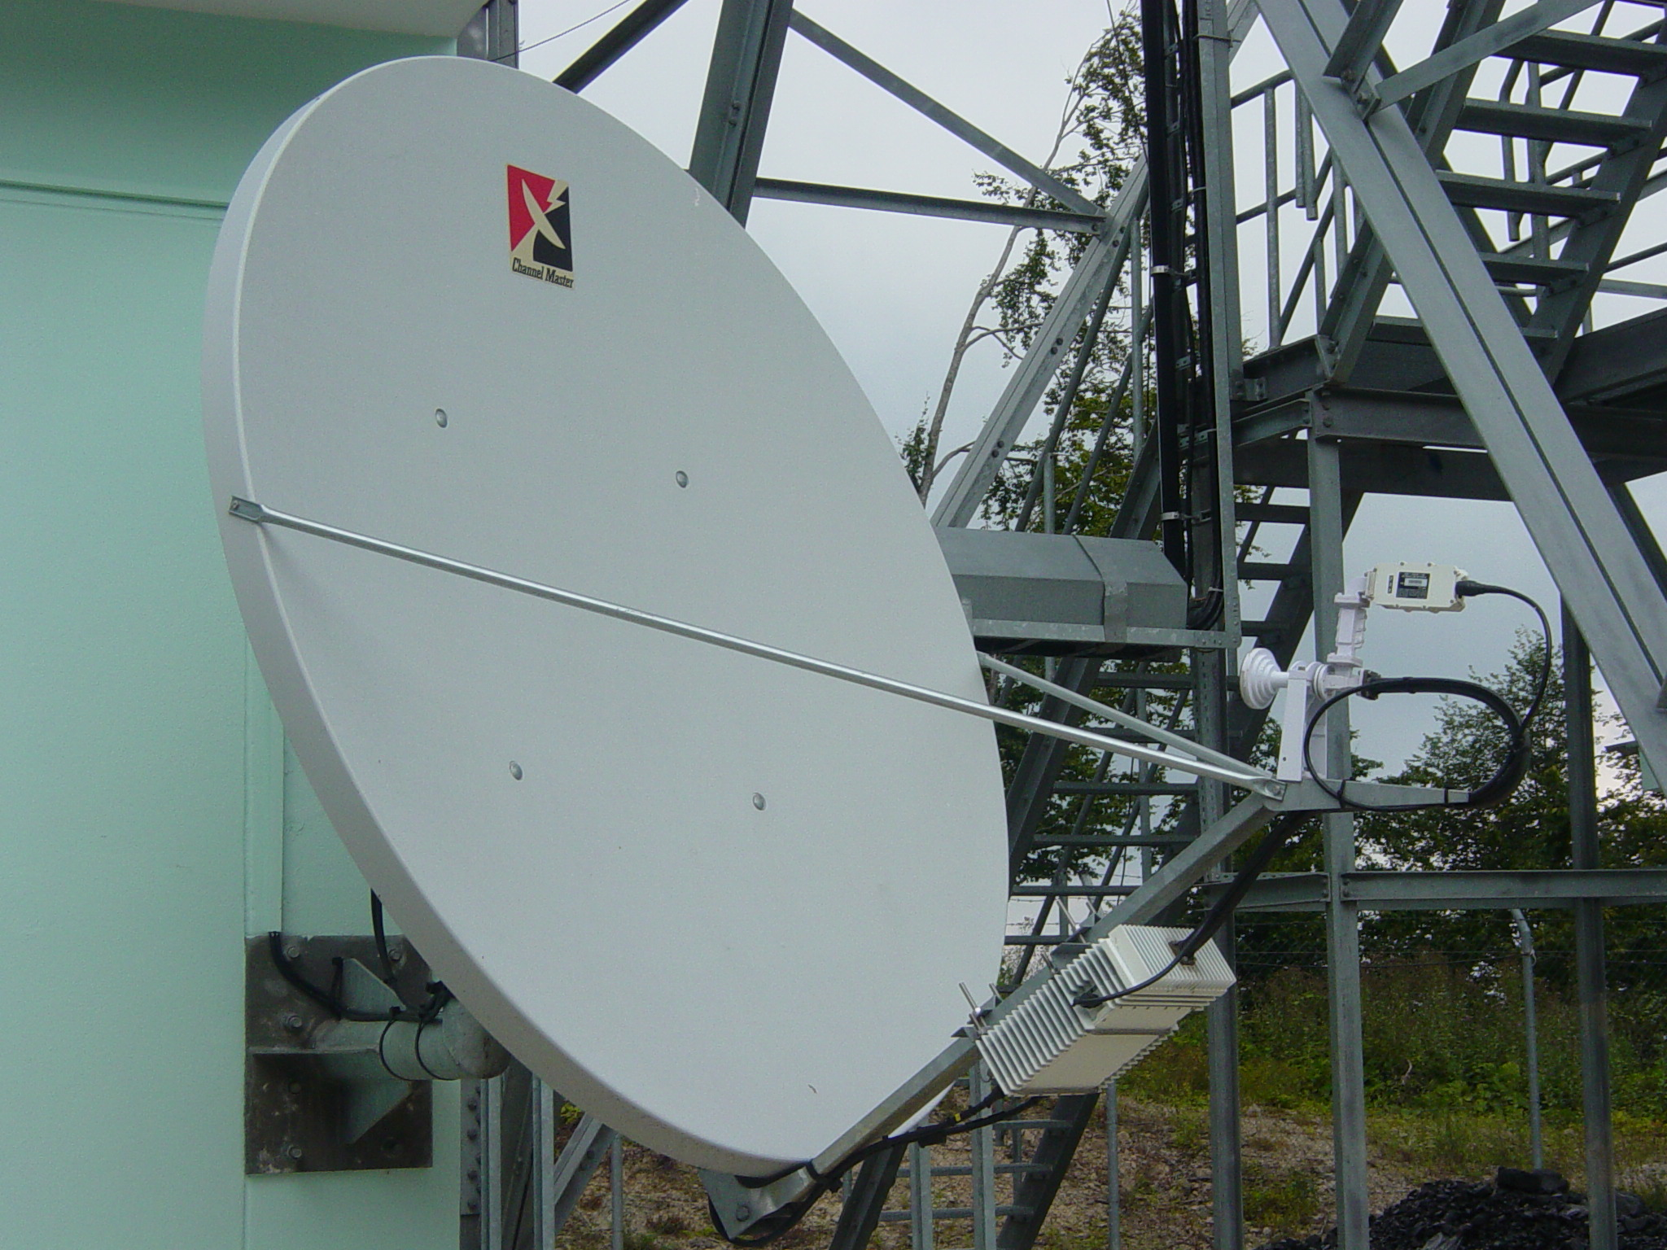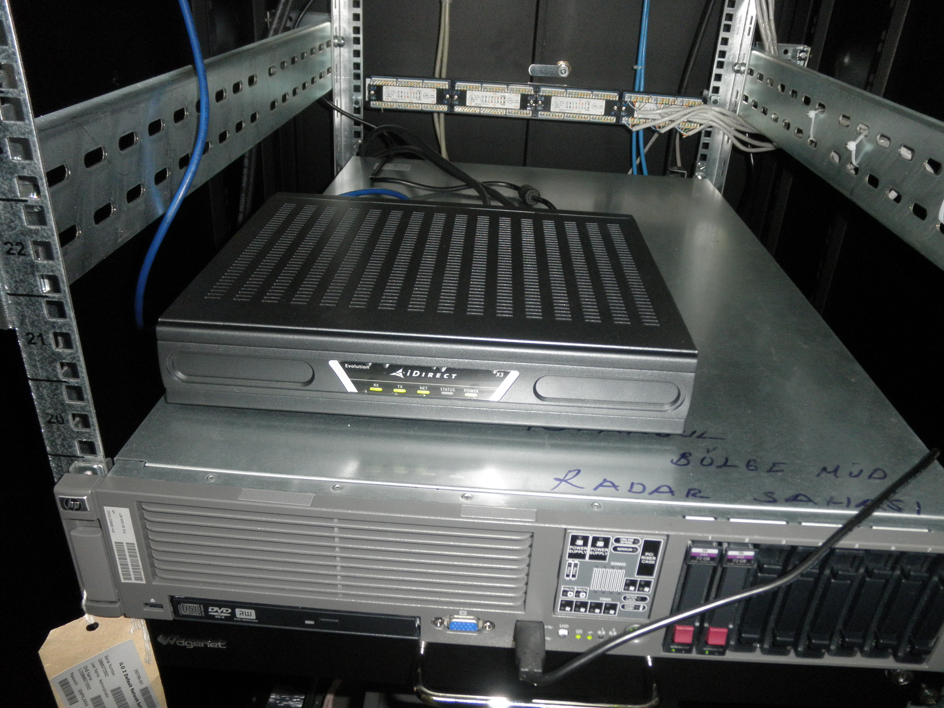
Pict.12 Antenna for Satellite Communication Pict.13 Modem for Satellite Communication

3.3.c-) Fire Detecting and Extinguishing System
Except equipment room, all rooms are extinguished automatically with carbon dioxide extinguishing system. In the equipment room, in case of any fire transmitter and receiver cabinets are extinguished automatically by a fire detecting and extinguishing system (Pict.14) with an FM200 gas. FM200 gas system does not give harm to human body and also provides the electronical equipments usable after extinguishing action.
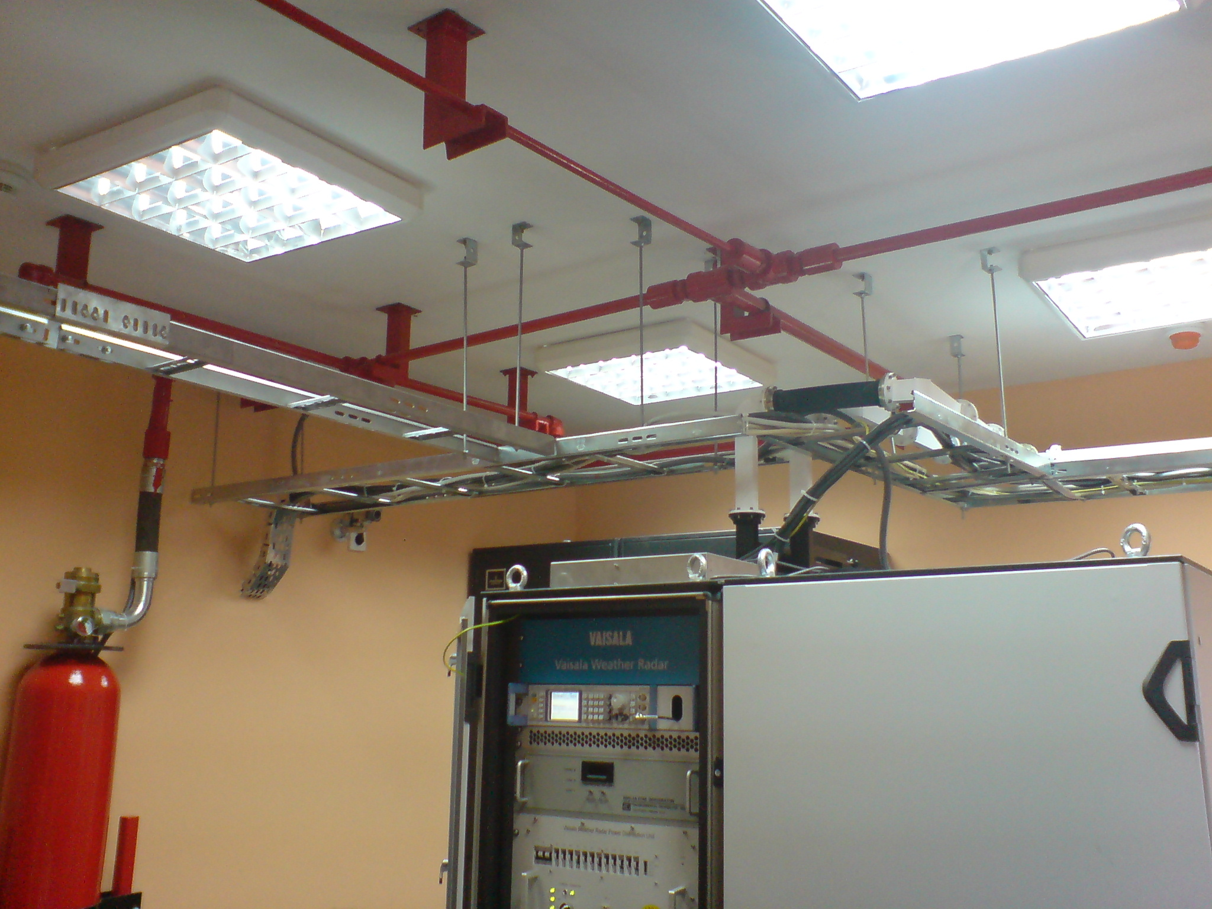
Pict.14- Fire detecting and extinguishing system for radar equipment

3.3.d-) Lightning Protection and Grounding System
In TSMS's present four radars, an equal-potential grounding system and lightning catching rods on radomes and on the buildings are used. One catching rod of 100 cm length on the top of radomes and three additional catching rods of 50 cm length on the radomes are mounted as perpendicular to the radome surface and with an angle of approximately 120 degrees between each other, and by making an angle of 45 degrees with the radome center axis. All groundings and lightning protection lines in the radar site are connected to the copper conductor surrounding radar site of 50 mm2 cross section by laying down at a depth of 50 cm underground. Grounding resistance of the radar site shall be 1 (one) ohm maximum.
In the 6 radar project, one catching rod of 100 cm length on the top of radome and 5 catching rods of 60 cm on the side of radome will be installed (Pict.15-16). Also catching rods will be installed at the four corners of the tower with a distance of 300 cm away from radome at the level of radome base ring and 100 cm length by making an angle of 45 degrees with horizontal. The benefit of 5 rods (air terminals) installation is spare parts handling and the maintenance as all panels installed on radome are identical with each other. Thus it is aimed that a whole coverage of radome protection is provided. The system will have two down conductors through the tower to the ground. The buildings will have lightning catching rods at their roofs and those rods will also be connected with all conductors at the ground. All groundings and lightning protection lines in the radar site shall be connected to the copper conductor surrounding radar site of 50 mm2 cross section by laying down at a depth of 50 cm underground. Grounding resistance of the radar site shall be 1 (one) ohm maximum.

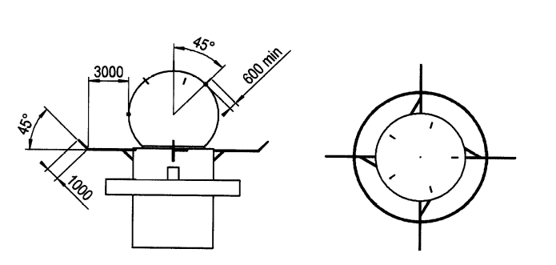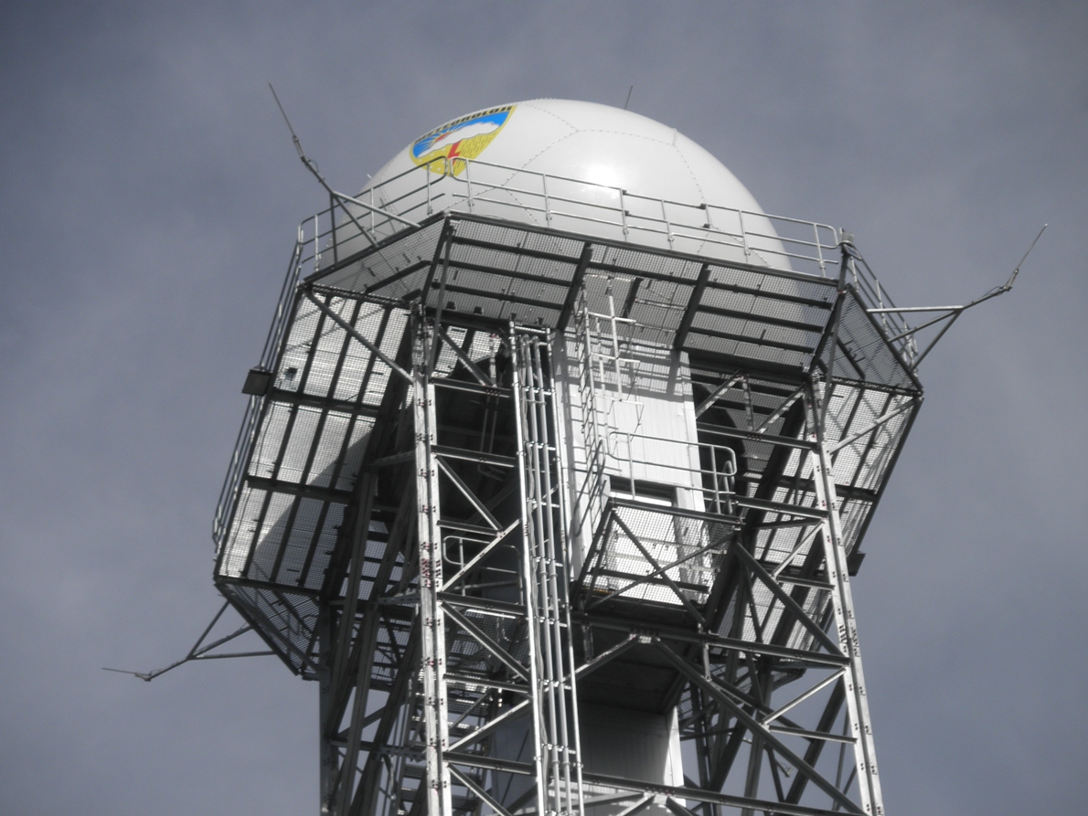
Pict. 15- Lightning Protection for Radome Pict.16- Radome tower with lightning rods

3.4- Other Improvements
3.4.a-) Disdrometer
Generally, in Europe radars one disdrometer is installed and used for each radar. TSMS is now actually operating four disdrometers for four radars. The present operating four radars use the data of disdrometers for radar rainfall estimation as well as the data of rain-gauge installed in many automated weather observing system (awos). But in our new project we will have two disdrometers (Pict.17) for one radar. The disdrometer directly gives reflectivity (dBz) of rain. And this enables the radar to compare the radar reflectivities and disdrometer reflectivities. All data generated by the disdrometer shall be stored as the raw data in the hard disk in hourly files. The original disdrometer software runs on the disdrometer computer (PC) in the operating center. Moreover, for each disdrometer, precipitation amount (mm/hr), radar reflectivity (dBZ), total precipitation amount (mm), visibility (m), WMO present weather precipitation code and instrument status information shall be displayed on the same screen as value and/or graphic by the original disdrometer software together with disdrometer code, latitude and longitude of the site, date-time and instantaneous value (latest received value).
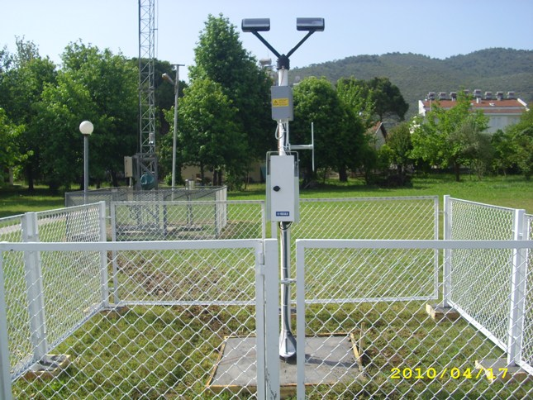
Pict. 17- Disdrometer with the new project

3.4.b-) Bitex for Maintenance
The weather radar network has been monitored by receiving real time status information via maintenance terminals in the radar operating center and radar maintenance center. These terminals allow the maintenance staff to monitor and control all radars and their environmental equipment, and perform all remote maintenance functions by connecting to the workstations in the radar sites.
The maintenance terminals operated by special maintenance software are capable of monitoring the status and bite information (bitex- built in test equipment) (Pict.18-19) including certain parameters of each sub units of radars, i.e. antenna, transmitter, receiver, radar control and signal processors, and environmental equipment such as UPS, generator, air conditioner, communication status. Also, the maintenance software shall show where the faulty part is. In case of any failure, system generates audible and visual alarm to warn operators and maintenance staff.

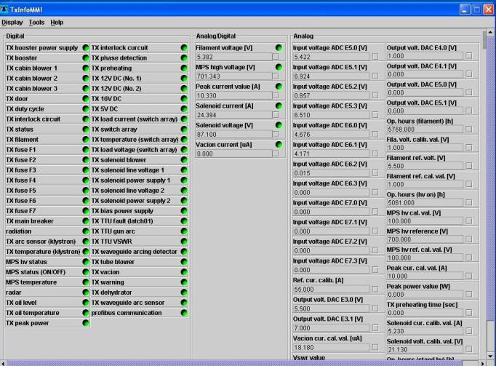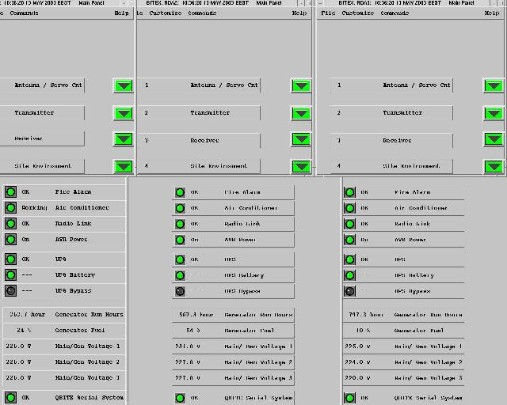
Pict.18- Bite information from first radar Pict.19- Bite information from three radars

4. Conclusion
TSMS has been planning to install new radars to be able to cover the whole country and trying to take into consideration the improvements of technology on weather radars. Day by day technology is adding new features to the radar systems. Therefore TSMS would like to have these new technological improvements according to the necessities.
TSMS has been planning to expand its network to cover whole country by adding new C- Band and X-Band radars by considering the topography, coverage and the meteorological targets. In future, to cover the whole Country, more than 15 C-Band and 15 X-Band Weather Radars are proposed to be installed.
TSMS has been trying to improve its observation capability by establishing modern and well developed observing systems in order to provide the meteorological services and products to the users. Regional and international cooperation is one critical component to improve the capacity of the agency, and to increase the quality of the service. This is why TSMS is always open for any cooperation activity.

References
- Ronald E. Rinehart, August 1997, Radar for Meteorologists
- Doviak R.J. and Zrnic D.S., 1993, Doppler Radar and Weather Observations
- Merrill I. Skolnik, Introduction to Radar System
- Gematronik GmbH, 12.July.2001, Meteor 1000CUser Manuel and Documentation-Doppler Weather Radar System
- Mitsubishi Electric Corp., 2002, RC-57A Weather Radar Training Document and User Manuel
- Ercan Buyukbas, Oguzhan Sireci, Aytac Hazer, Ismail Temir, Cihan Gozubuyuk, Abdurrahman Macit, M. Kemal Aydın, Mustafa Kocaman, 2002, Turkish Radar Network, Hardware Maintenance of Weather Radars, Training Notes
- Radar Lecture Notes and Articles available in internet
- Technical Brochures of Radar Manufacturers and Technical Correspondances with Manufacturers (Vaisala, Mitsubishi, Selex, EEC, Metstar, Baron and Radtec)
- Commission of Technical Specifications, 2008, TSMS Technical Specifications for The Tender of 6-Unit C-Band Doppler Weather Radars for Aegean, Mediterranean and Eastern Black Sea Regions

