NEW STANDARD ULTRASONIC WIND SENSOR PLATFORM

Jarmo Hietanen
Vaisala Oyj, Vanha Nurmijärventie 21, P.O.Box 26, FI-01670, Finland
+350-9-89491, jarmo.hietanen@vaisala.com

ABSTRACT

Requirements for surface wind measurement have been upgraded by WMO. To meet these requirements sensor evolution has been performed. In this paper, different Vaisala in-house technologies for solid state wind sensors are briefly introduced. Selected ultrasonic technology is shared, and professional ultrasonic wind sensor development work is discussed. The development work has led to new ultrasonic wind sensor plaform, which is applied to new standard ultrasonic wind sensors. Sensor performance and characteristics are shortly introduced. In addition, foreseen trends are discussed.

INTRODUCTION

Meteorological community applies high quality, professional sensors from small-scale individual research projects to demanding research programs, and all the way to operative networks. The World Meteorological Organization, WMO, has set guidelines for surface weather observations [1], in order to assist members of the international community to select appropriate sensors and to ensure sufficient and comparable measurement data across to world. Very often, other organizations, like ICAO [2], have adopted WMO guidelines directly or with minor modifications, which further emphasis the role of the WMO. From time to time, the WMO updates sensor recommendations to have better match to community's research needs and to fulfill needs of operative networks. From the wind sensor point of view, there is demand for professional sensors for high wind speed conditions up to 75 m/s and sensors for icy conditions at cold climates.

To be able to meet updated WMO recommendations for surface wind measurement, over 10 years of research was conducted for technology selection and competence development. In case of solid-state wind sensor, there were several potential candidates for sensor principles, methods, and technologies. Technology studies were performed to determine the weak and strong points of each technological option. Customer preferences and practices were also taken into consideration. Together with technology selection, competence development was performed. The outcome from competence development is the sensor platform, which is the core of products. After collecting customer requirements, product development including mandatory and voluntary product testing, setting subcontractor network, and manufacturing practices were performed.

In this paper, the technology and product development of a new wind sensor platform is reviewed. The intention is to provide background information on what has been done in Vaisala Oyj. New wind sensor platform is introduced and a set of end user features of the new WMT700 Vaisala Ultrasonic Wind Sensor Series are presented. The design principle was that this platform and related products can be applied from small individual research projects as a stand-alone device to national wide operative networks as a solid part of integrated and harmonized network systems. This emphasized both high quality performance and reasonable life-cycle cost including service operations. Last topic of this paper is trends both at sensor and system levels.

Solid-state wind sensors technologies

Traditional wind sensors after a wind sock are the mechanical anemometer and the mechanical vane, where wind characteristics are captured to the cup wheel rotation and orientation of vane. Mechanical instruments have bearings ensuring smooth response. In order to maintain sensor specifications over time, the bearings should be changed frequently. Other trade-offs with mechanical sensors are mechanical inertia preventing fast response and lack of self-diagnostics at sensor level. To overcome these issues solid-state sensors were developed.

Vaisala Oyj had three potential options for solid-state wind sensor. They were pressure-difference measurement method, thermal measurement method, and ultrasonic measurement method. Vaisala Oyj has pressure measurement experience for over 70 years. From implementation point of view, the pressure difference method is very easy technology [3]. Especially appealing aspect is the straightforward implementation of the unlimited heating, since the structure could be just a metal tube with pressure ports. On the other hand, this technology could be more sensitive for low wind speed and wind direction. Traditionally pressure measurement method has been applied in mountain areas where considerable heating is needed. Regrettably, the phase-out of this technology could already be observed.

Thermal flow measurement method is traditionally used in laboratory conditions, where relative low flow speeds are studied. This kind of laboratory equipment is relatively fragile. To overcome this disadvantage, more robust and larger instruments have been developed. The result was simple technology having a trade-off with low wind speed sensitivity. Very high power consumption and visibility at IR cameras could be seen as an issue for this technology, but then again heating implementation is half-way done. Even though Vaisala Oyj has managed to reduce power consumption of this technology outstandingly by utilizing innovatively microsensor techologies adopted partly from Vaisala Oyj:n carbon dioxide product line, the sensor performance has not met all customer needs of professional users [4]. This technology is quite often limited for military applications.

Ultrasonic flow measurement method has long traditions at field of process controls and thus the understanding of this phenomena and technology was developed in the 1960s already [5]. Ultrasonic technology is very scalable in terms of measurement range, applied frequency and aerodynamics, for instance. From sensor design point, the clear trade-off is the complex internal structure. On the other hand, once the design is functional, incremental improvements can done to meet new customer requirements. This technology has been applied in numerous applications and research projects.

When evaluating and selecting measurement method for development process of solid-state wind sensors, particular weight must be given to user experience and wide-ranging applicability within the user community, not limiting only to wind speed and wind direction parameters. Ultrasonic technology could be applied also to temperature measurement, liquid level measurement, and liquid flow measurement. Table 1 lists measurement method options, their benefits, trade-offs, and applicability.

Table 1. Measurement methods for solid-state wind sensor.
Method | Benefit | Trade-off | Applicability
1. Pressure | Very robust technology  Heating can be implemented easily | Insensitive for low wind speed  Insensitive for wind direction | Limited
2. Thermal | Simple technology  Heating is build in | High power consumption  Insensitive for low wind speed | Limited
3. Ultrasonic | Robust technology  Scalable technology | Complicated internal structure | Wide-ranging
Competence development

To construct new measurement instruments is a process, which combines several pre-studies over years. Each pre-study is set to increase the competence level and reduce technological risks. The following gives a short and limited overview of research performed at Vaisala Oyj in the field of ultrasonic development.

The first Vaisala 2D and 3D ultrasonic wind sensor prototypes utilized mechanical structure with metal bars and separate enclosure for electronics [6]. Electronics utilized commercial data acquisition board. The prototype was used to determinate applicable ballpark for ultrasound technology, electrical front end, and signal processing. Field tests provided operational feedback. Clear outcome from this pre-study was increased confidence that the mature solid-state wind sensors will be based on ultrasonic technology.

The first prototype utilized time-of-flight method, while the following pre-study applied phase difference method between fixed plates [7]. Apparently, it was very challenging to meet typical meteorological customer requirement with this approach. This method appeared promising, but after having sparrow (Passer domesticus) constructing a nest and spider crocheting a spider's web between the plates, this approach was abandoned.

When Vaisala Oyj acquired the Handar Corporation, the well-known WS425 professional wind sensor product family was added to Vaisala's product offering. Received technological insight was utilized during the development of the multi-parameter sensor package, which resulted in the Vaisala Weather Transmitter WXT500 Series. This product has six essential weather parameters in one package providing comprehensive view of local weather. Within this context, a wide range of other ultrasonic measurement principles was considered [8-9]. The outcome was that the Weather Transmitter utilizes ultrasonic for wind speed, wind direction, and precipitation detection.

The WS425 product family was substantially expanded when Vaisala developed a customer-specific product for The National Weather Service, USA. Later on, this Ice-Free model was provided as a public product under the name WS425F/G models. During this development phase, several aerodynamic sensor shapes and transducer technology variants were tested. Also digitalized signal acquisition was implemented to a prototype with special programmable controllers [10].

The ultrasonic technology development applicable to wind sensors at Vaisala Oyj has not been limited only to the above-mentioned methods utilizing free sample volume and PZT transducer technologies. Instead, sensor technologies applying surface physics [11-14] has been a very interesting approach. Recently, equally interesting research area has been signal detection and pulsing methods [15].

New Standard platform

Wind measurement and wind data is important in meteorology, aviation, transport safety, in ships and harbors, and in many industrial applications. Vaisala manufactures wind sensors for all these needs, from low cost combined units to sophisticated heated sensors for extreme weather conditions. An end-user perceives a modern sensor via its physical appearance, measurement performance, and provided features. From sensor point of view, these are constructed upon the sensor platform. The platform, including mechanical, electrical, and software portions, sets limits for sensor performance and feature development. In order to overrun these limits and to meet new customer needs, sensor platforms should be rebuilt frequently. This development work requires careful consideration, which platform portions are subject to modifications and which portions should be kept unmodified. At the end, there must be a good balance between new customer benefits and technological risks.

The new standard platform includes several assets from existing platforms. Traditional ultrasound principle and the very same measurement method are applied. The novelty of Vaisala's ultrasonic wind sensors is utilization of three cylinder-shaped transducers, which gives to them their unique appearance and performance. The sensor transmits an ultrasound burst from one transducer to two other transducers simultaneously. The transmission rotates with a revolver practice. From the received ultrasound bursts, the time-of-flight histograms are constructed. The implemented equations to calculate the flow between two transducers is same. In practice, an ultrasound burst is travelling from one transducer to another with speed given by

c + u_{a} = L_{a} / t₁ (1a)
c - u_{a} = L_{a} / t₂ (1b)

where equation (1a) is for burst travelling with tail wind and equation (1b) is for burst travelling with head wind. In these equations, c is speed of sound, u is velocity of flow, L_{a} is distance between transducers, t₁ is down-stream time-of-flight, and t₂ is up-stream time-of-flight as shown in Figure 1. Since both head and tail wind conditions are measured with a very short time interval, the speed of sound, c, can be treated as a constant. This is quite practical because c varies as a function of temperature, humidity, and pressure. With this presumption, the equation for each triangle side can be formulated without c as follows:

u_{a} = ( L_{a} / 2 ) x [ ( 1 / t₁ ) - ( 1 / t₂ ) ] (2)
⇒ u_{b} = ( L_{b} / 2 ) x [ ( 1 / t₃ ) - ( 1 / t₄ ) ] (3)
u_{c} = ( L_{c} / 2 ) x [ ( 1 / t₅ ) - ( 1 / t₆ ) ] (4)

The flow i.e. the wind speed and direction on the measurement plane can be determined with equations (2), (3), and (4). The flow aerodynamics and electro-mechanical transducers construction were un-modified. After all, the WS425 D/F/G -models have demonstrated to be operative up to 85 m/s. Thus, significant modifications of the fluid mechanics or transducers were not introduced. Only some minor enhancements have been performed under the practice of continuous improvements. With these minor improvements, upgraded electro-magnetic immunity was achieved.

Electronics has same major blocks as its predecessor. The controller has an accurate clock, which is started at the very moment when the trigger activates the burst generator. The energy of the burst generator is conducted to an electro-mechanical transducer that radiates airborne ultrasound towards receivers. There ultrasound burst is converted back to an electrical signal and guided to the amplifier. When the expected signal shape is distinguished in the detection block, the

Figure 1. Measurement geometry. Distance between transducers and correspondent measurement paths are shown.
clock is stopped and time-of-flight value is quantified. Figure 2 shows the hardware blocks of the measurement. Even though major blocks of the electronics are unmodified, one minor modification is done. The data acquisition is digitalized i.e. the digital front end is extended right after the amplification block. The purpose is to digitize the detection block. Also narrow band preamplifiers are replaced with broad band amplifiers in order to ensure sufficient impulse response of detected ultrasound signals. Firmware performs sufficient filtering. Also pulse generation will be redesigned for improved SNR without compromising the simplicity of HW design.

This small modification of electronics provides a different software approach. Meanwhile the predecessor platform has a traditional hardwired analogue peak detection block, this new platform has modern adjustable and adaptive DSP detection. The software operation system will utilize real time schedule, which would allow task interruptions. Tasks like maintenance, quality control, and user interface can be operated in the background without compromising time-of-flight measurement activity, which is essential for high quality measurement. Calculation process follows the main equations, but in order to attain a robust data stream, plenty of redundant calculations are performed. The main benefit from this new software approach is enhanced evaluation of signal quality and more extensive self-diagnostics. Additionally, the modern software architecture allows the implementation of post-processing packages quite freely, which assist adapting to future customer needs. Figure 3 shows the software blocks, which are data acquisition, time-of-flight algorithm, wind speed calculation, wind post processes, data output, user interface, controls, and system supervisor.

Several preliminary wind tunnel tests were performed during the development of this new platform. One of the first experiments with integrated electronics was performed in order to understand the robustness of the measurement core. This was performed by constructing purposely several different array structures under good design practices and measuring these in a wind tunnel. Performance over the entire measurement range with each measurement direction was of special interest. In Figure 4, one of the very first prototype measurement results is shown. In this figure, the wind tunnel reference value is on the x-axis and prototype values are on the y-axis. The prototype sensors were measured at fixed wind speeds (about 10 m/s, 20 m/s, 30 m/s, etc). During each fixed wind speed, the sensors were rotated full 360 degrees. Measured minimum and maximum wind speed values at certain fixed wind speed were detected. These minimum and maximum values are plotted on the graph. As a reference, expected error of ±5 % limits are drawn. The measurement bias compared to the reference value was corrected in next firmware versions.

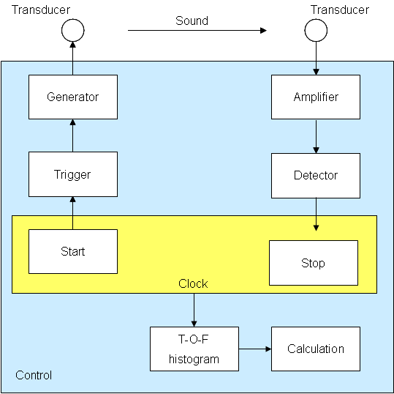 | 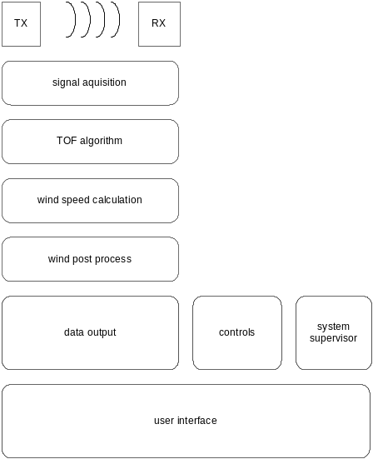
Figure 2. HW blocks of the measurement. | Figure 3. SW blocks of the measurement.
The new platform has a wide range of powering options in terms of voltage range and configurations. It includes both a digital data port and a digital service port. The platform has also analog outputs for wind speed and wind direction. Analog wind speed signals are voltage, current, and frequency, while as analog wind direction signals are voltage, current, and potentiometer simulation. The powering of the sensor and heating circuits are separate, which enables usage of generic power supplies including various solar panel and battery back-up installations for remote sites. Serial interfaces have same ground, but they are isolated from the operating and heating voltage ground.

The integrated heating capability of the platform is up to 150 W. This is achieved when three transducer heaters and arm heaters are installed at the factory. If transducer heaters alone are installed, heating capability of 30 W is provided, which is equivalent to the heated WS425B. The heating of 150 W is equivalent to WS425D/F/G models. The heating performance of the platform is shown in the Figure 5. The mechanical structure of the new platform differs slightly from WS425 structure, since the welded structure conduct heat from arm heaters to the sensor body. The heating is controlled with pulse width modulation (PWM) and normal surface temperature is 20 degrees Celsius. With challenging conditions, the sensor structure may heat up to 70 degrees Celsius, which should be considered as safety aspects during installation/maintenance operations.

Once the product is constructed on the top of the platform, extensive testing is performed in the laboratories at Vaisala Oyj, on third party facilities, and at the field. The primary testing of the wind sensor is naturally wind tunnel testing. In the case of an ultrasonic wind sensor, ISO 16622 test standard is applied to determinate type calibration for the sensor model. In addition, wide environmental testing program were conducted together with functional testing. In the table 2, the set of the test program for ultrasonic wind sensor is shown.

Discussion

The WMO has a significant role and great impact for equipment manufacturers when it updates the surface weather observations guidelines. From equipment manufacturer point of view, these guidelines clarify the expected features and measurement performance. However, the selection of fundamental measurement principle can be a very complex and time consuming process especially if there seem to be plenty of good technology candidates to start with. Once all technologies have been carefully studied, the most suitable one can be selected.

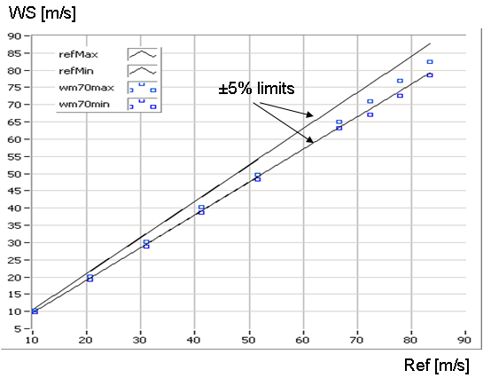 | 
Figure 4. Combined measurement performance from prototypes with several different array structures rotated full 360 degrees indicate tolerant sensor platform. | Figure 5. Heating experiment at Lapland during the winter 2009-2010. On right, the reference sensor Vaisala WS425B with heating of 30W. In the middle, the Vaisala Ultrasonic Wind Sensor WMT700 Series with heating of 150W. On left, WMT700 with inverted mounting.
Vaisala Oyj selected ultrasonic wind measurement technology instead of pressure and thermal principles, because it can better meet performance requirements of various demanding customer needs. To be able to meet the essential customer requirements in the long run, sensor platforms should be frequently developed, since each technology platform set limits for sensor performance and features. In this case, performed further digitalization of the wind sensor platform has enabled more robust products, and more importantly it provides more information from the measurement situation and thus opens new possibilities for sensor and application development.

When looking for industrial trends, there are three relevant trends for wind sensors: 1) Smart and collaborative utilization of measurement networks including shared data stream and maintenance operations, 2) Sensor fusion, and 3) Multifunctional components.

When wind data, or weather data in general, is combined from several networks, it is essential that the instrument characters like data format and performance as well as sensor internal quality control mechanism are similar in several networks. This provides predictable sensor response, enables accelerated learning curve, and allows utilization of very same quality control at system level during demanding weather conditions, which is one key element of network automation. This harmonization of networks requires scalable sensors with the very same sensor internal quality control - no matter, if a sensor is for the most demanding professional or for supportive usage. Equally important is that each sensor has directly all digital and analog communication options available. This way, field operations are fast and easy, and service organizations can effectively maintain various networks with minimal units in their inventory. From network harmonization point of view, it is always practical to replace an installed sensor with a sensor having higher measurement performance. This is especially valid with supportive networks when their performance is adjusted to be more suitable for professional users.

There are several definitions for sensor fusion or data fusion. Here sensor fusion is defined as follows: At least one sensor is able to listen to data stream from other sensors and to utilize that data in its own operations. In the case of a wind sensor, this could be receiving present weather data and being able to adjust the heating algorithm based on that information. Another case could be a wind sensor providing wind information for a precipitation sensor for wind correction. There are plenty of cases where clear benefits could be achieved. This kind of sensor fusion does not overrun independent and stand-alone operation requirement of each sensor. However, this can provide a new approach for cost effective performance improvements. This kind of sensor fusion emphasizes the need of adaptive sensor platforms with sufficient amount of communication ports and flexible hardware and software together with wide-range and unified product offering from sensor provider.

Table 2. Set of performed environmental and EMC tests.
Applicable std | Description | Level | Time of exposing
IEC 60068-2-1 | Cold / Low temperature | -55°C / -65°C | 48h / 4h
IEC 60068-2-2 | Dry heat | +70°C | 48h
IEC 60068-2-3 | Damp heat, steady state | +40°C / 90%RH | >96h
IEC 60068-2-14 | Change of temperature | +70°C to -55°C | 1°C/min two cycles
IEC 60068-2-6 | Vibration, sinusoidal | 5Hz - 100Hz, 0.7g | 90 min @ each res.freg
VDA 621 - 415 | Climate change Salt Fog | 100%RH, 5% NaCl | 70d
MIL-810G/m.506.5 | Wind driven rain | 18 m/s wind, 7.5ltr/min/100mm/h) | 30 min per each corner
IEC 60068-2-30 | Damp heat cyclic | +20°C to+55°C/93%RH | 2 x 12h
IEC 60529 | Leak test (IP) | IP66 & IP67 100l/min/1m@30min | 3min@angle/30min@1m
IEC 60068-2-31 | Free fall rough handling | 48" | 26 drops
MIL-202G | Shock Test | 300m/s2 | 11 ms pulse
EN55022/CISPR22 | CISPR22, Rad. emissions | 150kHz - 2GHz | Class B
EN55022/CISPR22 | CISPR22, Cond. emissions AC | 10kHz -30MHz | Class B
IEC 60947-2 | High Voltage (Dielectric test) | 2kV / 0.5kV | Class B
IEC 61000-4-2 | Electrostatic discharge | 8kV con / 15kV air | B
IEC 61000-4-3 | RF field immunity | 80MHz. - 4.2GHz, 10 V/m | A
IEC 61000-4-4 | Fast transient burst | 2kV | B
IEC 61000-4-5 | Transient surge | 2kV | B
IEC 61000-4-6 | Conducted RF immunity | 150kHz - 80MHz 4V rms | A
At sensor level, the utilization of multifunction components is good practice to improve quality. Multifunctional component is a component having more than just one function [16]. For instance, the sensor housing is protection against environmental aspects like precipitation and EMC, but it can also be used to conduct heat if thermal coupling is correctly designed. From sensor construction point of view, this drives towards simplified structures, which is equal to minimum number of components, and this way leading towards improved quality. However, while the structure becomes simpler, the design work gets more complicated and time consuming. In practice, the majority of multifunctional HW components are designed during platform development phase. However, the flexible software architecture and adaptive outputs enable the development of multifunctional SW components and features.

In summary, ultrasonic wind sensor technology was selected and new standard wind sensor platform was designed. The wind tunnel tests of the new standard wind sensor platform indicated that selected technical details like electronics block structure including signal digitalization, digital filtering, and digital detection are more than functional, and it is expected that there is plenty of performance potential left. The platform has pushed technological limits several steps further, so that essential customer needs can be met in the short and long run.

acknowledgements

I would like to thank my current and former colleagues in Vaisala Oyj and in various institutes who have worked with Vaisala wind sensor technologies.

References

[1] WMO (2008) Guide to Meteorological Instruments and Methods of Observation. World Meteorological Organization. WMO-No. 8. Edition 7. Annex 1.B. p I.-19-24.
[2] ICAO (2007) Meteorological Service for International Air Navigation. International Civil Aviation Organization. Annex 3. Edition 16. ATT A-1.
[3] Linna R. (1999) Vaisala internal report. 1999-Linna. Vaisala Oyj.
[4] Leivo M. (2002) Vaisala internal report. 2002-Leivo. Vaisala Oyj.
[5] Mungur P. and Gladwell M.L. (1969) Acoustical wave propagation in a sheared fluid contained in a duct. J. Sound Vibration. Vol. 9 (1). 28-48.
[6] Hakala T. (1997) Vaisala internal report. 1997-Hakala. Vaisala Oyj.
[7] Luukkala M. (1999) Vaisala internal report. 1999-Luukkala. Vaisala Oyj.
[8] Penttinen A. and Seppä H. (1999) Vaisala internal report. 1999-Penttinen-Seppä. Vaisala Oyj.
[9] Kelloniemi A. (2001) Vaisala internal report. 2001-Kelloniemi. Vaisala Oyj.
[10] Lockyer R. (2002) Vaisala internal report. 2002-Lockyer. Vaisala Oyj.
[11] Kelloniemi A. (2002) Vaisala internal report. 2002-Kelloniemi. Vaisala Oyj.
[12] Salonen J. (2002) Vaisala internal report. 2002-Salonen. Vaisala Oyj.
[13] Kelloniemi A. (2003) Vaisala internal report. 2003-Kelloniemi. Vaisala Oyj.
[14] Mäkinen J. (2003) Vaisala internal report. 2003-Mäkinen. Vaisala Oyj.
[15] Paavilainen J. (2007) Vaisala internal report. 2007-Paavilainen. Vaisala Oyj.
[16] Hietanen J. (1998) Invited paper: Integration of small transducers in commercial products. 16th ICA / 135th ASA, Seattle, USA, June 20th-26th (1998) pp. 917-918.

When reporting corporate internal research and development, it is very challenging to apply scientific reference practice. Since the focus of this paper is to provide background information, the author and year of corporate internal reports are provided, even the though actual reports are confidential and cannot be shared.

