Evaluation of L-band Operational Radiosonde
Dr. LI Wei
CMA Meteorological observation center
Abstract
This article describes the comparisons of the test data of two L-band operational radiosondes used in China’s current meteorological operation. The statistical analysis of the measurement data using error separation method is conducted by comparative tests by releasing multiple radiosondes with the same balloons at different upper-air sounding stations. The uncertainty of measurements of old operational radiosonde and new operational radiosonde with RS92 as reference are calculated. The hardware and software of new operational radiosonde is improved according to statistics result which has been proved that the effect is evident. Besides, there are detailed discussions to the filtering method for the measuring wind data of radar and the wind vector filtering algorithms is given.
Introduction
Currently there are 120 upper-air sounding stations in China, in which 114 upper-air sounding stations have deployed L-band sounding system, and there are three types of radiosonde distributed in different sites. The earliest-used radiosonde GTS1 produced in Shanghai Changwang Meteorological Instrument Plant occupy 90 stations; the newly-added radiosonde GTS1-1 produced by Taiyuan Meteorological Instrument Plant and GTS1-2 produced by Nanjing Bridge Machinery Company respectively occupy 12 stations. The sensors of GTS1 - 1 and GTS1 are of the same type, so their data results are basically the same. The temperature sensors, pressure sensors and humidity sensors of GTS1-2 are different from those of GTS1, and the measurement accuracy of GTS1-2 is improved. Therefore, it is necessary to compare and analyze the uncertainty of measurement of radiosonde GTS1 and GTS1-2 by dynamic tests.

- operational radiosonde types
China has used the 59-701 mechanical radiosonde for a long time. Due to its low precision, the new-generation sounding system has been rapidly constructed in recent years, and up to now, the sounding systems of 114 upper-air sounding stations have been changed by using the L-band digital electronic radiosonde systems. At first, the GTS1 radiosonde was deployed and still used by most upper-air sounding stations. The GTS1-1 and GTS1-2 radiosonde are newly-added and used in the rest stations since 2010. The sensors of GTS1-1 and GTS1 are of the same types, and their data results are the same, so this paper would not separately analyze the measured data of GTS1–1. The GTS1-2 radiosonde adopts different types of sensors(See Table 1), the manufacturer has conducted proper improvement on GTS1-2 radiosonde by changing the temperature to bead thermistor and adding the hardware and software improvements to the pressure according to the comparing and analyzing results(See their technical data in Table 2 and Figure 1).
Table 1 Types of radiosondes
Type  Sensors | GTS1 | GTS1-2 | GTS1-2  advanced version
Temperature | Rod thermistor  Diameter 1 mm | Rod thermistor  Diameter 1.2 mm | Bead thermistor  Diameter 0.5 mm
Pressure | Silicon piezoresistance | Aneroid capsule capacitor | Aneroid capsule capacitor
Humidity | Carbon hygristor | Thin-film capacitor | Thin-film capacitor
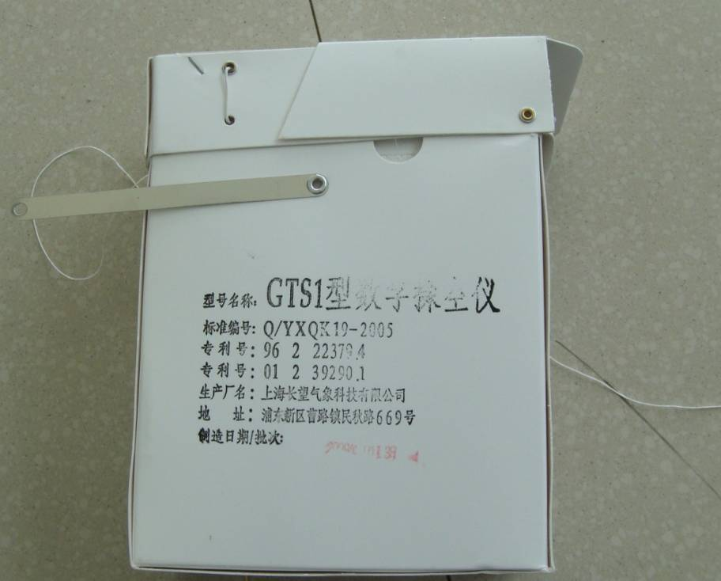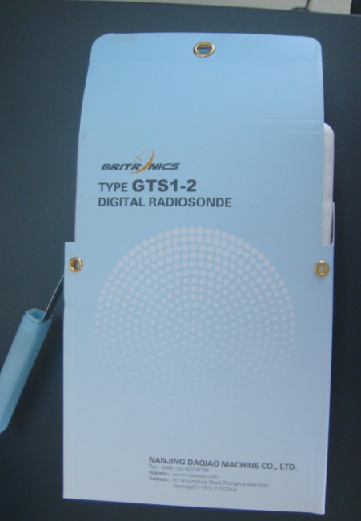
Figure 1 Pictures of GTS1 and GTS1-2
- The dynamic test and comparison methods of radiosondes
2.1 The method of multiple radiosondes attached on the same balloon
The test adopts with the method of releasing multiple radiosondes attached on the same balloon at one time, one or more tested L-band electronic radiosondes and two radiosondes RS92 are attached on the same balloon at the same time, which can be shown in the Figure 2.
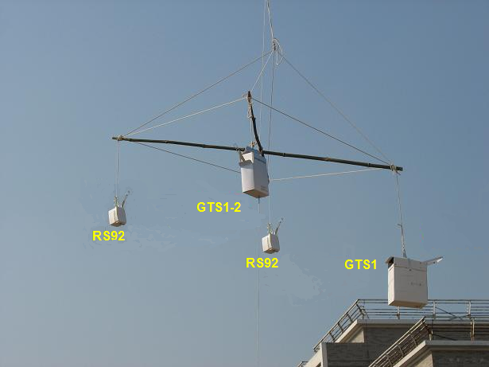
Figure2 Multiple radiosondes released by one balloon
2.2 Error separation method
In comparison test, statistical standard deviation (STD) between two radiosondes is synthesized by each of them. How to separate it?
Firstly if there are enough sample data, the data distribution will be normalization. Secondly two radiosondes with the same sensors between which the statistical systematic errors (SE) should be near zero, also the respective STD of them should be approximately equal. Using RS92 as a reference and GTS1, GTS1-2 as test radiosondes, the STD of them is given by formula (1):
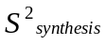=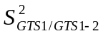+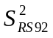

As the principle, the separated STD of RS92 is given by formula (2):
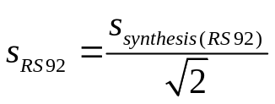
So the respective STD of RS92, GTS1 and GTS1-2 can be achieved.
- Analysis of tests results
  - Data descriptionu
When GTS1-2 radiosonde went through the examination and model approval, the comparing tests among GTS1-2 and the GTS1 and the RS92 were conducted at Nanjing upper-air sounding station in Jiangsu province in January of 2009, and 20 groups of valid data were obtained. The tests mainly focused on measurement accuracy comparison between GTS1 and GTS1-2, and analyze and summarize the measurement performances of different sensors.
Through comparative tests, the manufacturers of GTS1-2 summarize their experience and upgrade the temperature sensor to bead thermistor. They released and compared with the RS92 in Yangjiang upper-air sounding station in May, 2009, and obtained 11 groups of valid data. The results had shown that the temperature measurement accuracy had been improved significantly, but the pressure measured value had a clear system deviation in the areas of pressure from the ground to 700hPa and above 300hPa. Therefore, through software amendments, the comparing tests were conducted in June at the same year and 8 groups of valid data were obtained, the results show that pressure measurement accuracy has been improved significantly. The releasing method for radiosonde comparison can be shown in Figure 3.
GTS1
RS92
GTS1-2
GTS1-2 advanced
RS92
Yangjiang
Nanjing
Figure 3 Methods of tests
3.2 Results of comparison
3.2.1 Analysis of the pressure, temperature and humidity measurement
Table 1 Results of comparative tests
comparative results  (RS92 is standard) |  | P (hPa) |  |  | T (℃) |  |  | U (%RH)
comparative results  (RS92 is standard) |  | STD | SE |  | STD | SE |  | STD | SE
GTS1 | ≥500hPa | 0.76 | -1.22 | ≥100hPa | 0.23 | 0.12 | ≥-25℃ | 5.53 | -7.78
GTS1-2 | ≥500hPa | 0.59 | -0.28 | ≥100hPa | 0.32 | 0.05 | ≥-25℃ | 5.97 | 2.22
GTS1-2 advanced | ≥500hPa | 0.13 | -0.12
GTS1 | < 500hPa | 0.65 | -0.98 | <100hPa | 0.67 | 0.14 | <-25℃ | 8.47 | 2.78
GTS1-2 | < 500hPa | 0.48 | -0.45 | <100hPa | 0.40 | 0.09 | <-25℃ | 10.53 | -4.55
GTS1-2 advanced | < 500hPa | 0.31 | -0.31
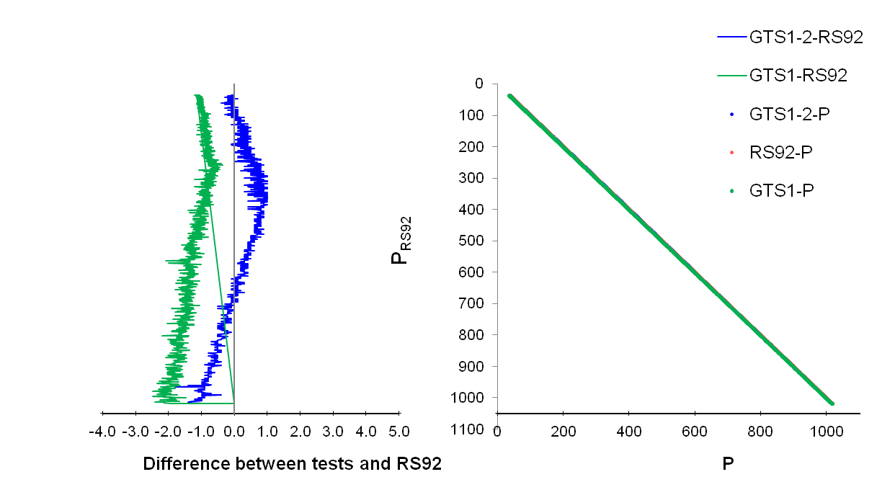
GTS1-2
GTS1
Figure 4 Difference pressure of GTS1 and GTS1-2 compared with RS92
It is seen from Figure 4, the measured value of pressure of GTS1 has a very large system error, and the standard deviations of GTS1 and GTS1-2 are approximately within 1hPa.
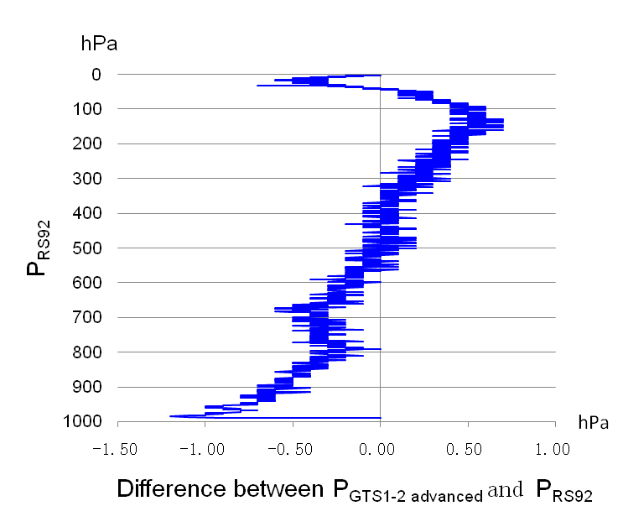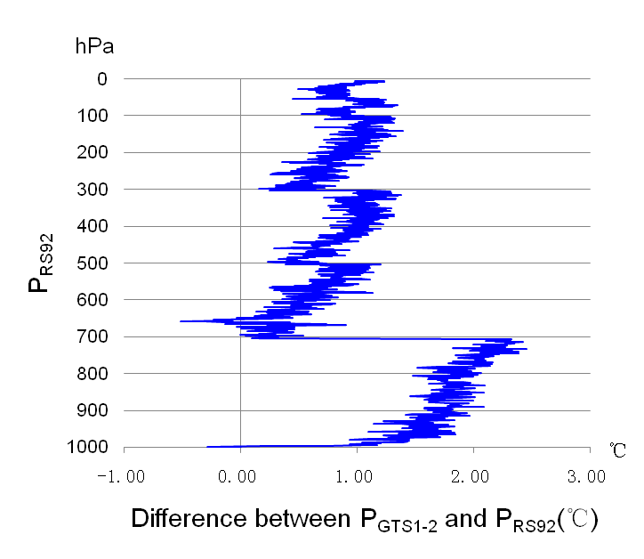
GTS1-2
GTS1-2 advanced version
Figure 5 Difference pressure of GTS1-2 and GTS1-2 advanced version compared with RS92
Figure 5 shows that GTS1-2 has large systematic error from the ground to 700hPa area and has an obvious jump near 300hPa. Amended by the software, GTS1-2 data can get much better results.
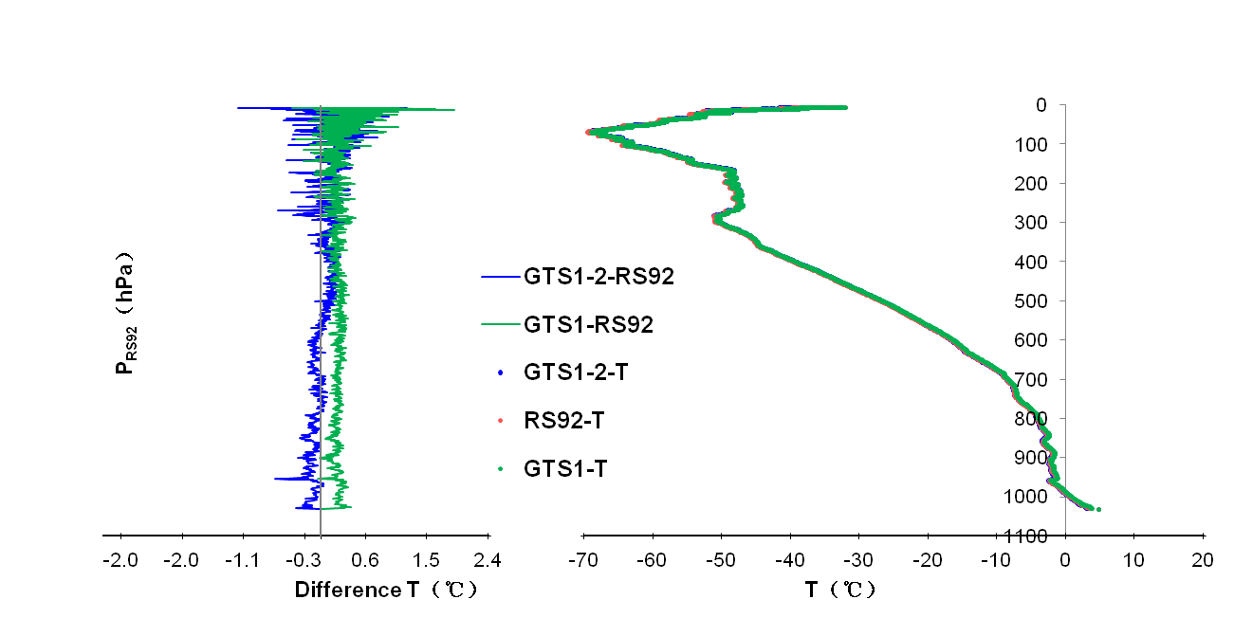
GTS1
GTS1-2
Figure 6 Difference temperature of GTS1and GTS1-2 compared with RS92
Figure 6 shows that the measured value of temperature of GTS1 also has certain systematic error. Above 300hPa, the random errors of temperature measurement values of GTS1 and GTS1-2 are gradually increased with the height.
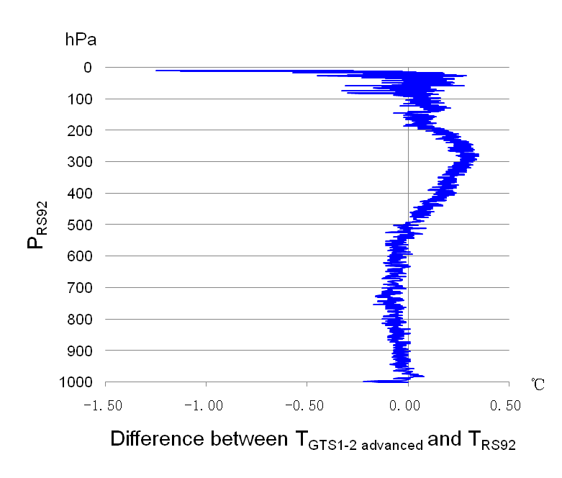
GTS1-2 advanced version
Figure 7 Difference temperature of GTS1-2 advanced version compared with RS92
Figure 7 shows that pressure problems for GTS1-2 have been solved very well.
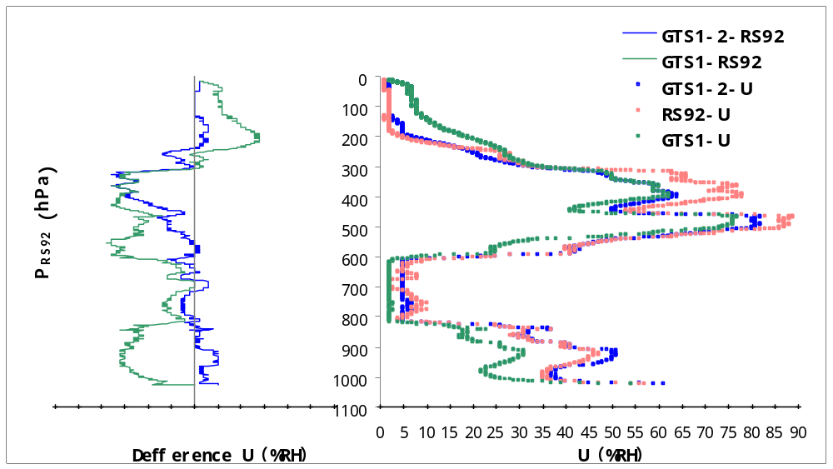
GTS1
GTS1-2
Figure 8 Difference humidity of GTS1-2 advanced version compared with RS92
The GTS1 humidity sensor uses the carbon hygristor, and the humidity sensor of GTS1-2 has been changed to the organic thin-film capacitor. The test result of both sensors indicates that the organic thin-film capacity humidity sensor can react quickly. The carbon hygristor has the shortcoming that the high temperature cannot come up, while the low temperature cannot get down.
    - Analysis of the wind measurement
The experiment is conducted at Xilinhaote upper-air sounding station in Inner Mongolia autonomous region where the climate is relatively drier than Yangjiang upper-air sounding station in Guangdong Province. The balloons were respectively released 30 and 15 times at Xilinhote and Yangjiang in June, 2008 and in July, 2008., and 40 groups of valid data were obtained.
The L-band surface radar can track and locate the floating balloon, obtain the elevation, distance and azimuth angles, and then convert to horizontal and vertical time displacement through the rectangular coordinates. The wind speed and wind direction values of the moment are composed by these two 1 minute time displacement. This method of calculation of the wind only use the minute data to calculate the wind, and the wind speed and wind direction values seem too smooth, which can be shown in Figure 9.

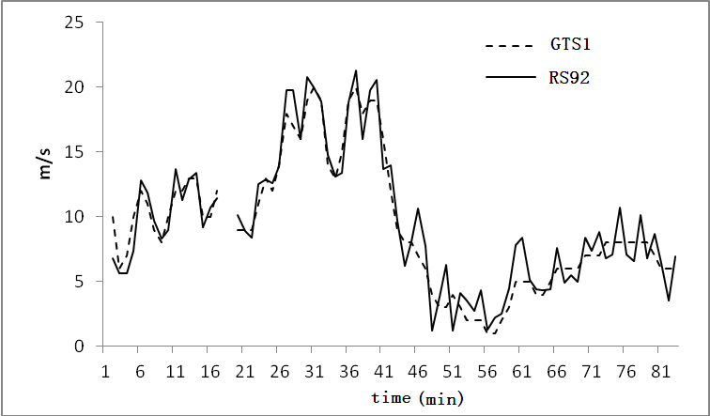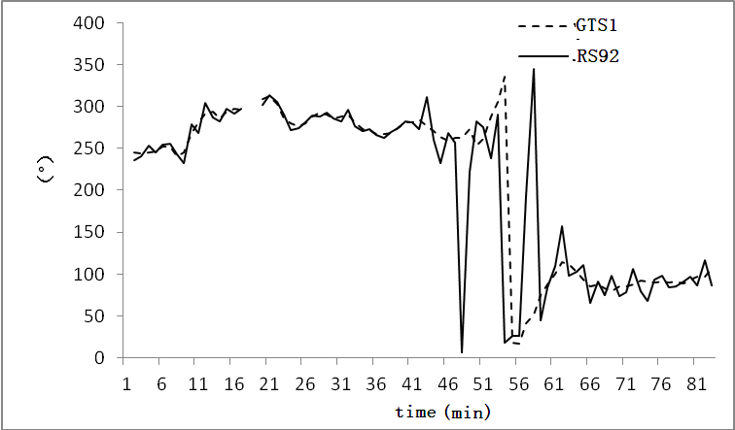
GTS1 & GTS1-2 (using the same type of L-band radar)
Fig. 9 Original operational WD&WS compared with RS92
In this experiment, the software of wind measurement data of the GTS1-2 adopts the average vector method to calculate the wind speed and wind direction values.

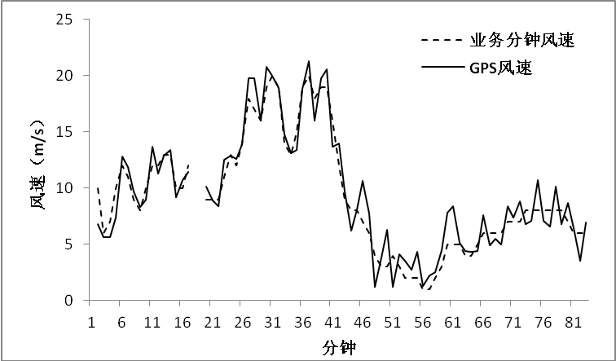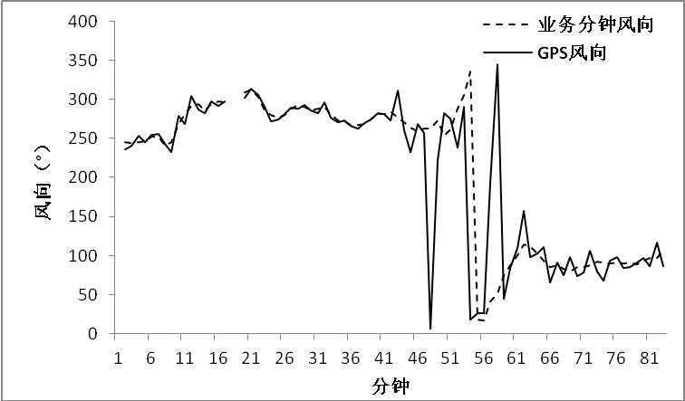
WS
WD
--- Original operation
— RS92
--- Original operation
— RS92
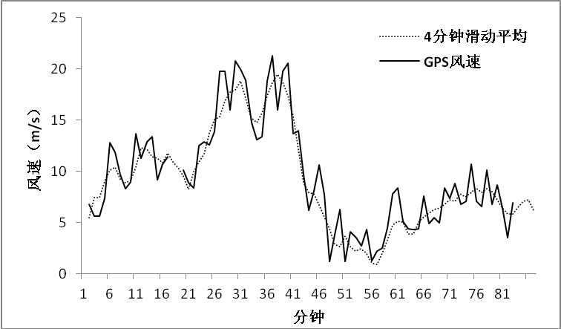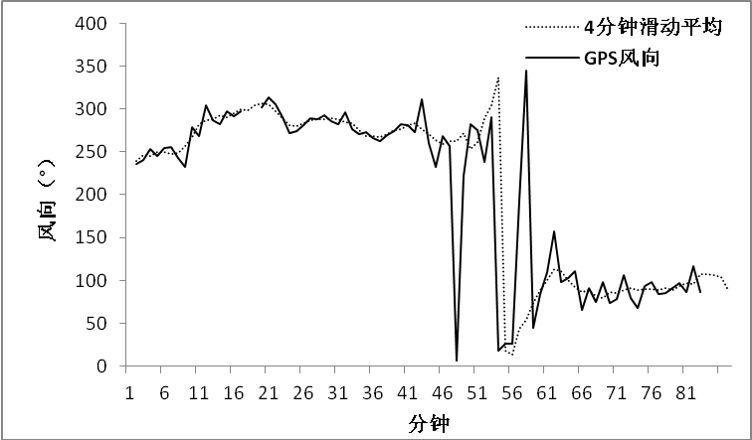
WS
WD
--- 4 min average time
— RS92
--- 4 min average time
— RS92
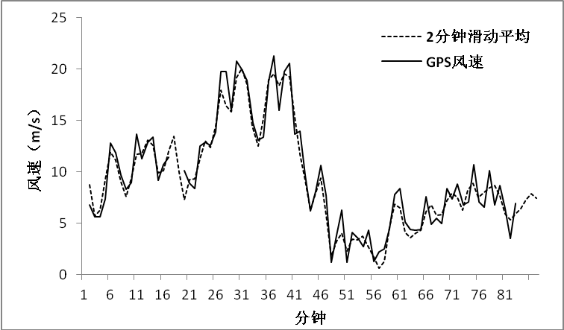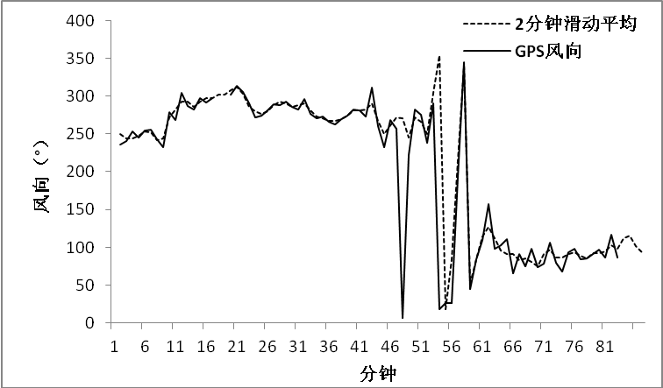
WD
WS
--- 2 min average time
— RS92
--- 2 min average time
— RS92
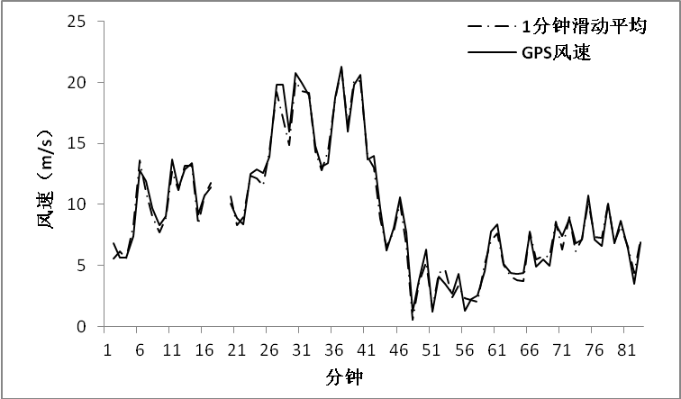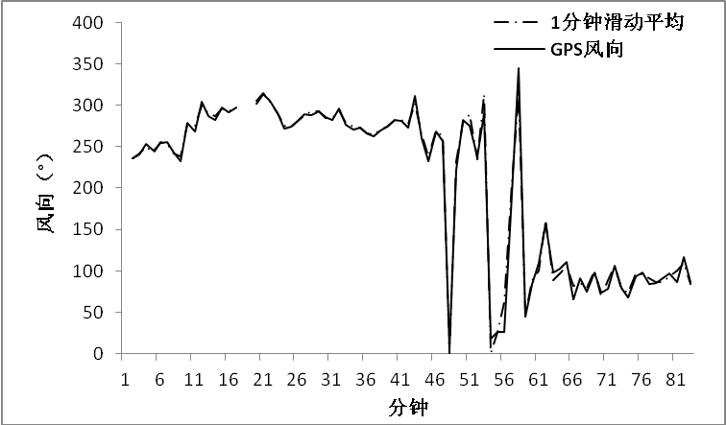
WS
--- 1 min average time
— RS92
--- 1 min average time
— RS92
WD
--- 30 sec average time
— RS92
--- 30 sec average time
— RS92
WS
WD
--- 10 sec average time
— RS92
WS
--- 10 sec average time
— RS92
WD
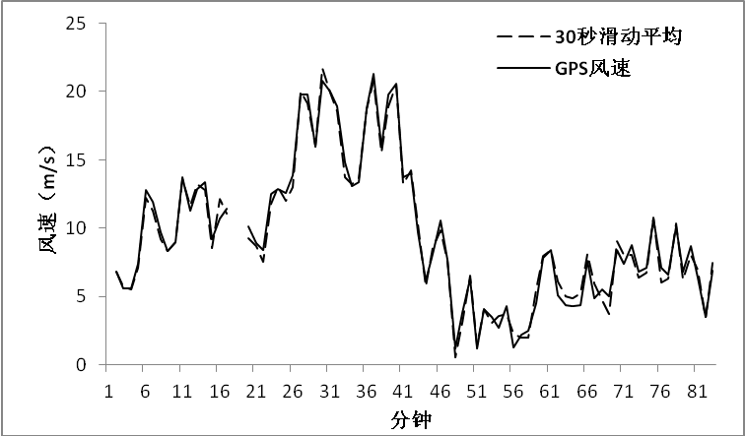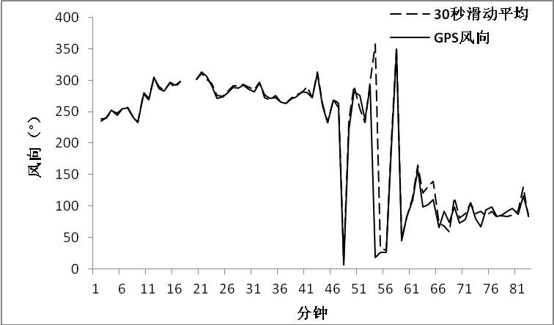
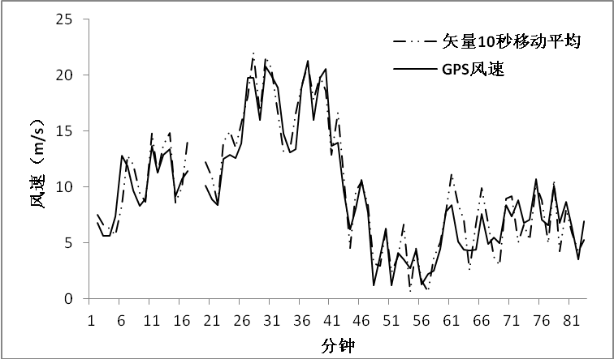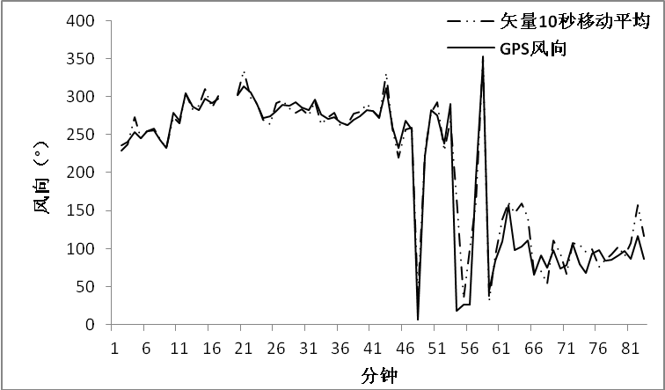
Fig. 10 Comparison of the average vector wind and the operational minute wind with GPS measuring wind on 21 Jun. 2008 at Xilinhaote upper-air station
Table 2 Statistical results of wind speed and direction
Reference  GPS RS92 | WS |  |  |  |  |  |  | WD
Reference  GPS RS92 | STD |  |  |  | SE |  |  | STD |  |  |  | SE
Reference  GPS RS92 | Xilinhaote | Yangjiang |  | Xilinhaote |  | Yangjiang | Xilinhaote |  | Yangjiang |  | Xilinhaote |  | Yangjiang
4min | 1.57 | 1.66 |  | -0.33 |  | -0.26 | 14.30 |  | 10.32 |  | 0.36 |  | -0.11
2min | 1.16 | 1.24 |  | -0.23 |  | -0.15 | 10.73 |  | 7.76 |  | 0.48 |  | 0.32
1min | 0.74 | 0.81 |  | -0.11 |  | -0.05 | 7.97 |  | 5.59 |  | 0.45 |  | 0.46
30sec | 0.73 | 0.85 |  | -0.01 |  | 0.06 | 8.11 |  | 6.32 |  | 0.71 |  | 0.37
10sec | 1.62 | 1.84 |  | 0.29 |  | 0.43 | 14.88 |  | 11.74 |  | 0.27 |  | -0.16
original operation | 1.50 | 1.62 |  | -0.26 |  | -0.10 | 14.20 |  | 8.95 |  | 0.49 |  | 0.49
- Conclusion
(1) The temperature sensor of radiosonde used in China has been changed from the rod-shaped thermistor to bead thermistor gradually, the measurement accuracy has been improved significantly, and the radiation error has also been effectively corrected.
(2) At present, the GTS1-2 radiosonde has better performance than GTS1, but the humidity measurement still exist a certain gap compared with RS92.
(3) Through software algorithm, bias for pressure measurement can be corrected largely.
(4)Current operational wind calculation method has relative large wind pulse affection, and some real results reflecting the wind speed and direction have also been smoothed. The moving average vector method can better eliminate the pulsation effect. If using the 1 minute moving average window to calculate the upper-air wind per second, it can be consistent with GPS wind measurement.

