DEVELOPMENT AND CHALLENGES IN SWISSMETNET, THE NEW SWISS METEOROLOGICAL NETWORK
Y.-A. Roulet, B. Landl, Ch. Félix, B. Calpini
MeteoSwiss, Aerological Station, 1530 Payerne, Switzerland
Phone:+41 26 662 62 58, Email: yves-alain.roulet@meteoswiss.ch

ABSTRACT

Among its duties, MeteoSwiss is responsible for the operation and maintenance of a meteorological (Nowcasting) and climatological (Climate Change) network, guaranteeing regular measurements on the entire Swiss territory. The ground-based network is currently being renewed under the project SwissMetNet (SMN), resulting in a state-of-the-art unified and secured network.
The renewal is taking place in two phases: In the first phase the former automatic network is renewed, which consists of stations which have their main relevance in climate monitoring and therefore build the backbone for the surface SMN. This phase ended in 2009. In the second phase the complementary network is integrated into the SMN which has the main purpose in security aspects (e.g. wind warnings). In addition a number of climate stations with human observers are partly or fully automated and integrated into the SMN.
Another measuring networks have been connected on the same SMN platform, which consists of three automatic weather station (AWS) equipped with windprofiler and microwave radiometer. Two of these stations are further equipped with humidity profiles based on passive microwave radiometer and one station measures in addition water vapor profile by Raman LIDAR.
This contribution focuses on the SMN network description. It will highlight some of the recent achievement obtained in the specification and performance of the current SMN. It will also demonstrate new possibilities that are offered with this new platform. In particular SMN allows for developing a fast, flexible and cost efficient solution for an extended network of AWS. Such request was recently defined for additional precipitation measurements in a specific Swiss Alps region.

Introduction
MeteoSwiss, the Swiss National Meteorological Service, is currently renewing and extending its ground-based automatic meteorological network under the project SwissMetNet. Existing networks are being merged into one unified network, and stations with human observers are being automatised and integrated into this new network. At the end of the project, 134 automatic weather stations will be connected to the SwissMetNet back-bone (see Figure 1) and will deliver continuous measurements covering the entire complex Swiss territory. The data are used for several purposes, internally for national security (alarming in case of extreme meteorological events, weather forecasting) or climate change studies, and by external customers, e.g. airports, tourism or agriculture.
The overall data availability for the whole network in 2009 exceeded 99.9%.
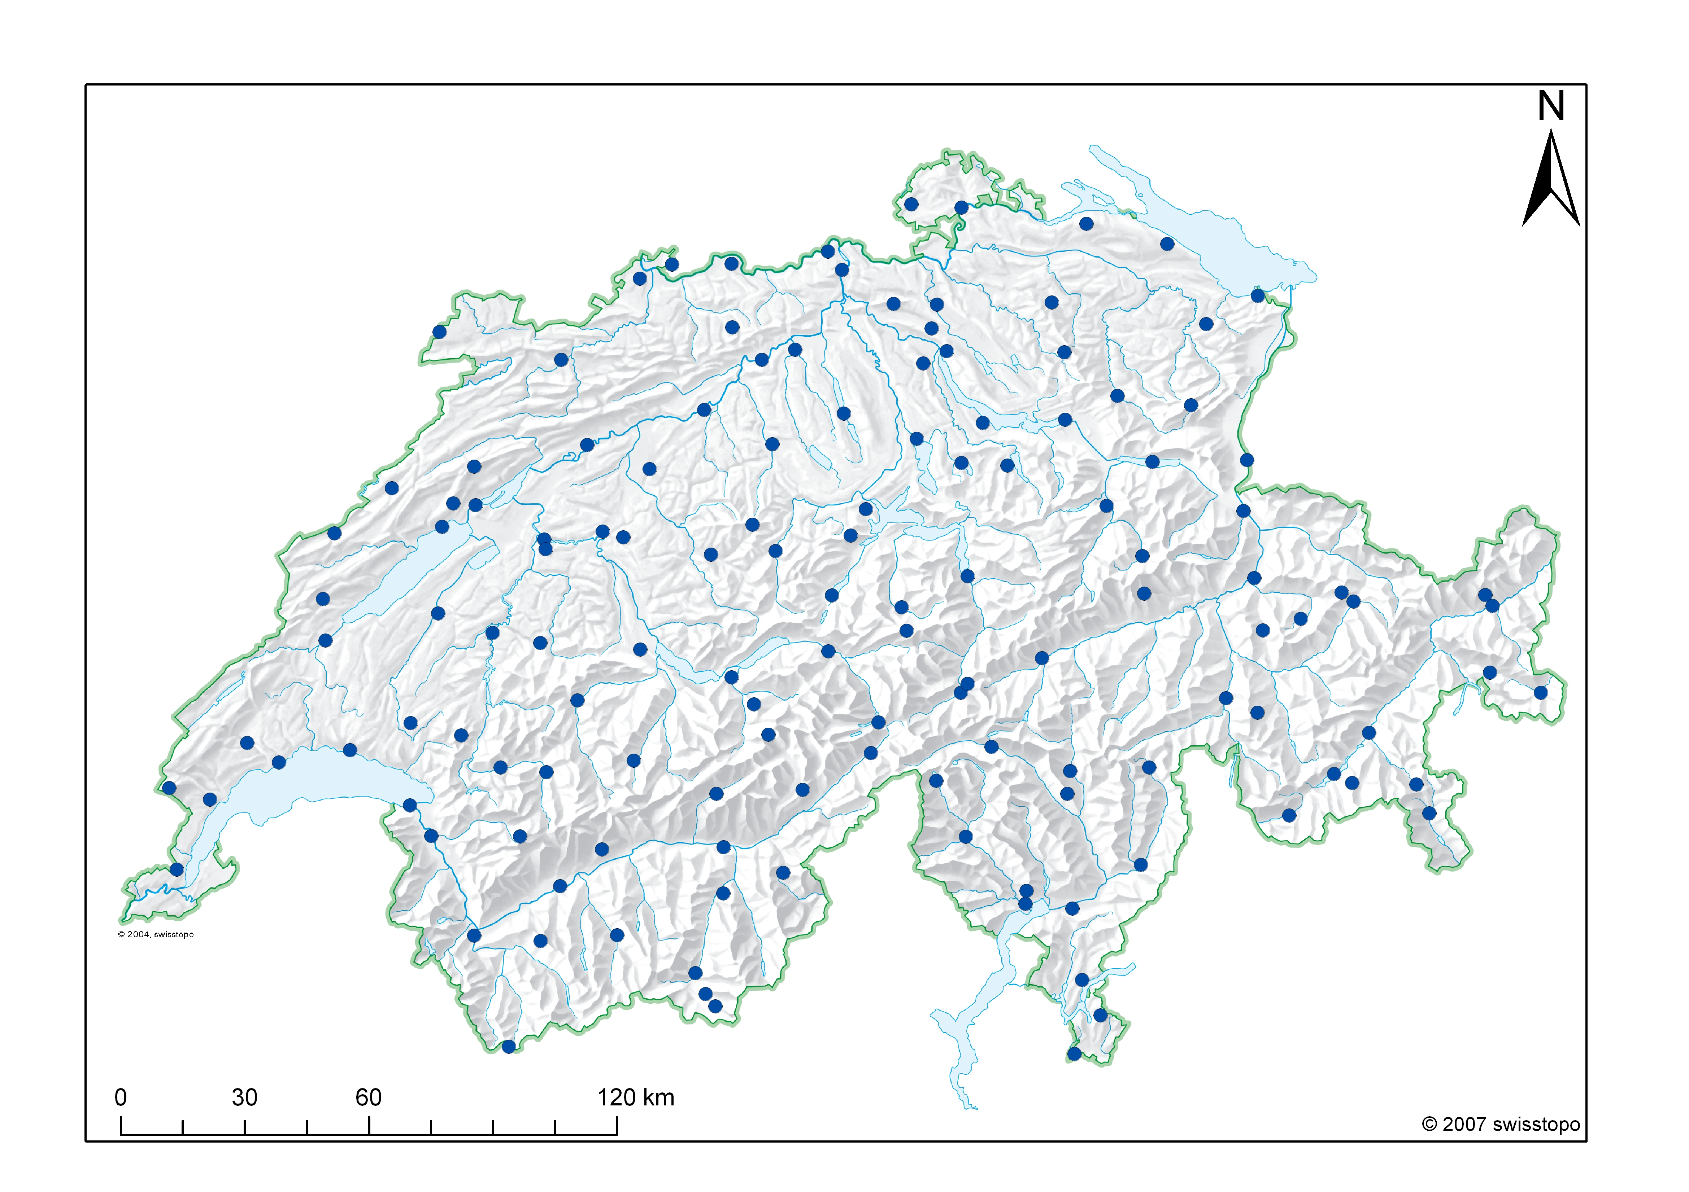
Figure 1 The SwissMetNet network in its final configuration, with 134 full automatic ground-based weather stations covering the entire Swiss territory.

The SwissMetNet platform is currently being extended to other measuring technologies, such as remote sensing instrumentation, or specific ground-based measurements, such as a dedicated precipitation measurement sub-network for a particular region, the idea being to develop a common unique data acquisition and transmission platform for various observation technologies.
The realization of full autonomous automatic stations is also investigated, and a SwissMetNet station working 100% on solar energy and with GPRS/UMTS data transmission has been recently installed on a glacier in the Swiss Alps at 2’800 m asl.

The SwissMetNet design
The standard SwissMetNet station consists in a 10 by 15 m fenced field with standard sensors positioning, with respect to WMO CIMO Guide recommendation. Depending on the environment and local conditions (e.g. large amount of snow in winter), the station design may vary (see Figure 2).
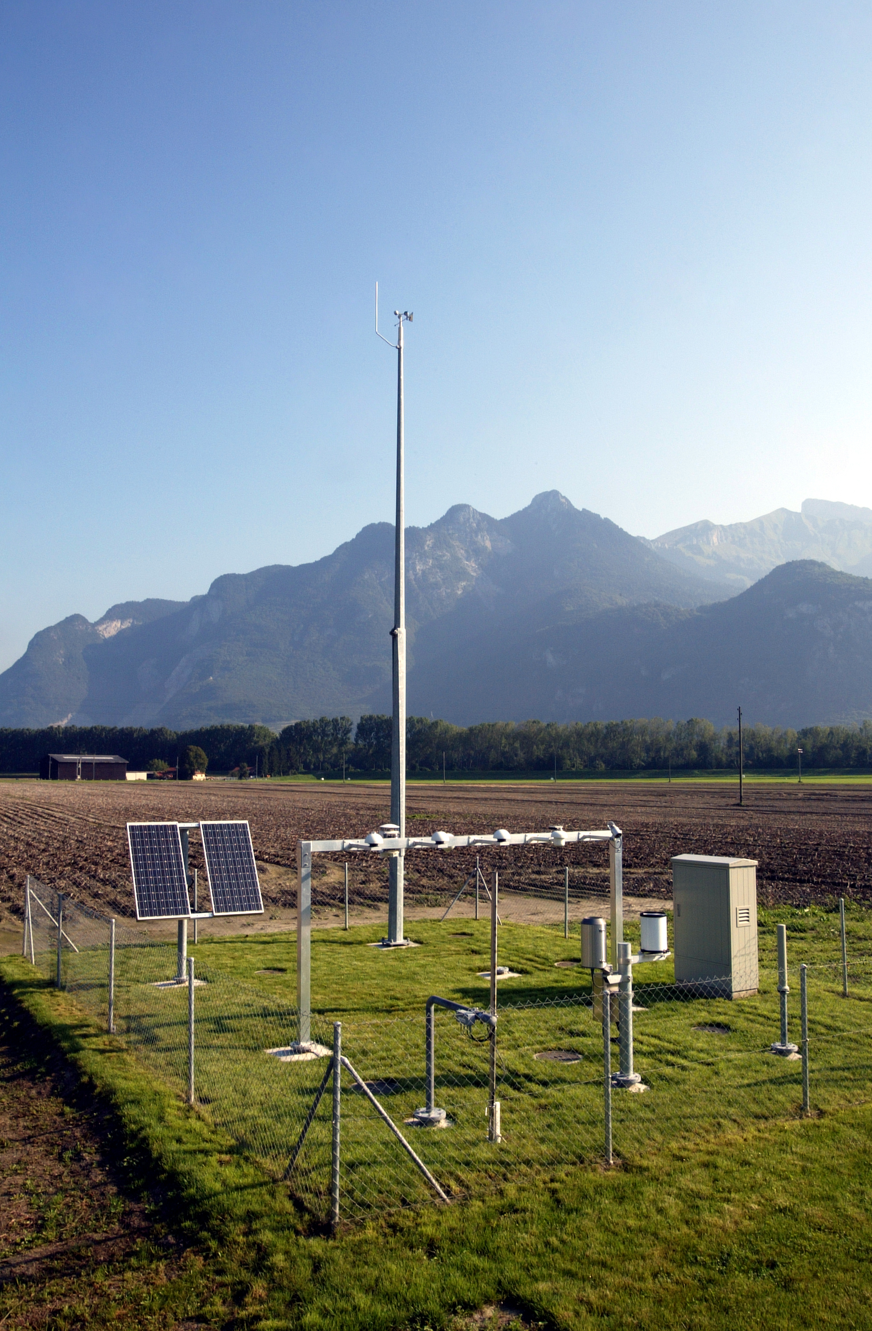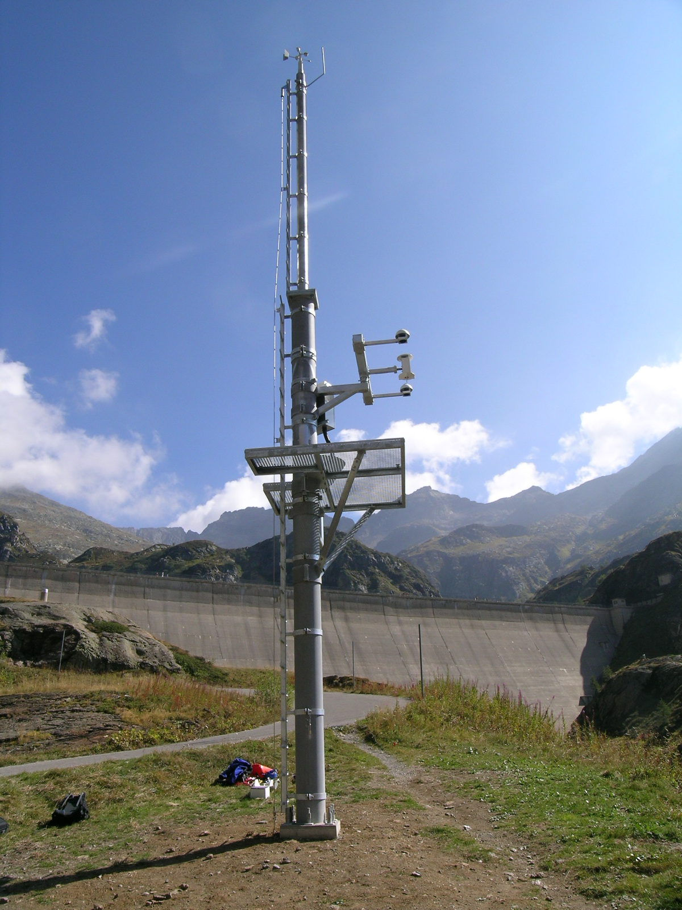
Figure 2 The SwissMetNet standard measuring field (left), and a specific compact configuration for Alpine area with high snow depth.

The network consists of redundant central servers, which actively retrieve the data from the AWS every 10 min. Some special stations for radiation measurement deliver 1 min bulletins. Meteorological alarms for wind, precipitation and temperature can be raised automatically from the AWS as soon as user defined threshold values are exceeded. The data acquisition and transmission unit is usually located on the measuring field in a special robust cabinet, so that the only connexion with outside infrastructure is the power line. The data logger has a buffer corresponding to about 30 days, so that the data are stored locally and can be retrieved after a communication interruption with the central server, thus avoiding any data loss. The electronic in the cabinet is exposed to temperature range of -30°C to + 45°C, therefore robustness of the cabinet and the components inside is a crucial parameter for the high data availability of the whole network (see Figure 3).
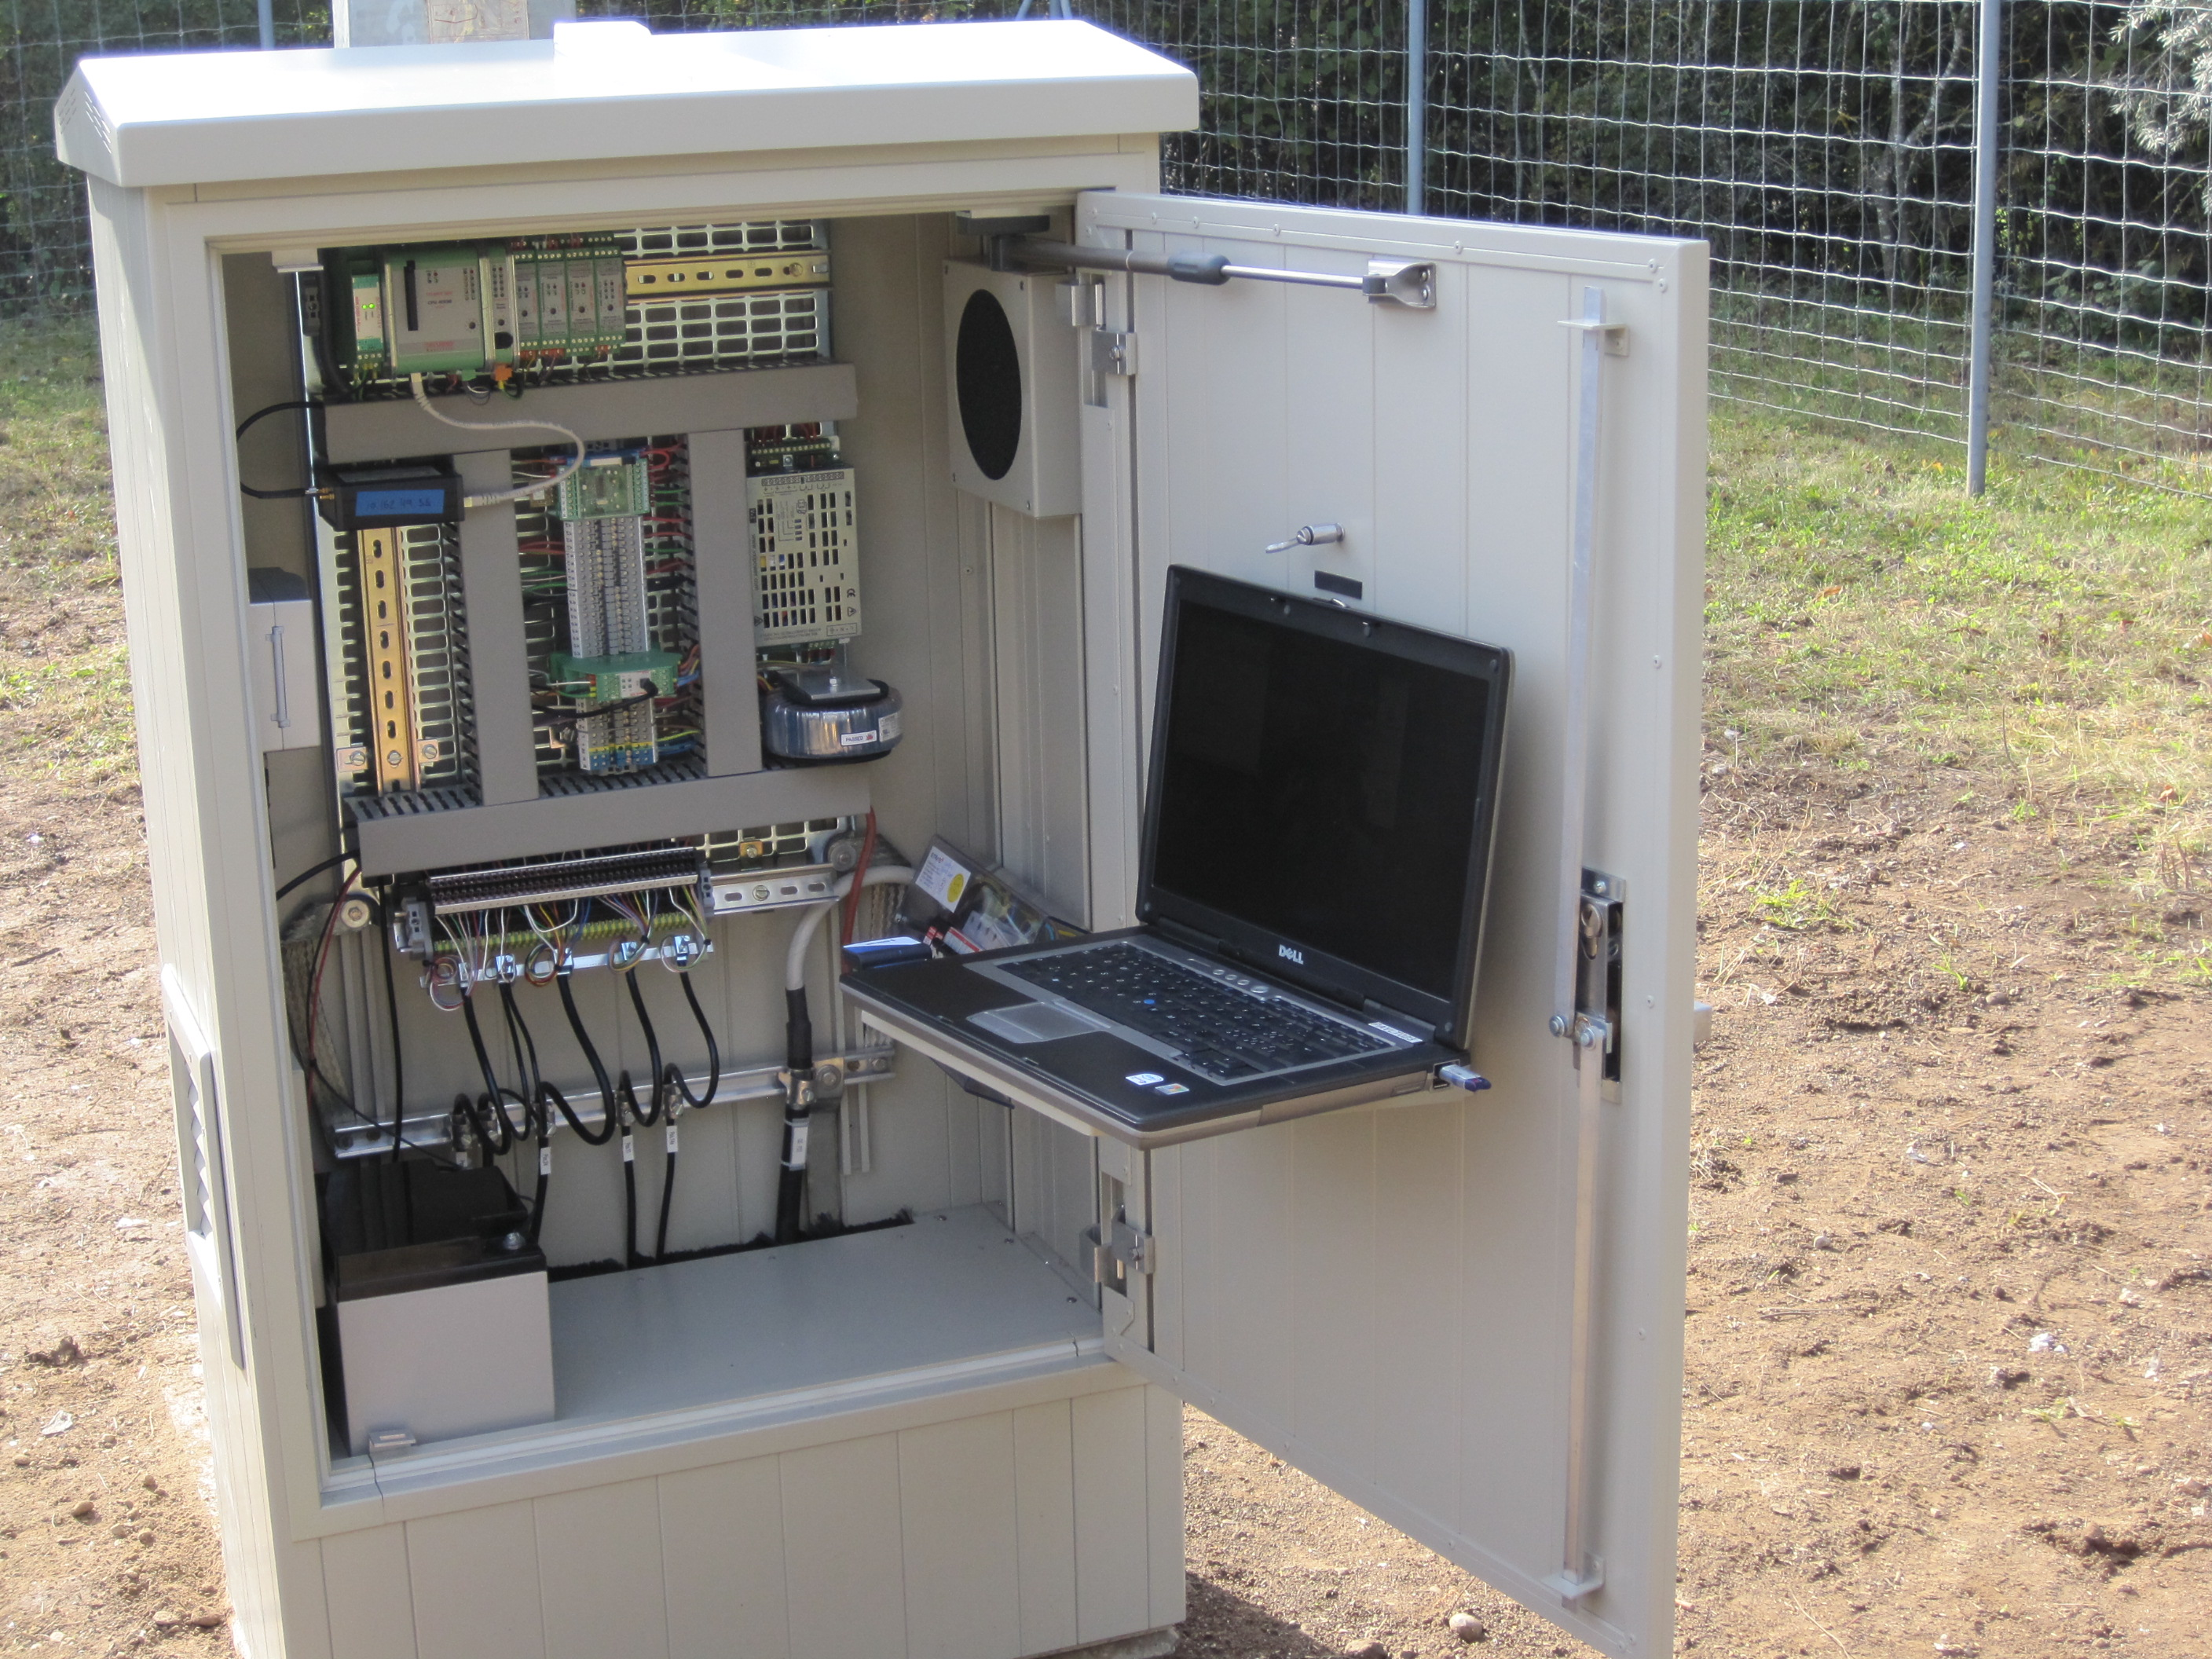
Figure 3 The cabinet of a SwissMetNet station and its robust components: wiring, power line and data logger. A laptop client can directly be connected to the station for maintenance purposes.

The very powerful high-end SW package driving the network allows remote diagnostics for all AWS components, from battery and heating processes up to modem and meteorological sensors.
More than 95% of the AWS are transmitting data via mobile phone network (GPRS/UMTS/HSPDA). The rest of the stations remain connected to fixed lines, either because mobile network coverage is not sufficient at that location, or because amount of transferred data is too high (special stations).

Operational organization
The monitoring of the network is centralised in a single control room. PC clients are used for the remote monitoring and configuration of the network. The SW system driving the network (servers, AWS) allows very accurate remote diagnosis for most technical problems occurring on the AWS (data logger, electronic parts, sensors), so that the dispatching for intervention and maintenance can be optimised. For the preventive and curative maintenance, four regional centers cover the entire Swiss territory.
The central servers are being monitored 24/365 and an operational organization with 3 levels support (monitoring, internal call service, external call service) is defined, so that a major breakdown leading to an interruption of data transmission of the whole network can be remotely fixed as soon as it appears, thus minimizing the data delivery delay.
The quality control on raw data is performed at two levels. A real-time control is done on the SwissMetNet platform, using pre-defined threshold values, dead band or jump criteria. An alarm is raised to the operator as soon as a suspicious value is detected. This helps the operator to detect any malfunction of a sensor or of any other component of the AWS (e.g. battery, charger, data logger). A second quality control is performed once a day using data from the past (typically 3 to 6 months). The idea of this QCT (Quality Control in Time, [1]) is to detect any instrumental drift that can not be seen on real-time values, in order to optimize the maintenance processes and thus reduce operational costs.

Integration of remote sensing technologies
The SwissMetNet platform is currently being extended to other measuring technologies. The idea is to develop one single data communication platform, which can handle various systems of observations, from ground-based meteorological stations up to remote sensing instrumentation or weather radars.
In the frame of a project dealing with nuclear power plants security ([2]), MeteoSwiss has installed three remote sensing observation sites, each equipped with a windprofiler and a temperature microwave radiometer. Each of these instruments has been interfaced on the SwissMetNet, in order to optimise the monitoring.

SwissMetNet extension plans
Development of autonomous weather stations for SwissMetNet has been studied. The first station being fully supplied by solar energy has been installed in 2008 in the Swiss Alps at 2’800 m asl on the Monte Rosa. The horizon at this location is largely influenced by surrounding summits, so that the maximum possible daily sun duration drops to 30 min for the period Mid December until Mid January. Nevertheless the station has been running with high data availability since its installation, as it is equipped with an intelligent module for energy consumption regulation (economic mode without heating).
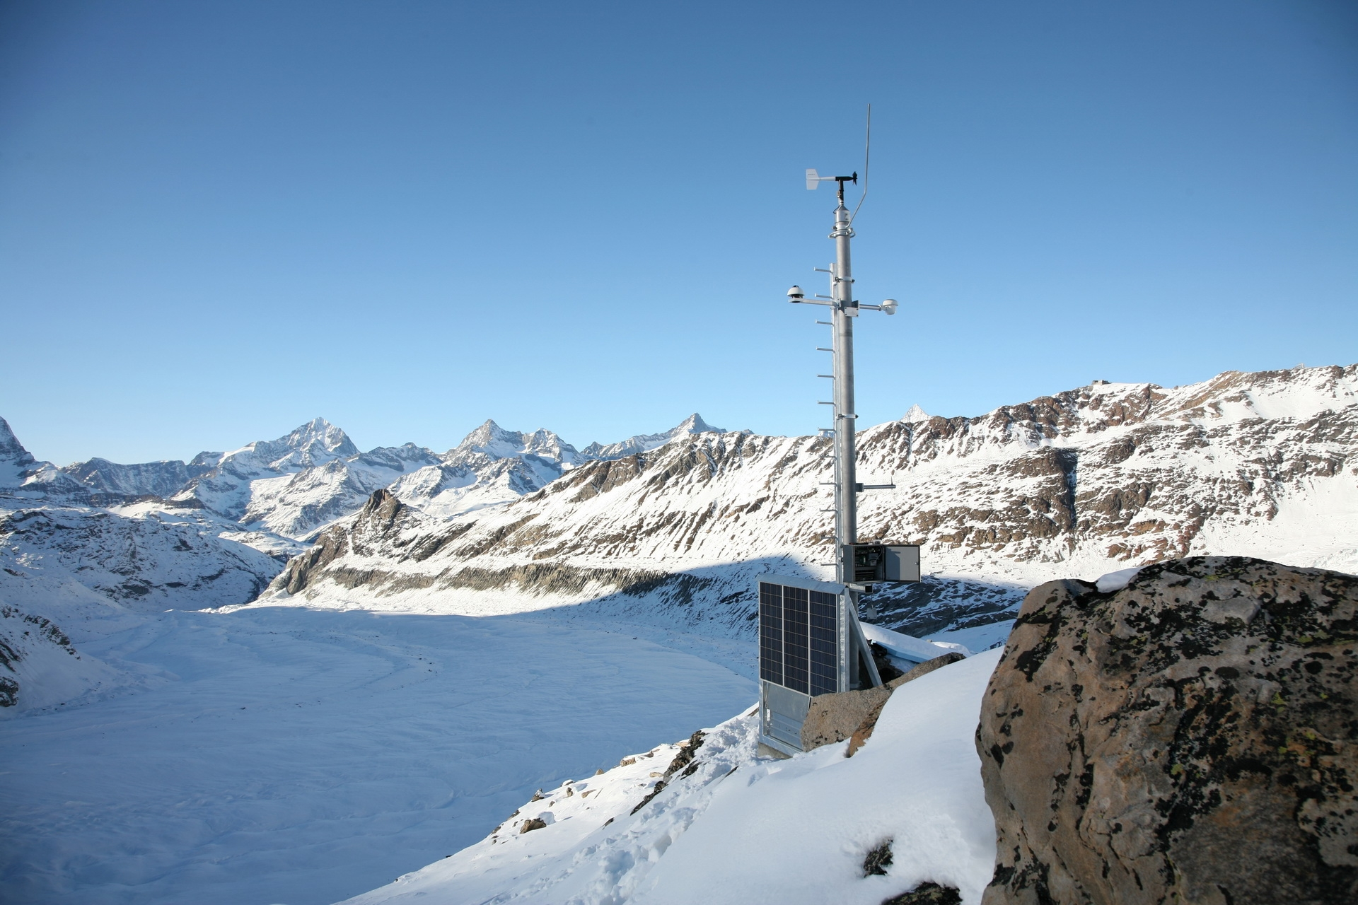
Figure 4 The SwissMetNet station at Monta Rosa (2’800 m asl), fully supplied with solar panels, and transmitting data via mobile phone network.

The next challenge is the realization of a precipitation sub-network on SwissMetNet, dedicated to a particular Swiss region. For this purpose, a compact easy to deploy station has been developed. In particular, no civil engineering or electric wiring works are needed at the installation. The station is entirely mounted and tested in the lab before being deployed. Transportable concrete blocks are used to stabilize the installation at ground.
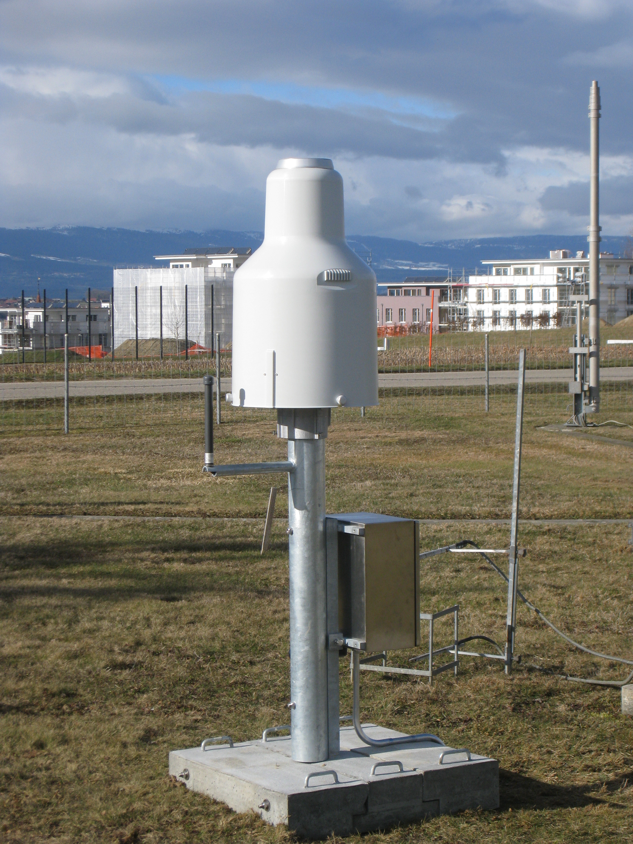
Figure 5 The SwissMetNet precipitation measuring station.

References
- B. Huguenin-Landl, Y.-A. Roulet, B. Calpini: Operational quality control on raw data of the MeteoSwiss automatic meteorological ground-based network, TECO-2010 – WMO, Helsinki, Finland, 30 August - 1 September 2010.
- Calpini B.: Surface and upper air recent developments in MeteoSwiss, TECO-2008 – WMO, St. Petersburg, Russian Federation, 27-29 November 2008.

